How to create a formatted search (FMS) in SAP Business One
This guide shows you how to create a formatted search (FMS) in SAP Business One that displays a customer's phone number on the Sales Order form. You create a user-defined field (UDF) for the phone number and write a saved query that retrieves it. You then link the query to the field so it fills in automatically when you select a customer.

Prerequisites
Before you begin, make sure you have:
- SAP Business One launched and running.
- The Sales Order window available under Sales - A/R.
- The table and field names you need. This guide uses the OCRD table and its Phone1 and CardCode fields.

Step 1: Open the Sales Order window and identify the missing information
- Launch SAP Business One.
- In the left navigation pane, expand Sales - A/R.
- Click Sales Order to open the Sales Order window.
- Review the form. The customer phone number isn't displayed by default.
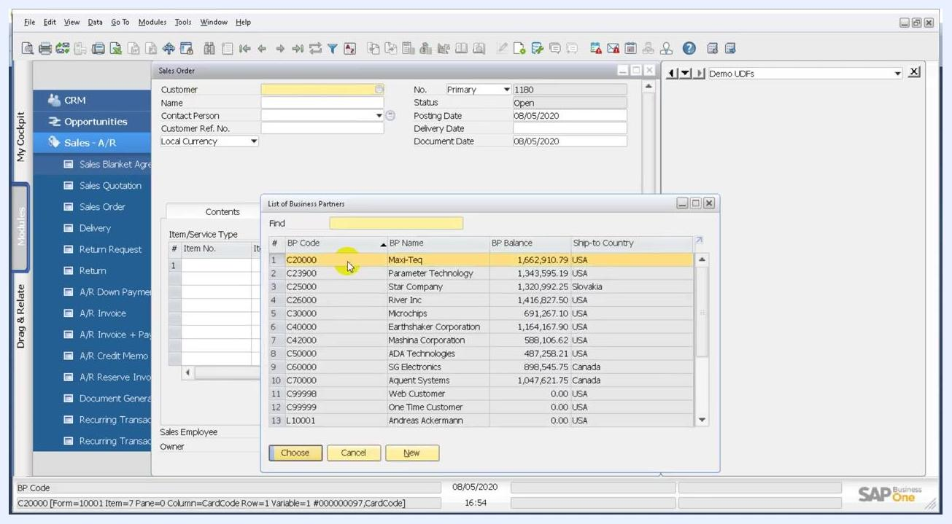
SAP Business One main screen with Sales - A/R expanded and Sales Order about to be selected

Step 2: Open User-Defined Fields – Management
- Close the Sales Order window.
- In the top menu, click Tools.
- Select User-Defined Fields – Management.
- In the User-Defined Fields – Management window, expand Marketing Documents.
- Expand Title under Marketing Documents.
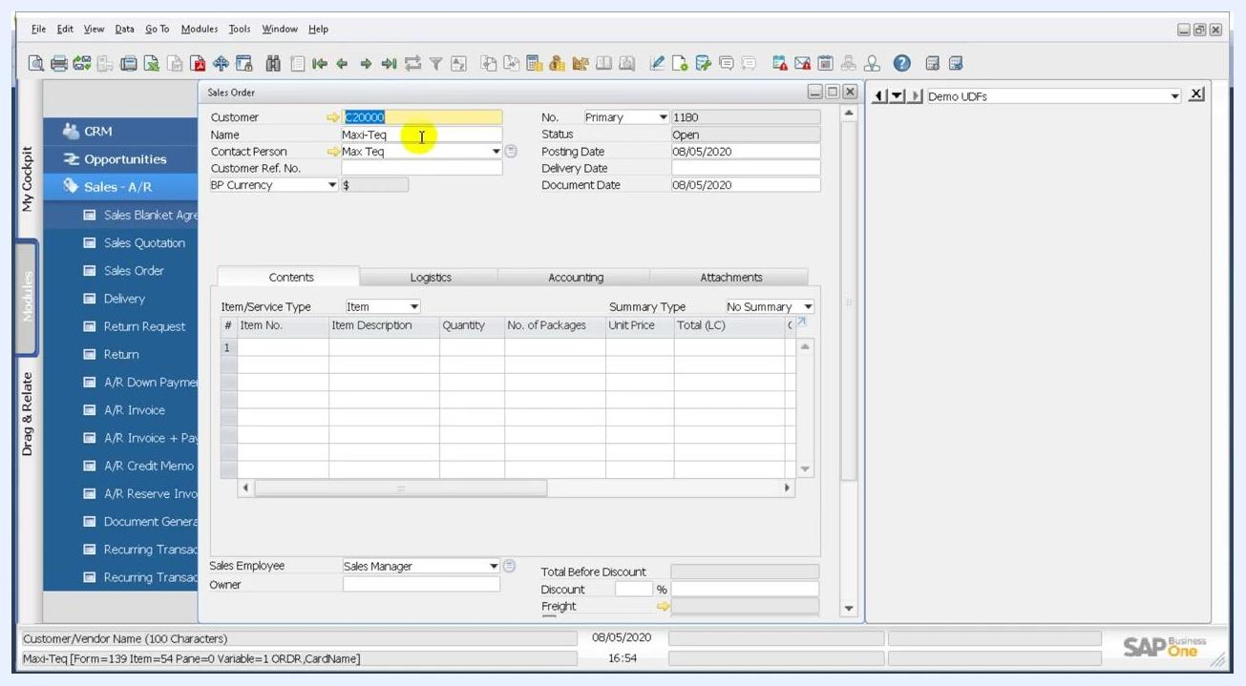
User-Defined Fields – Management window with Marketing Documents and Title expanded

Step 3: Add a new user-defined field
Click Add at the bottom of the window. In the Field Data dialog, enter the following values:
- Title: PhoneNo
- Description: Phone No
- Type: Alphanumeric
- Length: 15
- Structure: leave as Regular
- Validation: leave as None
Don't select Set Default Value for Field or Mandatory Field.
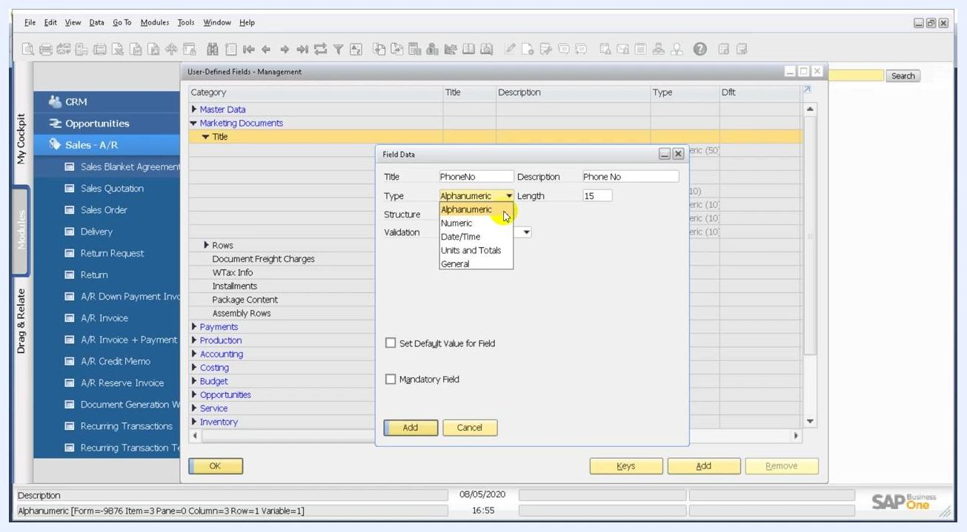
Field Data dialog for the new UDF with Title PhoneNo, Description Phone No, Type Alphanumeric and Length 15

Step 4: Confirm and add the field
Review the field settings to make sure they match:
- Title: PhoneNo
- Description: Phone No
- Type: Alphanumeric
- Length: 15
Click Add to create the user-defined field.
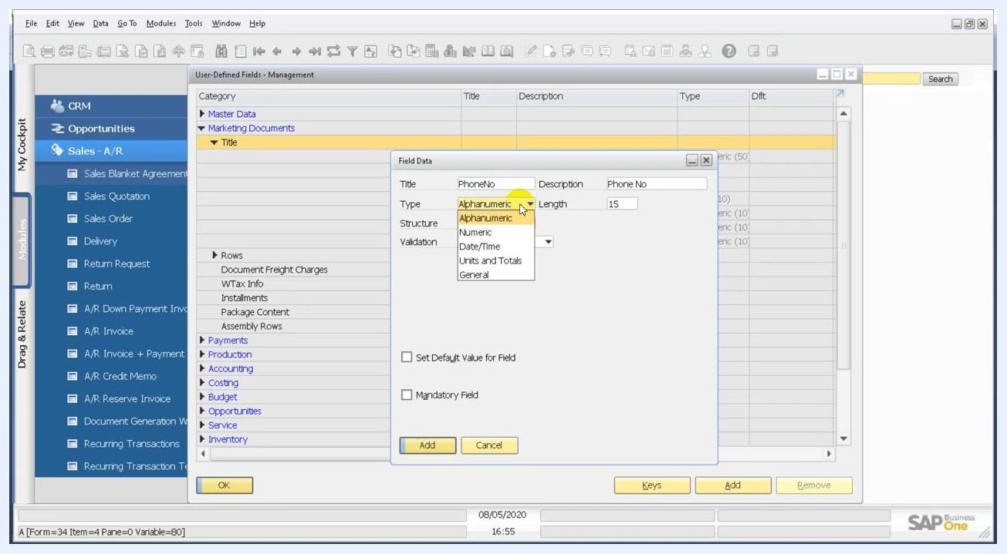
Field Data dialog with all settings filled in, ready to add the new UDF
You have now created a user-defined field for the customer phone number in the Sales Order module. Next, you assign a formatted search query to this field so it displays the phone number for the selected customer.

Step 5: Verify the UDF placement and technical name
- Open the Sales Order window.
- On the right side of the form, find the Phone No field under the Demo UDFs section.
- Hover your mouse over the Phone No field.
- Check the bottom left corner of the screen. The system information displays the UDF technical name, for example U_PhoneNo.
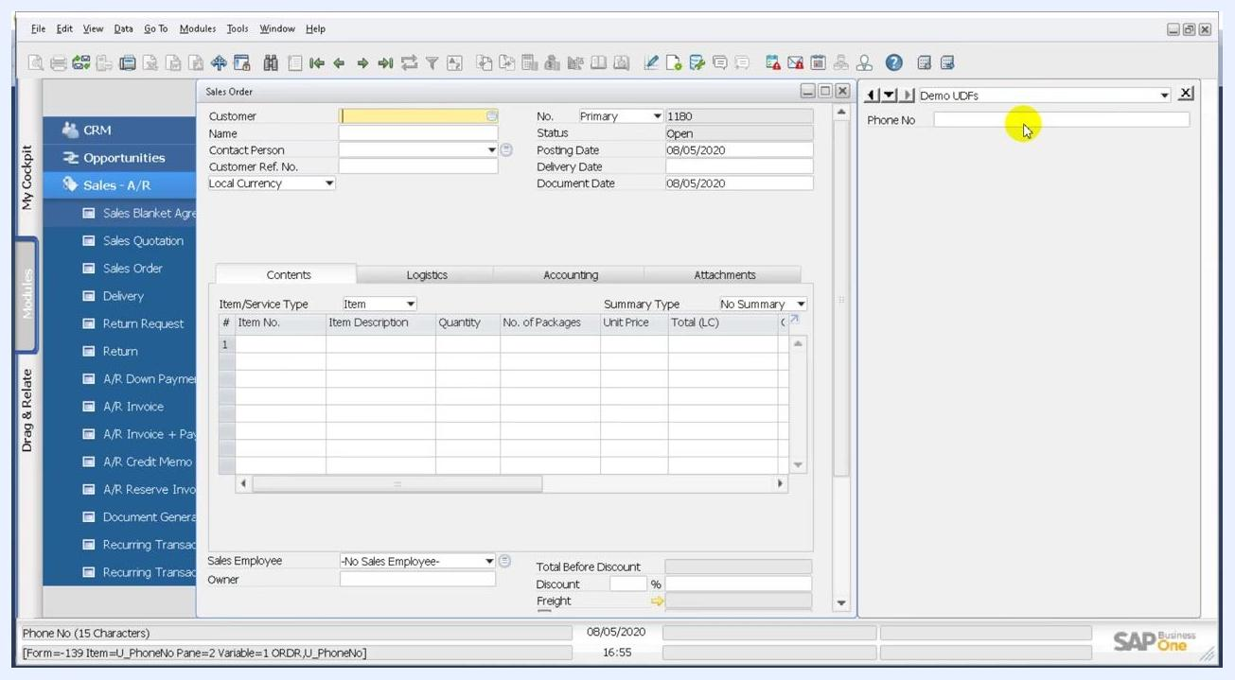
Sales Order window with the cursor over the Phone No UDF and the system information bar showing U_PhoneNo

Step 6: Find the item number of the Customer field
- In the Sales Order window, hover over the Customer field.
- Check the system information bar at the bottom. It displays: Form=139 Item=4 Pane=0 Variable=1 ORDR,CardCode
- Note that the item number is 4. This number matches the dynamic reference you use in your query.
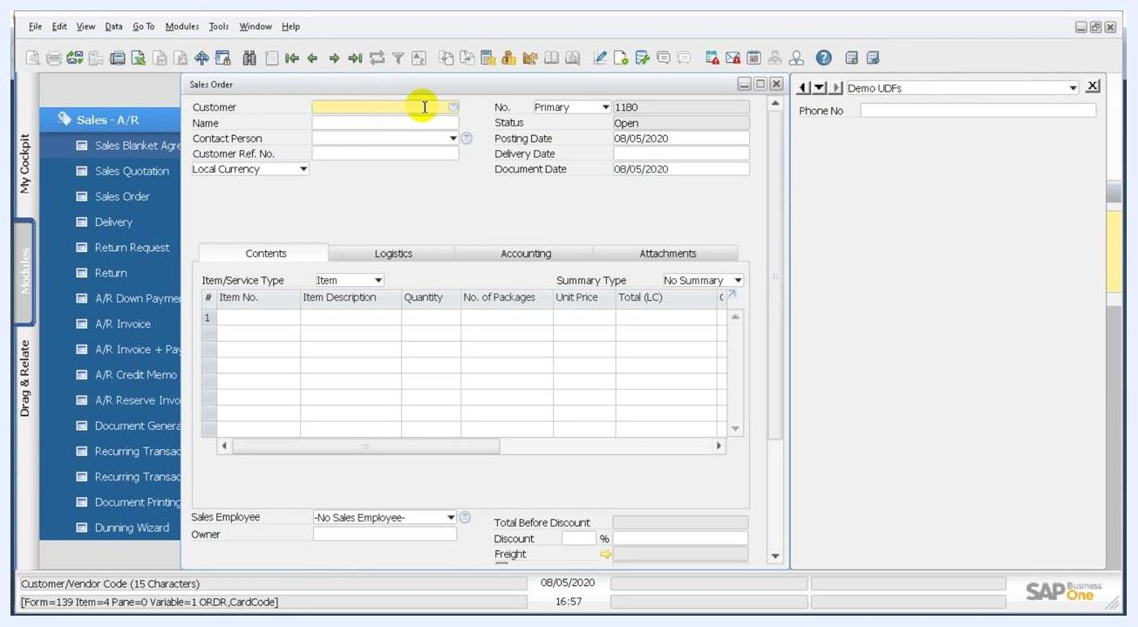
Sales Order window with the cursor over the Customer field and the system information bar showing item number 4

Step 7: Check the table and field names in Business Partner Master Data
If you're unsure about the table or field names, open Business Partner Master Data from the left navigation pane under Business Partners.
- The Telephone 1 field corresponds to Phone1 in the OCRD table.
- The Code field corresponds to the business partner's unique identifier (CardCode).
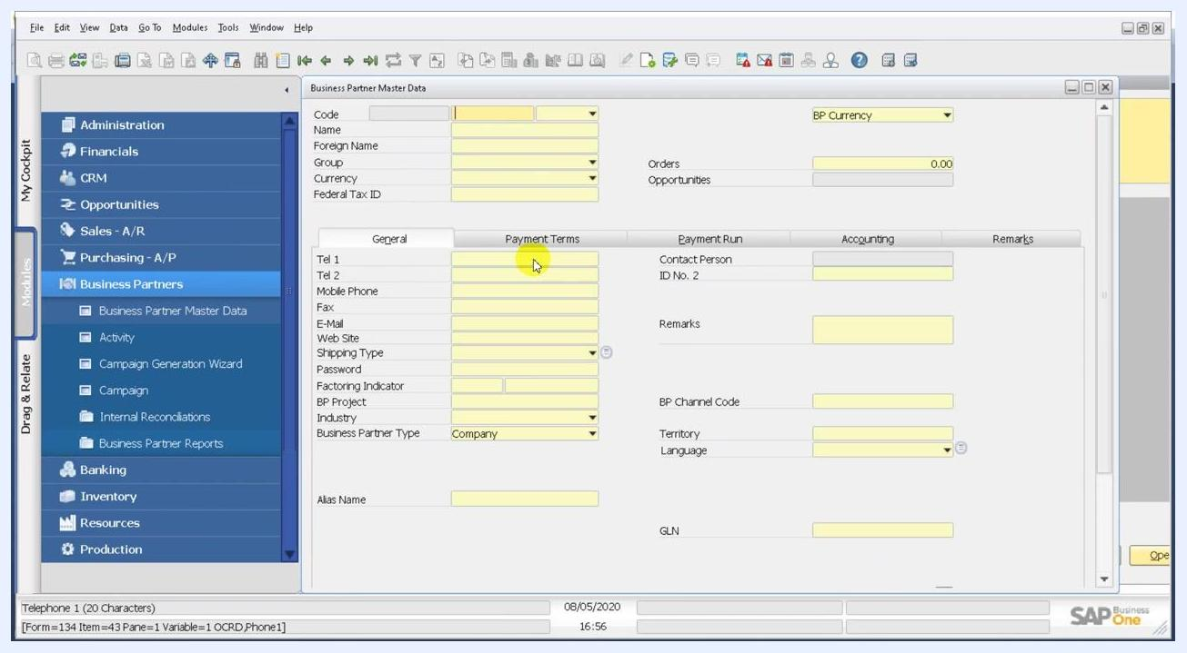
Business Partner Master Data window showing the Tel 1 and Code fields

Step 8: Open the Query Generator
- Close the Sales Order window if it's open.
- In the top menu, click Tools.
- Hover over Queries.
- Select Query Generator from the submenu.
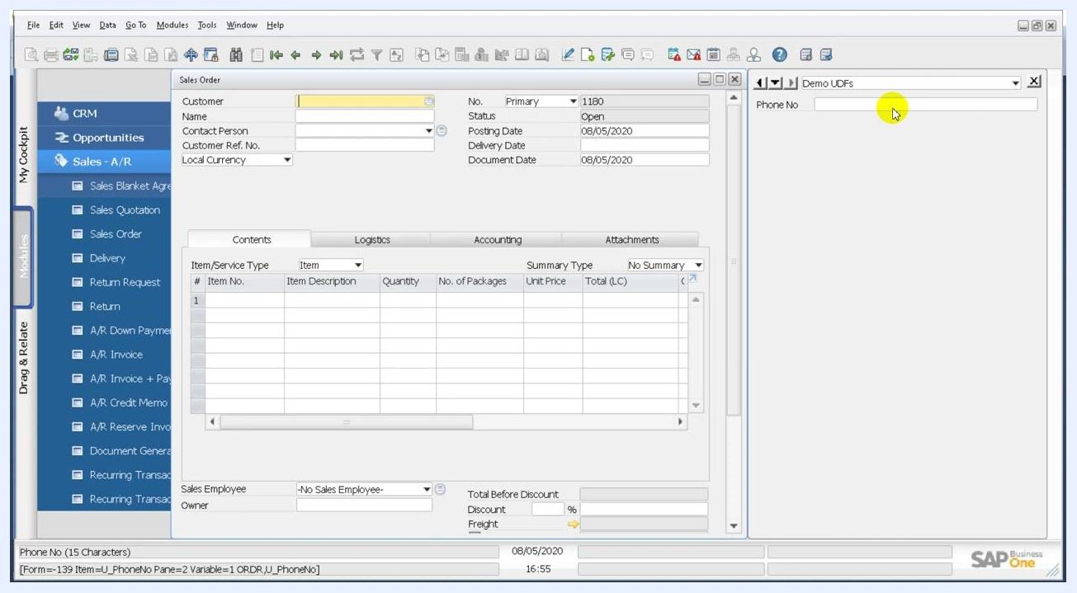
Tools menu open with Queries and Query Generator highlighted in SAP Business One

Step 9: Open the query editor
- In the Query Generator window, click Execute at the bottom left.
- Click the pencil icon to open the query editor, where you write a custom SQL query.
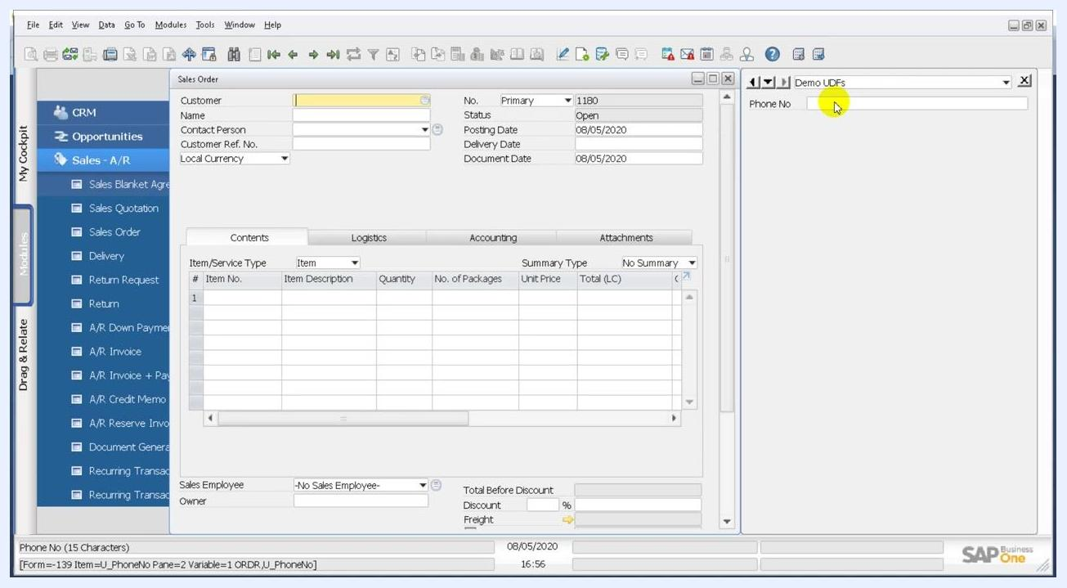
Query Generator window with the Execute button highlighted, ready to write a query

Step 10: Write the query with a dynamic condition
In the Query Preview window, make sure your SQL statement uses a dynamic reference for the customer code:

SELECT OCRD."Phone1" FROM OCRD WHERE OCRD."CardCode" = $[$4.0.0]
The placeholder $[$4.0.0] is built as follows:
- 4 is the item number of the Customer field in the Sales Order form. You saw it in the system information bar in Step 6.
- The first 0 refers to the column index. CardCode is the first column, so the index is 0.
- The second 0 refers to the data type. Alphanumeric is also indexed at 0 in SAP Business One.
This reference makes the query pull the customer code from the active Sales Order form.
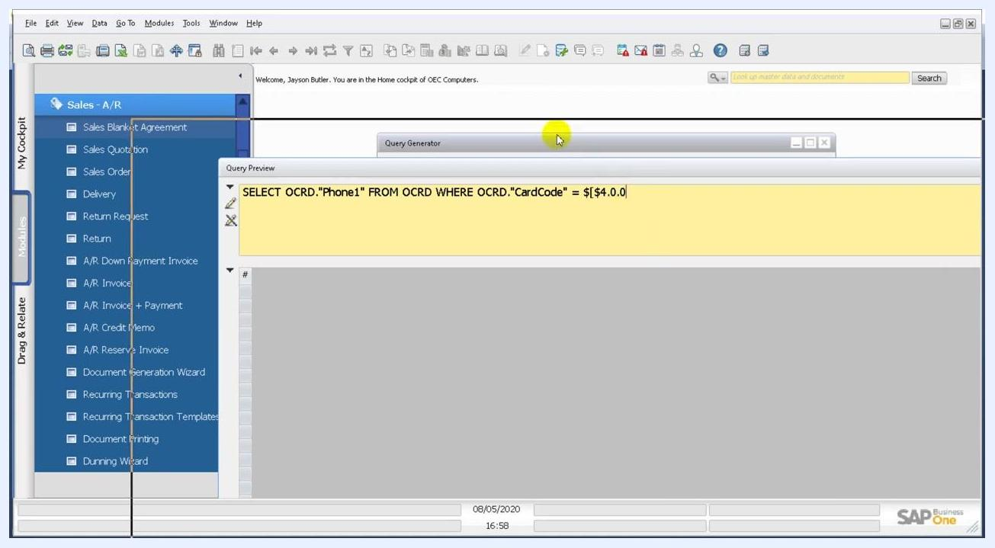
Query Preview window with SQL that uses a dynamic placeholder for CardCode

Step 11: Save the query
- In the Query Preview window, click Save.
- In the Save Query dialog, select the appropriate query category, for example General.
- Choose the query you want to replace, for example fms_phone. If you're creating a new query, enter a new name instead.
- Click Save to store the query.
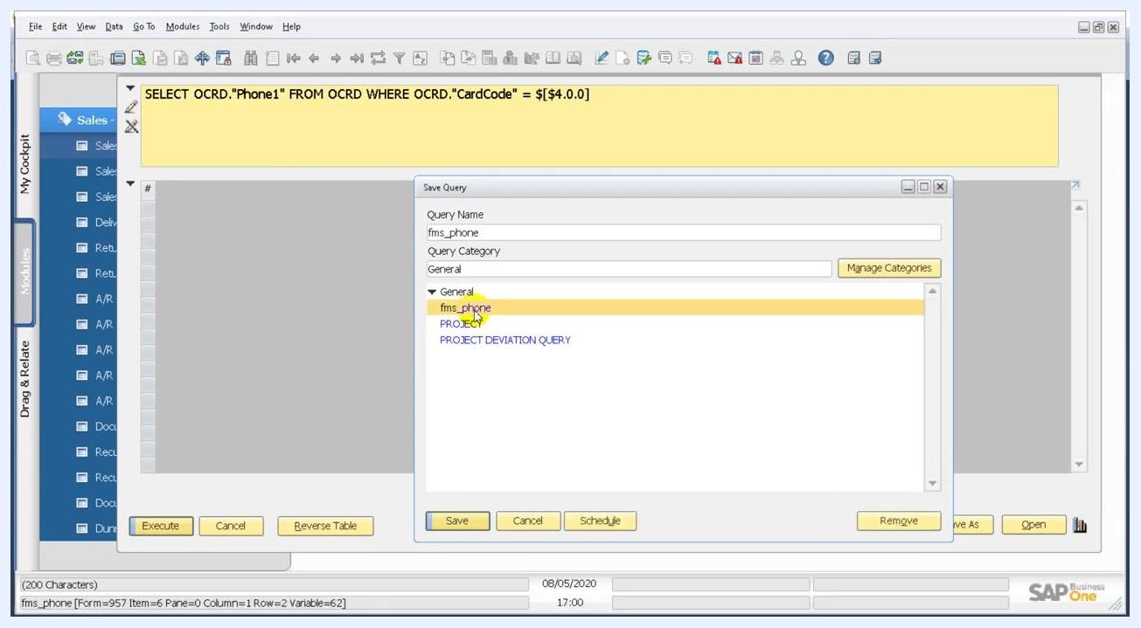
Save Query dialog with fms_phone selected in the General category

Step 12: Open User-Defined Values – Setup
- Open the SAP Business One application and go to the main workspace.
- In the top menu, select Tools.
- Hover over Customization Tools.
- Select User-Defined Values – Setup. The shortcut is Shift + Alt + F2.
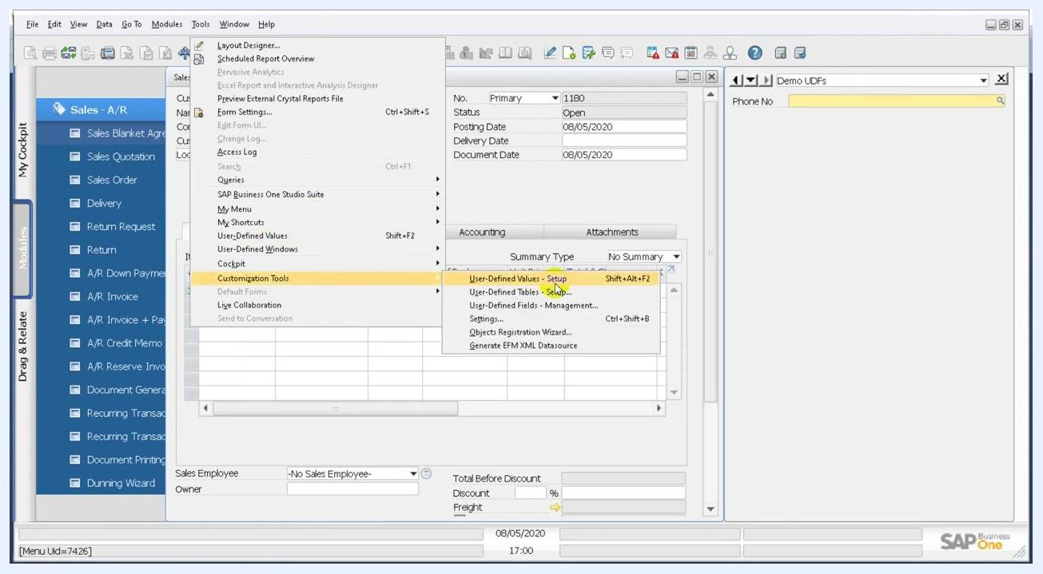
The Tools menu open with Customization Tools highlighted and User-Defined Values – Setup selected, with a Sales Order form in the background

Step 13: Link the saved query to the field
In the User-Defined Values – Setup dialog, configure the formatted search:
- Choose Search in Existing User-Defined Values according to Saved Query.
- Enter fms_phone in the field provided.
- Click Open Saved Query to select or review the saved query.
- Make sure Auto Refresh When Field Changes is selected.
- In the dropdown below it, select Customer/Vendor Code as the field that triggers the refresh.
- Choose Refresh Regularly so the values update as needed.
- Click OK to save the setup.
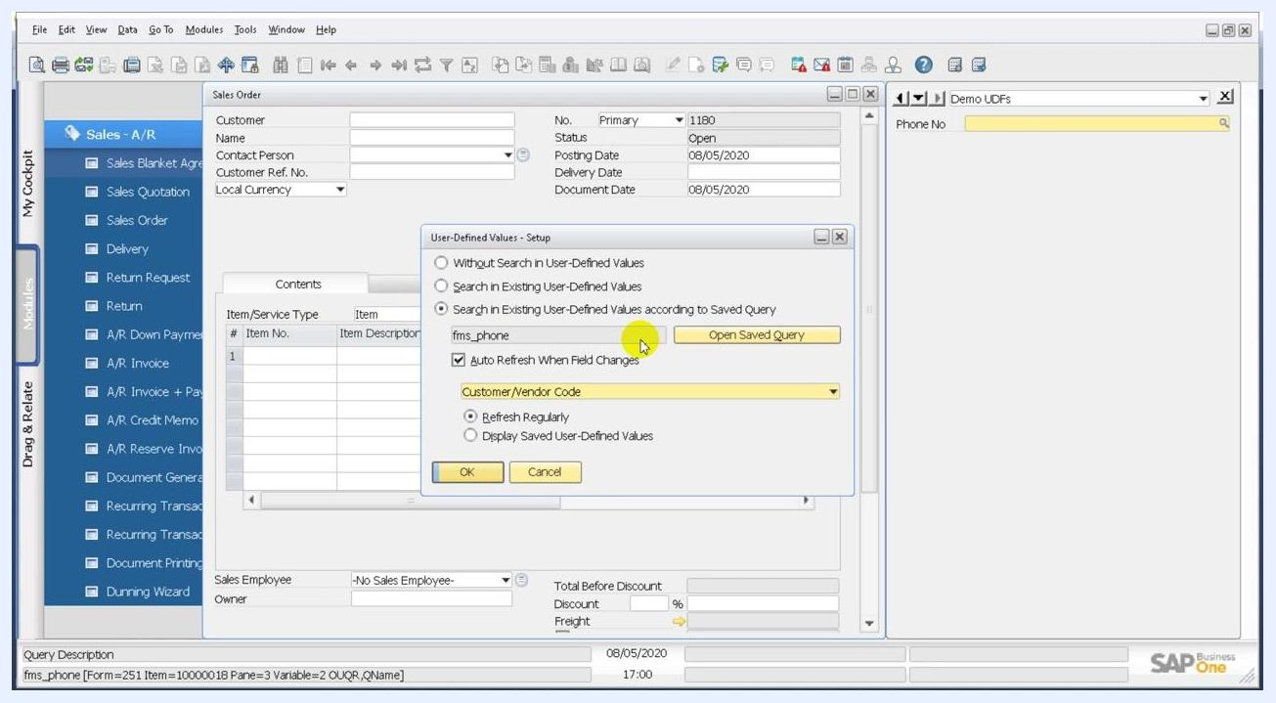
The User-Defined Values – Setup dialog with the saved query option selected, fms_phone entered, Auto Refresh When Field Changes selected and Customer/Vendor Code chosen

Step 14: Test the formatted search
Once setup is complete, the Phone No UDF fills in automatically with the phone number of the customer you select in the Sales Order form.
- In the Sales Order form, click the Customer field.
- In the List of Business Partners dialog, select a customer, for example BP Code C20000, Name Maxi-Teq.
- Click Choose.
- Check that the Phone No field in the Demo UDFs panel updates with the phone number of the selected customer.
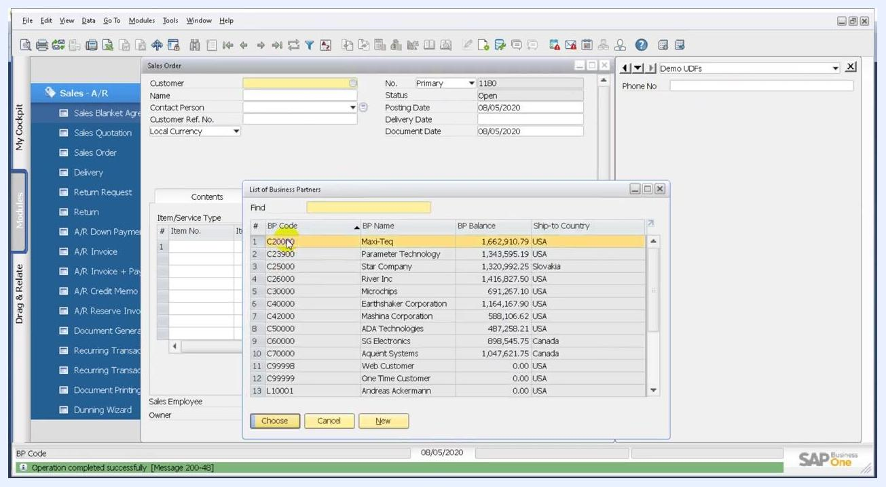
The List of Business Partners dialog showing BP Codes and Names while a customer is selected

Step 15: Repeat with another customer and review the form
- Select a different customer, for example BP Code C23900, Name Parameter Technology.
- Confirm that the phone number updates to match the new customer.
- Review the Sales Order form. Check that the relevant fields (Customer, Name, Contact Person, and so on) and the Phone No UDF are populated correctly.
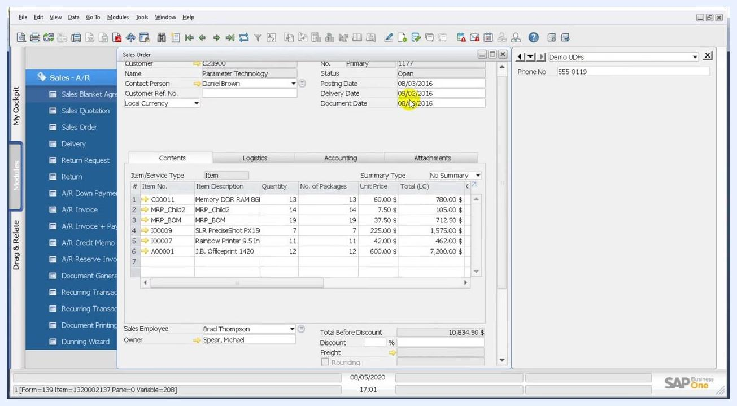
The Sales Order form filled with customer details and the Phone No field populated for the selected customer

Summary
You now know how to create a formatted search (FMS) in SAP Business One that displays a customer's phone number on the Sales Order form. You created the PhoneNo user-defined field and wrote and saved the fms_phone query. You then linked the query to the field in User-Defined Values – Setup so it refreshes whenever the customer changes.

