How to Create a Page Layout in Salesforce
Page layouts control what users see on a Salesforce record — which fields appear, how they're grouped, which related lists display, and which buttons and actions are available. This guide walks you through how to create a page layout in Salesforce for the Opportunity object, starting with how existing layouts work and finishing with building, customizing, and verifying a brand-new layout.

Prerequisites
- Access to a Salesforce Lightning instance with administrator or customization permissions.
- Familiarity with the Opportunity object and its standard fields (Amount, Stage, Close Date, etc.).
- Access to Setup and the Object Manager.

Exploring the Salesforce Home page and an Opportunity record

- Open the Salesforce Home page
Open your web browser and sign in to your Salesforce Lightning instance. On the Home page you can view dashboards such as "Quarterly Performance," "Today's Events," and "Today's Tasks." Check the Assistant panel on the right for new leads assigned to you.
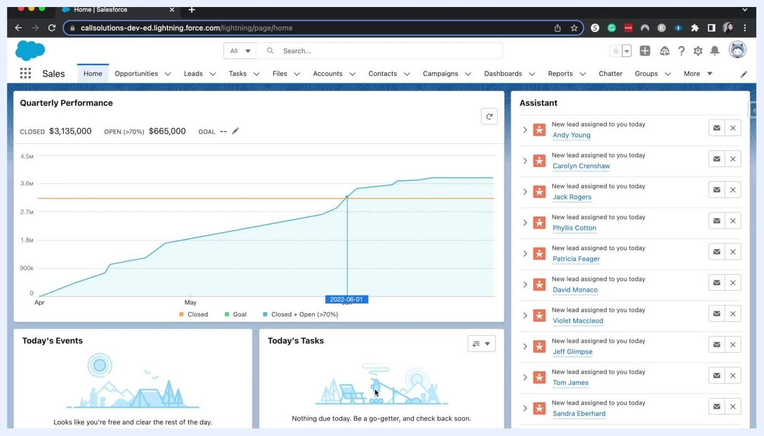
Salesforce Home page showing the Quarterly Performance dashboard, Today's Events, Today's Tasks, and the Assistant panel with new leads

- Navigate to an Opportunity record
Click the Opportunities tab in the top navigation bar to open the list of opportunities, then select one to view its details. The example below shows the "Pyramid Emergency Generators" opportunity, with stage indicators at the top, Activity, Details, and Chatter tabs, detail fields such as Opportunity Owner, Amount, and Close Date, and related lists like Products, Notes & Attachments, and Contact Roles on the right.
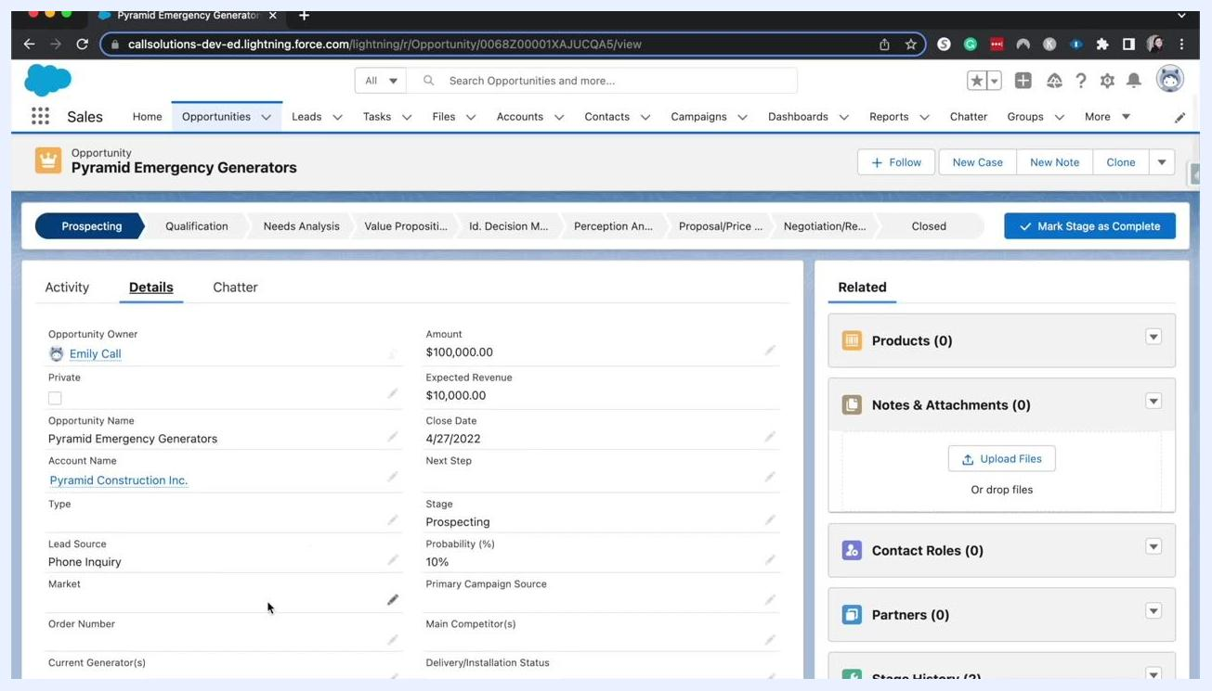
Opportunity record for Pyramid Emergency Generators showing details and related lists

- Review how the page layout controls the record view
The page layout determines which fields are visible and how they're arranged, which related lists appear and in what order, and which buttons, links, and actions show at the top of the record. You can also group, or "bucket," fields into collapsible sections, similar to how related lists can be expanded or collapsed.
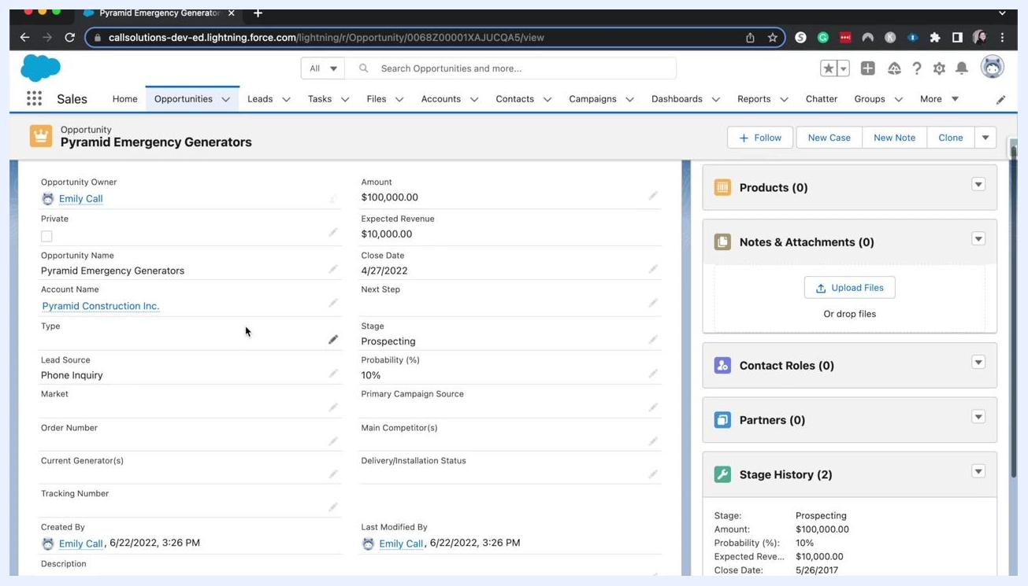
Opportunity details page showing grouped fields and related lists
Page layouts work together with record types and user profiles: the combination of a user's record type and profile determines exactly which fields and layout they see.

Viewing page layout assignments

- Open the Object Manager for Opportunity
Click the gear icon (Setup) in the upper right corner, then select Edit Object from the dropdown menu to open the Object Manager for the Opportunity object.
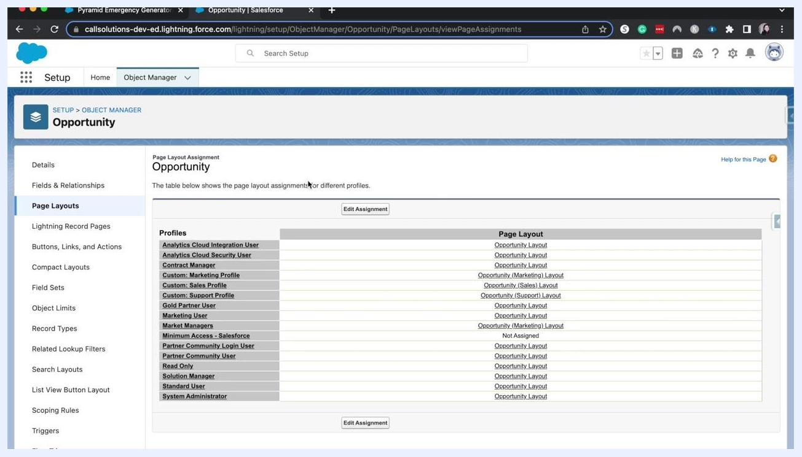
Salesforce Opportunity record with the Setup menu open and 'Edit Object' highlighted

- Check which layouts are assigned to each profile
In the Object Manager, select Page Layouts from the left sidebar, then click Page Layout Assignment. Review the table listing profiles (such as Analytics Cloud Integration User, Contract Manager, and Custom: Marketing Profile) alongside their assigned page layouts (such as Opportunity Layout and Opportunity (Marketing) Layout).
Page Layout Assignment screen showing profiles and their assigned page layouts

Assigning layouts by profile and record type

- Understand profile-based assignment
Salesforce lets you assign different page layouts to user profiles based on their role. For example, Marketing users are assigned the "Opportunity (Marketing) Layout," Sales users the "Opportunity (Sales) Layout," Support users the "Opportunity (Support) Layout," and all other users the default "Opportunity Layout."
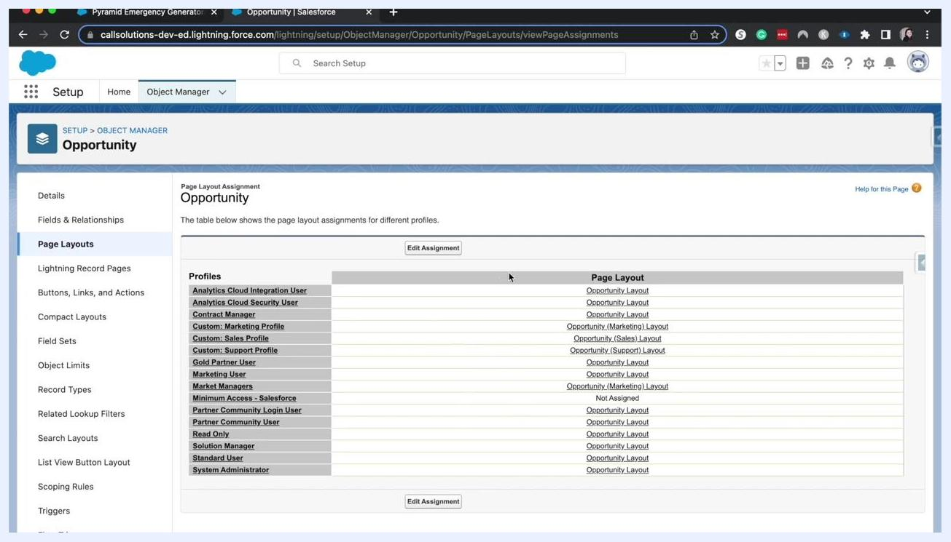
Salesforce Page Layout Assignment screen showing profiles and their assigned page layouts

- See how record types affect the assignment table
If only one record type exists, the assignment table shows a single "Page Layout" column. When multiple record types are present, an additional column appears for each one, so you can assign a different layout per profile-and-record-type combination.
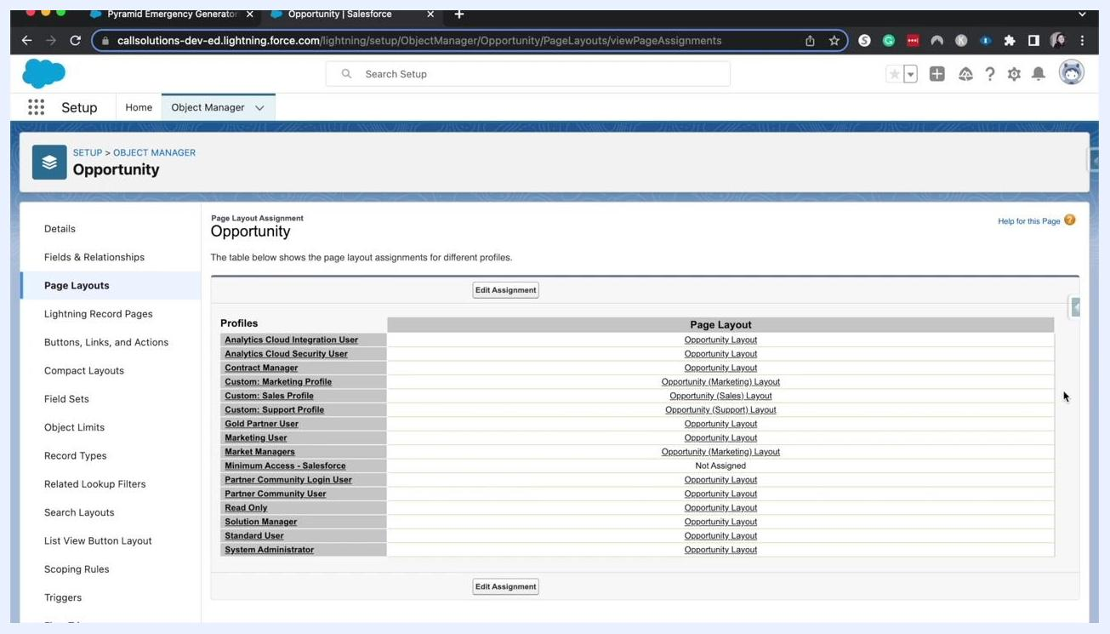
Page Layout Assignment table with a single record type and page layout assignments

- Assign a layout for each profile and record type
Use the assignment table to pick which layout each profile sees for each record type. For example, assign the "Opportunity Layout" to the Analytics Cloud Integration User profile for the first record type, the "Opportunity (Marketing) Layout" to the Marketing profile for the Marketing record type, and the "Opportunity (Sales) Layout" to the Sales profile for the Sales record type.
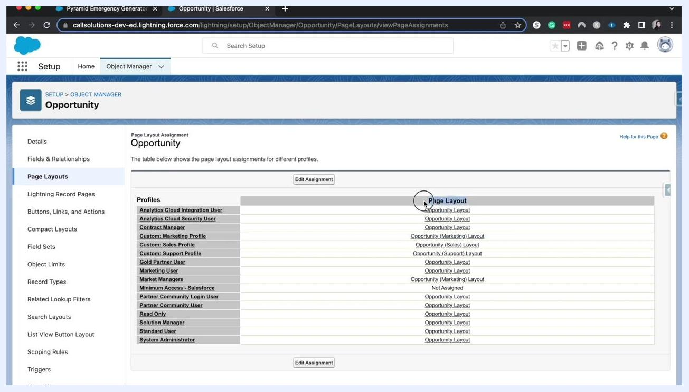
Page Layout Assignment table with cursor highlighting the assignment logic

- Edit assignments as needed
Click Edit Assignment to change which profiles map to which layouts, ensuring each user group sees the fields and actions most relevant to their role.
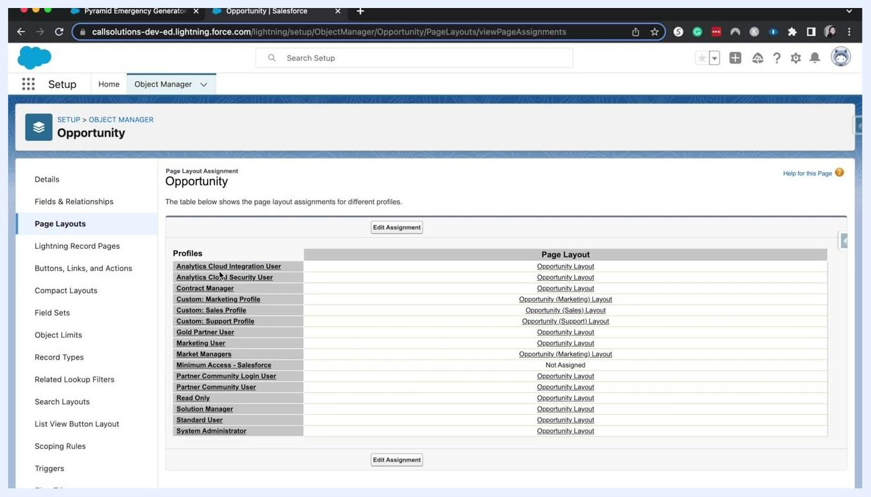
Page Layout Assignment table with cursor over a profile assignment

Creating and editing a page layout

- Start a new page layout
On the Page Layouts screen, click New to open a blank layout where you can add fields, sections, and components to tailor a layout for a new business process or user group.
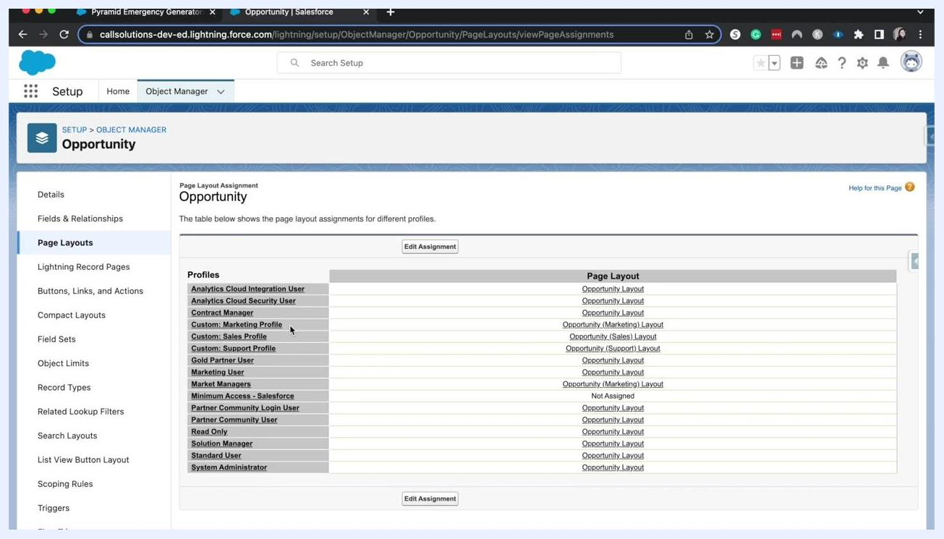
Page Layouts screen with the 'New' button highlighted for creating a new layout

- Open the layout editor
Select an existing page layout to edit its structure. The editor lets you drag and drop fields, sections, and related lists; add or remove buttons and actions; and organize the layout to match your business requirements. The Opportunity layout editor, for example, shows fields like Close Date, Account Name, Amount, Stage, and Probability, along with Salesforce Mobile and Lightning Experience Actions and standard buttons such as Edit, Delete, Clone, Change Owner, and Sharing.
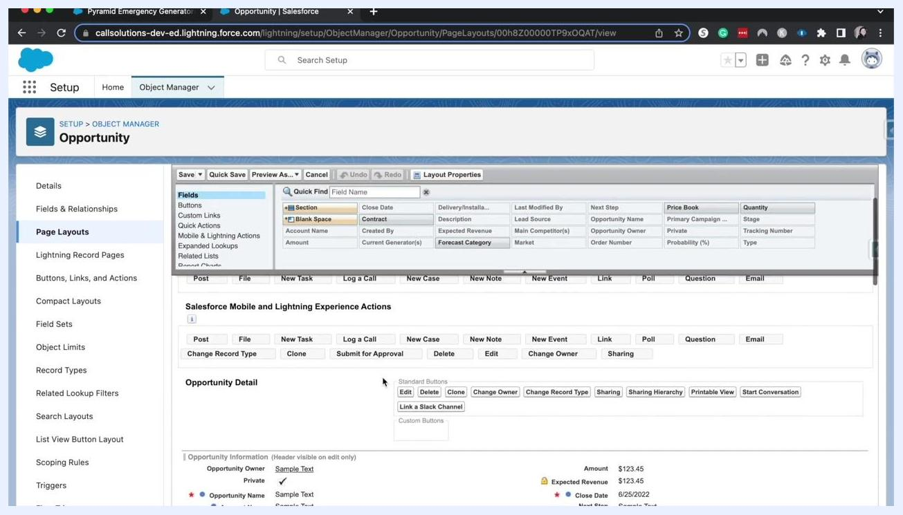
Opportunity page layout editor showing fields, actions, and layout customization options

Customizing sections, fields, and actions

- Make section headers visible and enable accordion sections
Ensure section headers (such as "Opportunity Information," "Other Information," "Additional Information," and "System Information") are visible so users can quickly navigate the page. Use the Detail Information setting to enable accordion functionality, letting users expand or collapse sections such as "System Information" or "Additional Information" as needed. You can also rename headers — for example, changing "Additional Information" to "Order Information" — for clarity.
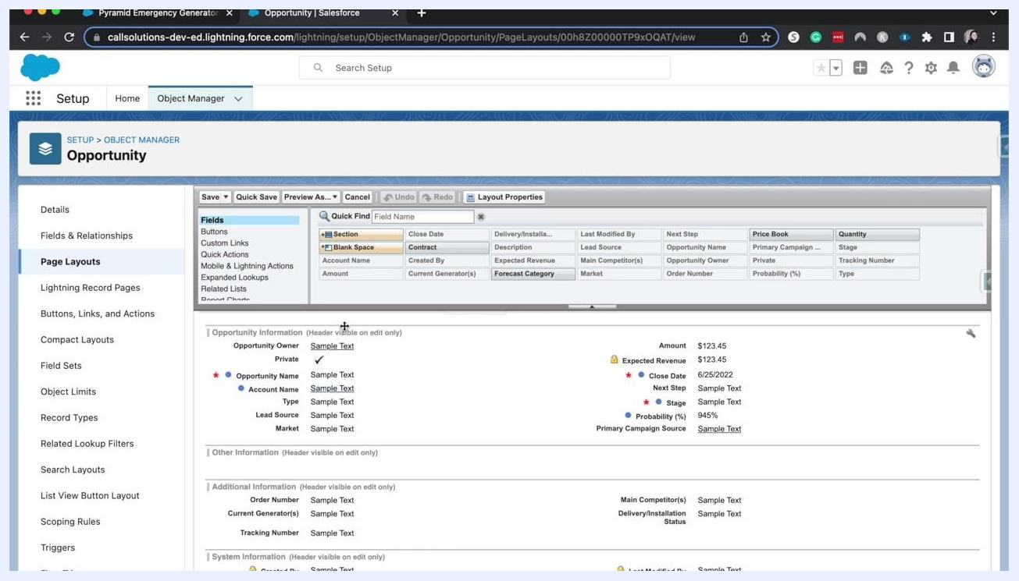
Salesforce Opportunity page layout editor showing multiple collapsible sections and visible headers

- Remove a field from the layout
Locate the field you want to remove (for example, "Next Step") within its section, then click the minus icon next to it, or drag it out of the section.
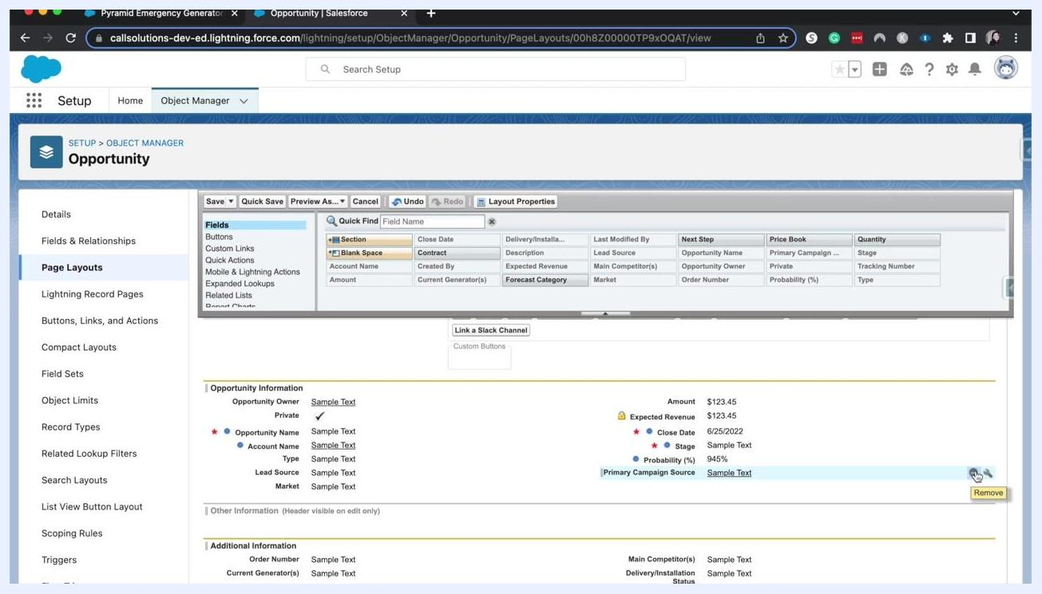
Cursor hovering over the remove icon for a field in the Opportunity Information section

- Add a field to the layout
Locate the field you want to add (for example, "Forecast Category") in the Fields palette at the top of the editor, then drag and drop it into the desired section. Only fields available on the Opportunity object appear in this palette.
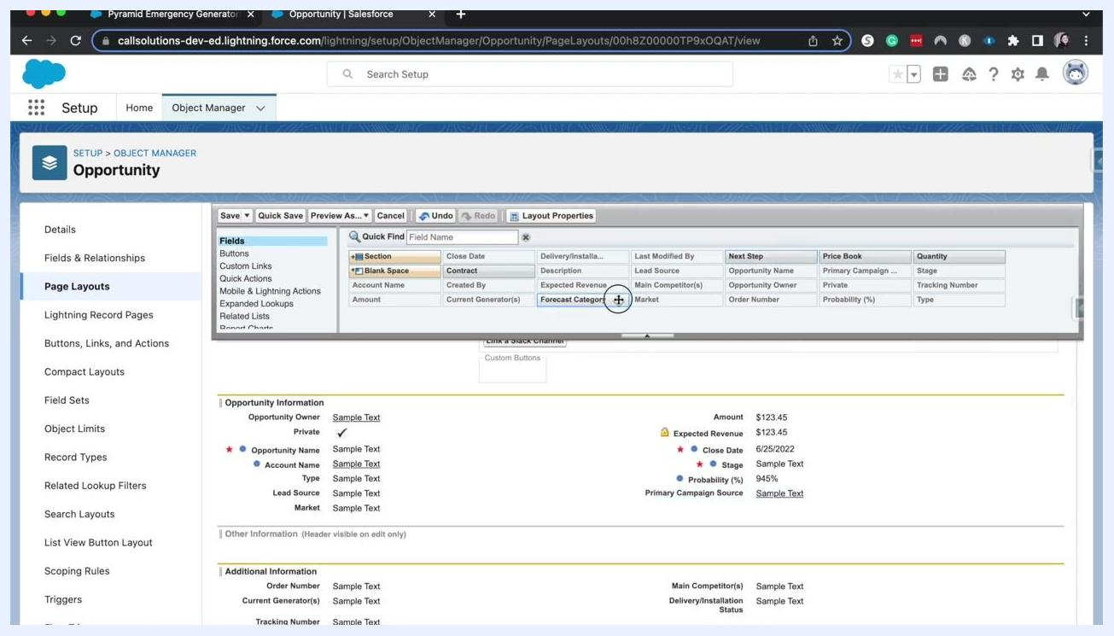
Dragging the Forecast Category field from the palette into the layout

- Customize buttons and quick actions
Switch to the Buttons section in the palette to add, remove, or rearrange standard and custom buttons such as Edit, Delete, Clone, Change Owner, Sharing, and custom buttons like "Link a Slack Channel." Configure Quick Actions for Salesforce Classic Publisher and for Salesforce Mobile and Lightning Experience, including actions like New Task, Log a Call, New Case, New Note, New Event, Link, Poll, Question, and Email.
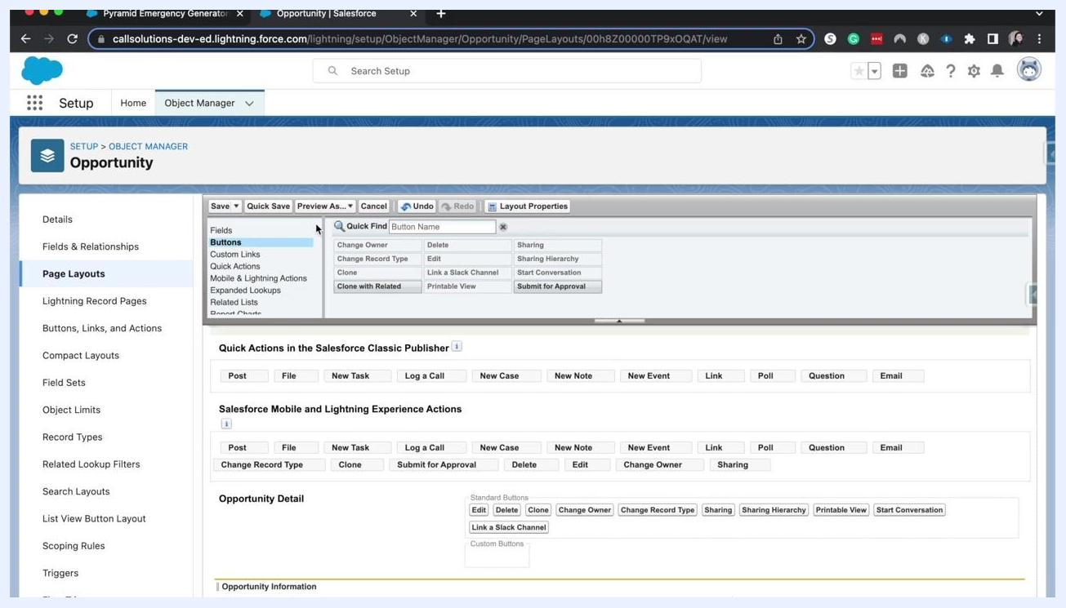
Buttons and quick actions configuration in the Opportunity page layout editor
Use the Mobile & Lightning Actions section to control which actions appear in the Salesforce mobile app and Lightning Experience, select Expanded Lookups to configure enhanced lookup features for related records, and use the Related Lists section to add, remove, or reorder related lists such as Activities, Contacts, and Products.

Configuring related lists

- Open the Related Lists section
In Setup, navigate to Object Manager, select Opportunity, click Page Layouts in the left sidebar, and select the layout you want to edit. In the layout editor, click the Related Lists section in the palette to see available related lists such as Activity History, Cases, Files, Orders, and Products — each representing a set of records linked to the current Opportunity.
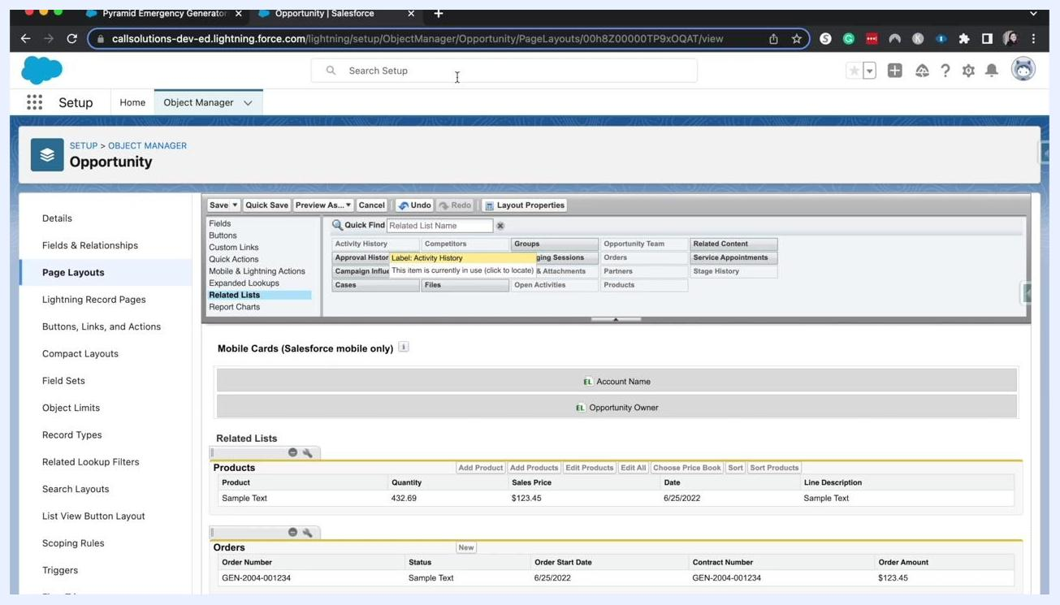
Salesforce Opportunity page layout editor showing the Related Lists section with Products and Orders, including columns and action buttons

- Review and customize related list columns and actions
Scroll to the Related Lists section in the layout editor to see which lists are currently included, such as "Products" (with columns for Product, Quantity, Sales Price, Date, and Line Description) and "Orders" (with columns for Status, Order Start Date, Contract Number, and Order Amount). Click the wrench icon next to a related list to add, remove, or reorder its columns, and configure which actions — such as Add, Edit, or Sort — are available.
- Add or remove related lists, then preview and save
To add a related list, drag it from the palette into the Related Lists section; to remove one, click the minus icon or drag it out. Use Preview As... to see how the layout will appear to users, then click Save or Quick Save to apply your changes.

Managing related lists during layout customization

- Review available and included related lists
In the layout editor's Related Lists section, available lists include Files, Groups, Opportunity Team, Service Appointments, Products, Orders, Activity History, Cases, Content Deliveries, Partners, Notes & Attachments, Open Activities, and Stage History. The lower section of the editor shows currently included lists, such as Products (with sample values like Product: Sample Text, Quantity: 432.69, Sales Price: $123.45, Date: 6/25/2022) and Orders (with sample values like Order Number: GEN-2004-001234, Status: Sample Text, Order Start Date: 6/25/2022, Order Amount: $123.45).
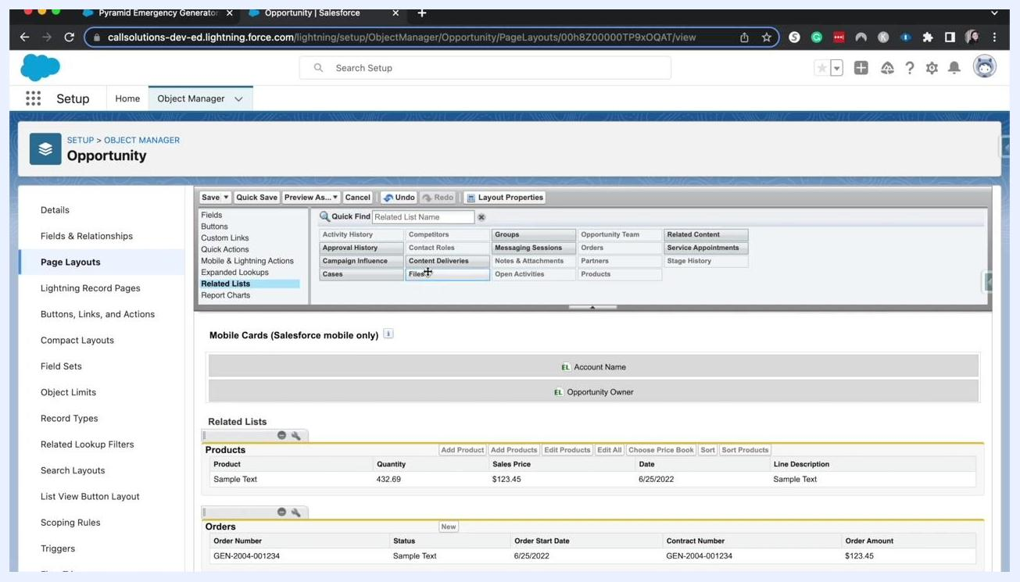
Salesforce Opportunity page layout editor showing related lists and sample data for Products and Orders

- Add or remove related lists by drag-and-drop
Drag related lists — such as Service Appointments or Open Activities — from the palette into the layout, or remove them by dragging them out of the layout area. Sections highlighted in green indicate an active drag-and-drop action.
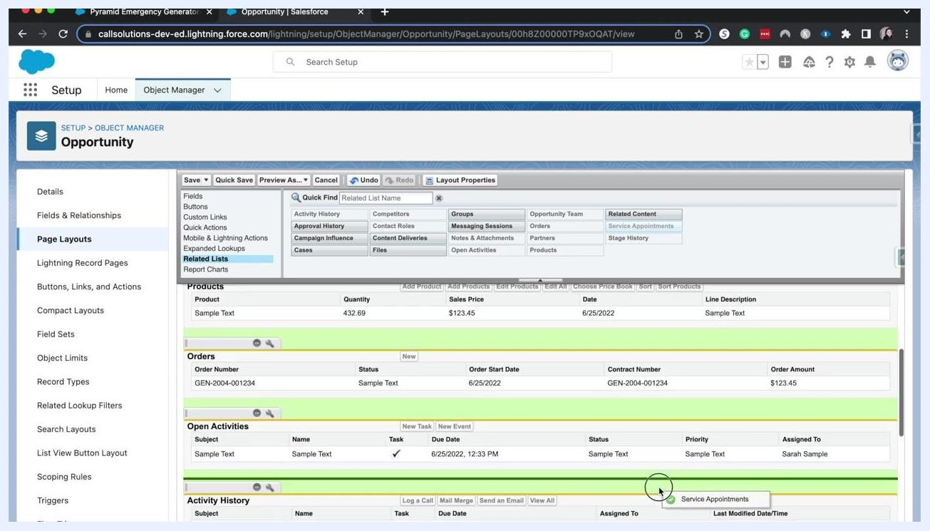
Salesforce Opportunity page layout editor with related lists being dragged and dropped, highlighting Service Appointments

- Quick Save your progress
Click Quick Save to save your changes without leaving the layout editor, so you can continue making further adjustments.
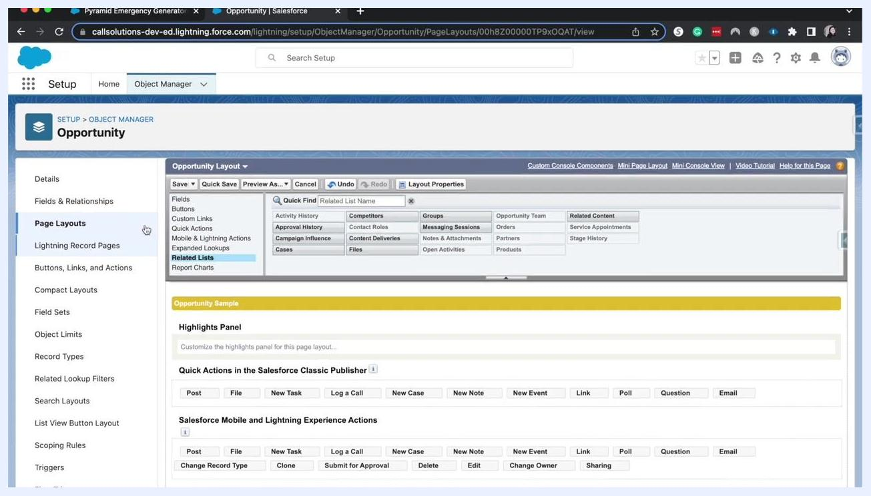
Salesforce Opportunity page layout editor after quick save, showing layout options and related lists

Rearranging fields and adjusting section properties

- Rearrange fields within a section
Scroll to the Opportunity Detail section and drag fields — such as Probability (%) or Forecast Category — to reorder them, making important fields more visible or moving others further down.
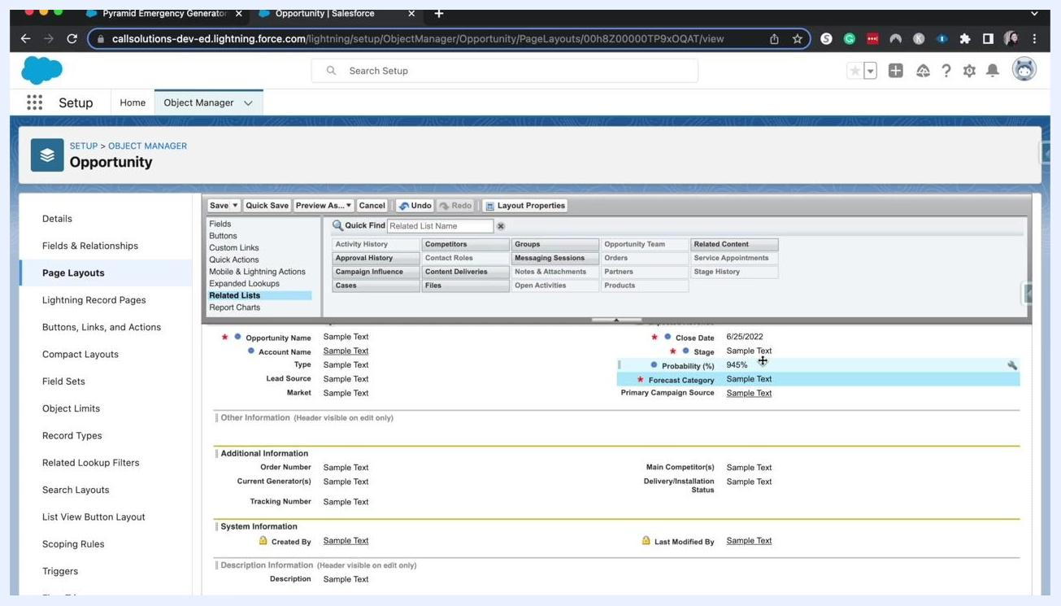
Salesforce Opportunity page layout editor with fields being rearranged in the Opportunity Detail section

- Adjust section properties
Double-click a section header (such as "Opportunity Information") to open the Section Properties dialog. Here you can change the Section Name, choose whether to display the header on the Detail Page and/or Edit Page, select a 2-Column or 1-Column Layout, and set the Tab-key Order to Left-Right or Top-Down. For example, select 2-Column layout with Left-Right tab-key order, then click OK to apply the changes.
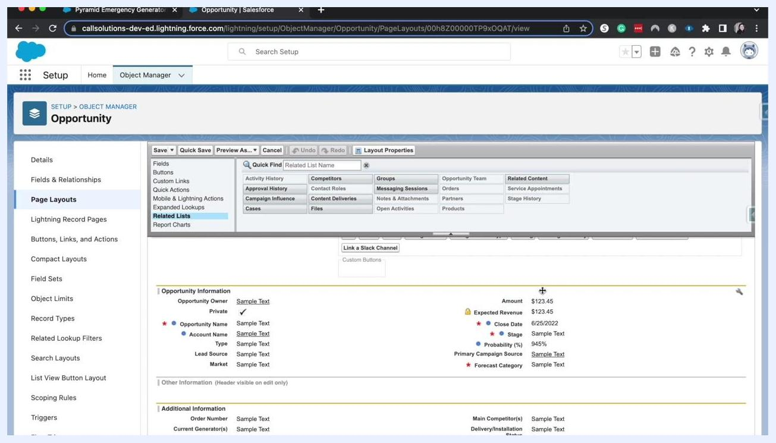
Section Properties dialog in the Salesforce Opportunity page layout editor, showing options for layout and tab-key order

- Save your finalized layout
Click Save to apply all changes. The updated layout now reflects your related list, field order, and section property adjustments.
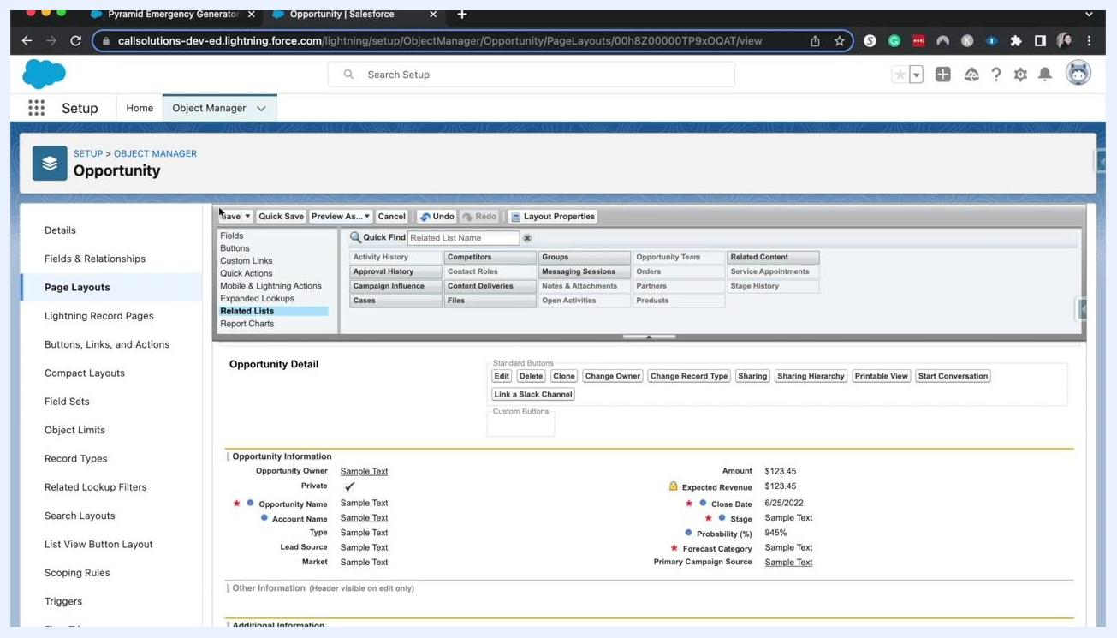
Salesforce Opportunity page layout editor showing the finalized layout with the updated Opportunity Detail section

Creating a new page layout from a clone

- Clone an existing layout to create a new one
In the Opportunity object manager, navigate to Page Layouts and click New. On the Create New Page Layout screen, select Opportunity Layout from the Existing Page Layout dropdown to clone it, enter a name such as "New opportunity layo" in the Page Layout Name field, and optionally enable Feed-Based Layout. Click Save to create the new layout, which copies the selected layout so you can customize it further.
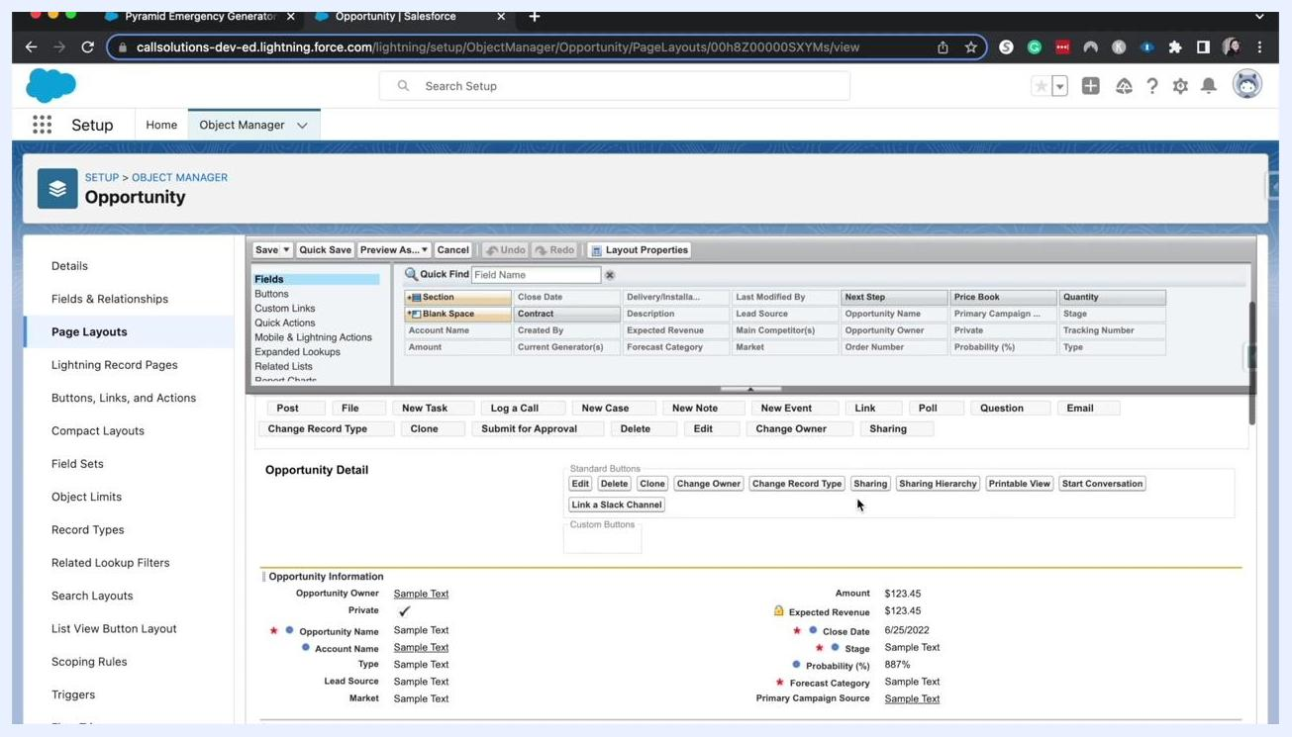
Salesforce "Create New Page Layout" screen for Opportunity, with "Opportunity Layout" selected and "New opportunity layo" entered as the name

- Tailor the new layout for a specific audience
After saving, you land in the layout editor for the new page layout. Use it to customize the view for specific audiences, such as external partners, limiting the fields and related lists shown for privacy or simplicity. The editor displays a palette of fields and components (Section, Blank Space, Contract, Account Name, etc.), the current layout structure (Opportunity Name, Stage, Probability (%), and more), standard buttons (Edit, Delete, Clone, Change Owner, Change Record Type, Sharing), and the Opportunity Detail section with sample data.
Salesforce Opportunity page layout editor showing fields, layout palette, and Opportunity Detail section with sample data

- Limit field visibility for restricted users
Adjust the layout to show only essential information for users with restricted access, removing or hiding sensitive fields so that only limited information — such as Opportunity Name, Stage, and Probability (%) — is visible. Drag and drop fields, sections, and related lists to customize the view as needed.
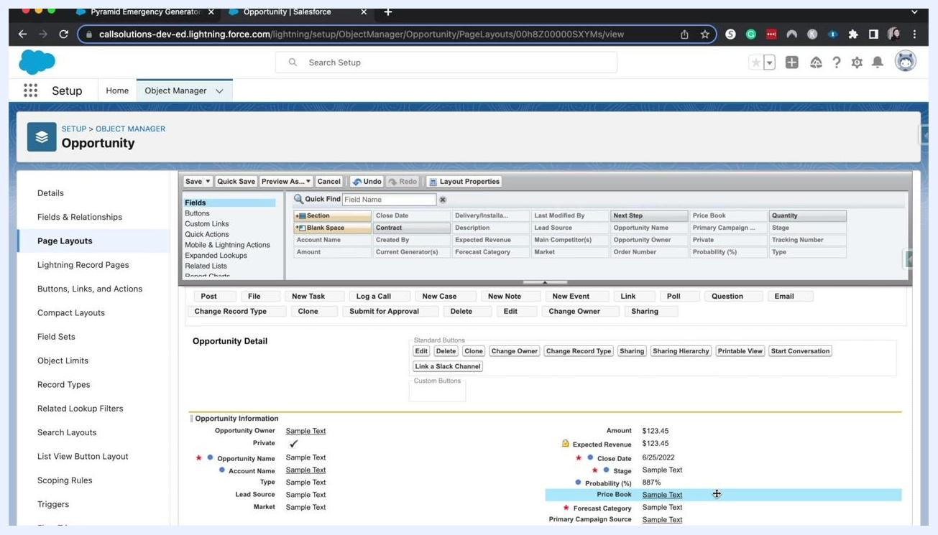
Salesforce Opportunity page layout editor with fields and Opportunity Detail section, highlighting limited information for restricted users

- Quick Save and return to the layout list
Click Quick Save to save your changes without exiting the editor, then click Page Layouts in the sidebar to return to the list of layouts. Note that after saving, changes may take a few moments to propagate to the record view.
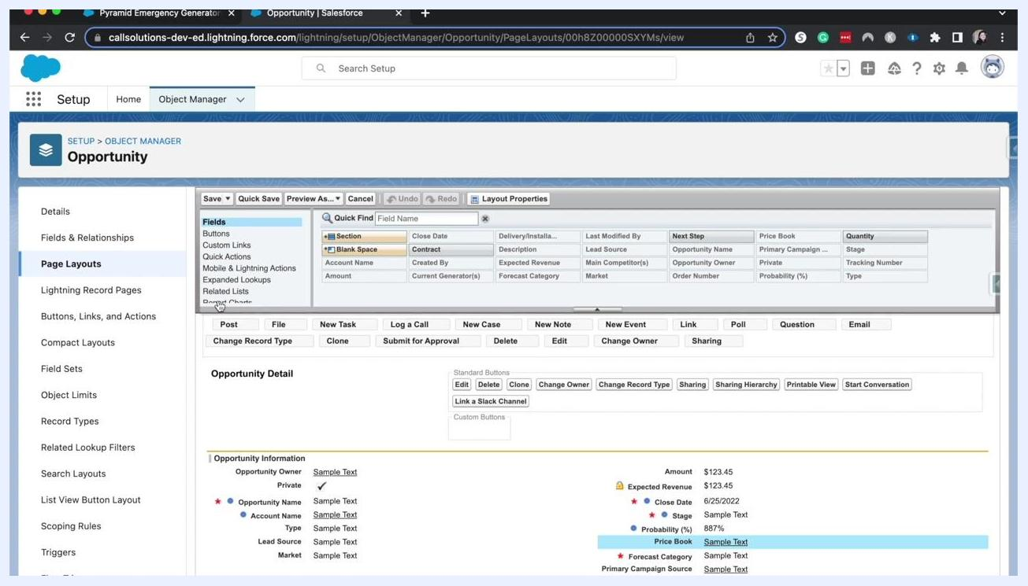
Salesforce Opportunity page layout editor after quick save, showing the layout palette and Opportunity Detail section

Verifying the new layout on a record

- Open a record to confirm the layout
Open an Opportunity record — such as "Pyramid Emergency Generators" — to review the applied layout. The record view displays Opportunity details (Account Name, Close Date, Amount, Opportunity Owner, Stage, Probability (%), etc.), related lists on the right (Products, Notes & Attachments, Contact Roles, Partners, Stage History), and the Details tab with editable fields and section headers (Opportunity Information, Additional Information, System Information). If changes aren't visible yet, refresh the page after a few moments.
Salesforce Opportunity record view showing details, related lists, and section headers after the layout update

- Explore accordion sections and related lists
Notice the accordion-style section headers, such as Additional Information and System Information, which help organize information and streamline the view. Expand or collapse these sections to focus on relevant details. Related lists — Products, Notes & Attachments, Contact Roles, Partners, and Stage History — appear on the right, each in its own expandable panel.
Salesforce Opportunity record view with accordion sections and related lists, showing streamlined information display

- Confirm the final configuration
Verify that the Opportunity record displays the correct fields and related lists as configured in your new layout. For example, the Related panel should show counts for Products, Service Appointments, Notes & Attachments, Contact Roles, and Partners, and the Details tab should reflect the fields and sections you arranged in the layout editor.
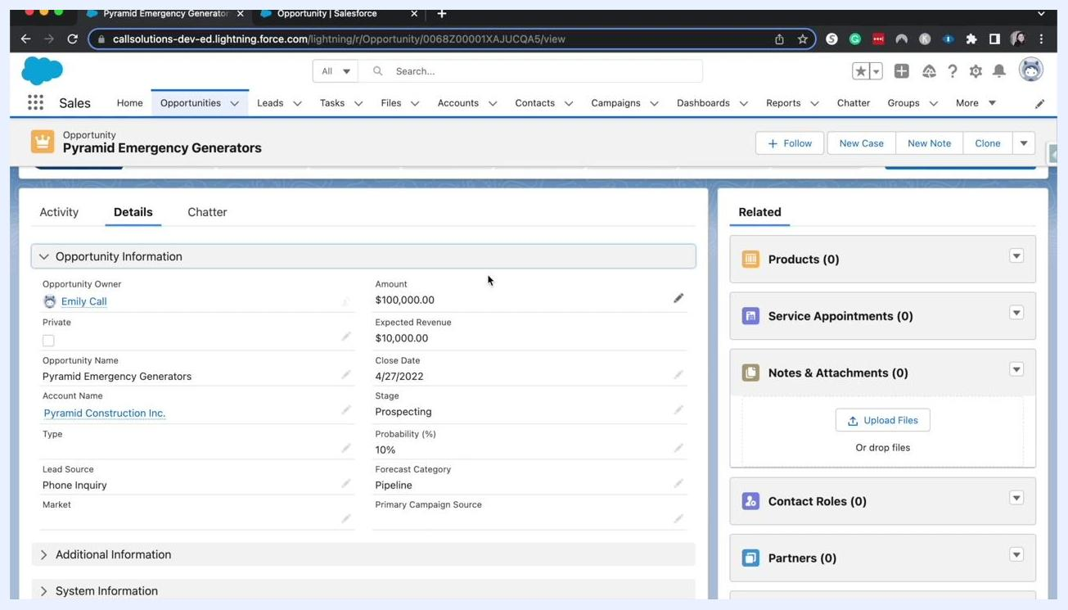
Salesforce Opportunity record view with the final layout, showing Opportunity Information, related lists, and section headers

What's next
You now know how to create a page layout in Salesforce for the Opportunity object: viewing existing layouts and assignments, assigning layouts by profile and record type, customizing sections, fields, buttons, and related lists, and cloning a layout to build a new one for a specific audience. Revisit the Opportunity object manager and page layout editor any time you need further customization or troubleshooting.

Screen with large white text "THANKS FOR WATCHING :)" on a blue gradient background. No other objects, people, or UI elements are present.

