How to Create a Connected App in Salesforce
Connected Apps let external applications, such as Postman, connect and authenticate with your Salesforce instance using OAuth. This guide walks you through how to create a connected app in Salesforce, configure its OAuth settings, and retrieve the credentials you need for external integration.

Prerequisites
- Access to a Salesforce account with permissions to open Setup.
- Administrative rights to create and manage connected apps in App Manager.

Step 1: Navigate to Salesforce Setup
Log in to your Salesforce account, then click the gear icon (⚙️) in the upper right corner and select Setup. This takes you to the Setup Home page, where you can access all administrative tools.
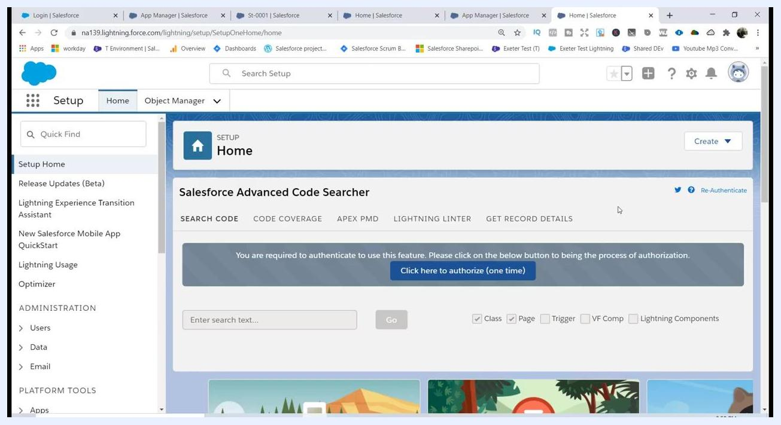
Salesforce Setup Home page with navigation sidebar and search bar visible

Step 2: Open App Manager
In the left sidebar, locate the Quick Find search box and type app. Under the Apps section that appears, click App Manager to open it.
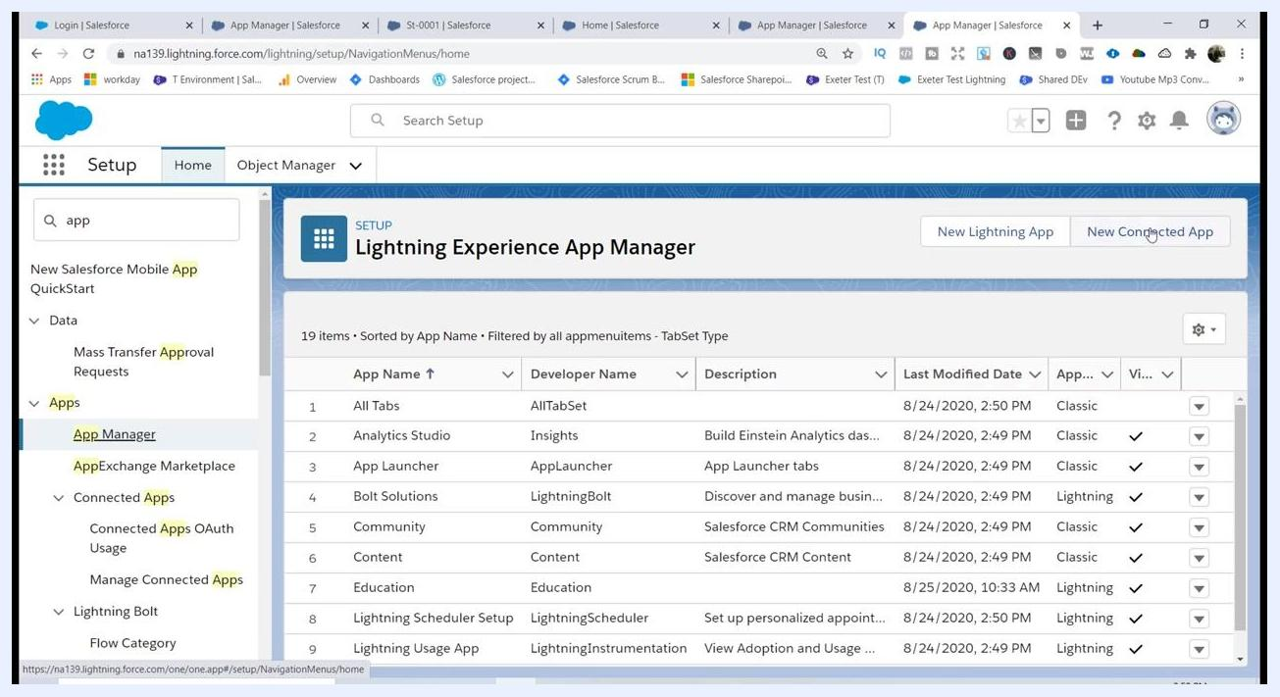
Quick Find search for 'app' with App Manager highlighted in the sidebar

Step 3: Start creating a new connected app
On the App Manager page, click the New Connected App button in the upper right corner to begin the setup process.
Lightning Experience App Manager with 'New Connected App' button highlighted

Step 4: Enter basic information for the app
In the New Connected App form, fill in the following fields:
- Connected App Name: TestSalesforce
- API Name: TestSalesforce (this is auto-filled based on the app name)
- Contact Email: info@mytutorialrack.com
Leave the remaining fields blank unless your integration has specific requirements.
New Connected App form with 'TestSalesforce' entered for both Connected App Name and API Name

Step 5: Enable OAuth settings and set the callback URL
Scroll down to the API (Enable OAuth Settings) section and check the box labeled Enable OAuth Settings. In the Callback URL field that appears, enter http://login.salesforce.com for now — you will update this to a secure URL in a later step.
Enable OAuth Settings section with Callback URL entered as 'http://login.salesforce.com'

Step 6: Select OAuth scopes
In the Available OAuth Scopes list, choose the level of access you want to grant the external application:
- For full access, select Full access (full).
- For more restrictive access, choose a scope such as Access and manage your Chatter data (chatter_api), depending on your requirements.
Click the Add arrow to move your selected scopes into the Selected OAuth Scopes list.
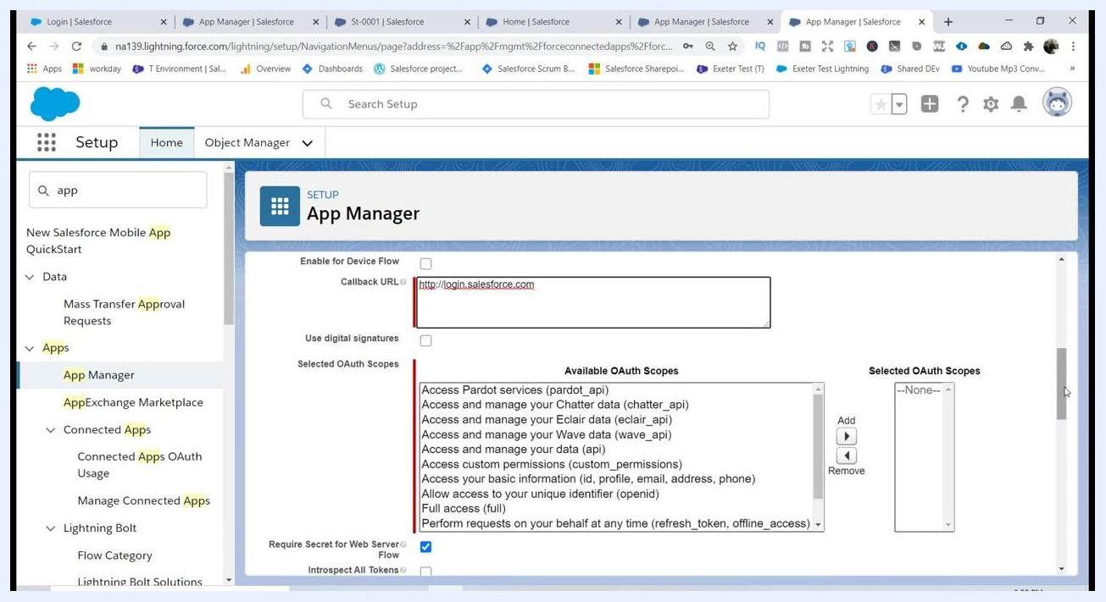
OAuth Scopes selection area showing available and selected scopes

Step 7: Add the full access scope
To grant the external application complete access to your Salesforce data, select Full access (full) in the Available OAuth Scopes list and click the Add arrow (>) to move it into Selected OAuth Scopes.
Only grant the minimum access required for your use case to enhance security.
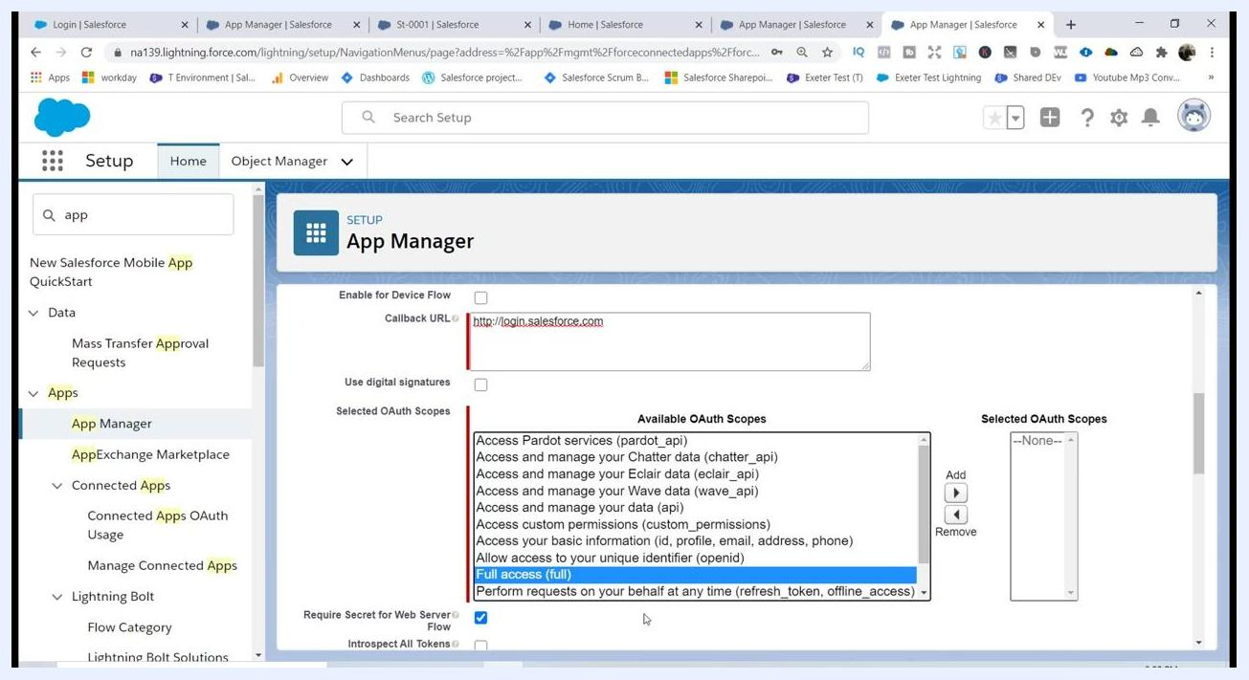
App Manager screen showing 'Full access (full)' selected in Available OAuth Scopes, ready to be added to Selected OAuth Scopes

Step 8: Update the callback URL to use HTTPS
For security compliance, ensure the Callback URL uses https:// instead of http://. Update the field to https://login.salesforce.com if necessary.
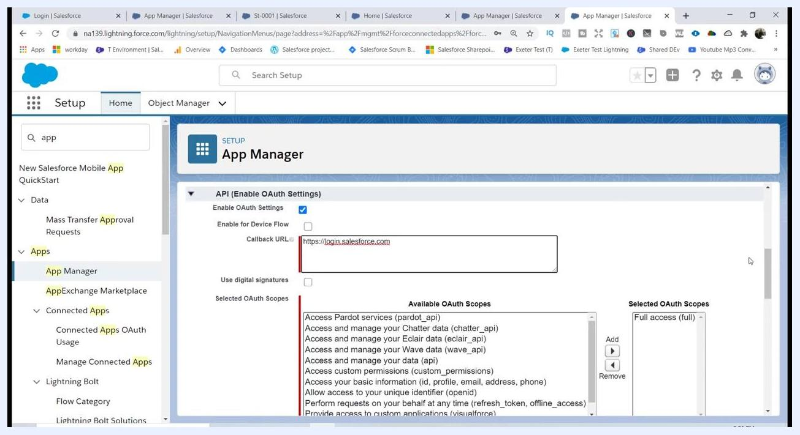
App Manager with Callback URL set to 'https://login.salesforce.com' and 'Full access (full)' in Selected OAuth Scopes

Step 9: Save the connected app
Review all entered information, then scroll to the bottom of the form and click Save. A confirmation message appears: "Allow from 2 to 10 minutes for your changes to take effect on the server before using the connected app." Click Continue to proceed.
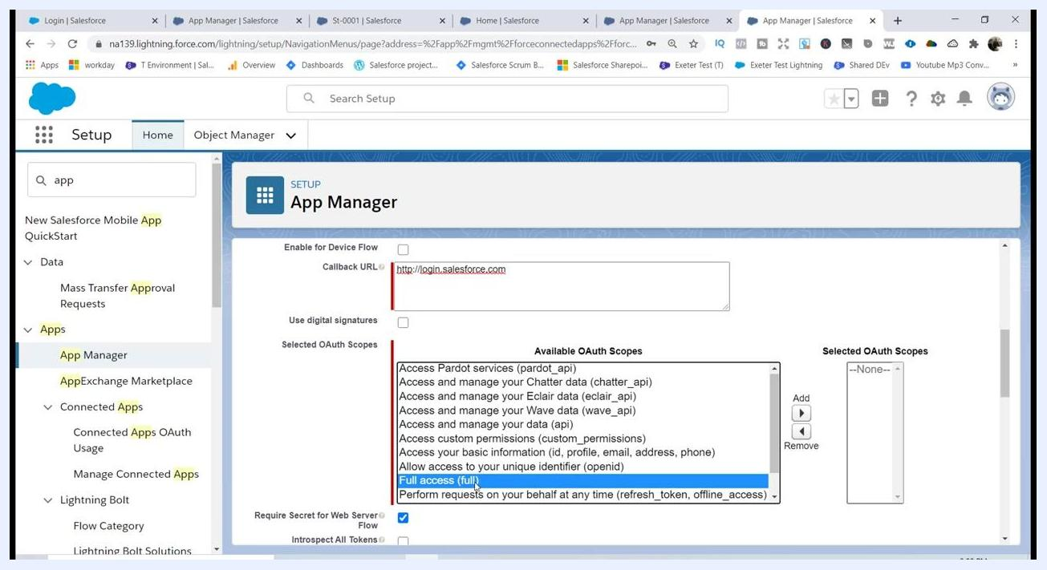
Confirmation screen showing 'Allow from 2 to 10 minutes for your changes to take effect on the server before using the connected app.' with Continue and Cancel buttons

Step 10: Retrieve the consumer key and consumer secret
After saving, navigate to Manage Connected Apps and locate your app (TestSalesforce). Click to view its details, then find the following credentials under API (Enable OAuth Settings):
- Consumer Key: displayed automatically (for example, 3MVG9l2zHsy...)
- Consumer Secret: click Click to reveal to display the value (for example, 54974578E7A4...)
Copy both values — you will need them to authenticate external applications, such as Postman, with Salesforce.
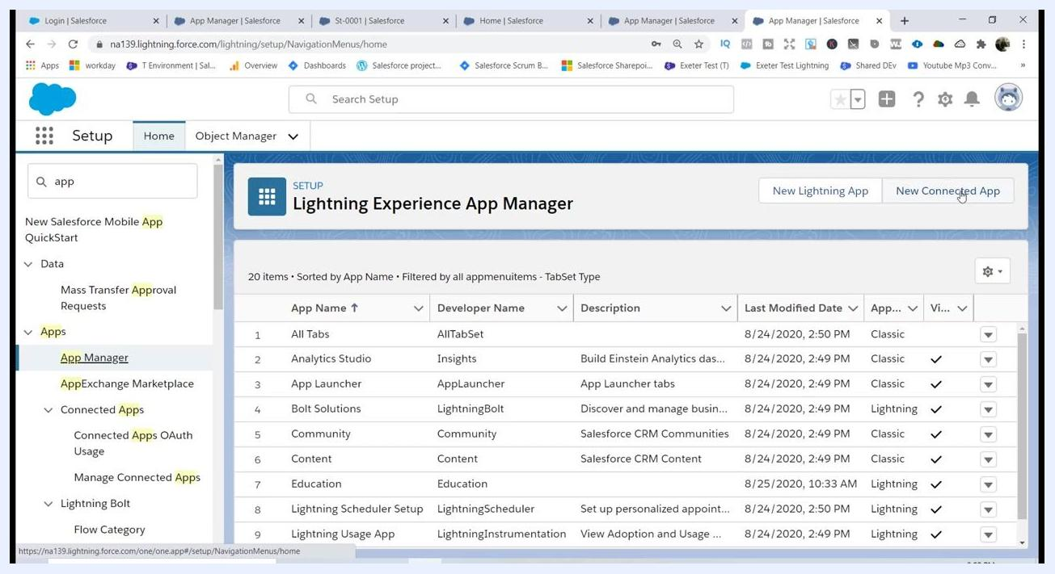
Manage Connected Apps screen showing Consumer Key and Consumer Secret for TestSalesforce

Step 11: Verify the connected app was created
Return to the Lightning Experience App Manager and scroll through the list of apps. Confirm that TestSalesforce now appears at the bottom of the list.
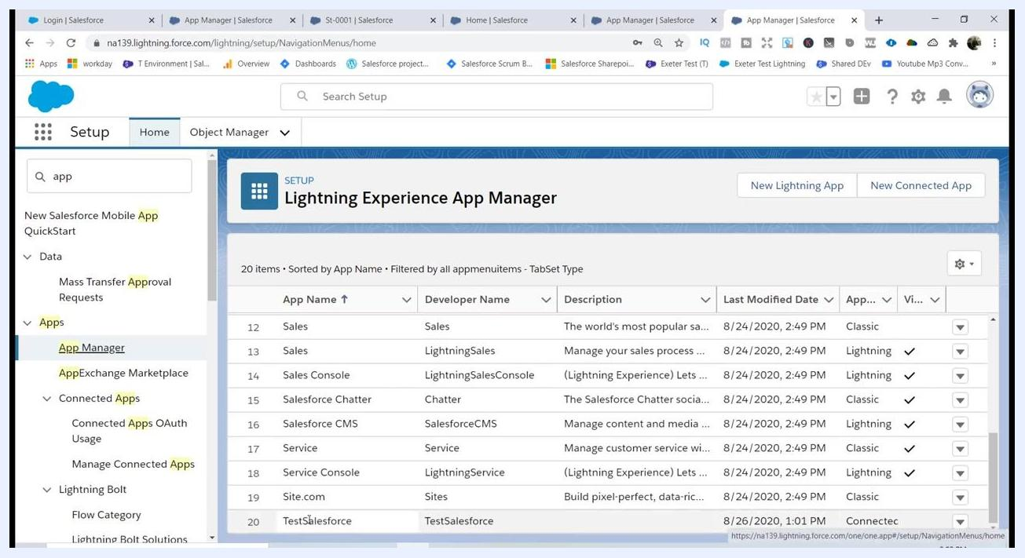
Lightning Experience App Manager showing TestSalesforce listed as the last app

Important notes
- The Consumer Key and Consumer Secret are required for OAuth authentication in external tools like Postman.
- Wait 2–10 minutes after saving before attempting to use the connected app.
- Always use https:// in your Callback URL for security.
- Only grant the minimum necessary OAuth scopes to external applications.

Summary
You have now learned how to create a connected app in Salesforce, enabled OAuth settings, secured the callback URL, and retrieved the Consumer Key and Consumer Secret needed for external authentication.
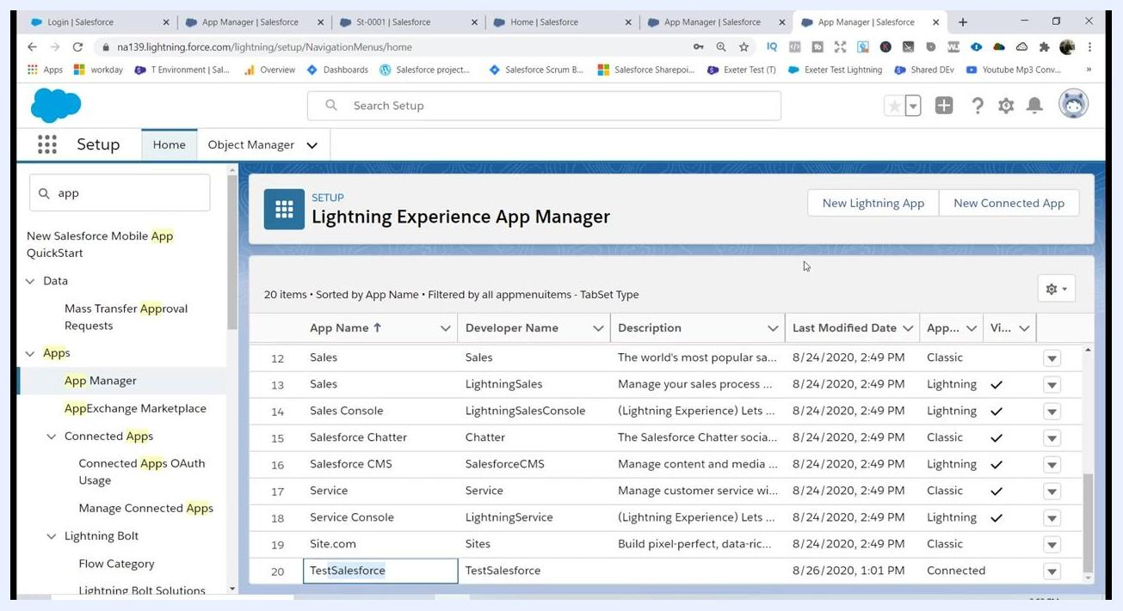
Lightning Experience App Manager showing TestSalesforce listed as the last app, with navigation menu on the left and options for New Lightning App and New Connected App at the top right

What's next
Before moving on, confirm the following:
- Your new app (TestSalesforce) appears at the bottom of the app list in Lightning Experience App Manager, with correct details for Developer Name, Description, Last Modified Date, App Type, and Visibility.
- You have your Consumer Key, Consumer Secret, and Callback URL (using https://) ready to use.
With these credentials in hand, you're ready to configure Postman to authenticate with Salesforce using OAuth 2.0 and test your connection with a REST API call.

