How to Create a Journal Entry in Sage Intacct
Journal entries let you record financial transactions directly in the general ledger, ensuring your accounting data stays accurate and well documented. This guide walks you through how to create a journal entry in Sage Intacct, from opening the entry screen to posting a fully balanced transaction.

Prerequisites
- Access to the Applications menu in Sage Intacct.
- Permissions to view and post entries in the General Ledger module.
- Relevant project, cost code, and account information for the transaction you want to record.

Step 1: Open the journal entries screen
Click the Applications menu at the top left of the Sage Intacct interface. From the list on the left, select General Ledger.
Under the General Ledger section, locate Journal entries in the center column. Make sure you are on the All tab at the top of the menu, then click the small plus sign (+) next to Journal entries to start a new entry.
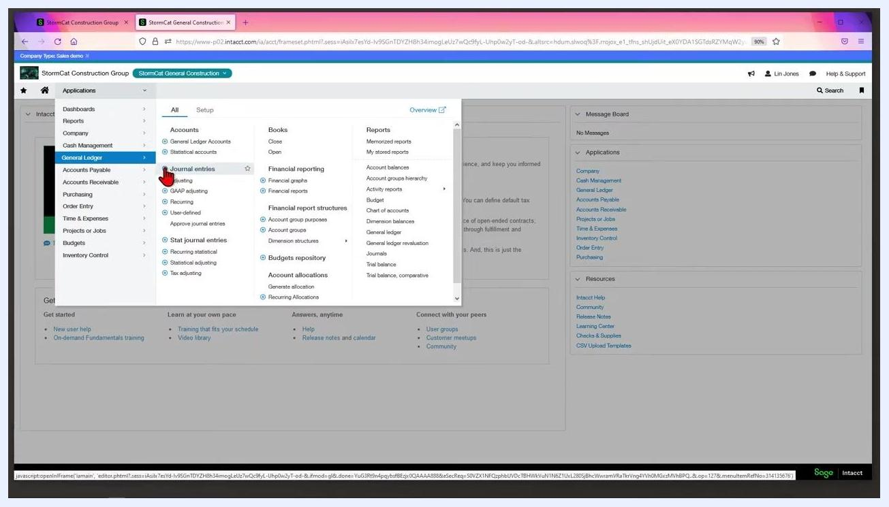
Applications menu open with General Ledger selected and the cursor hovering over Journal entries, showing the plus sign

Step 2: Fill out the header information
On the Journal Entries screen, select the journal you want to post to from the Journal dropdown—for example, GJ–General Journal.
Journal Entries screen with the Journal dropdown open, displaying the list of available journals
Enter the Posting date (for example, 07/27/2022). If the entry needs to reverse at a later date, enter an Automatic reversal date; Sage Intacct will automatically generate the reversing entry on that date.
Journal Entries screen showing the Journal, Posting date, and Automatic reversal date fields

Step 3: Enter a description and reference number
In the Description field, enter a description for the entry, such as "Permits Fees." If needed, add internal notes in the Comment field.
Enter a Reference number if one is available, such as "Permit 1234."
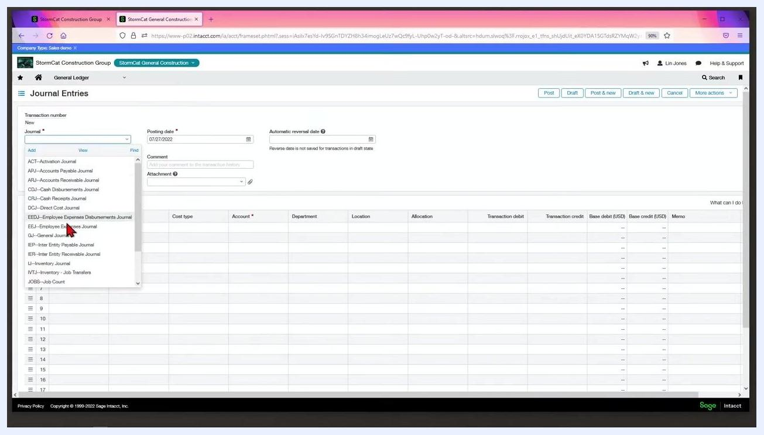
Journal Entries screen with the Description and Reference number fields completed

Step 4: Attach supporting documents
Use the Attachment field to upload any backup documents or supporting files that should remain associated with the entry.
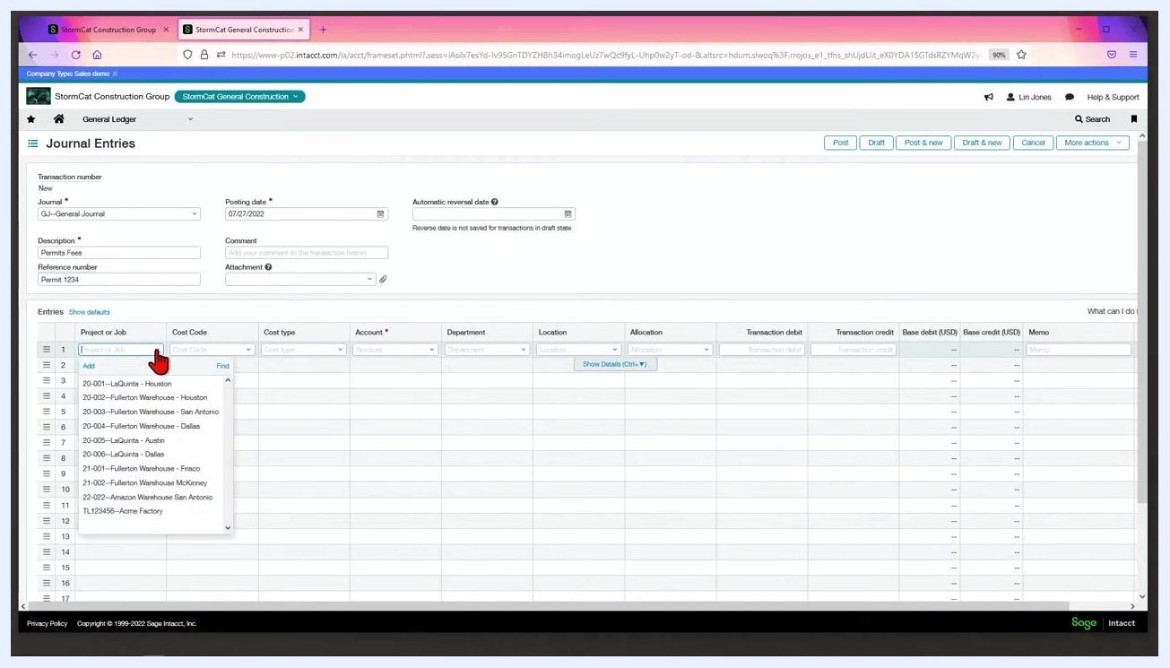
Journal Entries screen with the Attachment field highlighted

Step 5: Tag dimensions and enter line item details
In the Entries section, tag the required dimensions for the line:
- Project or Job: select the relevant project (e.g., "1--LaQuinta - Houston").
- Cost Code: select the appropriate code (e.g., "J65--Permits - General").
- Cost type: select the type (e.g., "1--Other--Other").
- Account: enter the GL account number (e.g., "5005" for "Cost of Sales - Other").
- Department: leave blank if not needed.
- Location: this field may auto-populate based on the project or job.
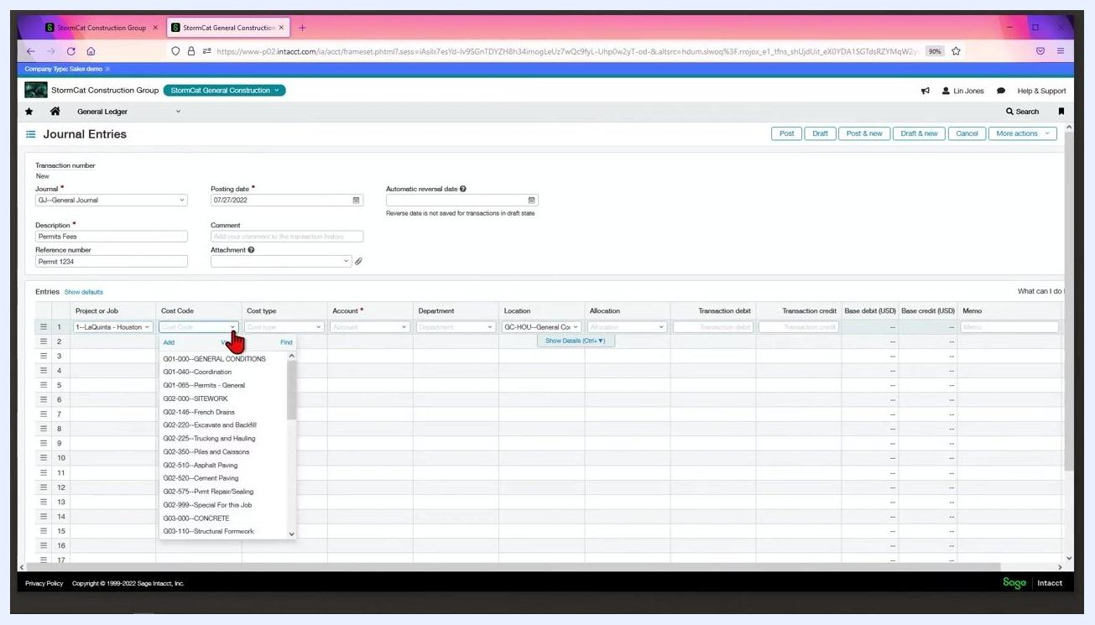
Journal Entries screen with Project, Cost Code, Cost Type, and Account fields being completed

Step 6: Enter the transaction amount
In the Transaction debit field, enter the amount, such as "2,000.00." The Base debit (USD) field will reflect the same amount if the transaction is in USD.

Step 7: Add a memo (optional)
If you need a memo different from the description, enter it in the Memo field for the line item, such as "Permits Fees."
Completed journal entry line with all fields filled in, including the memo

Step 8: Select the checking account for the credit entry
For the credit line, click the Account dropdown and select the checking account from which the expense will be paid, such as "1000--Wells Fargo Checking." Ensure all other required fields—Project or Job, Cost Code, Cost Type, Location, and Memo—are completed as needed.
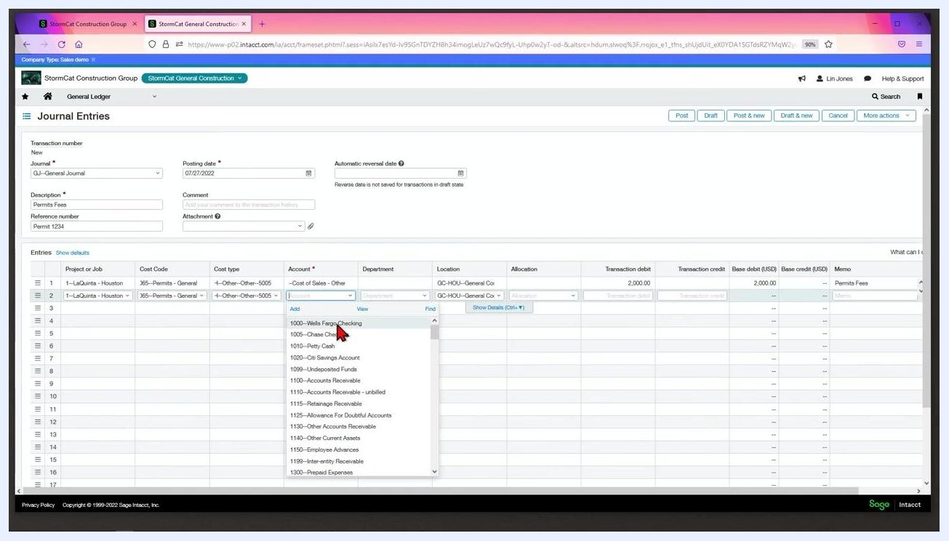
Journal Entries screen with the Account dropdown open and the cursor selecting "1000--Wells Fargo Checking" for the credit line

Step 9: Confirm debits and credits are equal
Sage Intacct uses double-entry accounting, which requires total debits and credits for your journal entry to match. In the Entries section, verify that the Transaction debit and Transaction credit columns show the same amount (for example, 2,000.00).
Make sure the dimensions—Project or Job, Cost Code, Cost Type, Account, and so on—are consistent across both the debit and credit lines.
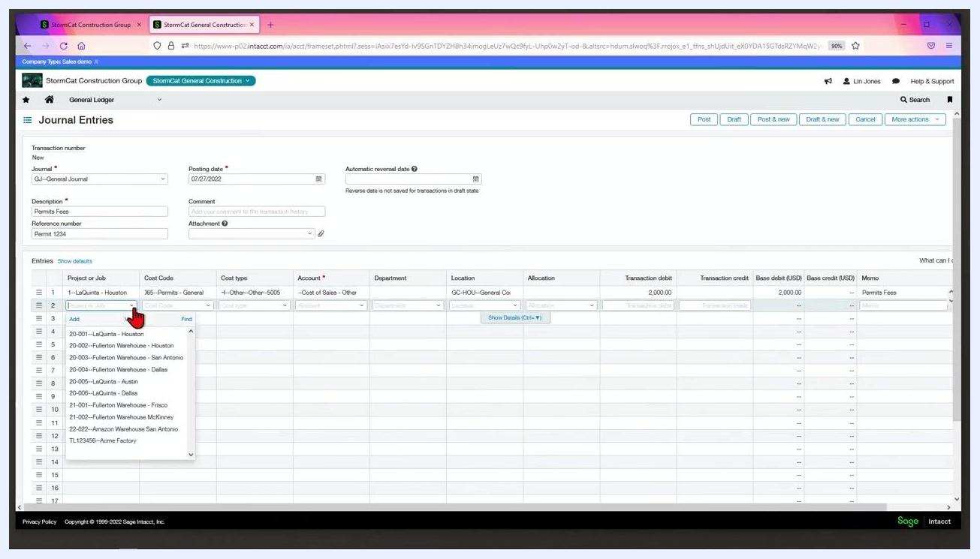
Journal Entries screen showing a debit line for Cost of Sales - Other and a credit line for Wells Fargo Checking, both at 2,000.00 with matching dimensions

Step 10: Post the journal entry
Once you have verified all the information, click the Post button at the top right of the Journal Entries screen. This posts the journal entry into the system.
Journal Entries screen with the cursor clicking the Post button at the top right

Summary
By following these steps, you will complete and post a balanced journal entry in Sage Intacct, ensuring compliance with double-entry accounting principles and proper documentation of all required details.

