How to Write Off Bad Debt in Sage 100
When a customer invoice becomes uncollectible, you can write off the bad debt directly in the Accounts Receivable module of Sage 100. This guide walks you through creating a cash receipts batch, applying the write-off to the correct invoice, posting the entry to the correct bad debt GL account, and verifying that the write-off was recorded correctly on the customer account.

Prerequisites
- Access to the Accounts Receivable module in Sage 100.
- The customer account and specific invoice you intend to write off.
- The GL account number designated for bad debt expense (e.g., 61500-01-000-000-000).

Step 1: Open the Accounts Receivable module
Open Sage 100 and make sure you are on the main dashboard. In the left navigation pane, select Accounts Receivable. This displays the module's main options, including Cash Receipts Entry, Customer Inquiry, and Customer Maintenance.
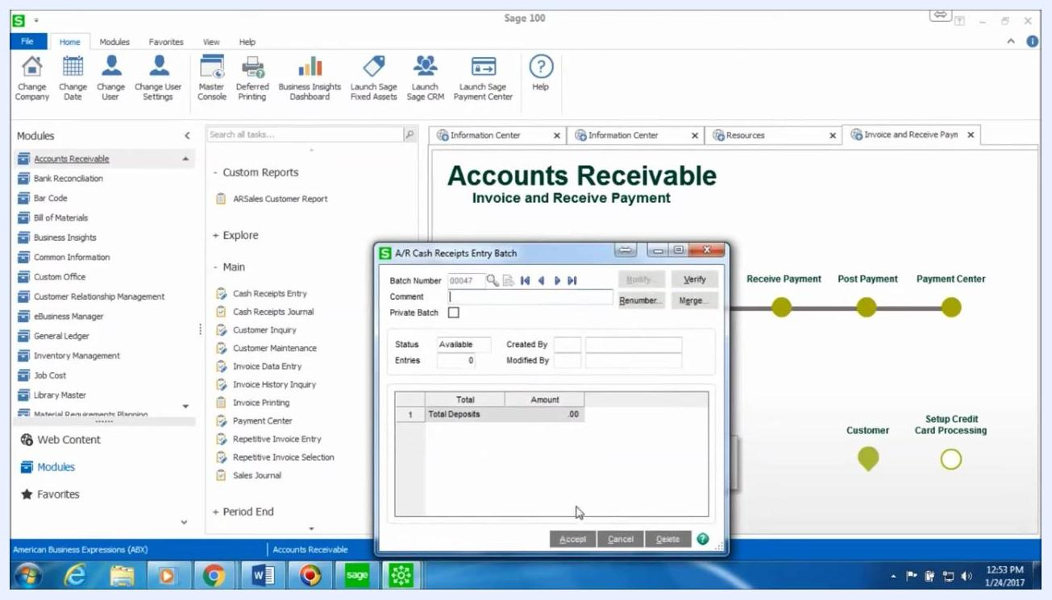
Sage 100 main dashboard with the Accounts Receivable module selected, showing options such as Cash Receipts Entry, Customer Inquiry, and Customer Maintenance

Step 2: Start a new cash receipts entry batch
In the Main section under Accounts Receivable, click Cash Receipts Entry. In the A/R Cash Receipts Entry Batch window, click the Next Batch Number field (for example, 00047), optionally enter a comment for reference, and click Accept to proceed.
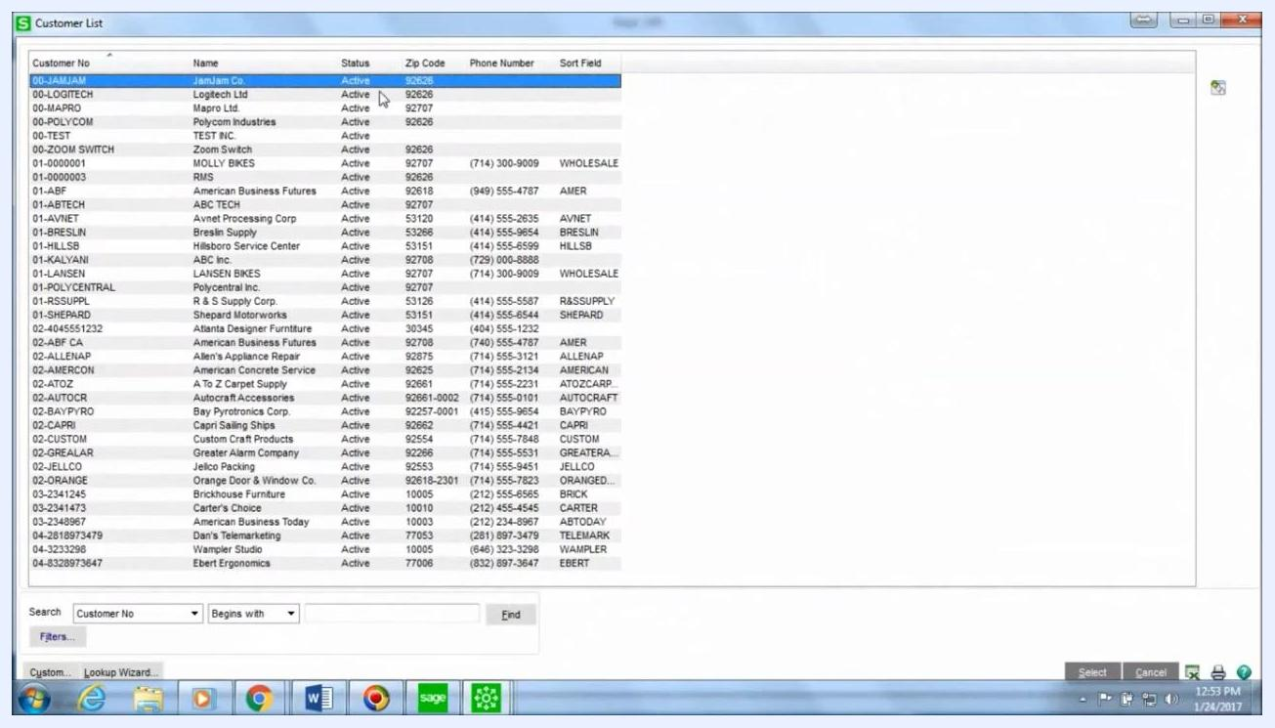
A/R Cash Receipts Entry Batch window showing the batch number, comment field, and Accept button

Step 3: Create a new cash receipts deposit
In the Cash Receipts Deposit window, click the Next Deposit Number field (for example, 00069) and enter a description such as Writeoff. Make sure both the Cash Deposit Amount and Credit Card Deposit Amount are set to 0.00, since no actual payment is being received. Click Accept to continue.
Cash Receipts Deposit window showing the deposit number, description "Writeoff," bank code, deposit date, and zeroed deposit amounts

Step 4: Select the customer for the write-off
In the customer lookup window, search for and select the customer associated with the invoice you are writing off. In this example, the customer is Polycom Industries (Customer No: 00-POLYCOM).
Customer List window showing various customers, with Polycom Industries highlighted

Step 5: Enter write-off details in Cash Receipts Entry
In the Cash Receipts Entry window, confirm that the Customer No field shows 00-POLYCOM. Set the Deposit Type to Cash, and in the Check No. field, enter WRITE OFF. Leave the Amount Received field on the Header tab set to 0.00, since this entry does not represent an actual cash payment.

Step 6: Select the invoice to write off
Go to the Lines tab. In the first line, click the lookup icon under Invoice No. to open the Select Cash Receipts Invoices window. Choose the invoice you want to write off (for example, Invoice No: 0000009-N, Inv Date: 1/18/2017, Inv Amount: 20.00), then click OK.
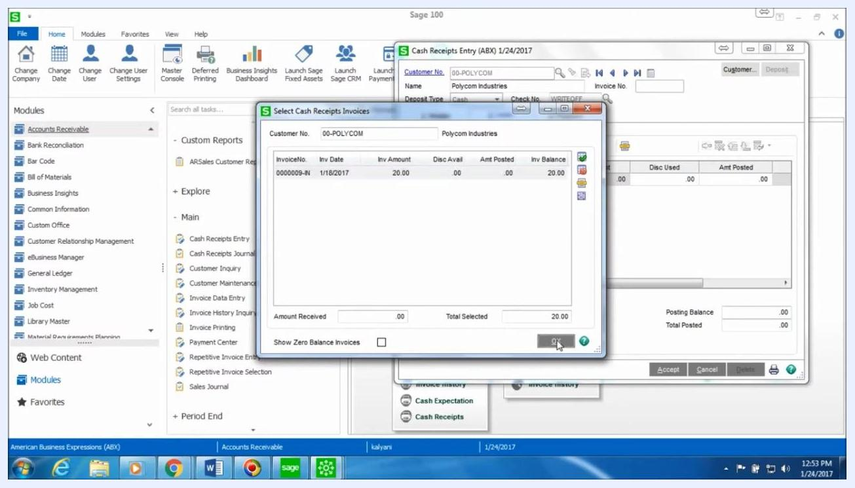
Select Cash Receipts Invoices window showing Polycom Industries, Invoice No 0000009-N, Inv Amount $20.00, with the OK button highlighted

Step 7: Enter the write-off amount
In the Amt Posted field for the selected invoice, enter the full amount you want to write off (for example, 20.00). Confirm that the Posting Balance and Total Posted fields reflect this write-off amount.
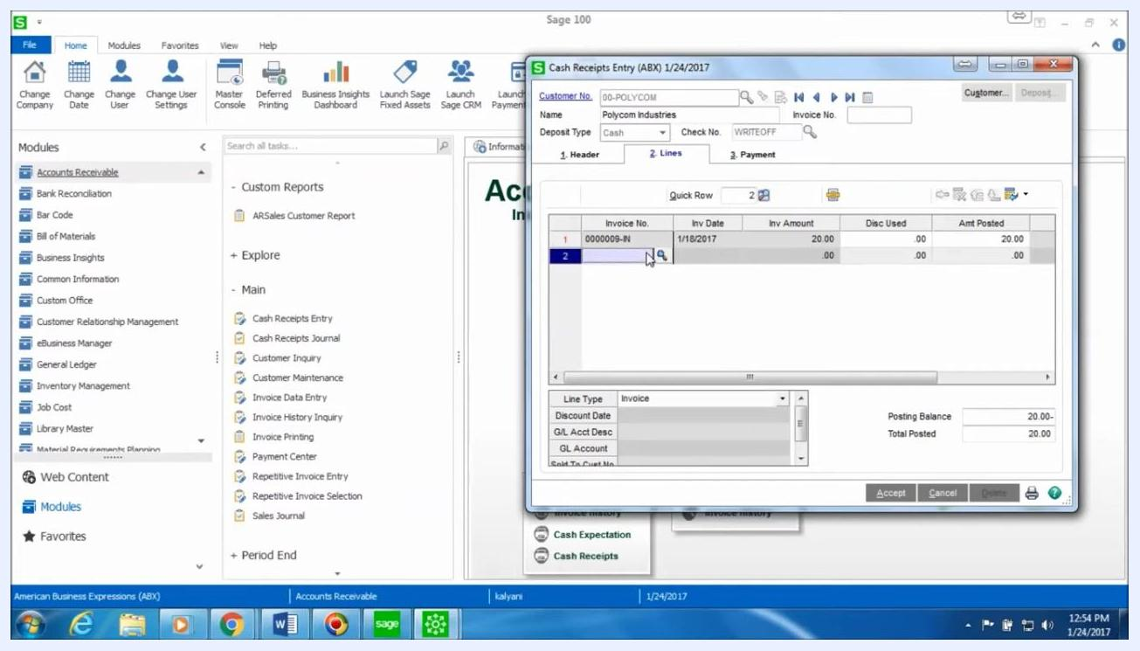
Cash Receipts Entry window showing the invoice line with Invoice No 0000009-N, Inv Amount $20.00, and Amt Posted $20.00

Step 8: Select the bad debt GL account and post the entry
Move to the next line in the Cash Receipts Entry window and change the Line Type to GL Account. In the G/L Account List window, search for and select the appropriate bad debt expense account (for example, 61500-01-000-000-000, Description: Bad Debt Exp.: Irvine-Main), then click Select to confirm.
Enter the write-off amount as a negative value (for example, -20.00) in the Amt Posted field for the GL account line. Confirm that the posting balance is zero, which indicates the entry is balanced. Click Accept to save the entry.
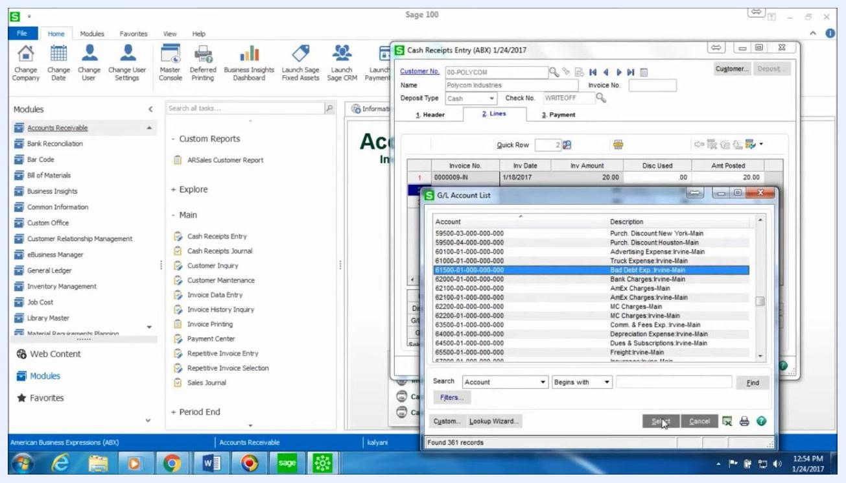
Cash Receipts Entry window with the G/L Account List open, Bad Debt Exp.: Irvine-Main account highlighted, and invoice write-off details visible

Step 9: Print and preview the Cash Receipts Journal
To post the entry, click the printer icon at the bottom right of the Cash Receipts Entry window. In the print dialog, select the batch to print (for example, Batch Number: 00047) and click Proceed. Choose to Preview the Cash Receipts Journal.
Review the generated report, which displays the amount being written off, the customer and company details (Polycom Industries, Customer No: 00-POLYCOM), and the invoice number, GL account, and check number (WRITE OFF).
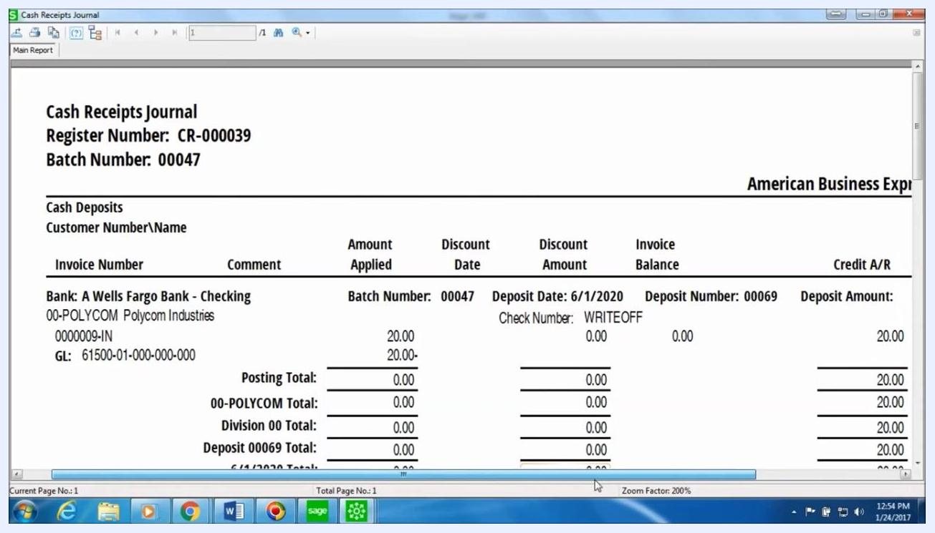
Cash Receipts Journal report showing Register Number CR-000039, Batch Number 00047, Polycom Industries, Invoice 0000009-IN, GL 61500-01-000-000-000, Check Number WRITE OFF, and the write-off amount

Step 10: Review the Accounts Receivable Recap report
After closing the Cash Receipts Journal preview, the Accounts Receivable Recap By Division report appears. Review it to see the debits and credits for the accounts involved, including Accounts Receivable: Irvine-Main and Bad Debt Exp.: Irvine-Main. Confirm the division totals show the write-off posted correctly, for example a debit of 20.00 to Bad Debt Expense and a credit of 20.00 to Accounts Receivable.
Accounts Receivable Recap By Division report showing GL accounts, descriptions, and debit/credit amounts for the write-off

Step 11: Update the Cash Receipts Journal
When prompted, click Yes to update the Cash Receipts Journal and finalize the posting of the write-off entry.

Step 12: Verify the write-off in Customer Maintenance
Return to the Main section of the Accounts Receivable module and click Customer Maintenance. Search for and select the customer (for example, 00-POLYCOM, Polycom Industries), then go to the Transactions tab.
Verify that an entry appears with the amount shown as negative (for example, -20.00), that the Check No. field displays WRITE OFF, and that the correct invoice number is referenced. This confirms the write-off has been recorded correctly for the customer and invoice.
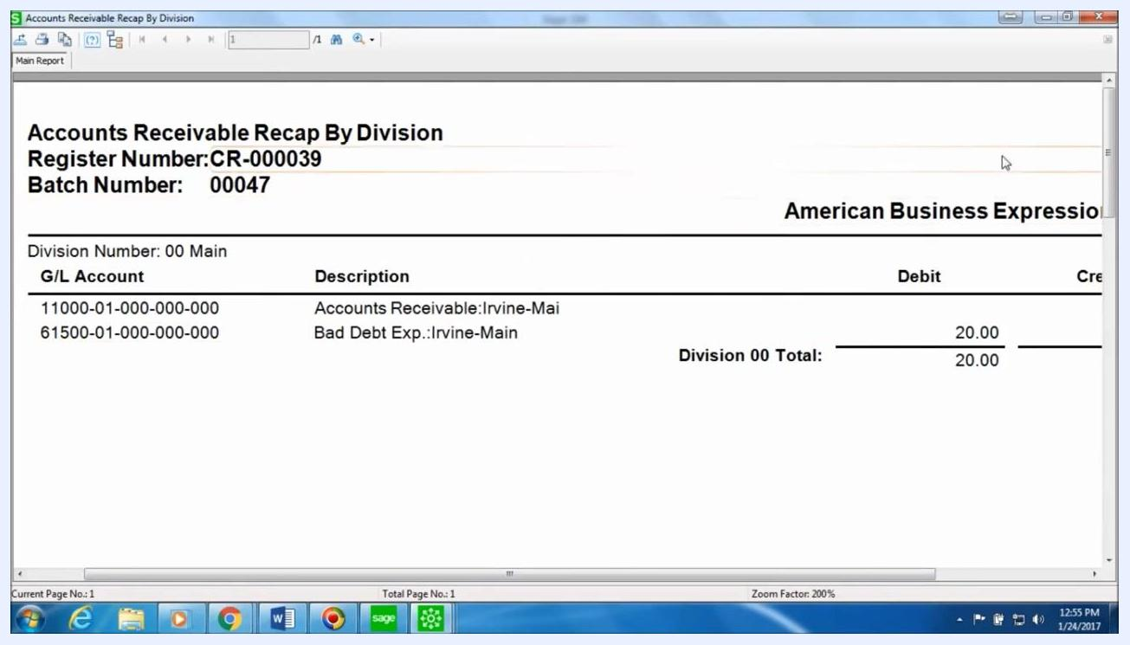
Customer Maintenance window, Transactions tab, showing a negative payment entry for invoice 0000009, check number WRITE OFF, and the correct amounts

Summary
You have now learned how to write off bad debt in Sage 100 by creating a zero-dollar cash receipts batch, applying the write-off to the invoice, offsetting it against a bad debt expense GL account, posting the Cash Receipts Journal, and confirming the write-off on the customer's transaction history.

