How to Export Data to Excel in Sage 100
Sage 100 lets you export customer records, transaction history, sales orders, and reports directly to Microsoft Excel for further analysis. This guide walks you through exporting data to Excel in Sage 100 from several areas of the application, including Customer Maintenance, the Business Insights Explorer, and the Accounts Receivable Aged Invoice Report, along with tips for formatting the exported data in Excel.

Prerequisites
- Access to Sage 100 (subscription version 2020 or similar).
- Microsoft Excel installed on your computer.
- Customer and transaction data already set up in Sage 100.

Exporting customer data from Customer Maintenance

1. Open Customer Maintenance
Launch Sage 100 and confirm you are on the main dashboard. The left Favorites panel displays options such as Customer Maintenance, Customer View, and Accounts Receivable Aged Invoice Report. Click Customer Maintenance in the Favorites panel to open it.
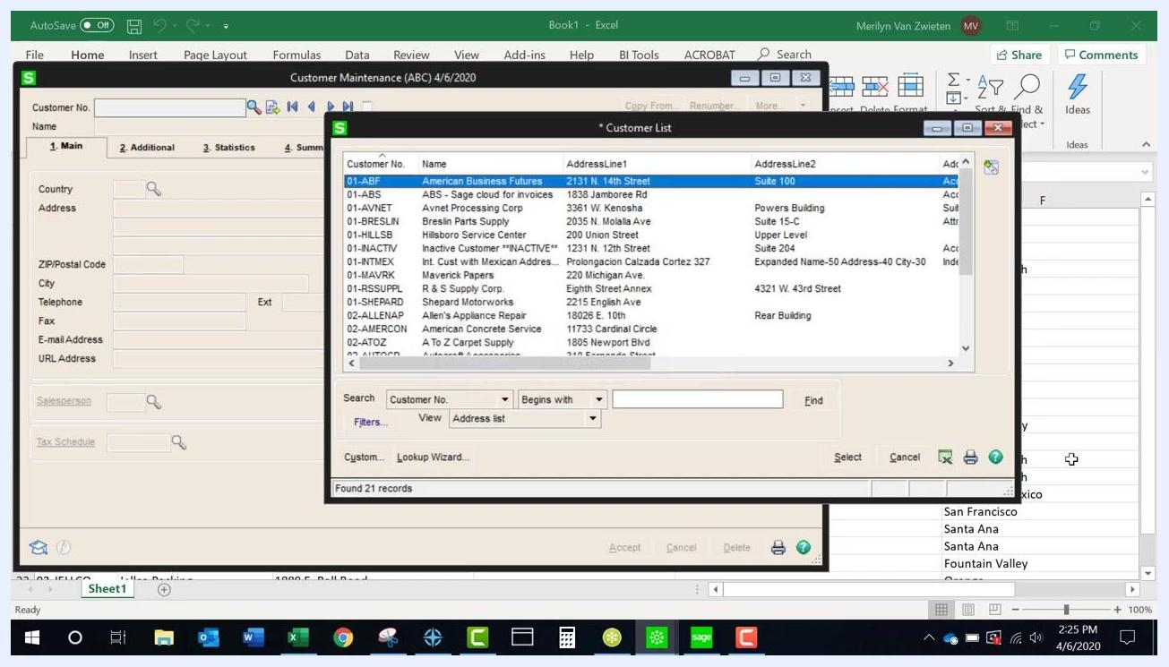
Sage 100 main dashboard with the Favorites panel and Customer Maintenance highlighted

2. Access the customer lookup list
Selecting Customer Maintenance opens a Customer List window. Use the View dropdown to choose the list type you want, such as Standard, Address list, or Stats. The list shows columns including Customer No., Name, Status, ZIP/Postal Code, and Phone Number. Locate the Excel export button, typically shown as an Excel icon, in the lookup list window.

3. Export the lookup list to Excel
Click the Excel export button to send the lookup list data to Microsoft Excel. The exported file opens automatically and includes columns such as Customer No., Name, AddressLine1, AddressLine2, AddressLine3, and City.
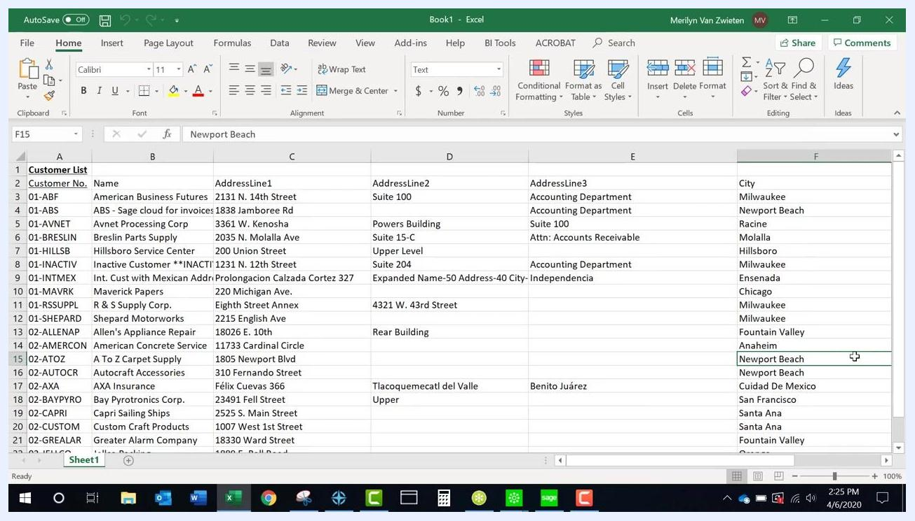
Customer List exported to Excel, showing customer details organized in columns

4. Export data from the Customer History tab
In the Customer Maintenance window, select a customer from the list and click the History tab. Right-click anywhere in the list or grid, then choose Export to Excel from the context menu. The exported data includes fields such as Period, Ending, Sales, Cost of Sales, Profit %, Profit Amt, Cash Received, and No. Invoices.
Customer Maintenance History tab with the right-click menu showing the Export to Excel option

5. Export data from the Invoices, Transactions, or Sales Orders tabs
Navigate to the Invoices, Transactions, or S/Os (Sales Orders) tab in Customer Maintenance. If the Excel export button is not active, click any line item in the list to enable it. Click the Excel export button to send the tab's data to Excel. The exported file is formatted according to the tab's columns, such as Invoice No., Invoice Type, Inv Date, Amount, Discount, Balance, Customer PO No., and Comments.
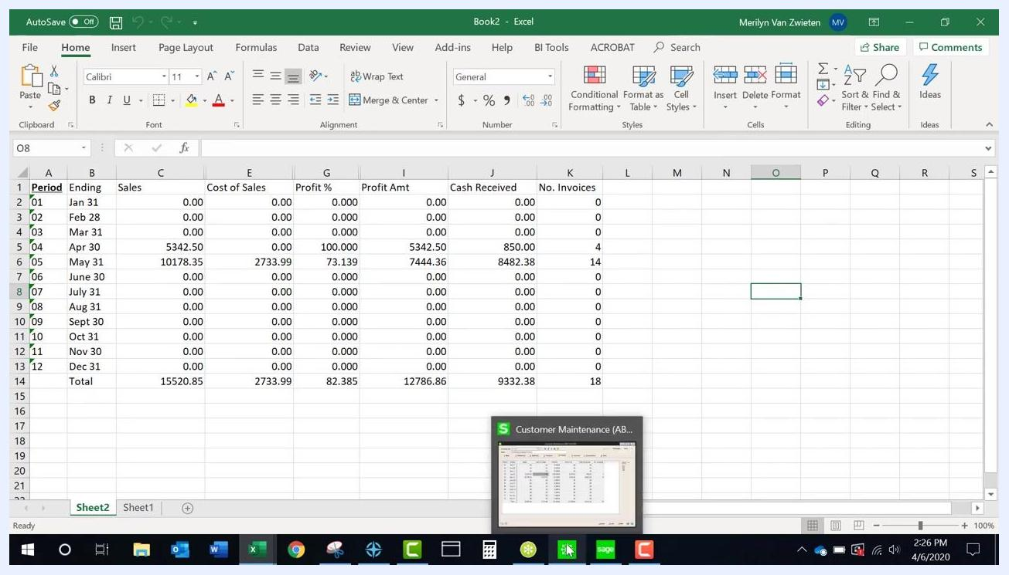
Customer Maintenance Invoices tab with exported data visible in Excel

 | Note: The export to Excel feature works the same way across different list views and data tabs in Sage 100. If the export button is not enabled, select or highlight a line item first.

6. Review sales order lines
In Customer Maintenance, open the S/Os (Sales Orders) tab to review the sales orders for the selected customer. The list includes columns such as Number, Type, Order Date, Ship/Expire, Customer PO No., Ship To, Order Amount, and Last Inv/Order.

7. Export sales order line items
Right-click anywhere in the sales order list or grid, then select Export to Excel from the context menu. This creates a worksheet containing all line items of the sales order, including Item Code, Description, Ordered, Shipped, Back Ordered, Unit Price, Extension, and Comment.
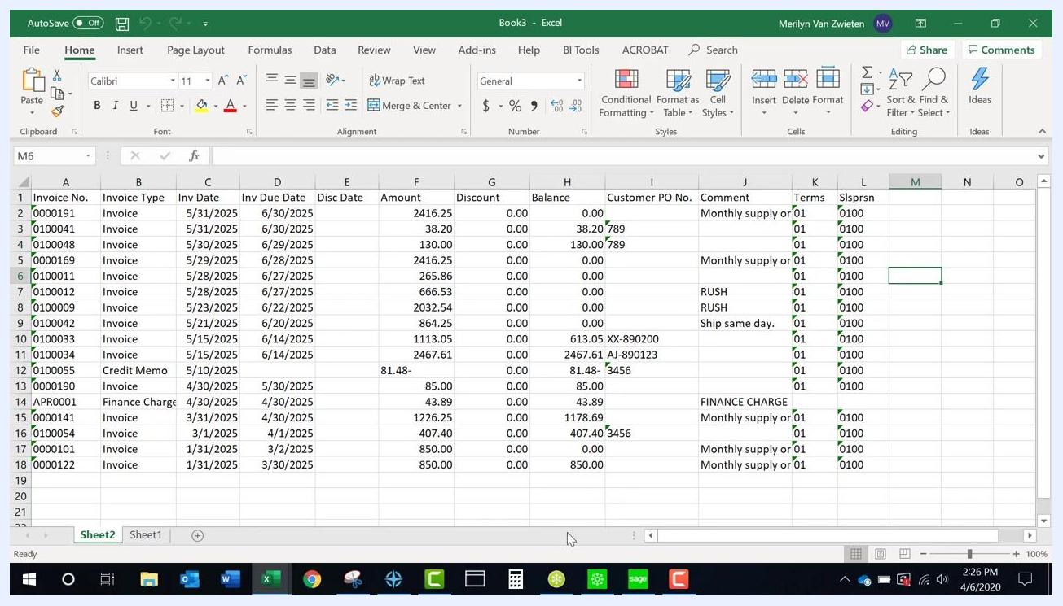
Excel worksheet showing exported sales order line items with columns for Item Code, Description, Ordered, Shipped, Back Ordered, Unit Price, Extension, and Comment

Exporting data from the Business Insights Explorer

8. Open the Customer View Explorer
Return to the Sage 100 main dashboard. In the left Favorites panel, scroll to the bottom of each module's menu list to find the Explorer view, then click Customer View under the Explorer section.
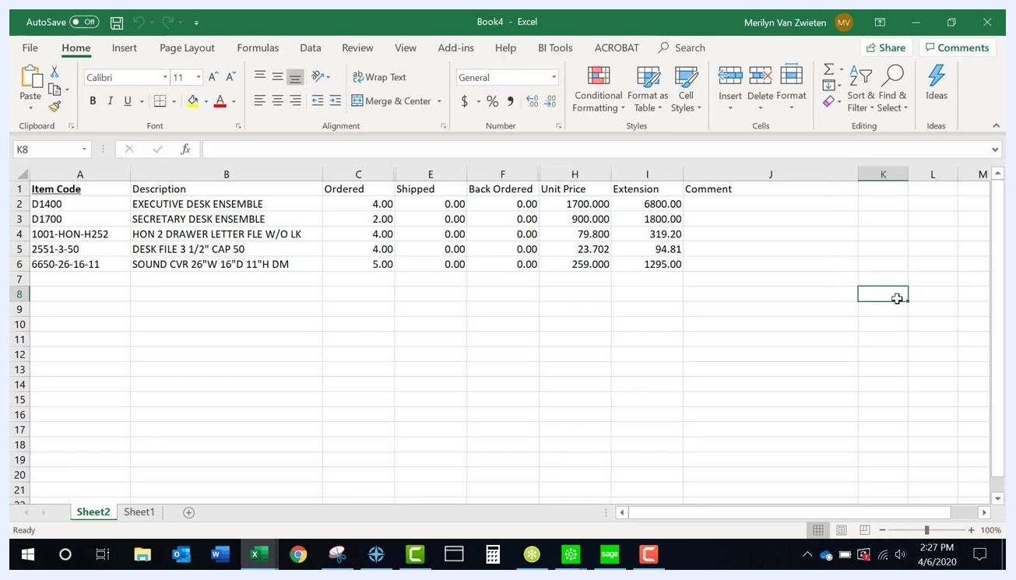
Sage 100 main dashboard with Customer View highlighted in the Favorites panel

9. Review data in the Explorer view
The Explorer view displays a data grid with customer information, including Div, Customer, Name, Hold, Current Balance, Aging 1-4, Salesperson, Credit Limit, Terms, and E-mail Address. Related panels, such as Customer Sales History by Period, show Fiscal Year, Dollars Sold, Cost of Goods Sold, Cash Received, Finance Charges, and Number of Invoices.
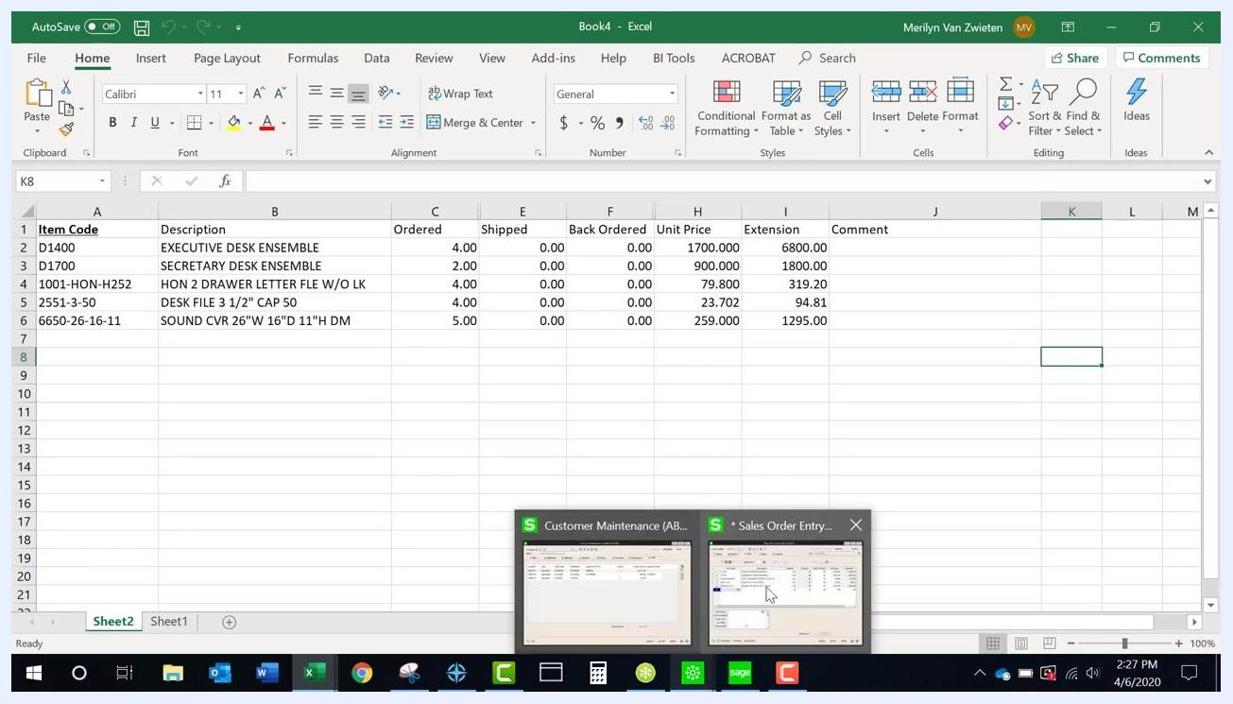
Sage 100 Business Insights Explorer displaying the customer data grid and sales history by period

10. Export Explorer data to Excel
In the Explorer window, click File in the top menu, select Export Options, and choose Excel from the list of formats. The data grid is exported to an Excel worksheet.
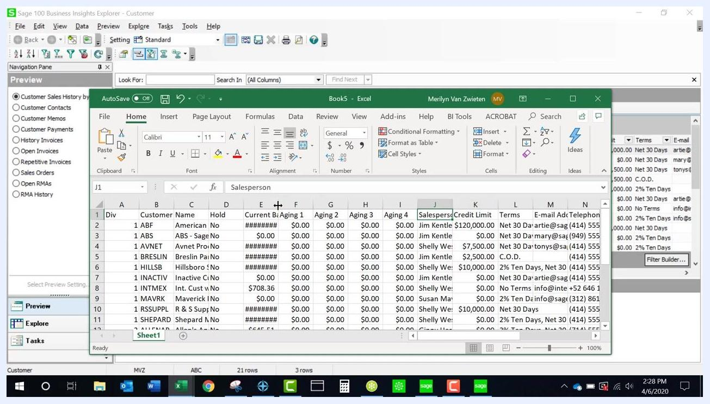
Sage 100 Business Insights Explorer with the File menu open, showing export options

11. Adjust exported Explorer data in Excel
Open the exported Excel file and review the data to confirm all columns are present. If a column shows "#######" (for example, in the Current Balance column), expand the column width in Excel to display the full value.
Exported Explorer data in Excel with columns that need width adjustment
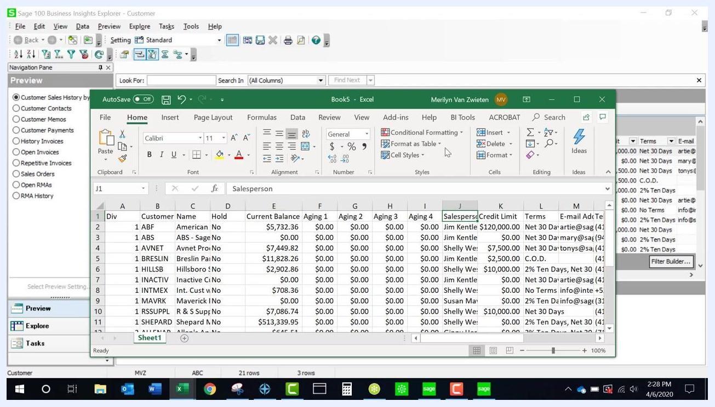
Exported Explorer data in Excel after adjusting column widths for readability

Tip: When exporting from the Explorer view, you may need to manually widen columns in Excel for readability. The export process is similar across data grids in Sage 100—look for a right-click context menu or the File > Export Options menu.

12. Select secondary grid data
In the Business Insights Explorer, locate the Preview panel on the left and select History Invoices to display historical invoice data for customers.
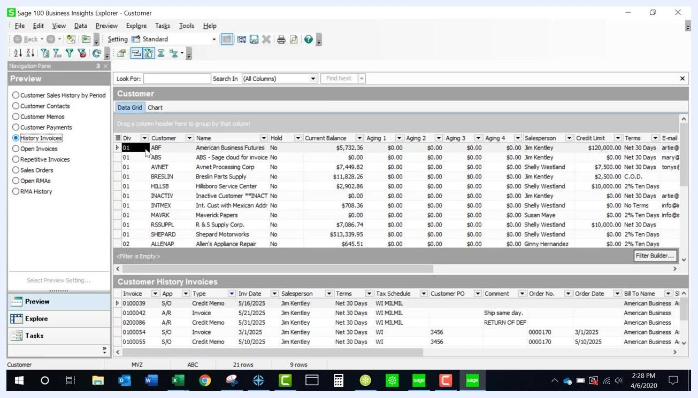
Business Insights Explorer with History Invoices selected in the Preview panel, showing customer data in the primary grid and invoice history in the secondary grid

13. Move secondary grid data to the primary grid
Double-click the desired customer in the main customer data grid. The secondary grid, History Invoices, is promoted to the primary grid and becomes available for export.
Business Insights Explorer showing History Invoices promoted to the primary grid, ready for export

14. Export the promoted data to Excel
With the History Invoices data now in the primary grid, click File in the top menu, select Export Options, and choose Microsoft Excel from the list of formats. You can choose to export all records or only the selected ones.
Export Options menu open in Business Insights Explorer, with Microsoft Excel selected as the export format

Exporting the Accounts Receivable Aged Invoice Report

15. Configure the report settings
From the Sage 100 main dashboard, select Accounts Receivable Aged Invoice Report from the Favorites panel. In the report setup window, configure the following options:
- Report Setting: SWK
- Description: Accounts Receivable Aged Invoice Report
- Aging Date: 4/6/2020
- Report Detail Option: Invoice
- Aging Option to Print: All Open Invoices
- Future Transactions: Include All
- Include Paid Invoices: Checked
- Age Credit Memos: Checked
- Print Transaction Date: Checked
- Print Condensed: Checked
Add any additional filters you need, such as Customer Number, Customer Name, or Salesperson.
Accounts Receivable Aged Invoice Report setup window showing all relevant options and filters

16. Preview and export the report
Click Preview to generate the report. In the preview window, click the export icon or select File > Export. In the Export dialog, choose Microsoft Excel (97-2003) Data-Only as the format, then click OK to export.
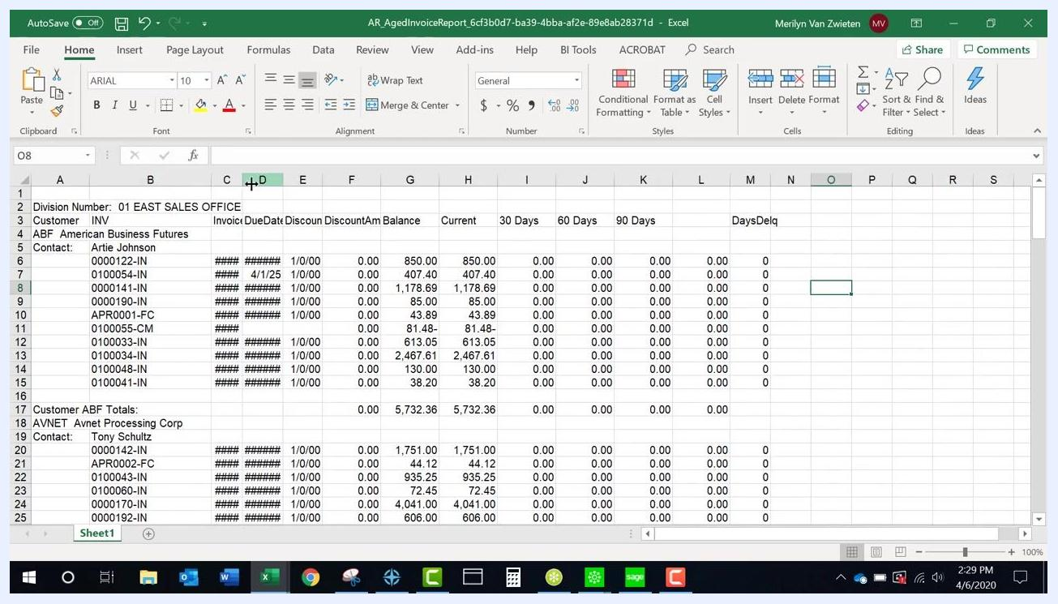
Export dialog in the Sage 100 report preview window with Microsoft Excel (97-2003) Data-Only selected

17. Adjust the exported report in Excel
Open the exported Excel file and review the data for completeness. If you see "#######" in any column, expand the column width to reveal the full data, and adjust row heights as needed for readability.
Exported Accounts Receivable Aged Invoice Report in Excel with columns that need width adjustment
Exported Accounts Receivable Aged Invoice Report in Excel after adjusting column widths and row heights

18. Review special columns and headers
Some columns may not have headers—for example, a retention column if retentions are not used. Confirm that all relevant data is present and that column headers align correctly with the data below them.
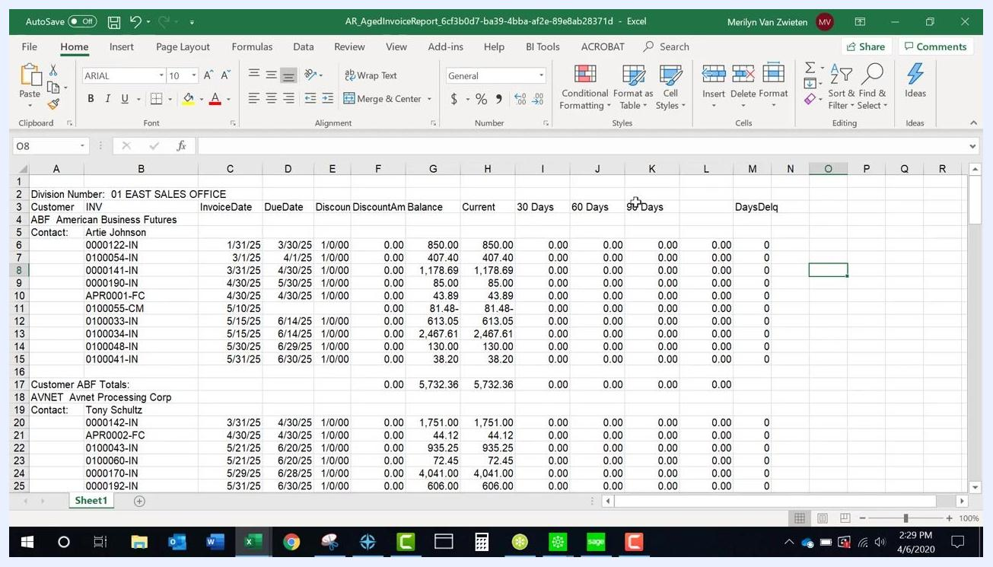
Final exported Accounts Receivable Aged Invoice Report in Excel with all columns and headers clearly visible

Tips: Use the Maintain Relative Object Position option, if available, to keep column headers aligned with their data. You may need to make minor adjustments in Excel, such as expanding columns or modifying row heights, to ensure all data is visible. Some report layouts may require changes in Crystal Reports, such as separating combined headers, for optimal export results.

Adjusting Crystal Reports column headers

19. Review the exported report for combined headers
Open the exported Accounts Receivable Aged Invoice Report in Excel and examine the column headers in row 3. Confirm that headers such as "Customer" and "INV" (Invoice) appear as separate columns, and that each data column—InvoiceDate, DueDate, Discount, Balance, Current, 30 Days, 60 Days, 90 Days, DaysDelq—has its own header. Check that data rows align under the correct headers and that customer and contact information, along with totals and subtotals, are clearly labeled.
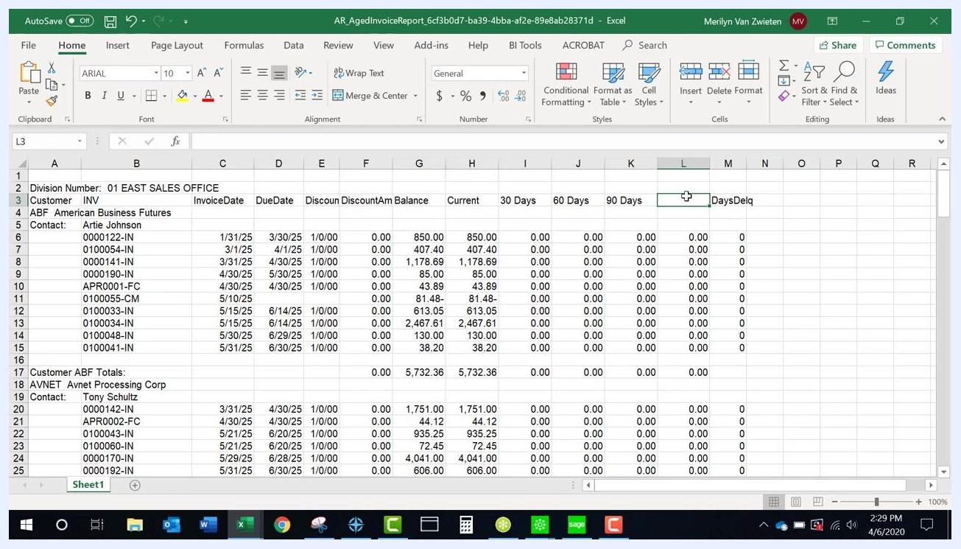
Excel spreadsheet showing the exported report with separated Customer and Invoice headers and clearly labeled data columns

20. Modify combined headers in Crystal Reports
If your exported report still shows combined headers, such as "Customer/Invoice," open the report layout in Crystal Reports. Locate the column header section and separate the combined header into individual fields—for example, one header for "Customer" and another for "INV." Make sure each data field has a corresponding, clearly labeled header, then save your changes and re-export the report to Excel to verify the improvement.

21. Add additional fields if needed
If you need additional fields, such as a phone number, insert a new header and corresponding data column. For example, add "Telephone Number" as a header and enter the relevant data for each customer, such as "973.758.6100."
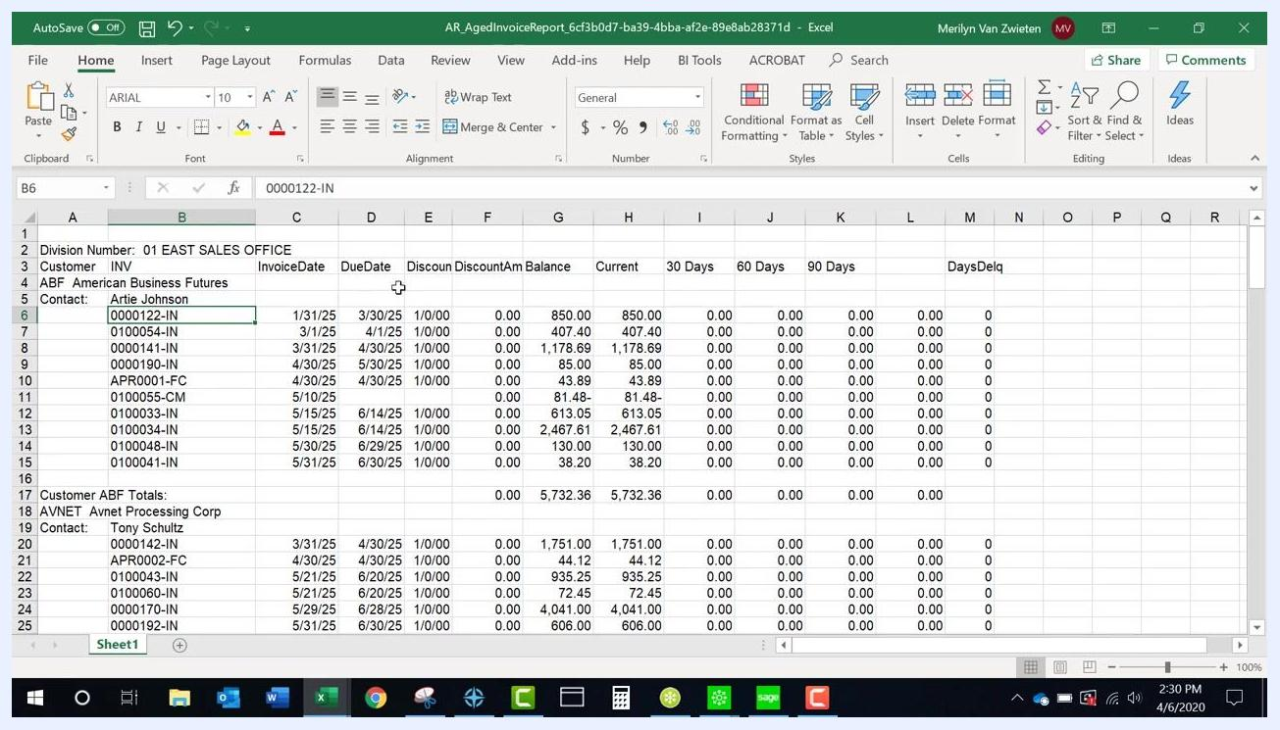
Excel spreadsheet showing the header row and invoice data, ready for additional fields

22. Remove unnecessary fields for proper alignment
Delete any columns or headers that are not needed for your report. Removing extra fields helps ensure that all remaining columns line up correctly and are easy to read.
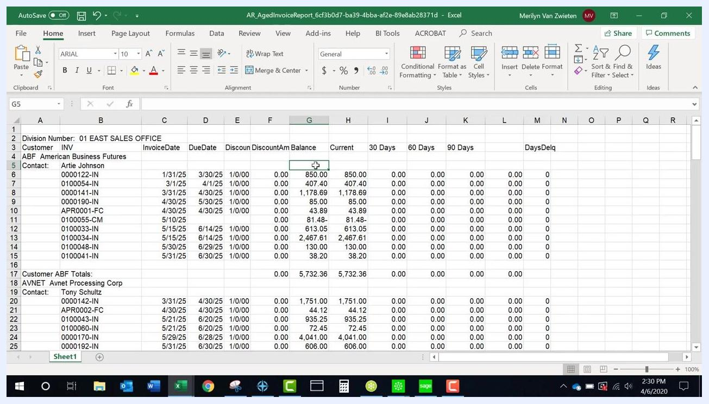
Excel spreadsheet with headers and data aligned after removing unnecessary fields

23. Reposition important fields under their headers
If a specific field, such as the phone number, is important, move it so it appears directly under its header and adjacent to related customer information. Confirm that all headers sit directly above their corresponding data.
Excel spreadsheet showing the Balance header and data properly aligned

Getting help
If you need further assistance exporting data in Sage 100, you can reach support through the following channels:
- Phone (direct): 973.758.6100
- Phone (toll free): 877.979.5462
- Fax: 973.758.6120
- Email: info@swktech.com
Call the direct or toll-free number for immediate assistance, send an email for support requests or inquiries, or use the fax number to send documents.

What's next
With these steps, you can export customer records, transaction history, sales order lines, Explorer grid data, and formatted reports from Sage 100 into Excel. Once exported, use the formatting tips above—adjusting column widths, row heights, and header alignment—to prepare your data for analysis or reporting.

