How to create a new GL account in Sage 100
This guide walks you through how to create a new GL account in Sage 100 ERP, including setting up the main account, configuring a sub account, and verifying that the new account has been created correctly. Follow each step in order to ensure all required fields are completed before you save your entries.

Prerequisites
- Access to the Sage ERP MAS 90 Desktop application.
- Permissions to open and edit General Ledger setup screens.
- Knowledge of the account group, category, and type you want to assign to the new account.

Step 1: Open General Ledger setup
In the left navigation pane of the Sage ERP MAS 90 Desktop, click the + next to General Ledger to expand its subfolders. Then click the + next to Setup to display the available setup options.
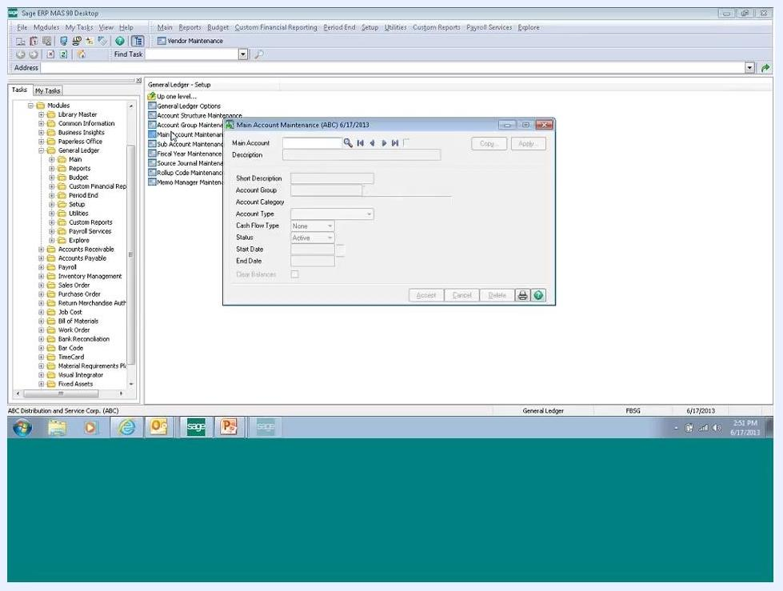
Sage ERP MAS 90 Desktop with the General Ledger and Setup folders expanded, showing the available setup options

Step 2: Open Main Account Maintenance
Click Main Account Maintenance in the Setup list to open the account maintenance window. This is where you will define the new main account.

Step 3: Enter the main account number
In the Main Account field, type the account number you want to add (for example, 999).

Step 4: Enter a description
In the Description field, type a full description for the account (for example, "PROVISION FOR INCOME TAXES").

Step 5: Enter a short description (optional)
In the Short Description field, you may enter an abbreviated version of the description (for example, "Desc").

Step 6: Review or modify the Account Group
The Account Group field defaults to the group you have already set up (for example, 990). To change it, click the magnifying glass icon to open the lookup and select a different group if needed.

Step 7: Set the Account Category and Account Type
Choose the appropriate category (for example, "Income Tax") and type (for example, "Income Tax") from the respective dropdown menus.

Step 8: Set the Cash Flow Type (optional)
Select a cash flow type if applicable, or leave this field set to "None."

Step 9: Confirm the account status
Use the Status dropdown to select Active, unless the account should remain inactive.

Step 10: Enter start and end dates (optional)
Only enter a Start Date and End Date if this is a temporary account. For permanent accounts, leave both fields blank.

Step 11: Save the new main account
Click Accept to save the new main account. Review all fields before saving to confirm accuracy.
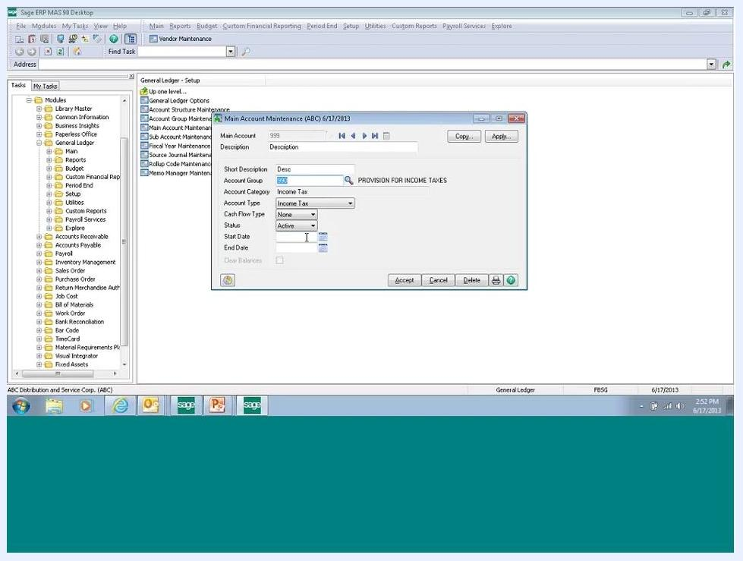
Main Account Maintenance window filled with sample data: Main Account 999, Description "PROVISION FOR INCOME TAXES", Short Description "Desc", Account Group 990, Account Category "Income Tax", Account Type "Income Tax", Cash Flow Type "None", Status "Active", with blank Start Date and End Date

Step 12: Close Main Account Maintenance
Click the X in the upper right corner of the window to close Main Account Maintenance.
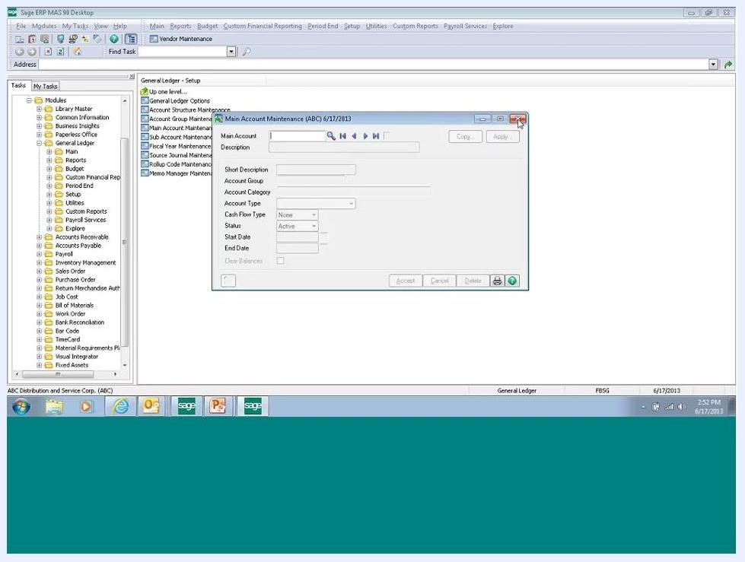
Main Account Maintenance window ready to close, with all fields cleared

Step 13: Open Sub Account Maintenance
Under the Setup tab, click Sub Account Maintenance to open the sub account window.

Step 14: Verify the segment setup
Check the Segment field to confirm it reflects the correct segment (for example, "Department" or "Location").

Step 15: Enter the sub account number
In the Sub Account field, type the sub account number (for example, 99).

Step 16: Enter a description for the sub account
In the Description field, type a description for the sub account (for example, "Desc" or "Description").

Step 17: Enter a short description (optional)
In the Short Description field, you may enter an abbreviated description.

Step 18: Confirm the sub account status
Use the Status dropdown to select Active.

Step 19: Enter start and end dates for temporary sub accounts (optional)
Only enter a Start Date and End Date if this is a temporary sub account. Leave these fields blank for permanent sub accounts.

Step 20: Include the sub account in financial reports (optional)
Select Print Financial Reports if you want this sub account included in your financial reports.

Step 21: Save the sub account
Click Accept to save the sub account.
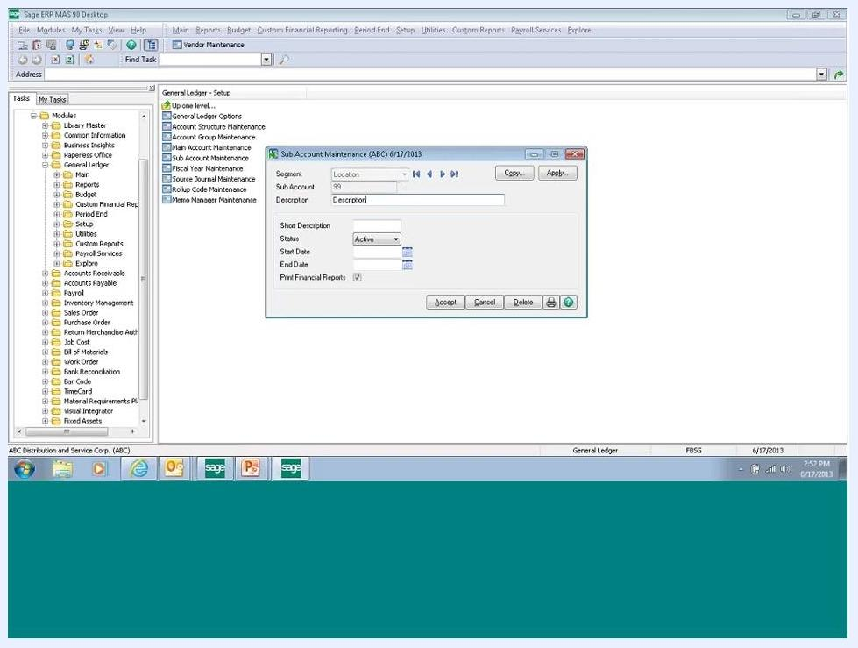
Sub Account Maintenance window with Segment "Location", Sub Account "99", Description "Description", Status "Active", blank Start Date and End Date, and Print Financial Reports unchecked

Step 22: Close Sub Account Maintenance
Click the X in the upper right corner of the window to close Sub Account Maintenance.

Step 23: Open Account Maintenance
In the left navigation pane, expand General Ledger, select Main, and click Account Maintenance to open the Account Maintenance window.
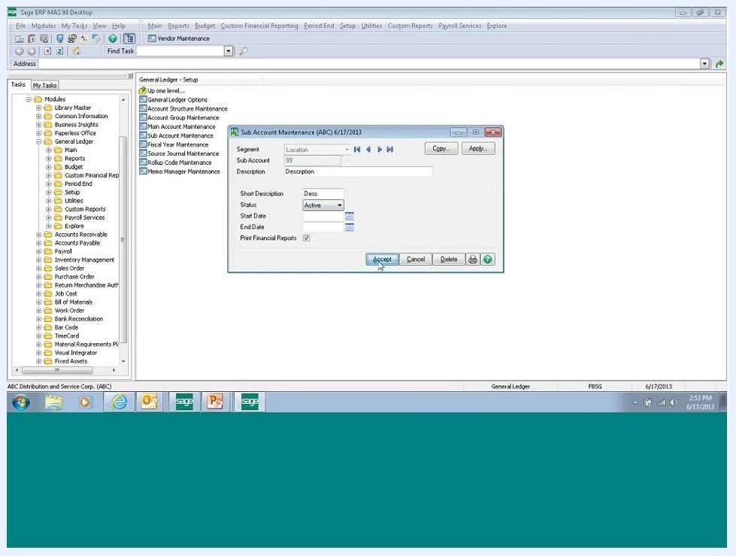
Sage ERP MAS 90 Desktop with the Sub Account Maintenance window open, cursor positioned on the Accept button, and General Ledger and Setup folders expanded

Step 24: Enter the new account number
In the Account No. field, type the full new account number (for example, 999-99-99). The system automatically pulls over the descriptions and settings from your main and sub account setup.
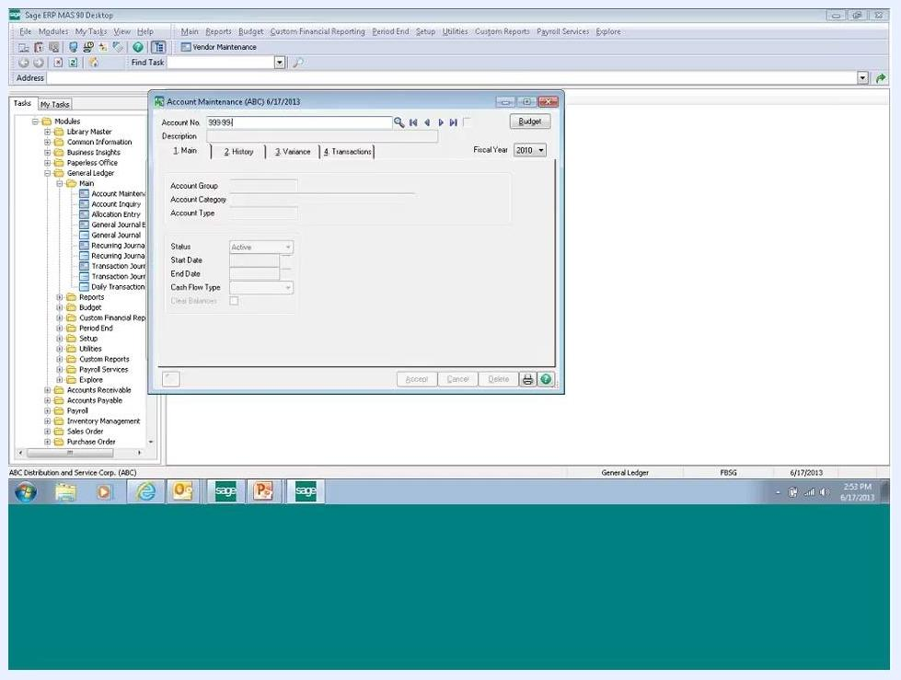
Account Maintenance window with Account No. "999-99-99" entered, Description field blank, and other fields inactive

Step 25: Review and finalize account details
Confirm that the Description field is pre-filled based on your setup, and edit it as needed (for example, change it to "Desc Desc Desc"). Confirm that the Account Group, Account Category, and Account Type fields are correct (for example, Account Group: 990, Account Category: Income Tax, Account Type: Income Tax).
Ensure Status is set to Active, leave Start Date and End Date blank unless this is a temporary account, and set Cash Flow Type as needed (for example, "None"). Click Accept to save the new account.
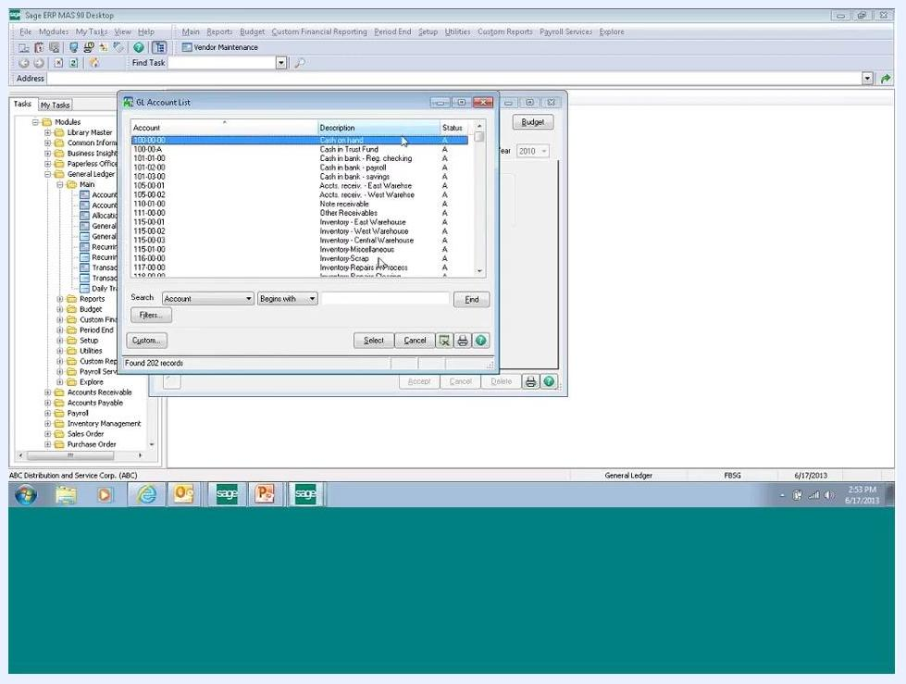
Account Maintenance window with Account No. "999-99-99", Description "Desc Desc Desc", Account Group 990, Account Category "Income Tax", Account Type "Income Tax", Status "Active", and Cash Flow Type "None"

Step 26: Look up the new account to verify it
Click the lookup (magnifying glass) icon next to the Account No. field. In the GL Account List window, set the search to Account and Begins with, enter "9" to filter for accounts beginning with 9, and click Find.
GL Account List window open, displaying accounts beginning with 9, including the newly added account

Step 27: Confirm the new account appears correctly
Verify that your new account number (for example, 999-99-99) and its description appear among the results. Check that the Status column shows "A" for Active.
GL Account List window filtered to accounts beginning with 9, with the new account "999-99-99" and its description visible, status shown as "A"

Summary
By completing these steps, you have successfully added and verified a new GL account and sub account in Sage 100 ERP. Always fill in all required fields and review your entries before saving, and use the lookup feature to confirm that your new account has been created and is active in the system.
Sage 100 ERP Video Series title screen with Faye Business Systems Group logo, topic, contact info, and Windows taskbar

