How to Adjust an AP Invoice in Sage 100
This guide walks you through how to adjust an AP invoice in Sage 100 using Invoice Data Entry. You'll learn how to locate an existing invoice, apply an adjustment amount, update the Accounts Payable Invoice Register, and confirm the change in Vendor Inquiry.

Prerequisites
- Access to the Accounts Payable module in Sage 100.
- The vendor number and invoice number for the invoice you need to adjust.
- The adjustment amount you want to apply to the invoice.

Step 1: Navigate to Invoice Data Entry
Open the Tasks pane in Sage 100, then expand the Modules tab. Click Accounts Payable, open the Main folder, and select Invoice Data Entry.
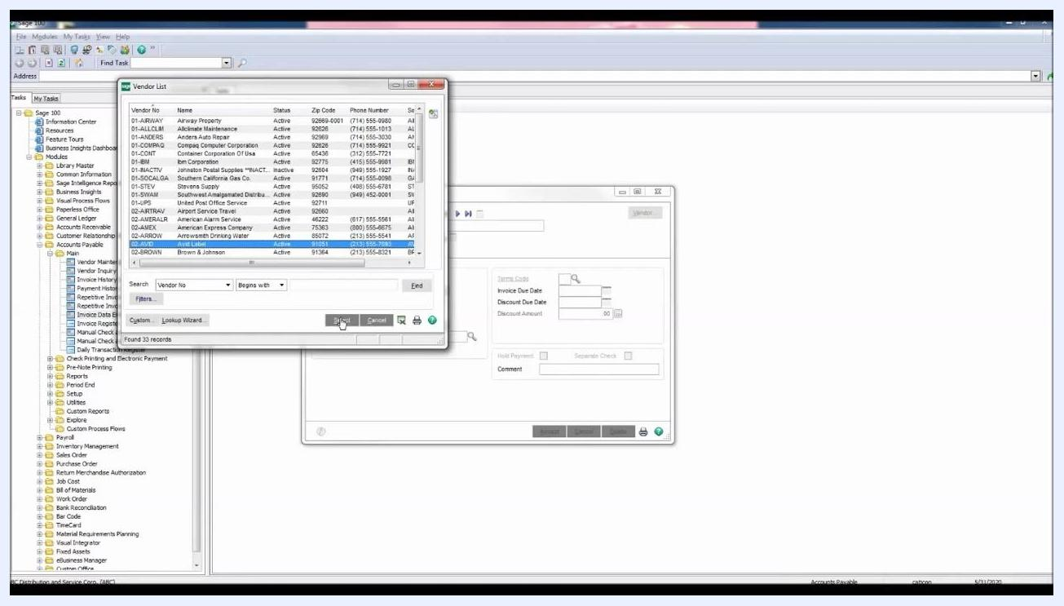
Sage 100 main window with the navigation pane open, the Accounts Payable module expanded, and Invoice Data Entry selected

Step 2: Select the vendor
In the A/P Invoice Data Entry window, click the lookup button next to the Vendor No. field to open the vendor list.
A/P Invoice Data Entry window open and ready for vendor selection
In the Vendor List window, locate and select vendor number 02-AVID for AVID Label, then click Select.
Vendor List window with vendor 02-AVID highlighted and the Select button clicked

Step 3: Enter the invoice number and start the adjustment
Enter the invoice number you want to adjust in the Invoice No. field and press Enter. When the Adjust Invoice on File window appears with a warning that the invoice is already on file, click the Adjust button in the bottom left.
A/P Invoice Data Entry window with the Adjust Invoice on File dialog showing a warning and the Adjust button

Step 4: Enter the adjustment amount
On the Header tab, select the Adjustment Amount field and enter the amount of the adjustment. In this example, the invoice is increased by $27.20.
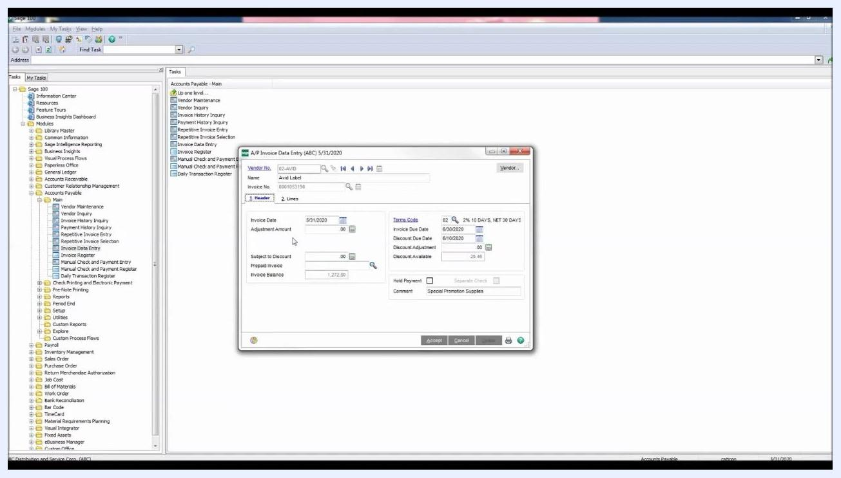
A/P Invoice Data Entry window, Header tab, with the Adjustment Amount field highlighted and $27.20 entered

Step 5: Enter the line details
Click the Lines tab and confirm that the vendor (AVID Label) has a General Ledger (GL) account assigned by default. If you need a different GL account, click the lookup button next to the GL Account field. Check that the Amount field retrieves the adjusted amount from the Header tab; if it does not, enter $27.20 manually.
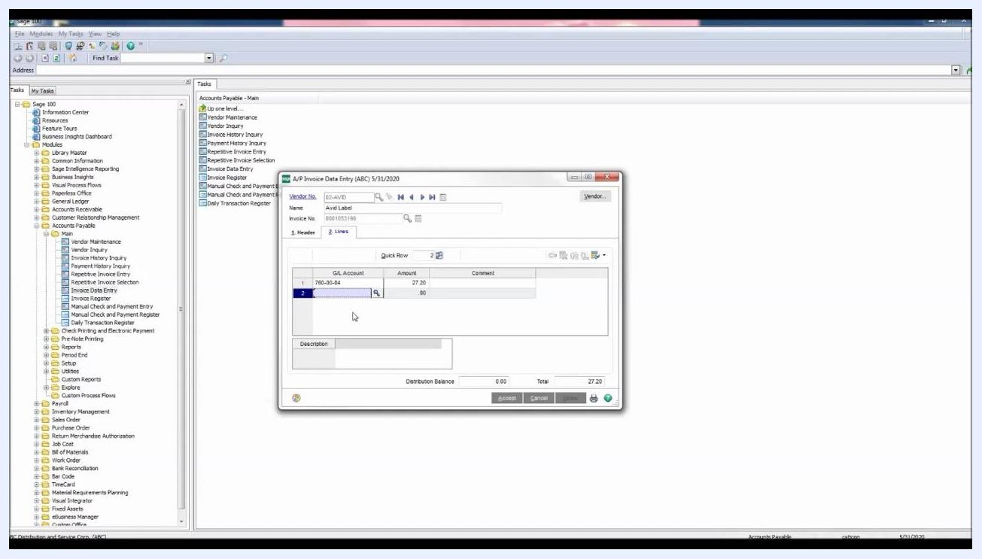
A/P Invoice Data Entry window, Lines tab, with GL Account 760-00-04 and Amount $27.20 entered

Step 6: Verify and accept the invoice adjustment
Carefully review all the information entered in the A/P Invoice Data Entry window. Confirm that the Vendor No. is 02-AVID for AVID Label, the GL Account is 760-00-04, and the Amount is $27.20. Click Accept at the bottom right of the window to save the adjustment.
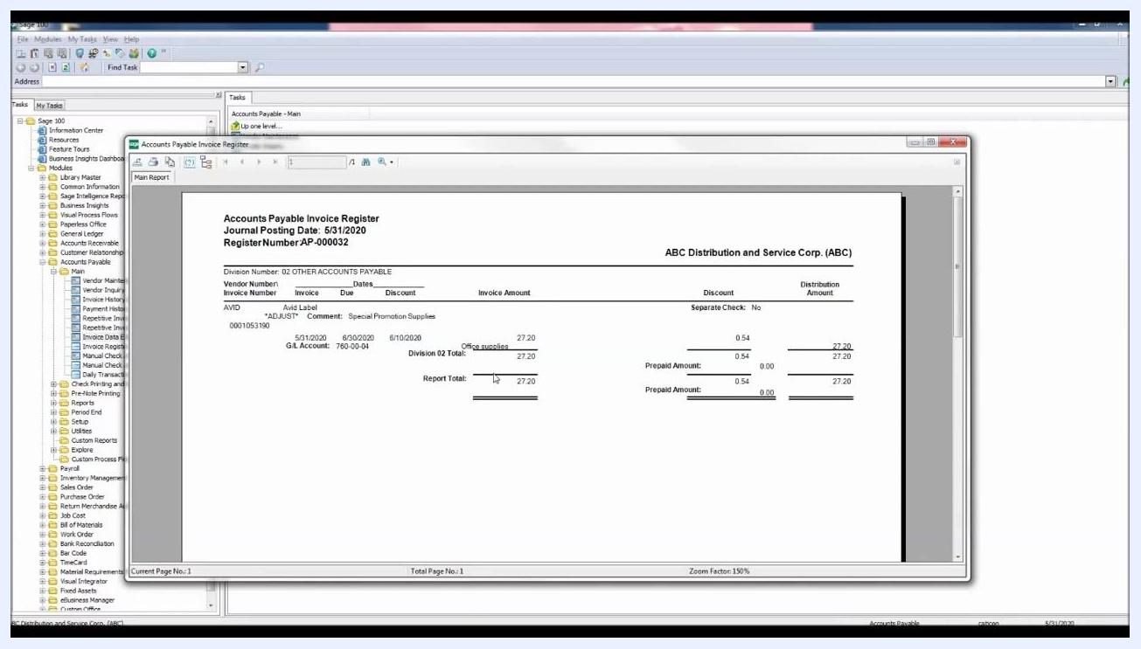
A/P Invoice Data Entry window showing Vendor No. 02-AVID, GL Account 760-00-04, Amount 27.20, and the Accept button highlighted

Step 7: Update the Accounts Payable Invoice Register
Click the printer icon to proceed with updating Accounts Payable. When the Accounts Payable Invoice Register dialog appears, review the Current General Ledger Period (05, ending 5/31/2020) and the Accounts Payable Posting Date (5/31/2020). Choose whether to print or preview the register; in this example, click Preview.
Accounts Payable Invoice Register dialog with the Preview button selected

Step 8: Review the Accounts Payable Invoice Register report
Review the Accounts Payable Invoice Register report that appears. Verify that the word ADJUST appears under the vendor number, confirming the adjustment, and that the adjusted amount of $27.20 is displayed for the invoice. Check that the Division and Report Totals reflect the adjustment.
Accounts Payable Invoice Register report showing Vendor Number 02-AVID, the ADJUST label, and the adjusted amount of $27.20

Step 9: Review the Recap by Division report
In the same report window, review the Recap by Division section. Confirm that the debits and credits shown for the adjustment match the adjustment amount.
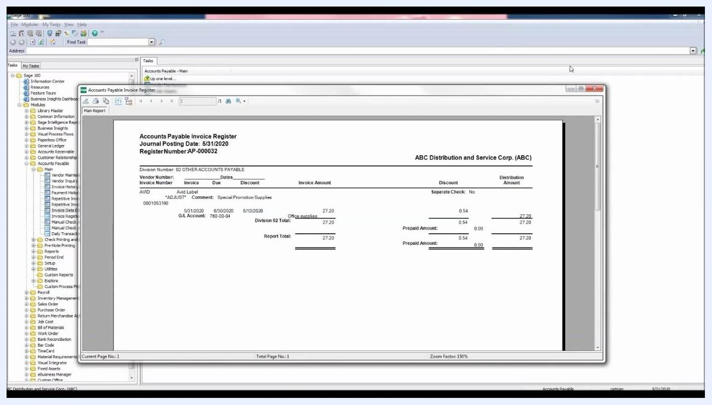
Accounts Payable Invoice Register report with the Recap by Division section showing debits and credits for the adjustment

Step 10: Finalize the update
When prompted to update the Invoice Register, click Yes. Wait for the Update in Progress bar to complete, which confirms that the adjustment has been posted.
Accounts Payable Invoice Register dialog with the Update in Progress bar

Step 11: Verify the adjustment in Vendor Inquiry
Go to the Main folder in the navigation pane and select Vendor Inquiry. In the Vendor List window, locate and select vendor number 02-AVID for AVID Label, then click Select.
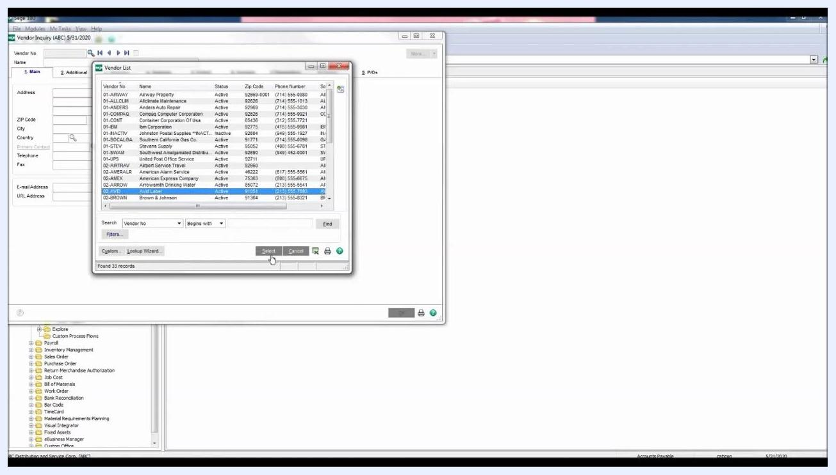
Vendor List window with 02-AVID selected and the Select button highlighted
In the Vendor Inquiry window, click the Invoices tab and locate the invoice you adjusted (Invoice No. 0001053190) at the top of the list. In the lower window, verify that the transaction type is Adjustment, the amount is $27.20, and the current balance is $1,375.00.
Vendor Inquiry window, Invoices tab, showing invoice 0001053190 with transaction type Adjustment, amount $27.20, and current balance $1,375.00

Summary
You have now adjusted an AP invoice in Sage 100 by entering an adjustment amount in Invoice Data Entry, updating the Accounts Payable Invoice Register, and confirming the adjustment in Vendor Inquiry. This process ensures that the invoice amount, GL account, and vendor balance all reflect the change accurately.

