How to Use an Emergency Eyewash Station
Eye injuries are one of the most common workplace incidents, with approximately 2,000 U.S. workers requiring medical treatment for job-related eye injuries every day. Ninety percent of these injuries could be prevented by wearing appropriate eye protection, and knowing how to use an emergency eyewash station correctly can prevent injury, reduce its severity, or even save your eyesight. This document explains when and how to use an emergency eyewash station if a hazardous substance or object contacts your eyes.
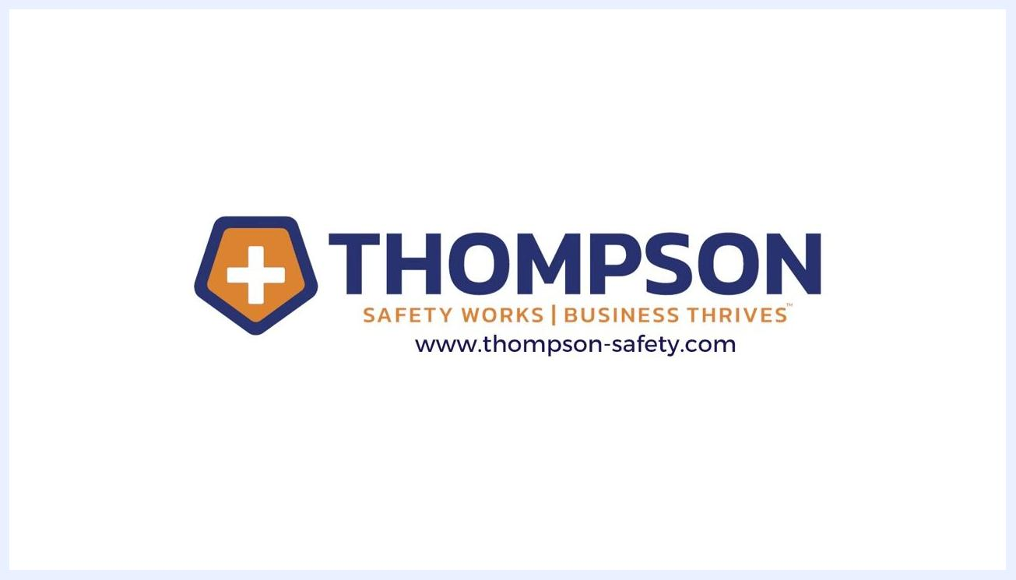
Circular infographic showing that 90% of eye injuries could be prevented by wearing appropriate eye protection, displayed with a green ring and bold text
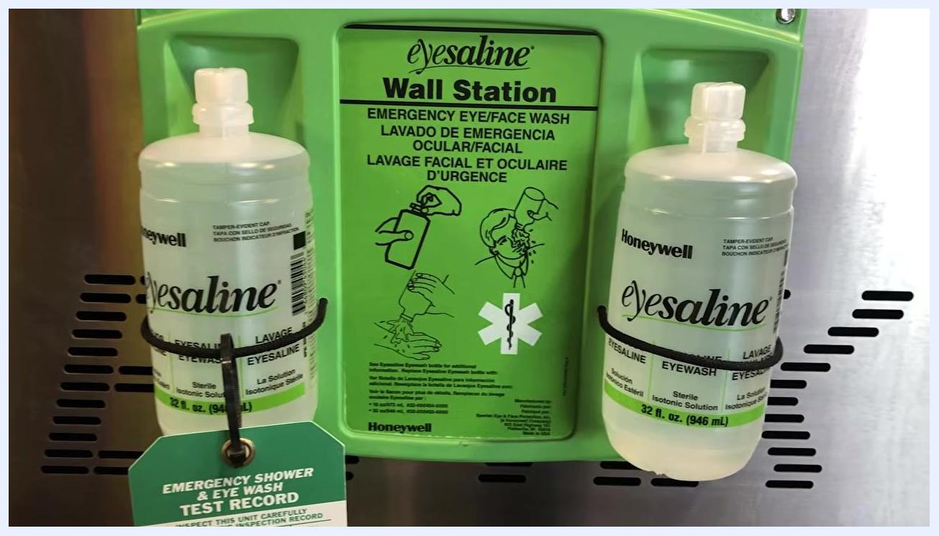
A woman stands next to a green and yellow wall-mounted emergency eyewash station, summarizing the importance of eye safety and injury prevention.

Purpose
This procedure describes the correct steps for using an emergency eyewash station to flush your eyes after exposure to a contaminant, chemical, or foreign object, minimizing the risk of scratches, abrasions, irritation, or permanent injury.

Scope
This procedure applies to any worker who is exposed to potential eye hazards on the job and needs to respond to an eye contamination incident using a workplace emergency eyewash station.

Required equipment and PPE
- Appropriate eye protection selected for the specific hazards of your job, worn at all times when exposed to potential hazards
- A workplace emergency eyewash station (wall-mounted units may vary in model, but basic operating instructions are generally the same)

Step 1: Recognize the need for immediate action
If you get something in your eye, proceed immediately to the nearest eyewash station. Do not delay treatment, even if the contaminant seems minor, such as a piece of sawdust. Immediate flushing can prevent scratches, abrasions, and irritation.
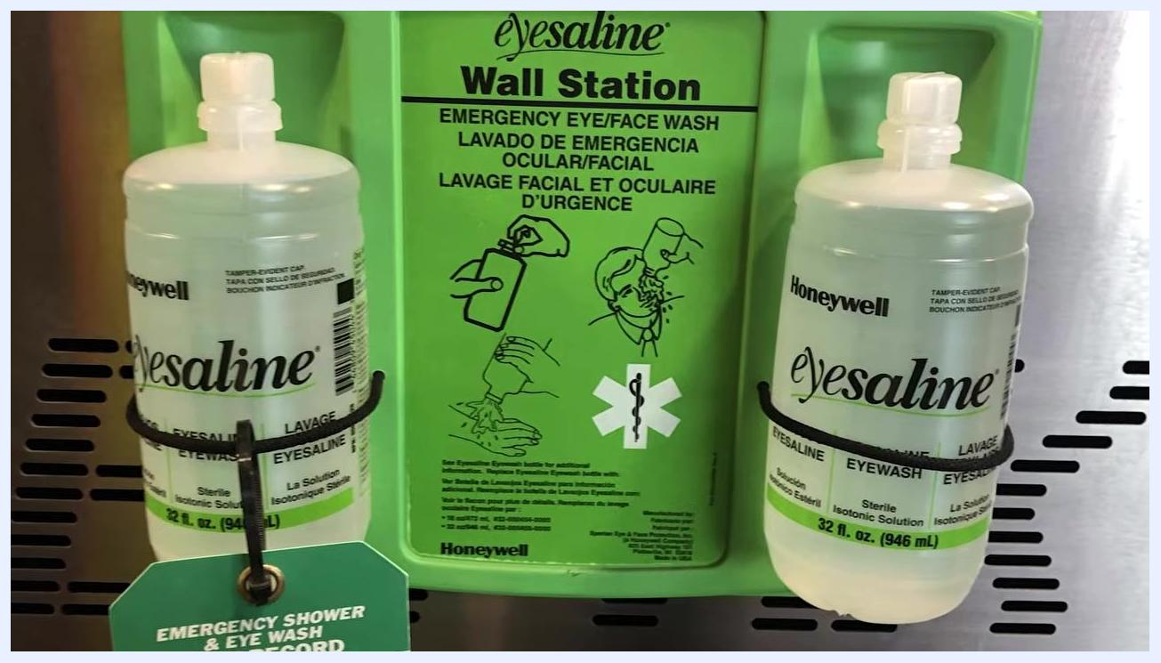
Green emergency eyewash station mounted on a white wall in an industrial facility, with yellow safety railings and clear signage above the station

Step 2: Locate the nearest eyewash station
Emergency eyewash stations are typically mounted on walls in accessible areas and clearly marked with signage. Familiarize yourself with the nearest station before an emergency occurs, since your vision may be impaired when you need to use it.
A woman stands next to a wall-mounted emergency eyewash station, which is green and yellow with clear instructional labels. The station is ready for use and the environment is clean and well-lit.

Step 3: Identify the eyewash solution
Some stations use bottles of sterile isotonic solution for emergency eye and face washing. These bottles are typically found in wall-mounted units and are clearly labeled for emergency use, with illustrated instructions on the station itself.
Close-up of a wall-mounted station with two bottles of sterile isotonic solution, labeled for emergency eye and face wash, with illustrated instructions

Step 4: Aim the water stream correctly
If only one eye is affected, aim the stream of water directly onto your forehead or over the affected eye. If both eyes are affected, direct the stream onto the bridge of your nose so water flows into both eyes. Ensure the water is flowing before positioning your face over the stream.
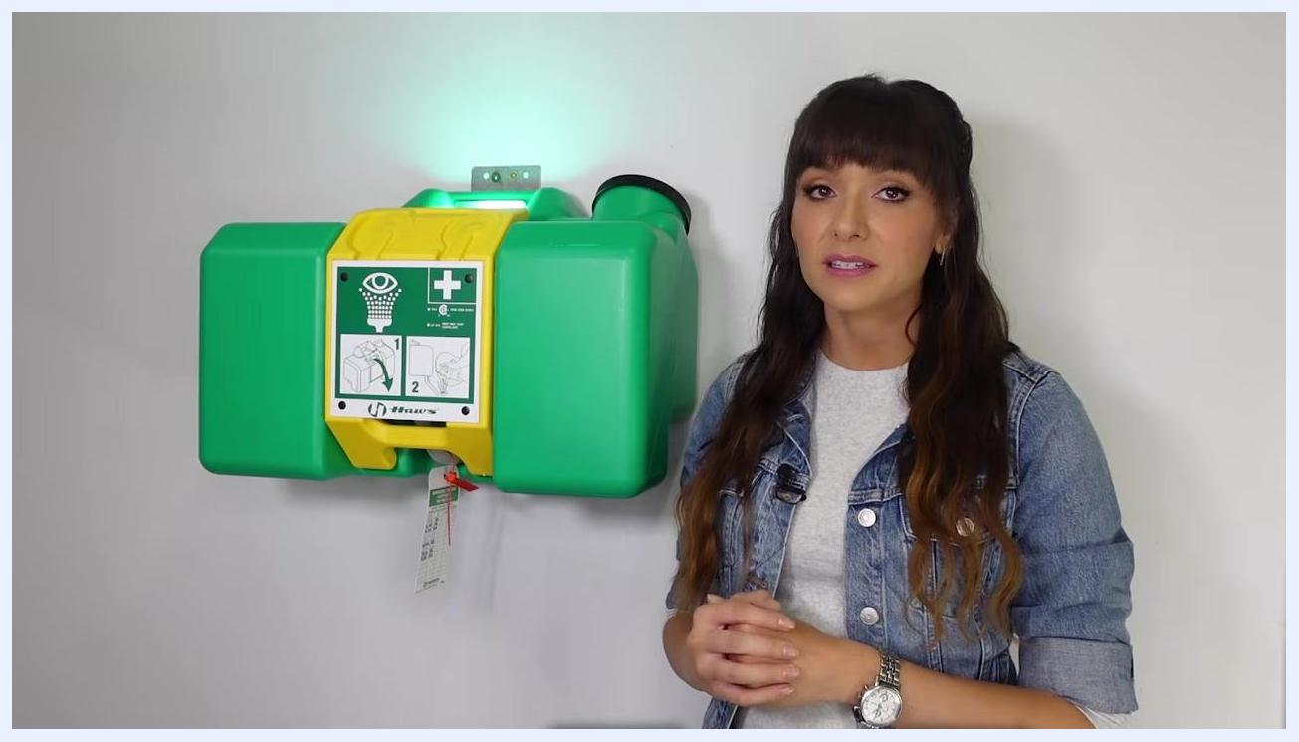
Close-up of a yellow emergency eyewash station in operation, with two streams of water spraying upward from green nozzles

Step 5: Hold your eyelids open and flush thoroughly
Use your fingers to hold your eyelids open so water can reach all surfaces of the eye. Let the water flow freely, and roll your eyes in all directions to ensure the water washes all surfaces and gets under the eyelids.
A person holding their eyelids open with their fingers while flushing an eye with water from an emergency eyewash station

Step 6: Remove contact lenses if worn
If you wear contact lenses, wash your hands first if possible. Carefully remove the lenses during the flushing process to prevent contaminants from being trapped behind them, then continue flushing your eyes after removal.
Close-up of a wall-mounted station with two bottles of sterile isotonic solution and a visible test record tag confirming the station has been checked

Step 7: Avoid rubbing your eyes
Do not rub your eyes or attempt to dislodge an object manually. Doing so can increase the risk of scratches or further injury.

Step 8: Flush for the recommended duration
If you were exposed to a chemical, continue flushing your eyes for a full 15 minutes to ensure the pH is neutralized. Fifteen minutes may feel like a long time, but it is necessary for effective decontamination.

Step 9: Seek medical attention if needed
After flushing, seek medical attention as soon as possible if irritation, pain, or vision problems persist.

Additional safety notes
- Note the location of every eyewash station in your workplace ahead of time. Emergency vision impairment makes prior knowledge critical, and stations should include a visible test record tag confirming they are maintained and ready for use.
- Always wear the proper eye protection for your job before beginning work.
- Use an emergency eyewash station immediately at the first sign of a chemical or substance in your eye to drastically reduce the risk of serious injury.
A woman stands next to a green and yellow wall-mounted emergency eyewash station, explaining the importance of seeking medical attention after using the station. The environment is clean and well-lit.

Verification and summary
Confirm that you have flushed both eyes for the appropriate duration, removed any contact lenses, avoided rubbing your eyes, and sought medical attention if irritation, pain, or vision problems persist. By following this procedure and wearing proper protective equipment, you help ensure you do not become one of the 2,000 people who suffer a workplace eye injury each day.
A woman stands next to a green and yellow wall-mounted emergency eyewash station, emphasizing the importance of using eyewash stations and proper eye protection.
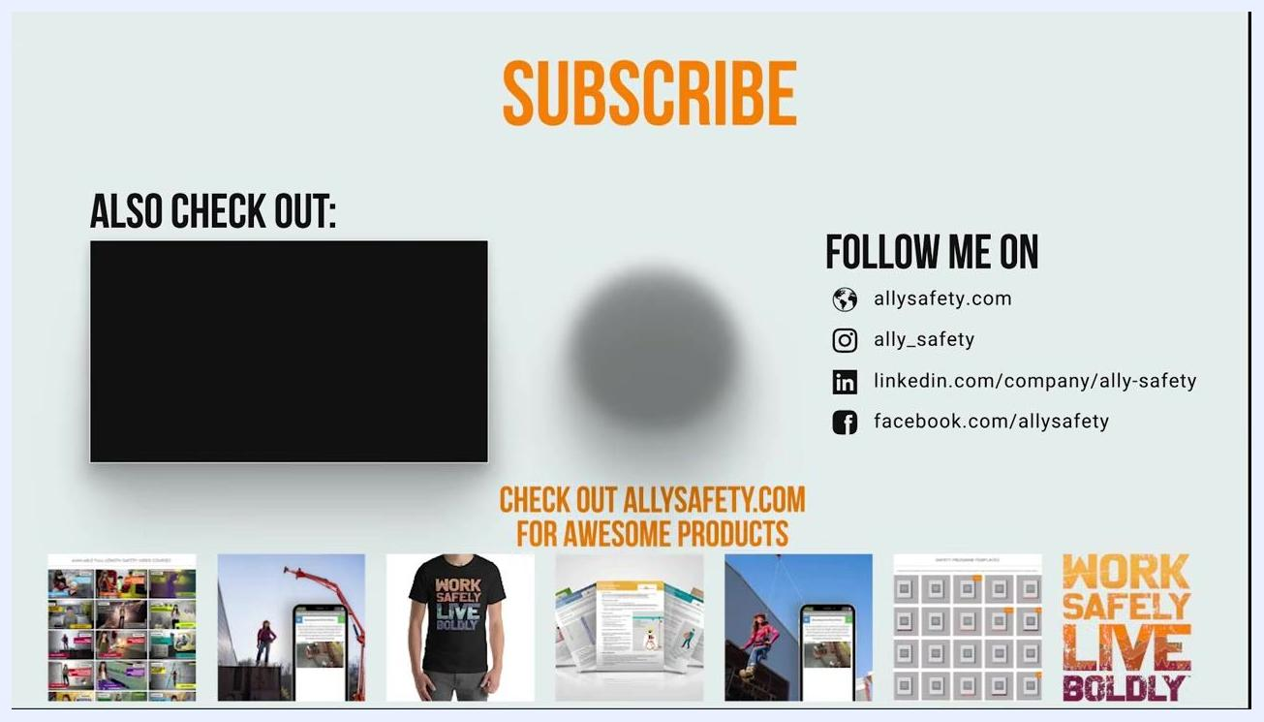
End screen with "SUBSCRIBE" in large orange text at the top center, a black video placeholder labeled "ALSO CHECK OUT:" on the left, social media and website links on the right, and a row of product/content images at the bottom.

