SOP: Fire Extinguisher Use During a House Fire Emergency

Purpose
This document provides standard operating guidance for safely and effectively using a fire extinguisher during a house fire emergency. It is based on expert demonstrations and observed common mistakes, and it is intended to help homeowners respond quickly and correctly when a fire occurs.

Scope
This procedure applies to any resident or occupant who may need to respond to a small, contained house fire using a portable fire extinguisher. It covers fire awareness, common mistakes to avoid, proper extinguisher technique, and decision-making about when to fight a fire versus when to evacuate.

Background and Risk Awareness
Before outlining the procedure, it is important to understand the context of fire risk:
- Approximately 1,000 house fires occur in the country every day.
- Fires can be caused by lightning, summer grills, and other common sources.
- FEMA warns that most people who believe they know how to use a fire extinguisher actually do not.
- Fire doubles in size every 60 seconds, so any delay in response significantly increases danger and damage.

Required equipment
- A portable fire extinguisher, in working condition and accessible
- A phone to call 911
- A clear, unobstructed escape route

Common mistakes to avoid
Real-life demonstrations, including tests where homeowners believed they were participating in a family fire drill but were actually being evaluated on extinguisher use, revealed the following common errors:
- Taking too long to pull the pin, which delays the response.
- Standing too far from the flames, which renders the extinguisher ineffective.
- Taking your eyes off the fire while operating the extinguisher.
Safety Note: If you are unable to operate the extinguisher effectively, prioritize evacuating the area immediately rather than continuing to attempt extinguishment.
The image below illustrates the difficulty of this situation: a homeowner attempting to control a rapidly growing fire.
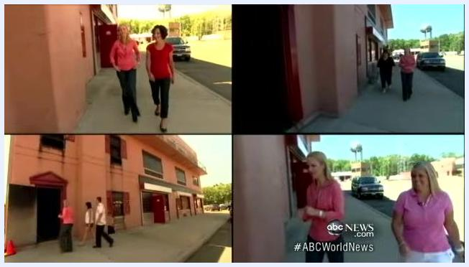
A woman in a red shirt attempts to use a fire extinguisher on a large, rapidly growing fire on a couch in a controlled indoor environment. The flames are intense and the extinguisher is being used from a distance. The setting is a fire safety demonstration.

Procedure

Step 1: Assign roles immediately upon discovering a fire
- Designate one person to call 911 immediately to alert emergency services.
- Designate a second person to operate the fire extinguisher only if it is safe to do so.
Safety Note: Always call 911 as soon as a fire is discovered, regardless of whether you plan to fight it yourself.

Step 2: Assess whether the fire is safe to fight
- Confirm the fire is small, contained, and still in its very early stages.
- Confirm you have a clear, unobstructed escape route before attempting to use the extinguisher.
- If the fire is no longer in its early stages, is growing rapidly, or you are unsure, do not attempt to fight it. Evacuate immediately.

Step 3: Apply the PASS method to operate the extinguisher
Follow the PASS method in sequence:
- P – Pull the pin to unlock the extinguisher.
- A – Aim the nozzle directly at the base of the flames, not at the top of the fire.
- S – Squeeze the trigger/handle to release the extinguishing agent.
- S – Sweep the nozzle from side to side to cover the entire area of the fire.
The image below demonstrates a fire safety instructor correctly performing the PASS method.
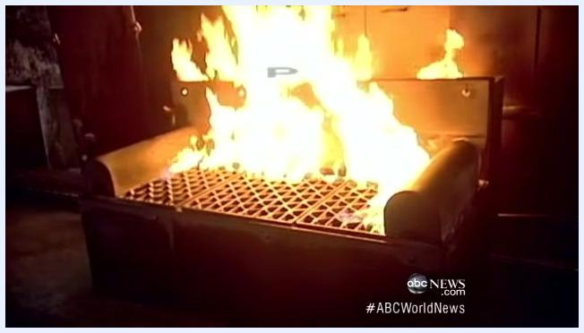
A firefighter in uniform demonstrates the PASS method by aiming and discharging a fire extinguisher at the base of a fire in a smoke-filled room. The extinguisher is actively spraying, and the environment shows visible smoke. Two chairs are visible in the background.
Verification: When the PASS method is performed correctly, the fire can be successfully extinguished. Confirm the flames are fully out before leaving the area.

Step 4: Evacuate if the fire cannot be controlled
- If the fire is too large, spreading quickly, or beyond your ability to control, stop attempting to extinguish it.
- Leave the area immediately and move toward a clear, illuminated exit.
- Wait outside for professional firefighters to arrive.
The image below shows the correct evacuation response when a fire is beyond control.
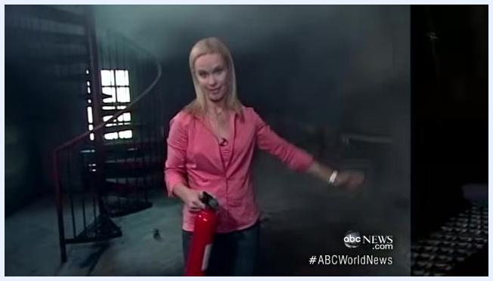
Two people are seen from behind walking out of a smoke-filled room toward a bright exit, illustrating evacuation during a fire emergency. The environment is hazy with smoke, and the exit is clearly illuminated.
Safety Note: Fire safety professionals, including those from the Bergen County Fire Academy, emphasize the importance of learning how to use a fire extinguisher before an emergency occurs, not during one.

Summary of key actions
- Familiarize yourself with your fire extinguisher's operation before an emergency happens.
- Assign one person to call 911 and another to operate the extinguisher, if safe.
- Use the PASS method: Pull, Aim, Squeeze, Sweep.
- Only attempt to extinguish very small, contained fires with a clear escape route available.
- Evacuate immediately if the fire grows, spreads rapidly, or you feel unsafe.
- Never take your eyes off the fire while operating the extinguisher, and do not stand too far from the flames.
- Always prioritize personal safety over property, and call for professional help without delay.

