How to Read a Safety Data Sheet (SDS)

Purpose
This procedure explains how to read a Safety Data Sheet (SDS) so you can safely identify, handle, store, and dispose of laboratory chemicals. Using isopropyl alcohol as a working example, this guide walks through every major SDS section so you know exactly what information to look for and how to apply it before working with any chemical.

Scope
This procedure applies to any chemical you plan to use in the laboratory. All Safety Data Sheets follow the same standardized 16-section format, so the steps below can be applied to any SDS, regardless of the specific chemical involved.

Required equipment and PPE
Before handling the chemical described on the SDS, gather the following:
- The Safety Data Sheet matching the exact chemical name on your container
- Protective gloves
- Protective clothing
- Eye protection
- Access to a fume hood or well-ventilated area

Procedure

1. Confirm you have the correct SDS
Always consult the Safety Data Sheet before working with any chemical. Locate the SDS for the specific substance you are using — for example, isopropyl alcohol, a common household chemical found in first aid kits for treating minor scrapes and wounds. Confirm that the chemical name on the SDS matches the name printed on your container.

2. Identify the chemical and manufacturer (Section 1)
Check that the SDS opens with chemical identification details, including the chemical name, manufacturer name and address, and an emergency phone number. For isopropyl alcohol, this section lists the chemical name as Isopropyl Alcohol, the manufacturer as Flinn Scientific, Inc., P.O. Box 219, Batavia, IL 60510, and an emergency phone number of (800) 424-9300.
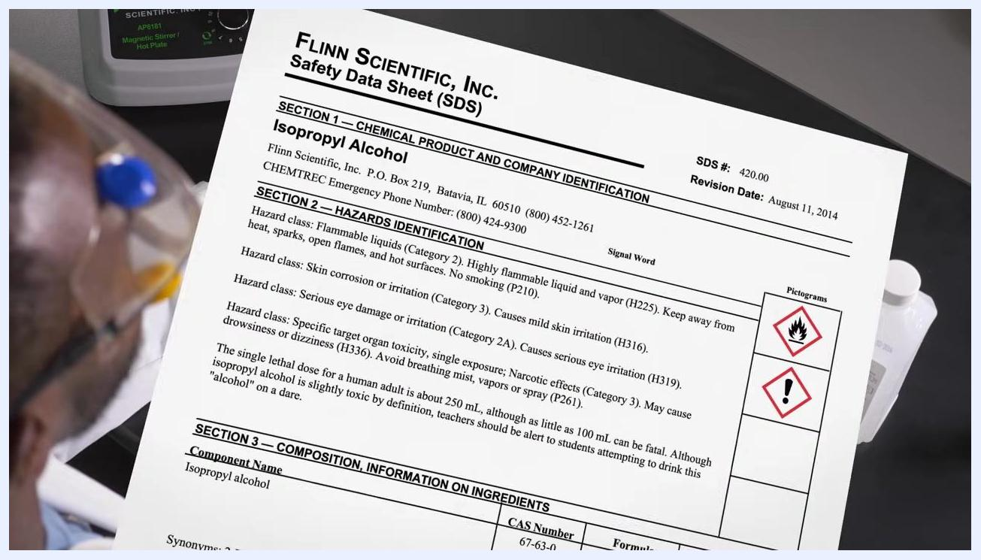
Close-up view of an SDS with the chemical name, manufacturer, and emergency contact information highlighted

3. Review the hazard identification section (Section 2)
Locate Section 2, which details the hazards associated with the chemical. Hazards are identified in three ways: a signal word, pictograms, and hazard classes with statements. For isopropyl alcohol, this includes the signal word "DANGER," flame and exclamation mark pictograms, and statements such as highly flammable liquid and vapor (H225), causes mild skin irritation (H316), causes serious eye irritation (H319), and may cause drowsiness or dizziness (H336).
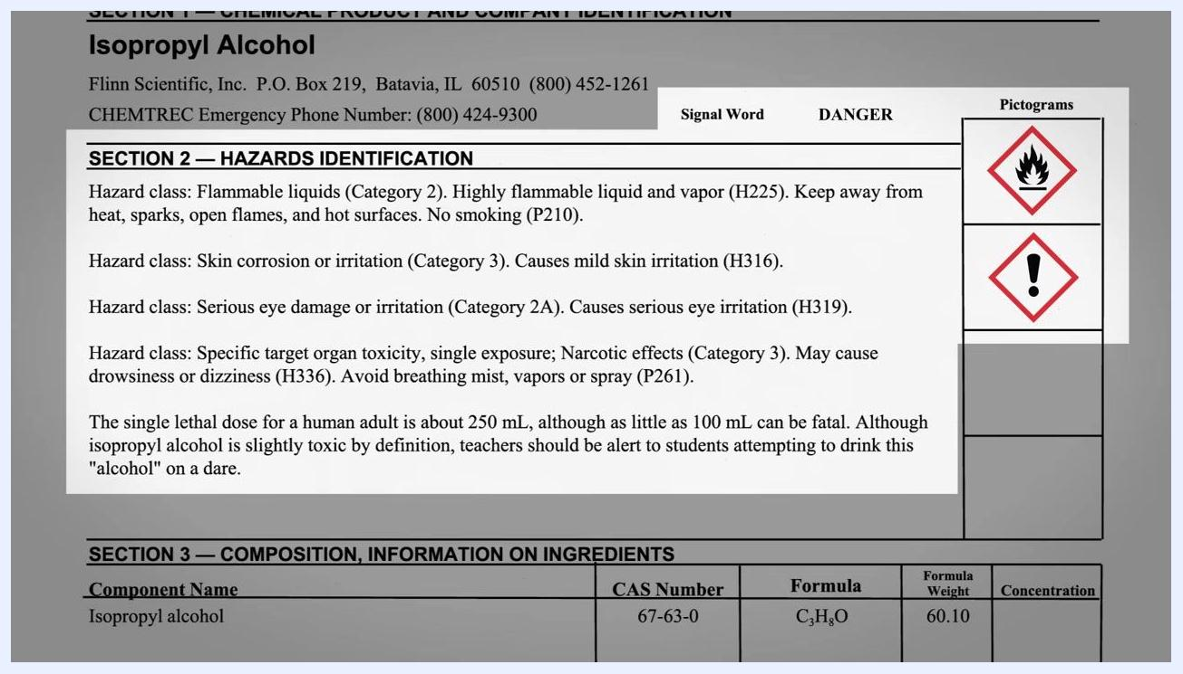
SDS section displaying hazard classes, the signal word "DANGER," and pictograms for isopropyl alcohol
Safety note: Precautionary statements accompanying these hazards include avoiding breathing mist, vapors, or spray (P261) and prohibiting smoking near the chemical (P210).

4. Interpret the signal word
Identify the signal word on the SDS to gauge the level of hazard. "DANGER" indicates a highly hazardous chemical, while "WARNING" indicates a less hazardous one. Non-hazardous chemicals may carry no signal word at all.
SDS excerpt with the "Signal Word: DANGER" field highlighted

5. Recognize the pictograms
Learn to identify the pictograms shown on the SDS, as each one represents a specific type of hazard. For isopropyl alcohol, the flame pictogram indicates flammability and the exclamation mark indicates irritation or other hazards.
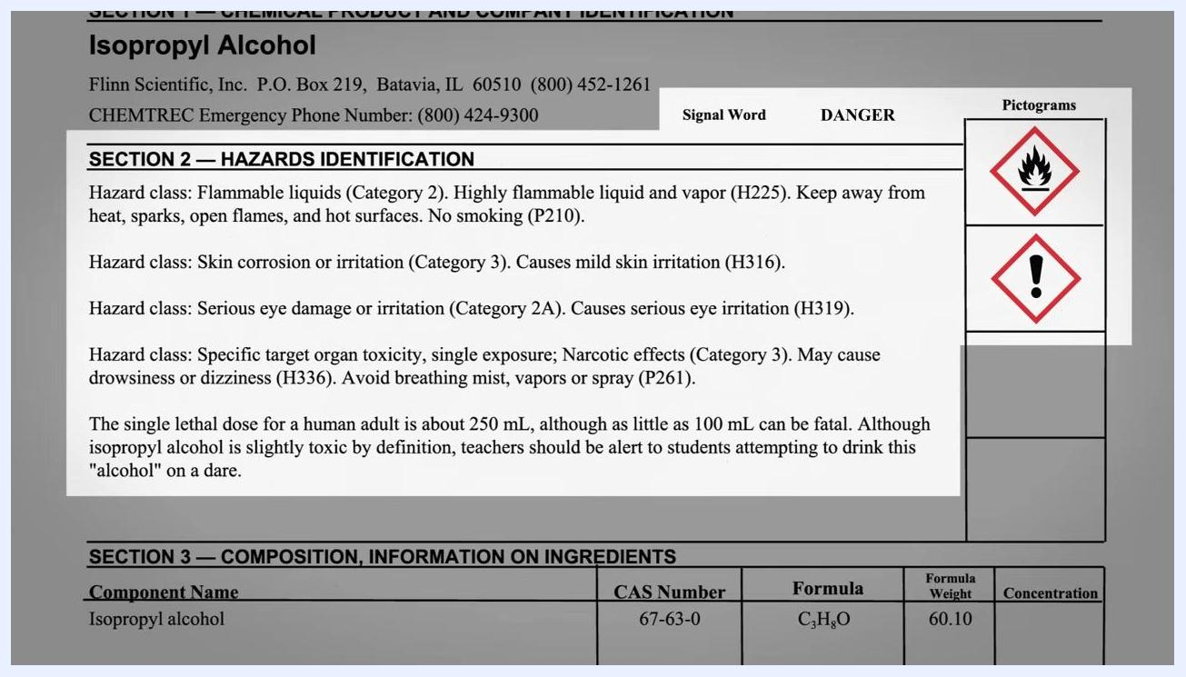
SDS section showing pictograms for flammability and irritation

6. Reference the full set of standard pictograms
There are nine standard pictograms used across all SDS documents to describe possible chemical hazards. Review the full set to build broader chemical safety awareness, even though only some pictograms apply to any given chemical.
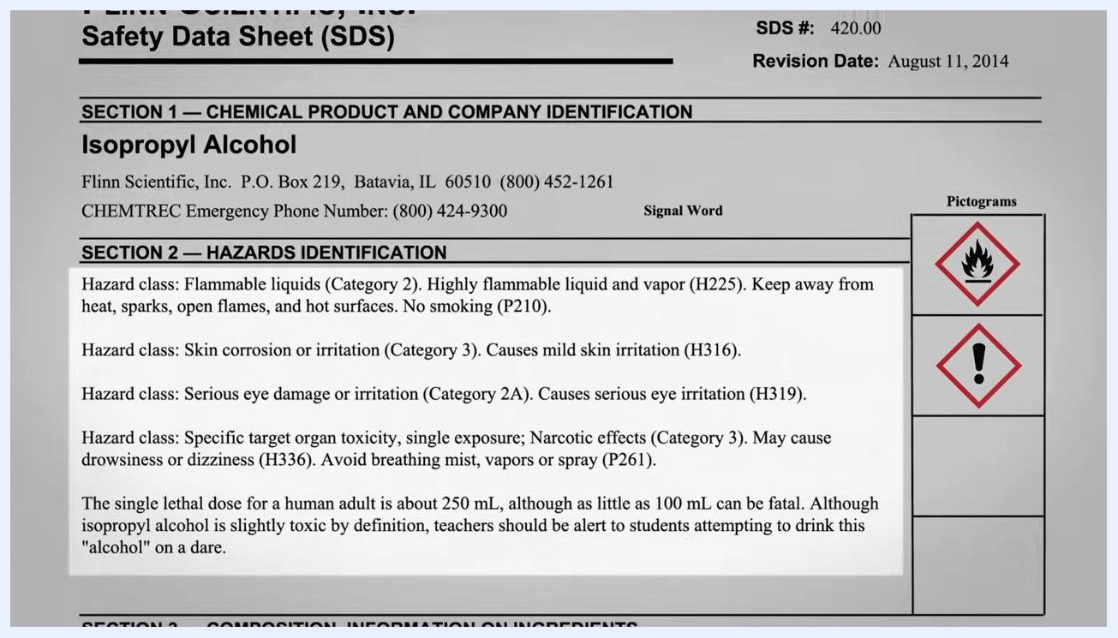
Grid of the nine standard hazard pictograms, including flame, exclamation mark, gas cylinder, corrosion, and skull and crossbones

7. Match pictograms to specific hazard text
Confirm what each pictogram means by reading the accompanying hazard text. For isopropyl alcohol, the flame pictogram is paired with the statement "Isopropyl alcohol will burn," and the exclamation mark pictogram is paired with "Other potential hazards."
SDS text stating "Isopropyl alcohol will burn" next to the flame pictogram, and "Other potential hazards" next to the exclamation mark pictogram, both highlighted

8. Review the principal hazards in detail
Read through each hazard statement listed for the chemical. For isopropyl alcohol, this includes: highly flammable liquid and vapor (H225, keep away from heat, sparks, open flames, and hot surfaces, no smoking — P210); mild skin irritation (H316); serious eye irritation (H319); and drowsiness or dizziness (H336, avoid breathing mist, vapors, or spray — P261).
SDS section listing detailed hazard classes for isopropyl alcohol, covering flammability, skin and eye irritation, and narcotic effects
Safety note: Ingestion of isopropyl alcohol can be fatal. Do not confuse it with ethanol.

9. Check the hazard category ratings
Review the specific hazard categories assigned to the chemical. For isopropyl alcohol: Flammable Liquid Category 2; Skin Corrosion/Irritation Category 3 (mild irritation); Serious Eye Damage/Irritation Category 2A; and Specific Target Organ Toxicity (Single Exposure) Category 3 (drowsiness or dizziness). These categories may be highlighted on the SDS for emphasis.
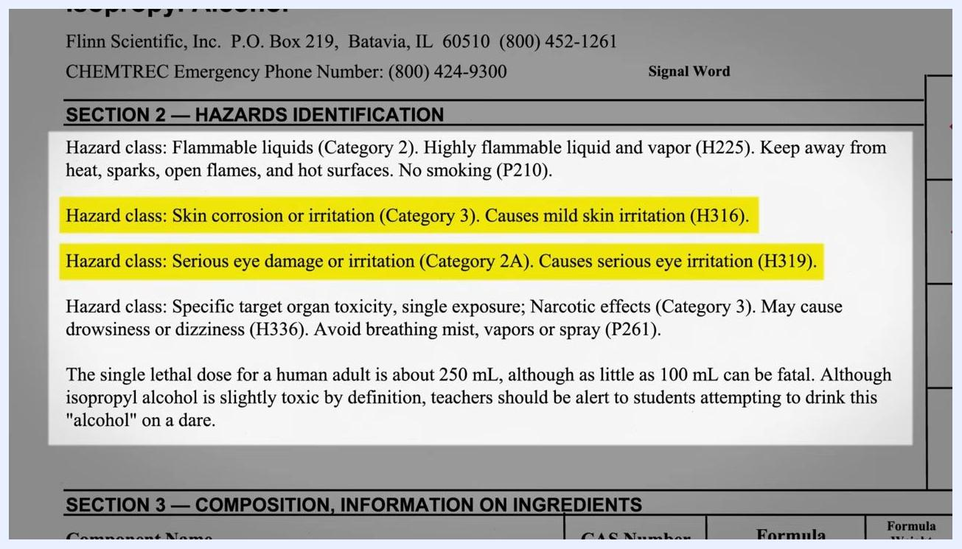
SDS hazard identification section with skin and eye irritation hazard classes highlighted in yellow
Safety note: The single lethal dose for a human adult is approximately 250 mL, with as little as 100 mL potentially fatal. Isopropyl alcohol is classified as slightly toxic. Supervisors should remain alert to the risk of anyone attempting to drink it.

10. Locate composition information (Section 3)
Check Section 3 for the chemical formula, CAS number, molecular weight, and synonyms. For isopropyl alcohol: Component Name — Isopropyl alcohol; CAS Number — 67-63-0; Formula — C₃H₈O; Formula Weight — 60.10; Synonyms — 2-Propanol, Rubbing alcohol.
SDS section listing composition and ingredient information, including CAS number, formula, and synonyms

11. Follow first aid measures (Section 4)
Locate the first aid instructions for each exposure route:
- If inhaled: Remove the person to fresh air and keep at rest in a comfortable position for breathing (P304+P340).
- If in eyes: Rinse cautiously with water for several minutes. Remove contact lenses if present and easy to do so, then continue rinsing. Seek medical advice if irritation persists (P305+P351+P338, P337+P313).
- If on skin or hair: Immediately remove contaminated clothing and rinse skin with water (P303+P361+P353). Seek medical advice if irritation occurs (P332+P313).
- If feeling unwell: Call a poison center or physician (P312).
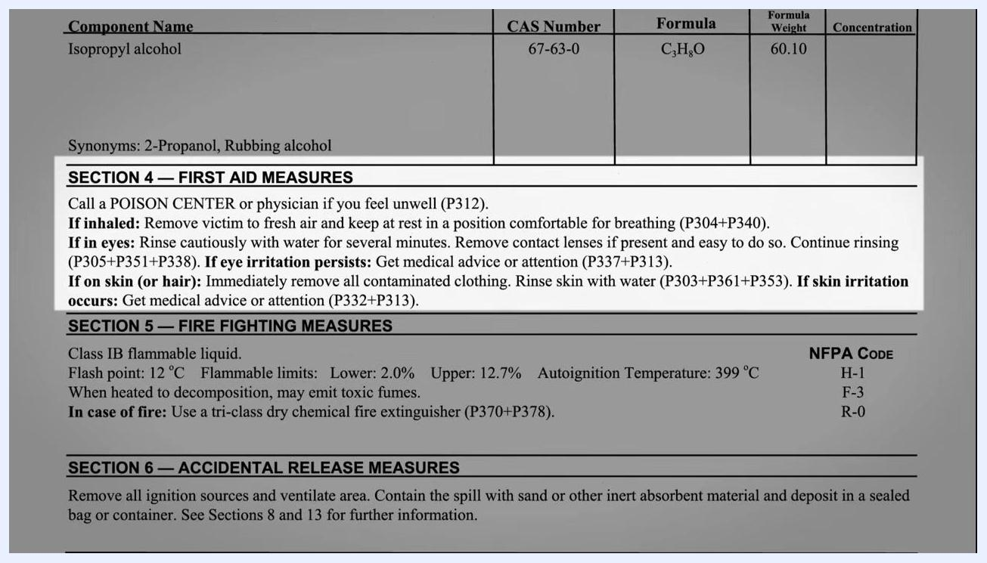
SDS section showing first aid measures for inhalation, eye, and skin exposure highlighted in yellow
Safety note: These first aid measures are written as standard precautionary statements and reinforce familiar laboratory safety practices, such as using an eye wash station or safety shower when needed.

12. Follow handling and storage guidance (Section 7)
Locate Section 7 and store the chemical according to the guidance provided. For isopropyl alcohol: store following the Flinn Suggested Chemical Storage Pattern Organic #2, with compatible chemicals such as alcohols, glycols, amines, and amides. Place the container in a dedicated flammables cabinet, or use a Flinn Saf-Stor™ can if one is unavailable. Keep the container tightly closed (P233) and keep it cool (P235). Use only in a hood or well-ventilated area (P271), and avoid prolonged storage.
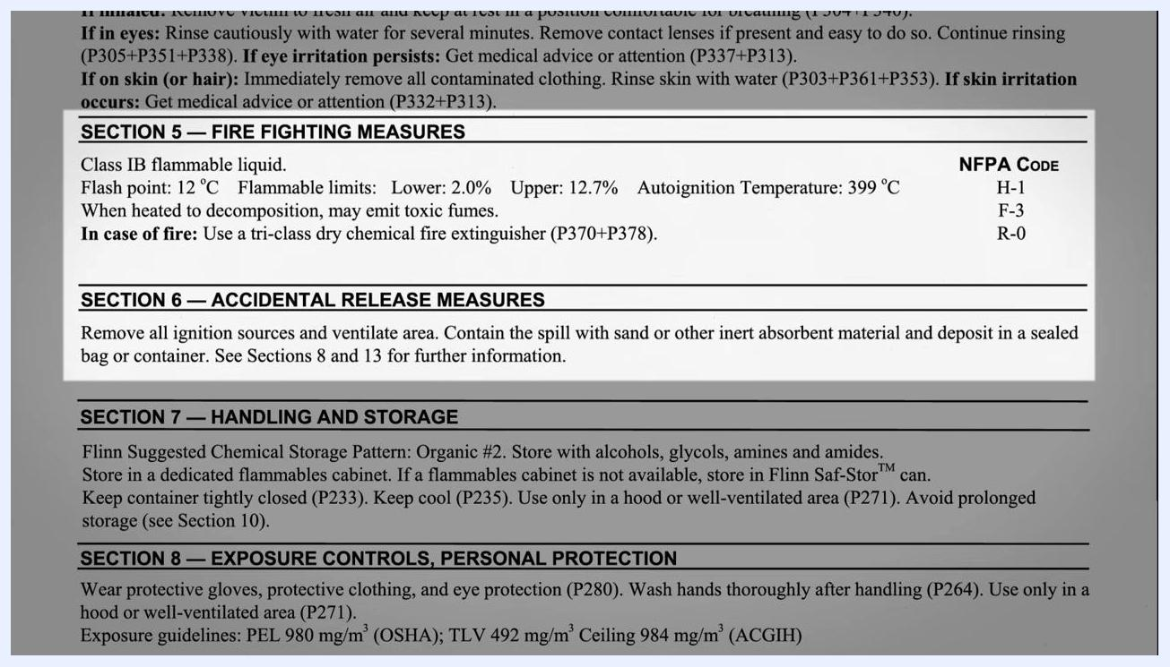
SDS Section 7 showing storage pattern, compatible chemicals, flammables cabinet requirement, and storage precautions

13. Apply exposure controls and PPE (Section 8)
Locate Section 8 for personal protection requirements. Wear protective gloves, protective clothing, and eye protection (P280). Wash hands thoroughly after handling (P264), and use only in a hood or well-ventilated area (P271). For isopropyl alcohol, exposure limits are: PEL 980 mg/m³ (OSHA), TLV 492 mg/m³, and Ceiling 984 mg/m³ (ACGIH).
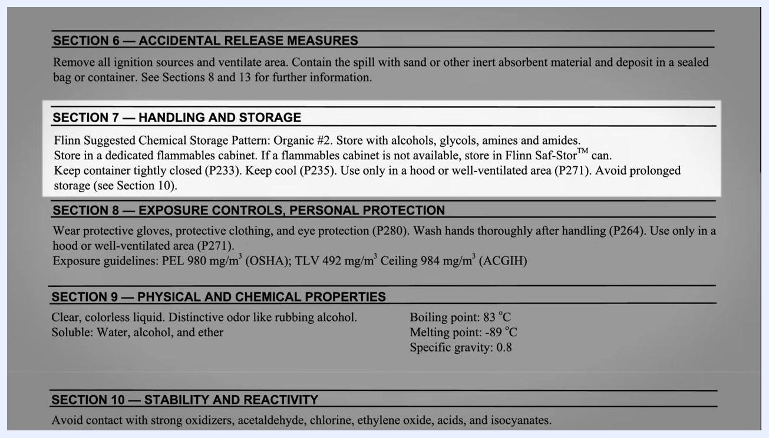
SDS Section 8 showing PPE requirements, hand-washing instructions, ventilation requirements, and exposure limits

14. Reference physical and chemical properties (Section 9)
Check Section 9 for physical properties useful for lab reports or presentations. For isopropyl alcohol: appearance is a clear, colorless liquid; odor is distinctive, like rubbing alcohol; solubility is water, alcohol, and ether; boiling point is 83°C; melting point is -89°C; specific gravity is 0.8.
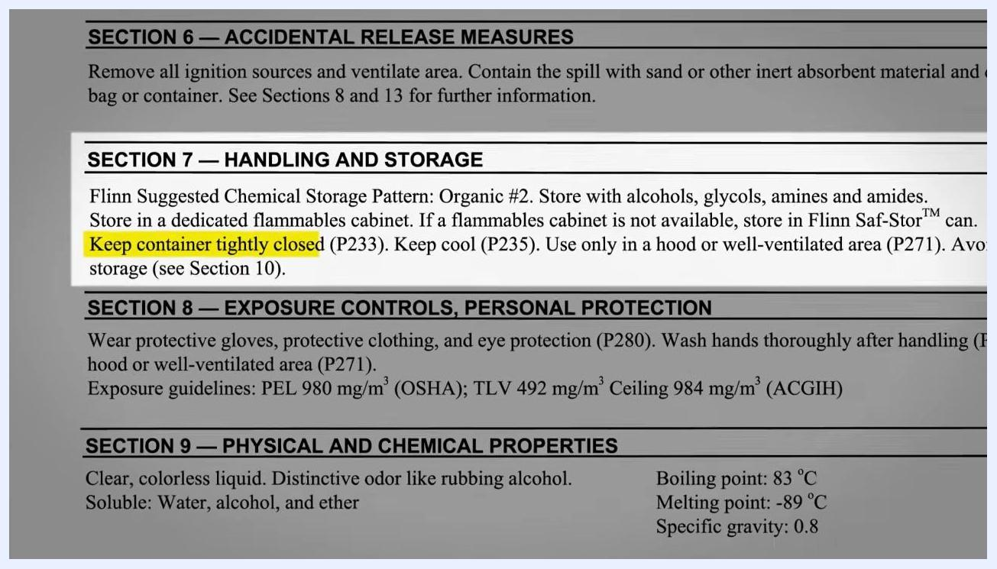
SDS Section 9 listing appearance, odor, solubility, boiling and melting points, and specific gravity

15. Review stability and reactivity information (Section 10)
Check Section 10 to identify incompatible substances. Avoid contact with strong oxidizers, acetaldehyde, chlorine, ethylene oxide, acids, and isocyanates. Note that shelf life is fair, and organic peroxides may develop if the chemical is exposed to light and air, which can result in explosions, particularly during distillation. Avoid prolonged storage.
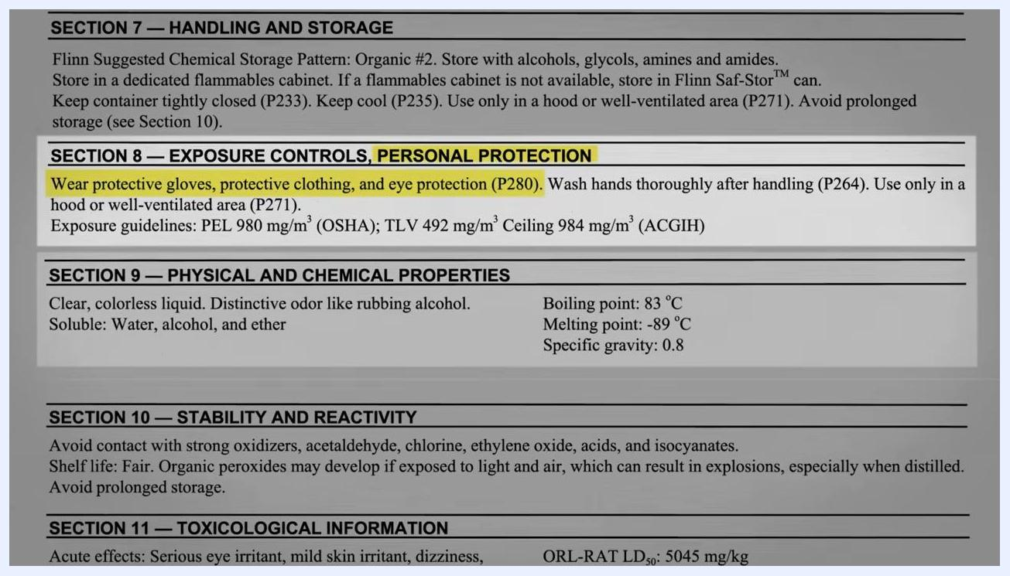
SDS Section 10 showing incompatible chemicals, shelf life, peroxide formation risk, and storage warnings

16. Interpret toxicological information (Section 11)
Check Section 11 for acute and chronic health effects. For isopropyl alcohol, acute effects include serious eye irritation, mild skin irritation, dizziness, drowsiness, nausea, and headache; chronic effects are listed as Not Available (N.A.). Target organs are the eyes, skin, and respiratory system. Key toxicity values include ORL-RAT LD₅₀ of 5045 mg/kg (oral, rat), IHL-RAT LC₅₀ of 16,000 ppm/8H (inhalation, rat), and SKN-RBT LD₅₀ of 12,800 mg/kg (skin, rabbit).
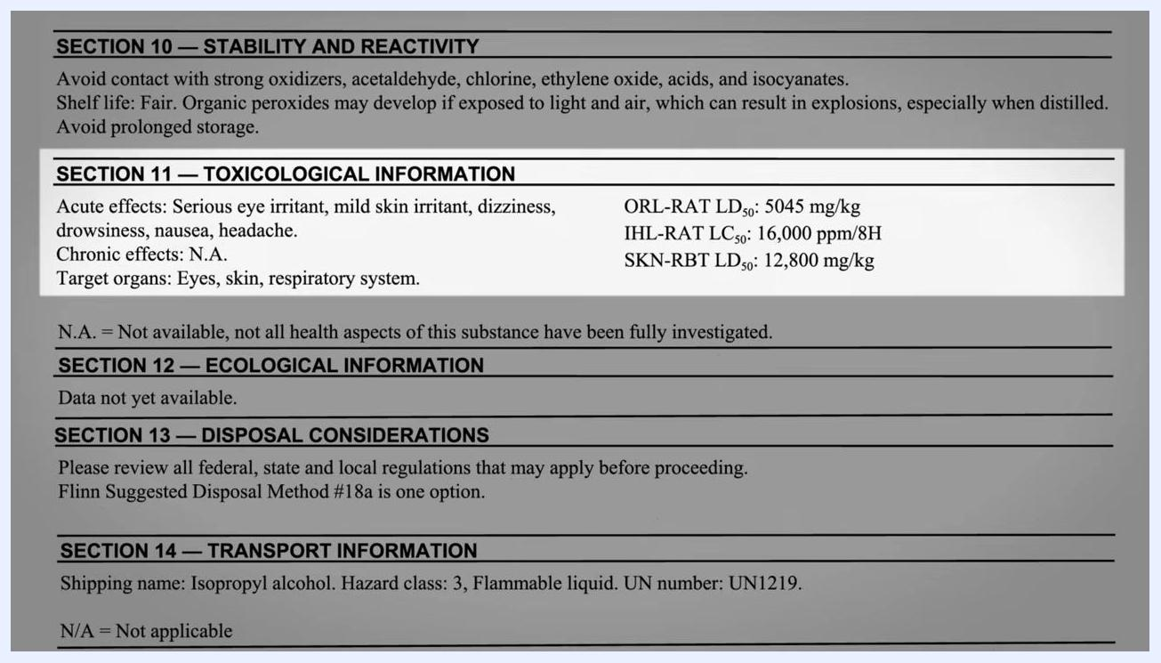
SDS Section 11 showing acute effects, target organs, LD50/LC50 values, and chronic effects marked as not available
Safety note: N.A. means not all health aspects of the substance have been fully investigated — it does not mean the substance is safe.

17. Check ecological and disposal information (Sections 12–13)
Review Section 12, Ecological Information — for isopropyl alcohol, environmental effects data is not yet available. Review Section 13, Disposal Considerations, and check all federal, state, and local regulations before disposal. Flinn Suggested Disposal Method #18a is one option for isopropyl alcohol.
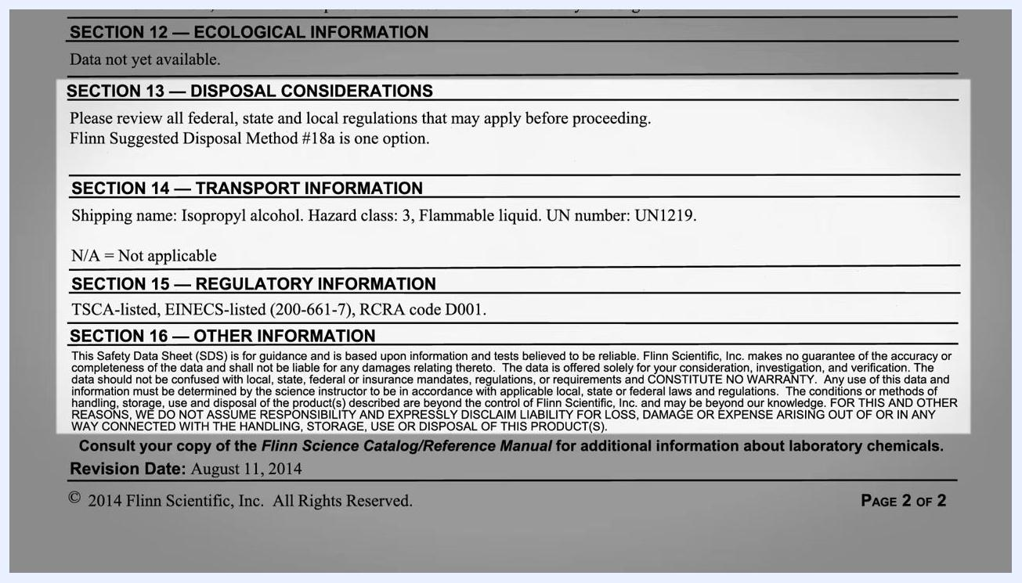
SDS Sections 11–13 showing toxicological, ecological, and disposal information with acute and chronic effects and target organs highlighted

18. Review transport and regulatory information (Sections 14–16)
Check Section 14, Transport Information, for the shipping name, hazard class, and UN number. For isopropyl alcohol: shipping name is Isopropyl alcohol; hazard class is 3 (Flammable liquid); UN number is UN1219. Check Section 15, Regulatory Information — isopropyl alcohol is TSCA-listed, EINECS-listed (200-661-7), with RCRA code D001. Check Section 16, Other Information, which notes that the SDS is for guidance and based on reliable information and tests, that the manufacturer does not guarantee accuracy or completeness, and lists the revision date (August 11, 2014 for this example).
SDS Sections 13–16 showing disposal, transport, regulatory, and other information for isopropyl alcohol

19. Confirm required PPE and equipment before handling
Before starting work, confirm that lab coat, safety goggles, and other required PPE are in place, and that the relevant equipment for the task is ready. In a typical isopropyl alcohol setup, this includes an Erlenmeyer flask, a graduated cylinder, a bottle of 99% isopropyl alcohol, and a hot plate.
Laboratory setup showing an Erlenmeyer flask, graduated cylinder, bottle of 99% isopropyl alcohol, and hot plate, with a lab coat and goggles in use
Safety note: The SDS is an important document and is crucial to your safety in the lab.

20. Confirm your understanding of the SDS's purpose
Before finishing your review, confirm that you understand what the SDS is telling you: the properties of the chemical, its hazards, and how to protect yourself from those hazards.
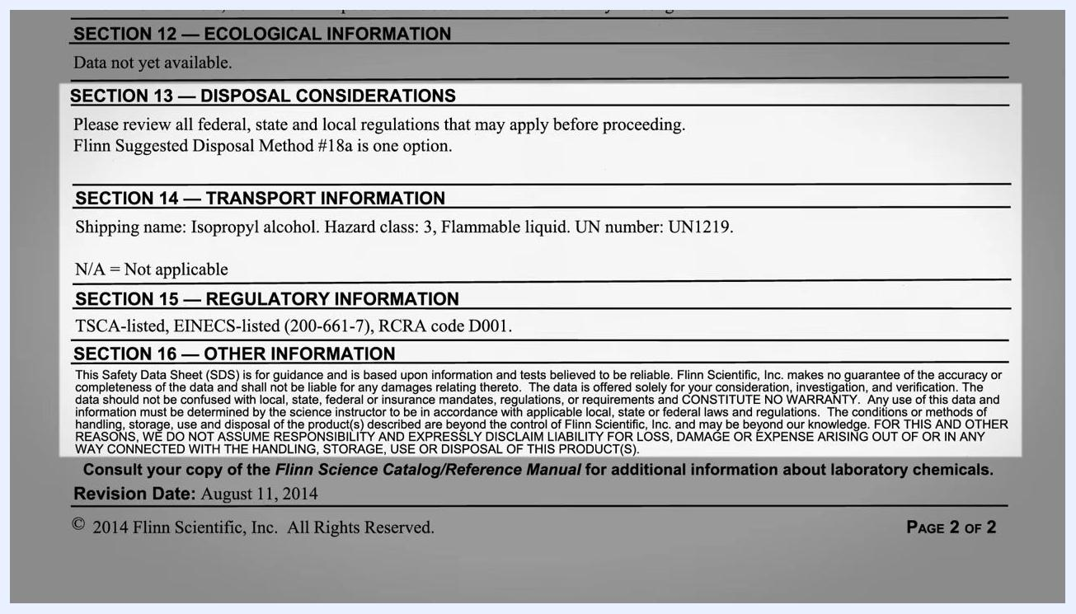
Reference text summarizing that Safety Data Sheets provide information about a chemical's properties, hazards, and protective measures

21. Confirm the three ways hazards are identified
As a final check, confirm you can identify hazards using all three SDS methods: the signal word ("Danger" or "Warning") alerts you that a chemical is harmful; pictograms represent specific hazard types, such as a flame for flammable chemicals; and hazard statements describe exactly how the chemical can hurt you.
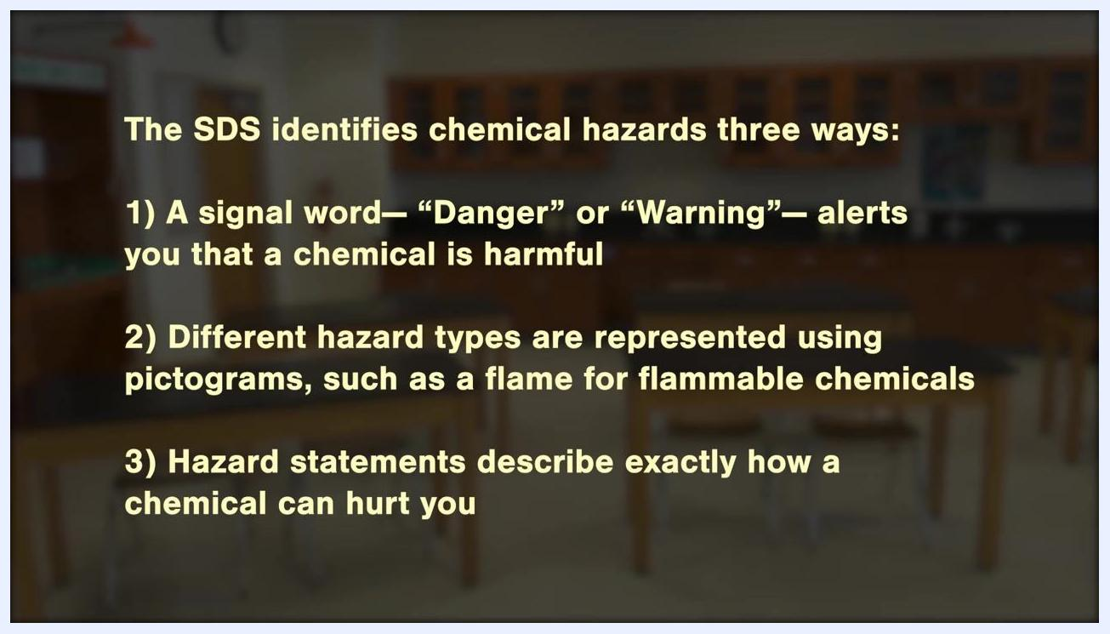
Reference text summarizing the three ways an SDS identifies chemical hazards: signal word, pictograms, and hazard statements

Verification and summary
Before working with any chemical, confirm that you have completed the following:
- Located the correct SDS matching the chemical name on your container
- Identified the manufacturer, emergency contact, signal word, pictograms, and hazard statements
- Reviewed the chemical composition, first aid measures, and toxicological information
- Applied the required PPE and handling, storage, and exposure control guidance
- Confirmed the transport, regulatory, and disposal requirements
Always consult the SDS before working with any chemical, and follow all disposal, transport, and regulatory guidelines as specified. Understanding how to read a Safety Data Sheet ensures you recognize chemical hazards and can protect yourself and others in the laboratory.

Acknowledgement slide thanking Jim Blizzard for his contribution to chemical safety resources
Acknowledgement slide listing contributors and supporters for the safety resources

Final acknowledgement slide with contributors and a "Thank you" message

End credits screen listing executive producer, host, sound mixer, director & editor, camera, and production assistants, with a digital blue background
Black screen with white text: "© 2019 American Chemical Society. All Rights Reserved."

