Standard Operating Procedure: Donning and Doffing Personal Protective Equipment (PPE)

Purpose
This procedure provides step-by-step instructions for safely donning (putting on) and doffing (removing) personal protective equipment (PPE) for two precaution types: Enhanced Airborne Droplet Contact Precautions and Droplet Contact Precautions. Following these steps correctly minimizes the risk of contamination to healthcare workers and patients.

Scope
This procedure applies to all healthcare workers entering or exiting patient rooms under Enhanced Airborne Droplet Contact Precautions or Droplet Contact Precautions, including care provided in negative pressure rooms and standard patient rooms.

Required equipment and PPE
- Isolation gown (yellow)
- N95 respirator (fit-tested) — for Enhanced Airborne Droplet Contact Precautions
- Procedure mask — for Droplet Contact Precautions
- Face shield — for Enhanced Airborne Droplet Contact Precautions
- Gloves
- Alcohol-based hand sanitizer (or soap and water if hands are visibly soiled)
- Garbage receptacle for used PPE disposal
Safety note: If you make an error at any point during donning or doffing, or suspect contamination, perform hand hygiene immediately and wash any area that has been mistakenly exposed.

Section 1: Donning PPE for Enhanced Airborne Droplet Contact Precautions

Step 1: Review PPE requirements
- Check the signage outside the patient room to determine which PPE is required.
- Confirm the type of precautions in effect (for example, Enhanced Airborne Droplet Contact Precautions).

Hospital door with signage, PPE supply station, and a healthcare worker in scrubs. The signage displays a "STOP" symbol and a list of required PPE. Text overlay: "Enhanced Airborne Droplet Contact Precautions"

Step 2: Prepare yourself
- Pull back your hair to ensure it is secured away from your face.
- Remove or minimize jewelry to reduce the risk of contamination.

Step 3: Perform hand hygiene
- Use an alcohol-based hand sanitizer for 15 to 20 seconds, unless hands are visibly soiled (in which case, use soap and water).
- Rub palms, wrists, between fingers and thumbs, back of hands, and along the nail beds.
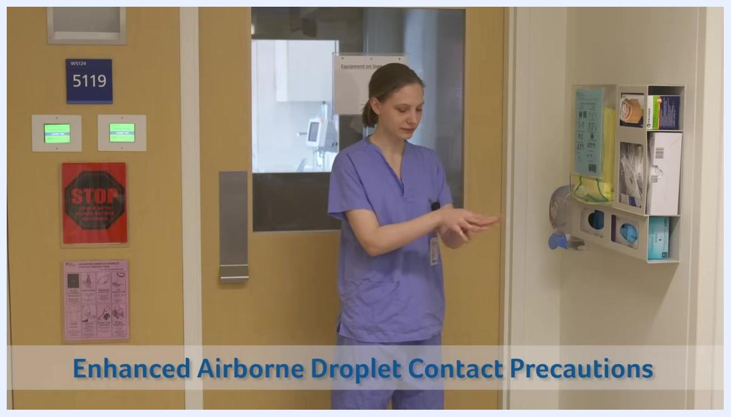
Healthcare worker in scrubs performing hand hygiene in front of a patient room door and PPE supply station. Text overlay: "Enhanced Airborne Droplet Contact Precautions"

Step 4: Don the gown
- Put on the isolation gown, ensuring it covers all clothing.
- Close the gown at the back of the neck.
- Tie the waist securely at the back, making sure no clothing is exposed.
Healthcare worker in a yellow isolation gown tying the waist at the back, ensuring full coverage. PPE supply station visible.
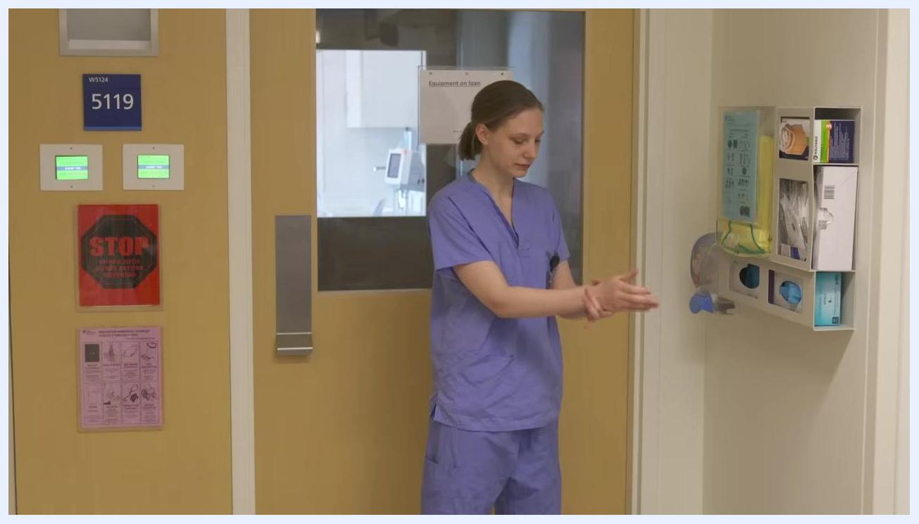
Close-up of hands tying the waist strap of a yellow isolation gown at the back.

Step 5: Don the N95 respirator
- Select a fit-tested N95 respirator from the PPE supply station.
- Place the mask over your nose and under your chin.
- Position the top strap at the crown of your head.
- Stretch the bottom strap over your head to the back of your neck.
- Mold the nose strip to ensure a secure fit and tight seal.
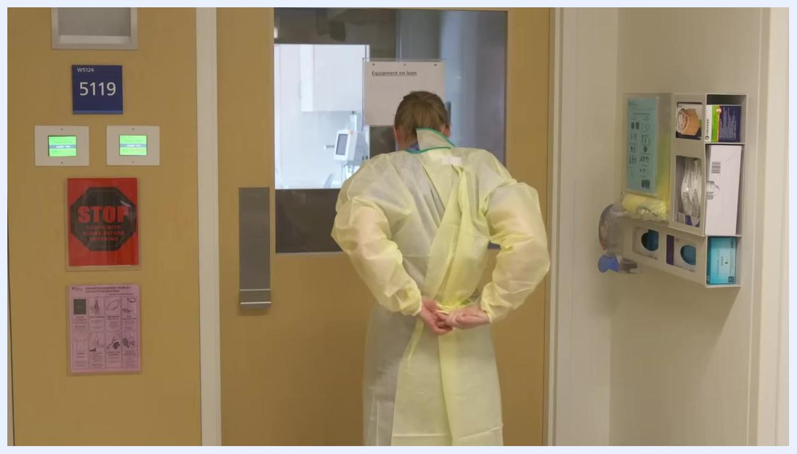
Healthcare worker placing the bottom strap of an N95 respirator over the back of her neck, wearing a yellow gown, with hair tied back.

Step 6: Perform a seal check
- Without touching the mask, place your hands at the top and bottom of the respirator.
- Take deep breaths to check for any air leaks.
- If air is felt escaping, readjust the mask for a proper seal.
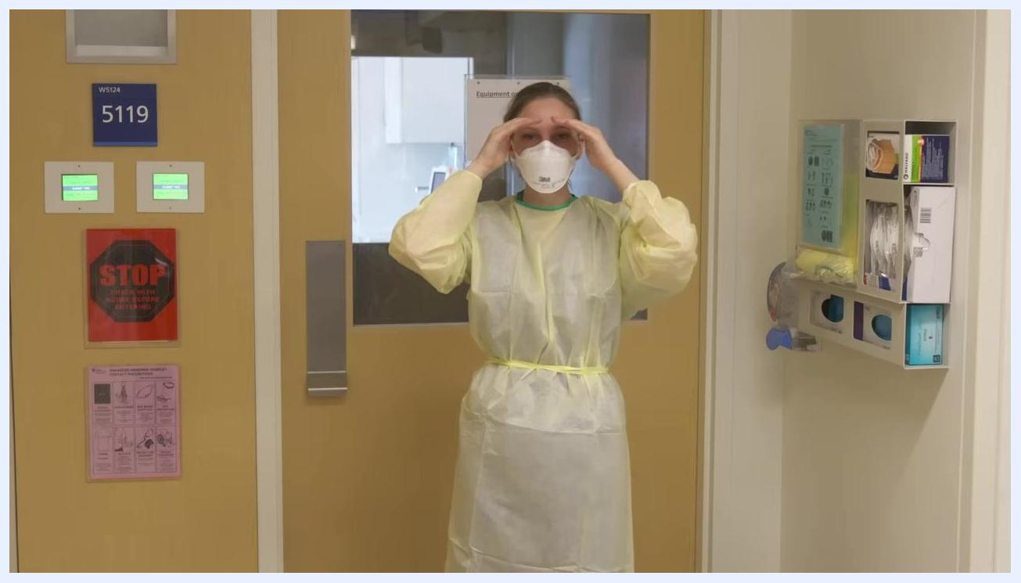
Healthcare worker in full gown and N95 respirator performing a seal check by placing hands around the mask.

Step 7: Don the face shield
- Place the face shield strap at the back of your head, ensuring full coverage of your face.
- Adjust as needed for comfort and protection.
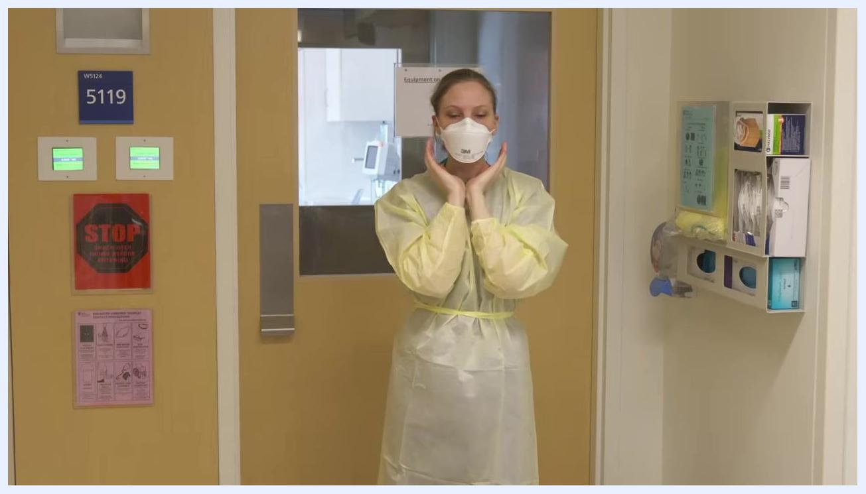
Healthcare worker in full PPE (gown and N95) preparing to don a face shield, hands positioned near the sides of the head.
Safety note: Always perform hand hygiene between steps if you suspect contamination or make an error. Use alcohol-based sanitizer unless hands are visibly soiled, in which case use soap and water.

Step 8: Don gloves
- Put on gloves one at a time.
- Ensure each glove is snug over the gown cuffs and that no skin is exposed.
- Confirm that the gloves fully cover the wrists and overlap the gown sleeves.
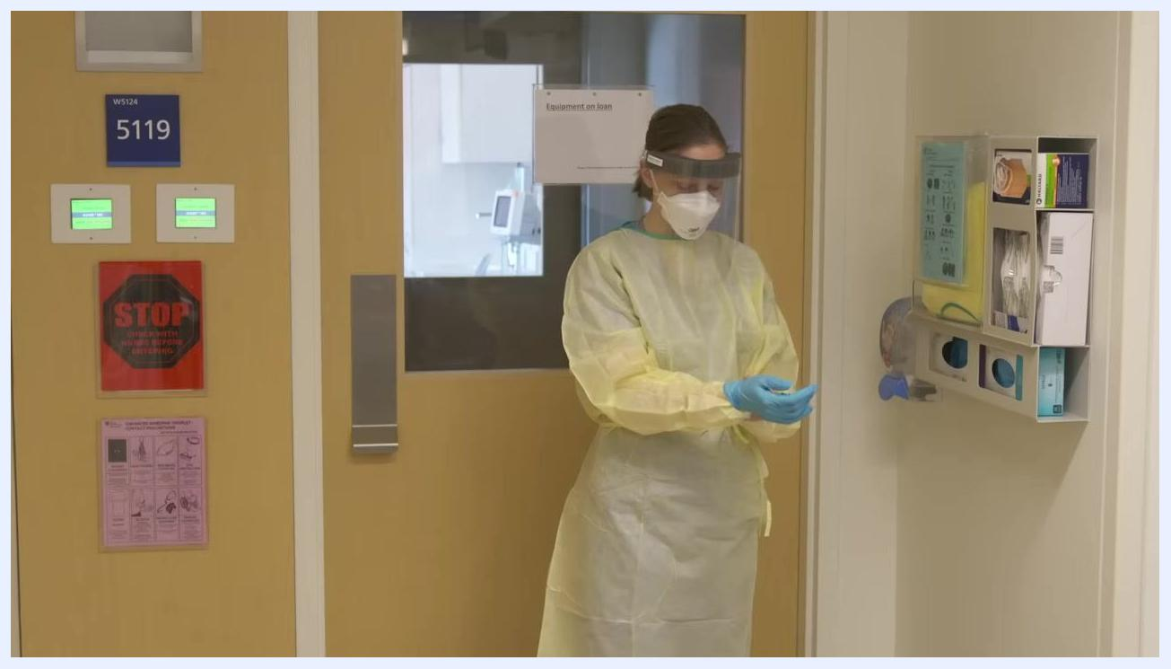
Healthcare worker in full PPE (yellow gown, N95, face shield) donning blue gloves in front of a patient room door. PPE supply station and signage visible.

Step 9: Enter the negative pressure room
- Open the door to the negative pressure room.
- Enter the room, ensuring the door is securely closed behind you to maintain negative pressure.
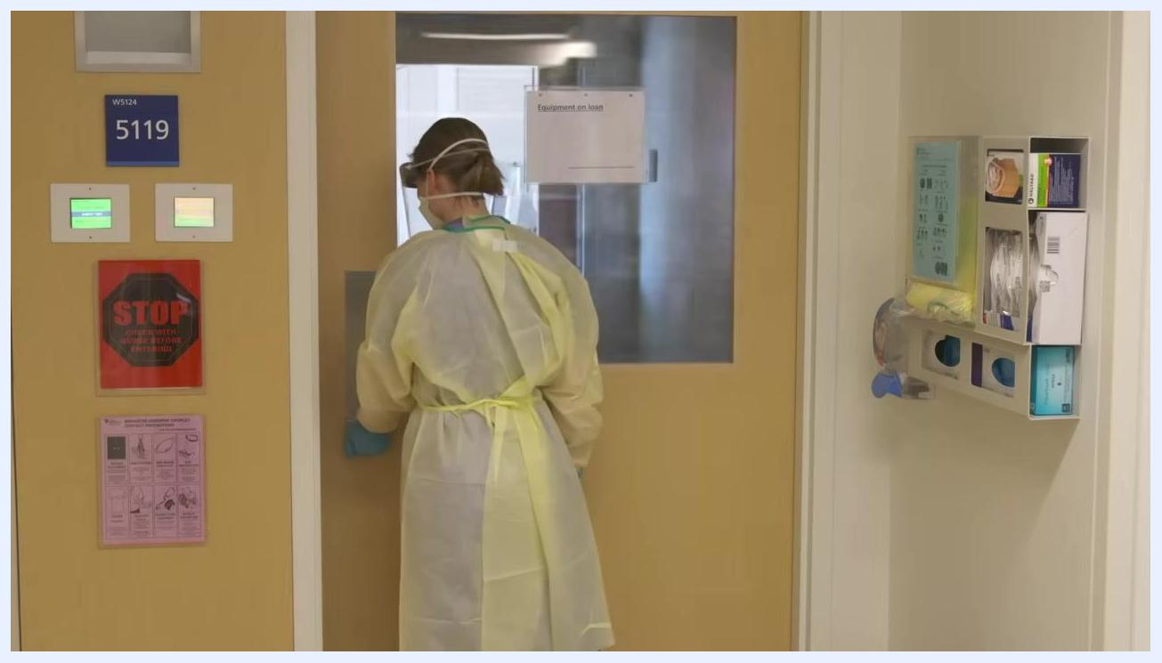
Healthcare worker in full PPE facing the door, reaching to open or close it. Room signage and PPE station visible.
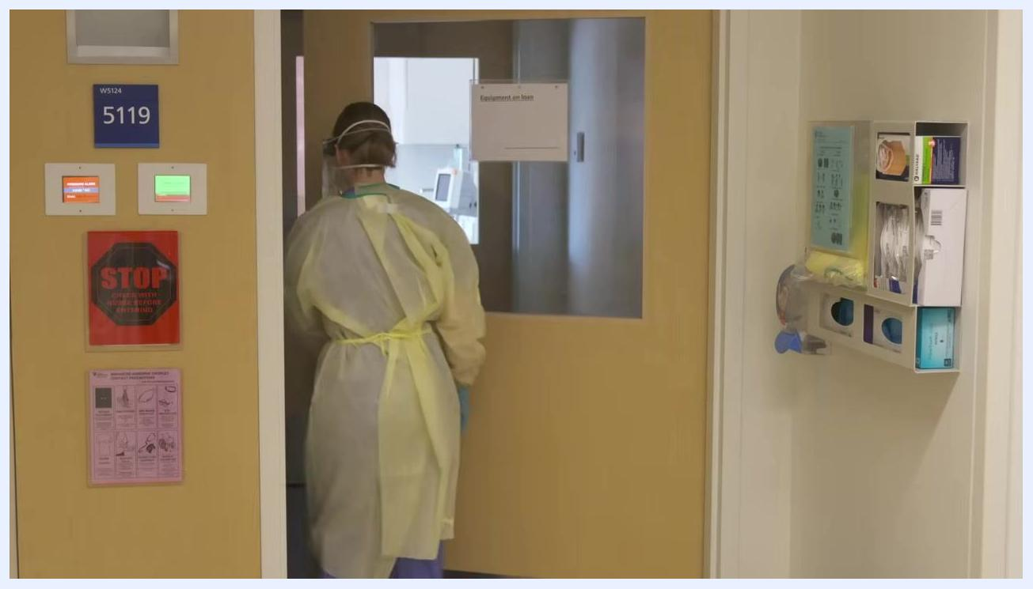
Healthcare worker in full PPE entering the negative pressure room, ensuring the door is closed behind.

Section 2: Doffing PPE (After Leaving a Negative Pressure Room)
Safety note: Always ensure you do not contaminate yourself or others during removal. If you make an error or suspect contamination, perform hand hygiene immediately.

Step 10: Step into the ante room
- When ready to doff PPE, step into the ante room (the area between the patient room and the hallway).
- Ensure the door to the patient room is closed behind you before beginning removal.

Step 11: Remove gloves
- Remove the first glove by pulling it up and away from the middle of your palm, ensuring you do not touch your skin.
Healthcare worker in full PPE (gown, gloves, face shield, N95) standing in ante room, preparing to remove gloves.
- Hold the removed glove in your gloved hand.
- Remove the second glove by placing a finger inside the clean area of the glove and pushing it off, balling up both gloves together.
Healthcare worker in full PPE using a gloved finger to remove the second glove, following proper technique.
- Dispose of both gloves in the garbage.
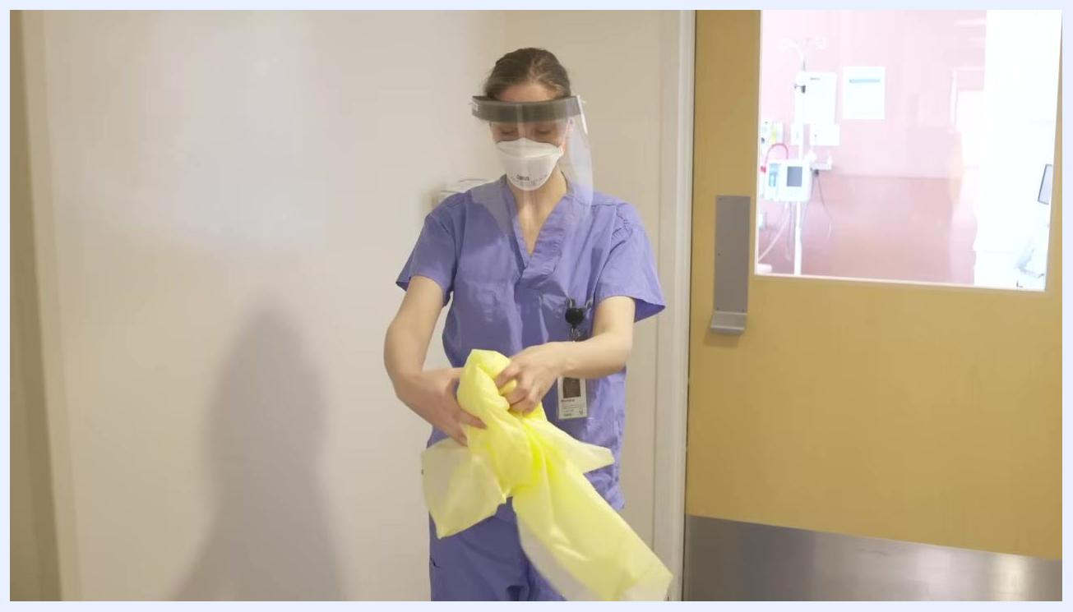
Healthcare worker holding balled-up gloves, extending arm to dispose of them in the garbage.

Step 12: Remove gown
- Untie or open the gown at the neck and then at the waist.
- From the back of the neck, take the gown and slowly pull it out and away from your body.
- Only touch the inside of the gown as you roll it into a ball.
- Dispose of the gown in the garbage.
Healthcare worker in scrubs, face shield, and N95 removing a yellow isolation gown by rolling it up.
Healthcare worker continuing to roll up and remove the yellow gown, ensuring only the inside is touched.

Step 13: Perform hand hygiene
- Use an alcohol-based hand sanitizer for 15 to 20 seconds.
- Rub palms, wrists, between fingers and thumbs, back of hands, and along the nail beds.

Step 14: Remove face shield
- Lean forward slightly.
- Pull the face shield strap forward and away from your head, avoiding contact with the front of the shield.
- Dispose of the face shield in the garbage.
Healthcare worker in scrubs and N95, preparing to remove the face shield by leaning forward.

Step 15: Remove N95 respirator
- Without touching the exterior of the mask, start by pulling the bottom strap over your head.
- Then pull the top strap over your head, moving the mask forward and away from your face.
- Dispose of the N95 respirator in the garbage.
Healthcare worker in scrubs removing the N95 respirator by pulling straps over the head, following proper doffing technique.
Safety note: Always perform hand hygiene between steps if you suspect contamination or make an error. Use alcohol-based sanitizer unless hands are visibly soiled, in which case use soap and water.

Section 3: Donning and Doffing for Droplet Contact Precautions
This section applies when Droplet Contact Precautions are required. A procedure mask replaces the N95 respirator used under Enhanced Airborne Droplet Contact Precautions.

Step 1: Dispose of used PPE and perform hand hygiene
- Place all used PPE (such as gloves, gown, and mask) into the garbage as soon as removal is complete.
- Immediately perform hand hygiene using an alcohol-based hand sanitizer.
- Rub hands together, covering all surfaces, for 15 to 20 seconds.
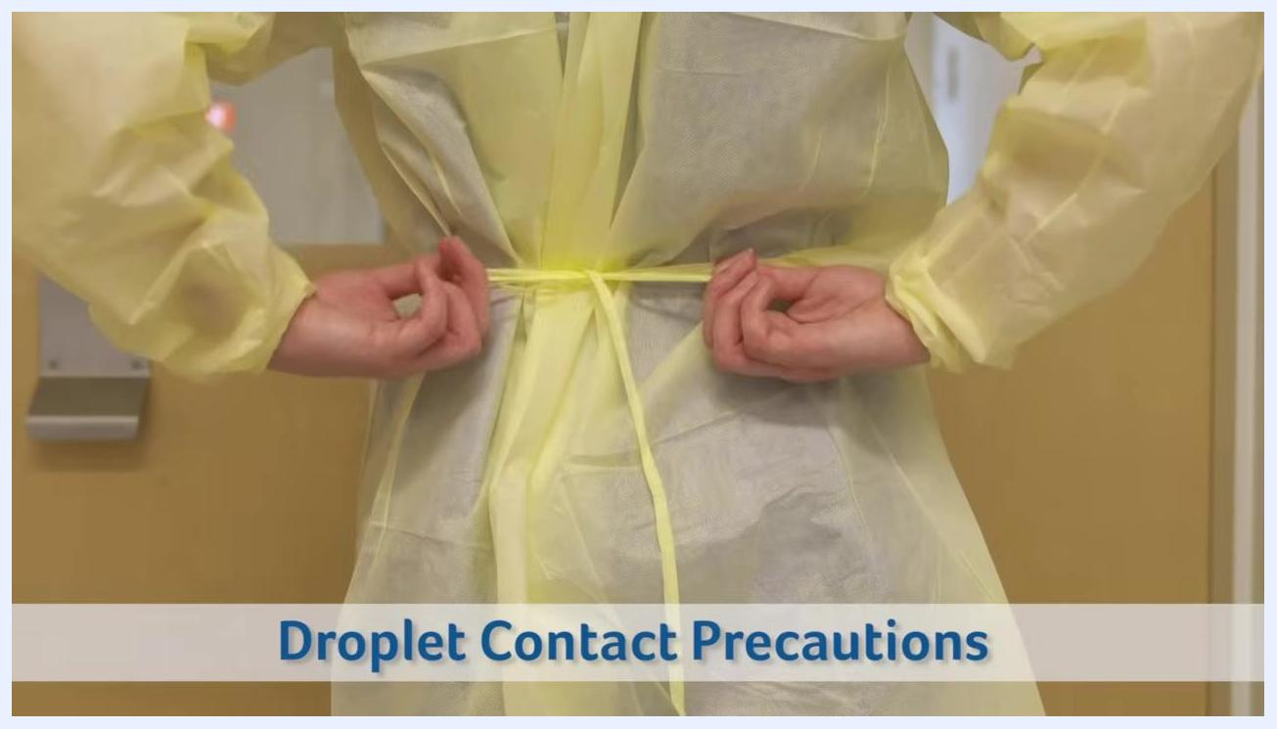
Healthcare worker in scrubs performing hand hygiene, rubbing hands together. Text overlay: "Droplet Contact Precautions"

Step 2: Don PPE for Droplet Contact Precautions
a. Perform hand hygiene
- Before donning any PPE, perform hand hygiene with alcohol-based sanitizer.
b. Put on gown
- Put on a yellow isolation gown.
- Secure the gown by tying it at the waist and neck, ensuring full coverage of clothing.
Healthcare worker tying the waist of a yellow isolation gown. Text overlay: "Droplet Contact Precautions"
c. Don procedure mask
- Take a procedure mask and place the elastics around your ears.
- Form the mask to the bridge of your nose for a secure fit.
- Pull the mask under your chin to ensure full coverage.
Healthcare worker in a yellow gown placing procedure mask elastics around ears, forming the mask to the nose and chin. Text overlay: "Droplet Contact Precautions"
d. Don gloves
- Put on gloves, ensuring they cover the cuffs of the gown and no skin is exposed.

Step 3: Doff PPE for Droplet Contact Precautions
a. Remove gloves
- Remove gloves one at a time using the glove-to-glove, skin-to-skin technique to avoid skin contact with contaminated surfaces.
b. Remove gown
- Untie or open the gown at the neck and then at the waist.
- From the back of the neck, take the gown and slowly pull it out and away from your body.
- Only touch the inside of the gown as you roll it into a ball.
- Place the gown into the garbage.
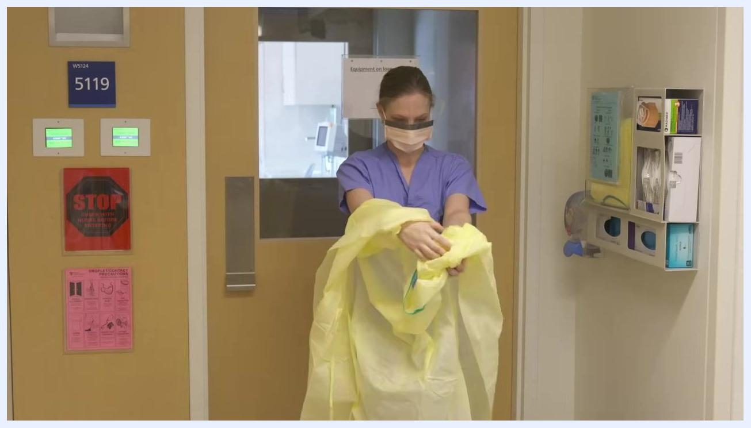
Healthcare worker in a yellow gown, untying at the neck as the first step of gown removal.

Healthcare worker in scrubs and mask, rolling up the yellow gown after removal, standing in front of a patient room door with PPE supply station visible.
c. Perform hand hygiene
- Immediately perform hand hygiene after removing the gown.

Healthcare worker in scrubs and mask, finishing removal of the yellow gown, preparing for hand hygiene.
d. Remove procedure mask
- Carefully remove the mask by taking the elastics off your ears.
- Pull the mask forward and away from your face and body.
- Dispose of the mask in the garbage.
e. Perform hand hygiene again
- Perform hand hygiene once more after removing the mask.

Verification and summary
- Always perform hand hygiene between steps if you suspect contamination or make an error.
- Use alcohol-based sanitizer unless hands are visibly soiled, in which case use soap and water.
- Confirm that all used PPE has been disposed of in the garbage after each doffing sequence.
- Confirm hand hygiene has been completed at every required checkpoint before proceeding to the next step.

Additional resources
For more information, visit your institution's infection prevention resources or contact Trillium Health Partners.
Trillium Health Partners logo and website, listing Credit Valley Hospital, Mississauga Hospital, and Queensway Health Centre, with the URL thp.ca
Trillium Health Partners logo and website, listing Credit Valley Hospital, Mississauga Hospital, and Queensway Health Centre, with the URL thp.ca

