How to Do a Lockout Tagout Procedure for Oil and Gas Equipment
Before Lockout Tagout (LOTO) practices were standardized, equipment often remained powered during repairs, creating hazardous conditions for maintenance personnel. There was no reliable system to secure equipment or communicate its operational status, and workers commonly relied on verbal requests asking operators not to start machinery — a method prone to miscommunication and serious injury.
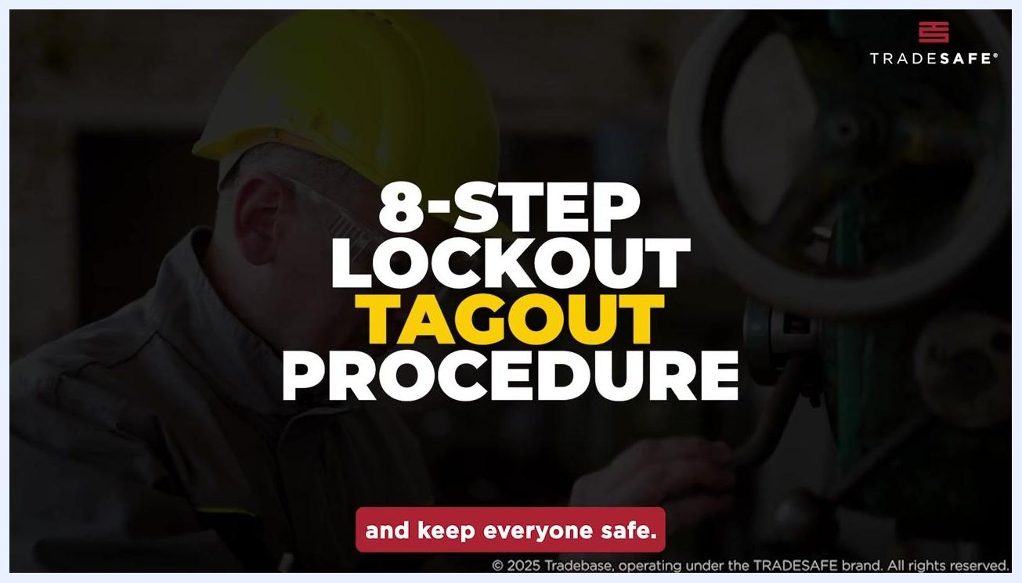
Two workers in a workshop, one operating machinery and the other communicating, illustrating reliance on verbal communication before standardized safety controls
This document explains how to do a lockout tagout procedure using the eight-step structured process designed to control hazardous energy and protect workers during equipment maintenance or repair.

Scope
A complete lockout tagout procedure should define the facility, the specific equipment tag being serviced, the job scope, the affected systems, and the boundaries of the work area before any isolation begins. This documentation covers the general eight-step LOTO process; your facility's specific equipment identifiers, job scope, and work boundaries should be recorded in your site-specific lockout permit or work order prior to starting the procedure.

End screen with "THANKS FOR WATCHING!", links for more videos, and the website trdsf.com. Social media handles are displayed at the bottom.

Energy Sources
Before beginning any lockout, identify all energy sources connected to the equipment. Based on the standard LOTO process, these include:
- Electrical power
- Hydraulic systems
- Pressurized air (pneumatic)
- Stored or residual energy, including trapped pressure in pneumatic systems and residual hydraulic fluid
- Gravity-related hazards from moving parts that could shift once isolated
Consult the equipment manuals to fully understand the system and its energy sources, and carefully inspect the machine for any hidden or secondary energy sources that may not be immediately visible.
Your site should also assess chemical and thermal hazards specific to your equipment during the manual review and inspection stage described above, as these are not detailed in this general procedure.

Isolation Points
Isolation points must be identified for every energy source connected to the equipment. The table below summarizes the isolation point types referenced in the standard procedure. Specific tag numbers, valve identifiers, and breaker numbers for your equipment should be recorded in your facility's isolation point log.
Isolation Point Type | Isolation Action | Locking Device | Tag Requirement | Responsible Authority
Circuit breaker | Flip breaker to off/isolated position | OSHA-standardized lock | Labeled tag showing who applied the lock and the reason for lockout | Employee performing the lockout
Valve | Close valve to isolate flow | OSHA-standardized lock | Labeled tag showing who applied the lock and the reason for lockout | Employee performing the lockout
Power supply connection | Disconnect power supply | OSHA-standardized lock | Labeled tag showing who applied the lock and the reason for lockout | Employee performing the lockout
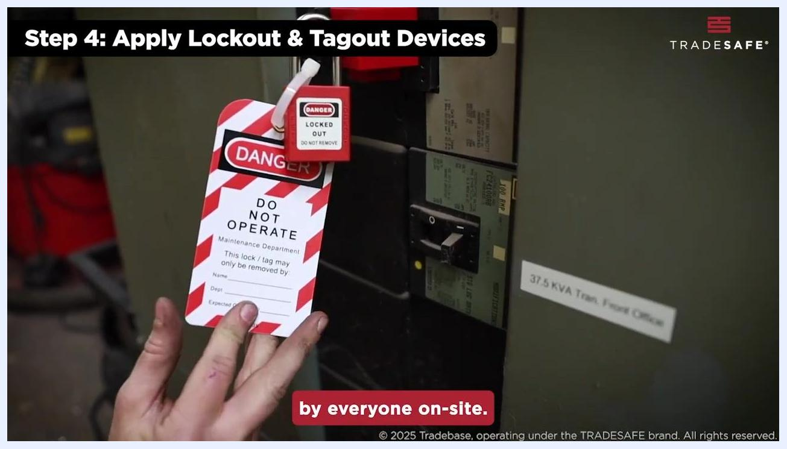
Lockout tag and lock applied to a breaker, with the tag reading "DANGER DO NOT OPERATE"
Use OSHA-standardized locks and tags at every isolation point so they are easily identifiable and universally understood by everyone on site.

Lockout Steps
Follow these numbered steps in sequence to shut down, isolate, depressurize, drain, lock, tag, and communicate the lockout status of the equipment.
Step 1: Prepare for lockout

- Identify all energy sources connected to the equipment (electrical, hydraulic, pressurized air).
- Consult equipment manuals to fully understand the system and its energy sources.
- Inspect the machine for any hidden or secondary energy sources.
- Communicate the lockout plan to all affected employees and ensure everyone understands the procedure.
Instructional reminder to inspect the machine for any hidden or secondary energy sources, with a worker visible in the background
Worker in safety gear consulting a clipboard in front of industrial equipment during the preparation step
Step 2: Shut down the equipment
5. Follow the manufacturer's or company-specific procedures to safely power down the equipment.
6. Ensure the equipment is completely shut down to prevent accidental restarts during maintenance.
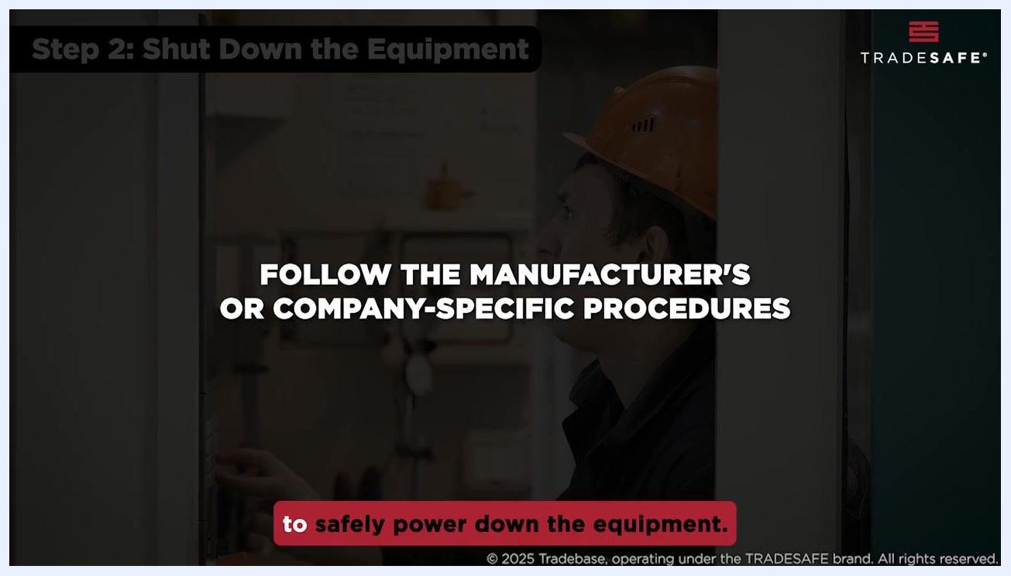
Worker in a hard hat following manufacturer or company-specific shutdown procedures
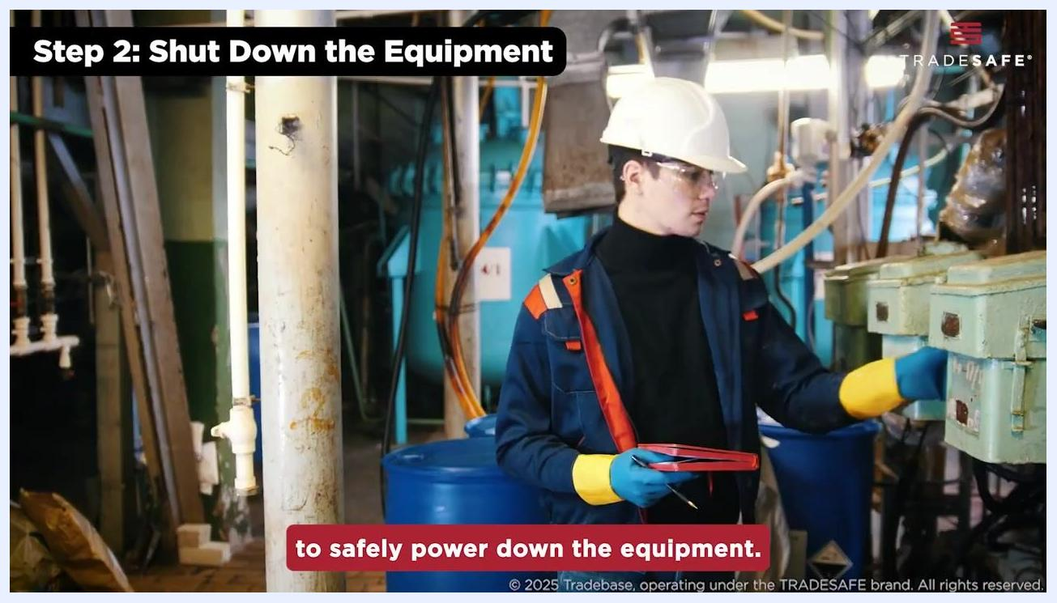
Worker in safety gear completing the equipment shutdown in an industrial setting
Step 3: Isolate energy sources
7. Isolate the equipment from all energy sources by flipping a circuit breaker, closing a valve, or disconnecting a power supply.
8. Confirm that all energy sources have been fully disconnected or isolated.
Close-up of a hand turning a red valve to isolate an energy source
Step 4: Apply lockout and tagout devices
9. Secure each isolation point by applying lockout devices to prevent accidental reconnection.
10. Attach a clearly labeled tag indicating who applied the lock and the reason for the lockout.
11. Use OSHA-standardized locks and tags so they are easily identifiable to everyone on site.
Step 5: Release stored energy
12. Release any residual or stored energy from the equipment to ensure it is completely safe for maintenance.
13. Bleed off hydraulic fluid from hydraulic systems.
14. Release any trapped air or pressure from pneumatic systems.
15. Secure or block any moving parts that could shift due to gravity or stored energy.
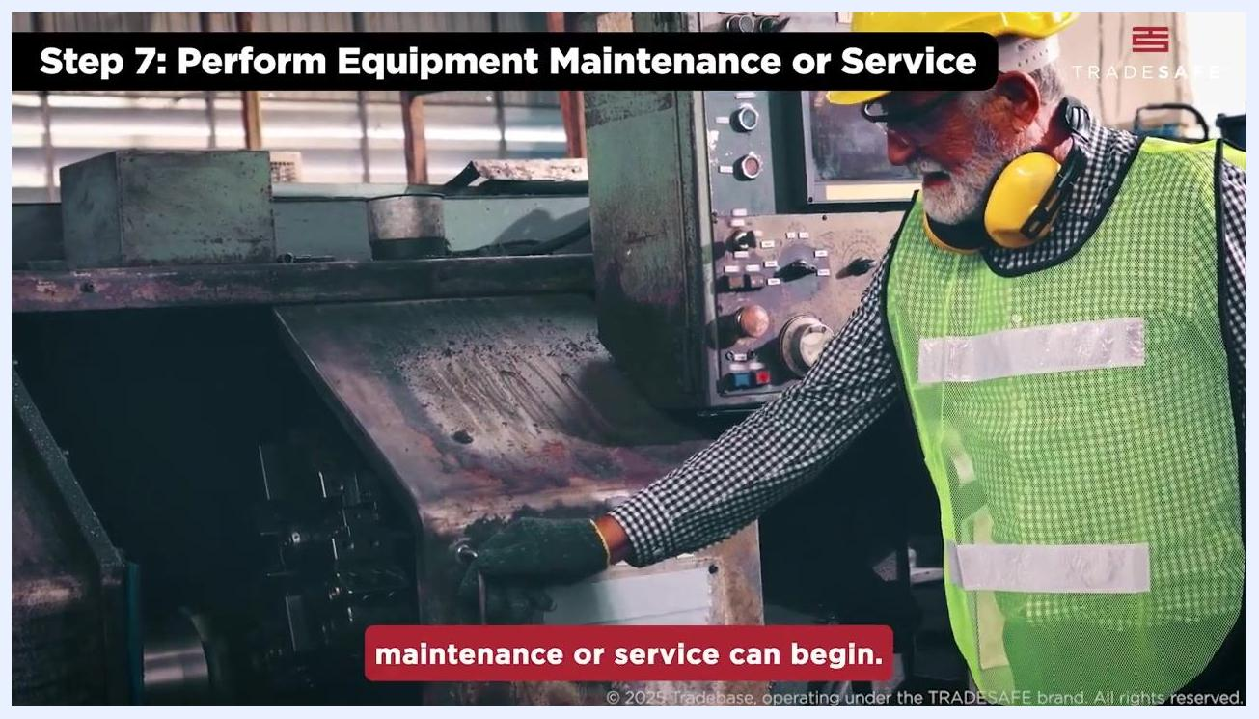
Hand turning a valve on a pressurized cylinder to release stored energy, surrounded by gas cylinders and copper piping

Zero-Energy Verification
Step 6: Verify isolation
Before beginning any maintenance or service, test the equipment controls to confirm that all energy sources have been fully isolated and the equipment is completely de-energized:
- Attempt to restart the machine using its normal controls.
- Ensure the machine does not power on or operate in any way.
- Treat this verification step as essential before beginning any work — do not proceed if the equipment shows any sign of remaining energized.
Worker in safety gear at a control panel attempting to start a large industrial machine, which does not power on
Refer to your LOTO checklist during this verification step to ensure no steps are missed and the procedure is implemented accurately.
Worker's hand holding a lockout tag attached to a valve, surrounded by gas cylinders and gauges, reinforcing the goal of minimizing risk

Shift Handover
Step 7: Perform equipment maintenance or service
Begin maintenance or service work only after confirming the equipment is locked out and verified safe. Follow the outlined procedures for your specific maintenance or service task and use all required tools and materials correctly and safely.
Worker in a high-visibility vest and hard hat performing maintenance on industrial equipment
Worker in a hard hat and safety gear performing maintenance in a workshop, with other workers visible in the background
Throughout the maintenance or service process, remain aware of the lockout status of the equipment and communicate any updates or changes in status with your team to ensure ongoing safety.
Personal lock transfer, group lock box use, permit continuity, and supervisor checks across shift changes should be documented according to your site's specific shift handover protocol.

Restoration
Step 8: Restore equipment after service
Once maintenance or service is complete, prepare to restore the equipment to operational status:
- Only the employees who originally installed the lockout or tagout devices are authorized to remove them.
- Remove all lockout and tagout devices from the equipment.
- Ensure all personnel are clear of the equipment before removing locks and tags.
- Reconnect all energy sources as per standard procedures.
- Test the equipment to confirm it is functioning properly and safely before returning it to service.
Close-up of hands removing a lockout tag, with text noting that only employees who installed the device may remove it
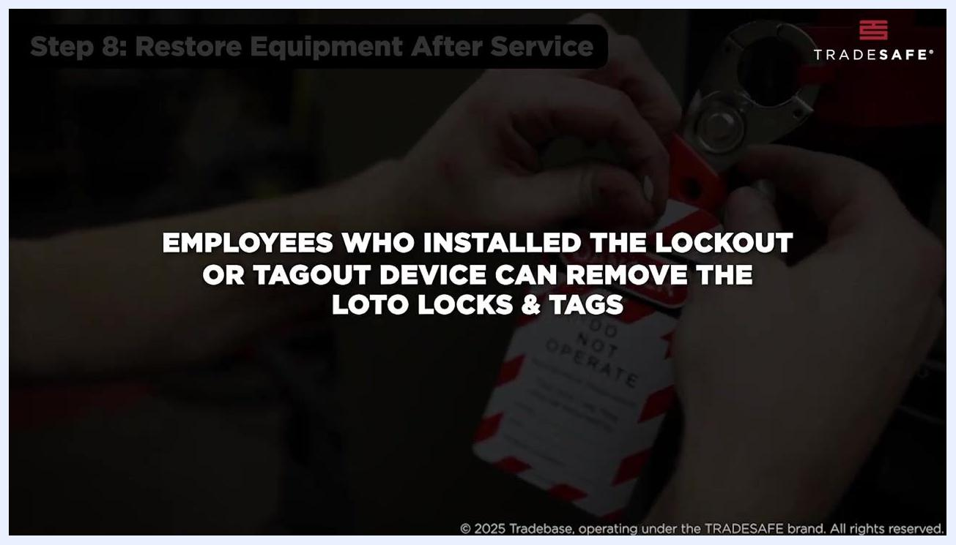
Close-up of hands removing a lockout tag, confirming that only the installing employee may remove LOTO locks and tags
By following the complete LOTO procedure, you minimize risks and maintain a safer work environment for everyone involved.
Hands applying a lockout device and tag to a valve as part of the LOTO checklist review, with the tag reading "DANGER DO NOT OPERATE"
Always follow your company's specific LOTO procedures and consult the official checklist for complete compliance and safety.

End screen with "THANKS FOR WATCHING!", links for more videos, and the website trdsf.com. Social media handles are displayed at the bottom.

