How to Conduct a Fire Drill: A Step-by-Step Emergency Drill Plan
Every year, fires cause more than 3,000 deaths and $25 billion in property losses, yet many organizations still underestimate how much preparation a fire drill requires. This SOP explains how to conduct a fire drill using a structured, five-step process: getting everyone on board, communicating your plan, setting goals, rehearsing the drill, and appointing observers to evaluate performance. Following this plan helps you build a documented fire evacuation program, assign clear roles, and continuously improve your organization's readiness for a real emergency.
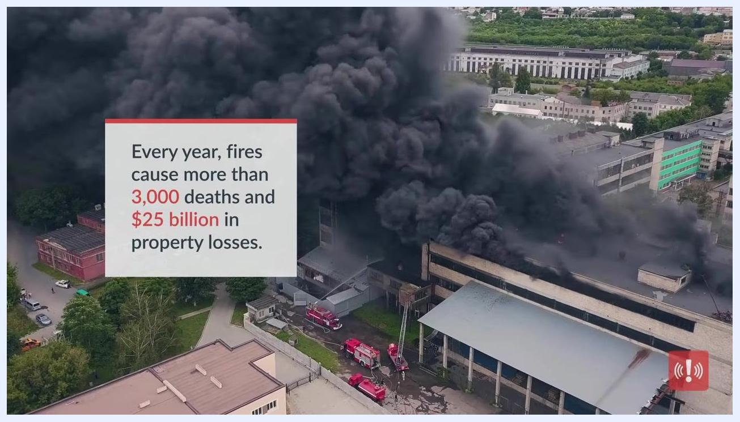
Aerial view of a large building fire with thick black smoke and fire trucks on scene, illustrating the scale of risk fires represent.

Prerequisites
Before you conduct a fire drill, you need a written fire evacuation plan that documents roles, responsibilities, and expected actions. If you do not already have one, use a step-by-step fire evacuation template to build this document before scheduling your first drill.
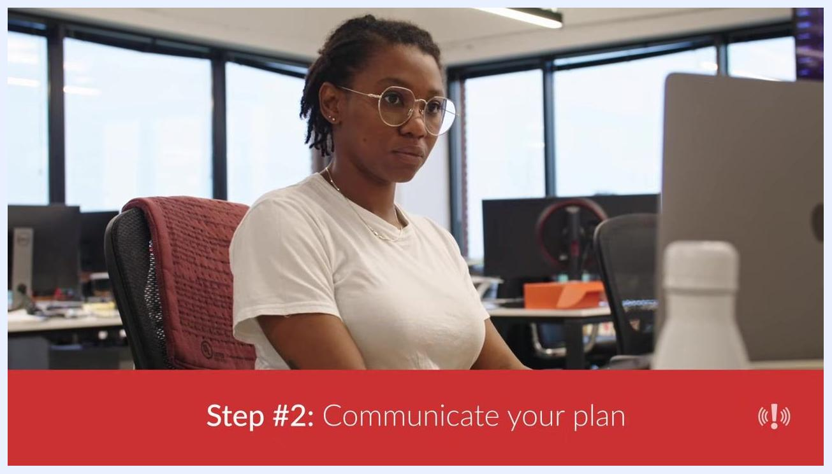
Employee at a desk looking at a computer while reviewing fire drill expectations and evacuation routes.

Exercise scope
Drill type: Workplace fire evacuation drill, ranging from simple walk-throughs to full-scale exercises.
Location: Office buildings, factory floors, or warehouse facilities where employees, fire team members, and executives are present.
Scheduling: Add the fire drill event to the shared company Outlook or Google Calendar so all employees know the date and time in advance.
Participating groups: The dedicated fire safety team, all employees at the location, and executive leadership who authorize employees to leave workstations, factory lines, or warehouse duties.
Capabilities tested: Evacuation procedures, internal emergency communication, equipment shutdown (where applicable), and the fire team's ability to execute the plan under realistic conditions.
Before scheduling the drill, evaluate fire risks in your building:
- Where might a fire start? Consider all possible ignition sources.
- Are there areas of the building more prone to fires, such as those with kitchen appliances or stored chemicals?
- Could wildfires threaten your business, especially during the summer months?
- What is the fire code or maximum occupancy limit for your building, and is your office in compliance?
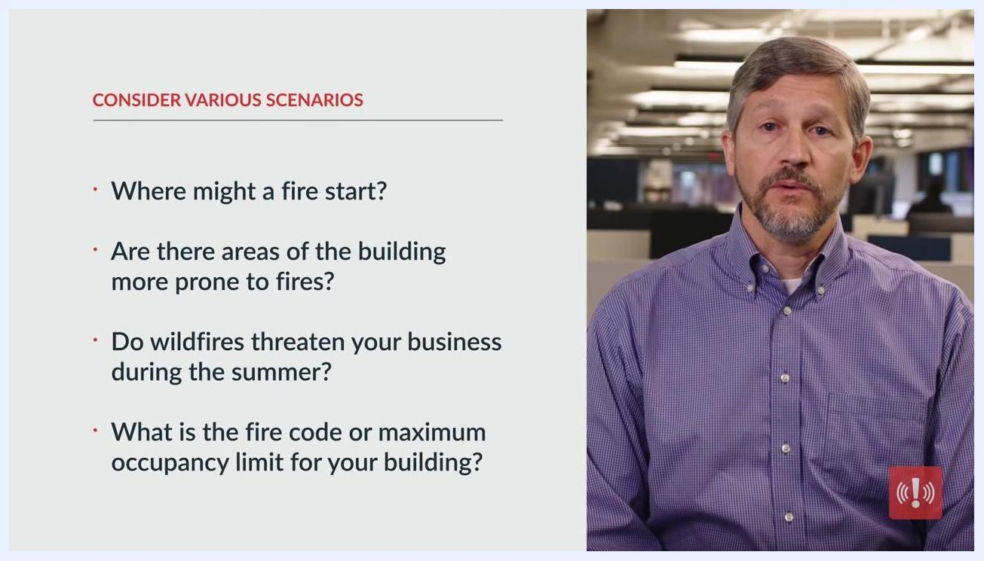
Slide listing fire-risk assessment questions: where a fire might start, whether certain areas are more prone to fires, whether wildfires threaten the business, and what the building's occupancy limit is.
Overlay reading "Step-by-step fire evacuation template in description below," referring to a downloadable planning resource.
If you do not already have a fire evacuation plan, use a step-by-step fire evacuation template as your starting document. Treat this plan as your playbook: it should outline exactly how you want the drill to proceed and include various scenarios to prepare for different types of emergencies. Document roles, responsibilities, and required actions clearly, and review and update the plan regularly to reflect changes in personnel, building layout, or regulations.
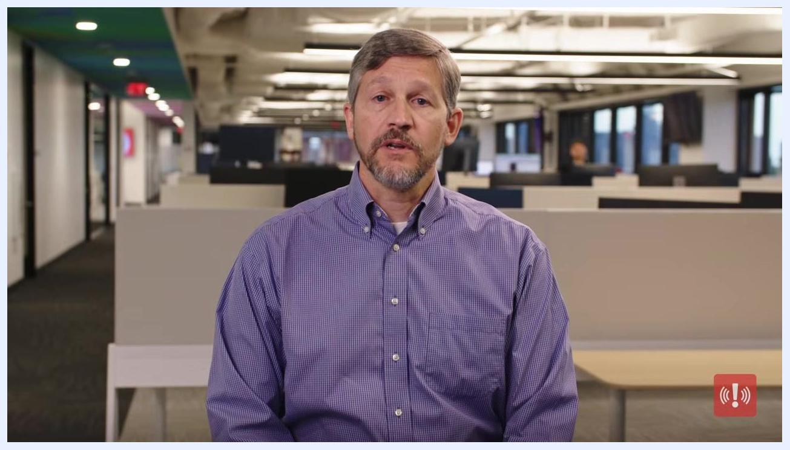
A person holding a clipboard and checking off names as employees exit a building during a fire drill.
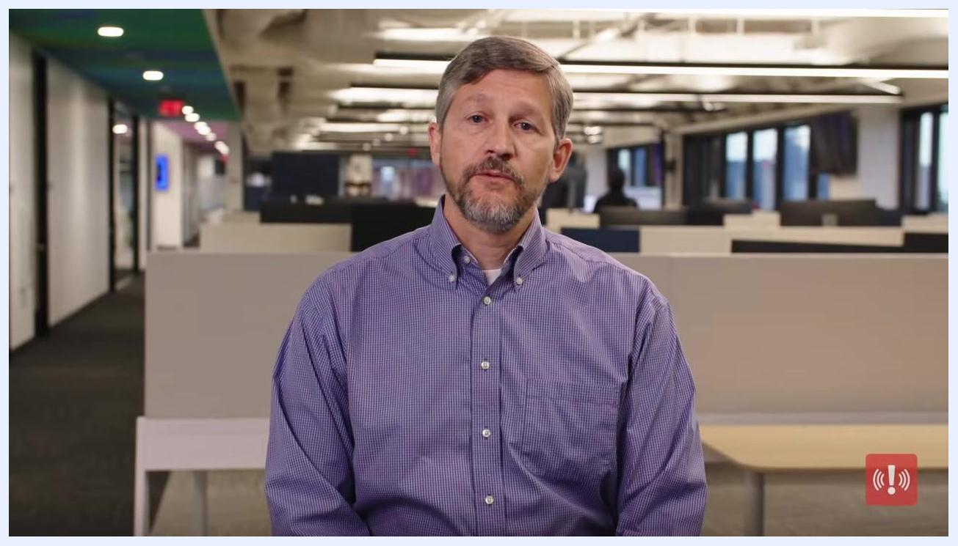
Presenter Peter Steinfeld in an office, continuing to explain the importance of a comprehensive evacuation plan.
Schedule fire drills regularly to condition employees to respond calmly and efficiently during a fire. Routine drills are among the most effective practices for ensuring company-wide safety.
Split-screen graphic listing the drill topics covered — how to prepare for a fire drill, the five steps to conduct one, and ways to practice better fire safety — alongside employees exiting a room in an orderly line.

Objectives and success criteria
Step 3 of the five-step process is to set goals for your fire drill. Before you run the exercise, define what you hope to achieve — for example, total evacuation time or participation rate. Use goal setting to create benchmarks for future improvement.
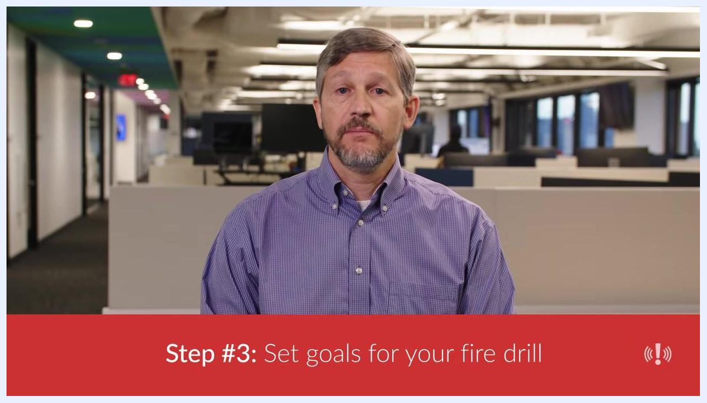
Close-up of hands typing on a keyboard at a desk while planning drill goals.
Identify specific metrics to measure during the drill:
- Time from drill activation to complete evacuation.
- Time to report completion of the drill.
- Successful shutdown of equipment, where appropriate.
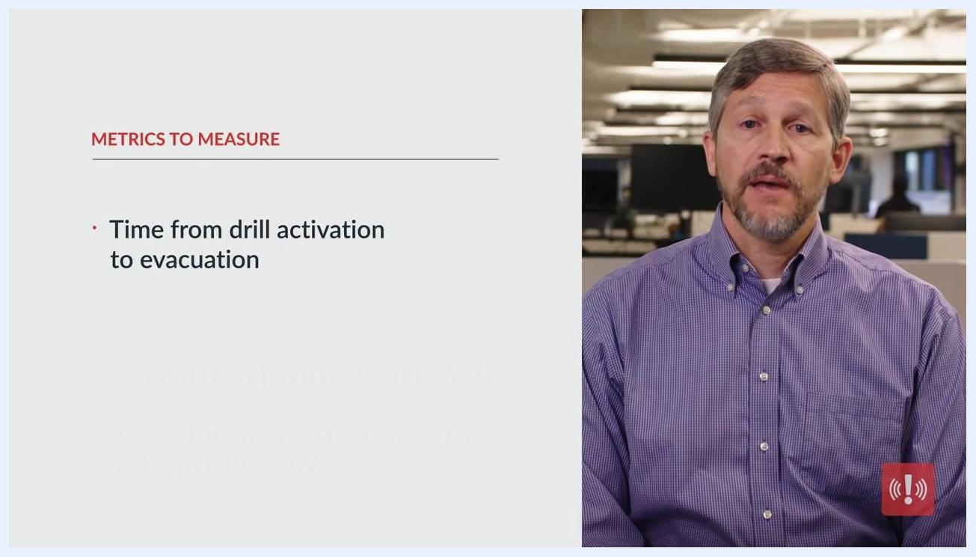
Employee working on a laptop with documents and a phone on the table, tracking drill metrics.
Analyze the results of your first drill against these benchmarks. For example, if it takes 15 minutes to evacuate because employees are in restrooms or finishing calls, note this as an area for improvement in future exercises.
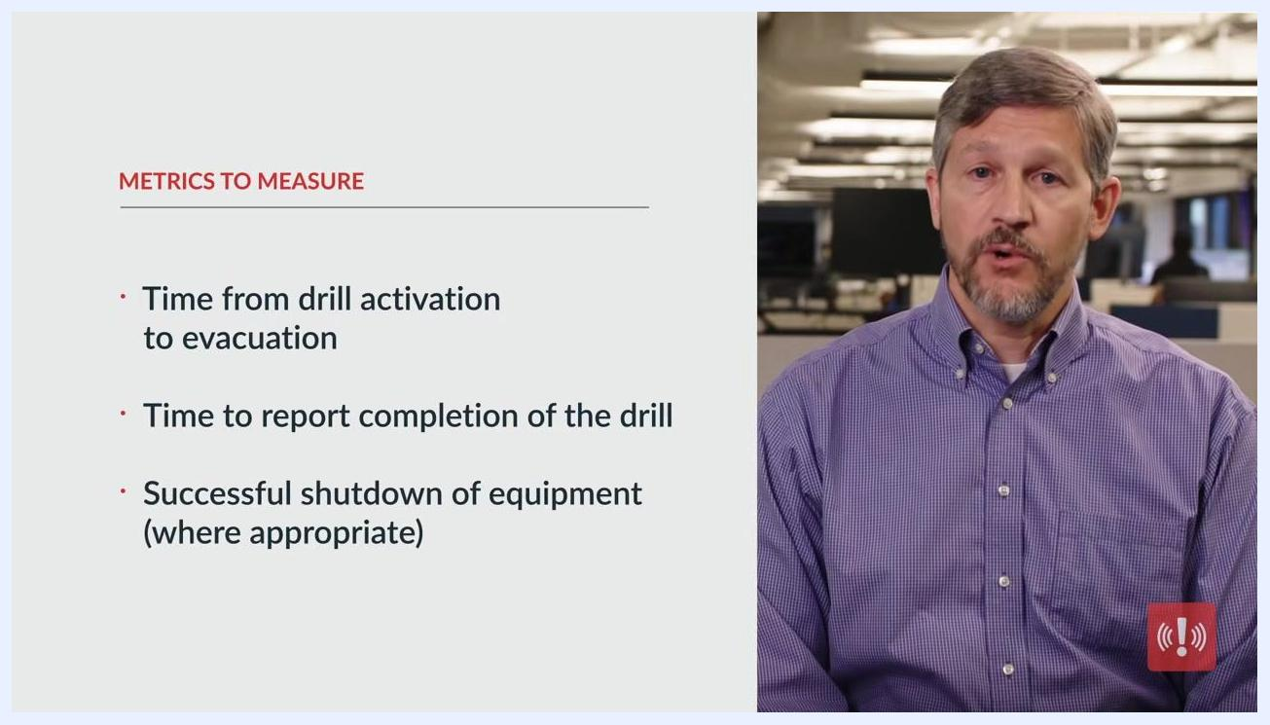
Presenter in an office, overlay: "Step #3: Set goals for your fire drill"
Success criteria are measured against the metrics above and refined after every drill using the deep-dive review questions described in the Evaluation Plan section below.

Scenario and injects
Step 4 is to rehearse the fire drill, beginning with simple walk-throughs and progressing to full-scale drills. Ensure all fire team members and employees involved in executing the drill are on the same page, and use rehearsals to identify potential issues, address confusion, and clarify expectations.
Presenter in an office with a slide: "METRICS TO MEASURE: Time from drill activation to evacuation"
Presenter in an office, overlay: "Step #4: Rehearse the fire drill"
Gather your team to discuss the actions that should be taken during the drill. Ensure all team members understand their roles and responsibilities, and encourage open discussion to resolve any uncertainties or questions.
Physically walk through the fire drill step by step with your team:
- Assign each person their specific role for the drill.
- Have everyone follow the evacuation procedures as if it were a real emergency.
- Move through hallways and designated routes as a group.
Conduct the drill by building or by section to minimize business disruptions. Organize the exercise so that not all areas evacuate at once, if possible, and ensure each section practices the drill thoroughly.
Injects and simulated constraints: Introduce variations and obstacles to create more realistic scenarios. Change variables within the drill to train employees on how to react to different situations — for example, simulate blocked exits or other hazards — and encourage adaptability and problem-solving during the drill.
Controller notes: Address any issues and confusion during rehearsals. Observe participants closely to identify areas where confusion or uncertainty arises, provide immediate clarification, and use rehearsal feedback to update instructions, signage, or procedures as needed. Clearly communicate expectations for each participant, including evacuation routes, assembly points, and reporting procedures, and remind employees of the fire safety team's roles and how to seek assistance if needed. Emphasize that rehearsals are a learning opportunity, not a test, to reduce anxiety and improve participation.
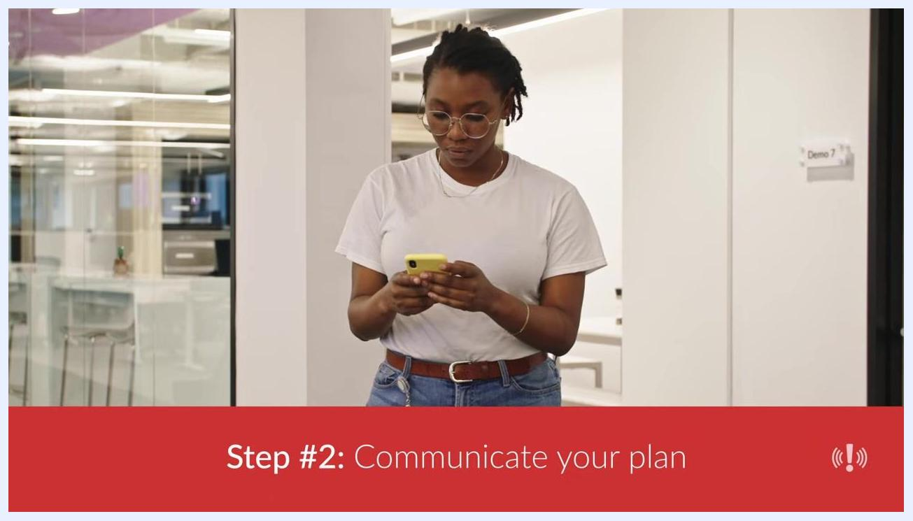
Employee in an office using a yellow smartphone, with overlay: "Step #2: Communicate your plan"
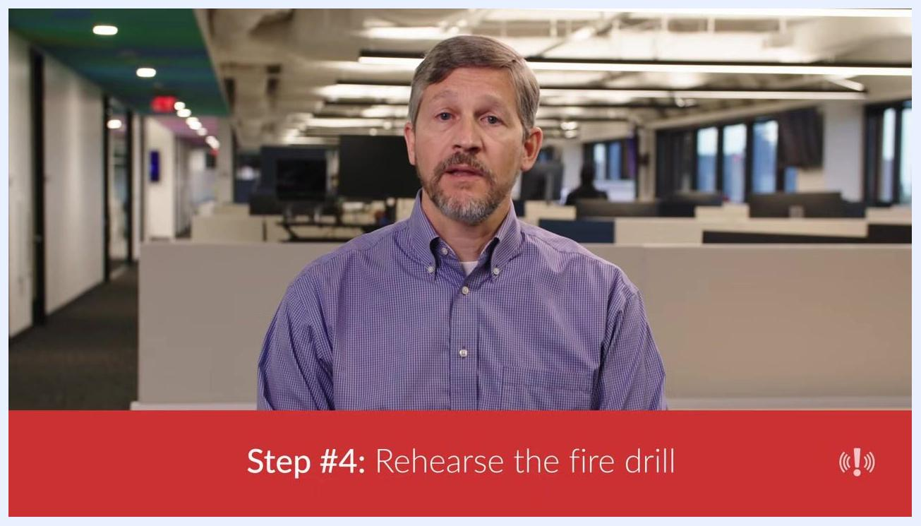
A person in a purple checkered shirt seated in front of open-plan cubicles, with a banner reading "Step #4: Rehearse the fire drill."
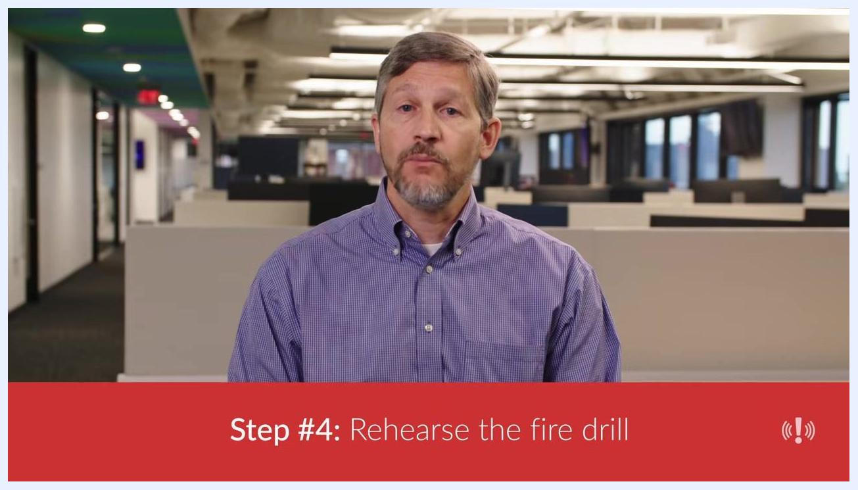
Group of people walking through an office hallway holding papers, actively participating in a fire drill rehearsal.
Employees exiting a brick office building in an orderly line during a fire drill.
A safety leader in an office environment explaining the importance of realistic fire drill scenarios.

Participants and roles
Step 1 is to ensure everyone is on board. Begin preparations well before the drill by discussing with your teams why fire drills are critical. Ensure the entire fire team is fully trained on evacuation procedures and ready to execute the drill successfully. Secure executive buy-in, since the drill will require employees to leave their workstations, factory lines, or warehouse duties. Make sure all employees understand the critical nature of the fire drill so they take it seriously.
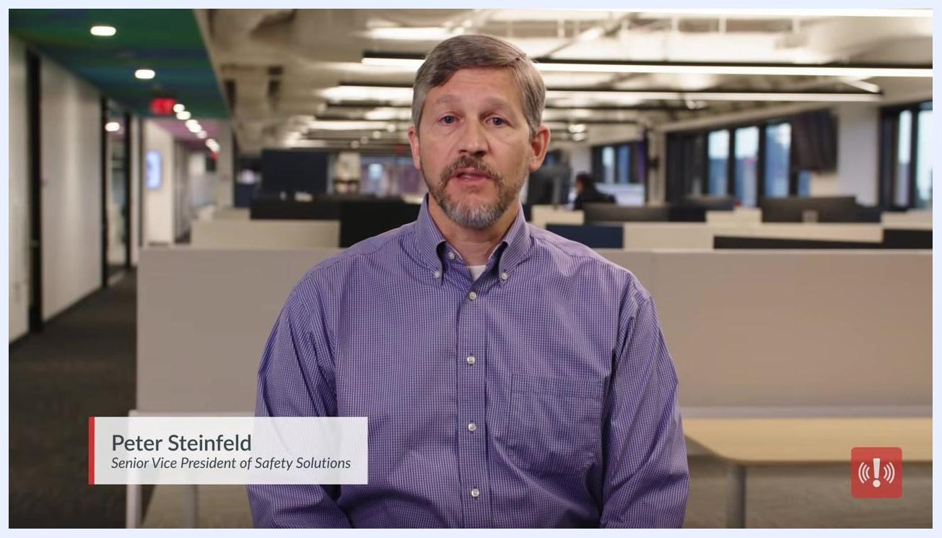
Four employees walking in a line through an office hallway, simulating an orderly fire drill evacuation.
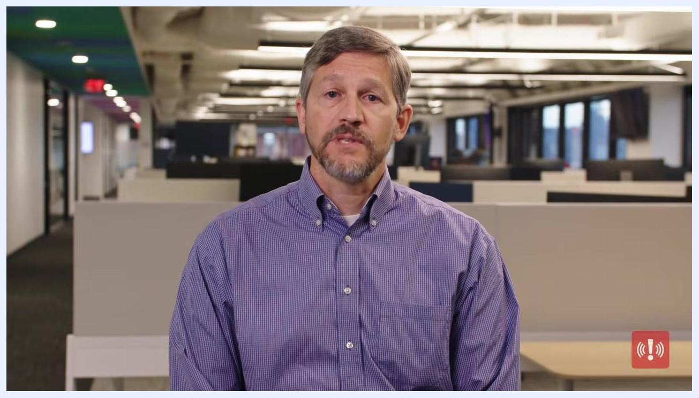
Two employees in an office reviewing a clipboard together, confirming that the fire team is trained and executive buy-in is secured.
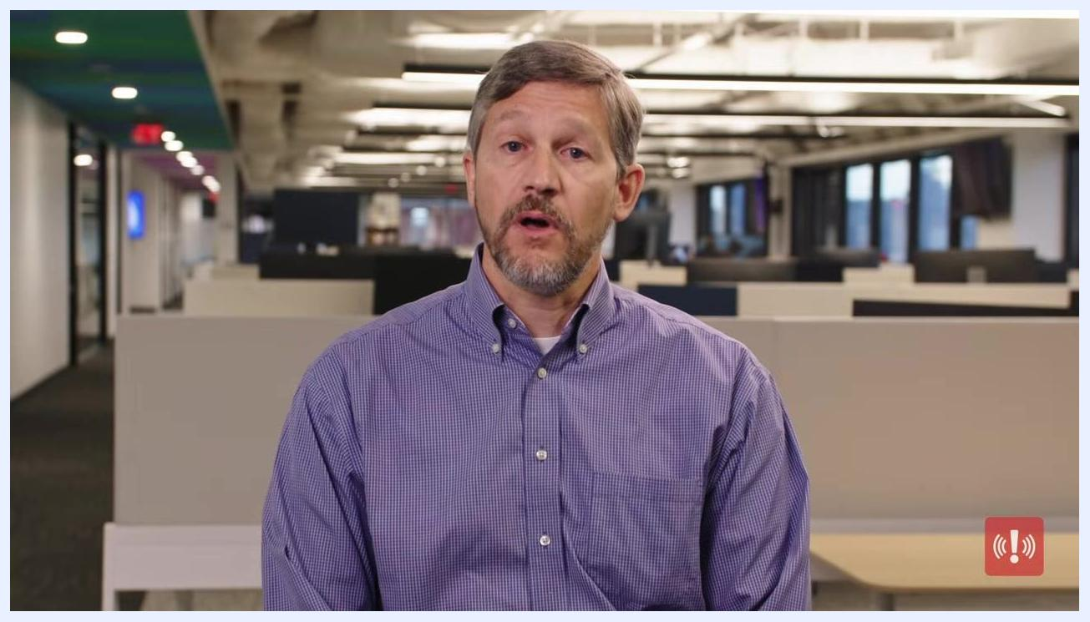
Two employees at a conference table discussing documents related to the fire drill plan.
Hold meetings or discussions to reinforce that all employees are aware of the drill's significance. If employees do not understand the importance, they may not take the drill — or your leadership — seriously.
Step 2 is to communicate your plan. Announce the first fire drill in every location where employees will see it, such as the employee portal, intranet, company website, and relevant messaging channels. Insufficient communication is a common reason drills fail — in an actual emergency, leaving even one employee uninformed and in harm's way is a massive failure.
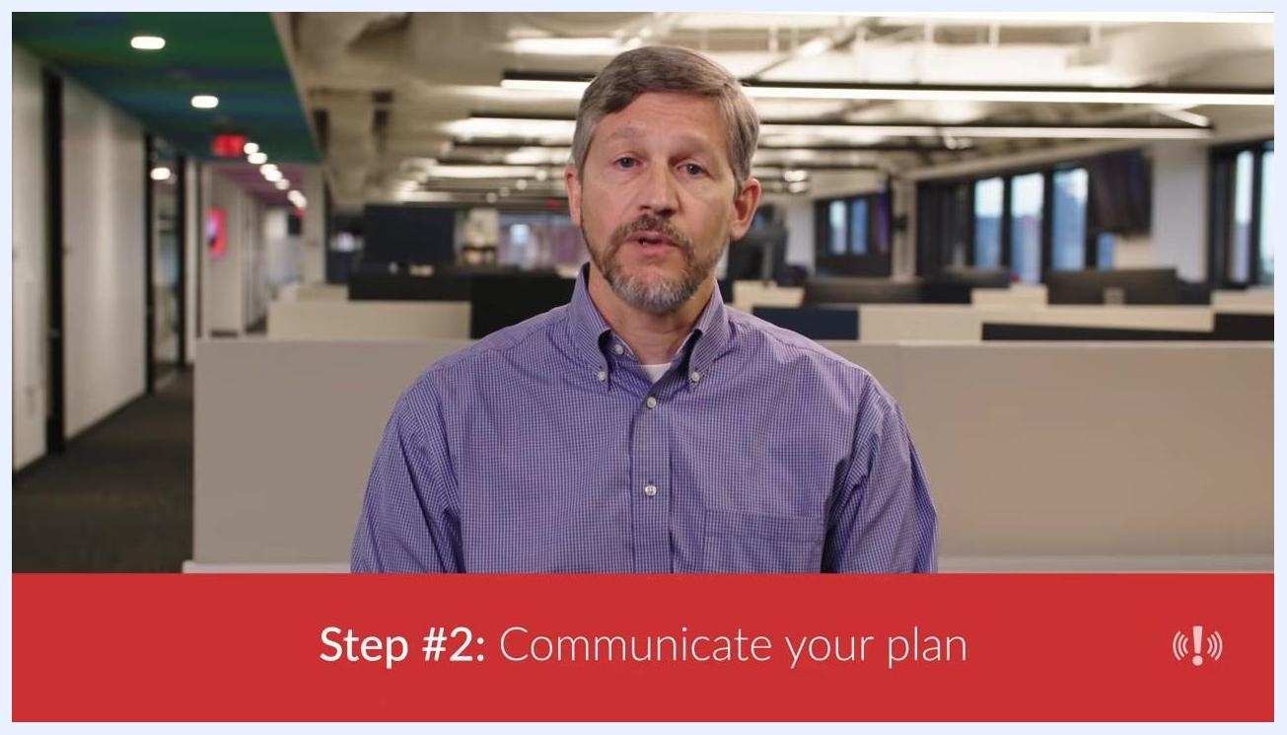
Overlay reading "Step #2: Communicate your plan" over an office setting.
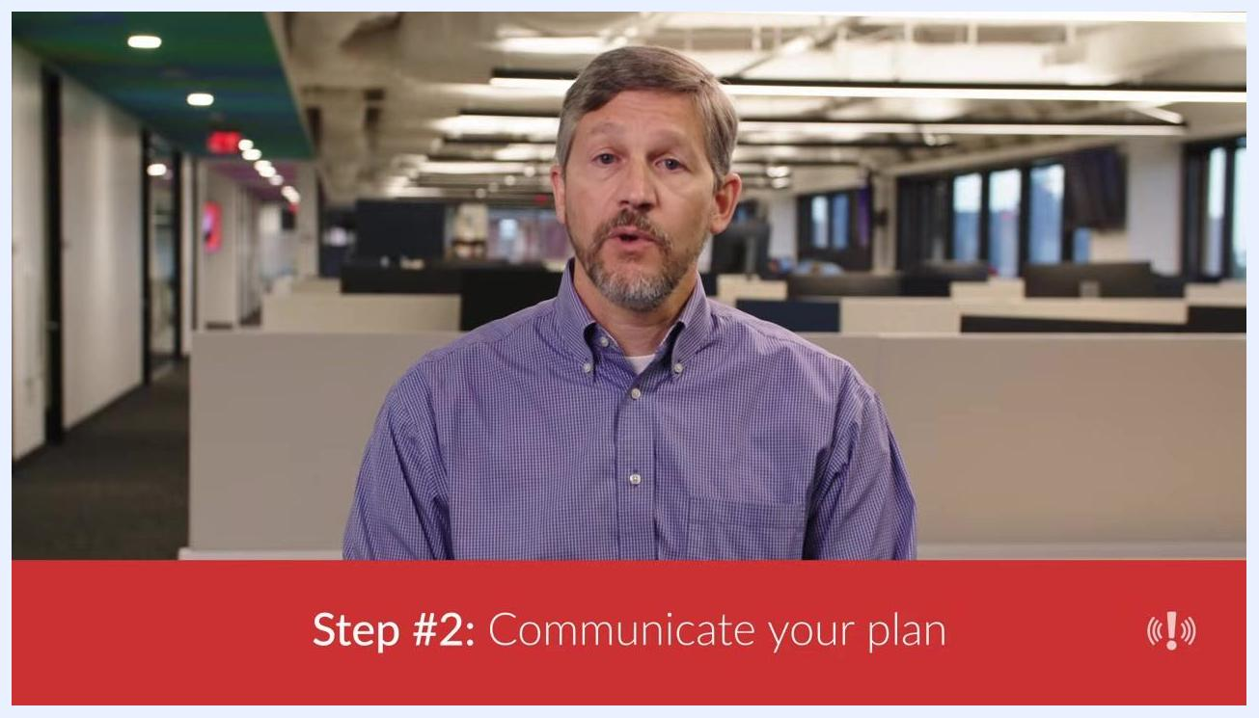
Presenter in an office with an overlay: "Step #2: Communicate your plan"
Use all available communication channels to announce the drill:
- Post notifications in the employee portal, intranet, company website, and relevant Microsoft Teams or Slack channels.
- Include the announcement in your employee newsletter.
- Send a text message using your emergency communication solution, which should support multi-channel messaging for maximum reach.
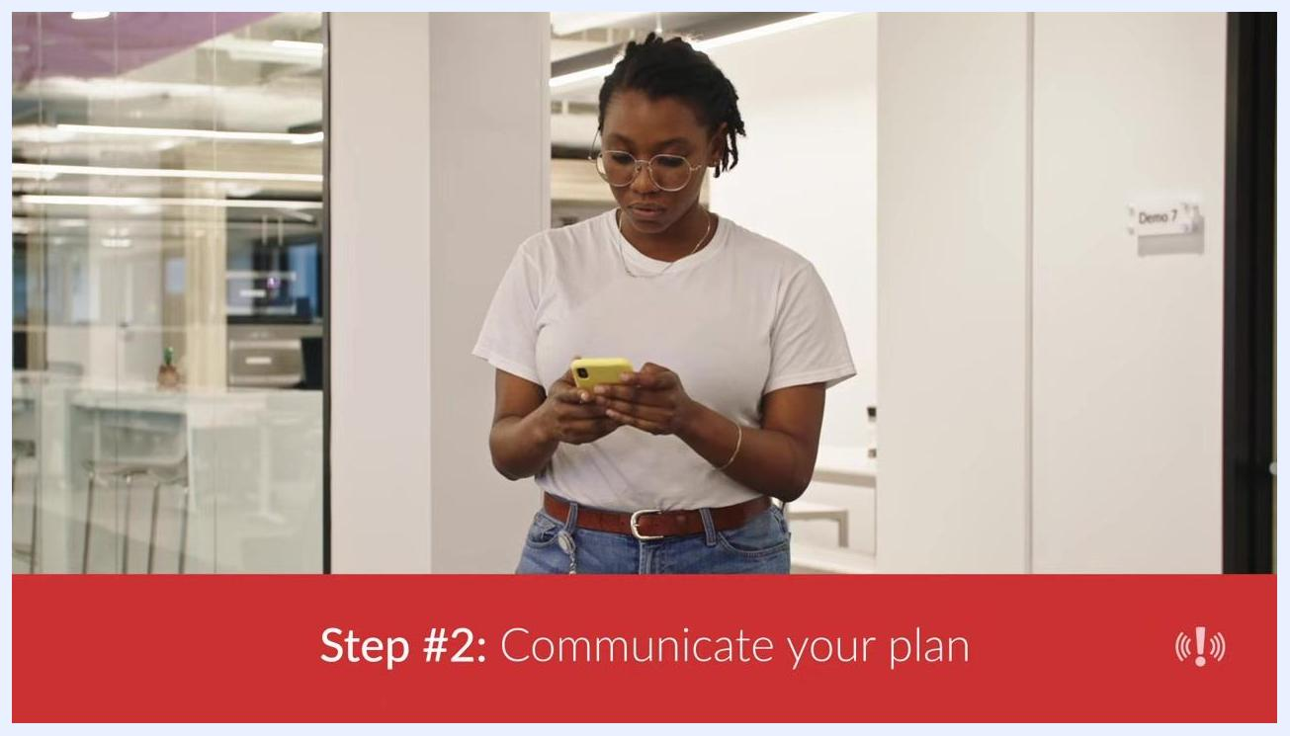
Employee in an office using a smartphone to receive fire drill communications.
Communicate additional important context: inform employees which colleagues are on the dedicated fire safety team and what their specific roles are, and share evacuation routes and employee expectations so everyone knows what to do during the drill.
Document all communications and ensure every employee receives the information through at least one channel.
Step 5 is to appoint neutral observers. Select individuals who will not participate in the drill but will observe and take notes on employee behavior (see Evaluation Plan below).
Roles summary:
- Fire safety team — trained on evacuation procedures and responsible for executing the drill.
- Executive sponsors — provide buy-in so employees are authorized to participate.
- All employees — follow evacuation routes and expectations communicated in advance.
- Neutral observers — do not participate in the drill; they monitor and record behavior for the debrief.

Safety and real-world response
The source material does not define a separate stop-drill trigger, dedicated medical support team, or emergency contact list distinct from the drill itself; document these details separately for your facility before conducting a drill.
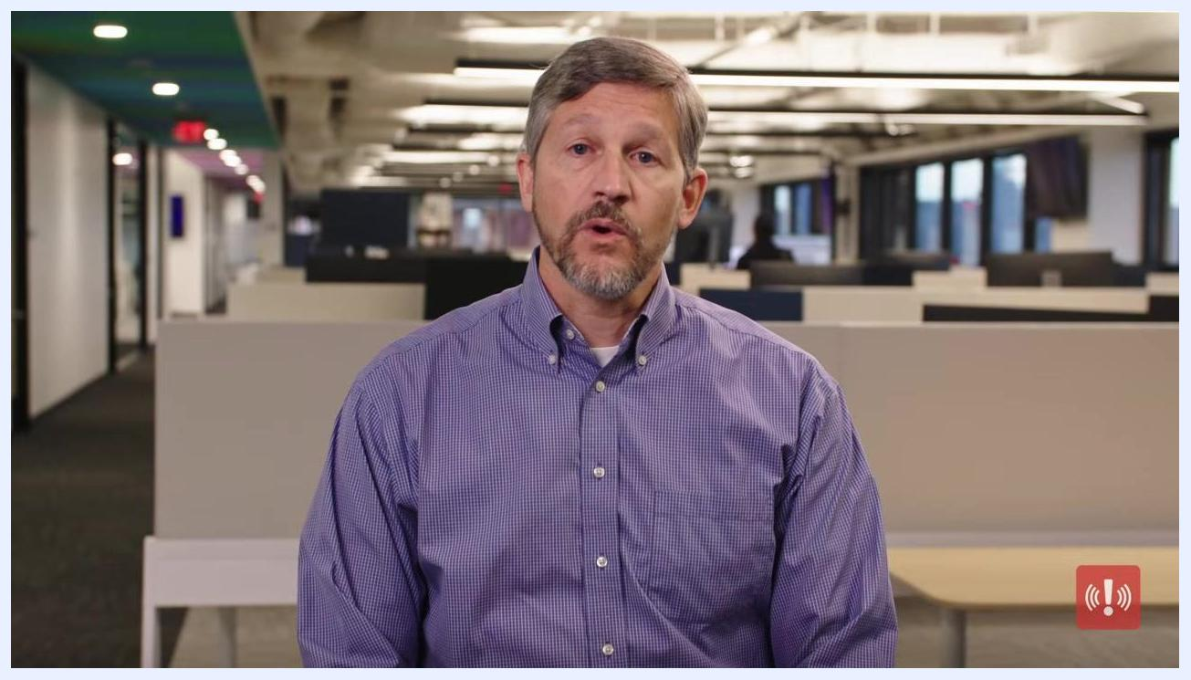
A man in a red sweater exits a conference room labeled "01" while looking at his phone. A woman in the background gathers papers. The environment is a modern office with pendant lights and a conference table. Red alert icon in the lower right.
To keep the drill clearly separated from a real emergency, confirm the fire alarm is reset and the alarm company is notified of the drill as part of your post-drill checklist. This step, reviewed during debriefing, helps ensure your monitoring service and emergency systems are not left in a triggered state after the exercise.
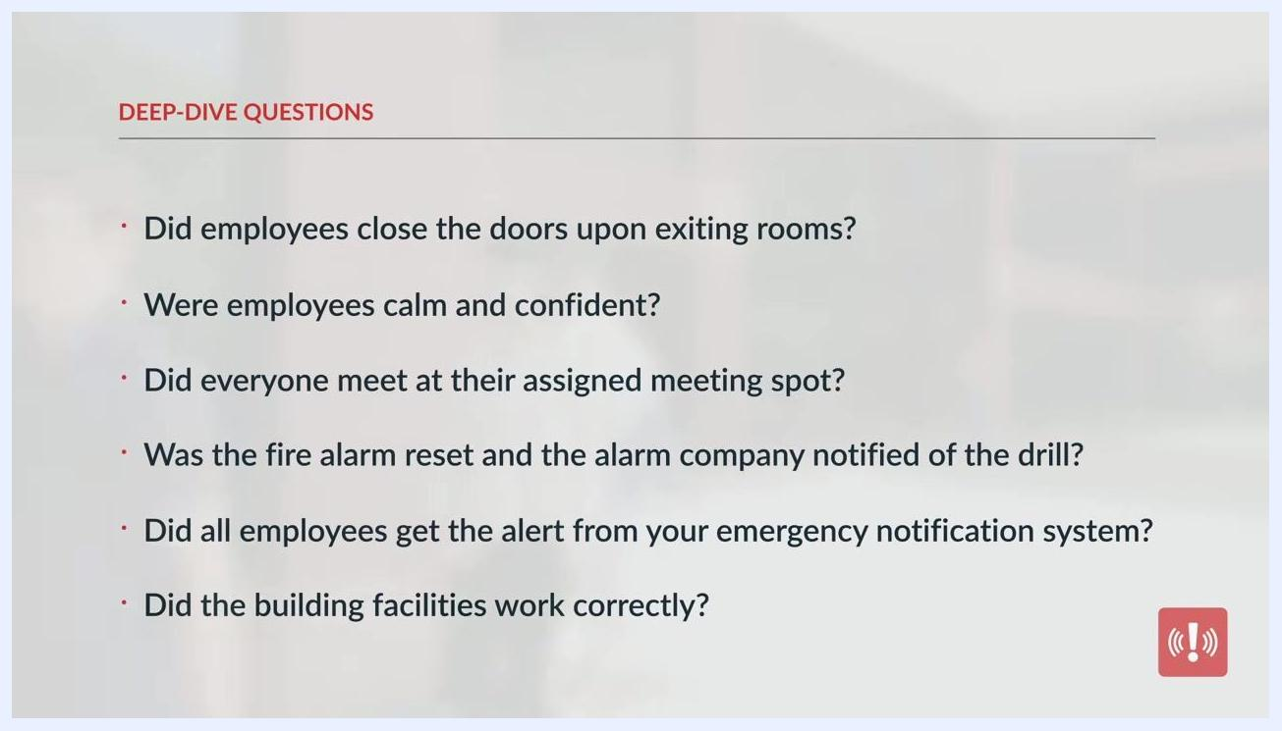
Slide titled "Other considerations," listing the value of realistic future scenarios and onboarding walk-throughs for new employees.
Consider implementing two-way, multi-channel emergency communication software — such as AlertMedia — to streamline notifications and responses both during drills and during actual emergencies, so employees can stay informed and connected before, during, and after any incident.
A person in a red sweater exits a conference room while looking at a phone, demonstrating how mobile devices are used to receive emergency alerts and instructions.

Evaluation plan
Appoint neutral observers to monitor the drill. Observers should look for:
- Large groups moving slowly or talking with each other.
- People on cell phones or using other mobile devices.
- Unhelpful behavior, such as grabbing coats, purses, and bags.
- People with disabilities experiencing difficulties exiting the facility.
- Employees who use a different exit than the one closest to their workstation.
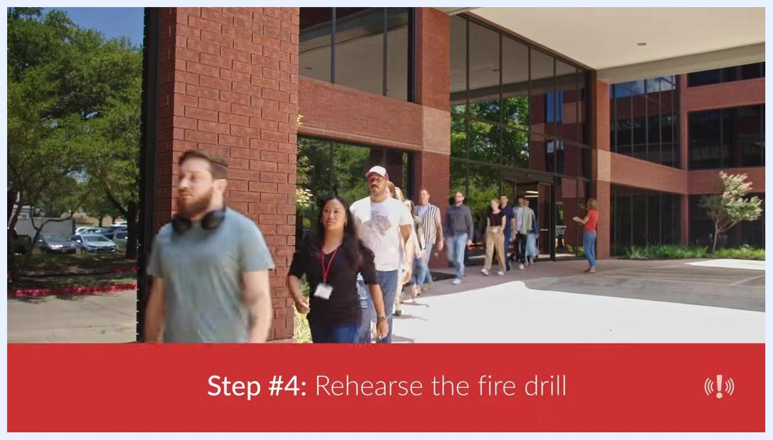
Two people in a meeting room discussing drill actions and responsibilities.
Data collection tools consist of the metrics defined in the Objectives section (time from activation to evacuation, time to report completion, and successful equipment shutdown) combined with observer notes gathered during the walk-through.
Slide titled "Metrics to measure," listing time from drill activation to evacuation, time to report completion of the drill, and successful shutdown of equipment where appropriate.
Use a checklist of deep-dive questions to guide your review:
- Did employees close the doors upon exiting rooms?
- Were employees calm and confident?
- Did everyone meet at their assigned meeting spot?
- Was the fire alarm reset and the alarm company notified of the drill?
Expand your review to include additional critical questions:
- Did all employees get the alert from your emergency notification system?
- Did the building facilities work correctly?
Scoring method: Compare recorded metrics and observer findings against the goals set in Step 3. Note gaps — such as slow evacuation times caused by employees being in restrooms or finishing calls — as specific areas for improvement.
Overlay reading "Step #4: Rehearse the fire drill" over an office setting where drill logistics are being reviewed.
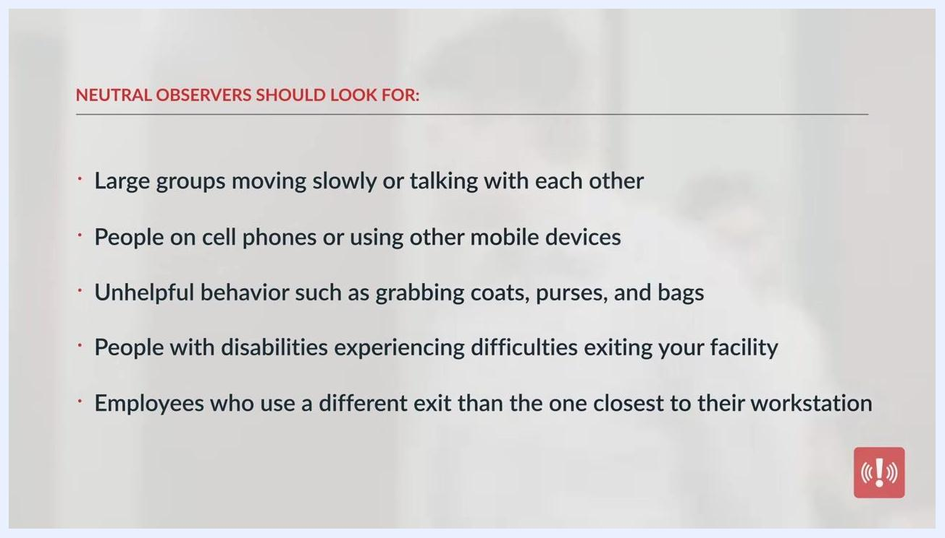
Slide listing what neutral observers should look for during a fire drill, including slow-moving groups, mobile phone use, unhelpful behavior, accessibility difficulties, and unexpected exit choices.
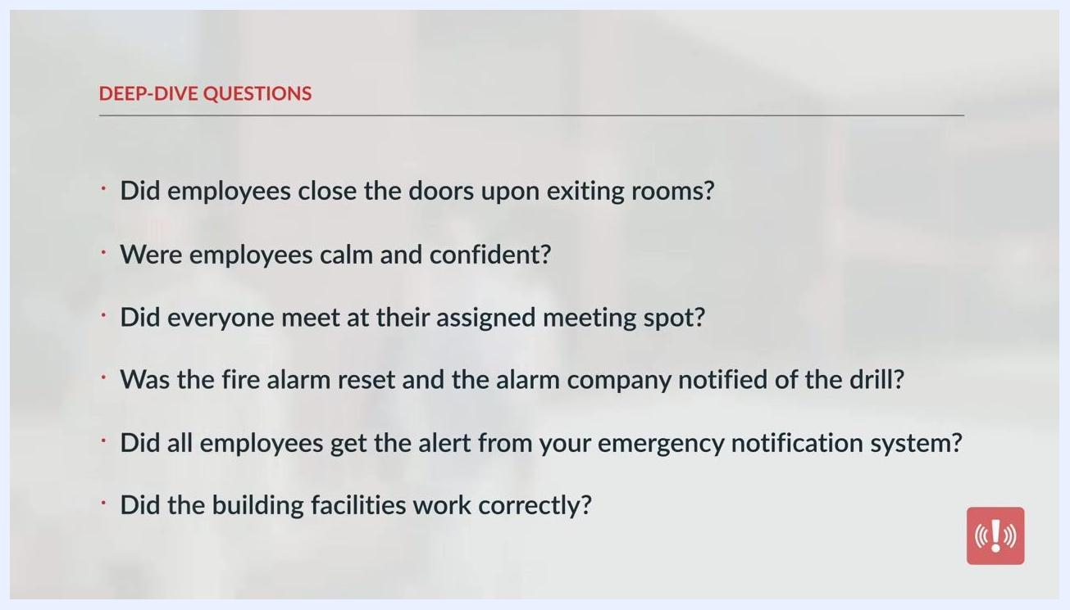
Slide listing additional deep-dive questions about the emergency notification system and building facility performance.

Debrief and improvement process
Immediately after the fire drill, gather the fire team for a debriefing session. Meet in a conference room or designated meeting area, ensure all key fire team members are present, and discuss observations while the details are still fresh.
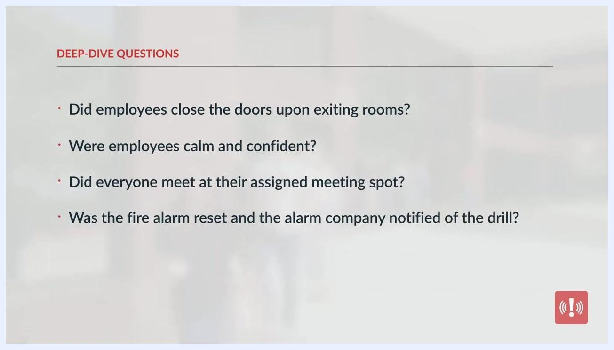
Four people seated around a conference table in a meeting room, discussing notes and observations shortly after the drill.
Assess all steps taken during the drill and compile notes. Each observer should share their findings, and the team should discuss what went well and what could be improved, using the deep-dive checklist questions listed in the Evaluation Plan section.
Slide listing deep-dive review questions about closed doors, employee composure, meeting-point compliance, and alarm reset procedures.
Ongoing best practices to build into your after-action process:
- Work in various realistic scenarios for future drills.
- Walk through the evacuation route with new employees during onboarding.
Further enhance your fire drill program by:
- Conducting drills at random times to simulate real-world scenarios.
- Scheduling drills regularly, depending on your fire risks.
- Replacing and training new fire leaders immediately following departures.
Same group in meeting room, focused on discussion and note-taking. Text overlay: "Step #5: Appoint observers"
Ensure your fire drill process remains efficient and professional by holding regular review meetings with your fire team, encouraging open feedback and continuous improvement, and demonstrating leadership and preparedness to all employees.
Recognize that evacuation skills are a crucial component of every employee's safety training program, and reinforce that preparedness and practice are essential for effective emergency response.
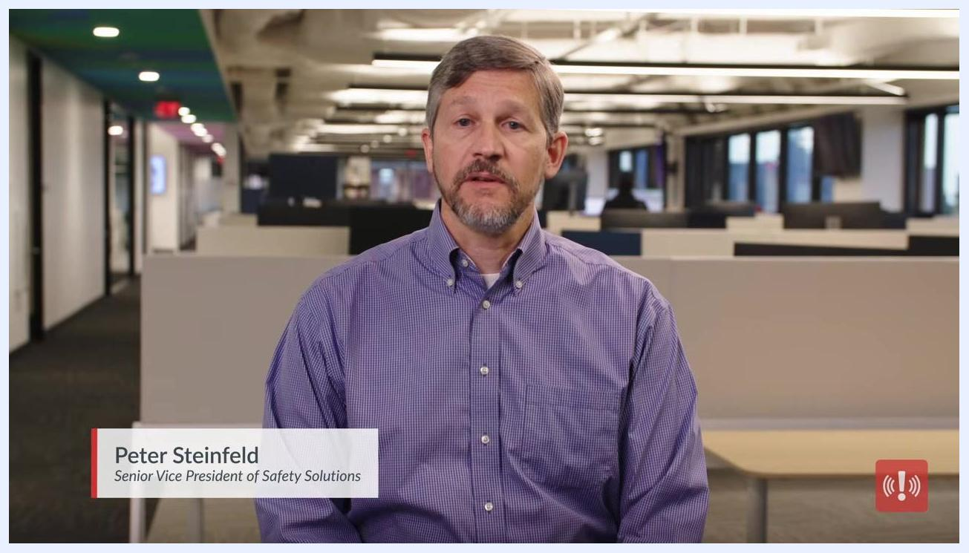
Presenter Peter Steinfeld, labeled as Senior Vice President of Safety Solutions, sitting in a modern office environment.
Successful drills and emergency activities begin with strong communication. Prioritize clear, timely communication when facilitating drills or coordinating emergency activities across your organization, and leverage available resources and support to strengthen your communication strategy over time.
Encourage employees to subscribe to safety-focused resources for regular updates and tutorials, and direct staff to additional free fire safety resources for continuous improvement.
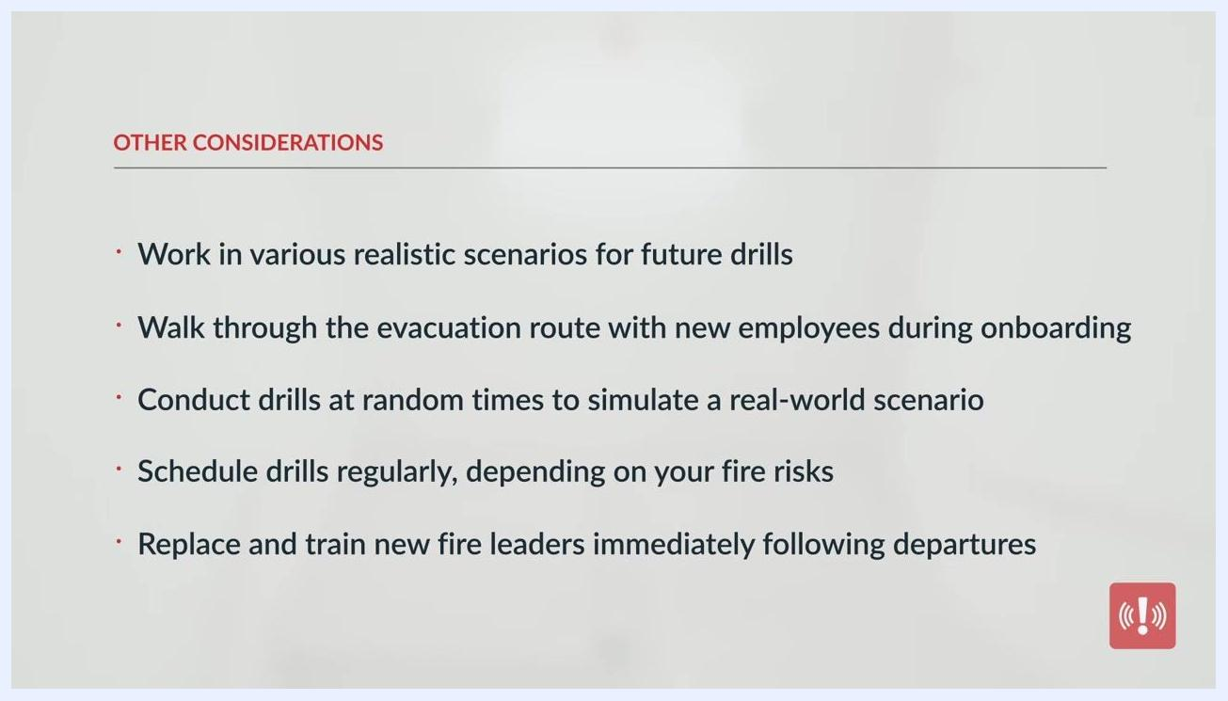
Slide titled "Other considerations," listing random drill timing, regular scheduling, and prompt replacement of fire leaders.
Four people seated around a table reviewing documents and a laptop during a fire team review meeting.
A person in a purple button-down shirt in an open office setting, with on-screen text stating that evacuation skills are a crucial component of employee training.
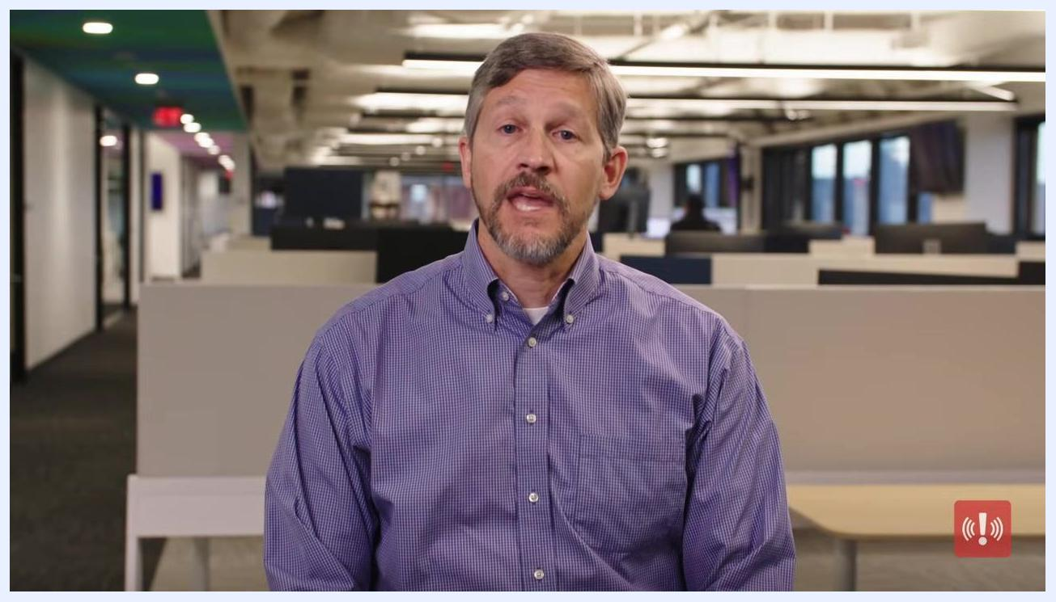
A person in a purple shirt in an office setting, with on-screen text encouraging viewers to access more employee safety tutorials.

What's next
After completing your first fire drill and debrief, schedule your next drill at a random time to simulate a real-world scenario, incorporate the realistic variations and obstacles noted during rehearsal, and confirm that any departing fire team leaders have been replaced and trained before the following exercise.
Presenter Peter Steinfeld in an office, emphasizing the reality of workplace disasters.
The man continues speaking in the same office environment. No new on-screen text, red alert icon remains in the lower right.
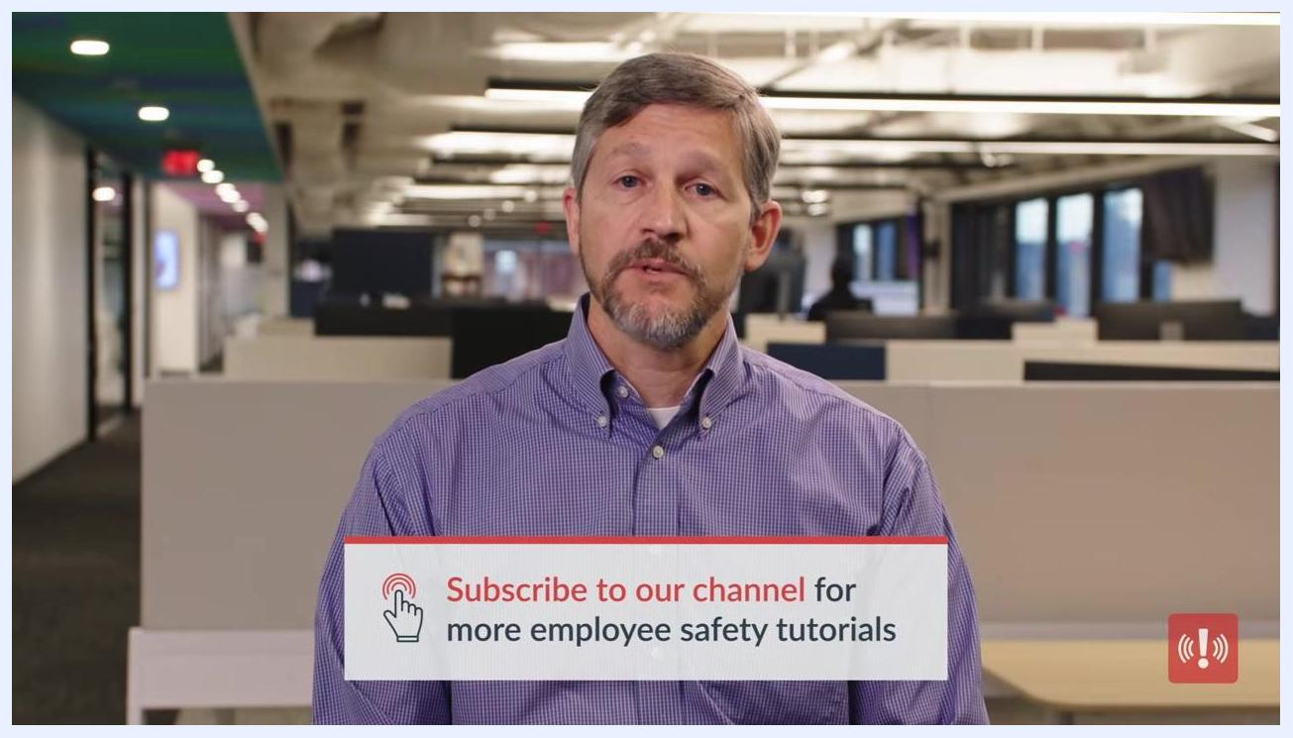
The same man continues speaking, with the same on-screen text and red alert icon as the previous frame.
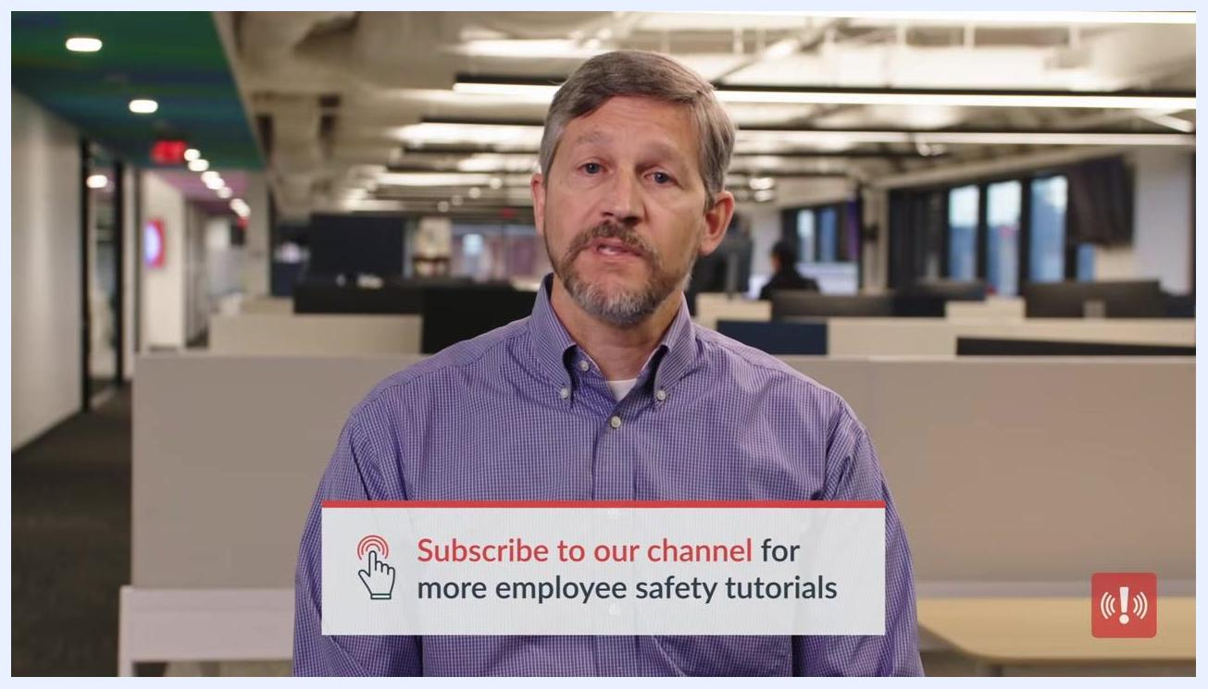
A white screen displays the AlertMedia logo, tagline "Keep Your People Safe, Informed, and Connected," and the website "alertmedia.com".

