5S Audit Checklist
A 5S audit checklist is the primary tool used to evaluate and sustain the fifth pillar of the 5S methodology, "Sustain." This document explains how to build, apply, and maintain a 5S audit checklist so that workplace organization standards are verified consistently, objectively, and with minimal disruption to daily operations. Use this checklist framework whenever you plan, schedule, or conduct a 5S (or extended 6S) audit in your area.

Scope & Purpose
This checklist applies to any area covered by an implemented 5S system and is used to verify ongoing compliance with 5S standards, not to assign blame.
Key principles that define the scope of a 5S audit:
- An audit is not the same as control. An audit is carried out based on a plan, and its aim is to ensure compliance with the implemented system.
- The purpose of an audit is to maintain implemented standards and drive continuous improvement.
- The purpose of control, by contrast, is to find irregularities and punish those responsible — this is not the intent of a 5S audit.
- The audit is connected with the area being reviewed, not with specific people or processes.
- The most important feature of a 5S audit is independence, which comes from the auditor's objectivity.
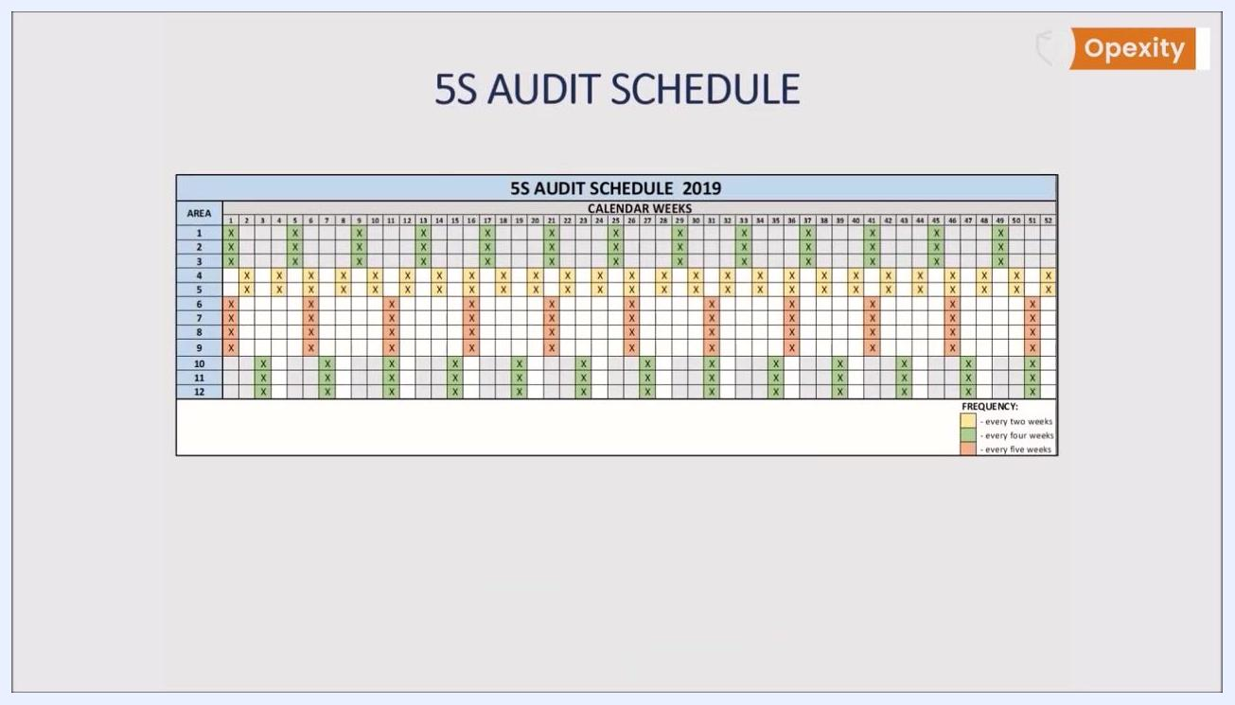
Comparison slide showing audit versus control: audits pursue continuous improvement, seek improvements, remain objective, and require knowledge of the 5S system, while controls pursue disposable improvement, look for the guilty, are subjective, and may lack knowledge of standards
Use this checklist on a regular, recurring basis rather than as a one-time event, since audits only achieve their desired results when performed consistently across every area covered by the 5S system.

Reference Documents
Before conducting an audit, confirm the following reference materials are current and available:
- 5S Audit Schedule — a plan indicating a general time frame (week number or month) for auditing each area. Avoid overly precise dates so the schedule remains flexible and supports daily, organization-wide improvement rather than improvement limited to scheduled events.
- Current 5S standards for each audited area — auditors must have knowledge of these standards and understand the principles of the 5S system.
- 5S Audit Form — the checklist document used during the audit itself (detailed below).
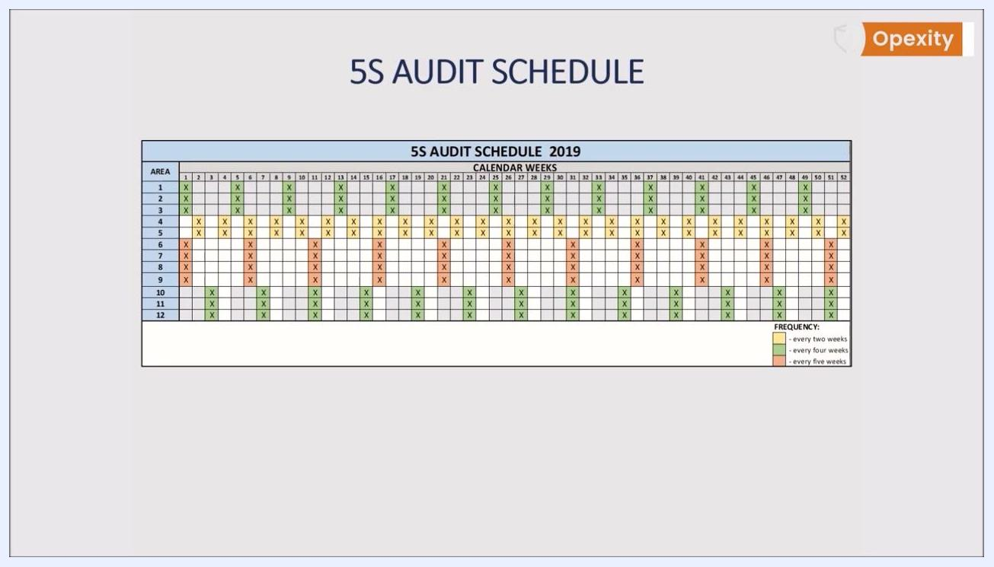
5S Audit Schedule table repeated with areas, calendar weeks, and color-coded audit frequencies
Color coding on the schedule communicates frequency at a glance:
- Green: audit every two weeks
- Yellow: audit every four weeks
- Orange: audit every five weeks
Share the schedule with all relevant personnel so everyone understands when audits may occur, while emphasizing that it is a guideline rather than a strict timetable.

Equipment Required
No specialized measuring instruments are needed to conduct a 5S audit. The essential tools are documentation-based:
- 5S Audit Form — prepared in advance, simple and not overly complicated, to maximize effectiveness.
- Scoring key — a defined key stating the number of points assigned to each desired state (for example, 0 = standard does not exist, 5 = standard observed everywhere).
- Sufficient time allotted per area: the audit should be designed to be completed in several minutes to several dozen minutes, depending on the size of the area.
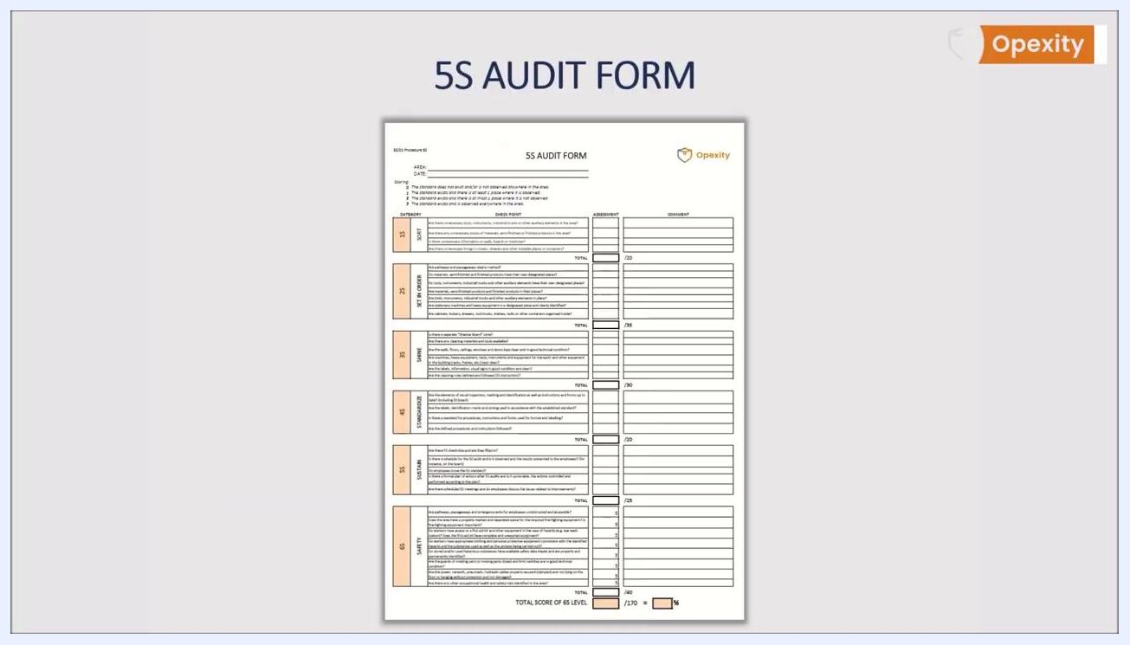
5S Audit Form template showing fields for area, date, a scoring key, and checklist questions
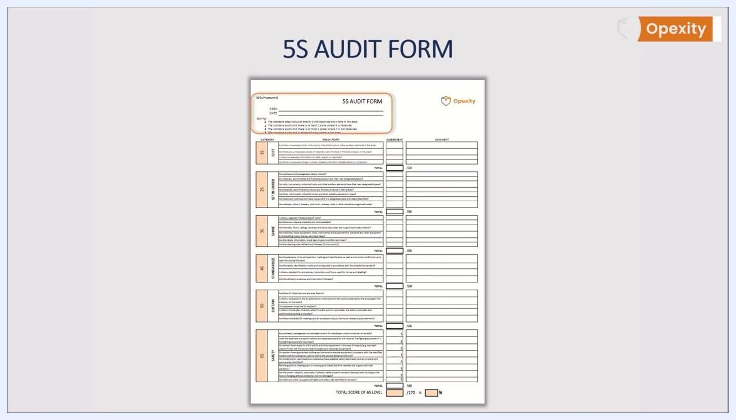
Detailed 5S Audit Form showing checklist questions, scoring, area and date fields, and comment sections
The form should contain all elements needed for a self-contained audit: area and date fields, clear scoring criteria, checklist questions for each 5S category, assessment and comment sections, and a total score calculation for the overall 5S level.
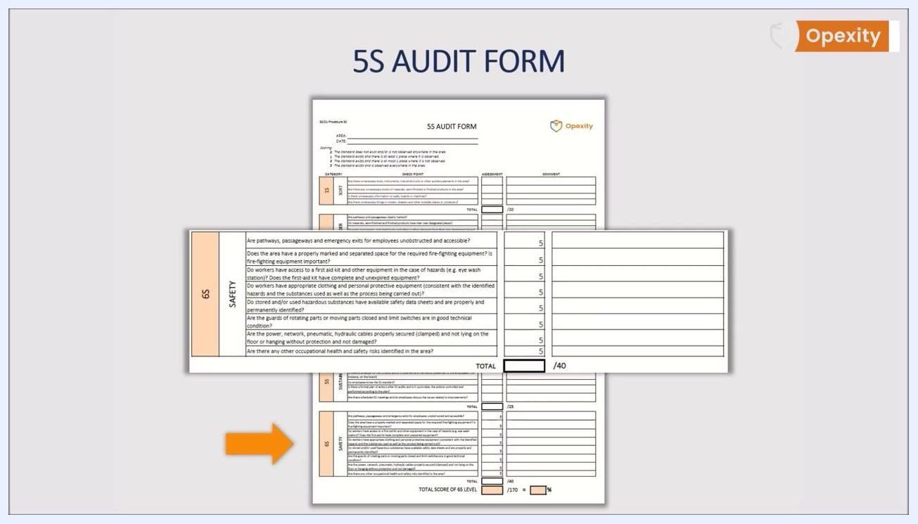
Zoomed-in overlay of the 6S Safety section showing detailed safety questions and scoring columns

Inspection Points
Divide the 5S audit checklist into five thematic sections corresponding to the 5S methodology, each with targeted questions used to objectively assess compliance.

1S – Sort
Characteristic | Specification | Method (example question) | Sample scope
Sort | No unnecessary tools, instruments, industrial trucks, or auxiliary elements present | Are there unnecessary tools, instruments, industrial trucks, or other auxiliary elements in the area? | Whole audited area
Sort | No unnecessary stock | Are there any unnecessary stocks of materials, semi-finished, or finished products in the area? | Whole audited area
Sort | No unnecessary information displayed | Is there unnecessary information on walls, boards, or machines? | Walls, boards, machines
Sort | No unnecessary items stored | Are there unnecessary things in closets, drawers, and other lockable places or containers? | Closets, drawers, containers
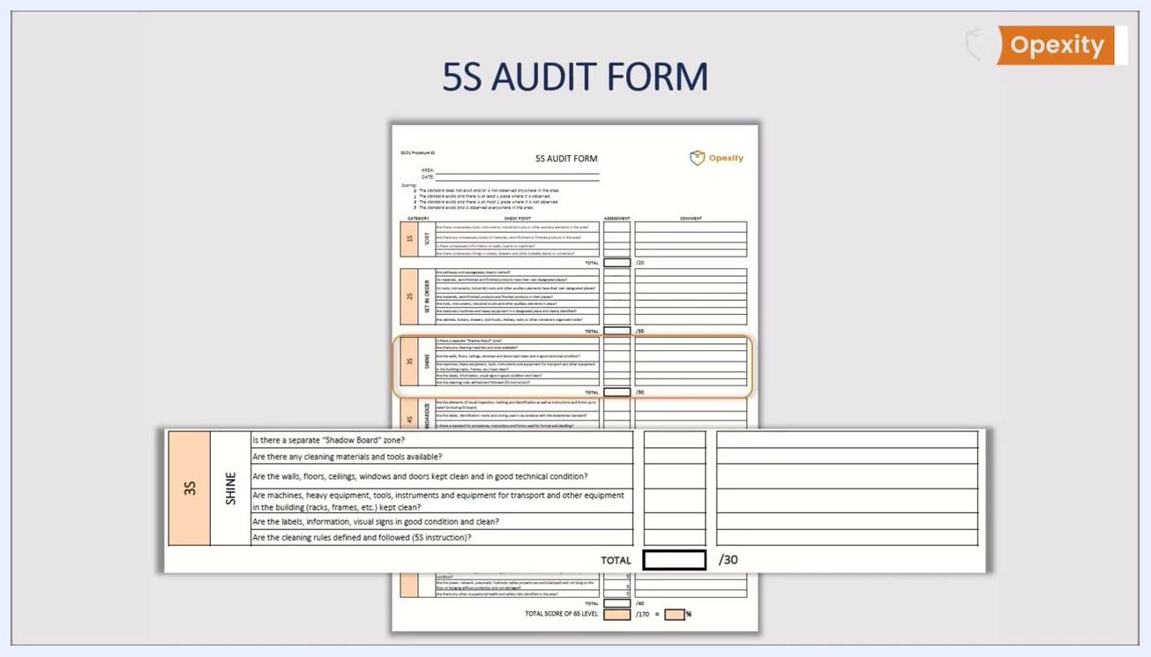
5S Audit Form checklist for 3S (Shine) with questions about cleaning tools, cleanliness, and technical condition, plus assessment and comment fields

2S – Set in Order
Characteristic | Specification | Method (example question) | Sample scope
Set in Order | Pathways clearly marked | Are pathways and passageways clearly marked? | Floor markings
Set in Order | Designated storage locations exist | Do materials, semi-finished, and finished products have their own designated places? | Storage areas
Set in Order | Tools and equipment have assigned places | Do tools, instruments, industrial trucks, and other auxiliary elements have their own designated places? | Tool storage
Set in Order | Items located correctly | Are materials, semi-finished products, and finished products in their places? | Storage areas
Set in Order | Machines and equipment identified | Are stationary machines and heavy equipment in a designated place and clearly identified? | Machine locations
Set in Order | Organized containers | Are cabinets, lockers, drawers, tool trucks, shelves, racks, or other containers organized inside? | Storage furniture
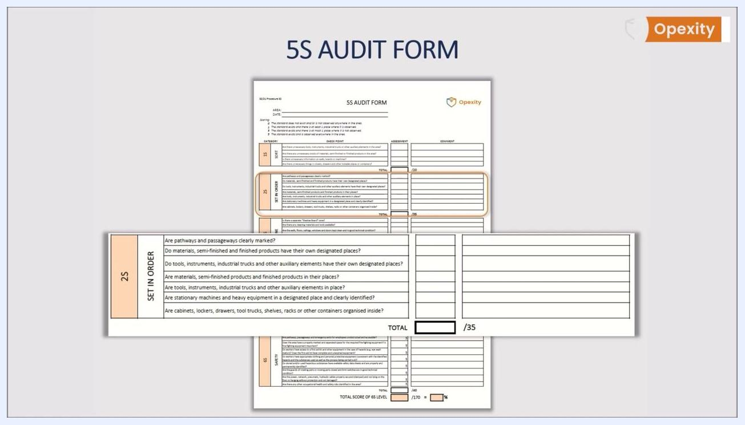
5S Audit Form checklist for 1S (Sort) with questions about unnecessary items, stocks, and information, plus assessment and comment fields

3S – Shine
Characteristic | Specification | Method (example question) | Sample scope
Shine | Shadow board zone exists | Is there a separate "Shadow Board" zone? | Tool area
Shine | Cleaning supplies available | Are there any cleaning materials and tools available? | Cleaning stations
Shine | Facility in clean, good condition | Are the walls, floors, ceilings, windows, and doors kept clean and in good technical condition? | Whole area
Shine | Equipment kept clean | Are machines, heavy equipment, tools, instruments, and equipment for transport kept clean? | Machines and equipment
Shine | Signage clean and legible | Are the labels, information, and visual signs in good condition and clean? | Signage
Shine | Cleaning rules followed | Are the cleaning rules defined and followed (5S instruction)? | Cleaning procedure
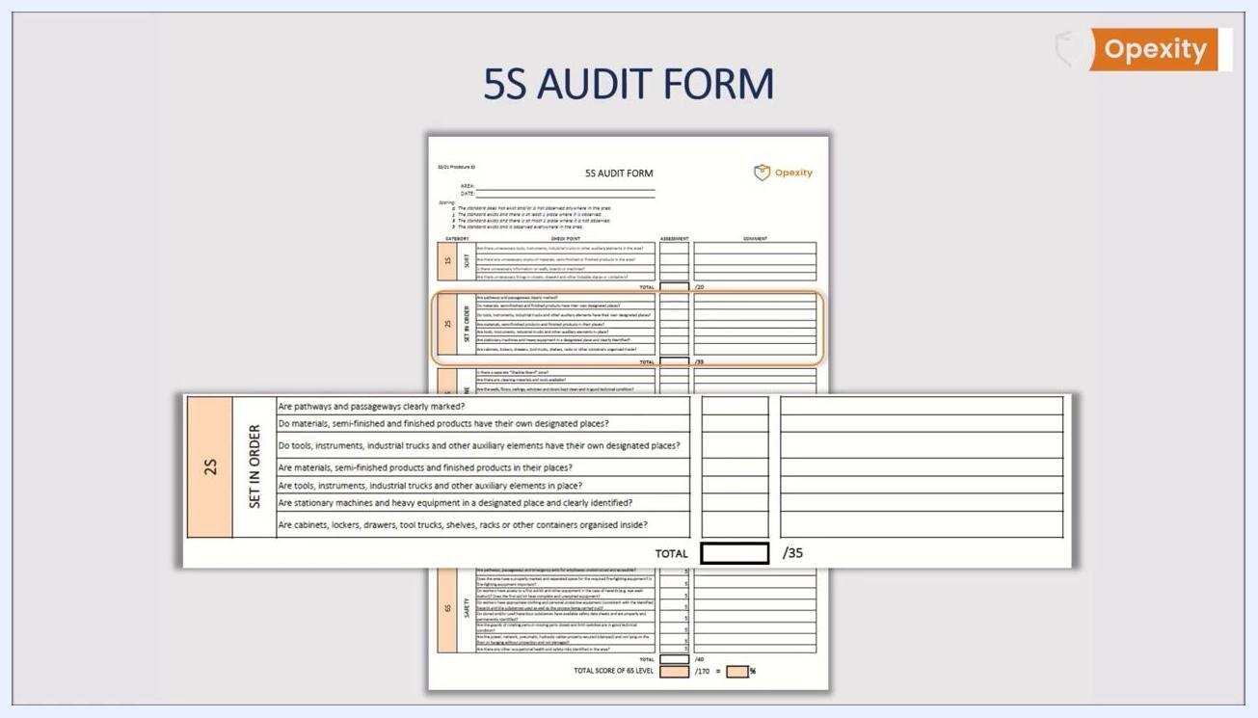
5S Audit Form checklist for 2S (Set in Order) with questions about item placement, marking, and organization, plus assessment and comment fields

4S – Standardize
Characteristic | Specification | Method (example question) | Sample scope
Standardize | Visual controls up to date | Are the elements of visual inspection, marking, and identification, as well as instructions and forms, up to date (including the 5S board)? | 5S board, instructions
Standardize | Labeling matches standard | Are the labels, identification marks, and zoning used in accordance with the established standard? | Labels and zoning
Standardize | Standard exists for forms/labels | Is there a standard for procedures, instructions, and forms used for format and labeling? | Documentation
Standardize | Procedures followed | Are the defined procedures and instructions followed? | Work practice
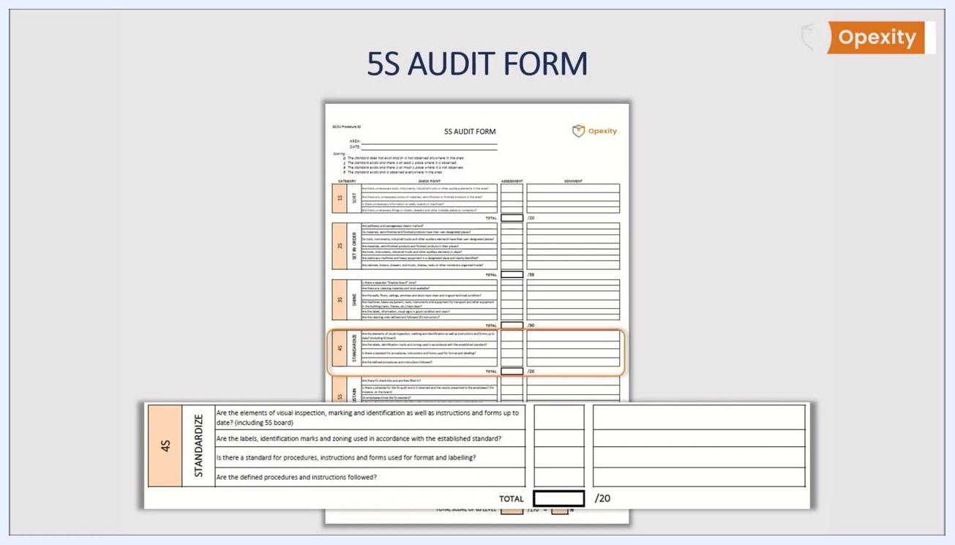
5S Audit Form checklist for 4S (Standardize) with questions about standards, labeling, and procedure adherence, plus assessment and comment fields

5S – Sustain
Characteristic | Specification | Method (example question) | Sample scope
Sustain | Checklists filled in | Are there 5S check-lists and are they filled in? | Audit records
Sustain | Audit schedule observed | Is there a schedule for the 5S audit and is it observed and the results presented to the employees (e.g., on the board)? | Audit schedule
Sustain | Standards known | Do employees know the 5S standard? | Employee interviews
Sustain | Action plan maintained | Is there a formal plan of actions after 5S audits, and is it up-to-date, with actions controlled and performed according to the plan? | Action plan
Sustain | Meetings held | Are scheduled 5S meetings held and do employees discuss issues related to improvements? | Meeting records
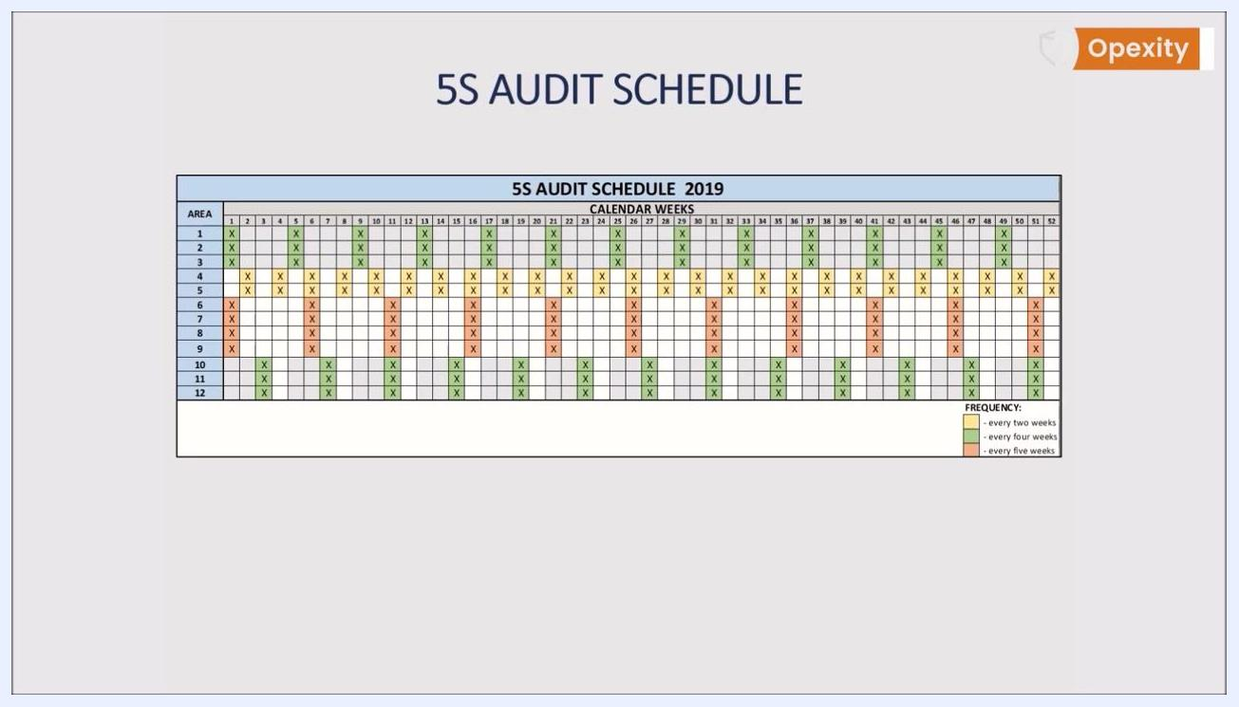
5S Audit Schedule table listing areas and calendar weeks, with color-coded audit frequencies of every two, four, or five weeks

Set in Order / Safety – Fire and emergency marking
Characteristic | Specification | Method (example question) | Sample scope
Set in Order | Emergency equipment correctly marked | Are fire extinguishers, hydrants, and emergency exits correctly marked and accessible? | Emergency equipment locations
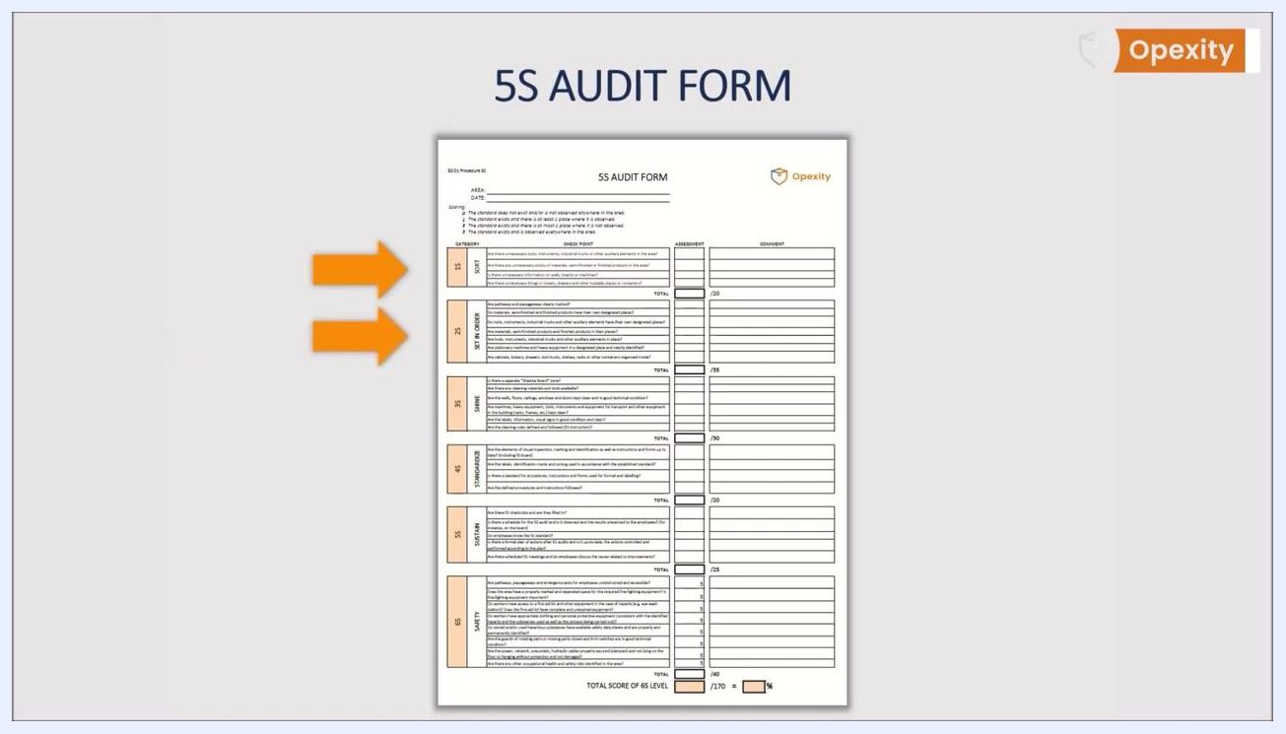
5S Audit Form with arrows pointing to the Set in Order and Safety sections, highlighting fire safety questions

Ergonomics
Characteristic | Specification | Method (example question) | Sample scope
Safety/Ergonomics | Workstation ergonomics addressed | Are ergonomic practices and workstation setup evaluated as part of the audit? | Individual workstations
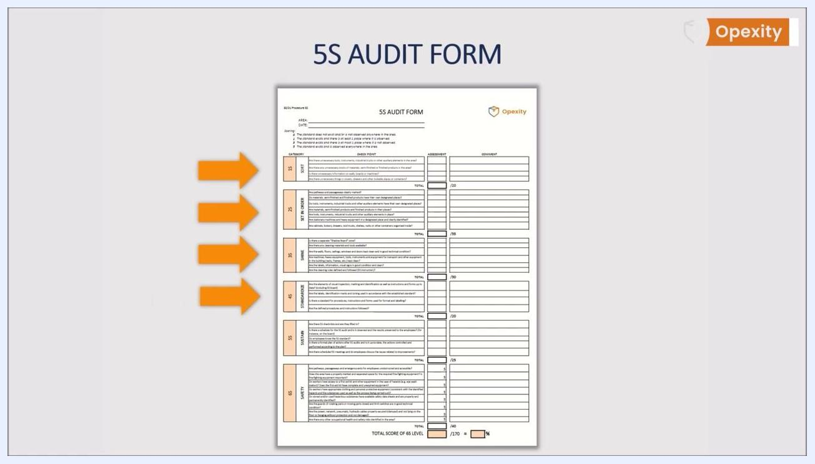
5S Audit Form with multiple arrows highlighting sections related to ergonomics and safety

Safety
Characteristic | Specification | Method (example question) | Sample scope
Safety | No new security risks | Have no additional security risks been identified? | Whole area, reviewed each cycle
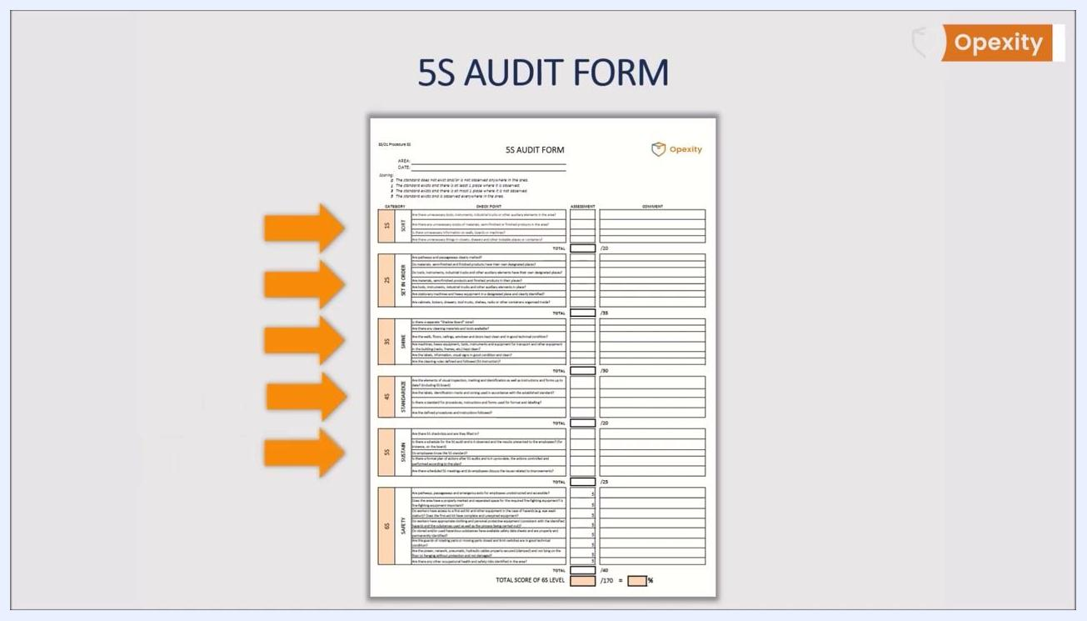
5S Audit Form with arrows highlighting the Safety section and its questions about security risks

6S Safety (extended audit)
When your organization extends the 5S audit checklist to include a dedicated Safety category, add a 6S SAFETY section, clearly separated and highlighted like the other categories, with its own scoring column and comment area.
5S Audit Form on a neutral background showing all sections including the new 6S Safety section
Characteristic | Specification | Method (example question) | Sample scope
6S Safety | Pathways and exits unobstructed | Are pathways, passageways, and emergency exits for employees unobstructed and accessible? | Emergency routes
6S Safety | Fire-fighting equipment marked | Does the area have a properly marked and separated space for the required fire-fighting equipment? Is fire-fighting equipment present? | Fire safety points
6S Safety | First aid equipment complete | Do workers have access to a first aid kit and other hazard equipment (e.g., eye wash station)? Does the first aid kit have complete, unexpired equipment? | First aid stations
6S Safety | PPE appropriate | Do workers have appropriate clothing and personal protective equipment consistent with identified hazards, substances used, and the process carried out? | Workers on site
6S Safety | Safety data sheets available | Do stored and/or used hazardous substances have available safety data sheets, properly and permanently identified? | Chemical storage
6S Safety | Machine guards intact | Are the guards of rotating or moving parts closed, and are limit switches in good technical condition? | Machinery
6S Safety | Cables secured | Are power, network, pneumatic, and hydraulic cables properly secured (clamped), not lying on the floor, not hanging unprotected, and undamaged? | Cabling and lines
6S Safety | Other OHS risks | Are there any other occupational health and safety risks identified in the area? | Whole area
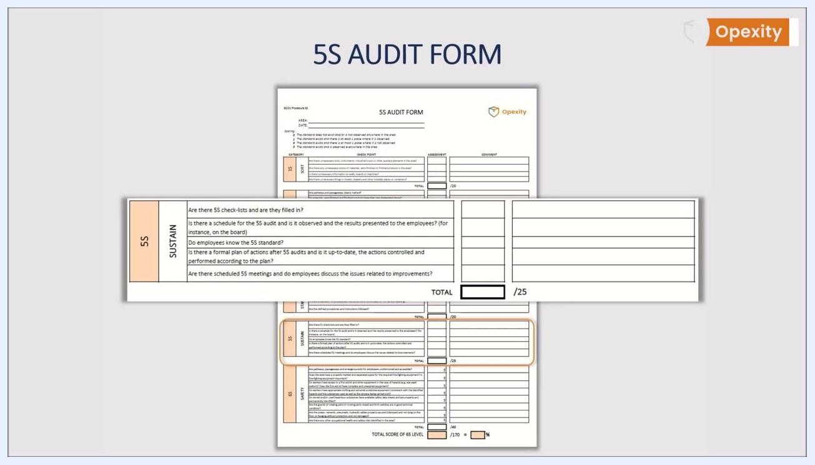
5S Audit Form with the Sustain section in focus, showing assessment and comment columns

Acceptance Criteria
Score each checklist item according to the defined scoring key, where 0 indicates the standard does not exist and 5 indicates the standard is observed everywhere. Assign a scoring value (for example, 5 points) to each question.
- Calculate a total score for each of the five (or six) categories.
- Sum category scores into a total score representing the overall 5S (or 6S) level of the area.
- For the 6S Safety section specifically, calculate its own subtotal (for example, out of 40 points) and add it to the overall audit score for a comprehensive 6S evaluation.
White background with the website URL "www.opexity.com" centered in black text

Non-Conformance Handling
When a checklist item is scored below the desired state, follow these steps:
- Record the assessment and comments for the specific question in the comment section of the audit form.
- Present the audit findings to the team after each audit rather than holding them back.
- Use the comment section to note feedback or discussion points raised during that review.
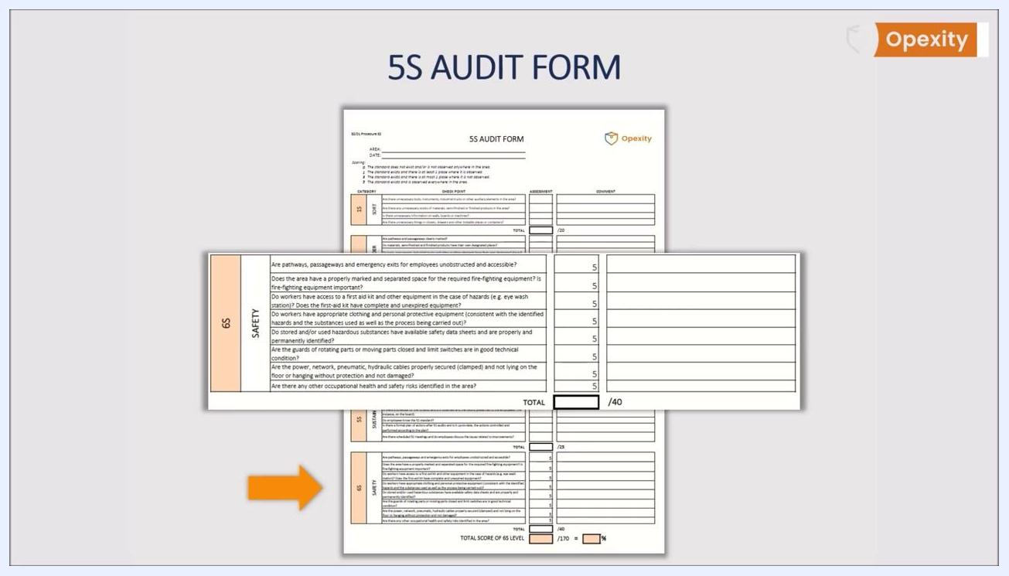
Close-up of the 6S Safety section showing all safety questions, scoring, and comment fields
- Maintain a formal, up-to-date plan of actions following each 5S audit.
- Ensure actions identified in the plan are controlled and performed according to schedule.
- Track whether suggestions and improvements identified during the audit are actually put into practice.
- Hold scheduled 5S meetings so employees can discuss issues related to improvements and non-conformances.
- Regularly review and update the Safety section to address any newly identified risks, making this part of every audit cycle.
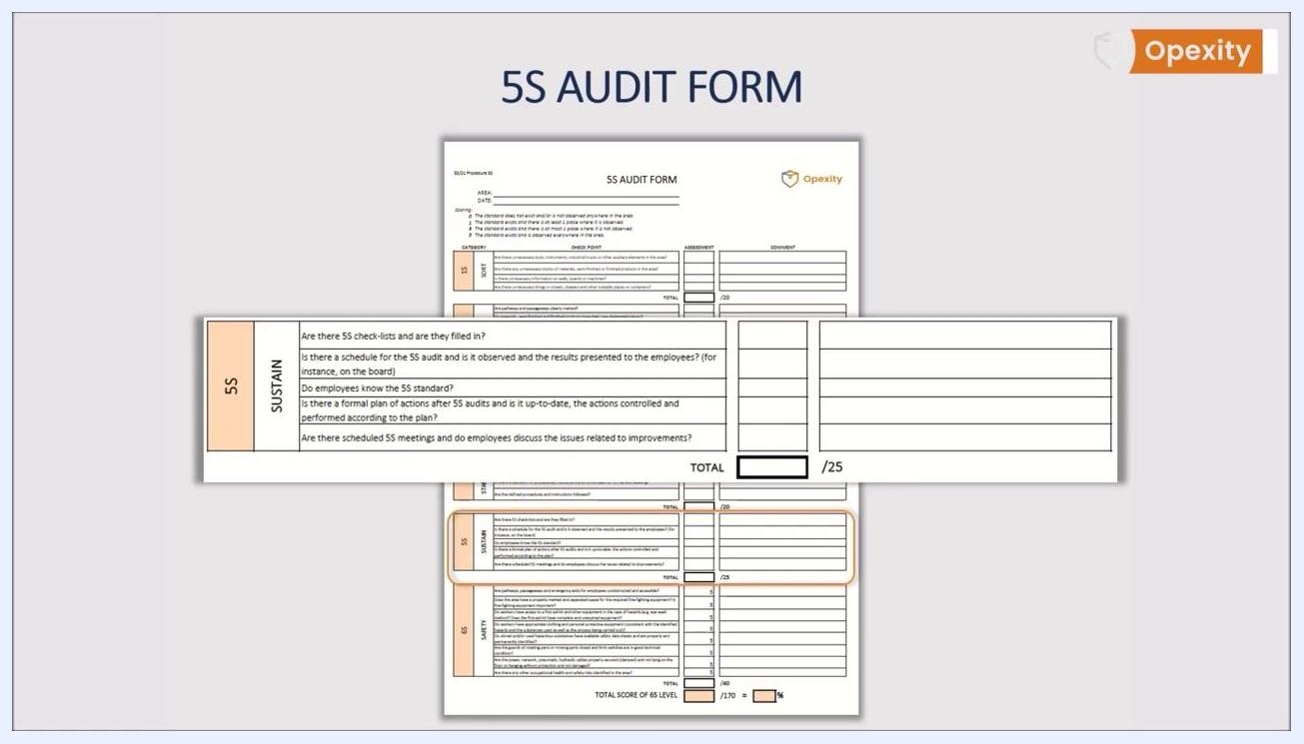
5S Audit Form with the Sustain section in focus, showing checklist items, assessment column, and comment section

Record Keeping
Keep the audit form concise — ideally limited to one A4 page — for clarity and ease of use.
Make the form simple, transparent, and understandable for all employees, using clear language and a logical structure so it is accessible to everyone in the company.
Traceability requirements for the completed form:
- AREA field identifying the location audited.
- DATE field recording when the audit took place.
- Scoring key referenced on the form for consistent interpretation of results.
- Comment fields documenting observations, safety concerns, corrective actions, or follow-up requirements for each category.
- Total score section for each category and a final total score at the bottom of the form.
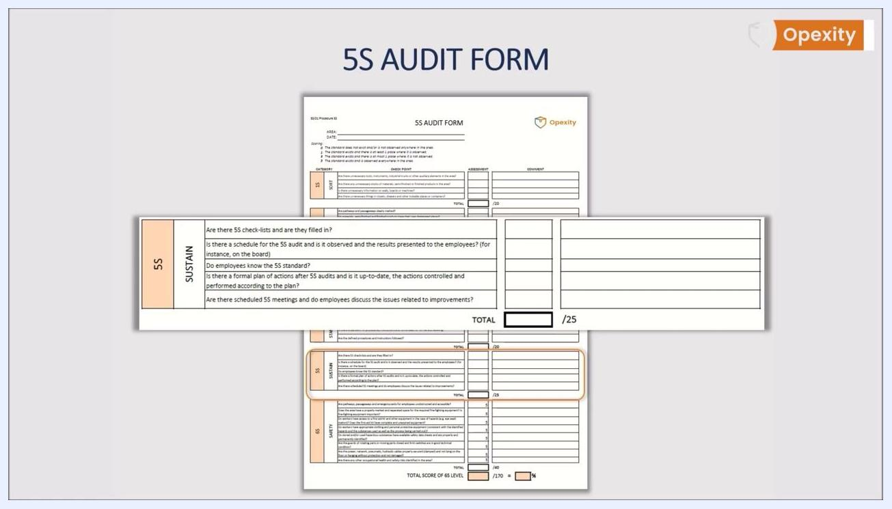
Example of a completed 5S Audit Form fitting on a single A4 page
For additional templates or guidance on building out a 5S or 6S audit form, refer to the resource materials provided by your audit form creator.
Full 5S Audit Form displayed showing all sections in a clear, readable layout

What's Next
Once your 5S audit checklist and schedule are established, apply them consistently across every area, present findings to employees after each cycle, and track corrective actions through to completion. Where safety is a priority, extend the form with a dedicated 6S Safety section so that occupational health and safety risks are evaluated alongside standard workplace organization criteria.
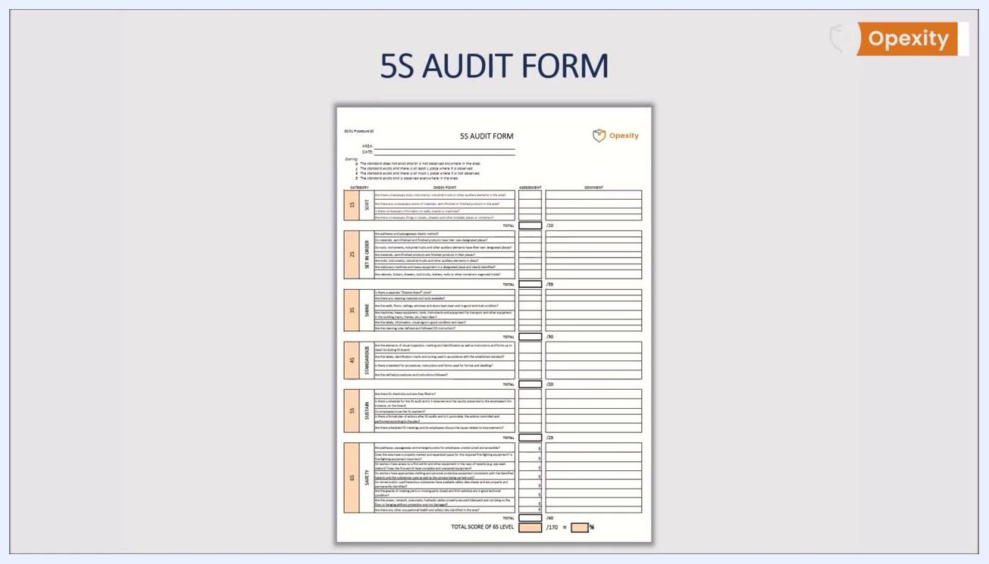
Presenter standing next to the 5S Audit Form, emphasizing the importance of safety and ergonomics

