How to create a recurring invoice in QuickBooks Online
If you bill customers on a regular schedule, you can save time by learning how to create a recurring invoice in QuickBooks Online. Recurring invoices let you automate the billing process, and with the AutoPay option, you can even collect payments automatically. This guide walks you through setting up a recurring invoice series, configuring payment options, and managing your templates afterward.

Prerequisites
- Access to the QuickBooks dashboard.
- A QuickBooks Payments account if you want to accept credit card or bank transfer payments through AutoPay.

Create a recurring invoice

1. Start a new invoice
Go to the QuickBooks dashboard and click the + New button on the left sidebar. Select Invoice from the available options to begin creating your invoice.
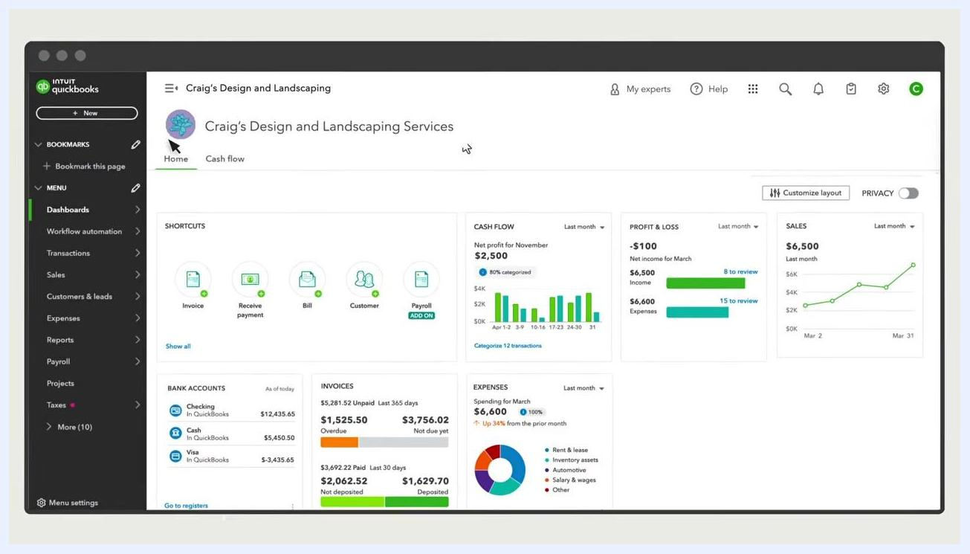
QuickBooks dashboard with the "+ New" button and Invoice shortcut highlighted

2. Open the invoice scheduling options
If the scheduling menu is not already open, select Manage in the upper right of the invoice screen. Locate the Scheduling section on the right side of the invoice creation screen.

3. Choose a recurring option
QuickBooks offers two recurring options:
- Recurring invoice: Creates invoices that repeat on a schedule. Customers pay each invoice individually.
- Recurring payment (NEW): Lets customers approve payment terms and enter their payment information through a secure online portal, with payments collected automatically on your schedule.
With recurring payments, you receive on-time payments automatically. With recurring invoices, you must wait for the customer to pay each invoice.
Invoice creation screen with the Scheduling panel showing options for Recurring invoice and Recurring payment
For this guide, select Make invoice recurring under the Recurring invoice section.

4. Name your recurring invoice series
Enter a descriptive name in the Template name field, such as "Monthly gardening for Aaron." This helps you identify the series later.

5. Select the recurring type
Click the Type drop-down menu and choose one of the following:
- Scheduled: QuickBooks automatically creates invoices in this series on the schedule you set.
- Unscheduled: Creates a template saved with partial or complete data, but without a schedule.
- Reminder: QuickBooks reminds you to create your invoice but does not create it automatically.
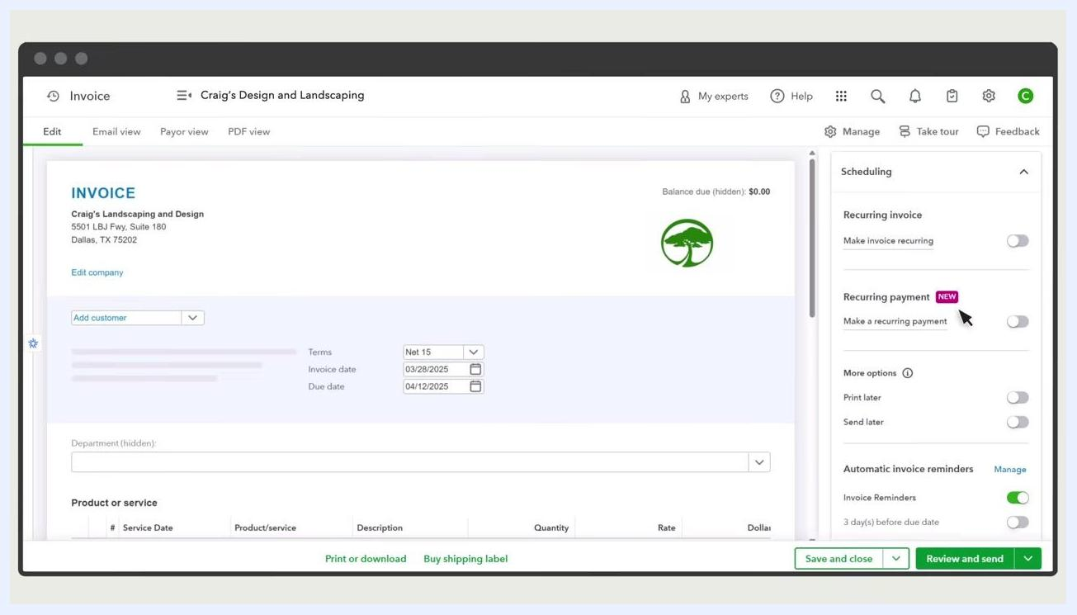
Recurring settings panel with the Template name field filled in and the Type drop-down showing Scheduled, Reminder, and Unscheduled options
For this guide, select Scheduled as the recurring type. In the Recurring settings panel, confirm the Type drop-down is set to Scheduled. Optionally, enter a value in the Create number of days in advance field — for example, enter 3 to have QuickBooks create the invoice three days ahead of the send date so you can review it first.
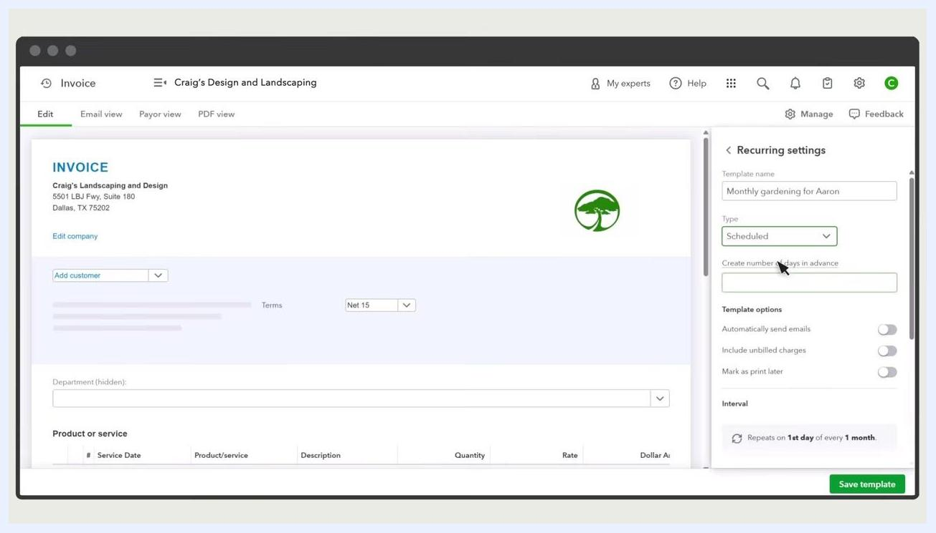
Recurring settings panel with Type set to Scheduled and the "Create number of days in advance" field highlighted

6. Enable automatic email delivery
Toggle Automatically send emails to the ON position if you want QuickBooks to email invoices to your customers automatically.
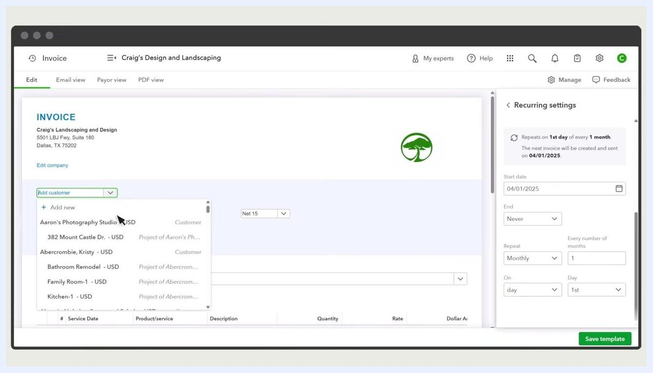
Recurring settings panel with "Automatically send emails" toggled on

7. Configure additional template options (optional)
- Toggle Include unbilled charges ON if you want QuickBooks to add any unbilled charges for the customer to each invoice.
- Toggle Mark as print later ON if you want invoices queued for batch printing.

8. Set the invoice interval and schedule
Under Interval, specify how often QuickBooks should send the invoice. In this example, the invoice repeats on the 1st day of every 1 month.
- Set the Start date (for example, 04/01/2025).
- Set the End date if you want the recurring series to stop after a certain date or number of occurrences. The default is Never.
- Confirm the Repeat frequency, such as Monthly, every 1 month.
- Confirm the On field is set to day and 1st.
Recurring settings panel showing the interval set to repeat on the 1st day of every month, with start date and other scheduling options

9. Fill in the invoice details
In the invoice form, select the customer from the Add customer drop-down, such as "Aaron's Photography Studio." Add the product or service by typing in the Product or service field — for example, type "gardening" and select the appropriate service. Then enter the quantity, rate, and any other required details for the invoice line items.
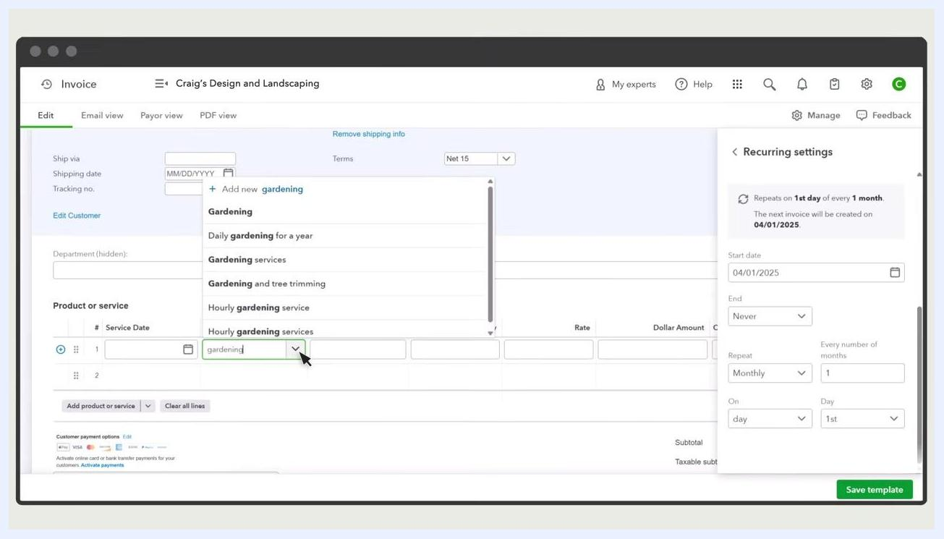
Invoice form with the customer and product/service being selected, and recurring settings visible

Set up payment options and save your template

10. Configure payment options for AutoPay
In the Payment options section, make sure you have a QuickBooks Payments account. If you do not, follow the prompts to set one up. Then select the payment methods you want to accept for these invoices:
- Toggle Credit card ON to accept card payments (Visa, Mastercard, Discover, American Express, Apple Pay).
- Toggle Bank transfer ON to accept ACH payments.
AutoPay works for both card and ACH transactions.
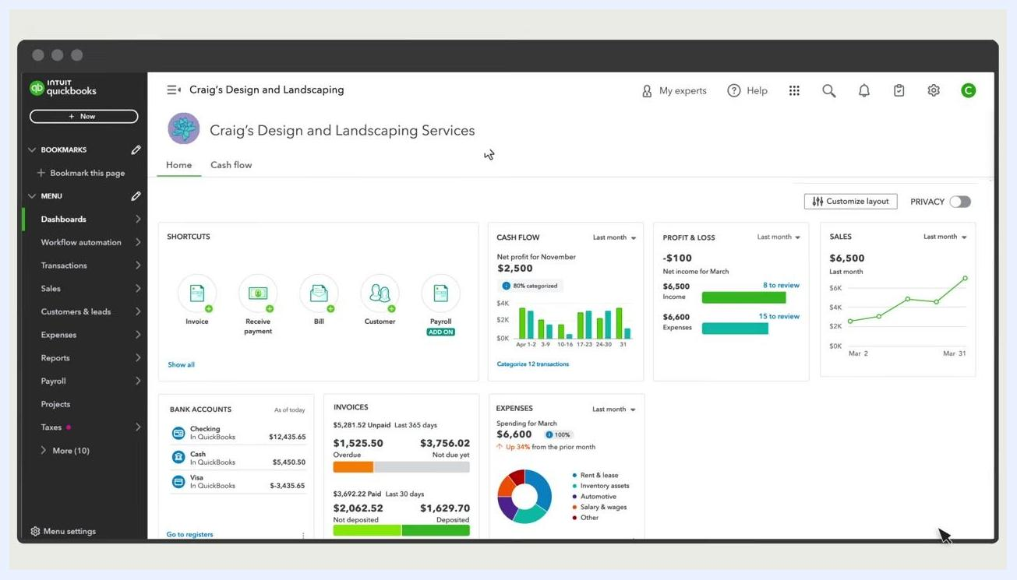
Payment options panel with Credit card and Bank transfer toggled on
When your customer receives the invoice by email, they can click Review and Pay and choose Set Up Autopay for future invoices. Customers can cancel AutoPay at any time.

11. Save your recurring invoice template
Review all details for accuracy, then click the Save template button at the bottom right of the screen to finish creating your recurring invoice.

Check invoices and AutoPay status

12. Identify recurring invoices in your invoice list
Go to the Invoices tab. All recurring invoices display a special symbol next to them for easy identification. The invoice list shows columns for Date, No., Customer/Project, Amount, Status, and Action. For example, Invoice #10348 for "Auldridge Windows" appears with its status and action options.
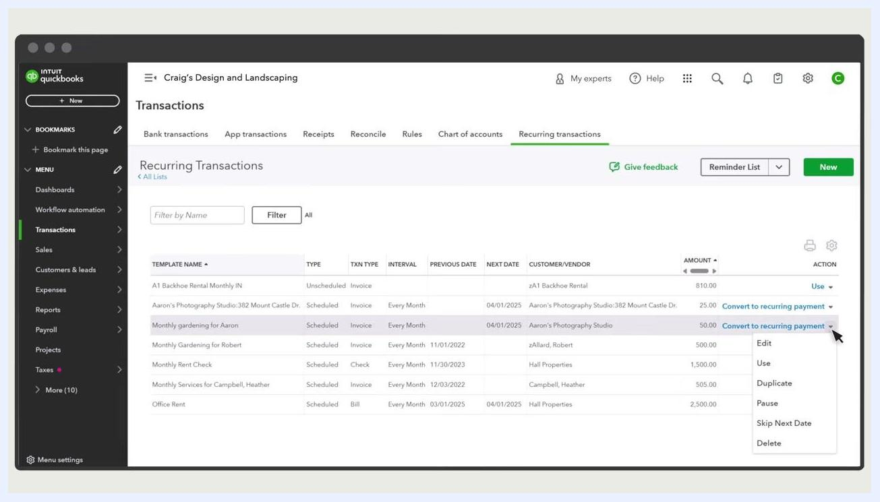
QuickBooks Invoices tab showing the recurring invoice symbol, invoice list, and action options

13. View or edit invoice details
Select any invoice in the list to view its activity details or edit it. Use the View/Edit link in the Action column to open the invoice for modifications. The status column indicates whether an invoice is overdue, paid, or scheduled for AutoPay.

14. Check AutoPay scheduled status
For invoices set to be auto-paid, the status column displays the AutoPay scheduled status, helping you quickly see which invoices are set up for automatic payment.
Invoice list with the status column showing AutoPay scheduled status and other invoice statuses

Manage your recurring invoice series

15. Access the Recurring Transactions page
To manage all recurring invoice templates, go to the Settings menu and select Recurring Transactions. This page lists all templates, including their type, transaction type, interval, previous date, next date, customer/vendor, amount, and available actions.
Use the Filter by Name field to quickly locate a specific template. In the Action column, click the dropdown to access options such as Edit, Use, Duplicate, Pause, Skip Next Date, or Delete for each recurring template.
Recurring Transactions page with the template list and the action dropdown expanded for editing options

16. Edit a recurring invoice template
Select Edit from the action dropdown next to the template you want to modify. Make any necessary changes to the schedule, customer, products/services, or payment options, then save your changes to update the recurring invoice series.
Recurring Transactions page with the action dropdown showing Edit and other options

What's next
Now that you know how to create a recurring invoice in QuickBooks Online, you can set up additional templates for other customers, adjust AutoPay settings as needed, or use the Recurring Transactions page to pause, duplicate, or delete series as your billing needs change.

