How to create a new project in Procore
This guide walks you through how to create a new project in Procore, from reviewing your company's best practices checklist to logging in, filling out the required project setup fields, and confirming that your new project has been created successfully.

Prerequisites
Before you create a new project in Procore, make sure you have the following:
- Access to your company's Procore Best Practices Checklist, typically distributed via email. This checklist outlines tasks, responsible roles, and best practice notes for every stage of a project.
- An active Procore account with a valid email address and password.
- The project details you'll need to enter, including the project name, number, description, address, and stage, as defined by your organization's naming conventions.

Review the Procore Best Practices Checklist
Before creating a project, review your organization's checklist to understand what's required at each stage.
The checklist is a structured document organized into columns for Task, Project Roles (DPM, PM, S, C), and Best Practice. Blue bars indicate milestones—key events that typically involve client interaction—and each milestone triggers a set of follow-up tasks.
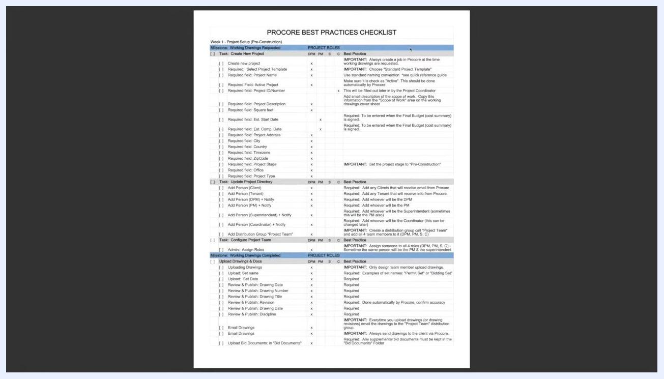
Screenshot of the "Procore Best Practices Checklist" showing columns for tasks, project roles (DPM, PM, S, C), and best practices. Blue bars highlight milestones such as "Working Drawing Requested" and "Working Drawings Completed." Tasks include creating a new project, updating the project directory, configuring the project team, and uploading drawings and documents, with required fields and responsible roles noted for each.
Use the checklist to confirm:
- The sequence of tasks required at each milestone.
- The roles responsible for each action.
- The best practices and required fields for each step.

Identify tasks tied to the "Working Drawing Requested" milestone
When a client requests working drawings, this triggers the Working Drawing Requested milestone. According to the checklist, the Design Project Manager (DPM) is primarily responsible for the initial tasks at this stage.
The three immediate tasks under this milestone are:
- Create a new project in Procore.
- Update the project directory.
- Configure the project team.
These tasks should be initiated as soon as working drawings are requested.
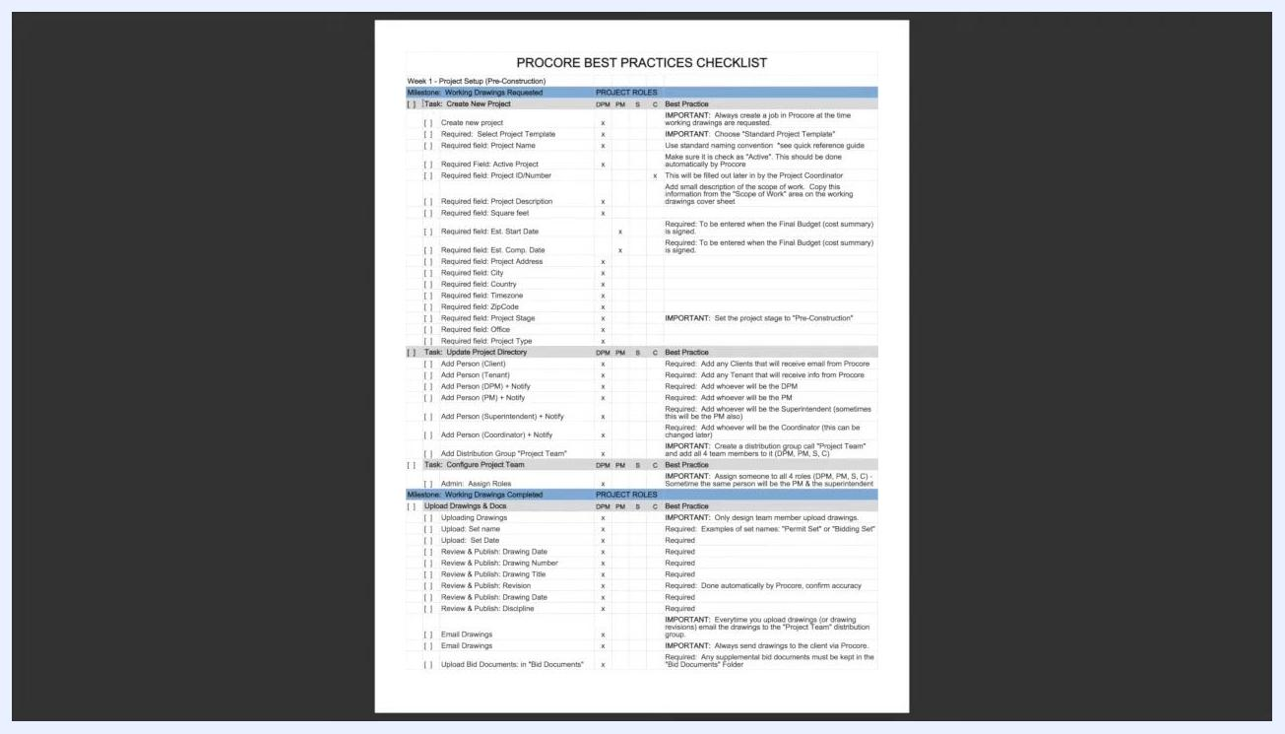
Procore Best Practices Checklist showing the "Working Drawing Requested" milestone, with tasks for creating a new project, updating the project directory, and configuring the project team, along with responsible roles and best practice notes.
The checklist also lists required fields for each task—such as Project Name, Project Address, and Project Stage—along with best practice notes. For example, you should always create a job in Procore at the time working drawings are requested, use your organization's standard naming convention, and set the project stage to Pre-Construction.
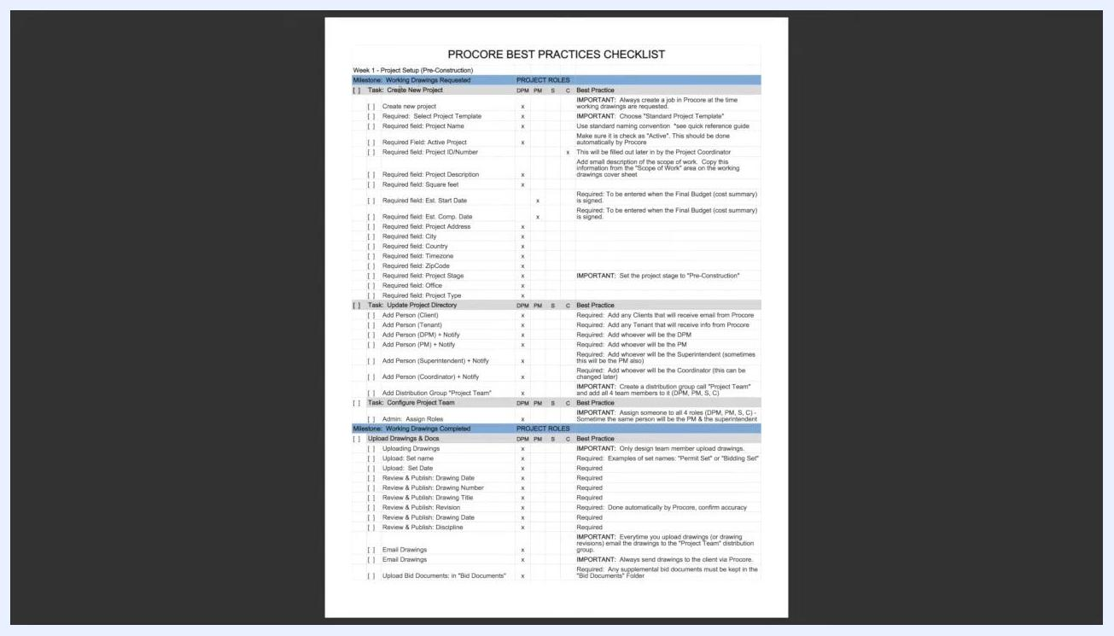
Close-up of the checklist showing required fields and best practice notes for creating a new project, updating the project directory, and configuring the project team.

Step 1: Log in to Procore
Open your web browser and navigate to https://app.procore.com/account/login. The login page displays the Procore logo, a login form, and informational panels about financial data and webinars.
Enter your email address and password, then click the orange Log In button. If you want your email saved for future logins, check Remember my email on this computer before signing in.
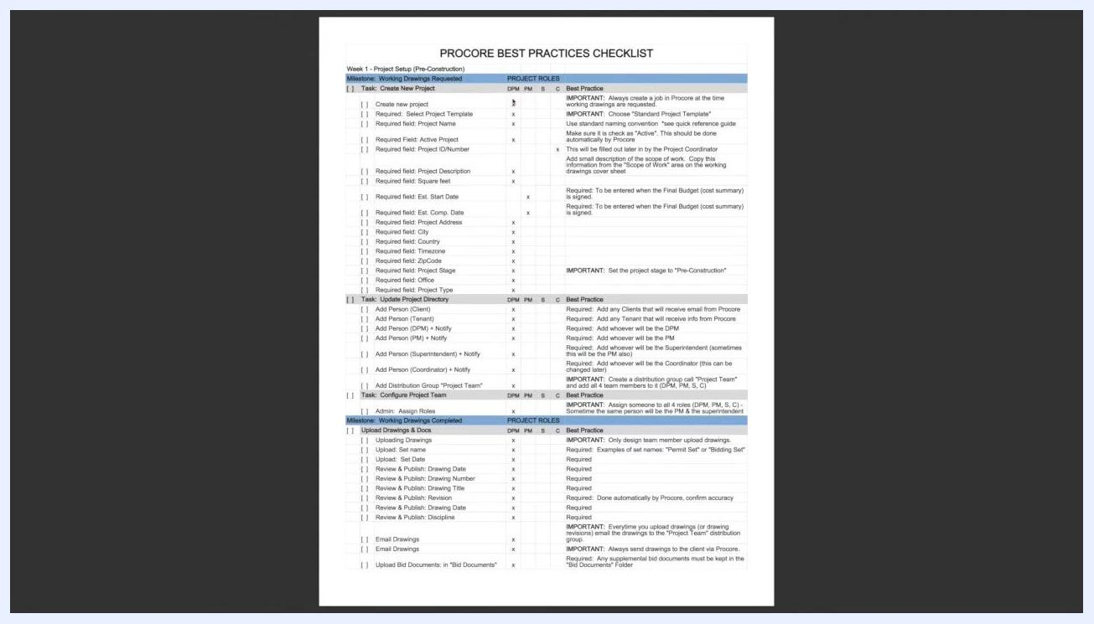
Procore login screen with fields for email and password, a "Log In" button, and informational panels about financial data and webinars.
If you are new to Procore, you can click Join our Free Training Presentations! for additional help.

If you or a subcontractor cannot log in
If you've forgotten your email or password, use the Forgot your email or password? link on the login page to reset your credentials. This feature is available to all users and is simple to use—direct subcontractors to this link if they have trouble accessing their accounts.
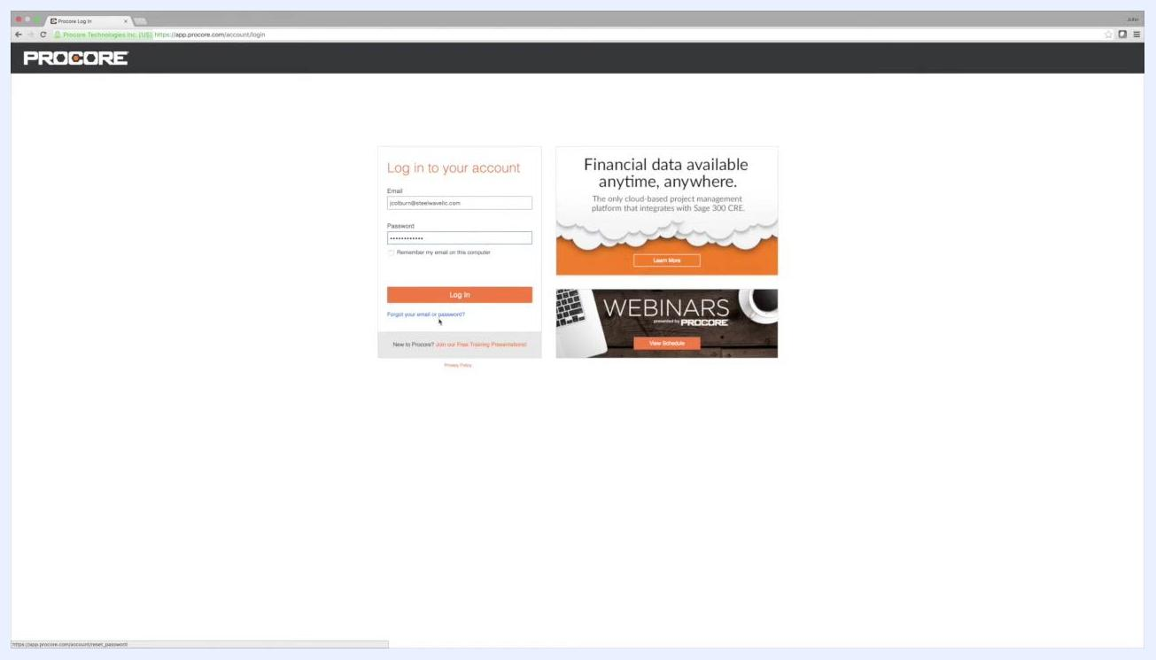
Procore login screen with the "Forgot your email or password?" link highlighted, along with the email and password fields and informational panels.
If login issues persist, contact your company's support contact for assistance. Make sure everyone on your team has an active Procore account before proceeding.

Step 2: Open the Portfolio List
After logging in, you'll land on the Procore Portfolio List. This screen displays all current projects, with columns for Name, Project #, Address, City, State, ZIP, Phone, Program, Status, Stage, Type, Department, and Notes. Use the search and filter options on the right to locate existing projects if needed.
To start creating a new project, click the orange + Add New Project button located at the top right of the Portfolio List screen.
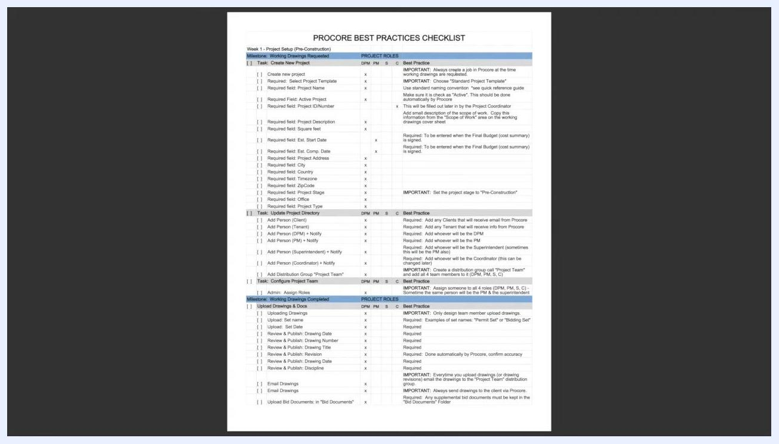
Procore Portfolio List screen with the "+ Add New Project" button highlighted, a list of existing projects, and filter and search options on the right.

Step 3: Select a standard project template
When the Create a new project... dialog appears, locate the Select a project template dropdown. Choose your organization's standard project template to ensure consistency across all projects. If you're unsure which template to use, refer to your company's guidelines or the Procore Best Practices Checklist.
Click Continue to proceed.
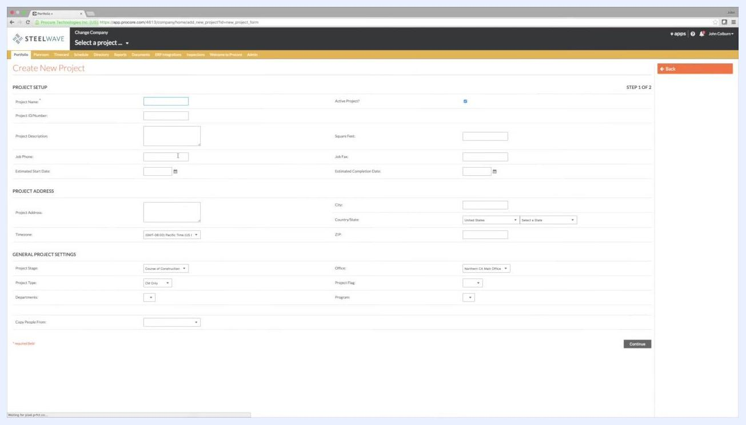
Dialog box titled "Create a new project..." with a dropdown for selecting a project template, and "Continue" and "Cancel" buttons visible over the Portfolio List.
This takes you to the Create New Project form, divided into three sections: Project Setup, Project Address, and General Project Settings. The page header confirms you're on STEP 1 OF 2.

Step 4: Enter the project name
In the Project Name field under Project Setup, enter the project name according to your organization's standard naming convention. If you don't know the naming convention, consult the quick reference guide included in your onboarding materials. For training purposes, you can use the project number as the project name (for example, "Project 18").
Make sure the Active Project? checkbox is checked—it is checked by default.
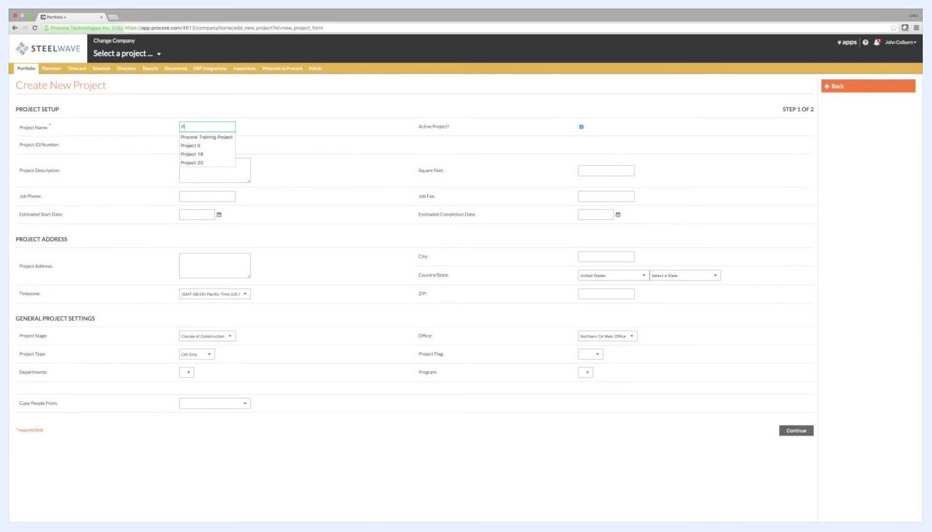
Create New Project form with the Project Name field highlighted and a dropdown showing suggested names such as "Procore Training Project," "Project 18," and "Project 20." The "Active Project?" checkbox is checked.

Step 5: Enter the Project ID/Number
Locate the Project ID/Number field directly below Project Name. Enter the official project number as listed on your organization's project roster—this field is used for tracking and reporting purposes. If the number is not yet known, you can leave this field blank and fill it in later.

Step 6: Enter the project description
Click into the Project Description field and enter a short description similar to what would typically appear on the cover sheet of the working drawings. For example: 3 Private Offices, 1 Break Area, .... If you're unsure what to enter, use a brief summary of the project scope.
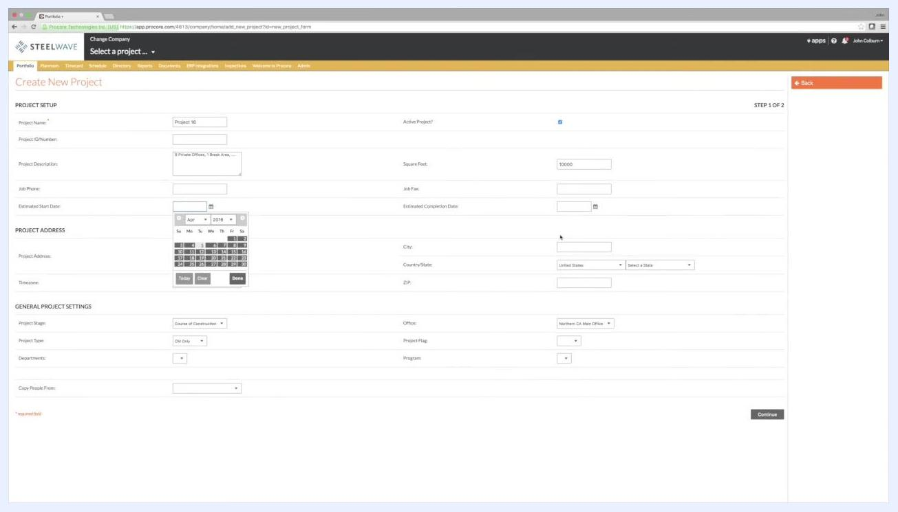
Project Description field filled with example text: "3 Private Offices, 1 Break Area, ..."

Step 7: Enter square footage and optional details
In the Square Feet field, enter the appropriate value (for example, 10000).
You can also fill in the following optional fields as needed:
- Job Phone: Leave blank if not specified.
- Job Fax: Leave blank if not specified.
- Estimated Start Date: Click the calendar icon and select the appropriate date.
- Estimated Completion Date: Leave blank if not specified.

Step 8: Fill in the Project Address fields
Complete all required fields in the Project Address section:
- Project Address: Enter the street address.
- City: Enter the city name.
- Country/State: Select the appropriate country and state.
- ZIP: Enter the ZIP code.
These fields are required and must not be left blank. The system may auto-populate some fields, but you should verify that all required information is filled in correctly.
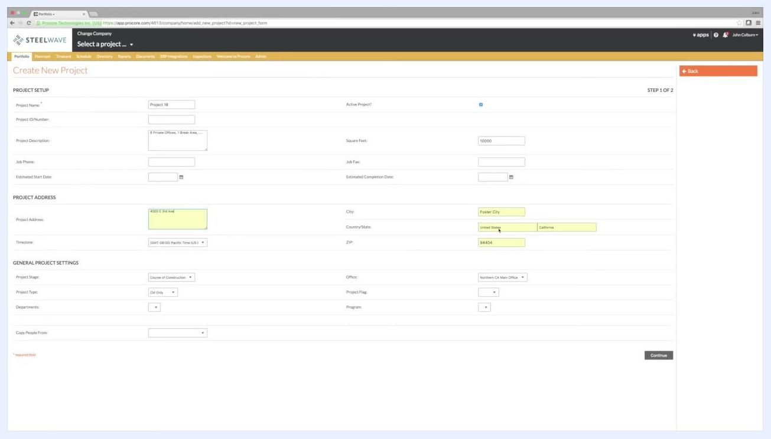
Project Address, City, Country/State, and ZIP fields highlighted and filled in.

Step 9: Set the timezone
In the Timezone dropdown, confirm it is set to the correct timezone for your project (for example, (GMT-08:00) Pacific Time (US & Canada)). Setting the correct timezone is important because it affects scheduling and notifications.
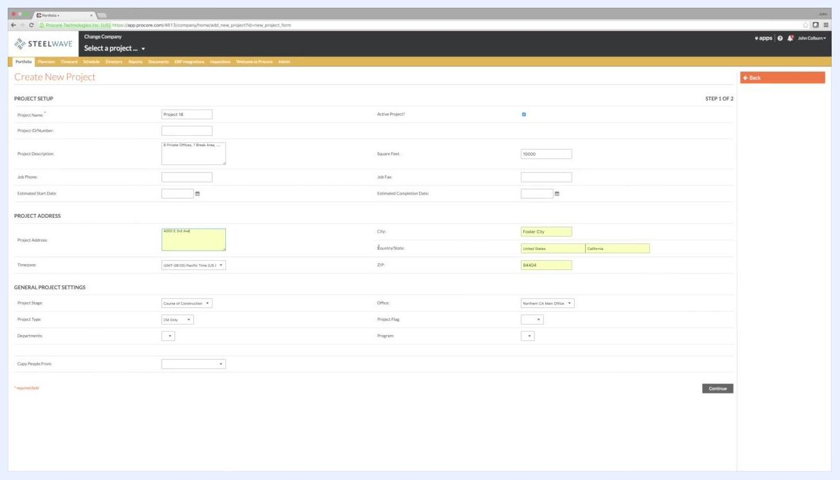
Timezone dropdown set to (GMT-08:00) Pacific Time (US & Canada).

Step 10: Select the Project Stage
Under General Project Settings, open the Project Stage dropdown and choose the stage that matches your project. For a job in the planning phase, select Pre-Construction. Other available options include Bidding, Course of Construction, and Post-Construction.
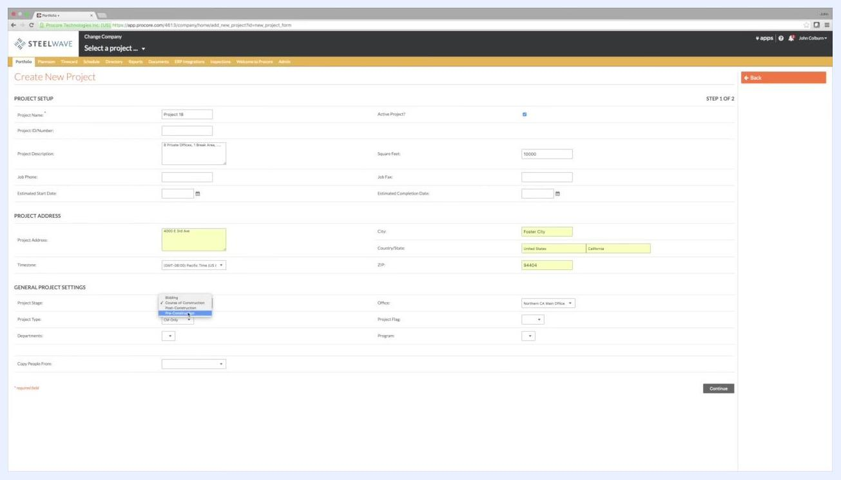
Project Stage dropdown open with "Pre-Construction" selected.

Step 11: Choose the Project Type
Open the Project Type dropdown and select the type that best fits your project. For example, select Design/VDC. Other available options include CM Only, Design Only, Design/CM, and GC Only.
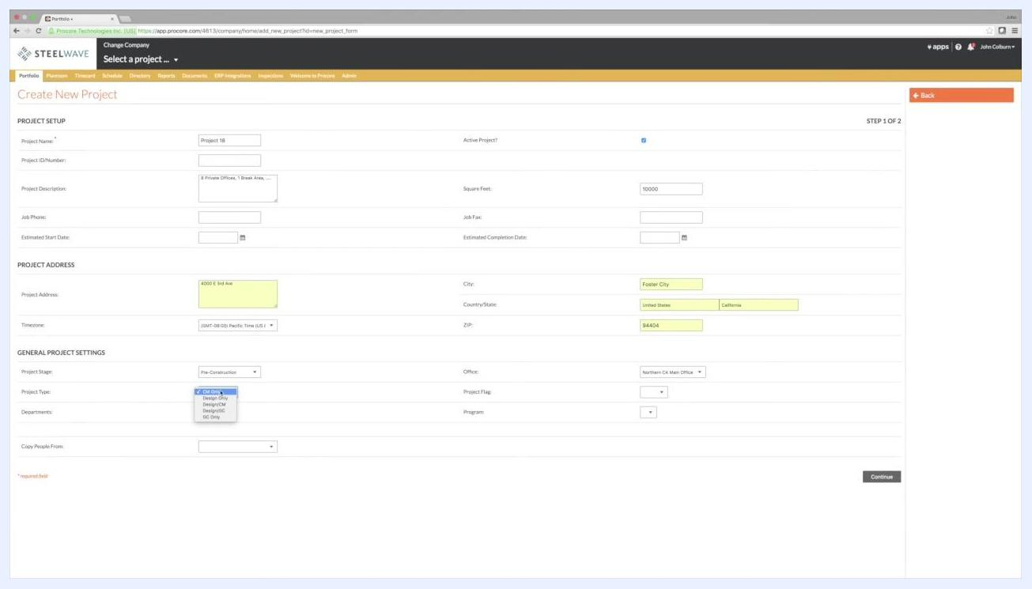
Project Type dropdown open with "Design/VDC" selected.

Step 12: Review your entries before continuing
Before submitting, double-check that all required fields—marked with a red asterisk—are completed correctly. Your entries should include values such as:
- Project Name
- Project Description
- Square Feet
- Project Address, City, Country/State, and ZIP
- Timezone
- Project Stage
- Project Type
- Office
Project Description and Square Feet fields filled in, with the calendar open for selecting the Estimated Start Date.
Note: The project number is typically the responsibility of the project coordinator and may be left blank or filled in later, depending on your organization's process. For the Project Description, use a concise summary similar to what would appear on the cover sheet of the working drawings.

Step 13: Submit the form
Once all required fields are completed, click the Continue button at the bottom right of the form. Wait for the system to process your request.
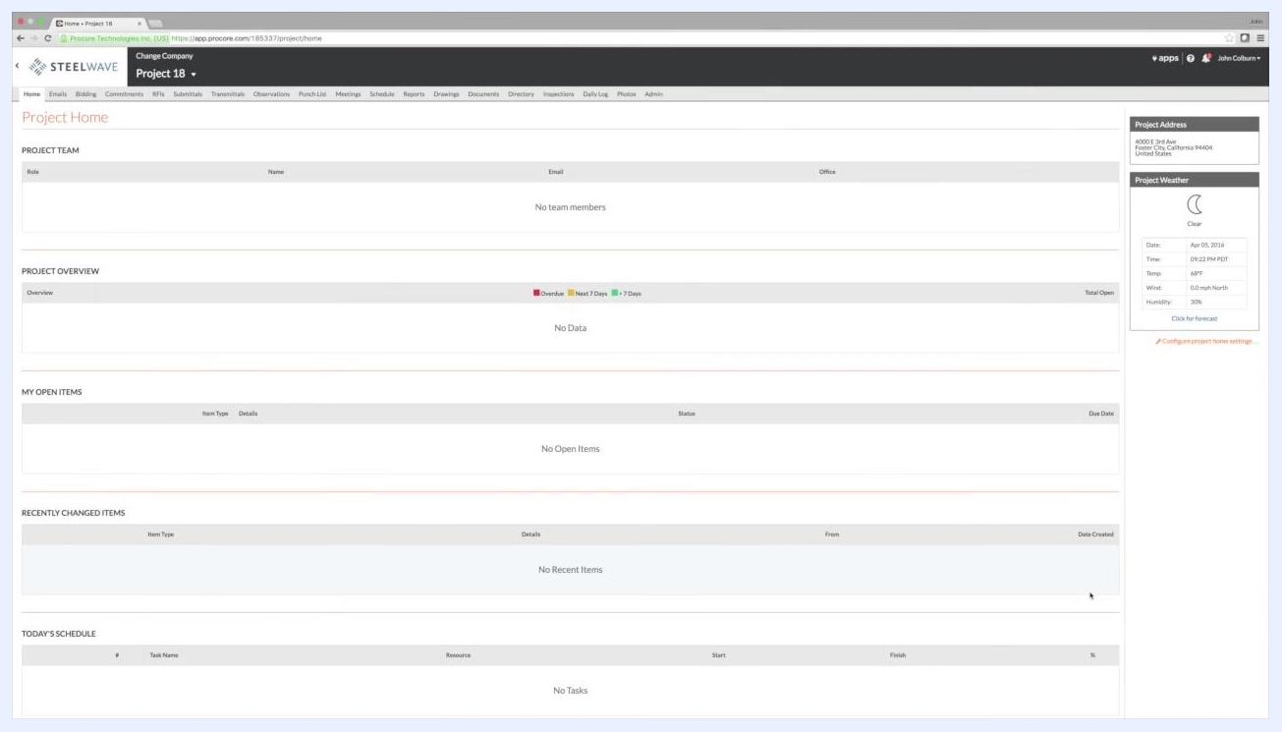
All fields completed and ready for submission, with the Continue button visible.

Step 14: Verify that the project was created
After submission, you're redirected to the Project Home page for your new project. This page initially displays:
- Project Team (empty until members are added)
- Project Overview (no data yet)
- My Open Items (none yet)
- Recently Changed Items (none yet)
- Today's Schedule (no tasks yet)
The right sidebar shows the Project Address and Project Weather. Confirm that the project name and address details match what you entered.
Project Home page for the newly created project, showing empty sections and the project address in the sidebar.

Best practices and notes
- Always complete all required fields before submitting the form.
- Use clear, descriptive names and summaries so the project is easy to identify later.
- For training or practice purposes, use example values as needed.
- The project number is the coordinator's responsibility and can be added later if it's not yet known.

What's next
Now that you know how to create a new project in Procore, you can invite team members, update the project directory, and configure additional project settings to continue setting up collaboration on the project.

