How to Do an Incident Report in PointClickCare
Documenting an incident thoroughly and accurately is an essential part of resident care. This guide walks you through how to do an incident report in PointClickCare, from creating the initial record through to completing injury details, documenting contributing factors, recording witness statements, triggering the Morse Fall Scale form, and collecting the required signatures. The steps below use an example incident — a witnessed fall involving resident James Anderson — to illustrate each stage of the process.

Prerequisites
- Access to the Care Services module in PointClickCare.
- Appropriate security permissions to create, sign, and, if needed, lock incident reports.
- Knowledge of the resident's details and the circumstances of the incident being reported.

Starting a new incident report

1. Open the Incidents section
Navigate to the Care Services module and select the Incidents section.

2. Confirm you are in the Active view
Make sure you are on the Active tab, located at the top of the Incidents section. This view displays incident graphs and summary information for the community.
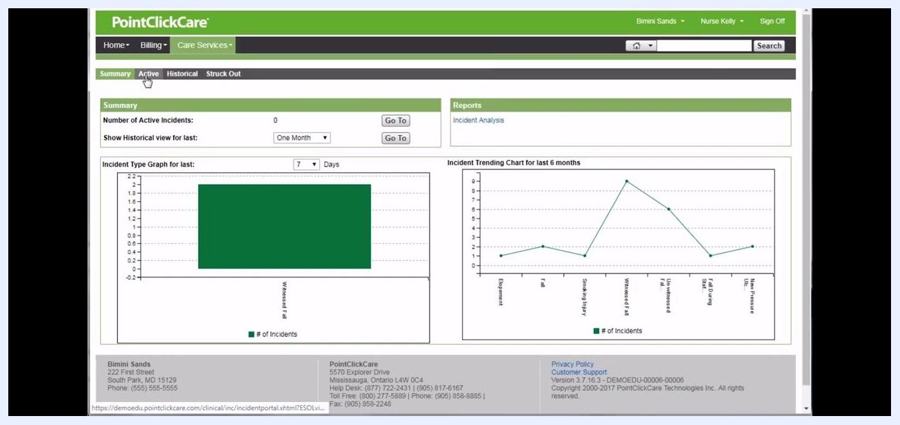
The PointClickCare dashboard showing the Care Services > Incidents section with the Active tab highlighted. The screen displays incident graphs and summary information.

3. Create a new incident
Click the New button to create a new incident report.

Documenting incident details

4. Enter the Nursing Description
After clicking New, you are taken to the Details section of the incident report, where you'll see fields for Incident Description and Immediate Action Taken.
Incident Details screen for a new incident report, with fields for Nursing Description, Resident Description, Resident Unable to Give Description checkbox, Description of Action Taken, and Resident Taken to Hospital checkbox. Resident: Anderson, James. Type/Nature of Incident: Witnessed Fall. Date of Incident: 9/27/2018 10:09.
Enter the Nursing Description of the incident. For example:

 | "The resident was witnessed falling to the floor while leaving the dining room. The resident was wearing his house slippers and slipped on the wet floor. The resident did not hit his head and is alert and oriented. The resident has a skin tear to his R forearm and has full range of motion to all his extremities and denies any pain."

5. Record the resident's statement
Obtain and enter the resident's own account of the incident in the Resident Description field. If the resident is unable to describe what happened, select the Resident Unable to give Description checkbox instead.
In this example, Mr. Anderson is able to describe the incident, so the following is entered:

"I slipped on the wet floor while leaving the dining room and I hit my R arm."
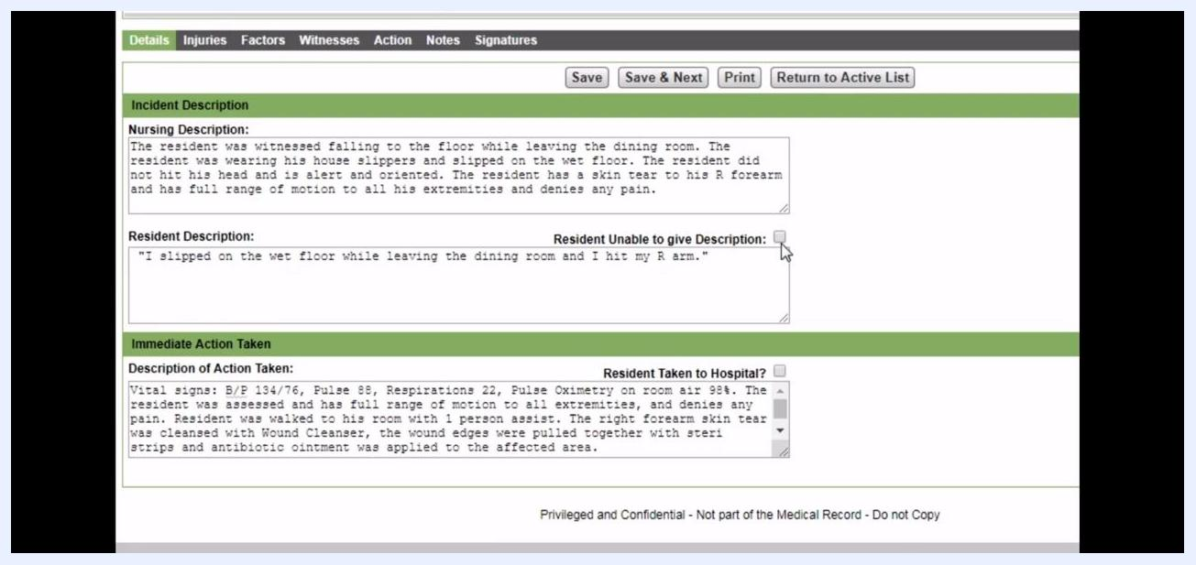
Incident Details screen with Nursing Description and Resident Description fields filled in. Nursing Description details the witnessed fall, and Resident Description contains the resident's statement.

6. Document the action taken
In the Description of Action Taken field, record the clinical response to the incident. For example:

"Vital signs: B/P 134/76, Pulse 88, Respirations 22, Pulse Oximetry on room air 98%. The resident was assessed and has full range of motion to all extremities, and denies any pain. Resident was walked to his room with 1 person assist. The right forearm skin tear was cleansed with Wound Cleanser, the wound edges were pulled together with steri strips and antibiotic ointment was applied to the affected area."
Incident Details screen with all fields completed, including detailed action taken and the resident's statement.

7. Indicate whether the resident was hospitalized
If the resident was taken to the hospital, select the Resident Taken to Hospital? checkbox. This enables additional hospital information fields for reporting purposes. In this example, the box remains unchecked since Mr. Anderson was not taken to the hospital.

Recording injuries and pain assessment

8. Save and move to the Injuries section
Once you have completed the Immediate Action Taken section, click Save & Next at the top of the screen to advance.
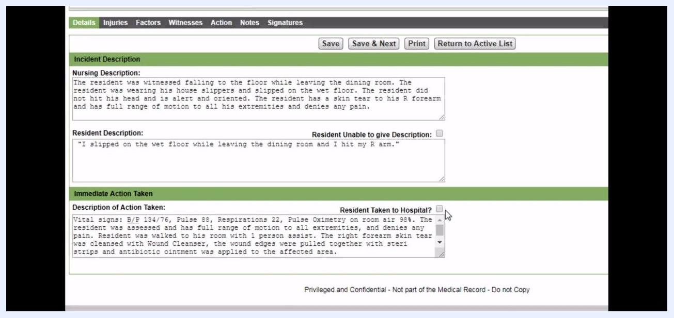
Incident Details screen with the Save & Next button highlighted, ready to proceed to the Injuries section.
The Injuries tab opens, displaying "Injuries Observed At Time Of Incident." If no injuries are listed yet, click New to add one.

9. Add injury details
In the New Injury at Time of Incident popup:
- Set Type of Injury to Skin Tear.
- Set Location of Injury to 60) Right Forearm.
Click Save to add the injury.
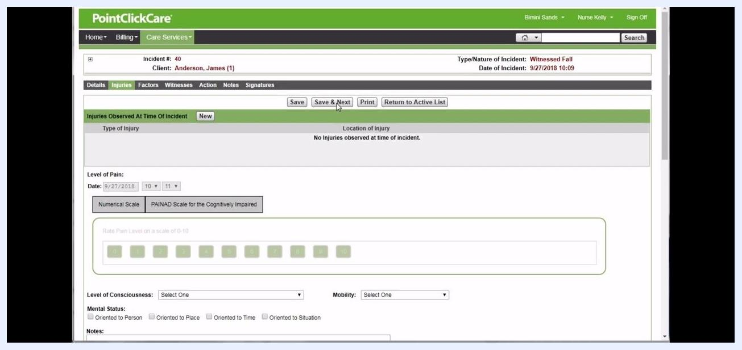
Popup window for adding a new injury, with Type of Injury set to Skin Tear and Location of Injury set to 60) Right Forearm.

10. Document the pain level
In the Level of Pain section:
- Set the Date to 9/27/2018.
- Select the Numerical Scale.
- Rate the pain level as 2 by clicking the corresponding button on the scale.
This pain value will also appear in the Weights and Vitals tabs of the resident's chart.

11. Record consciousness, mobility, and mental status
Complete the remaining assessment fields:
- Set Level of Consciousness to Alert.
- Set Mobility to Ambulatory with assistance.
- Under Mental Status, check all that apply: Oriented to Person, Oriented to Place, Oriented to Time, and Oriented to Situation.
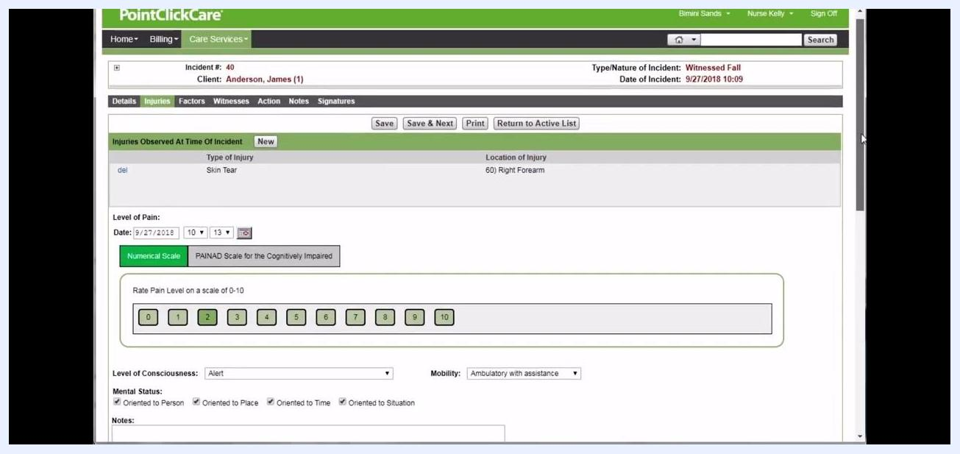
Injuries section completed with Skin Tear on Right Forearm, Pain Level 2, Alert consciousness, Ambulatory with assistance, and all orientation boxes checked.
If your community is configured for post-incident injury reporting, you can also enter injuries discovered after the initial incident, such as bruising found days later. In this example, there are no post-incident injuries, so this section is left blank.

Documenting contributing factors

12. Record predisposing factors
Click Save & Next to move to the Factors tab. This section lets you document environmental, physiological, and situational factors that may have contributed to the incident.
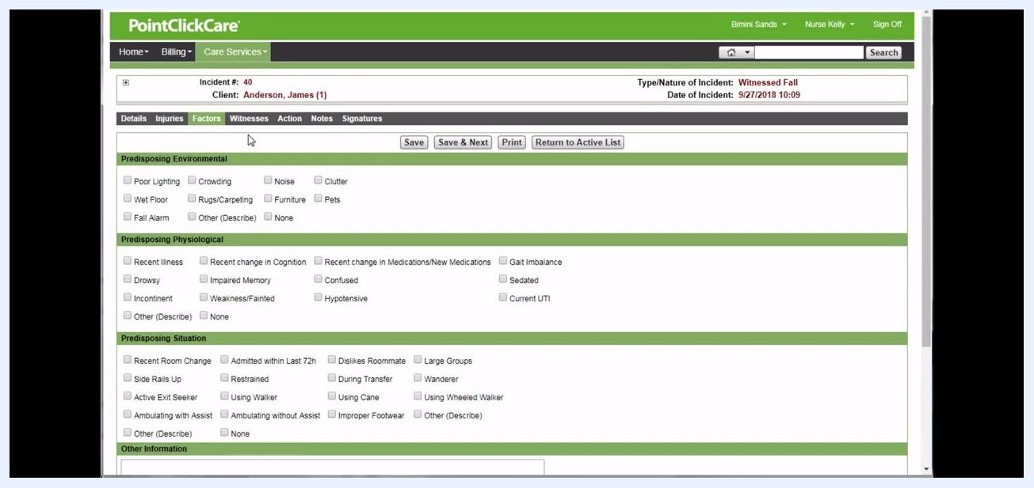
Factors section with checkboxes for environmental, physiological, and situational factors such as Wet Floor, Gait Imbalance, and Improper Footwear.
In this example:
- Under Predisposing Environmental, check Wet Floor.
- Under Predisposing Situation, check Improper Footwear.
- In the Other Information field, enter: Resident was wearing house slippers at the time of the fall.
Click Save & Next to proceed to the Witnesses section.
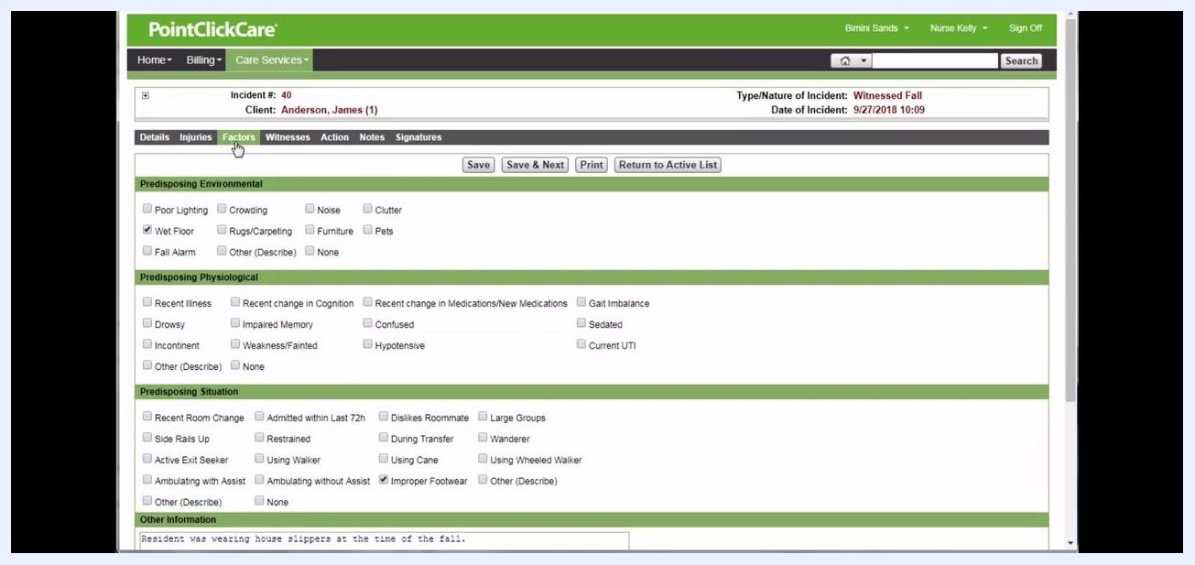
Factors tab with Wet Floor and Improper Footwear checked, and the note about house slippers entered in Other Information.

Adding witness information

13. Add a witness
In the Witnesses tab, check the box for Was this incident witnessed?, then click New to add a witness.
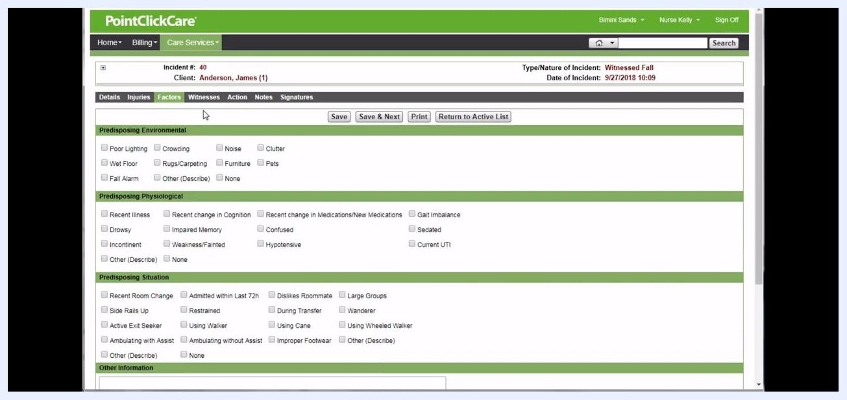
Witnesses tab with the "Was this incident witnessed?" checkbox and New button, with no witnesses listed yet.
In the Incident Witness popup, enter the witness details:
- Set Relation to Staff.
- Enter Name: Angela.
- Set Position as appropriate (for example, Registered Nurse).
- Set Date to 9/27/2018.
- In Who took statement, enter Nurse Kelly.
- In Statement, enter Angela's account of the incident.
- Enter any available phone numbers if required.
Click Save to add the witness.
Incident Witness popup with fields for Relation, Name, Position, Date, Who took statement, Statement, and phone numbers.

Recording notifications and progress notes

14. Notify and document relevant parties
Go to the Action tab to record notifications, progress notes, and triggered forms. Under Agencies / People Notified, click New.
In the popup:
- Set Agency / Person to Physician.
- Enter Name: Brindan, Adam.
- Set Date to 9/27/2018 and Time to 10:24.
Click Save.
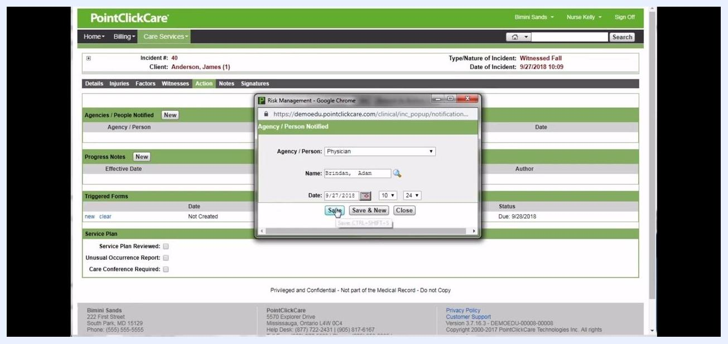
Agency/Person Notified popup with Physician, Brindan Adam, and date/time fields filled in, with the Save button highlighted.
Under Progress Notes, click New. In the New Progress Note popup:
- Select the appropriate Type (for example, Incident Note).
- Set Effective Date to 9/27/2018 and Time to 10:25.
- Enter the progress note details about the incident.
- Check any relevant boxes, such as Show on Shift Report or Show on 24 Hour Report.
- Click Sign and follow the prompt to sign the note.
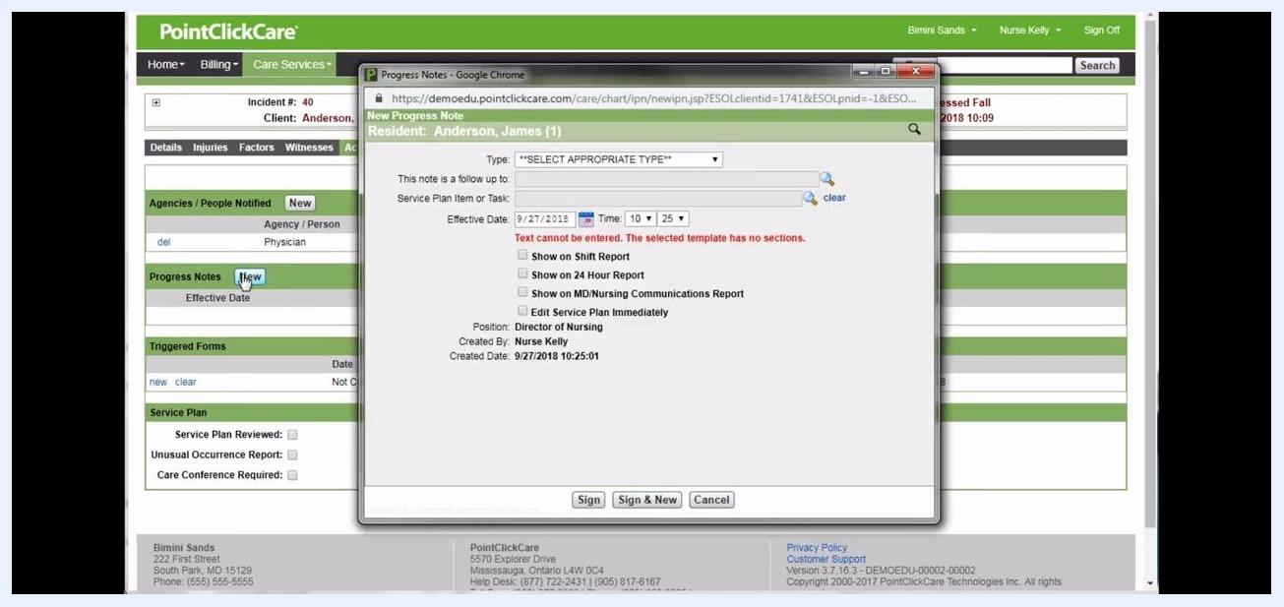
New Progress Note popup with fields for Type and Effective Date, and options for shift/24-hour report, ready for signing.
After saving and signing, verify the progress note appears correctly, showing:
- Effective Date: 9/27/2018 10:25
- Type: Incident Note
- Note: a summary of the incident
- Author: Nurse Kelly
Action tab showing the completed notification to the Physician, the progress note entry, and the triggered forms section.

Triggering and completing the Morse Fall Scale

15. Trigger the Morse Fall Scale form
Navigate to the Action tab of the incident report, confirming you are on the correct incident by checking the Incident # and Client name at the top. Review the Agencies / People Notified and Progress Notes sections for accuracy.
Under Triggered Forms, locate the MORSE FALL SCALE entry. If the form has not yet been created, click the new link to begin.
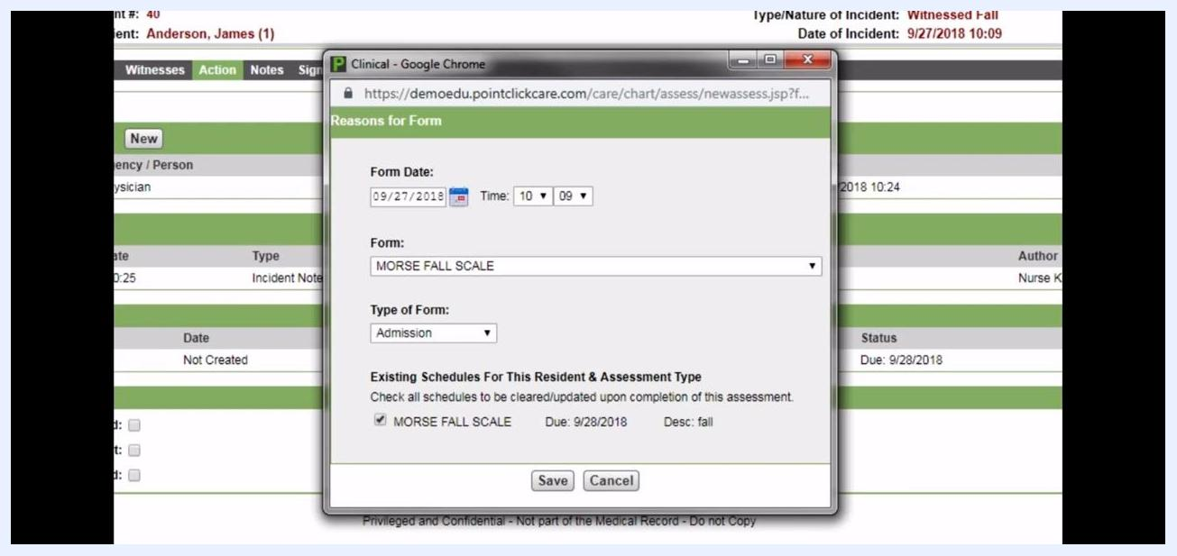
Action tab with the new link under Triggered Forms for Morse Fall Scale, cursor pointing to new, showing incident details and notification sections.
When prompted, fill out the Reasons for Form dialog:
- Set the Form Date to 09/27/2018 and Time to 10:09.
- Ensure the Form field is set to MORSE FALL SCALE.
- In the Type of Form dropdown, select the appropriate type (for example, Post Fall).
- Review the Existing Schedules For This Resident & Assessment Type and ensure the relevant schedule (MORSE FALL SCALE, Due: 9/28/2018, Desc: fall) is checked.
Click Save to create the form with the specified date and time.
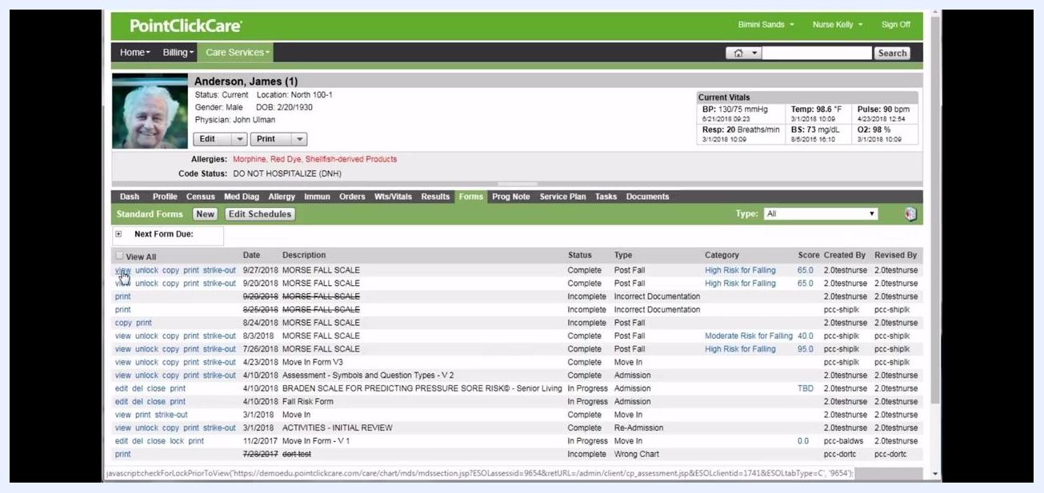
Reasons for Form dialog with Form Date 09/27/2018, Time 10:09, Form set to Morse Fall Scale, and Type of Form set to Post Fall.

16. Complete the Morse Fall Scale form
Fill in all required fields:
- History of Falling: select 1 (No) or 2 (Yes).
- Secondary Diagnosis: select 1 (No) or 2 (Yes).
- Ambulatory Aid: choose the appropriate option (None/bedrest/wheelchair/nurse assist, Uses crutches/cane/walker, or Uses furniture for support).
- IV or IV Access: select 1 (No) or 2 (Yes).
- Gait: select the appropriate description (Impaired or Weak).
Use Save & Sign, Save, Save & Exit, or Save & Sign & Lock & Exit as appropriate, and follow any prompts to complete, sign, and lock the form.
Morse Fall Scale form with fields for History of Falling, Secondary Diagnosis, Ambulatory Aid, IV Access, and Gait, with action buttons at the top.

17. Review the completed form
Go to the Forms tab in the resident's chart and locate the most recent MORSE FALL SCALE entry (for example, 9/27/2018, Status: Complete, Type: Post Fall, Category: High Risk for Falling, Score: 65.0). Use the view link to open and review the form.
With appropriate security permissions, you can also use the go to Incident link within the form to return directly to the incident report.
Resident chart Forms tab showing a list of completed forms, including multiple Morse Fall Scale entries with view, unlock, copy, and print options.

18. Return to the incident from the form
In the Morse Fall Scale form, click the go to Incident link next to the triggering event to navigate back to the incident report.
Completed Morse Fall Scale form with the go to Incident link highlighted, showing score, category, and triggering event.

19. Confirm the triggered form status
Back in the Action tab, verify that the Triggered Forms section now shows the completed Morse Fall Scale form with the correct date and a status of Complete. You can use the view or print links to access or print the completed form.
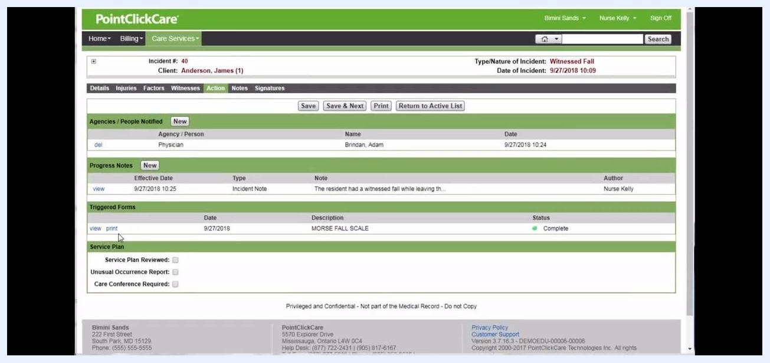
Action tab showing the completed Morse Fall Scale form with view and print options and status Complete.

Adding notes and collecting signatures

20. Add a note about the incident
Navigate to the Notes tab within the incident report, then click New to add a note. Enter relevant details about the incident. For example:

"Mr. Anderson was wearing his house slippers at the time of his fall. Mr. Anderson states none of his shoes fit due to the swelling in his feet. The only footwear Mr. Anderson has to wear is his house slippers."
Keep in mind that notes entered in this section are not stored in the medical record. For progress notes that flow to the medical record, use the Action tab instead.
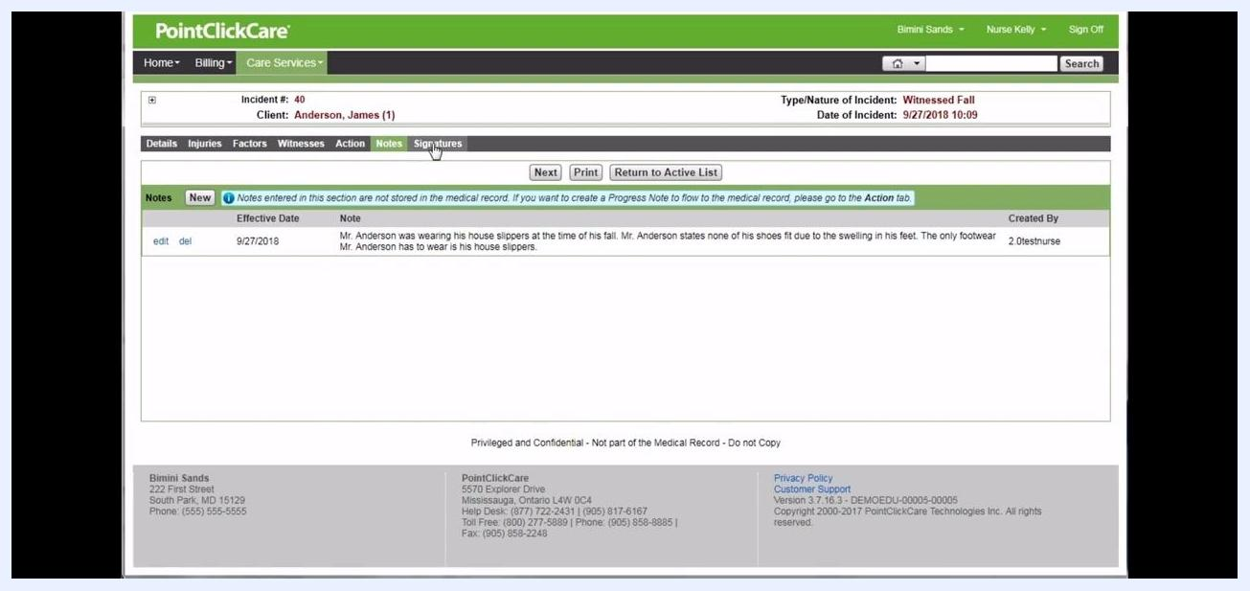
Notes tab with the New button clicked, cursor on New, and an informational message about notes not being part of the medical record.

21. Review and edit the note
After saving, review the note entry under the Notes tab. You can use the edit or del (delete) links to modify or remove the note if needed. Confirm the note displays the correct Effective Date (for example, 9/27/2018) and is attributed to the correct user.
When finished, click the Signatures tab to proceed.
Notes tab showing the entered note about Mr. Anderson's footwear, with edit and delete options and the cursor on the Signatures tab.

22. Sign the incident report
In the Signatures tab, review the list of required signers. The table displays positions such as Administrator, Director of Nursing, and Registered Nurse, each with a sign link.
Click the sign link next to your role to electronically sign the report. Depending on configuration, the system may also allow you to lock the incident report upon signature.
Signatures tab showing sign links for Administrator, Director of Nursing, and Registered Nurse.

23. Verify and manage signatures
Once signed, your name and the date appear in the corresponding row. If needed, use the unsign link to remove your signature, or the Unlock button to make further edits before finalizing. When all required signatures are collected, the incident report is considered complete.
Signatures tab showing Registered Nurse signed as Nurse Kelly, with an unsign option and the Return to Active List button highlighted.

24. Return to the Active List
Click the Return to Active List button to exit the incident report and return to the main list of active incidents. This allows other staff to view, sign, or further process the incident as needed.
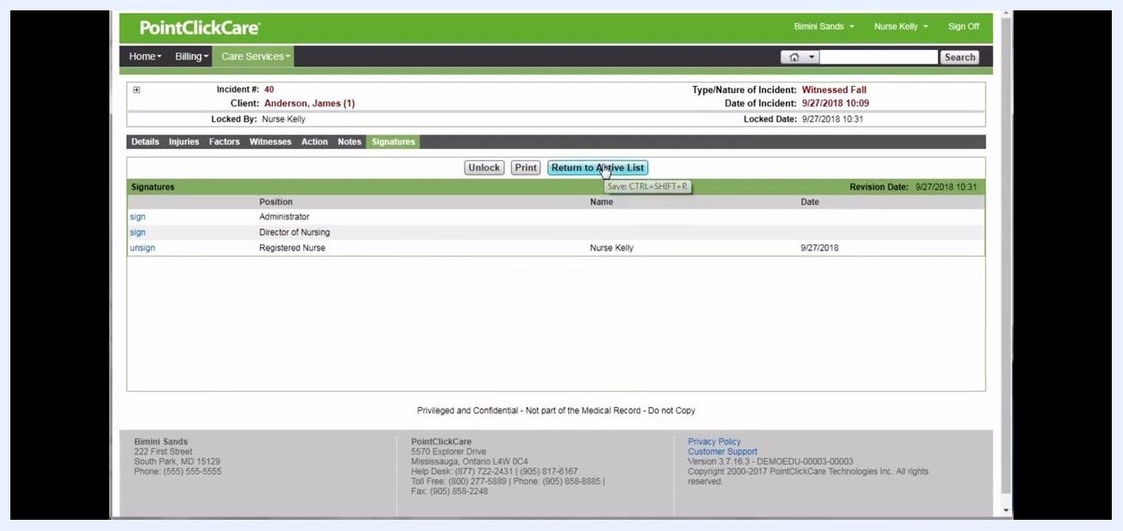
Active Incidents list showing incident number 40 for Anderson, James, with options to view, unlock, or print, and the incident pending a signature from the Director of Nursing.

Summary
By following these steps, you create a complete and accurate incident report in PointClickCare — from the initial nursing and resident descriptions, through injury and pain assessment, contributing factors, witness statements, physician notification, and the Morse Fall Scale form, to the final notes and signatures. A thoroughly documented incident report, like the one created here for Mr. Anderson's witnessed fall, is ready for review and sign-off by other staff as needed.

