How to convert a classic page to a fluid page in PeopleSoft
If you need to know how to convert a classic page to a fluid page in PeopleSoft, the process for a plain Classic page is short. You mark the component as Fluid Mode, mark the page as a Fluid Page, and wrap the page content in an outer group box with a style class. This guide uses a "My Uniforms" Classic component as the example. You start by locating the legacy component, then convert it in PeopleSoft Application Designer, and finally adjust the layout to three columns.

Before you begin
Consider why you are converting. Fluid is Oracle's strategic direction for PeopleSoft, and new content and business process wrappers are likely to be Fluid-based. Fluid also provides responsive and adaptive design, which suits mobile usage. If you don't need mobile access, consider whether Classic Plus is a better fit.
The best conversion approach depends on your use case. This guide covers converting a plain Classic page to a plain Fluid page. Embedding content in a two-panel layout requires a different approach.
You need the following:
- Access to your PeopleSoft application, with Fluid navigation in use.
- PeopleSoft Application Designer installed on your workstation.
- The name of the Classic page and its component. In this example, the page is JSM_UNIFORMS and the component is JSM_MY_UNIFORMS.
- A plain Classic page that is not embedded in a two-panel layout.

Step 1: Open the Student Homepage
Open the PeopleSoft application and go to the Student Homepage. The homepage shows several Fluid tiles, including Academic Progress, Academic Records, Financial Account, Financial Aid, Manage Classes, Profile, and Tasks. These tiles confirm that the environment uses Fluid navigation.
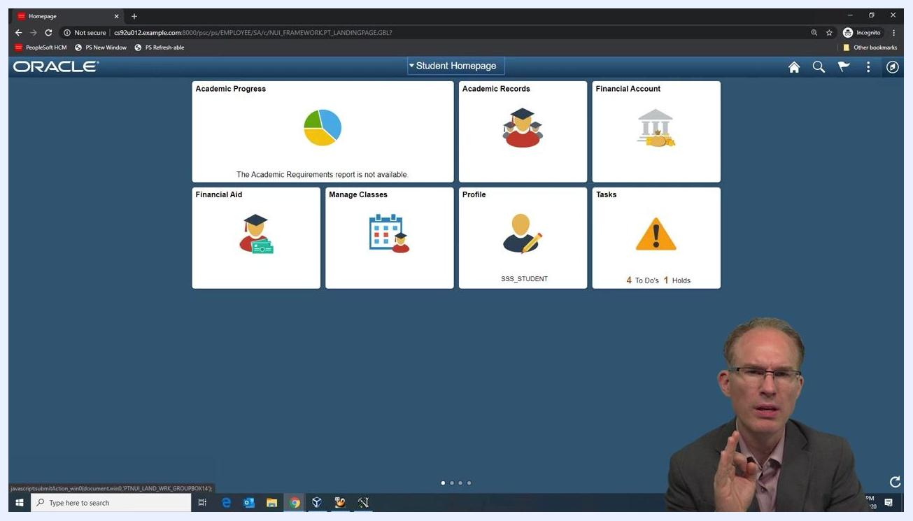
The Student Homepage showing Fluid tiles, with the Profile tile (SSS_STUDENT) about to be selected.

Step 2: Open the Profile component
Select the Profile tile (SSS_STUDENT). The Profile component appears in a Fluid layout.
The left navigation lists Personal Details, Contact Details, Addresses, Emergency Contacts, Ethnicity, Privacy Restrictions, and My Uniforms. The main panel shows personal details such as Name, Date of Birth, Gender, Social Security Number, and a list of names.
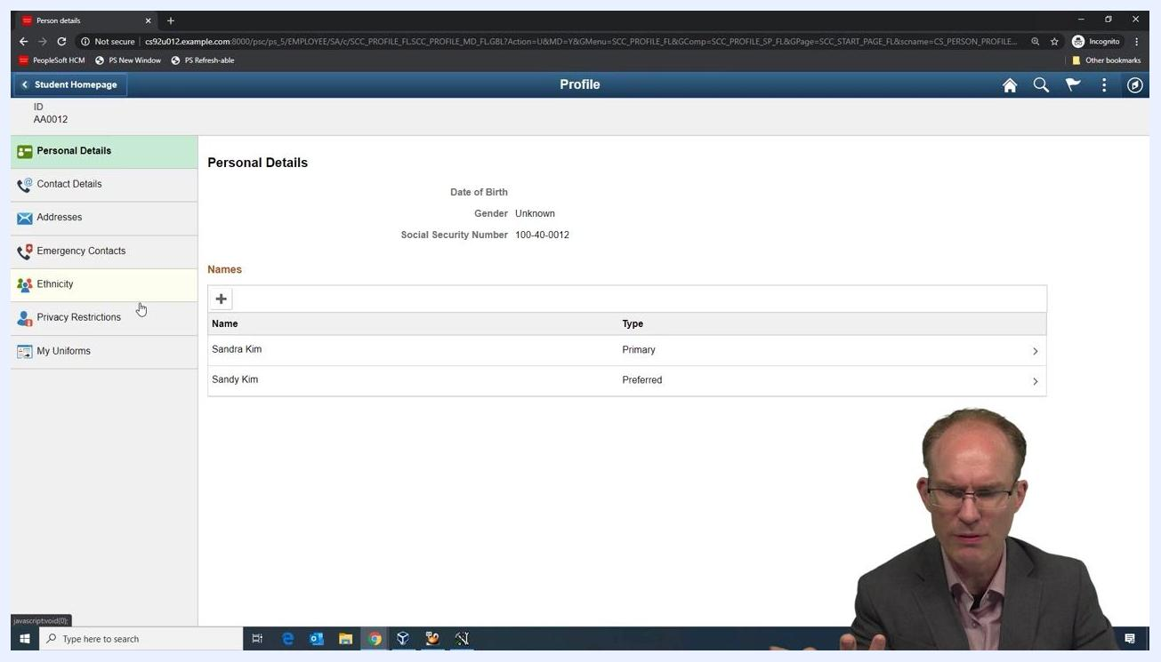
The Profile component in a Fluid layout, showing Personal Details and the left navigation menu.

Step 3: Identify the legacy Classic component
Click My Uniforms in the left navigation menu. This page uses a Classic layout inside the Fluid navigation shell.
The page includes Personal Characteristics, Shirt, and Slacks sections and a table of items. It also has Save, Return to Search, Notify, and Add buttons. This is the component you convert.
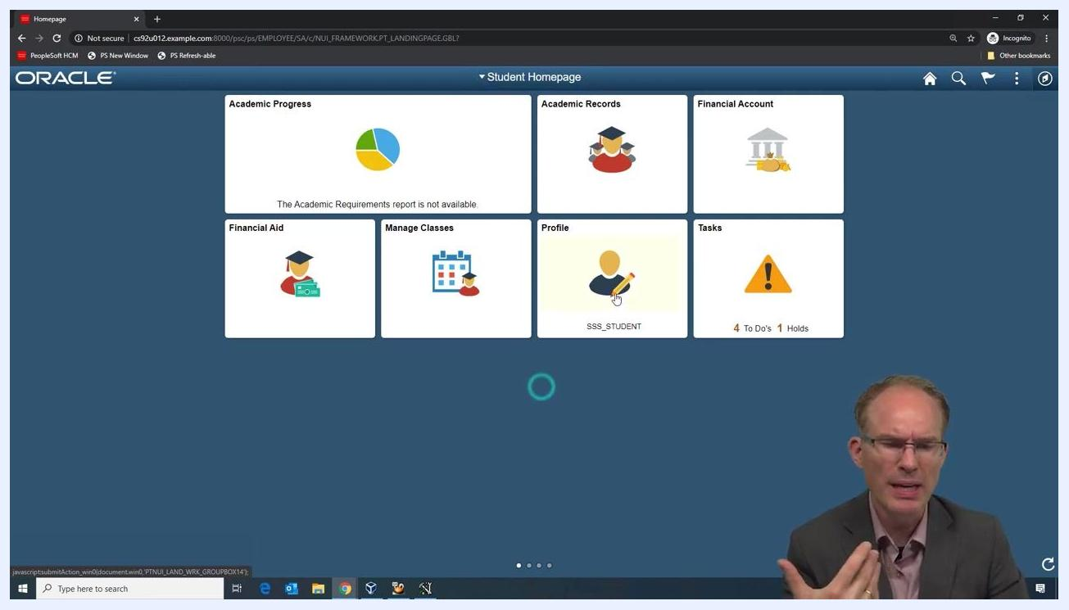
The My Uniforms Classic component inside the Fluid navigation, showing the legacy layout and controls.
Before you continue, confirm that conversion is a good fit:
- Self-service components are often accessed on mobile devices, so Fluid conversion is highly beneficial for responsive design.
- The target page is a plain Classic page, not embedded in a two-panel layout.
- The My Uniforms component is accessed through a navigation collection (or a master-detail structure in Campus Solutions). You convert only the main transaction area, which is the content panel, and not the navigation shell.

Step 4: Open the Classic page in Application Designer
Launch PeopleSoft Application Designer and open the JSM_UNIFORMS page. This page could be used to manage uniforms in a private school, on a sports team, or in a workplace.
The page contains these elements:
- A "Personal Characteristics" section with Height and Weight fields.
- A "Shirt" section with Neck and Sleeve fields.
- A "Slacks" section with Waist and Inseam fields.
- A table with the columns As Of, Item, Color, Item Count, and Active Flag.
This is a typical Classic page layout.
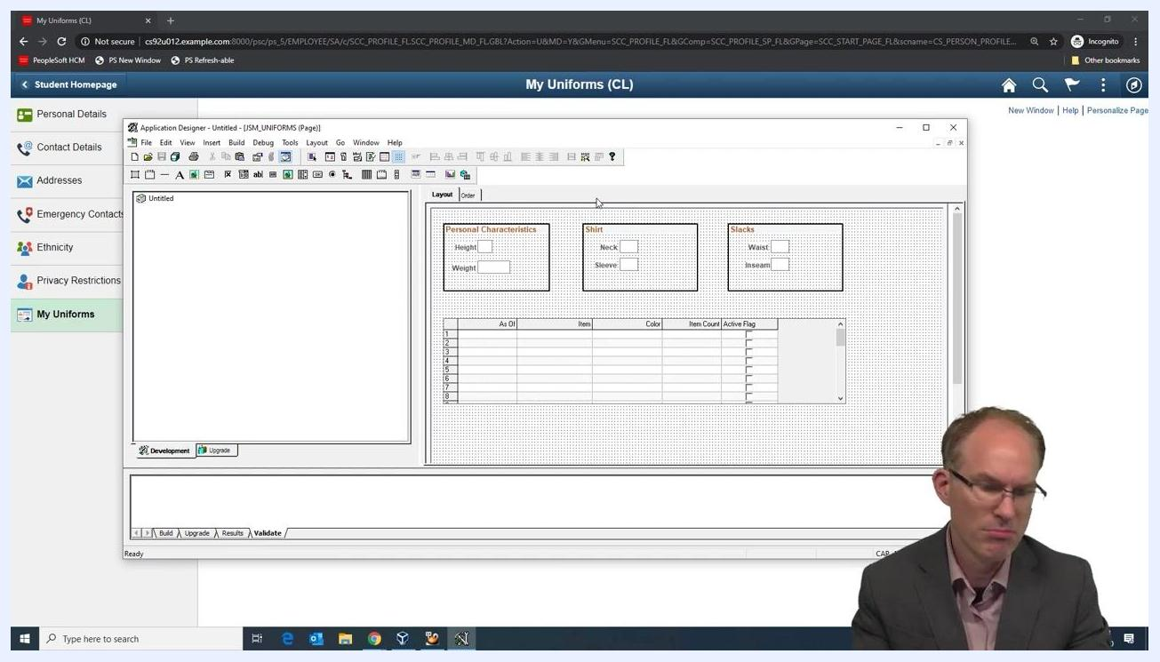
Application Designer showing the JSM_UNIFORMS Classic page with the Personal Characteristics, Shirt, and Slacks sections and the item table.

Step 5: Open the component definition
Rendering mode is set at the component level, so open the component that uses this page. In Application Designer, open the Open Definition dialog and follow these steps:
- Select Component as the definition type.
- Enter JSM_MY_UNIFORMS in the selection criteria.
- Click Open.
The Open Definition dialog in Application Designer with the JSM_MY_UNIFORMS component selected.

Step 6: Mark the component as Fluid Mode
Open the Component Properties for JSM_MY_UNIFORMS. On the Use tab, find the Component Attributes section and select Fluid Mode. Click OK to save the change.
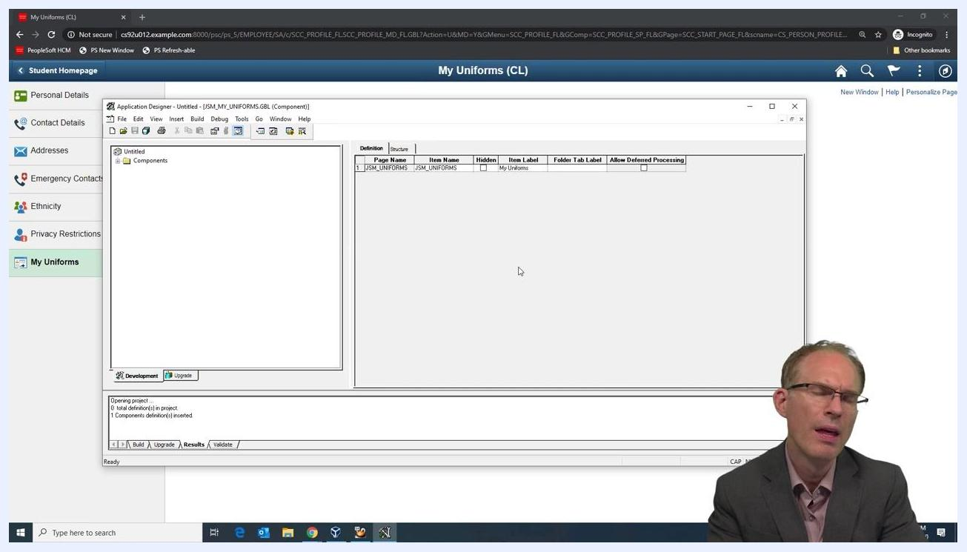
The Component Properties dialog with the Fluid Mode checkbox highlighted for the JSM_MY_UNIFORMS component.

Step 7: Reload the navigation collection and view the Fluid rendering
Refresh or reload the navigation collection in your PeopleSoft environment, then go to My Uniforms. The component now renders in Fluid mode, but the layout is not yet optimal.
All sections and fields (Height, Weight, Neck, Sleeve, Waist, and Inseam) appear stacked vertically instead of aligned horizontally. In Fluid, data entry fields are block elements, so each field takes the full width of its parent container.
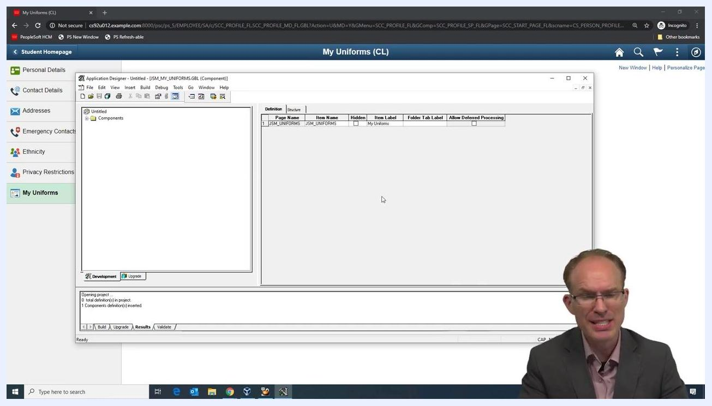
The My Uniforms page in Fluid mode, with all fields rendered vertically and the navigation menu on the left.

Step 8: Identify layout issues and compare with the Classic layout
The default Fluid rendering has these problems:
- All fields are stacked vertically, which uses space inefficiently.
- There is no padding along the sides of the content area.
- When you resize the window, scroll bars may be missing, which shows the page lacks a proper Fluid structure.
Refer to the Classic layout in Application Designer to see the original horizontal grouping of the fields. Use it as a reference for the Fluid layout you want to reach.
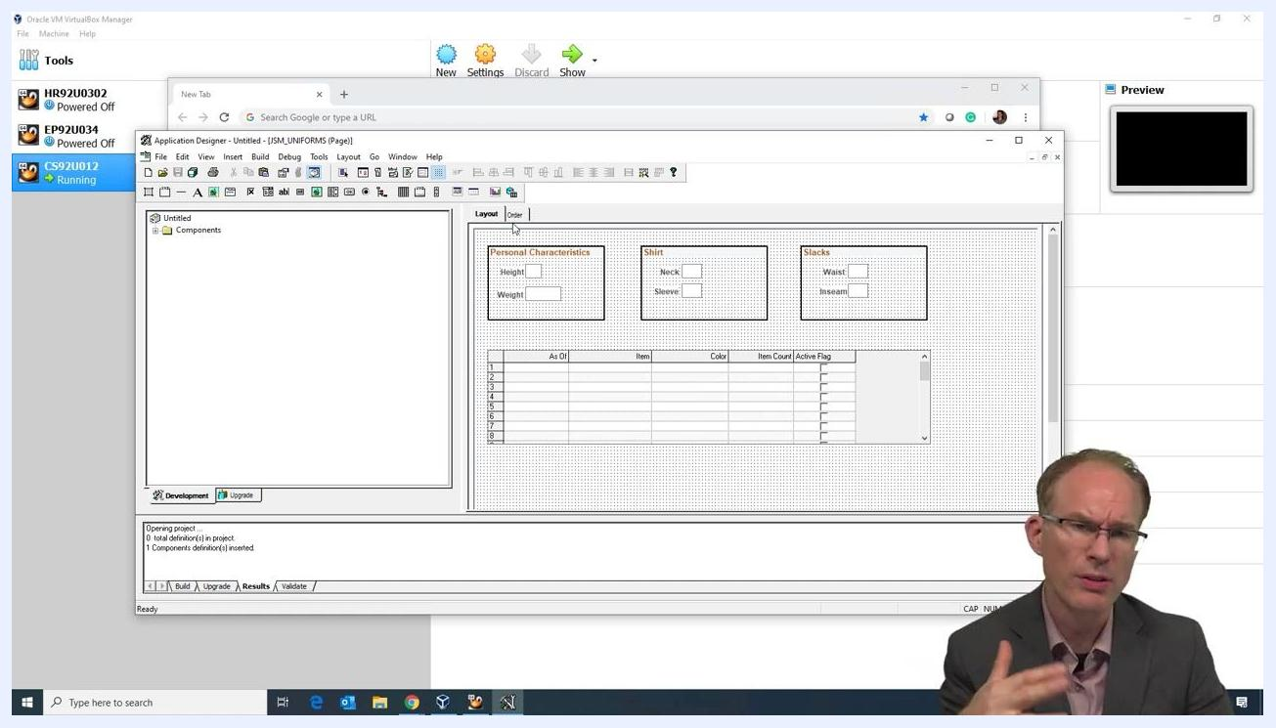
Application Designer showing the Classic page layout with the Personal Characteristics, Shirt, and Slacks sections arranged horizontally.

Step 9: Mark the page as a Fluid Page
Open the Page Properties dialog for the JSM_UNIFORMS page from the Application Designer toolbar or menu. This step enables the Fluid attributes the page needs for proper layout and responsive behavior.
In the dialog, confirm these settings:
- Page Type: Standard Page
- Page Size: Custom size (Width: 863, Height: 600)
- Style: Use Default Style Sheet and Page Background
- Fluid Page: selected
Click OK to apply the settings.
The "Fluid" safety switch is an option intended for Classic pages. Enabling it does no harm. If the safety switch is not selected, the Fluid tab is disabled for all items on the page. Make sure the Fluid page checkbox is selected so the Fluid tab is available for page items.

Step 10: Make room on the layout
Rearrange the "Personal Characteristics," "Shirt," and "Slacks" group boxes and the grid. Leave enough space for additional group boxes. Group boxes are commonly used in Fluid layouts.
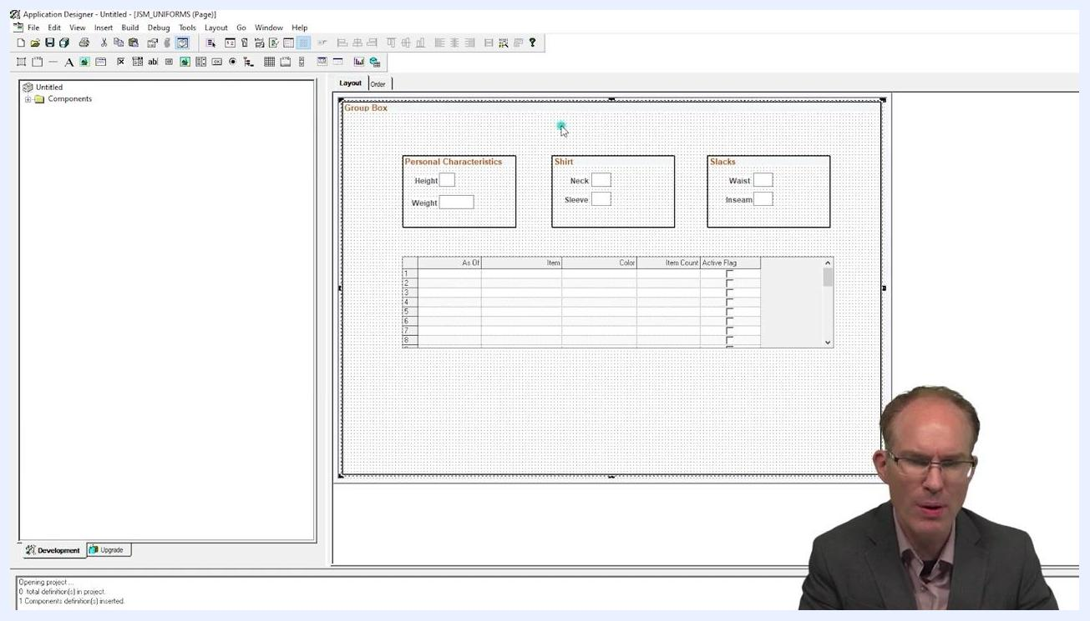
The Application Designer layout with the group boxes and grid spaced out.

Step 11: Add and configure the outer group box
Insert a new group box to act as the outer container for the Fluid layout. An outer group box is standard practice for Fluid pages. Configure it as follows:
- Clear the label field so the group box is invisible, because it is used only for layout.
- Set the group box type to Layout Only so it does not display visually.
- Assign the style class PSAppsContent. Check the spelling of the style class carefully.
- Save the group box configuration.

Step 12: Save and preview the converted page
Save your changes in Application Designer. Then open the My Uniforms page in your browser. The Personal Characteristics, Shirt, and Slacks sections are visible with their input fields, and the item grid appears below them.
A scroll bar and padding now appear around the items, which shows the Fluid layout is taking effect. The page is nearly ready for production use. The conversion took only two checkboxes and a group box with a style class.
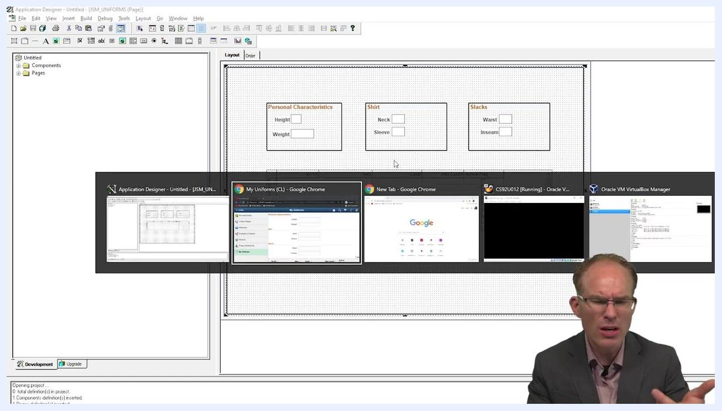
A web browser showing the My Uniforms page with its sections and the item grid.

Step 13: Review the layout before the three-column change
You can improve the layout further by placing all three sections side by side across the top of the page. In the browser, the sections are still stacked vertically, each with its input fields, and the grid appears below them.
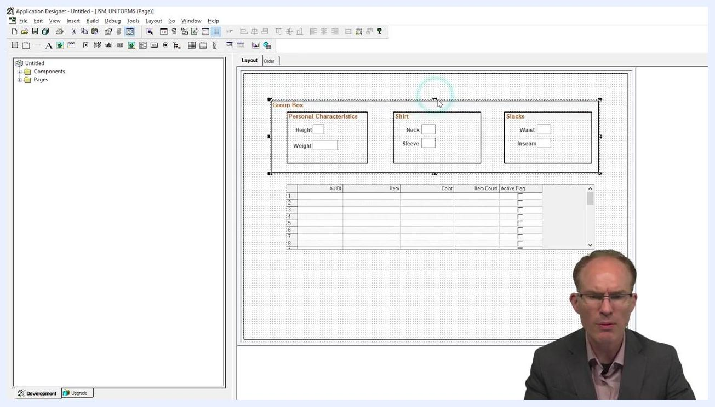
The My Uniforms page in a web browser with vertically stacked sections and the grid, before the three-column adjustment.

Step 14: Select the outer group box in Application Designer
Switch to Application Designer with your project loaded. The layout shows the outer group box containing three inner group boxes: "Personal Characteristics," "Shirt," and "Slacks." The grid for item details is below them. Select the outer group box to prepare for the three-column layout.
Application Designer showing three inner group boxes within an outer group box, ready for the three-column layout.

Step 15: Apply the three-column style class to the outer group box
With the outer group box selected, assign the style class psc_column-3 to enable a three-column layout.
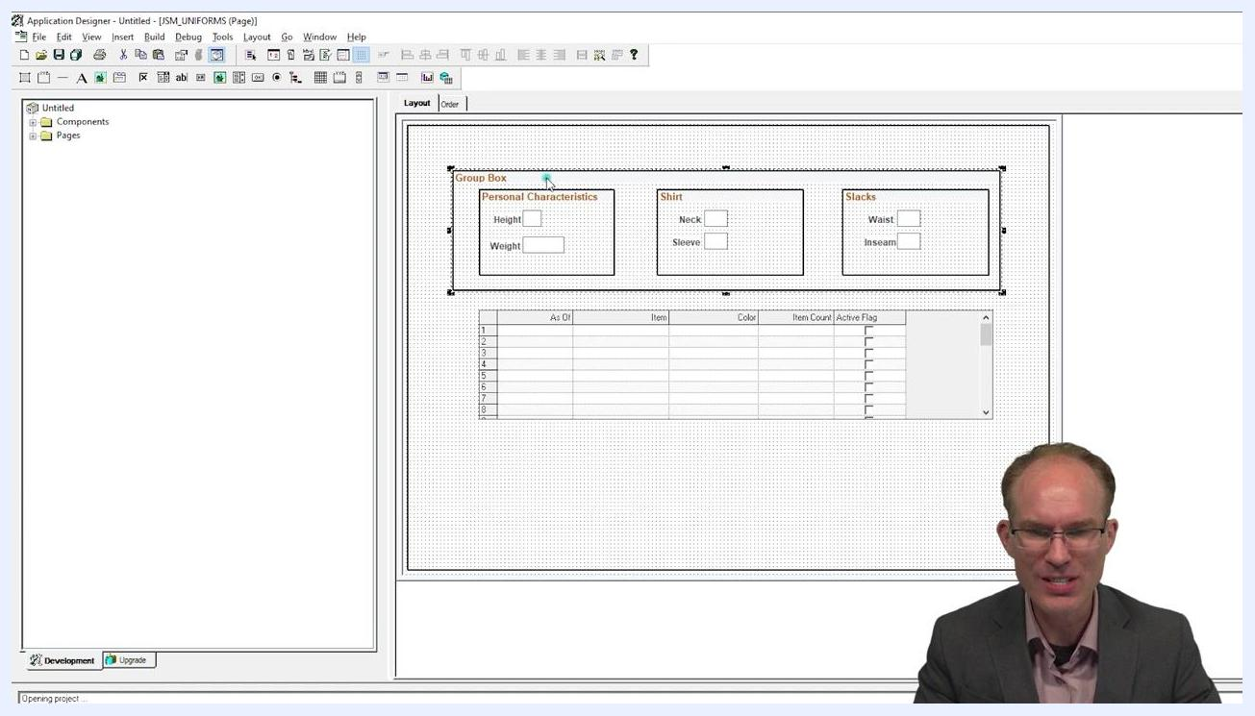
Application Designer with the outer group box assigned the psc_column-3 style class and three inner group boxes arranged horizontally.

Step 16: Apply a column item style class to each inner group box
Select each inner group box ("Personal Characteristics," "Shirt," and "Slacks") one at a time and open its Group Box Properties dialog. In the Style Classes field, enter psc_columnitem-1of3, or the equivalent class referenced in your documentation. Leave other properties, such as Group Box Type and HTML Tag Type, as you configured them earlier.
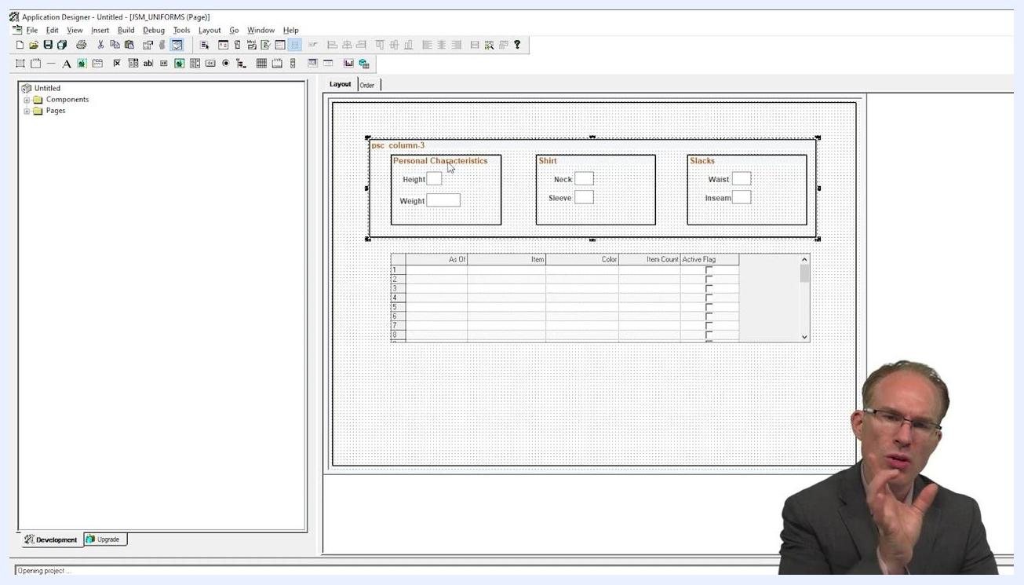
The Group Box Properties dialog in Application Designer with the psc_columnitem-1of3 style class being applied.

Step 17: Save and preview the three-column layout
Save your changes in Application Designer, then open the My Uniforms page in your browser. The "Personal Characteristics," "Shirt," and "Slacks" sections now appear in three columns across the top, with the grid below. Confirm that the layout is visually consistent and matches your design.

Step 18: Test responsive behavior
Place the browser window in front of Application Designer so you can compare the live page with the design layout. Resize the browser window gradually. At a certain width, the layout breaks over, and the columns stack vertically for smaller screen widths.
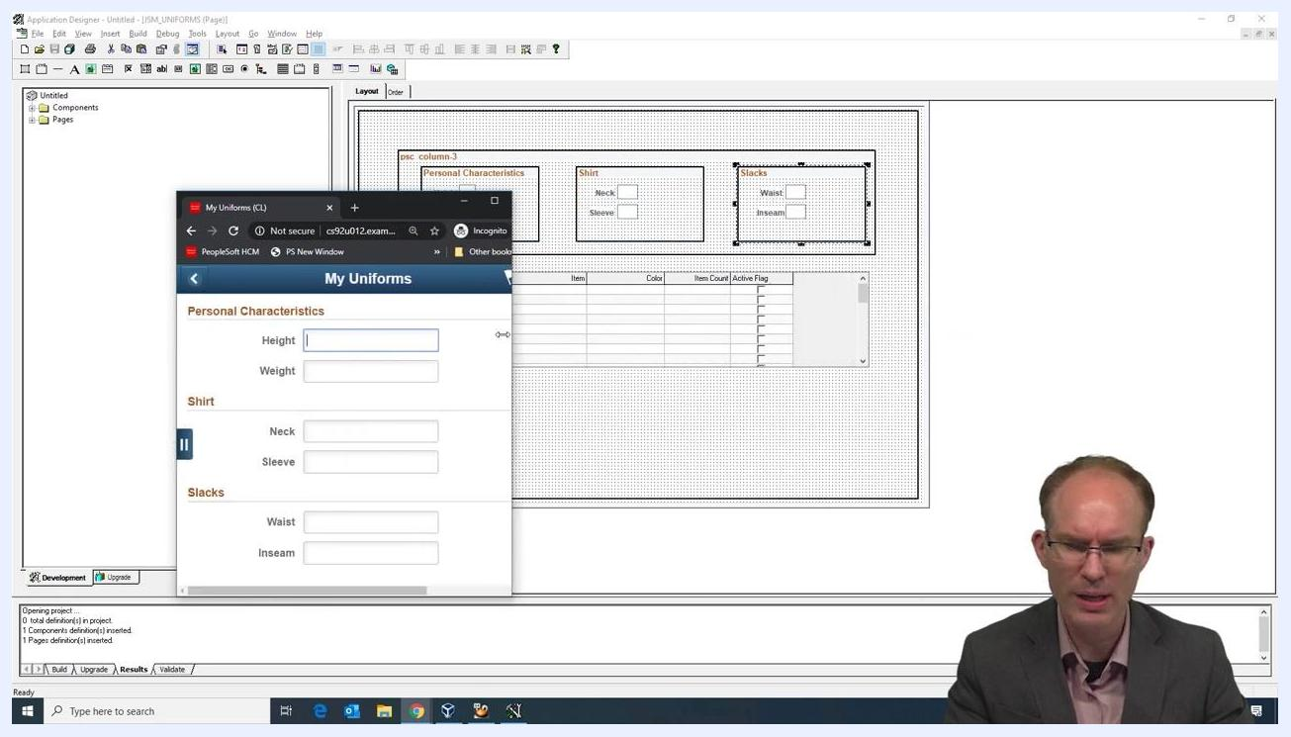
The My Uniforms page in a browser in front of Application Designer, with the three sections stacked vertically at a narrower window width.

Summary
To convert a classic page to a fluid page in PeopleSoft, you completed these tasks:
- Identified the legacy Classic component within your Fluid navigation and confirmed that a plain Classic page is suitable for conversion.
- Opened the page (JSM_UNIFORMS) and its component (JSM_MY_UNIFORMS) in Application Designer.
- Selected Fluid Mode at the component level and Fluid Page in the Page Properties.
- Wrapped the page content in a Layout Only outer group box with the PSAppsContent style class.
- Applied psc_column-3 to the outer group box and psc_columnitem-1of3 to each inner group box to create a three-column layout.
- Resized the browser to confirm that the columns stack on smaller screen widths.

