How to Find Your W-2 in Paylocity
If you need to locate your W-2 tax form, Paylocity makes it easy to view, download, and print the document directly from your employee account. This guide walks you through how to find your W-2 in Paylocity, from logging in to saving a secure copy for your records.
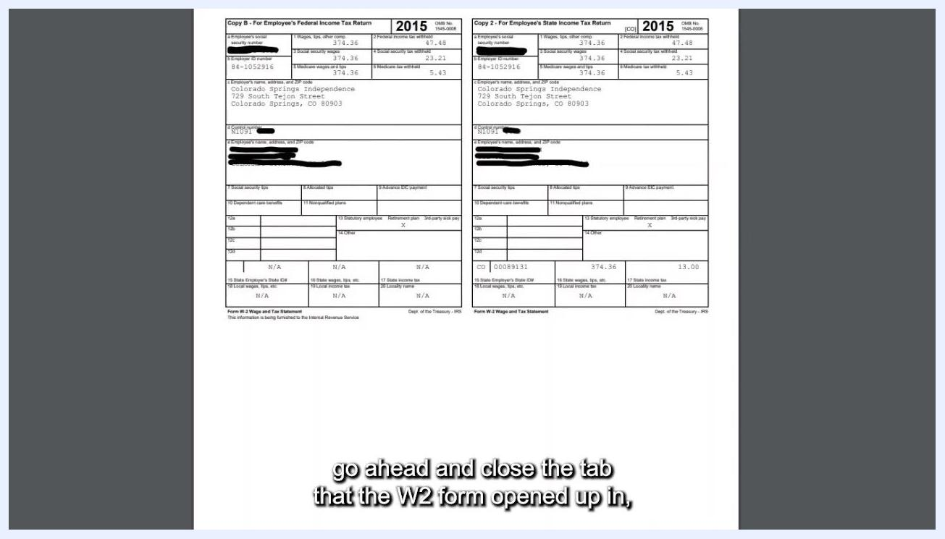
Paylocity W-2 Online Preview screen with the Back button visible at the top left, showing the list of W-2 forms and the 2015 preview

Prerequisites
- An active Paylocity employee account with your login credentials.
- Access to a web browser (the steps below use the Paylocity website).
- Adobe Acrobat Reader 5.0 or later if you choose to password protect your W-2 PDF.
- If you prefer to use the Paylocity mobile app instead, visit , click Employee Login at the top of the screen, and scroll down to the Payroll area for mobile-specific instructions.
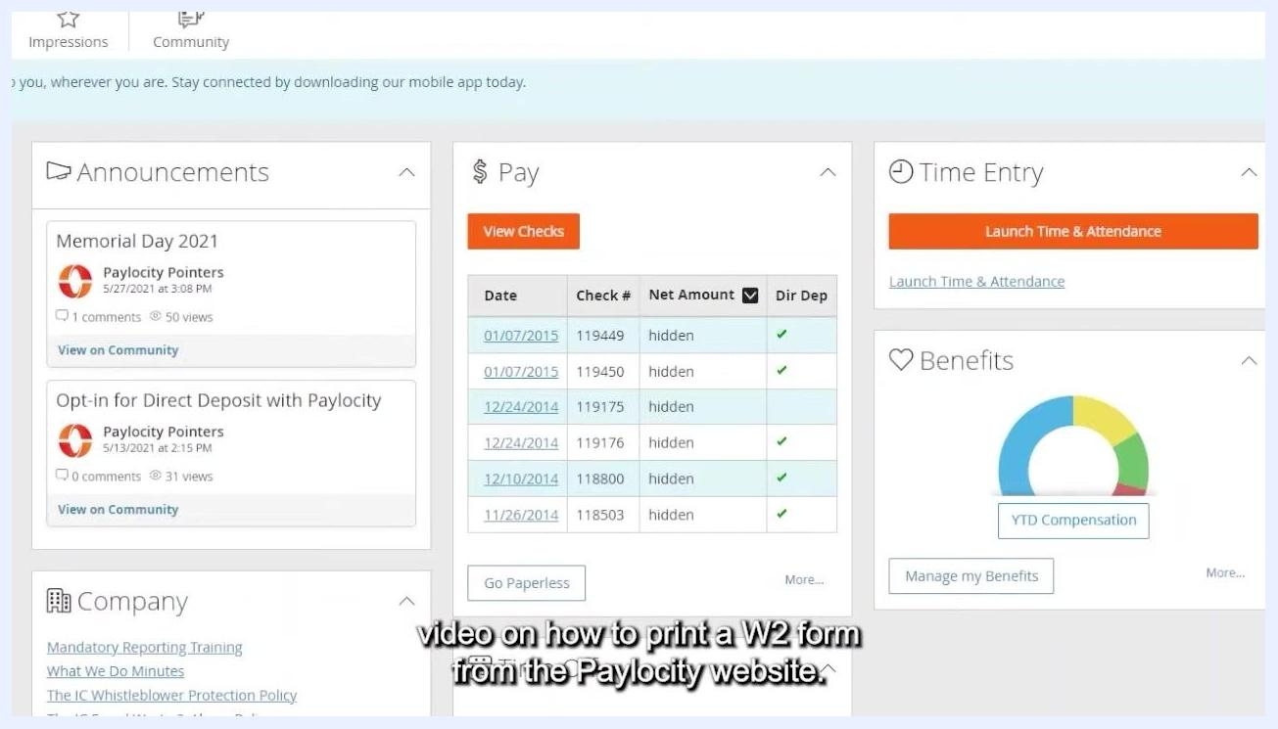
Paylocity dashboard with the Pay box, View Checks button, and surrounding Announcements, Time Entry, and Benefits sections

Step 1: Log in to Paylocity
Log in to the Paylocity website using your credentials. After logging in, you should land on the main dashboard page.
If you do not see the dashboard right away, proceed to the next step to open the Self Service Portal manually.

Step 2: Open the Self Service Portal
If you are not already on the dashboard:
- Go to the upper left-hand corner of the screen.
- Click the black box (menu icon).
- Select Self Service Portal from the menu.
- Wait for the screen to refresh and load the Self Service Portal.
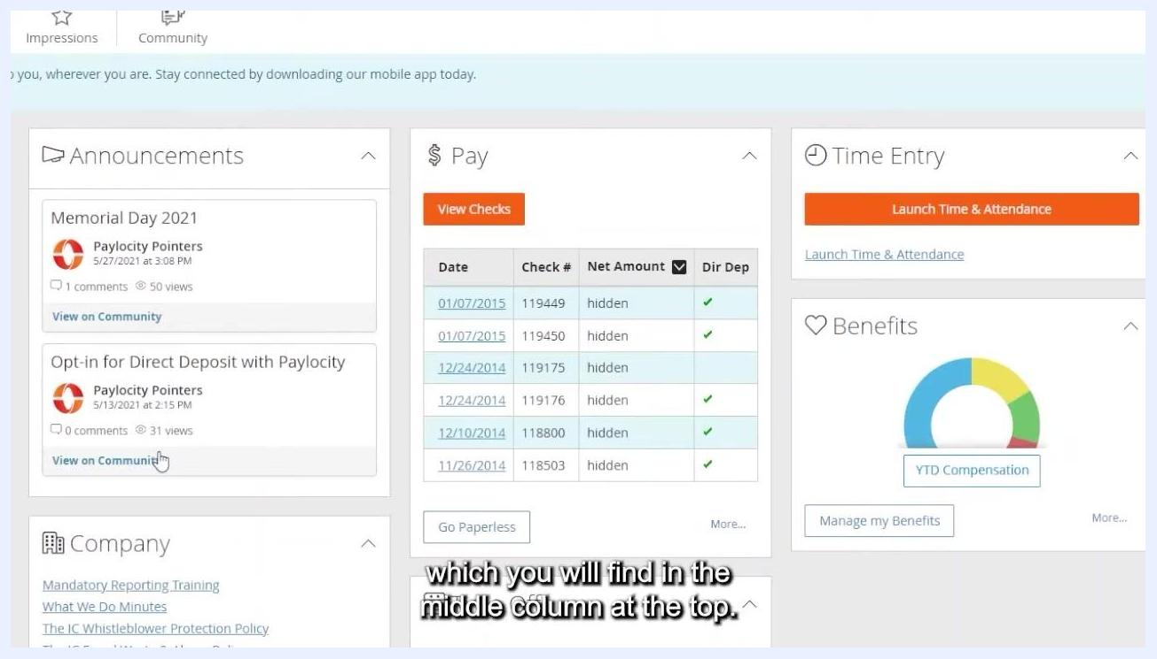
Paylocity Pay section showing the Checks and Tax Forms tabs with a "No Checks Selected" message
The Self Service Portal displays three columns, each containing boxes organized by category.

Step 3: Locate the Pay box and view your checks
In the middle column at the top of the Self Service Portal, find the box labeled Pay. Directly under the word "Pay," click the View Checks button.

Step 4: Switch to the Tax Forms tab
The View Checks area opens with your checks displayed by default. At the top of this page, you will see two tabs: Checks and Tax Forms. Click Tax Forms to switch to your tax documents.

Step 5: Select the year for your W-2
On the Tax Forms tab, you will see a list of all available W-2 forms on the left side of the screen, labeled by year (for example, 2015, 2014, 2013). There should be one W-2 for each year you have worked.
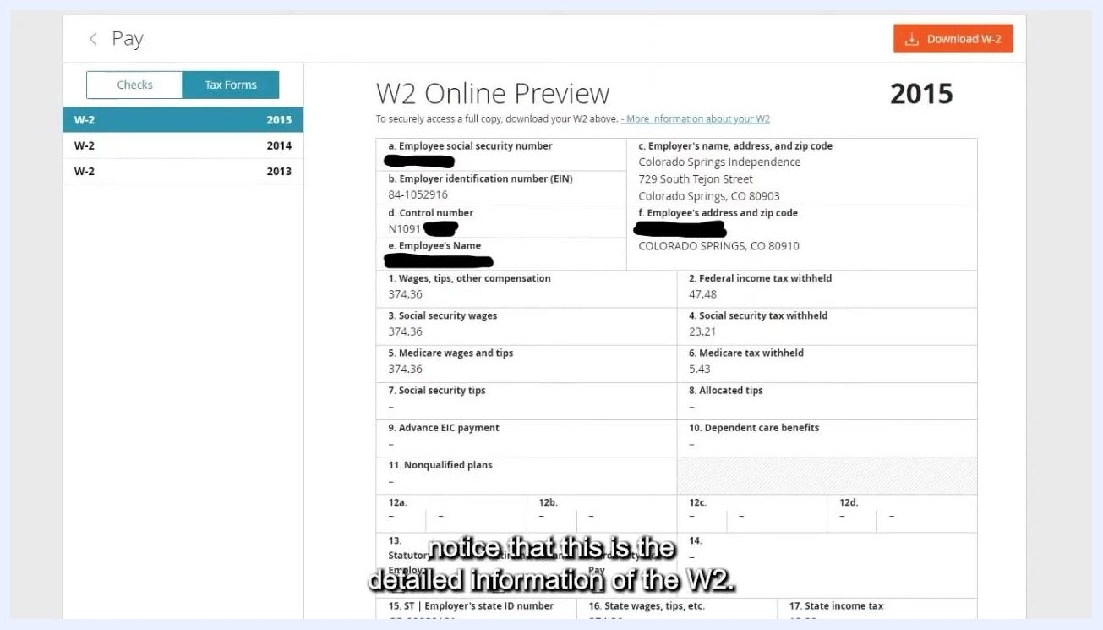
W-2 Online Preview for 2015 with employer and employee details, wages, and tax withholdings
Click the year you want to view. The detailed W-2 information appears as a preview on the right side of the screen—review it to confirm you have selected the correct year.

Step 6: Download your W-2 form
Once you have confirmed the correct year is selected, click the Download W-2 button in the top right corner of the screen.
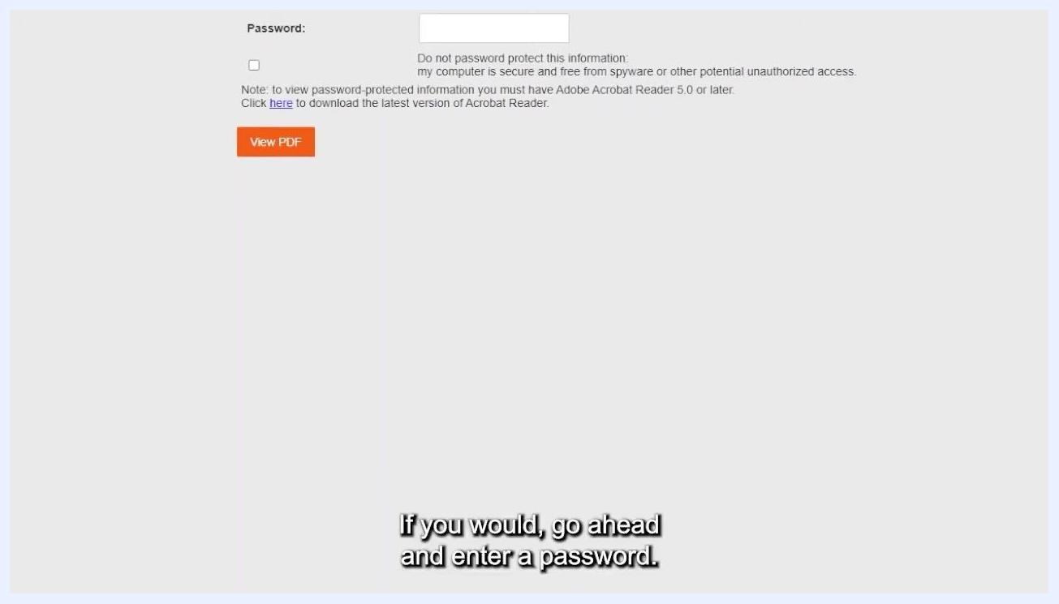
Password protection screen with the password field ready for entry and the View PDF button below

Step 7: Choose your password protection settings
After clicking Download W-2, click the highlighted Download W-2 button to proceed to the password protection screen.
A new screen appears with the following options:
- A Password field at the top.
- A checkbox labeled Do not password protect this information: my computer is secure and free from spyware or other potential unauthorized access.
- A note stating that viewing password-protected information requires Adobe Acrobat Reader 5.0 or later.
- A View PDF button below these options.
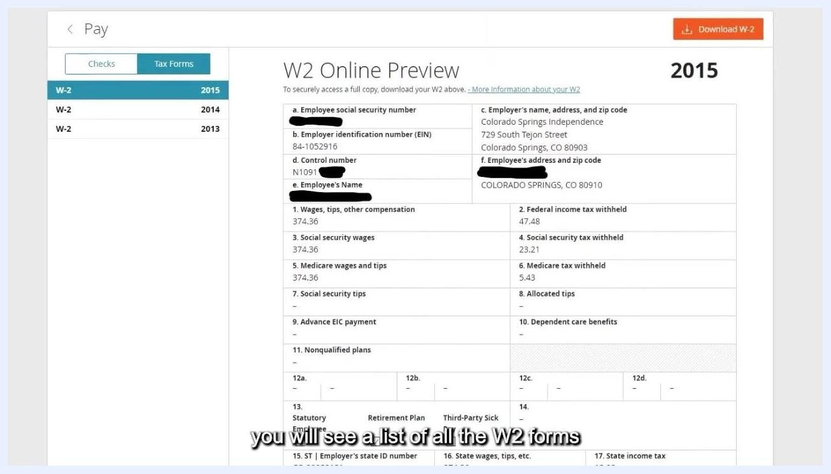
Paylocity W-2 Online Preview listing W-2 forms by year, with a detailed preview of the 2015 form on the right and the Download W-2 button in the top right corner

Step 8: Enter a password (optional)
If you want to password protect your W-2 PDF, enter a password of your choice in the Password field. Be sure to remember this password, as you will need it to open the PDF in a later step.
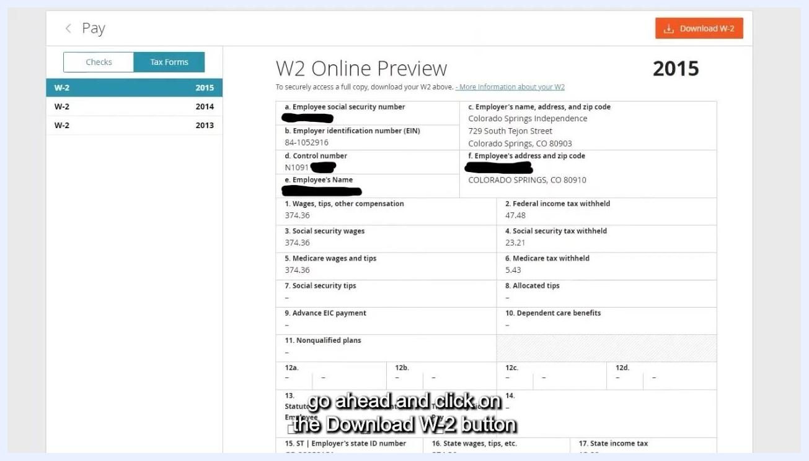
W-2 Online Preview with the Download W-2 button highlighted in the top right corner

Step 9: Skip password protection (optional)
If your computer is secure and free from spyware or unauthorized access, you can skip password protection instead. Click the checkbox labeled Do not password protect this information.
Password protection screen for the W-2 download, showing a password field, a "do not password protect" checkbox, and a View PDF button

Step 10: Generate and view your PDF
Once you have either entered a password or checked the box to skip password protection, click the orange View PDF button to generate your W-2 form.
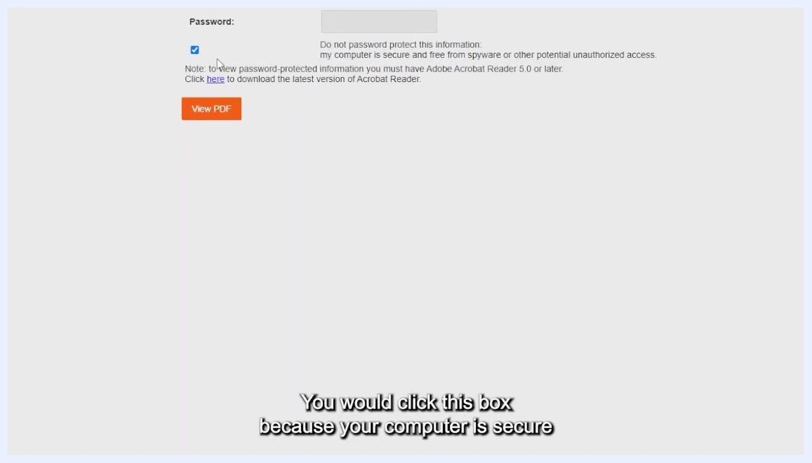
Password protection screen with the "do not password protect" checkbox checked and the View PDF button below
- If you chose password protection, you will be prompted to enter your password again to open the PDF.
- If you chose not to password protect it, the PDF will open immediately.

Step 11: Review your W-2 PDF
Review the W-2 PDF that opens for the selected year. The form includes all relevant tax information, such as wages, tax withholdings, and employer and employee details.
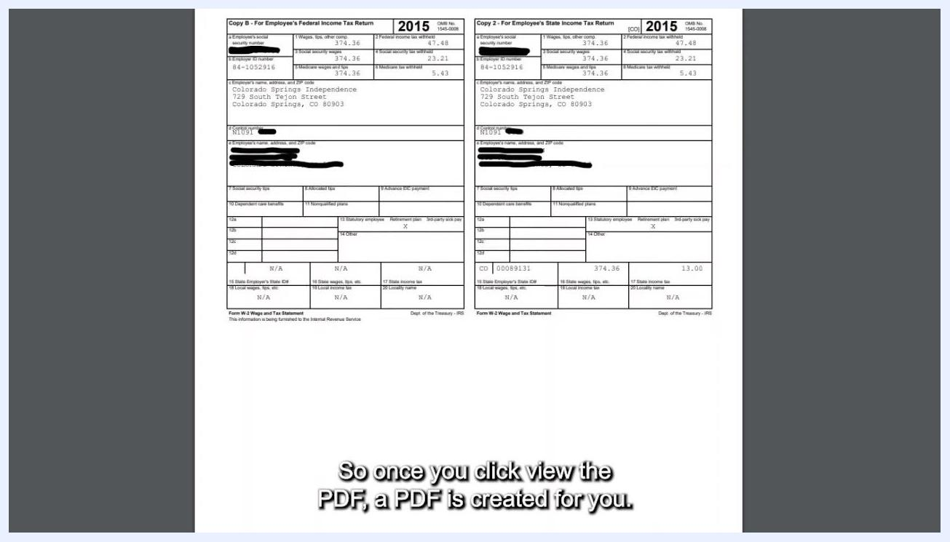
W-2 PDF document open, showing two copies of the 2015 W-2 form with all tax details visible
There may be a second page showing the same information in a larger font for easier reading—both pages contain identical information, just formatted differently.

Step 12: Save or print your W-2
Use your PDF viewer's options to save the file to your computer for future reference, or print the W-2 directly from the PDF viewer. Once saved, you can email the file, keep it for your records, or print additional copies as needed.
Password protection screen with the checkbox checked and the View PDF button visible

Step 13: Close the PDF and return to Paylocity
When you are finished with your W-2 PDF, close the browser tab or window where the PDF opened. This returns you to the W-2 Online Preview section of the Paylocity website.
W-2 PDF document open with two copies of the 2015 form, ready to be closed
To view or download another W-2 form, select a different year from the list on the left and repeat the download process.

Step 14: Return to the Self Service Portal
When you are finished, click the Back button at the top left of the Paylocity W-2 Online Preview screen to return to the Self Service Portal.
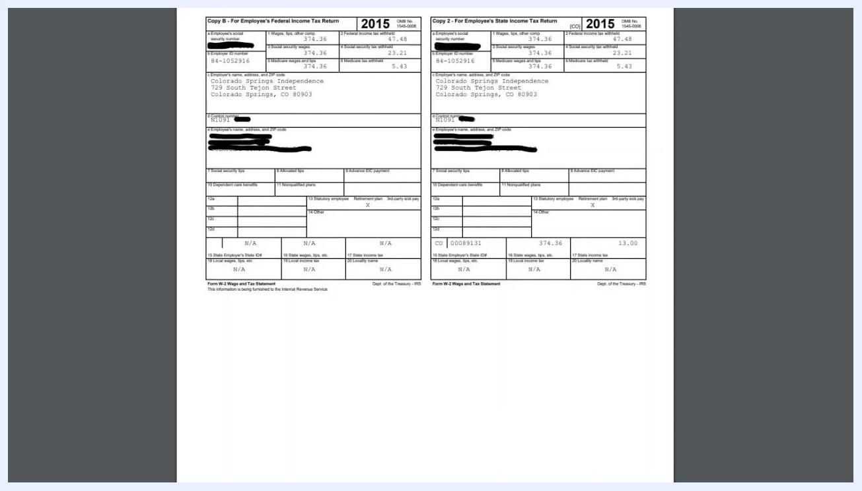
Paylocity W-2 Online Preview screen confirming the return to the Self Service Portal, with the Back button and 2015 preview still visible
You are now back at the Self Service Portal page, where you can continue with other tasks or log out as needed.

Step 15: Return to the main dashboard
After completing your W-2 tasks, you will return to the main Self Service Portal dashboard, which includes:
- Announcements: Updates such as "Memorial Day 2021" and "Opt-in for Direct Deposit with Paylocity," with comment and view counts and links to community details.
- Pay: A summary of recent paychecks, including Date, Check #, Net Amount (hidden for privacy), and Direct Deposit status, along with the View Checks button and a "Go Paperless" option.
- Time Entry: A section to launch the Time & Attendance system via the orange Launch Time & Attendance button.
- Benefits: A graphical summary of Year-To-Date (YTD) Compensation and a Manage my Benefits button.
- Company: Links to resources such as "Mandatory Reporting Training," "What We Do Minutes," and "The IC Whistleblower Protection Policy."
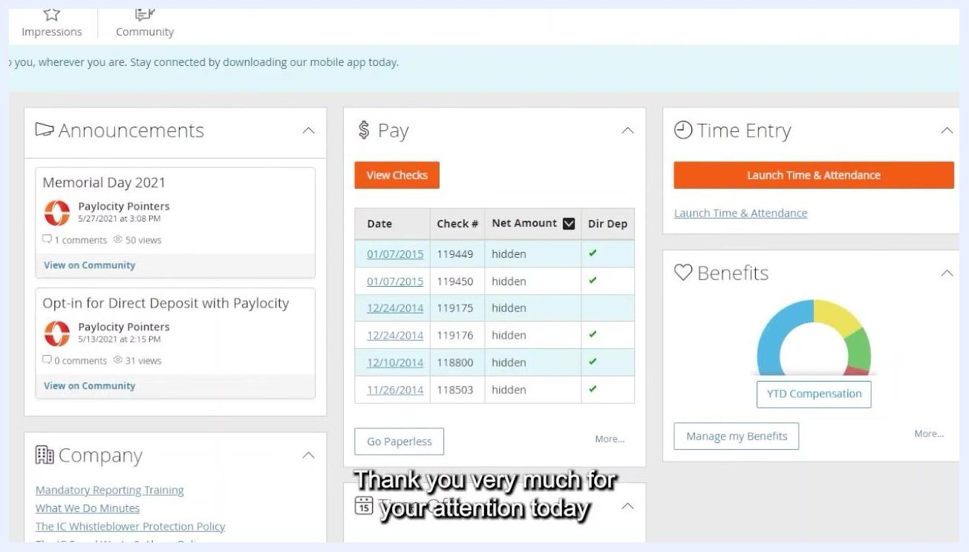
Paylocity Self Service Portal dashboard showing the Announcements, Pay, Time Entry, Benefits, and Company sections
Closing screen with the Independence Center logo and the message "People with disabilities building community" over a background image of the center's building and sign.

What's next
Now that you know how to find your W-2 in Paylocity, you can revisit the Tax Forms tab at any time to download W-2s from previous years. Always store saved files securely, especially if you chose not to password protect your PDF. For further assistance, explore the other sections of the Self Service Portal dashboard.
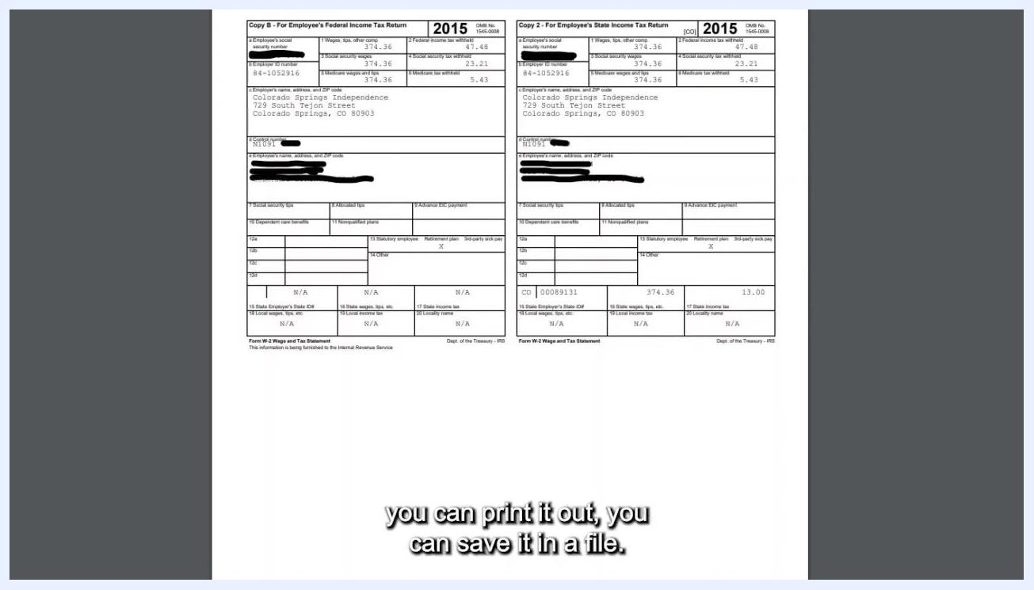
W-2 PDF document open with two copies of the 2015 form showing full tax details

