How to schedule an OTBI report in Oracle Fusion: Creating a Scheduled Birthday Email Agent for Managers
This guide shows you how to schedule an OTBI report in Oracle Fusion to automatically send managers a personalized list of their team members' upcoming birthdays. By building an agent around the Birthday E-mail Analysis, you can automate monthly delivery so each manager receives only information relevant to their own team.

Prerequisites
- Access to Oracle Transactional Business Intelligence (OTBI) with the Birthday E-mail Analysis available under the Others section.
- Permissions to create and schedule agents in the Catalog.

Reviewing the Birthday E-mail Analysis

1. Open the Birthday E-mail Analysis
From the Oracle Transactional Business Intelligence home screen, locate Birthday E-mail Analysis under the Others section. Click Open next to it to launch the analysis.
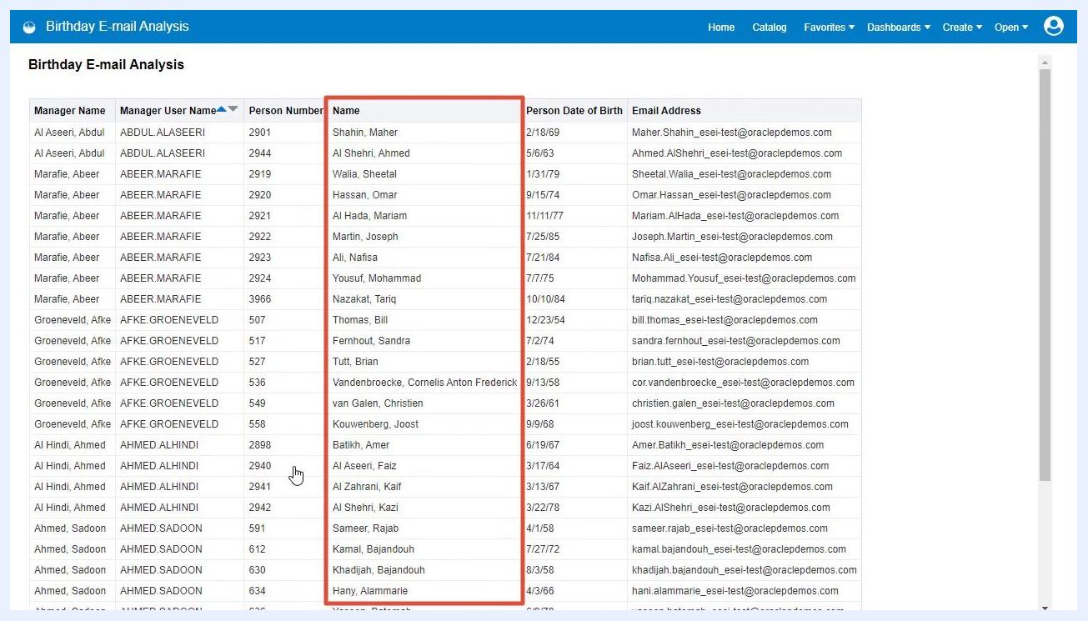
Oracle BI home screen with 'Birthday E-mail Analysis' listed under Others, showing options to Open, Edit, or access More actions

2. Review the analysis data
The analysis displays a table with the following columns: Manager Name, Manager User Name, Person Number, Name, Person Date of Birth, and Email Address. Confirm that the table lists all managers, their employees, and the employees' upcoming birthdays.
Birthday E-mail Analysis table showing columns for Manager Name, Manager User Name, Person Number, Name, Person Date of Birth, and Email Address
Note that "upcoming" refers to employees who have birthdays in the following month. Verify that the Person Date of Birth column is present and contains relevant dates.
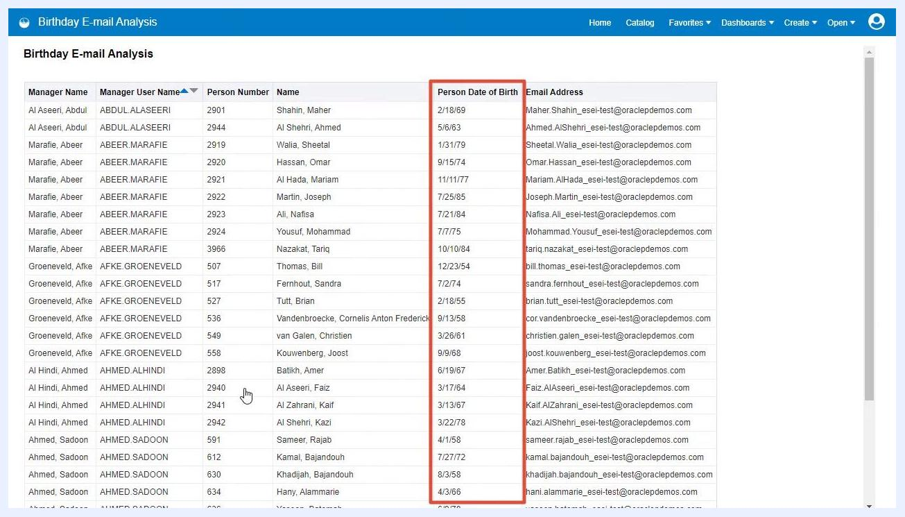
Birthday E-mail Analysis table with the 'Person Date of Birth' column highlighted, showing various birth dates
Confirm that each manager should only receive the list of their direct reports, not all employees. The analysis groups employees under their respective managers.
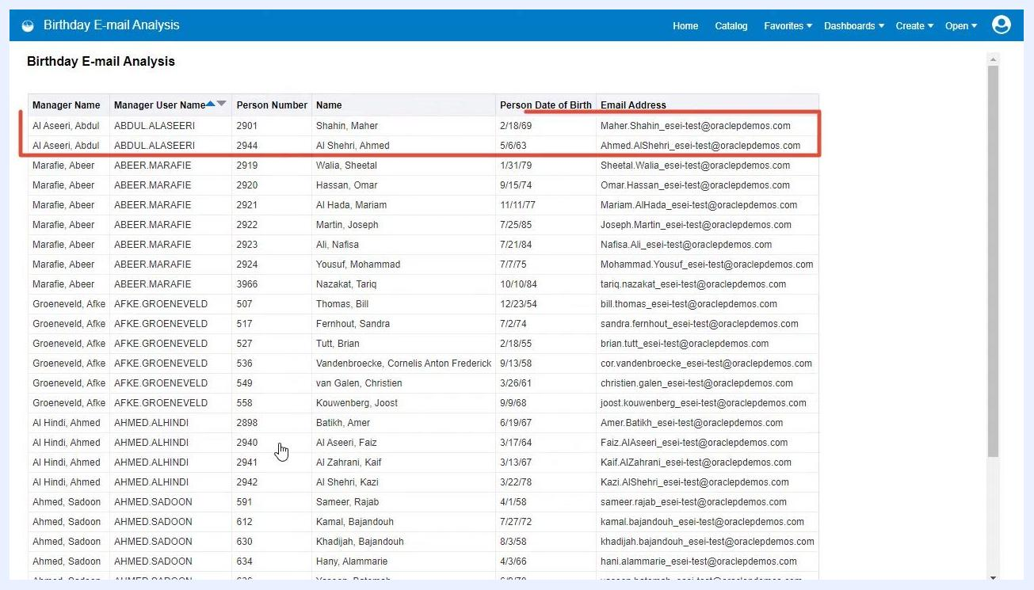
Birthday E-mail Analysis table with rows grouped by Manager Name, showing only the relevant employees for each manager

Creating and scheduling the agent

3. Return to the Catalog to create a new agent
Click the Catalog button in the top navigation bar, then navigate to the folder where you want to create the agent (for example, My Folders).
Oracle BI Catalog view showing folders and the 'Birthday E-mail Analysis' file

4. Create and schedule the agent
Start creating a new agent, then open the Schedule tab. Set the frequency to Monthly, select Day 1, and ensure all months are checked. Set the start date and time as needed, and make sure the agent is Enabled.
Agent scheduling screen with frequency set to Monthly, Day 1, and all months selected

5. Set the condition for the agent
Go to the Condition tab and use the default condition, which checks whether there are birthdays for the current month. Test the condition to confirm it works as expected.

Configuring delivery content and recipients

6. Configure delivery content
Go to the Delivery Content tab and set the subject to "Manager Team Birthday List". For content, select the path to your Birthday E-mail Analysis, and leave the format as Device default. Choose whether to deliver results directly or as an attachment.
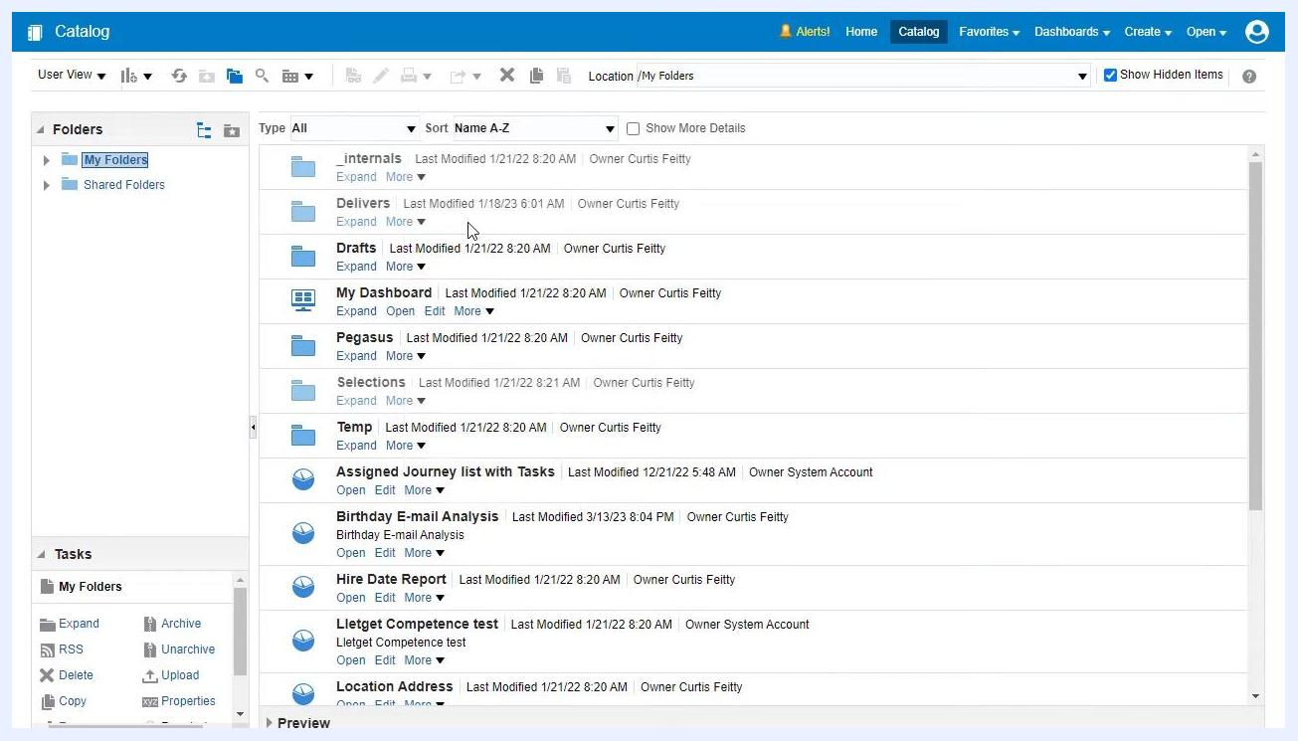
Delivery Content tab with subject set to 'Manager Team Birthday List', content path set, and format as device default

7. Configure recipients to include only managers
Go to the Recipients tab and remove any default recipients. Check the box for Get Recipients from the Analysis Used in the Agent Condition, then select Birthday E-mail Analysis as the source.
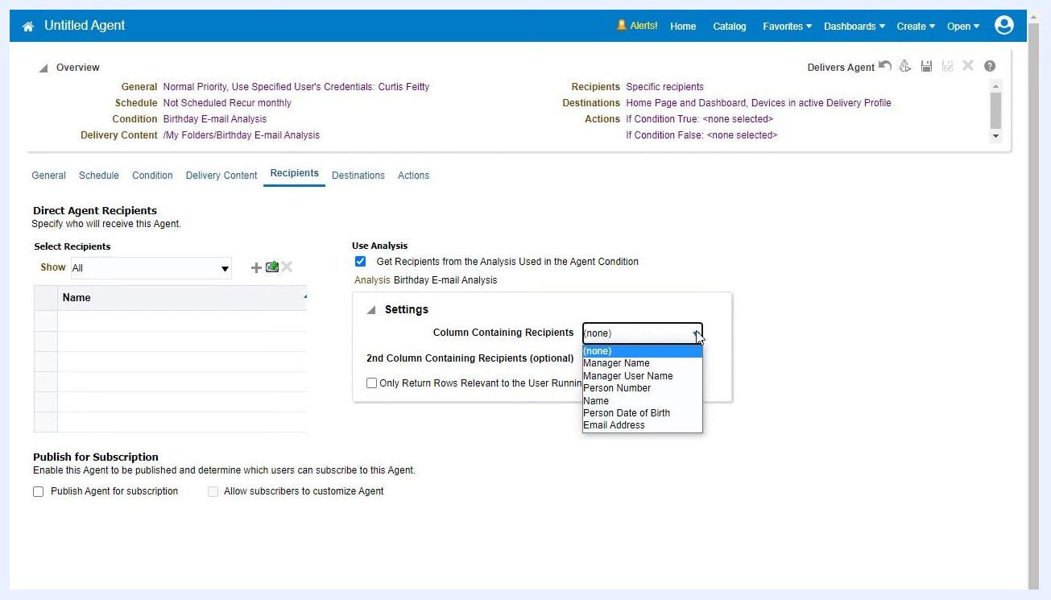
Recipients tab showing option to get recipients from analysis and a list of available columns for recipient selection
In the recipient column settings, choose Manager User Name from the dropdown menu for Column Containing Recipients. Do not select a second column, since only the manager's username is needed.
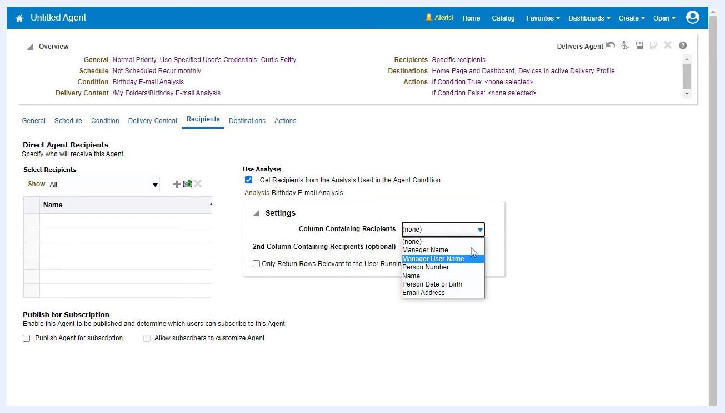
Recipients tab with dropdown menu open, highlighting 'Manager User Name' as the selected column for recipients

8. (Optional) Restrict rows to the user running the agent
In the Recipients tab, under Settings, check Only Return Rows Relevant to the User Running the Agent if you want each manager to see only their own team's birthdays. This filters the results so each recipient only receives information relevant to them.
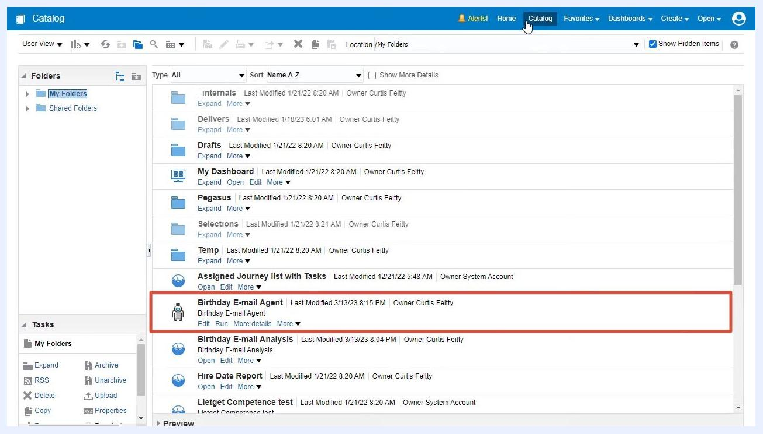
Recipients tab with 'Only Return Rows Relevant to the User Running the Agent' option highlighted, 'Manager User Name' selected as the recipient column, and the agent overview visible at the top

Saving and verifying the agent

9. Save the agent
Click the Save icon (floppy disk) in the agent setup window. Confirm that your agent is now listed in the Catalog under your chosen folder (for example, My Folders) as Birthday E-mail Agent. The agent is now configured to run automatically on the first day of every month.
Oracle BI Catalog view showing 'Birthday E-mail Agent' listed, with last modified date and owner information, confirming the agent is saved and ready

10. Verify agent setup
In the Catalog, locate the Birthday E-mail Agent entry. Confirm the last modified date and owner details to ensure your changes have been saved. The agent is now ready to deliver the list of upcoming birthdays to each manager as scheduled.
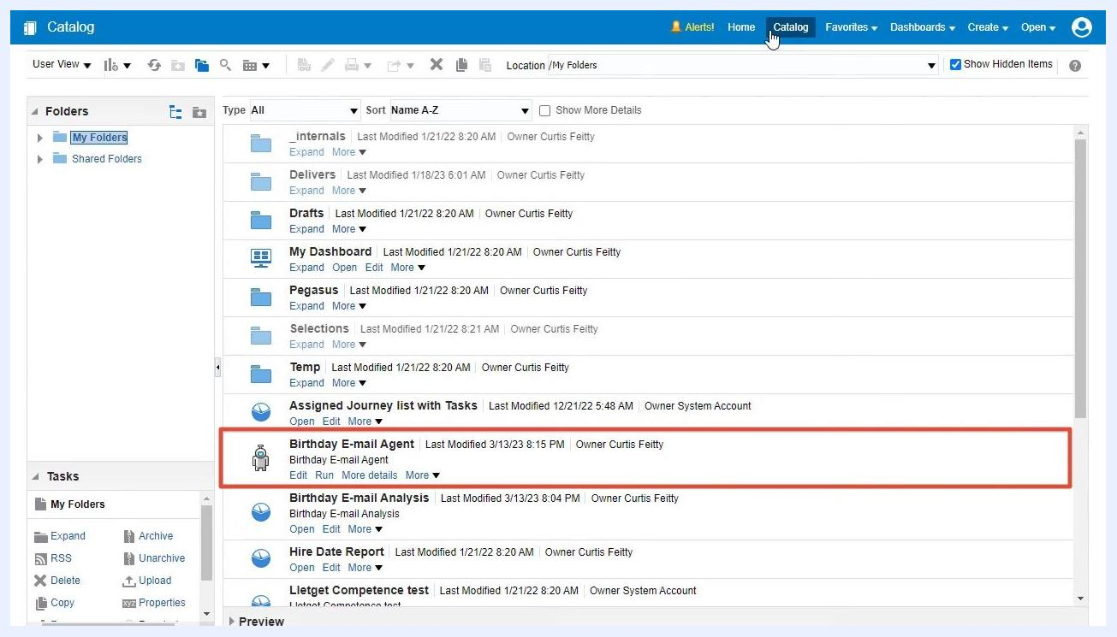
Catalog view with 'Birthday E-mail Agent' highlighted, showing confirmation of agent creation and readiness for scheduled delivery

Summary
By completing these steps, you have successfully learned how to schedule an OTBI report in Oracle Fusion that automatically sends each manager a personalized list of their team members with upcoming birthdays on the first day of every month. This approach ensures privacy, relevance, and automation for your organization's birthday notifications.

