How to Enable Visual Builder Studio in Oracle Fusion
Visual Builder Studio (VB Studio) lets you extend your Oracle Cloud Applications with custom pages, components, and logic. This guide walks you through how to enable Visual Builder Studio in Oracle Fusion, create a VB Studio project, and complete the initial configuration so your development team can begin extending your Oracle Cloud Application.

Prerequisites
Before you enable Visual Builder Studio in Oracle Fusion, confirm the following:
- Your Oracle Cloud Application and Visual Builder Studio installations are already set up and running.
- You have administrative privileges for Visual Builder Studio (VB Studio).
- Your developers have a suitable Oracle Cloud Applications role or privilege.

Acceptable Oracle Cloud Applications roles
Assign one of the following roles (or a custom role based on one of these) to your developers:
- Application Administrator
- Sales Administrator
- Customer Relationship Management Application Administrator
- Application Developer
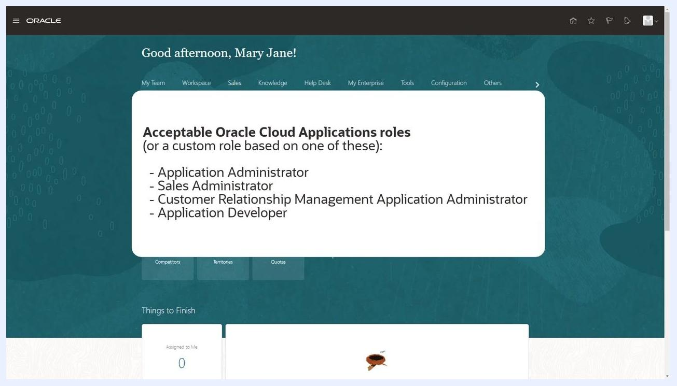
List of acceptable Oracle Cloud Applications roles displayed on the Oracle Cloud Applications dashboard

Step 1: Navigate to Visual Builder Studio
Open your Oracle Cloud Applications dashboard. Use the navigation menu at the top to locate the Configuration section, then click Visual Builder under the Configuration menu.
Oracle Cloud Applications dashboard with the navigation menu open and "Visual Builder" highlighted under Configuration

Step 2: Create a new VB Studio project
In VB Studio, select the option to create a new project. Enter a project name, such as the name of your Oracle Cloud app (for example, "Digital Sales").
In the New Project dialog, choose the Application Extension template. This template is essential because it sets up the necessary development environment and resources for Oracle Cloud App extensions.
VB Studio "New Project" dialog with "Application Extension" template selected

Step 3: Review and configure project properties
Based on your project name and selections, VB Studio automatically populates the following fields:
- Extension Name — for example, digital-sales Extension
- Extension Id — for example, site_digitalsalesExtension
- Workspace Name — for example, Workspace 1 (your private Git repository for development work)
- Oracle Cloud Applications Development Instance — for example, Oracle Cloud Applications (Fusion)
- Git Repository Name — for example, digital-sales.git
- Working Branch Name — for example, branch1
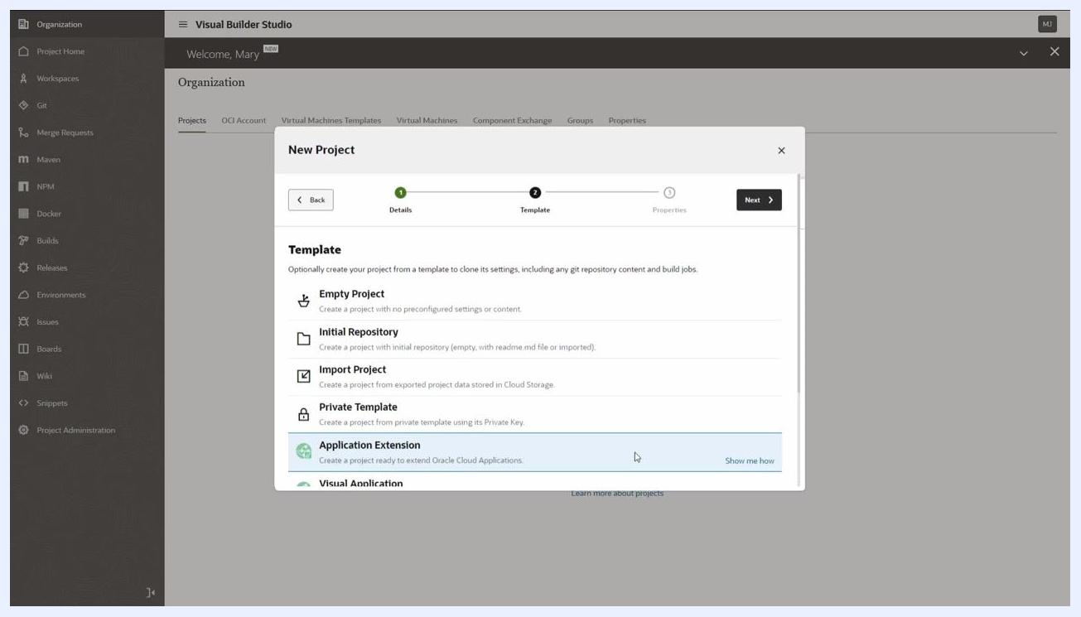
VB Studio "New Project" properties screen showing Extension Name, Workspace Name, Development Instance, Base Application, Git Repository Name, and Working Branch Name fields
From the Base Application dropdown, select the Oracle Cloud Application your developers will extend (for example, Digital Sales, Contact Center, and so on).
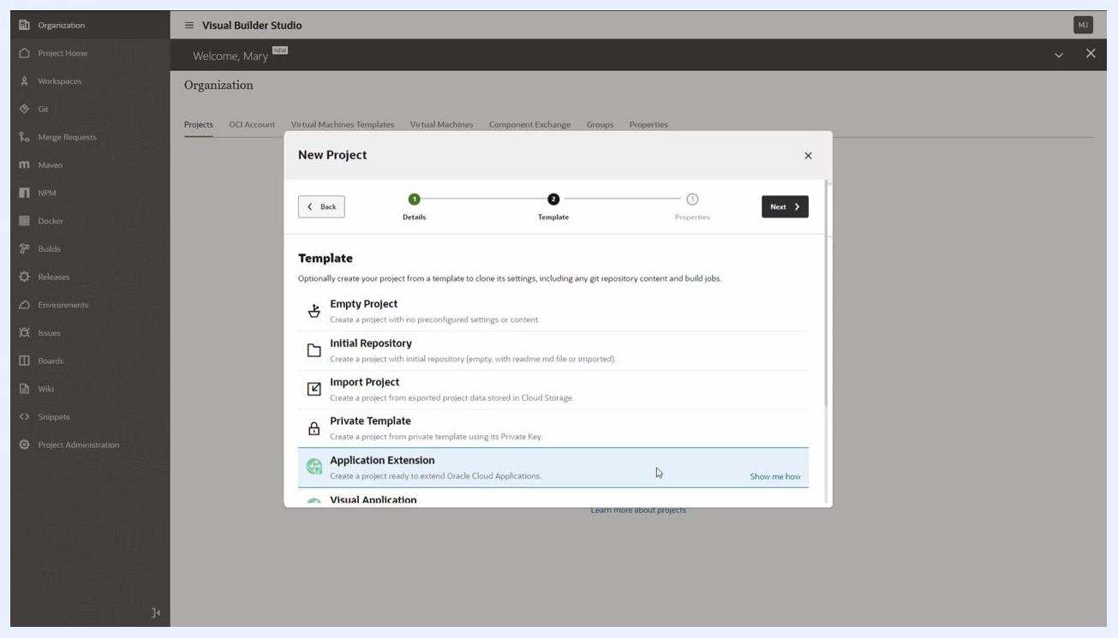
Dropdown menu for selecting the base Oracle Cloud Application in the VB Studio project properties
If desired, you can modify the Git repository name or the working branch name before continuing.

Step 4: Finish creating the project
Review all details and click Finish to create your VB Studio project for Oracle Cloud Application extensions.
Once you complete these steps, you have a properly configured VB Studio project, ready for your development team to begin extending your Oracle Cloud Application.

Step 5: Review the project homepage and auto-created artifacts
After the project is created, navigate to the Project Home page in Visual Builder Studio. Confirm that the following artifacts have been automatically created:
- Git repository — for example, digital-sales.git
- Workspace — for example, Workspace1
- Environment — for example, Development
- Two build jobs (for packaging and deployment)
- Pipeline (for orchestrating build and deployment)
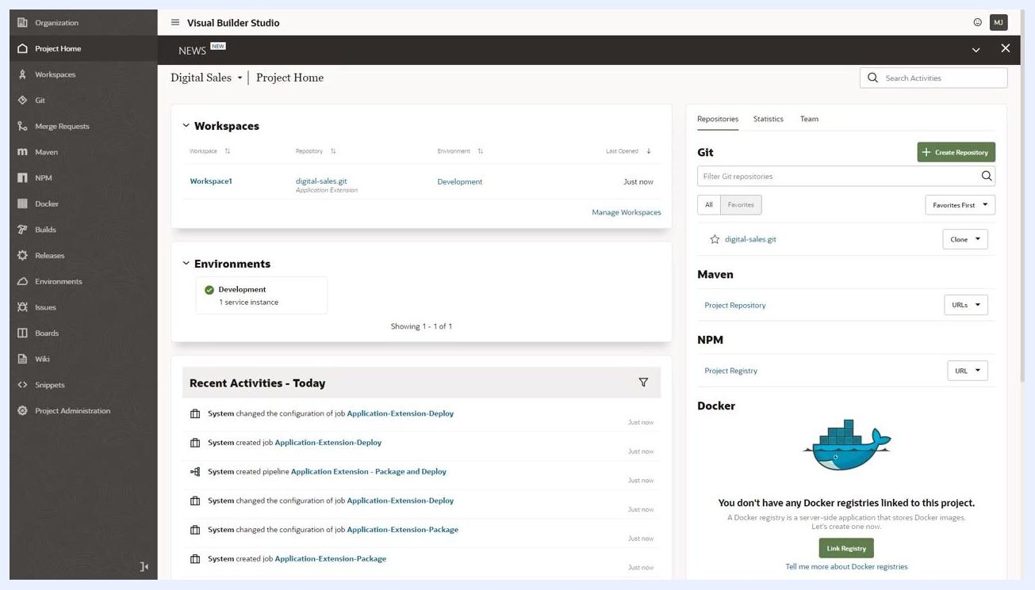
VB Studio Project Home showing Workspaces, Environments, Recent Activities, and Git repository panel
Review the Recent Activities section to see system-generated actions, such as job and pipeline creation.

Step 6: Explore the workspace and environment
In the Workspaces section, verify that your workspace (for example, Workspace1) is linked to the correct repository and environment. In the Environments section, confirm the presence of the Development environment with at least one service instance.
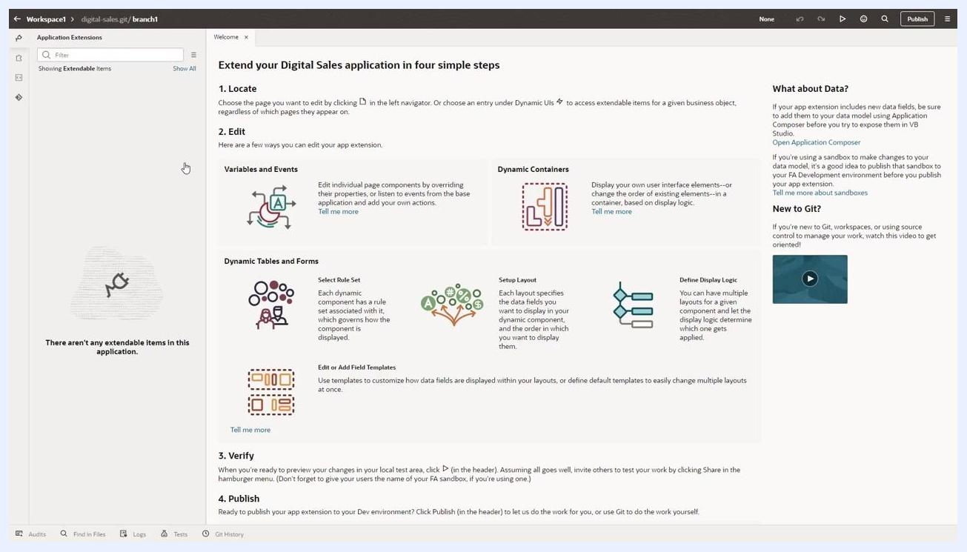
Workspaces and Environments sections highlighted, showing Workspace1 and the Development environment

Step 7: Edit the app extension in VB Studio Designer
Open your workspace to access the VB Studio Designer. Use the four-step guide to extend your application:
- Locate — choose the page or component to edit
- Edit — modify variables, events, containers, tables, forms, and display logic
- Verify — preview and test your changes
- Publish — deploy your extension to the development environment
VB Studio Designer workspace with four-step extension guide and no extendable items listed
If there are no extendable items, the left panel will indicate this.

Step 8: Configure build jobs for deployment
Go to the Builds section and select the Application-Extension-Deploy job. Click Configure to specify the credentials required to connect to your target development instance.
Builds section with Application-Extension-Deploy job selected and Configure button highlighted
This step is mandatory and only needs to be done once per project, even if multiple developers will use it.

Step 9: Set up production jobs and pipelines (optional)
While in the Builds section, consider creating additional jobs and pipelines for production deployment. Set up a pipeline for packaging and deploying from your Oracle Cloud App development instance to your production instance.
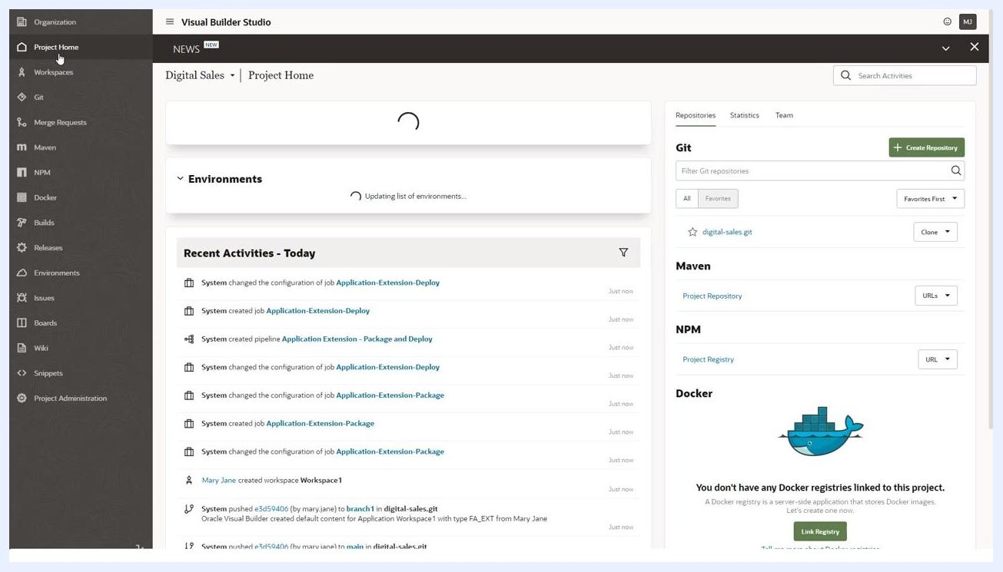
Pipelines tab showing both development and production package and deploy pipelines, with the production pipeline highlighted
- Make jobs private to restrict access to authorized users only.
- Ensure that the pipeline is set to be manually triggered for added control.

Step 10: Add project members and assign privileges
Return to Project Home and open the Team tab. Click Add Member and enter the username (for example, Don Developer). Assign the appropriate membership level:
Add Member dialog with membership levels: Project Owner, Developer Full Access, Developer Limited Access, Contributor
- Project Owner
- Developer Full Access
- Developer Limited Access
- Contributor
As the project owner, you have full access by default.

Step 11: Review and expand your Oracle Cloud App environments
Confirm that your Development Oracle Cloud App instance is set up as specified during project creation. To view the details of your environment, click the Development environment tile in the Environments section. This displays information about the associated service instance and its configuration.
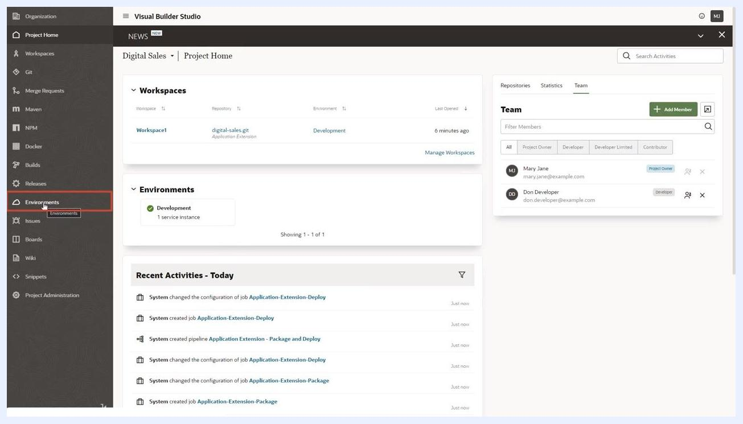
Project Home screen showing the Environments section with the Development environment tile highlighted, cursor pointing to "Environments" in the sidebar. Workspace, Team, and Recent Activities panels are also visible.
As your project grows, consider setting up additional environments for Test and Production Oracle Cloud Applications instances:
- Add new environments by clicking the Environments section and following the prompts to specify the target Oracle Cloud instance.
- Each environment should have at least one service instance associated with it.
After adding a production environment, verify that both Development and Production environments are listed, each with their own service instance.
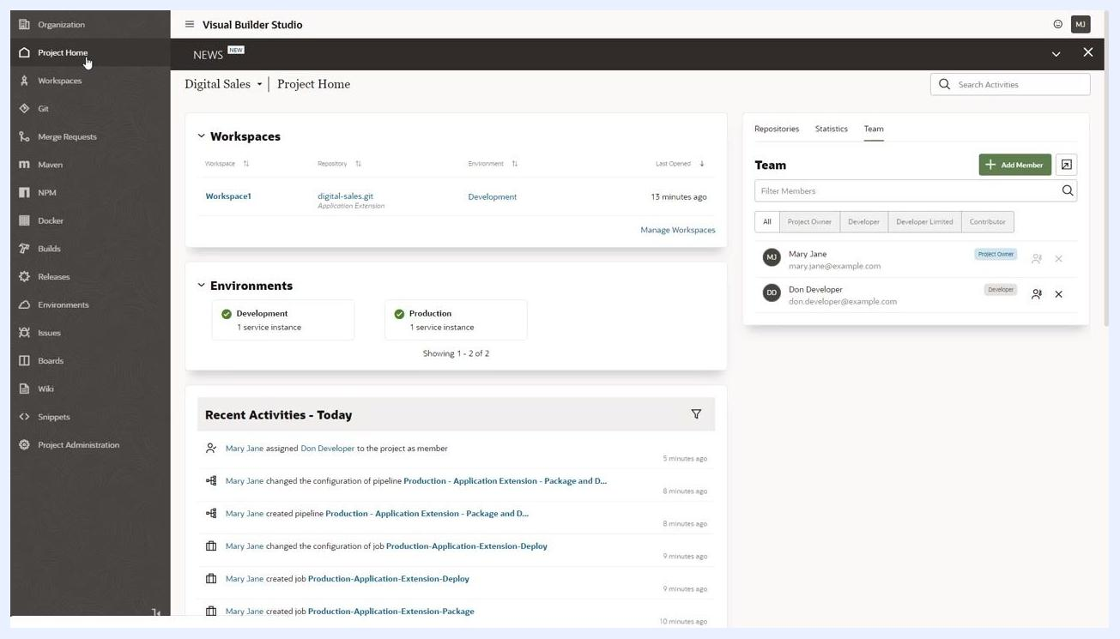
Project Home screen showing both Development and Production environments, each with 1 service instance. Workspace, Team, and Recent Activities panels are visible.

Summary
You have now enabled Visual Builder Studio in Oracle Fusion, created an Application Extension project, verified its auto-generated artifacts, configured build jobs and pipelines, added team members, and reviewed your environments. Your VB Studio project is ready for your development team to begin building and deploying extensions to your Oracle Cloud Application.

