How to Create Infolets in Oracle Fusion
Infolets are small, interactive widgets that display key information relevant to your work areas. You can use them to monitor important metrics and identify items that may require follow-up. This guide explains how to create infolets in Oracle Fusion, from setting up your sandbox to configuring views, adding content, and publishing the finished infolet for all users.

Prerequisites
Before you create an infolet, ensure you have access to a sandbox environment with the Page Composer tool enabled and set to the Site Context layer. You can test your new infolet in the sandbox before making it available to all users.

Step 1: Enter the sandbox
From the Sandboxes screen, locate a sandbox with the Page Composer tool and Site Context enabled. Example sandboxes include "GA Infolets Sandbox," "Infolets Sandbox," and "pennytest." Make sure the selected sandbox is publishable and has the required tools enabled.
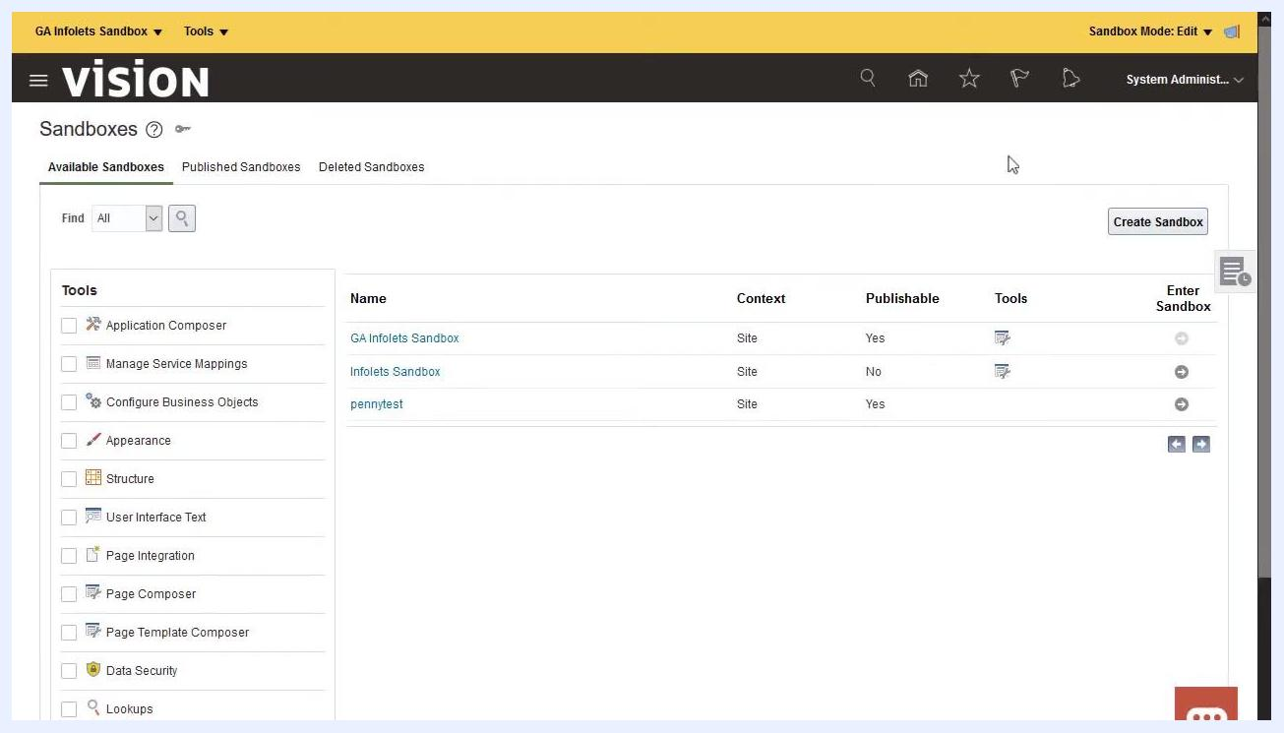
Sandboxes screen showing available sandboxes, their context, publishable status, and enabled tools
Click the Enter Sandbox icon next to your chosen sandbox to begin editing.

Step 2: Navigate to the infolet page
Go to the page where you want to add the new infolet. For example, the Analytics dashboard displays various infolets such as Close Calendar, Global Revenues, AR Reconciliation, AP Reconciliation, Travel Costs, Journals by Status, and Unallocated. Tabs at the top may include General Accounting Infolets, Source to Settle Infolets, Plan to Produce Infolets, and Order to Cash Infolets. Review the existing infolets to understand the layout and available information.
Analytics dashboard showing multiple infolets with key metrics and tabs for different infolet categories

Step 3: Select Edit Pages
On the infolet page, select Edit Pages to enable editing mode.

Step 4: Open the infolet repository and create a new infolet
Click the Infolet Repository icon, typically found in the editing toolbar or menu. A dropdown appears listing available infolets and categories, such as AP Reconciliation, AR Reconciliation, Balance Sheet, Cash, Claims by Reason, Close Calendar, Debt, Global Revenues, IC Reconciliation, IC Transactions, Income, Journals, Margin YTD, Margins, Open Subledgers, Policy by Product, Travel Costs, and Turnover.
Analytics dashboard in edit mode with the Infolet Repository dropdown open, showing a list of available infolets
In the Infolet Repository, select the option to create a new infolet.

Step 5: Configure the infolet views
Enter the infolet title (for example, "Balance"). Specify the front view dimensions by selecting from options such as 1x1, 2x1, 3x1, 1x2, 2x2, 3x2, 1x3, or 2x3. Enable the back view, which automatically inherits the same dimensions as the front view. Enable the expanded view if you need a larger display area.
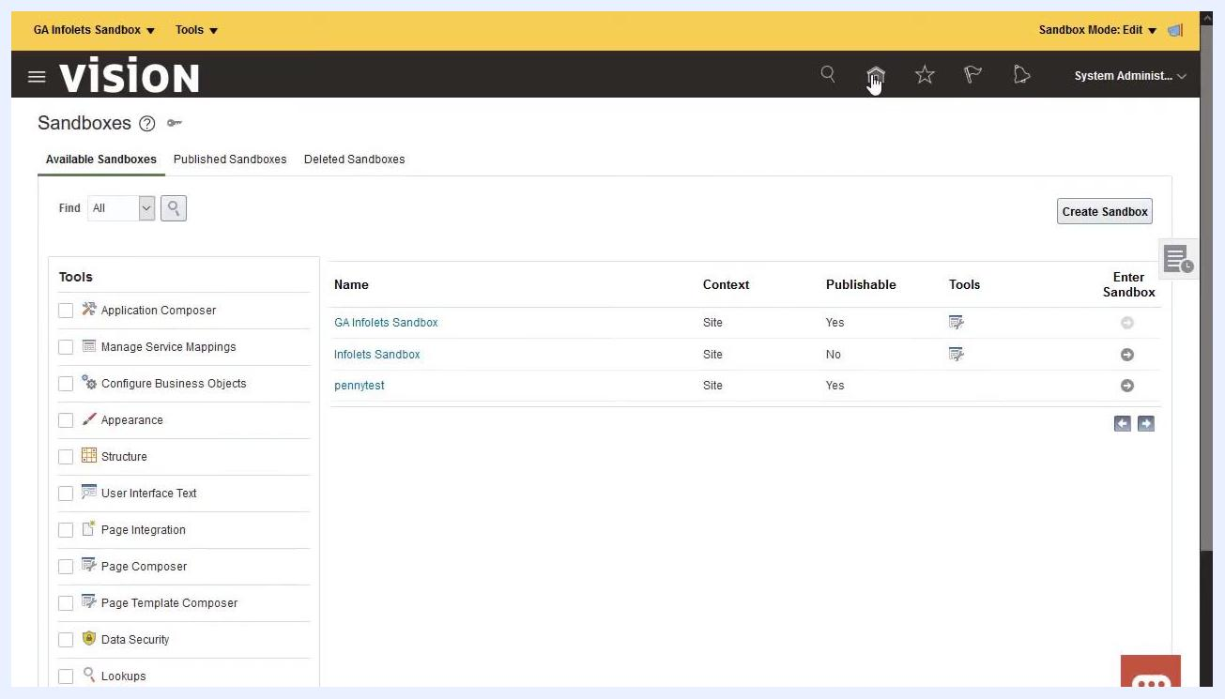
Create Infolet: Select Views screen showing title entry, dimension selection, and options for front, back, and expanded views

Step 6: Add content to the infolet
Once the infolet is created, locate it on the dashboard (for example, the "Balance" infolet with an Add Content button). Click Add Content to begin populating the infolet with data or visualizations.
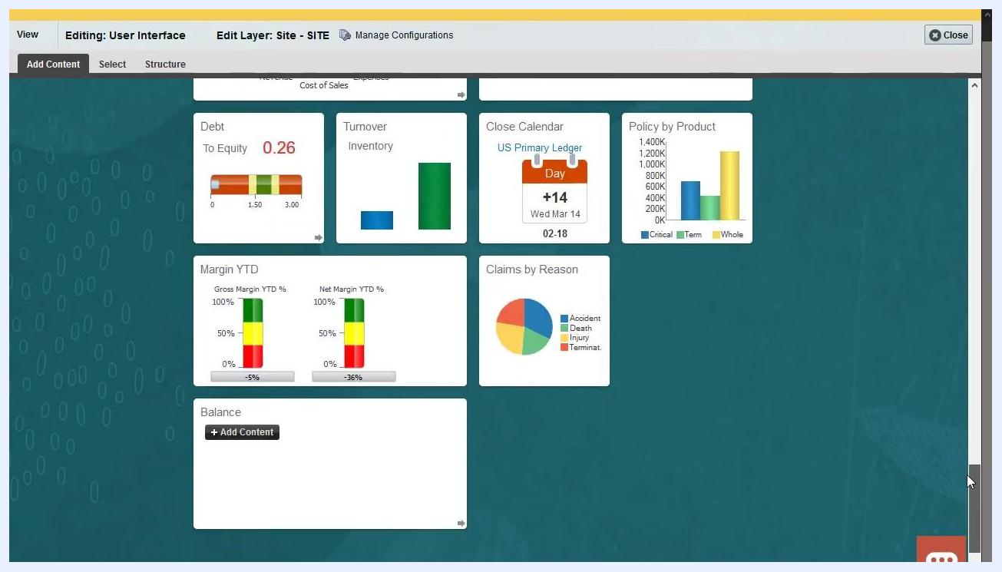
Dashboard showing the newly created "Balance" infolet with an Add Content button, ready for content addition

Step 7: Add a report to the infolet
To add content, navigate through the Reports and Analytics folder structure: BI Presentation Server > Shared Folders > continue navigating to the desired report. Select the desired report and add it to the infolet's front view.

Step 8: Add a link to a detailed report
For more detailed information, add a link to the detailed report within the infolet. This allows users to access comprehensive data directly from the infolet.
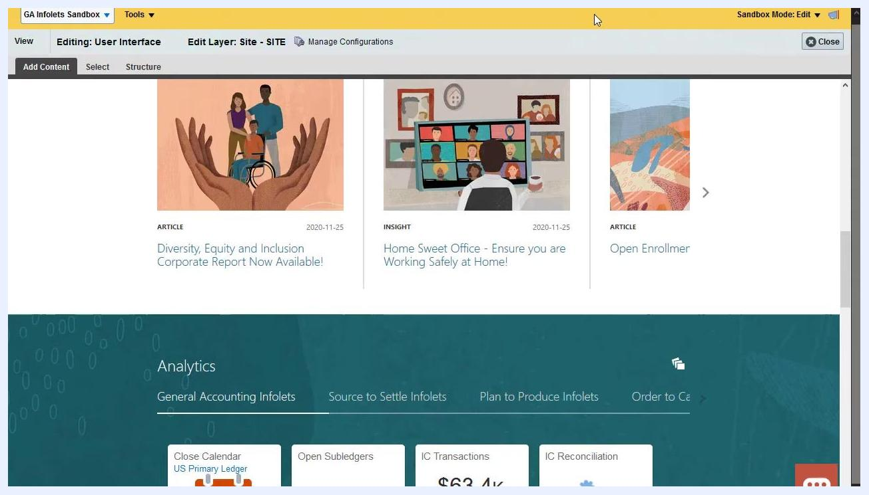
Dashboard in edit mode, showing the infolet area and options to add or link detailed reports

Step 9: Add content to the detailed report page
Navigate to the Reports and Analytics folder structure and select the desired report (for example, "Assets by Categories and Projects"). Add the report to the detailed report page, then click Done when finished.
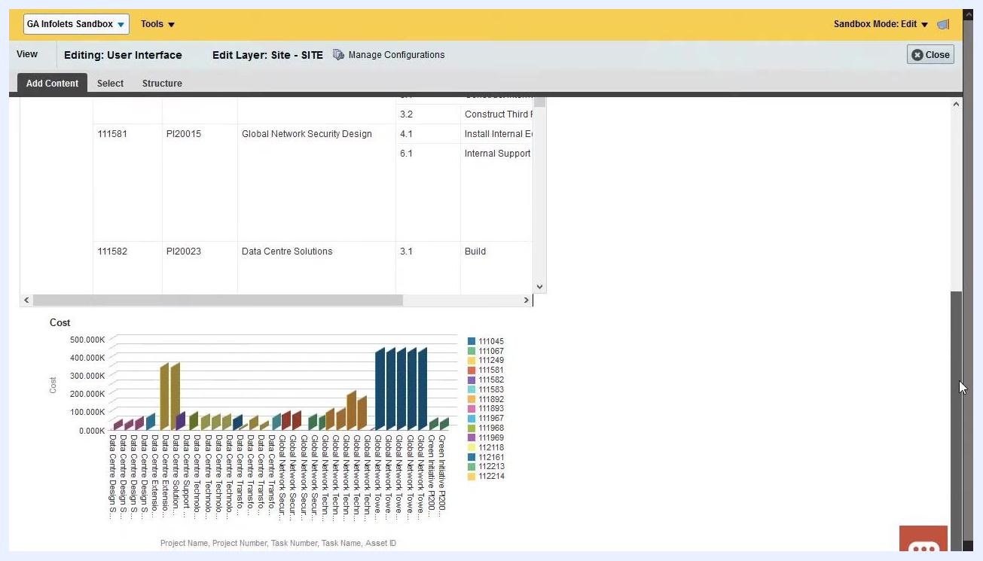
Detailed report page showing "Assets by Categories and Projects" with project details and a cost chart

Step 10: Return to the infolet for additional content
Navigate back to your infolet on the dashboard. Follow the same steps as before to locate and add another report to the infolet's back view.
Dashboard with infolets, including the "Balance" infolet, ready for additional content to be added

Step 11: Add a report to the expanded view
Select the expanded view option for your infolet. Navigate to the Reports and Analytics folder, then select and add the appropriate report to the expanded view.
Dashboard showing infolets with various charts and graphs, including the expanded view being configured

Step 12: Review the completed infolet
Confirm that all required views—front, back, and expanded—have the correct reports and visualizations, and that the infolet displays all necessary data and links.
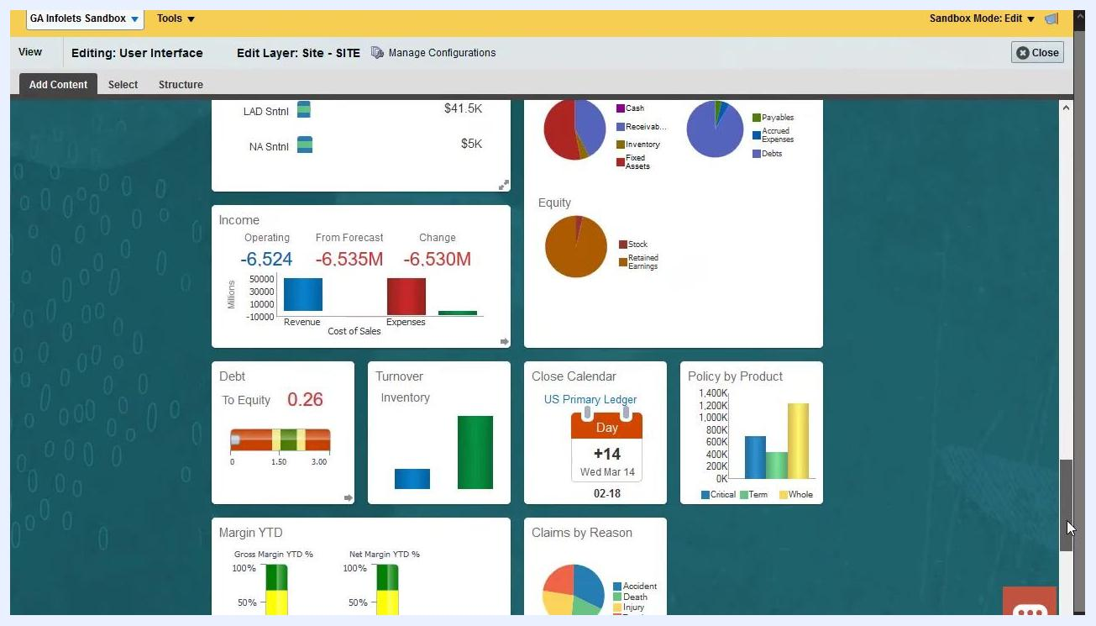
Dashboard with all infolet views populated, showing charts for assets, liabilities, equity, income, and more

Step 13: Close the infolet editing session
Click Close in the editing toolbar to exit the infolet configuration mode.
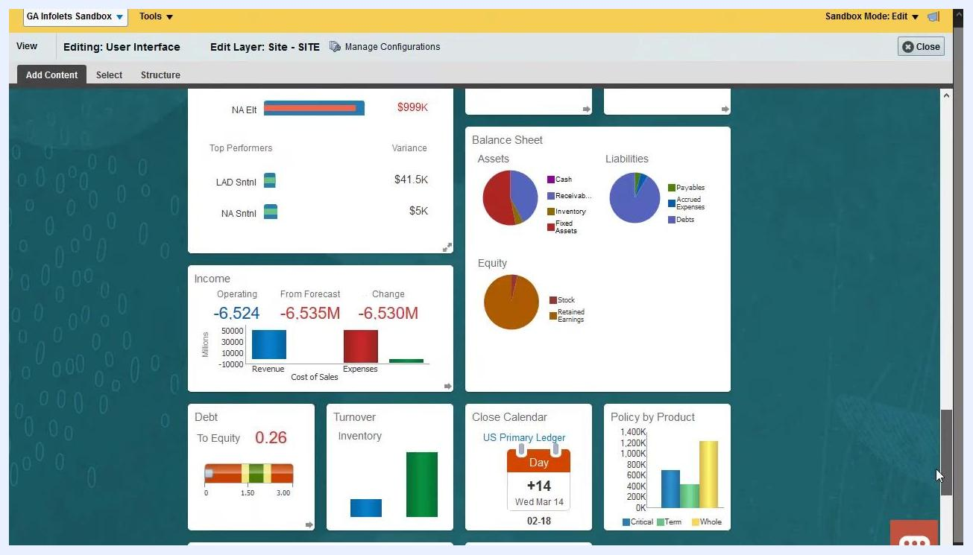
Dashboard with infolets, editing session ready to be closed

Step 14: Preview the infolet
Preview the infolet to verify its appearance and functionality. Drill down to the detailed report to confirm the link works, and review the back and expanded views for accuracy.
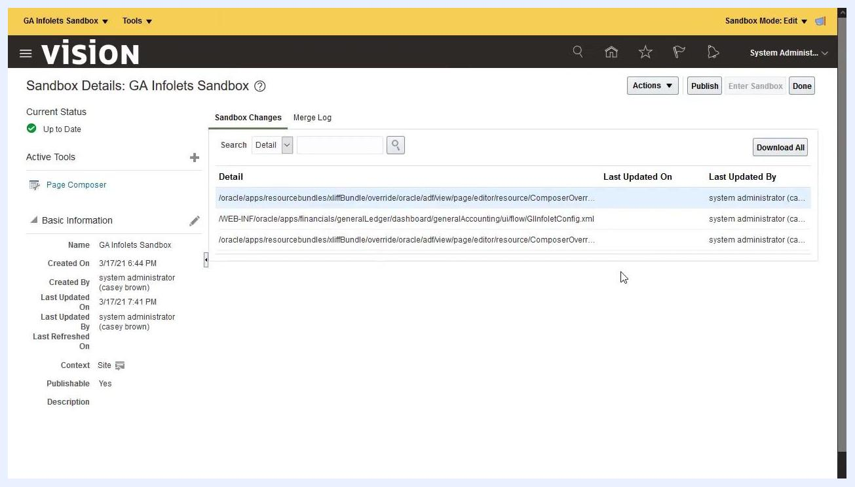
Detailed report preview showing "Assets by Categories and Projects" with project and cost details

Step 15: Finalize and publish the sandbox
Navigate to the Sandbox Details page and click Publish to make your new infolet available to all users. Confirm the publish action when prompted.
Sandbox Details page showing GA Infolets Sandbox, with the Publish button highlighted

Step 16: Verify the infolet is available
Return to the dashboard and confirm that your new infolet is visible and accessible to users.

Summary
By following these steps, you can create, configure, and populate a new infolet in Oracle Fusion, making key information easily accessible and actionable for users. With all views configured and content added, publishing the sandbox ensures key metrics and reports are available organization-wide.

