How to Create an HCM Extract in Oracle Fusion
This guide walks you through how to create an HCM extract in Oracle Fusion, from understanding the System Extract tool to configuring, delivering, submitting, and reviewing the output of your extract. You will build a full employee data extract step by step, using the Oracle HCM Data Exchange module.

Understanding System Extract
System Extract is essential for techno-functional consultants because of its customization capabilities. You can write formulas and tailor extracts to specific business needs, making the tool valuable for both reporting and data transmission between Oracle HCM modules or external systems.
In Oracle Fusion, System Extract is built on Fast Formula and processed by the payroll engine. In ERP, System Extract is based on the benefits engine, which marks a key difference in architecture and use case between the two.

Prerequisites
- Access to the Oracle HCM home screen with the My Client Groups tab available.
- Permissions to create, edit, and submit extract definitions in Data Exchange.
- Familiarity with the business objects (such as Person, Person Name, and E-Mail) you plan to include in your extract.

Step 1: Review the Oracle HCM home screen
The main dashboard displays a welcome message and user information. Navigation tabs include Me, My Team, My Client Groups, Benefits Administration, Workspace, Risk Management, and Partner Management.
Quick Actions are listed on the left, including:
- HCM Experience Design Studio
- Hire an Employee
- Add a Contingent Worker
- Add a Pending Worker
- Add a Nonworker
- Pending Workers
- Document Delivery Preferences
- Mass Download of Document Records
The central area displays application tiles, including Journeys, New Person, Person Management, Person Spotlight, Absences, Time Management, Compensation, Goals, Performance, Profiles, Career Development, Talent Review, Succession Plans, and Workforce Structures.
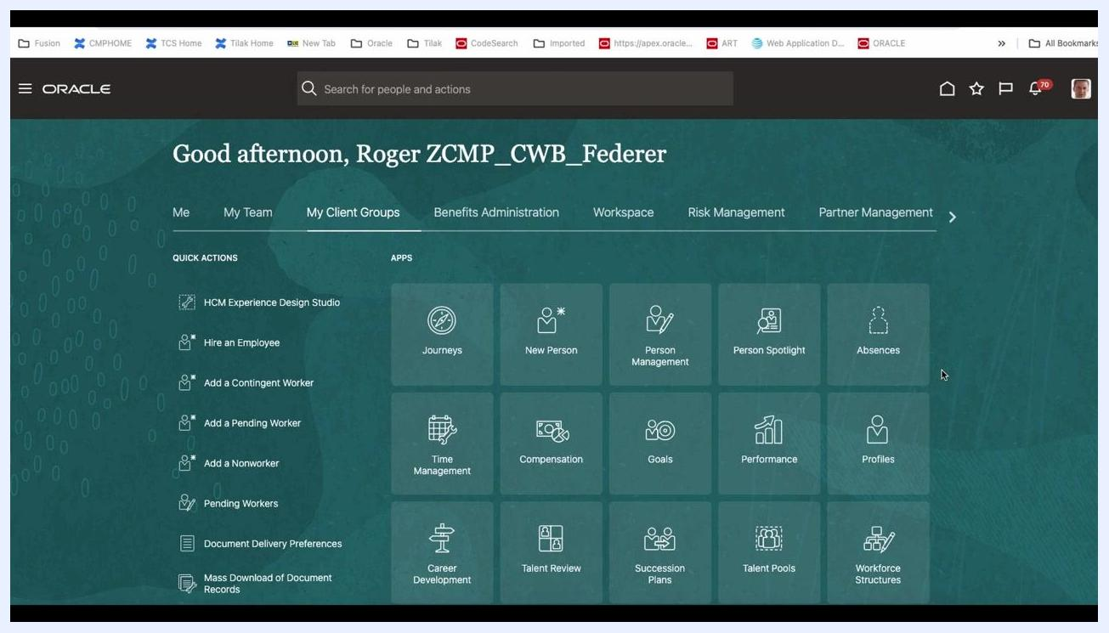
Oracle HCM home screen with navigation tabs, quick actions, and application tiles, greeting the user "Good afternoon, Roger ZCMP_CWB_Federer."

Step 2: Navigate to My Client Groups
From the main navigation bar at the top, click My Client Groups. This tab provides access to various HR-related modules and actions.
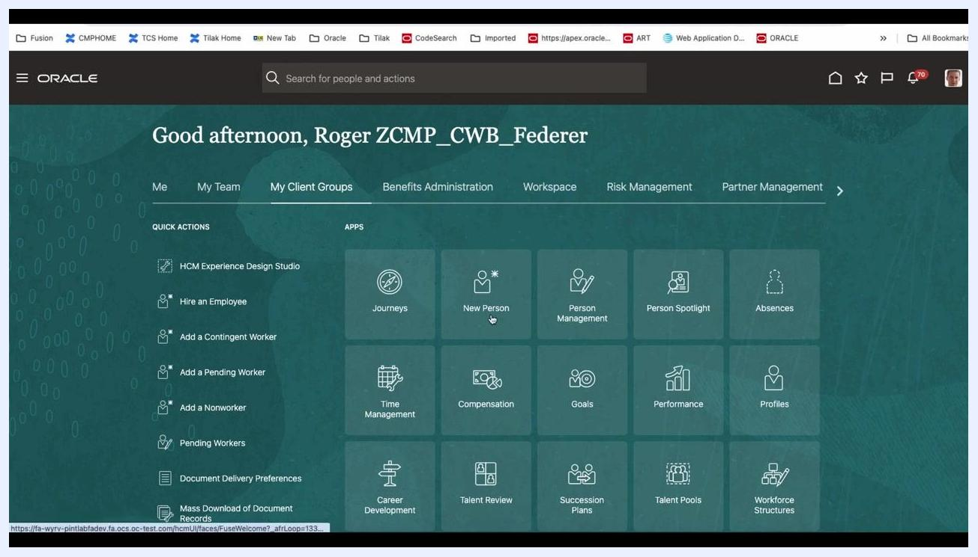
Oracle HCM home screen with the My Client Groups tab selected, showing quick actions and application tiles.

Step 3: Open Data Exchange
Scroll through the application tiles under My Client Groups and click the Data Exchange tile, located at the bottom right of the app grid.
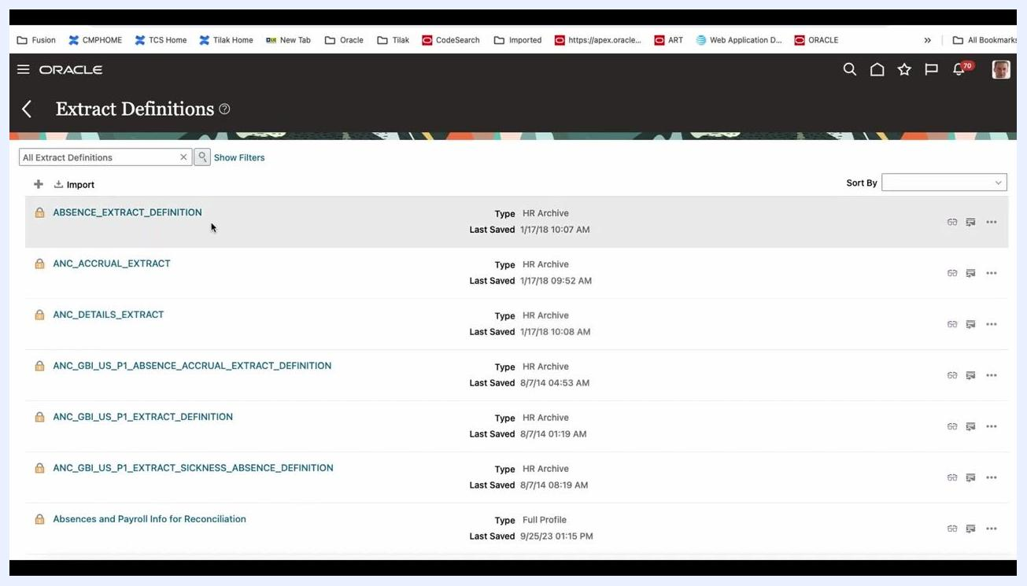
Oracle HCM My Client Groups tab with the Data Exchange tile highlighted among other HR modules.

Step 4: Access Extract Definitions
The system displays the Extract Definitions page. Here you can view all previously created extract definitions, including their names, types (for example, HR Archive or Full Profile), and last saved dates.

Step 5: Create a new extract definition from a template
Click the plus (+) Import button, then select Create from Template in the dropdown. Using a pre-defined template simplifies setup, especially if you are new to building extracts.
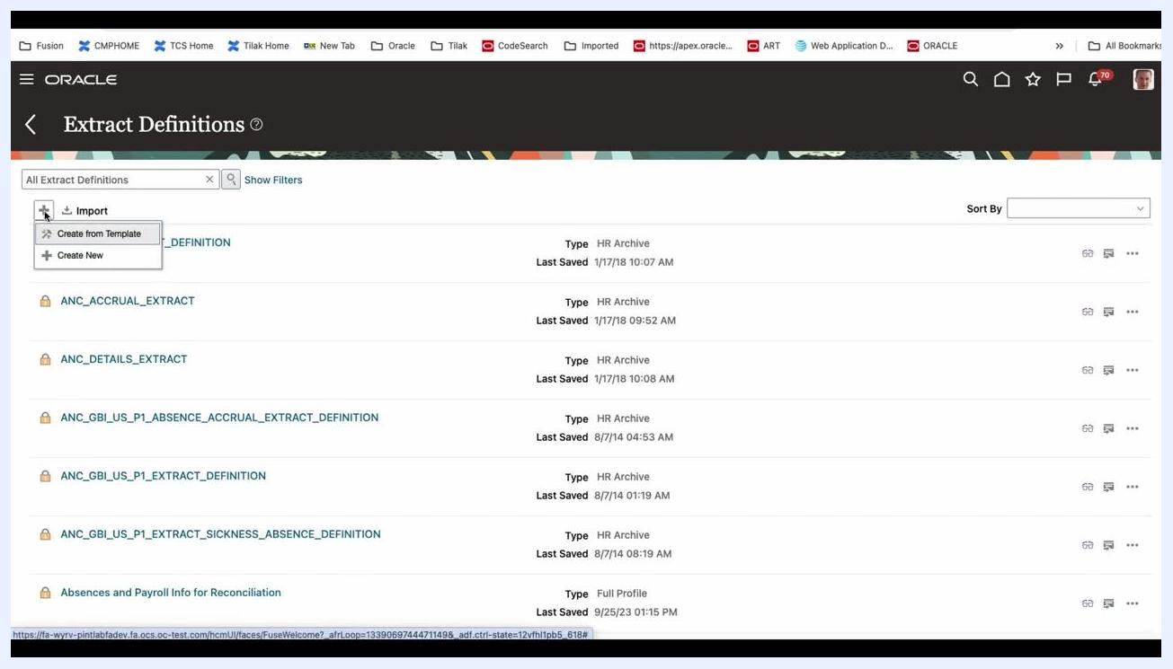
Extract Definitions page with the Create from Template option selected in the Import dropdown.

Step 6: Choose the source template
In the Create Extract Definition window, a list of source templates appears on the left. Expand the HR Archive section and select Employees to use the employee extract template.
Create Extract Definition screen with HR Archive > Employees selected as the source template.

Step 7: Configure the extract definition details
Fill in the required fields for your new extract:
- Name: Enter Demo-Test-001.
- Start Date: Enter 1/1/00.
- Consumer: Select Report from the dropdown.
- Changes Only: Select No (the default, which produces a full extract; Yes would limit results to changed records only).
You can leave the remaining fields blank for this basic setup.
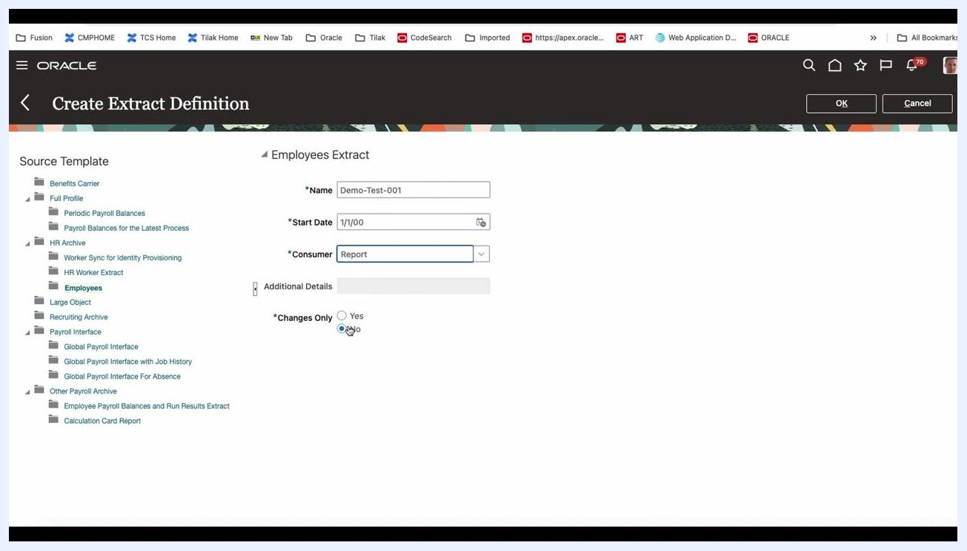
Create Extract Definition form filled in with Name Demo-Test-001, Start Date 1/1/00, Consumer Report, and Changes Only set to No.
Using a template is recommended if you are new to this tool, since it pre-populates many settings. Report is the default and most common Consumer choice, while Undefined is rarely used. Selecting No for Changes Only ensures a full data extract.

Step 8: Expand the Person business object
In the Define tab, locate the Business Objects panel. Click the arrow next to Person to expand its available sub-objects and attributes.
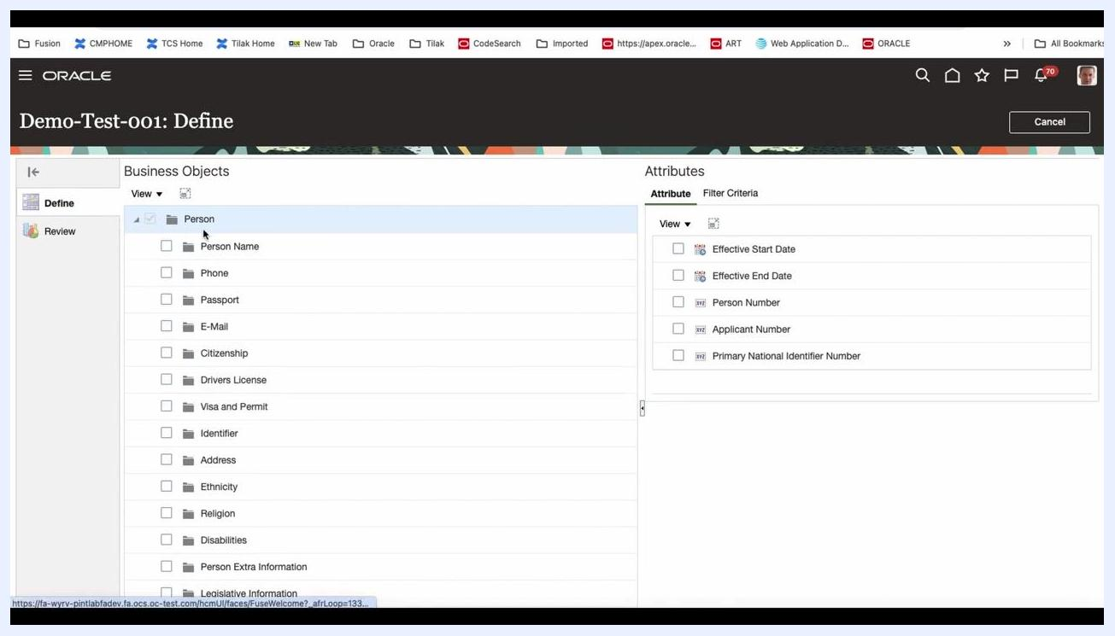
Oracle HCM Define screen with the Person business object expanded, showing sub-objects such as Person Name, Phone, Passport, and E-Mail.

Step 9: Select Person Name and choose required attributes
Click the checkbox next to Person Name under the Person object. The Attributes panel on the right then displays all available attributes for Person Name.
Do not select the top-level checkbox unless you want to include all attributes. Instead, individually select only the required attributes:
- First Name
- Last Name
- Full Name
- Type
- Effective Start Date
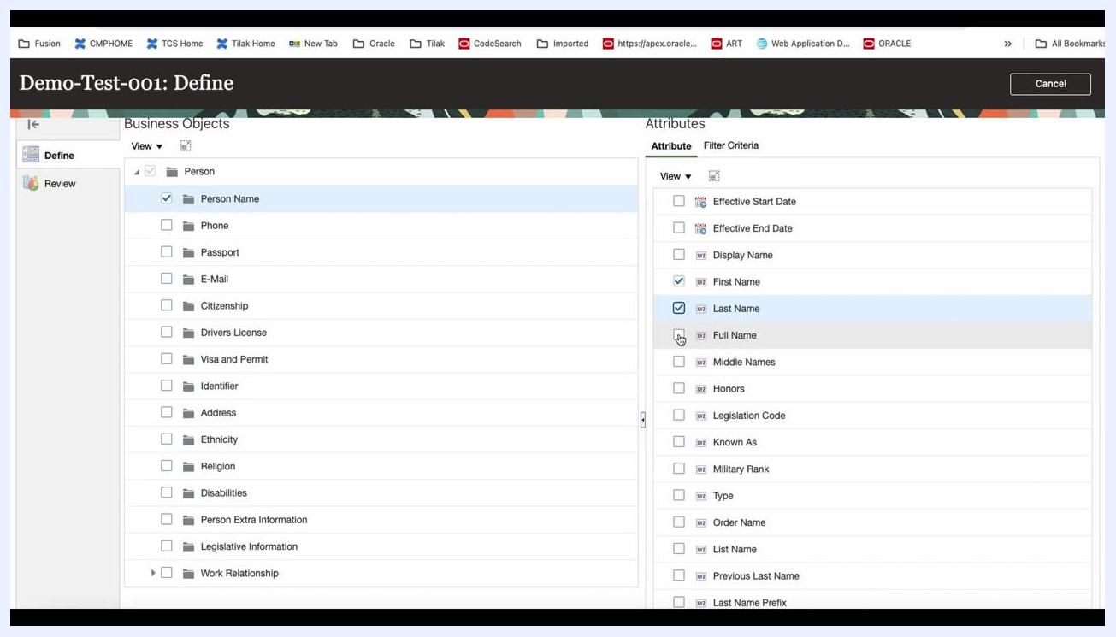
Person Name attributes selected, including First Name, Last Name, Full Name, Type, and Effective Start Date.

Step 10: Select E-Mail and choose required attributes
In the Business Objects panel, check the box next to E-Mail. In the Attributes panel, select the following attributes:
- Date From
- E-Mail Type
- E-Mail Address
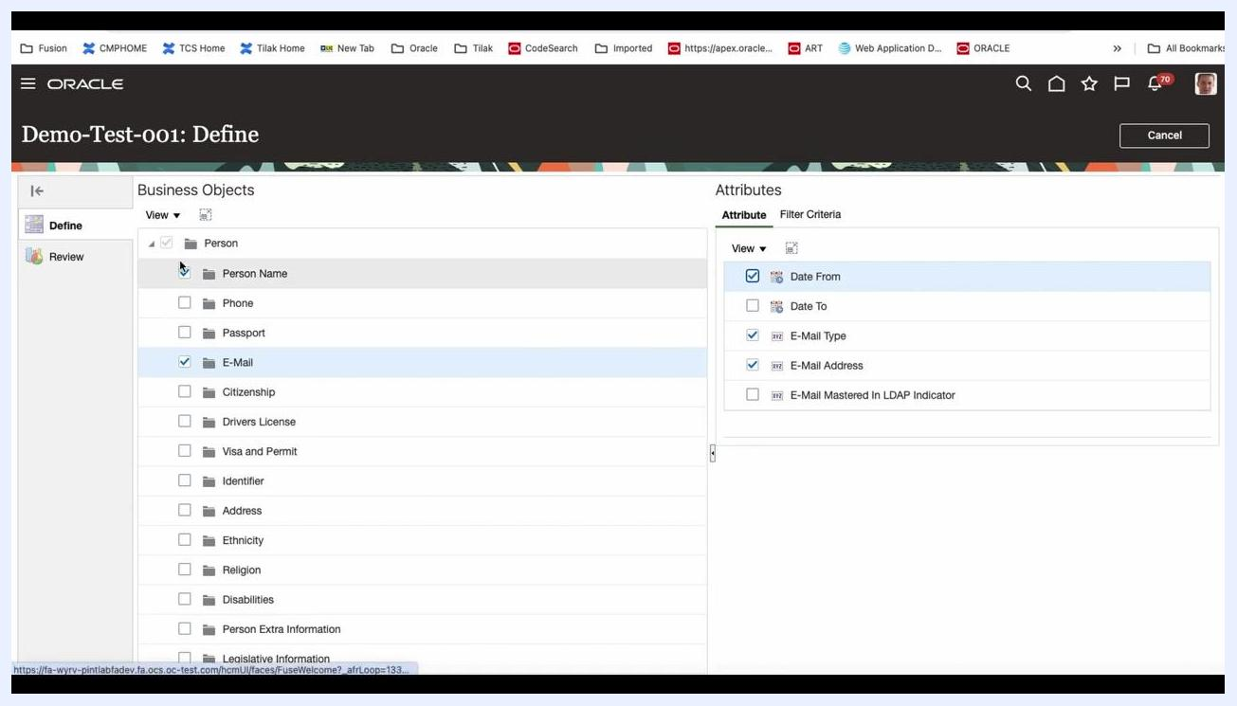
E-Mail attributes selected, including Date From, E-Mail Type, and E-Mail Address.

Step 11: Review your attribute selections
Once you have selected all required attributes, click the Review tab on the left sidebar. This displays a summary of your selected data groups and attributes. Confirm that the following are listed:
- Under Person Name: Effective Start Date, First Name, Last Name, Full Name, Type
- Under E-Mail: Date From, E-Mail Type, E-Mail Address

Step 12: Save the extract definition
Click the Save button in the top right corner. A confirmation dialog appears, asking: "The changes will be submitted. Do you want to continue?" Click Yes to confirm and save your extract definition.
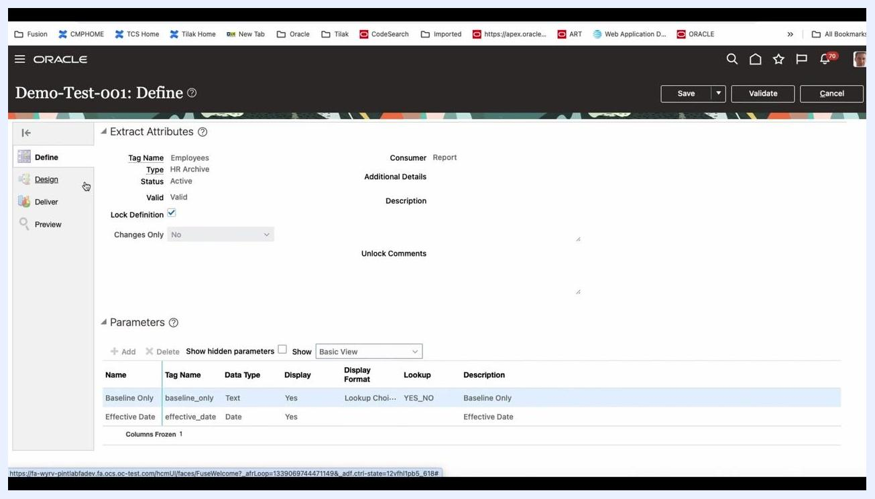
Confirmation dialog for saving the extract definition, with Yes and No options.

Step 13: Verify the extract definition status
After saving, the system displays the Review screen with your selected attributes and a status indicator, such as "In Progress." Ensure all selected fields are correctly listed under their respective data groups.
Review screen showing selected attributes under Person Name and E-Mail, with status In Progress.

Step 14: Review the Extract Attributes section
In the Define tab, locate the Extract Attributes panel at the top of the screen. Confirm the following details:
- Tag Name: Employees
- Type: HR Archive
- Status: Active
- Valid: Valid
- Consumer: Report
- Lock Definition: Checked (enabled)
- Changes Only: No (dropdown disabled)
Additional fields such as Additional Details, Description, and Unlock Comments are present but not filled in for this example.
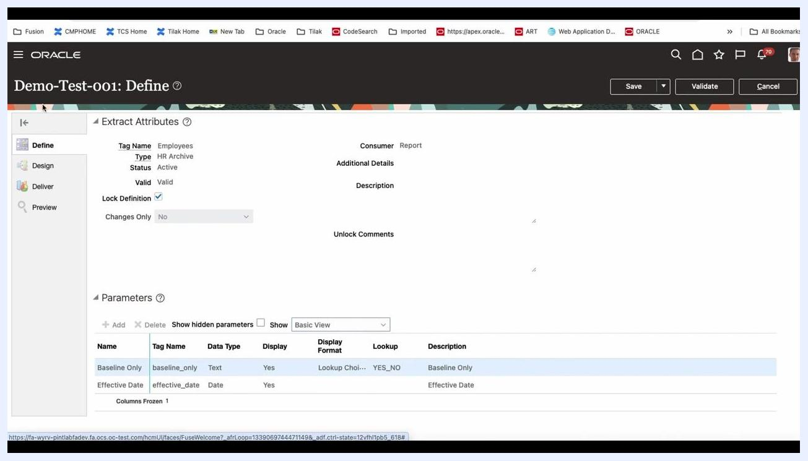
Oracle HCM Define screen showing Extract Attributes: Tag Name Employees, Type HR Archive, Status Active, Valid, Consumer Report, Lock Definition checked, and Changes Only set to No.

Step 15: Verify the Parameters section
Scroll down to the Parameters panel and ensure the following parameters are listed:
- Baseline Only — Tag Name: baseline_only, Data Type: Text, Display: Yes, Display Format: Lookup Choice, Lookup: YES_NO, Description: Baseline Only
- Effective Date — Tag Name: effective_date, Data Type: Date, Display: Yes, Description: Effective Date
Confirm that both parameters are visible and set to display.

Step 16: Validate or edit as needed
If any details are incorrect, use the Edit options to make changes. Use the Validate button in the top right to check for errors in your extract definition. Use the Save button to save any further changes, or Cancel to discard them.
Double-check all attribute values for accuracy before proceeding, and ensure all required parameters are present and correctly configured. When Lock Definition is checked, it prevents further changes unless unlocked. Always validate your extract before moving to delivery or scheduling.

Step 17: Update the Unlock Comments field
Enter a descriptive value in the Unlock Comments field, for example HCM_USER2 04-Feb-2024 Test. This field is now populated with the user and date information.
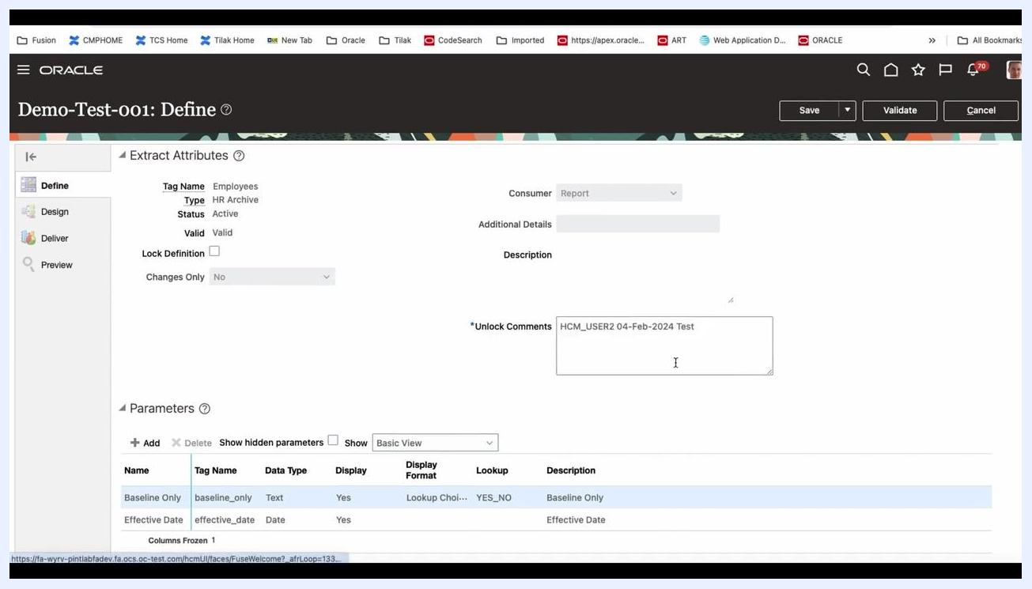
Unlock Comments field updated with "HCM_USER2 04-Feb-2024 Test" in the Define section.

Step 18: Review the Person object in the Design section
Select Design from the left navigation menu. The Design section displays a list of objects, such as Person, E-Mail, Person Name, and Person Name Details.
With the Person object selected, its properties display as follows:
- Name: Person
- Tag Name: Person
- User Entity: PER_EXT_SEC_PERSON_UE
- Threading Database Item: Extract Person ID
- Threading Action Type: Object actions
- Description: Person Data Group
Design section with the Person object selected, showing its properties.

Step 19: Review E-Mail Details properties
Click E-Mail Details under the E-Mail object in the Design section. The properties display as follows:
- Effective Start Date: 1/1/00
- Name: E-Mail Details
- Tag Name: EmailDetails
- Type: Detail record
- Process Type: Fast Formula
- Next Data Group: (blank)
- Description: (blank)
- Generated Fast Formula: EXT_EXT_HEX_EE_E_MAIL_DETAILS_100105326649390
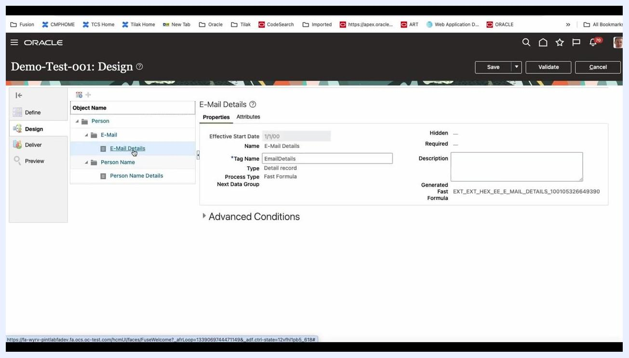
E-Mail Details object selected, showing its properties in the Design section.

Step 20: Confirm the E-Mail Details properties and attributes
Review the Effective Start Date, Tag Name, and other details to confirm they are correct.
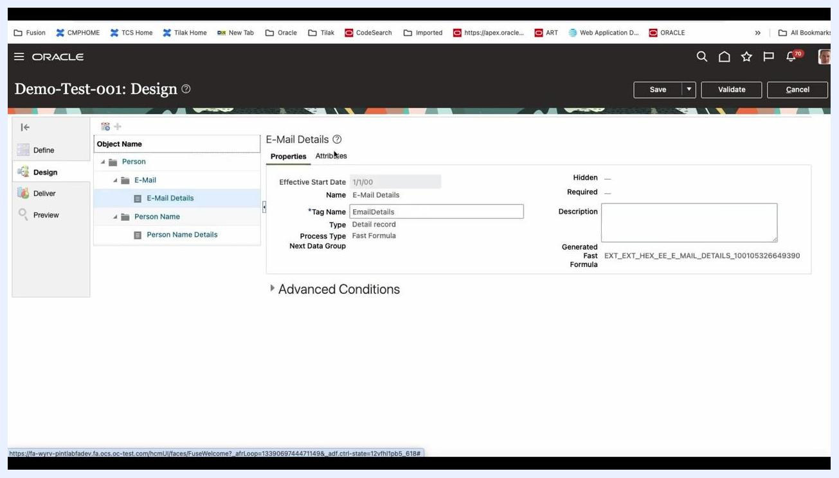
E-Mail Details properties and attributes visible in the Design section.

Step 21: Review Person Name Details properties
Select Person Name Details under the Person Name object in the Design section. The properties display as follows:
- Effective Start Date: 1/1/00
- Name: Person Name Details
- Tag Name: PersonNameDetails
- Type: Detail record
- Process Type: Fast Formula
- Next Data Group: (blank)
- Description: (blank)
- Generated Fast Formula: EXT_EXT_HEX_EE_PERSON_NAME_DETAILS_100105326649387
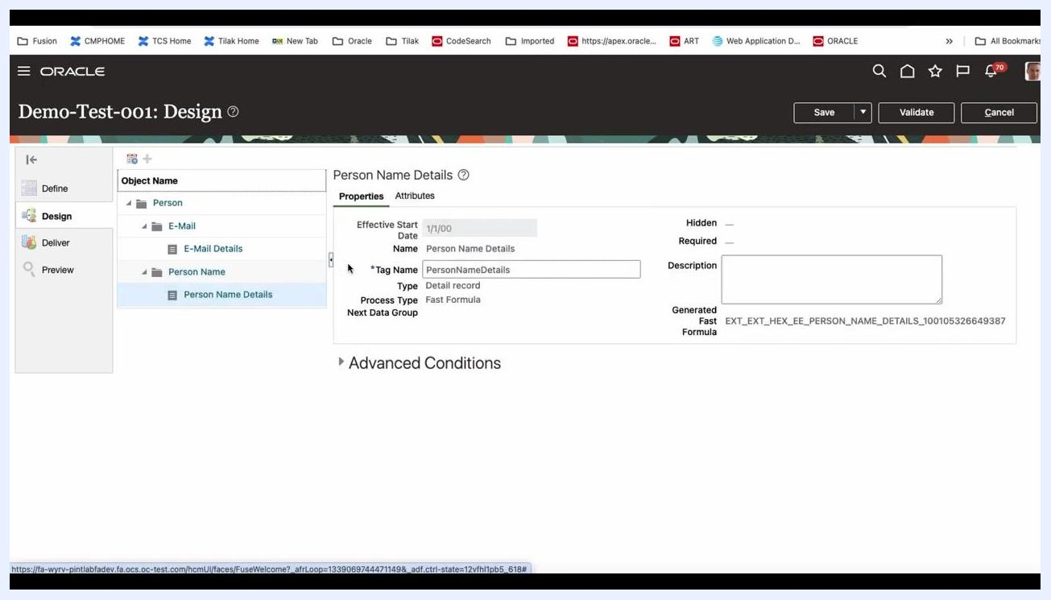
Person Name Details object selected, showing its properties in the Design section.

Step 22: View Person Name Details attributes
Click the Attributes tab for Person Name Details to view its attributes:
- Effective Start Date (Type: Database item group)
- Person Name Id (Type: Database item group, Key Attribute)
- First Name (Type: Database item group)
- Last Name (Type: Database item group)
- Full Name (Type: Database item group)
- Type (Type: Database item group)
Attributes tab for Person Name Details showing all attribute fields.

Step 23: Navigate to the Deliver section
Select Deliver from the left navigation menu. The Extract Delivery Options screen displays the delivery option Employees Data with the following details:
- Start Date: 1/1/00
- Output Type: Data
- Report: (blank)
- Template Name: (blank)
- Output Name: EmployeesData
- Delivery Type: None
- Required: Checked
- Overriding Delivery Mode: (blank)
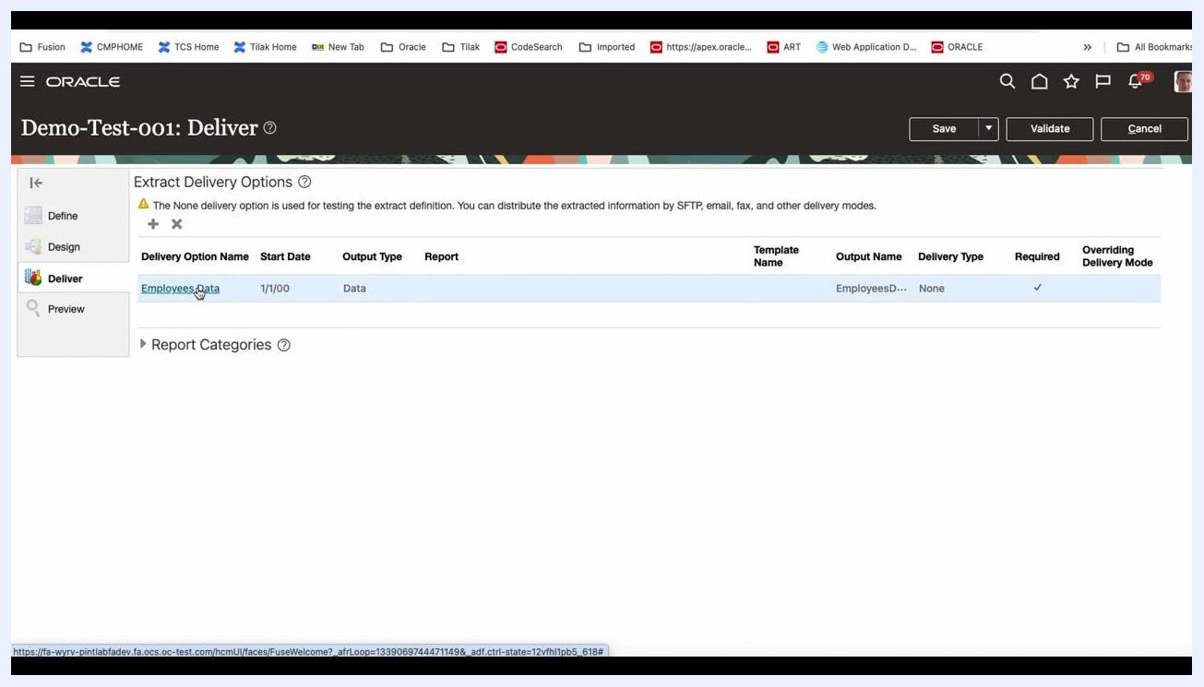
Deliver section with the Employees Data delivery option listed.

Step 24: Review the Employees Data delivery option details
Click Employees Data to view or edit its details:
- Output Type: Data
- Report: (blank)
- Template Name: (blank)
- Output Name: EmployeesData
- Delivery Type: NONE
- Overriding Delivery Mode: (blank)
- Required: Checked
- Advanced options: Bursting, Locale, Key, and Select Attribute fields are available.
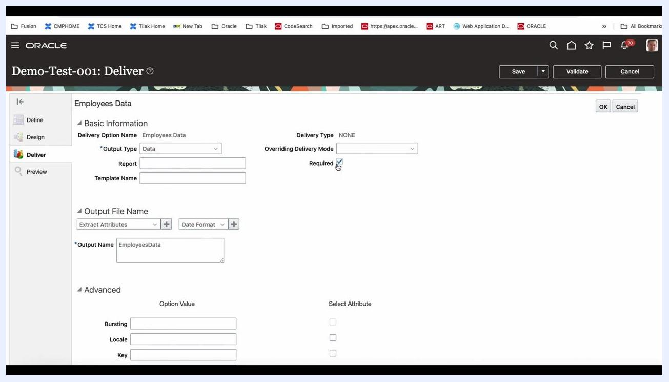
Employees Data delivery option details with Output Type, Output Name, and Required checked.

Step 25: Update the delivery option details
In the Deliver section, confirm and update the following fields:
- Output Type: Data
- Delivery Type: NONE
- Overriding Delivery Mode: leave blank or select as needed
- Required: Checked
- Output Name: EmployeesData_001
Optionally, configure advanced options such as Bursting, Locale, and Key if required.
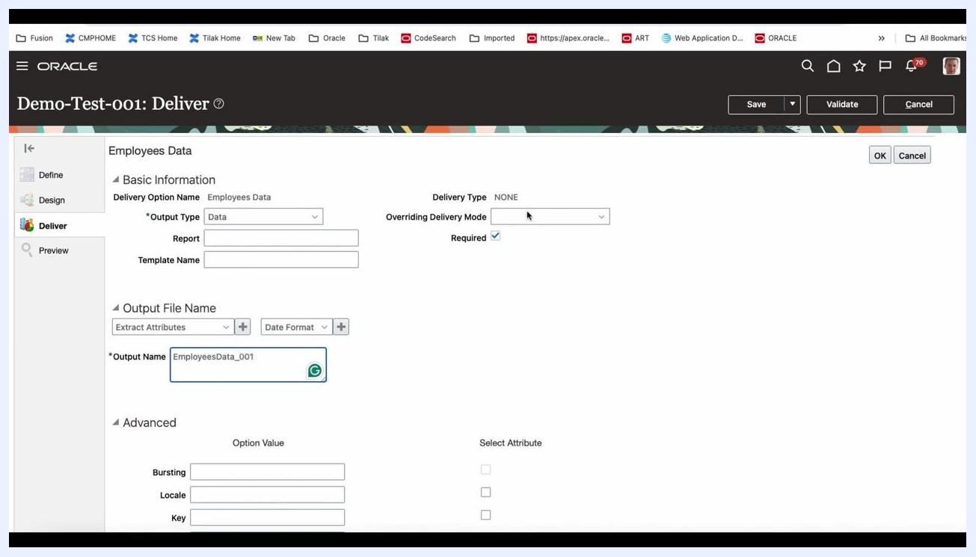
Deliver section with Output Name set to EmployeesData_001 and advanced options visible.

Step 26: Access the Preview functionality
Click Preview in the left navigation menu to access the preview functionality. This allows you to run the extract for a single person in debug or regular mode.
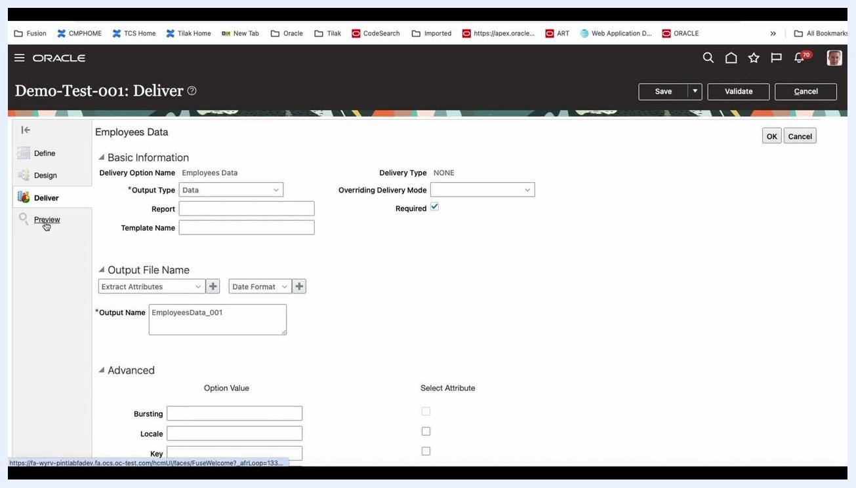
Preview option selected in the navigation menu, with the Deliver section still visible.

Step 27: Confirm the unsaved changes warning
If prompted with a warning dialog stating "Your changes aren't saved. If you leave this page, then your changes will be lost. Do you want to continue?", choose Yes to proceed to the Preview screen.
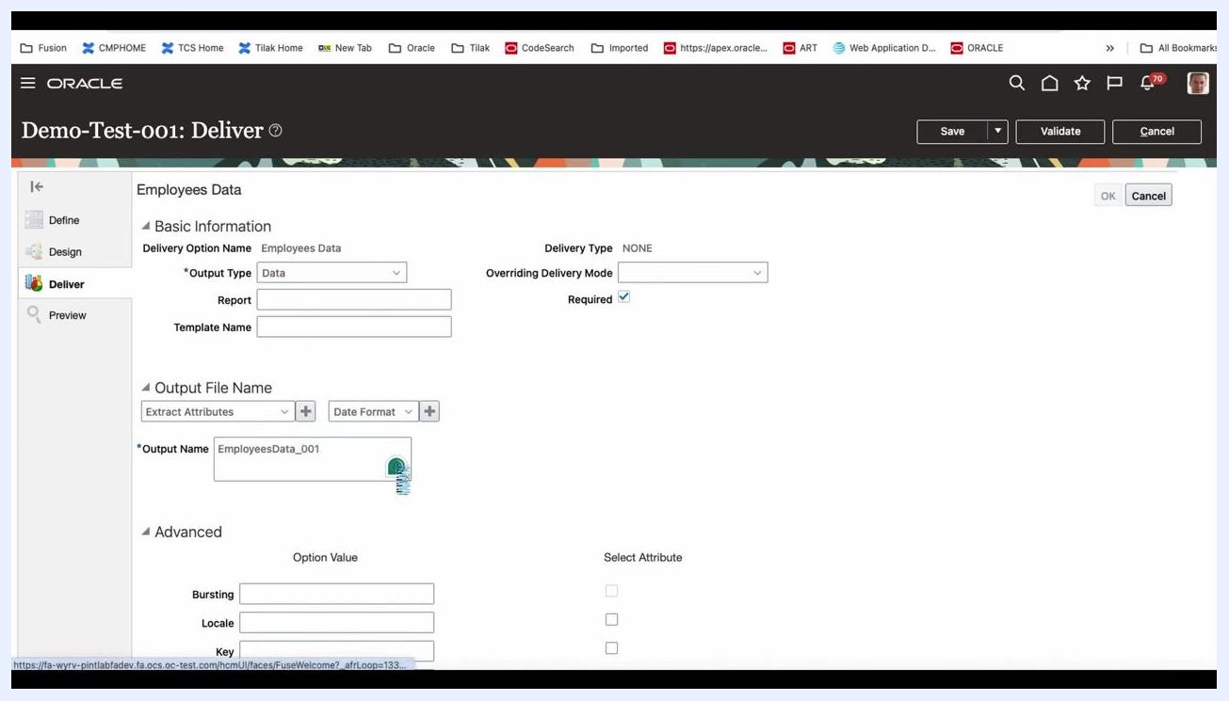
Preview screen with a warning dialog about unsaved changes.

Step 28: Review the Preview parameters
On the Preview screen, enter the Effective Date in the format m/d/yy. Optionally, enter a value for Threading Object ID if required for your extract, and select Yes or No for Diagnostics as needed.
Preview screen with Effective Date and Threading Object ID fields.

Step 29: Return to the Extract Definitions overview
Locate your extract (for example, Demo-Test-001) in the Extract Definitions list. Click the three-dot menu on the right to access additional actions, including:
- Hierarchy (view the extract hierarchy)
- Export Extract
- Delete
- Copy or Rename
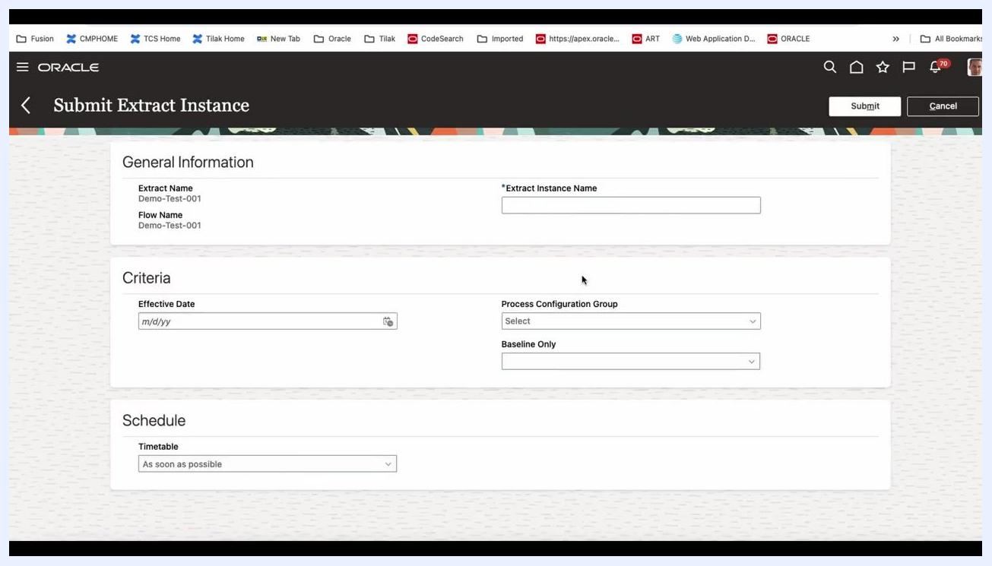
Extract Definitions screen with the actions menu open for Demo-Test-001.

Step 30: View the extract hierarchy
Select Hierarchy from the actions menu to display the structure and relationships within the extract definition.
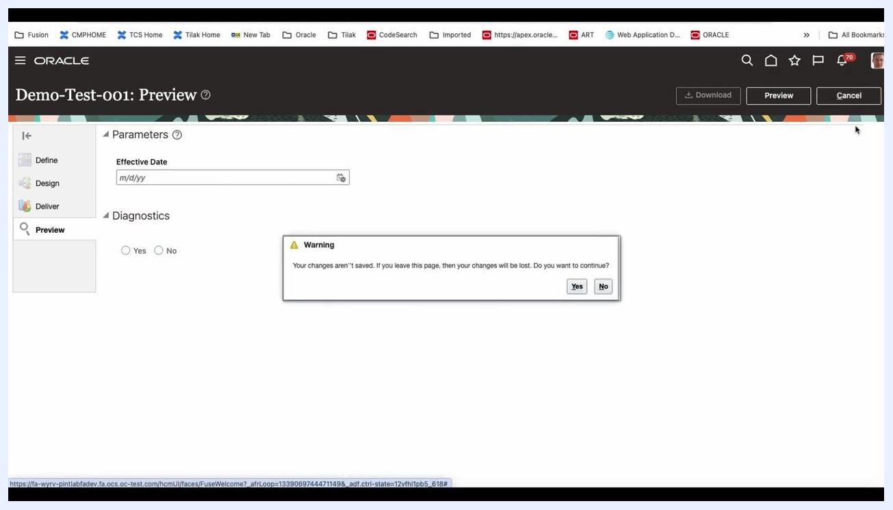
Extract Definitions screen with the Hierarchy option highlighted in the actions menu.

Step 31: Manage, export, or duplicate the extract
Use the corresponding options in the actions menu to move, delete, copy, or rename the extract:
- Select Export Extract to export the definition.
- Select Delete to remove the extract (after moving the product, if needed).
- Select Copy or Rename to duplicate or rename the extract.
Extract Definitions screen with Export, Delete, and Copy or Rename options visible.

Step 32: Submit the extract instance
To run the extract, proceed to the Submit Extract Instance screen. Enter the following under General Information:
- Extract Name: Demo-Test-001
- Flow Name: Demo-Test-001
- Extract Instance Name: enter a unique name, for example Demo-Test-001-02040416, using the date and time for uniqueness
Under Criteria, enter the Effective Date (m/d/yy), select the Process Configuration Group as needed, and set Baseline Only as required.
Under Schedule, select a Timetable such as As soon as possible, or another schedule as needed.
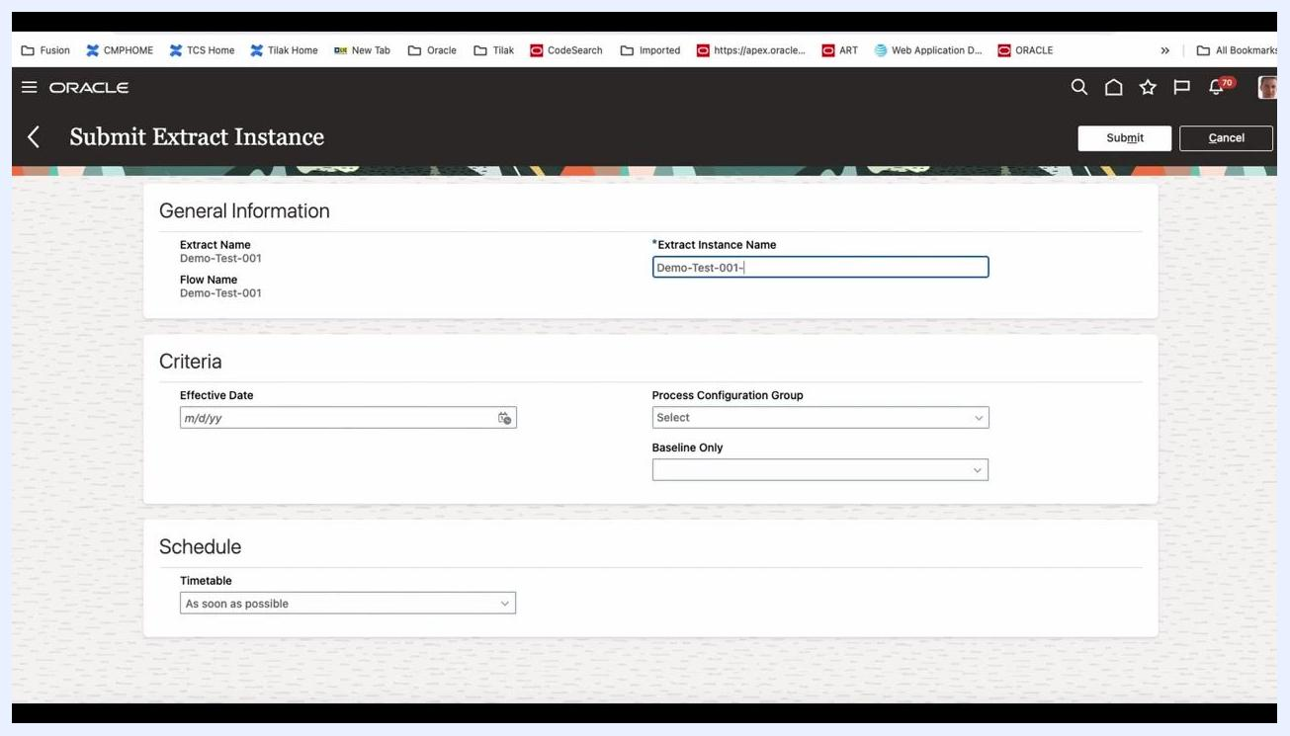
Submit Extract Instance screen with fields for Extract Instance Name, Effective Date, and schedule options.

Step 33: Enter the extract instance name and open the date picker
In the Extract Instance Name field, enter Demo-Test-001-0204:16. Under Criteria, click the calendar icon in the Effective Date field to open the date picker.
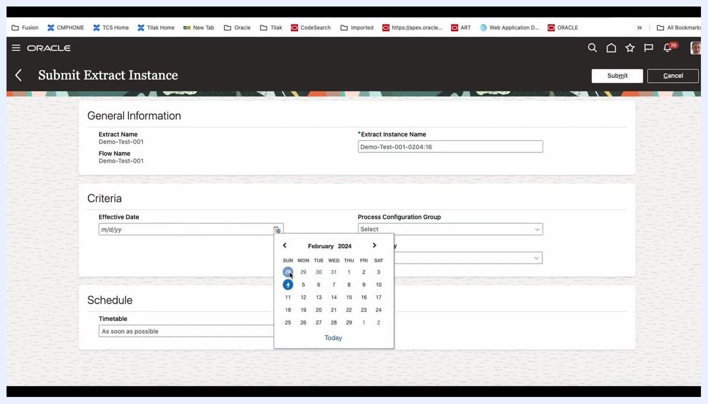
Submit Extract Instance screen with the calendar picker open for Effective Date, with February 4, 2024 selected.

Step 34: Select the effective date and baseline only option
In the date picker, choose February 4, 2024 (2/4/24) as the effective date; the selected date populates the Effective Date field. Leave Process Configuration Group as "Select" unless a specific group is required.
For Baseline Only, click the dropdown and select either Yes or No as needed for your extract.
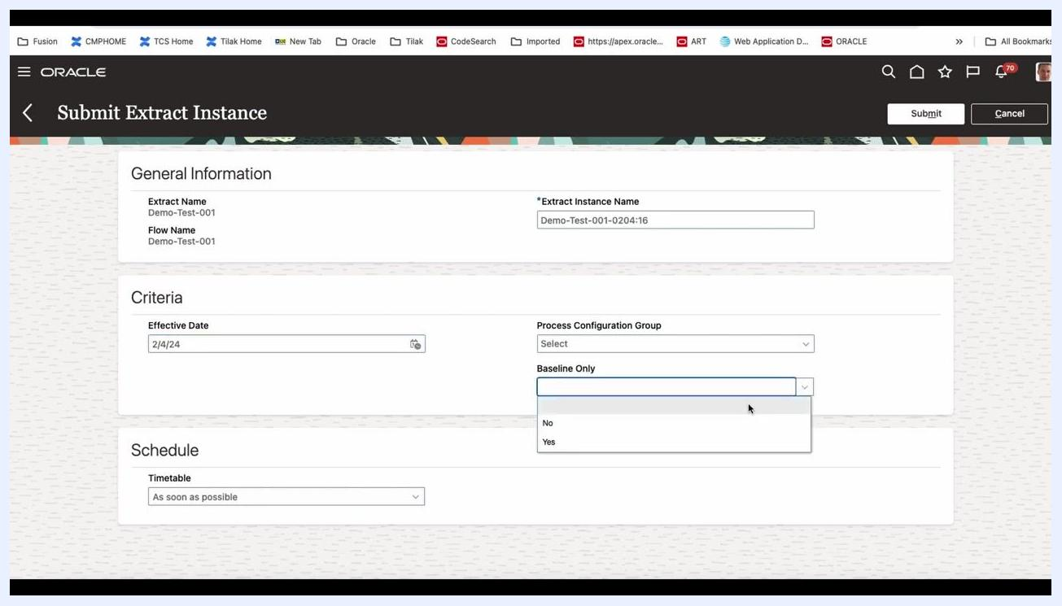
Submit Extract Instance screen with the Baseline Only dropdown open, showing Yes and No options.

Step 35: Review all entered information
Before submitting, confirm the following values:
- Extract Name: Demo-Test-001
- Flow Name: Demo-Test-001
- Extract Instance Name: Demo-Test-001-0204:16
- Effective Date: 2/4/24
- Process Configuration Group: leave as needed
- Baseline Only: select Yes or No as required
- Timetable: As soon as possible

Step 36: Submit and view the extract results
Click the Submit button in the upper right to submit the extract instance for processing. You are then redirected to the View Extract Results screen, where the new extract instance appears in the Extract Instances list with the following details:
- Instance Name: Demo-Test-001-0204:16
- Extract Name: Demo-Test-001
- Flow Name: Demo-Test-001
- Submitted On: timestamp appears after processing
The status of the instance updates as it processes.
View Extract Results screen showing the submitted extract instance Demo-Test-001-0204:16.

Step 37: Monitor the extract instance status
Click the instance name (Demo-Test-001-0204:16) in the Extract Instances list to open the instance details page, which displays:
- General Information: Extract Name, Flow Name, Submitted By, Submitted On, Status (for example, In Progress), Elapsed Time, Recurring, Scheduled On, Completed On
- Expandable sections for Criteria, Instance Details, and Extract Delivery Options
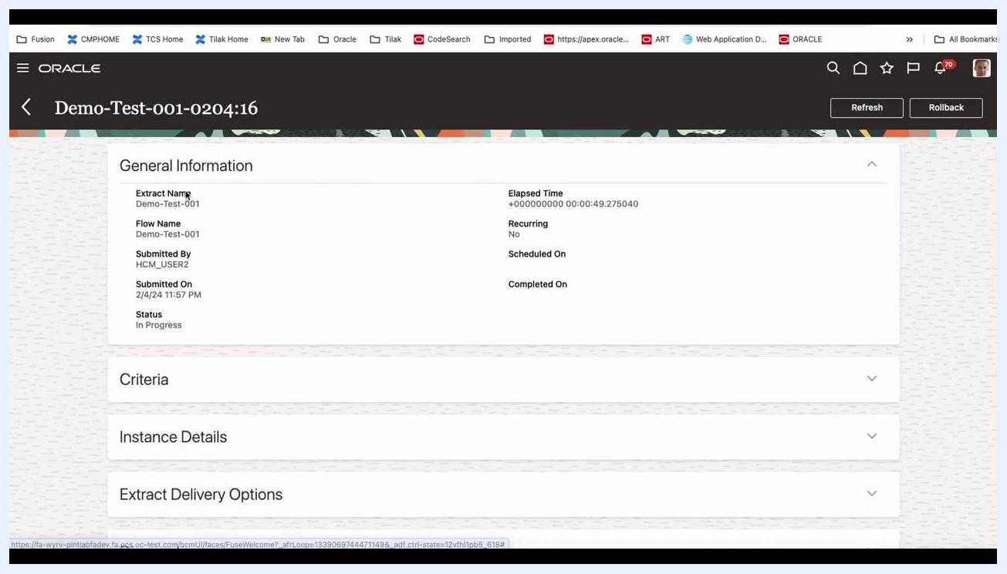
Extract instance details page showing status, elapsed time, and expandable sections.

Step 38: Review the extract run summary
On the Demo-Test-001-0204:16 summary page, locate the General Information section and confirm the following details:
- Extract Name: Demo-Test-001
- Flow Name: Demo-Test-001
- Submitted By: HCM_USER2
- Submitted On: 2/4/24 11:57 PM
- Status: Completed
- Elapsed Time: 00:00:49.361000
- Recurring: No
- Completed On: 2/4/24 11:58 PM
Review the Instance Details section for process status:
- Extract Run: Process ID 78003, Status: Running
- ElevatedFlowEssJobDefn: Process ID 78004, Status: Succeeded
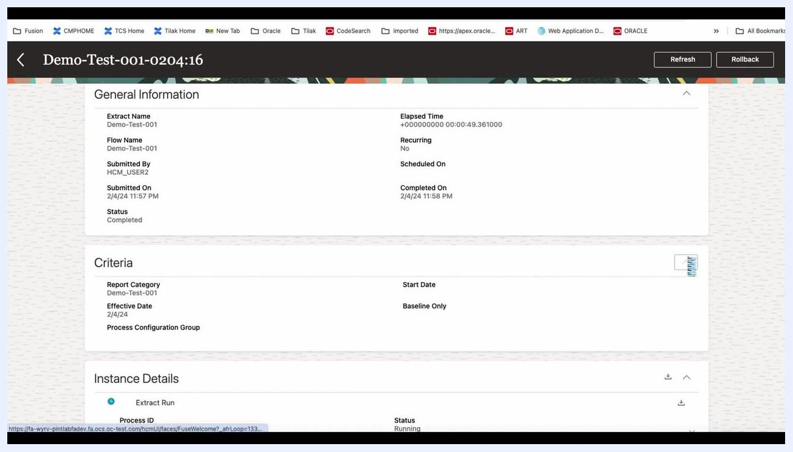
General Information and Instance Details for Demo-Test-001-0204:16, showing extract and flow names, submission details, status, elapsed time, and process IDs with statuses.

Step 39: Review the criteria used for the extract
Expand the Criteria section to view the report parameters:
- Report Category: Demo-Test-001
- Effective Date: 2/4/24
- Process Configuration Group: value not shown
- Start Date: Baseline Only

Step 40: Check diagnostics and extract run analysis
Expand the Diagnostics and Extract Run Analysis sections if troubleshooting is required. If there are no errors or issues, these sections may be empty or display a zero error count.

Step 41: Access and open the output file
Download the XML output file (for example, ESS_ARCHIVE_300100591776995_OP) from the Output Files - Others section, then open it using a compatible application such as a web browser or text editor.
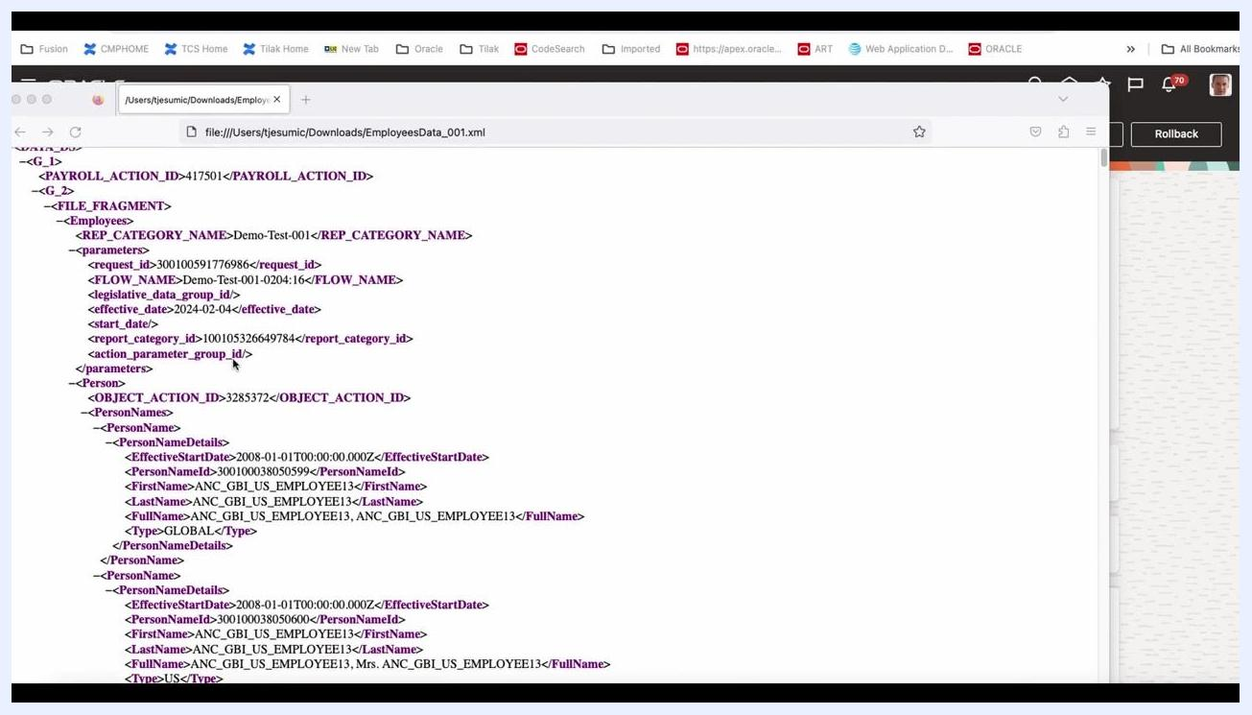
Browser window displaying the XML output file EmployeesData_001.xml with structured data.

Step 42: Review the XML output structure
Examine the XML file for the following key elements:
- <REF_CATEGORY_NAME>: Demo-Test-001
- <FLOW_NAME>: Demo-Test-001-0204:16
- <effective_date>: 2024-02-04
- <report_category_id>: 100105326649784
- <OBJECT_ACTION_ID>: 3285372 (and others)
- <PersonNameDetails>: contains details such as EffectiveStartDate, PersonNameId, FirstName, LastName, FullName, and Type
Each <Person> entry contains nested <PersonNames> and <PersonNameDetails> elements with employee data.
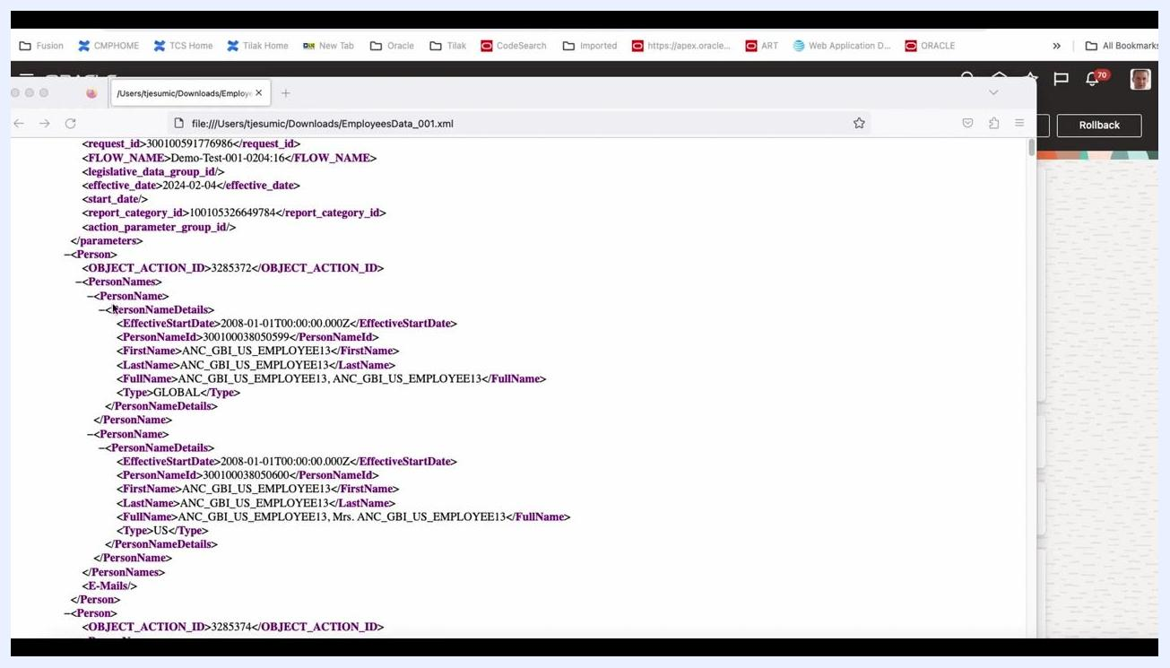
XML file open in the browser, showing employee data with tags for category, flow, effective date, object action ID, and person name details.

Step 43: Interpret the XML data
For each <Person>, review the <PersonNameDetails>:
- EffectiveStartDate: 2008-01-01T00:00:00.000Z
- PersonNameId: 300100038050599 (example)
- FirstName/LastName/FullName: ANC_GBI_US_EMPLOYEE13
- Type: GLOBAL or US
Multiple <Person> entries may be present, each representing a different employee or record.
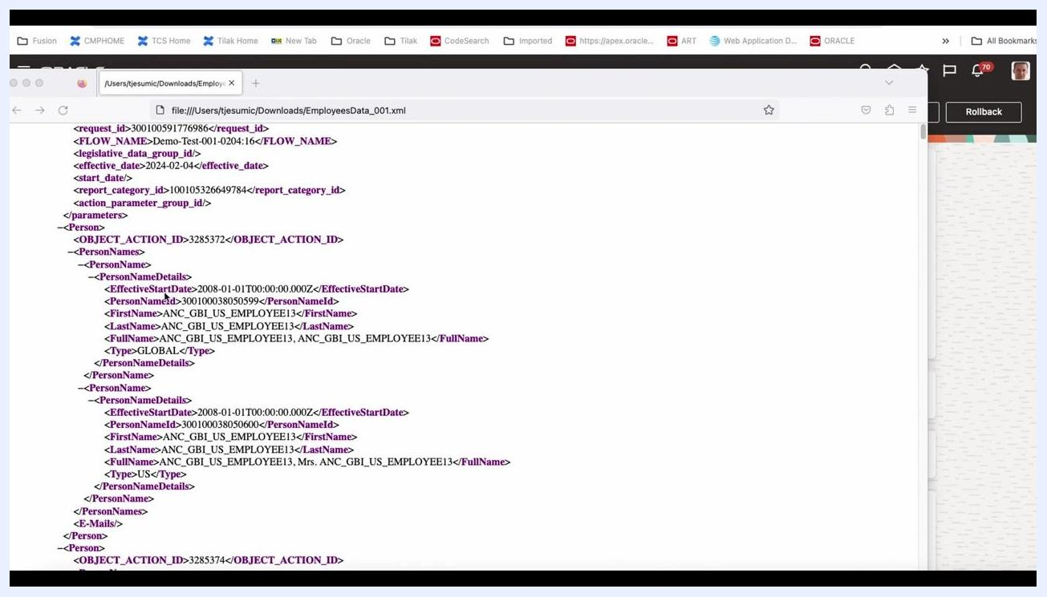
XML file open in the browser, showing multiple PersonNameDetails entries for different employees.

Step 44: Analyze name types and record duplication
Review the XML output for employee records with multiple <PersonNameDetails> entries. Observe that the employee with FirstName = ANC_GBI_US_EMPLOYEE13 and LastName = ANC_GBI_US_EMPLOYEE13 appears twice: one entry has <Type>GLOBAL</Type> and another has <Type>US</Type>.
Both entries share the same EffectiveStartDate = 2008-01-01T00:00:00.000Z but have different PersonNameId values. This duplication occurs because the same person has multiple name types (for example, GLOBAL and US), which results in multiple records for that employee.
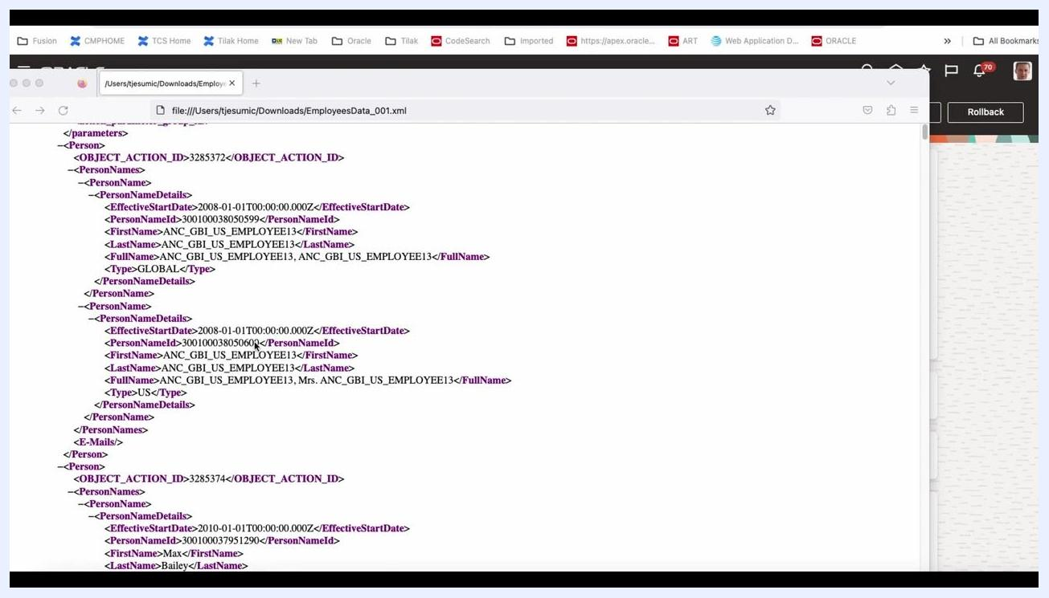
Browser window displaying XML with two PersonNameDetails entries for ANC_GBI_US_EMPLOYEE13, one with Type GLOBAL and one with Type US.

Step 45: Apply filtering options for name types
You can filter records later based on the <Type> field (for example, GLOBAL or US) to avoid duplication or to focus on a specific name type. Keep this in mind for your analysis or reporting.
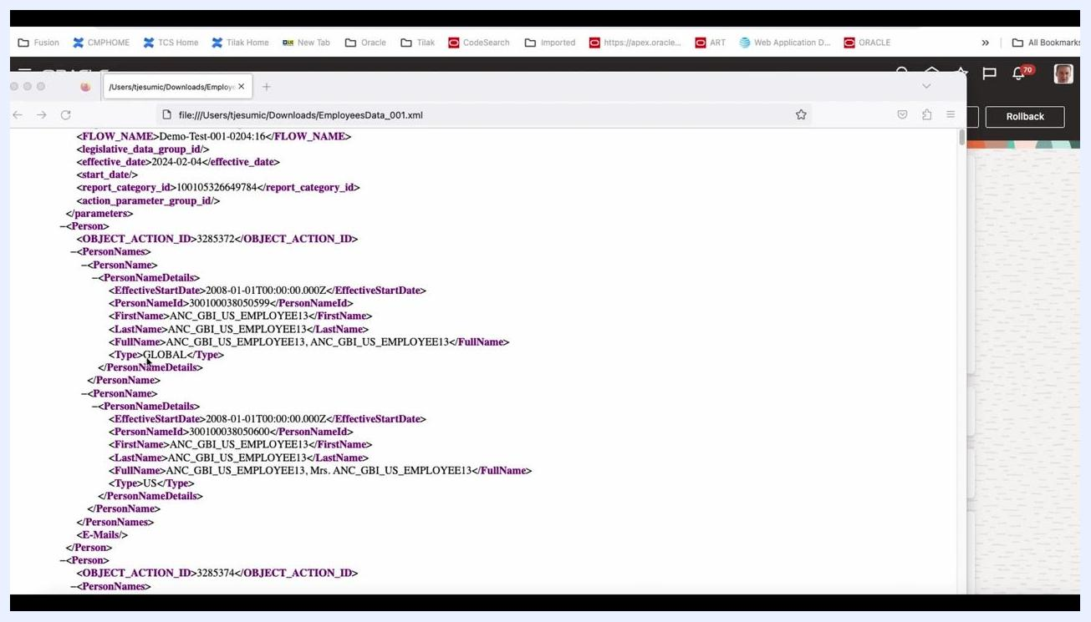
XML file showing PersonNameDetails with Type GLOBAL and Type US for the same employee, illustrating the need for filtering.

Step 46: Locate and review email information
Scroll to the <E-Mails> section within each <Person> entry to identify which employees have associated email addresses. For example, the employee with FirstName = Max and LastName = Bailey has an <Email> entry.
Review the <EmailDetails>:
- DateFrom: 2010-01-01T00:00:00.000Z
- EmailType: W1 (likely indicating a work email)
- EmailAddressID: 300100037951320
- EmailAddress: sendmail-test-discard@oracle.com
Note that not all employees may have an email address listed.
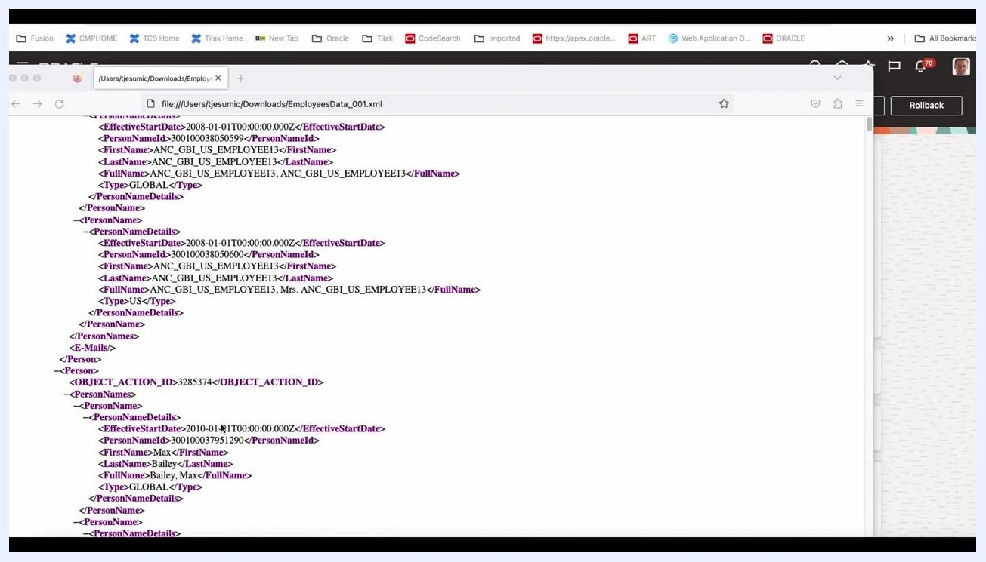
XML file showing EmailDetails for Max Bailey, including EmailType W1 and the email address sendmail-test-discard@oracle.com.

Step 47: Consider output formatting and conversion options
The XML output can be processed further:
- Apply a BIP (BI Publisher) template to format the data as needed.
- Convert the XML data into RTF (Rich Text Format) or Excel for easier analysis or reporting.
Choose the output format that best suits your reporting requirements.
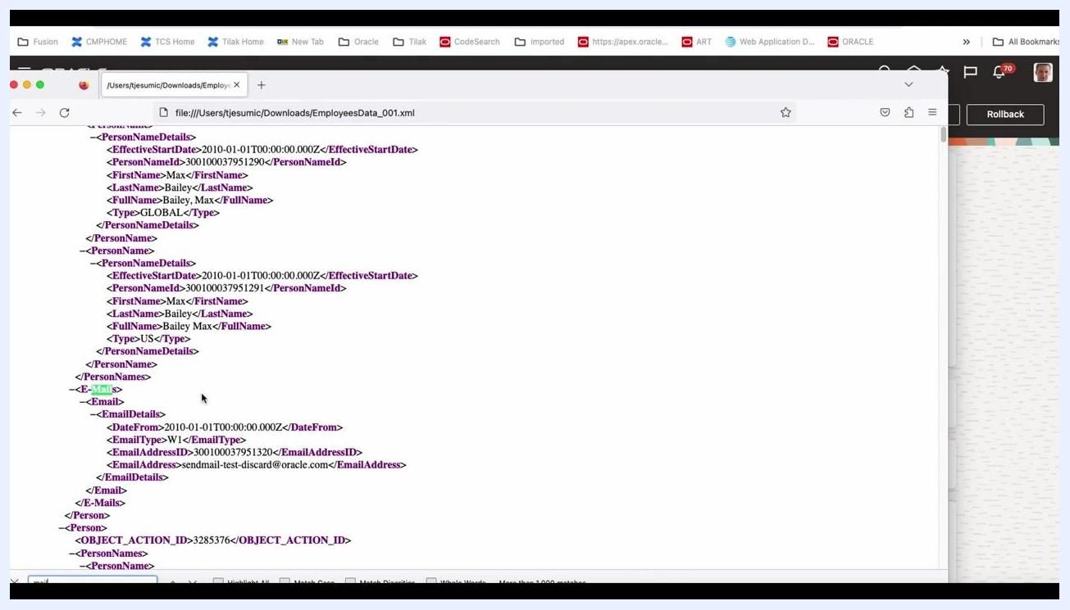
XML file with employee and email details, suitable for conversion to other formats such as RTF or Excel.

Summary
You have now learned how to create an HCM extract in Oracle Fusion from start to finish: building the extract definition from a template, selecting business objects and attributes, reviewing the Design and Deliver sections, previewing the extract, submitting an extract instance, and reviewing the resulting XML output. You have also reviewed the extract run summary, criteria, and output delivery options, and examined the structure and content of the XML file to identify key employee data fields such as name types and email addresses.

What's Next
Continue to apply the filtering options discussed for name types, and consider converting your XML output using a BIP template into RTF or Excel format for further analysis or reporting.

