How to Create a Legal Entity in Oracle Fusion SaaS Cloud
Setting up a legal entity is a foundational task in Oracle Fusion SaaS Cloud, as it defines your company's structure within the application. This guide walks you through how to create a legal entity in Oracle Fusion, from accessing the setup area to saving and confirming the new entity.

Prerequisites
- Confirm you are using Oracle Fusion Cloud Applications Release 13, Version 23D (11.13.23.10.0). You can verify this by opening the About This Application dialog within the application.
- Have your legal entity details ready, including the company's legal identifier, registration number, and registered address, as provided by your country's company registrar.
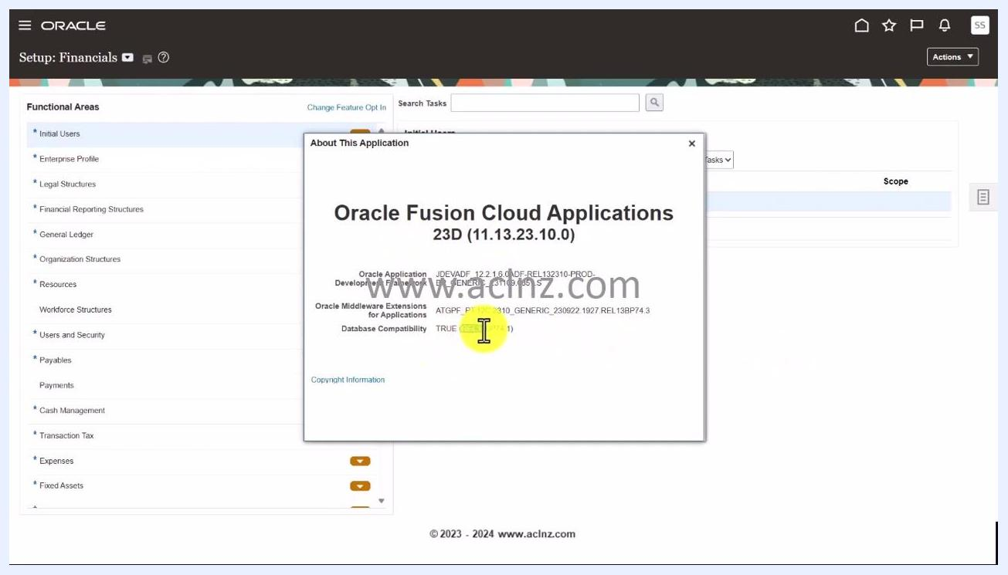
Oracle Fusion Cloud Applications About dialog showing version 23D (11.13.23.10.0)

Step 1: Access the Setup: Financials area
From the main menu, navigate to the Setup: Financials section. The left panel displays various functional areas, such as Initial Users, Enterprise Profile, and Legal Structures.

Step 2: Search for the Manage Legal Entity task
In the Search Tasks field at the top, type Manage Legal Entity. As you type, a dropdown suggests related tasks, including Manage Locations, Manage Legal Address, and Manage Legal Entity.
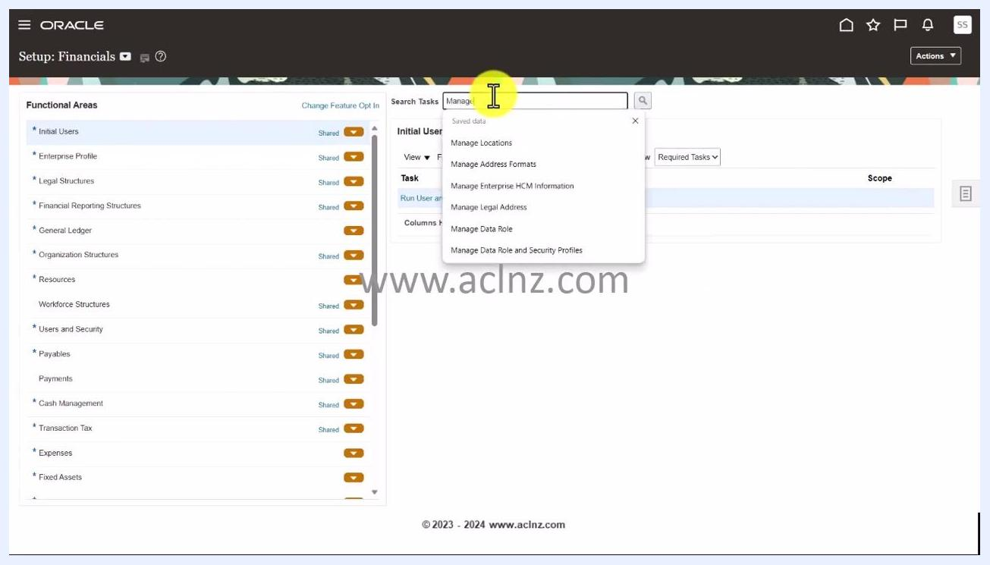
Search Tasks field with "Manage Legal Entity" being typed and a suggestions dropdown visible
Click the Manage Legal Entity hyperlink from the dropdown or search results to proceed.

Step 3: Create a new legal entity
A Select Scope dialog appears. Click the dropdown under Legal Entity and select Create New, then click Apply and Go to Task to continue.
Select Scope dialog with "Create New" selected and the "Apply and Go to Task" button highlighted

Step 4: Open the Create Legal Entity form
On the Manage Legal Entities screen, click the plus (+) icon to start creating a new legal entity. This opens the Create Legal Entity form.

Manage Legal Entities screen with the plus (+) icon highlighted for creating a new entity

Step 5: Select the country
In the Create Legal Entity form, locate the Country dropdown at the top. Click it and either scroll or use the search functionality to locate your country. In this example, select New Zealand.
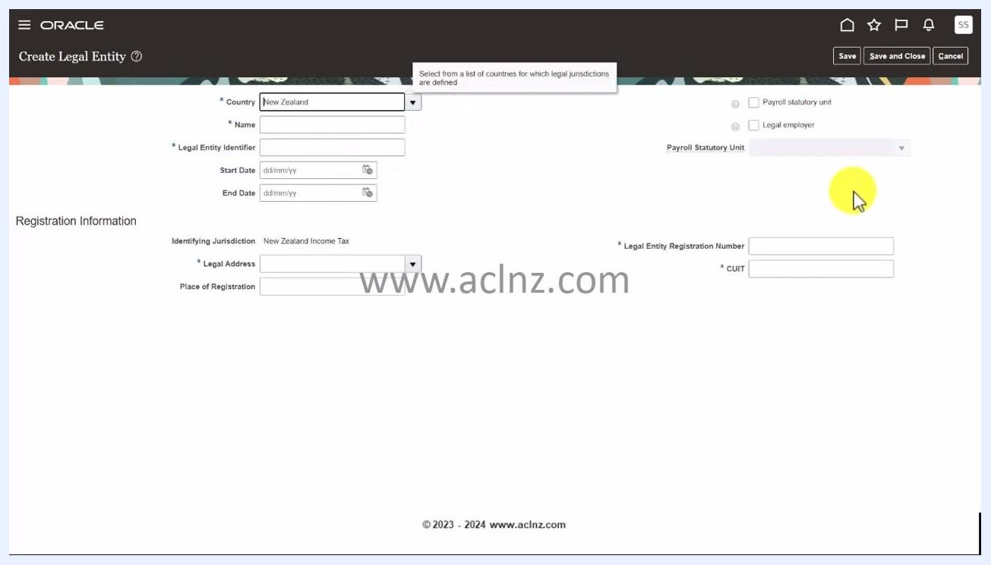
Create Legal Entity form with the Country dropdown being used to select New Zealand

Step 6: Enter the legal entity name
In the Name field, enter the name of your legal entity. For this example, type Orange New Zealand Limited.
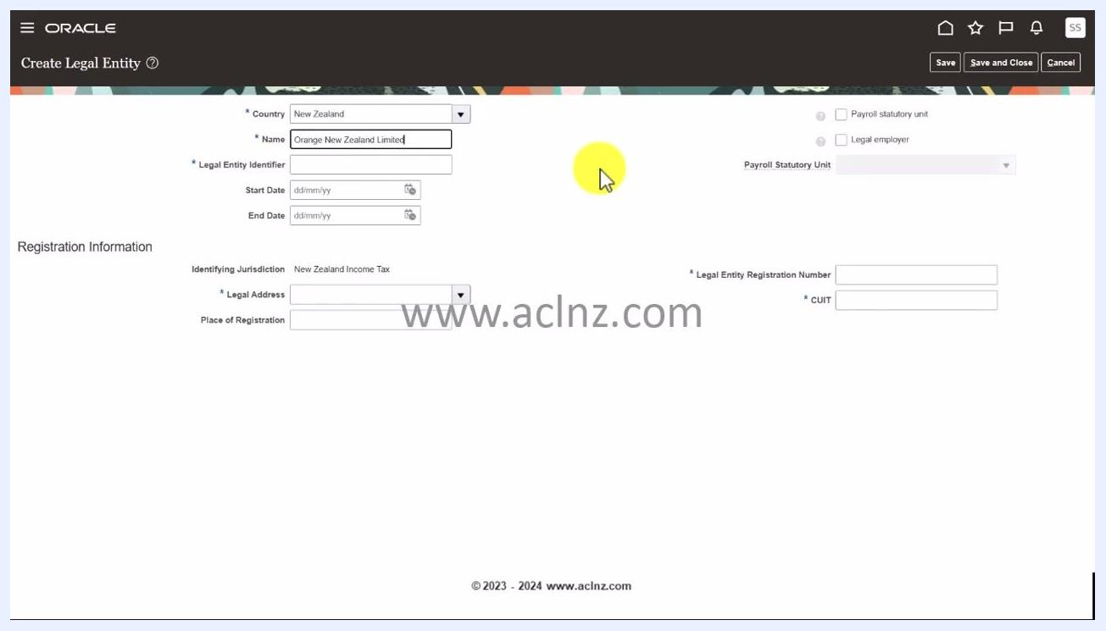
Create Legal Entity form with the Name field filled in as "Orange New Zealand Limited"

Step 7: Enter the legal entity identifier
In the Legal Entity Identifier field, enter the unique identifier for your company, as provided by your country's company registrar. This example uses 9425013517629. This identifier uniquely identifies your company in official records.
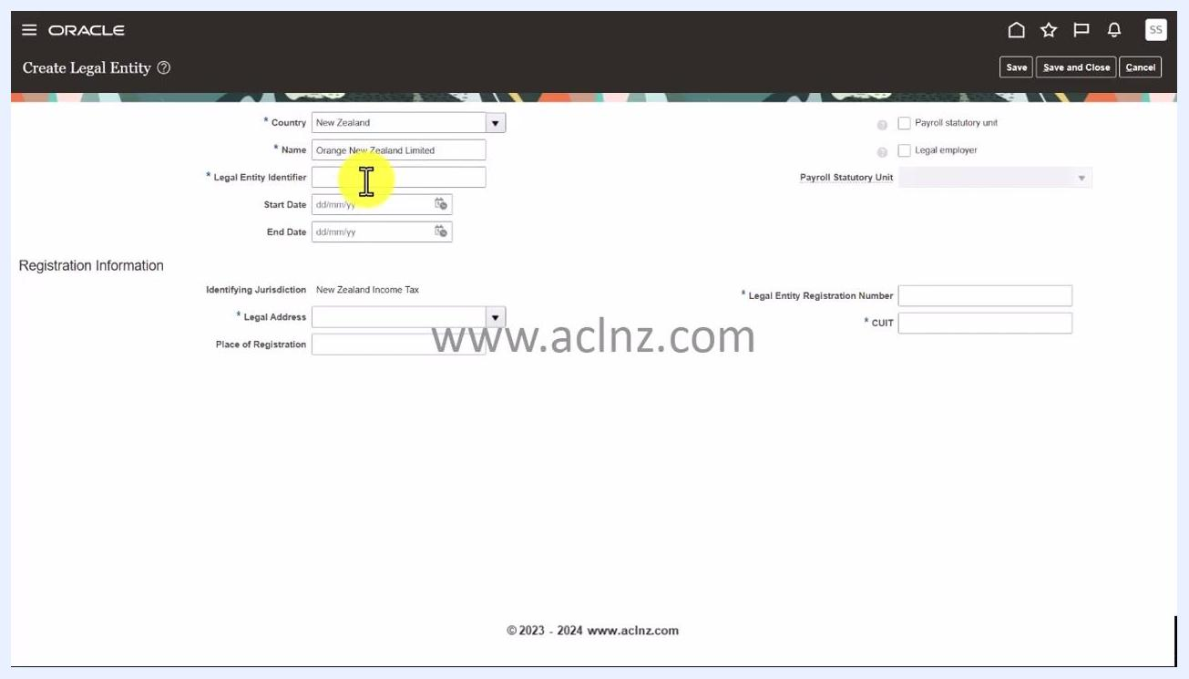
Create Legal Entity form with the Legal Entity Identifier field being filled in

Step 8: Enter the start date
In the Start Date field, enter the date the legal entity becomes effective. You can choose any appropriate date, such as 01/01/1970 or 01/01/1949. Click the calendar icon to select the date, or type it directly in dd/mm/yy format.
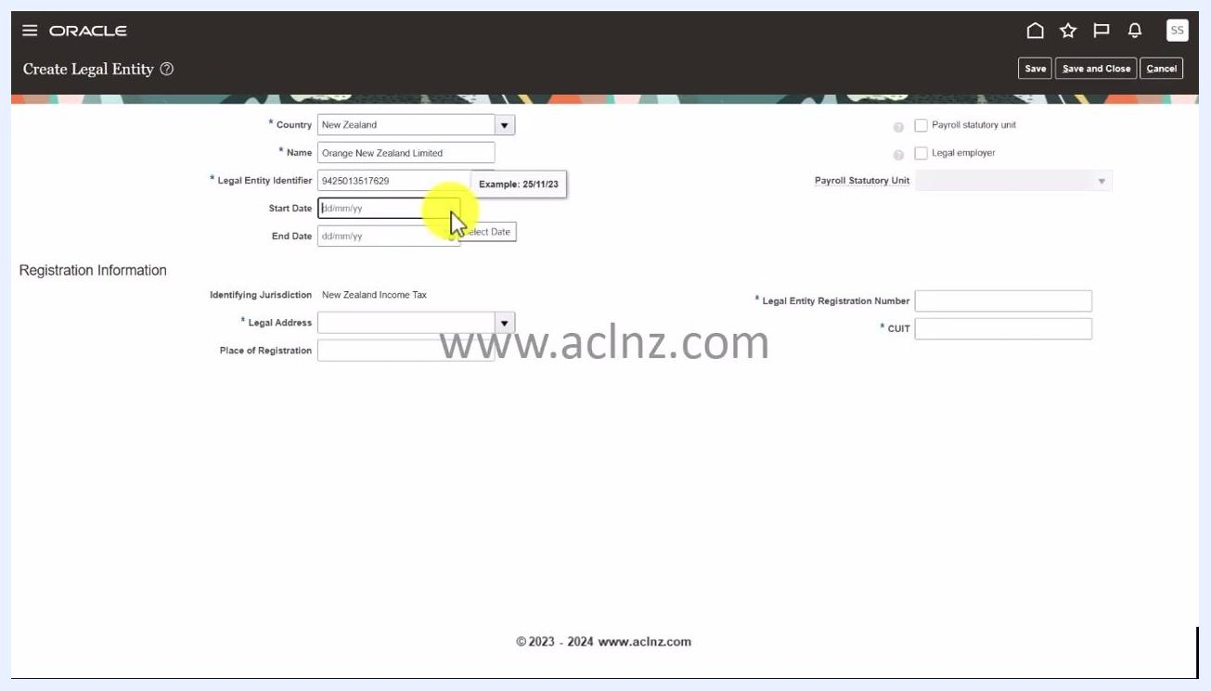
Create Legal Entity form with the Legal Entity Identifier and Start Date fields being filled in

Step 9: Enter an end date (optional)
If applicable, enter an End Date for the legal entity. Leave this field blank if the entity is ongoing.

Step 10: Specify payroll and legal employer status
Decide whether the company will be a payroll statutory unit, meaning it is responsible for payroll processing and statutory reporting. Also decide whether it will be a legal employer, meaning it will employ people and maintain payroll details.
Check the boxes for Payroll statutory unit and Legal employer if both apply to your business scenario.
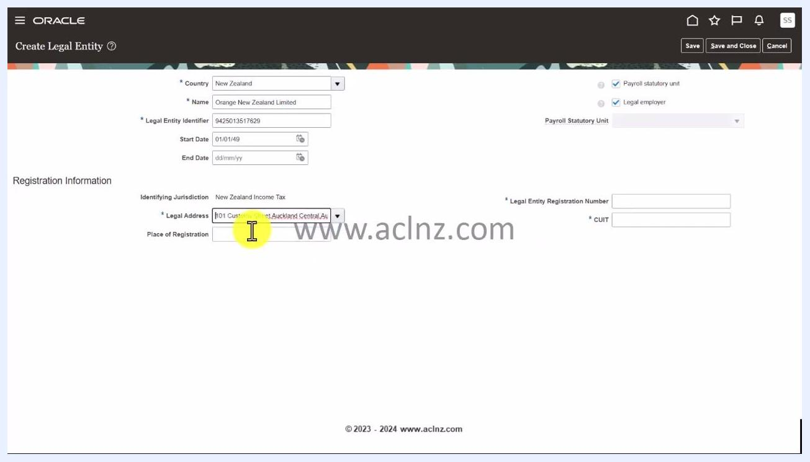
Create Legal Entity form with both the Payroll statutory unit and Legal employer checkboxes selected

Step 11: Select the legal address
In the Legal Address field, select the address you previously created for the legal entity. This example uses 101 Customs Street, Auckland Central, Auckland.
Legal Address field populated with "101 Customs Street, Auckland Central, Auckland"

Step 12: Enter the place of registration
In the Place of Registration field, enter the city or location where the entity is registered. This example uses Auckland.
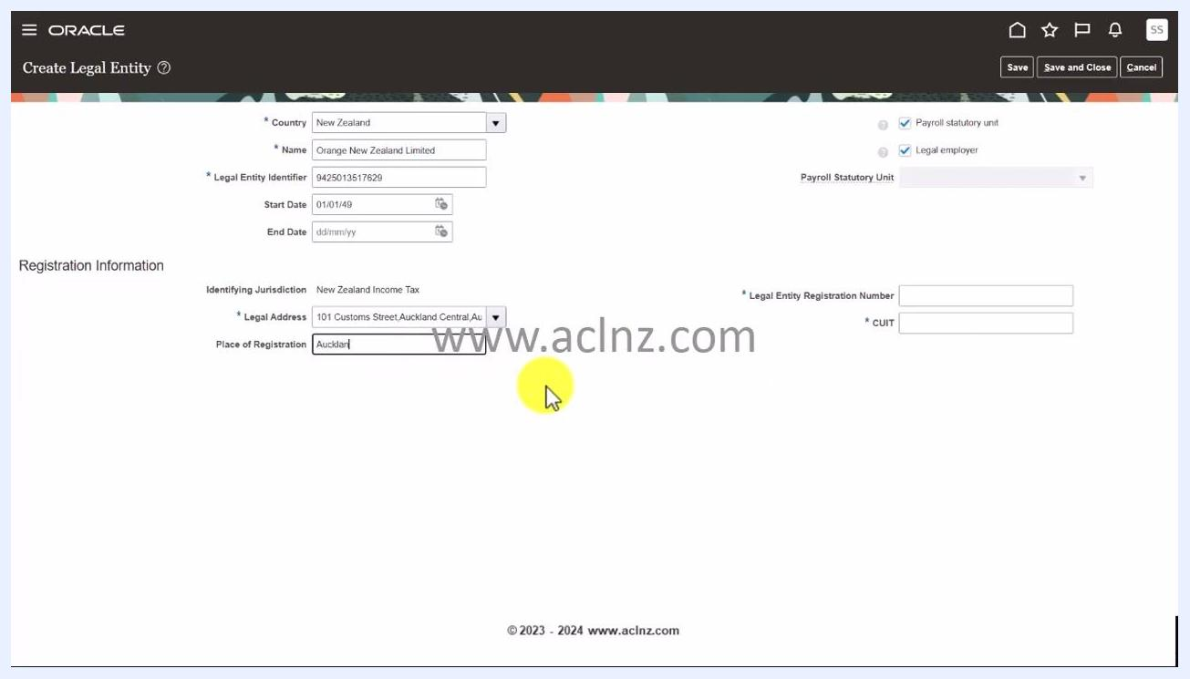
Place of Registration field filled in with "Auckland"

Step 13: Enter the legal entity registration number
In the Legal Entity Registration Number field, enter the unique registration number provided by the company board or registrar. This example uses 1911130.
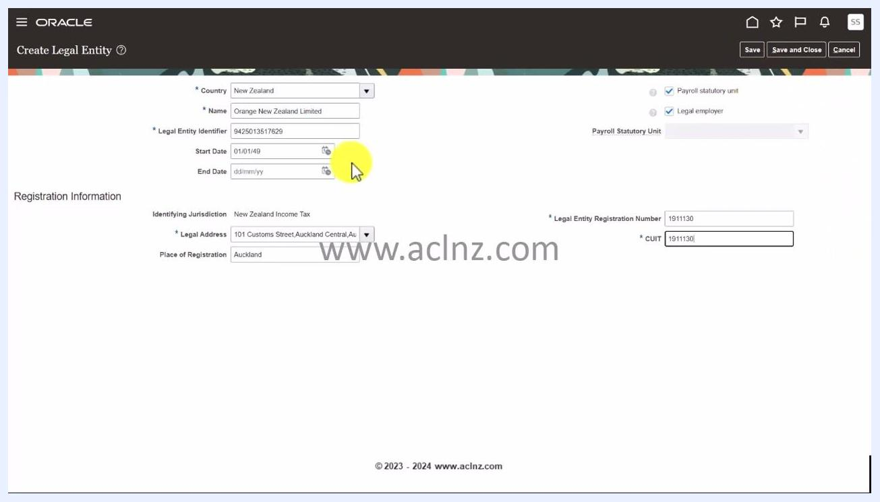
Legal Entity Registration Number and CUIT fields being filled in with "1911130"

Step 14: Enter the CUIT
In the CUIT field, enter the same registration number if applicable, or the specific CUIT number as required. This example also uses 1911130.

Step 15: Review the entered information
Before saving, double-check all fields: Country, Name, Legal Entity Identifier, Start Date, Legal Address, Place of Registration, Legal Entity Registration Number, and CUIT. Confirm that Payroll statutory unit and Legal employer are both checked if the entity will employ people and process payroll.

Step 16: Save the legal entity
Click Save at the top right of the form to save your new legal entity. The system may perform background validations; if there are any issues, such as invalid registration numbers, error messages appear for correction.
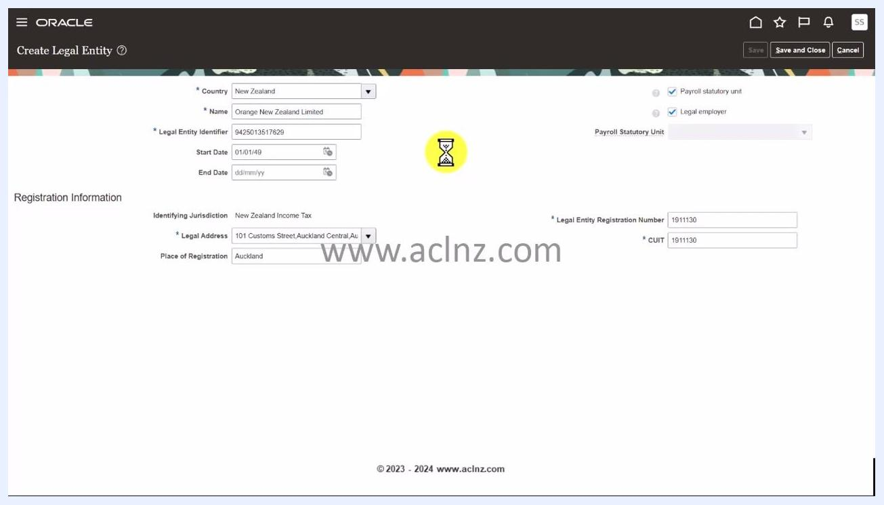
Save button clicked, with an hourglass icon appearing to indicate processing and validation

Step 17: Wait for background validation to complete
After clicking Save, watch for an indication that the system is processing your request. A yellow hourglass icon appears in the center of the Create Legal Entity form while Oracle Fusion SaaS Cloud performs background validations.
Do not close the window or navigate away while the hourglass icon is visible, as this may interrupt the validation and saving process. The form remains populated with your entered data, including:
- Country: New Zealand
- Name: Orange New Zealand Limited
- Legal Entity Identifier: 9425013517629
- Start Date: 01/01/49
- Legal Address: 101 Customs Street, Auckland Central, Auckland
- Place of Registration: Auckland
- Legal Entity Registration Number: 1911130
- CUIT: 1911130
- Both Payroll statutory unit and Legal employer checkboxes selected
The Save, Save and Close, and Cancel buttons remain visible at the top right but are typically disabled during processing. Wait until the hourglass icon disappears and the system confirms the save or displays any validation errors.
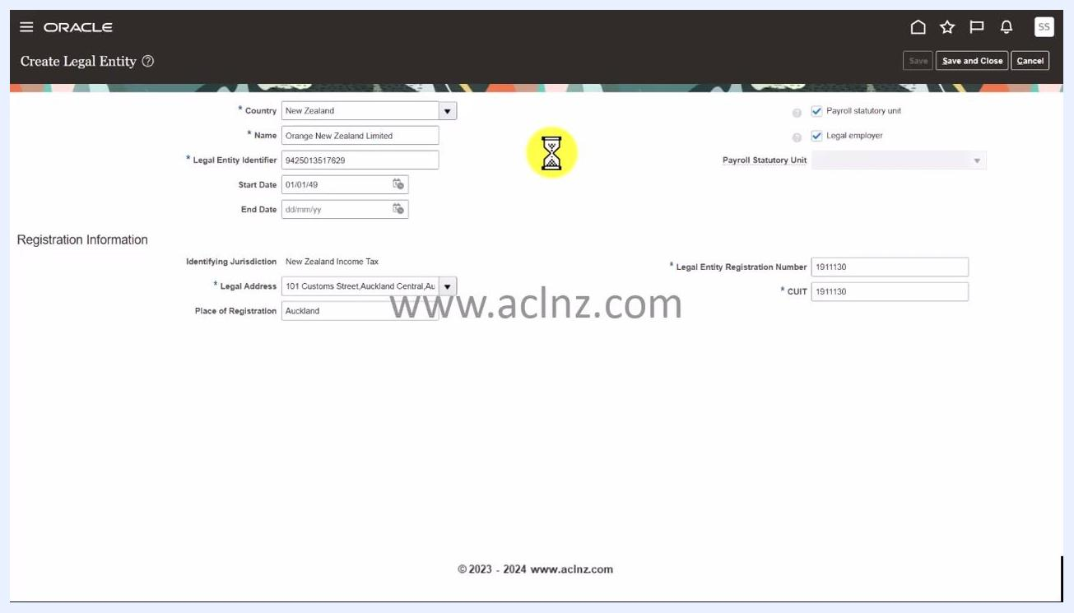
Create Legal Entity form with all fields filled in, both checkboxes selected, and a yellow hourglass icon in the center indicating background validation in progress
If any errors appear, review the error messages and correct the indicated fields before attempting to save again.

Step 18: Confirm the save
Once the save process completes, a pop-up labeled Confirmation appears with the message "Your changes were saved." Click OK to acknowledge and close the dialog.
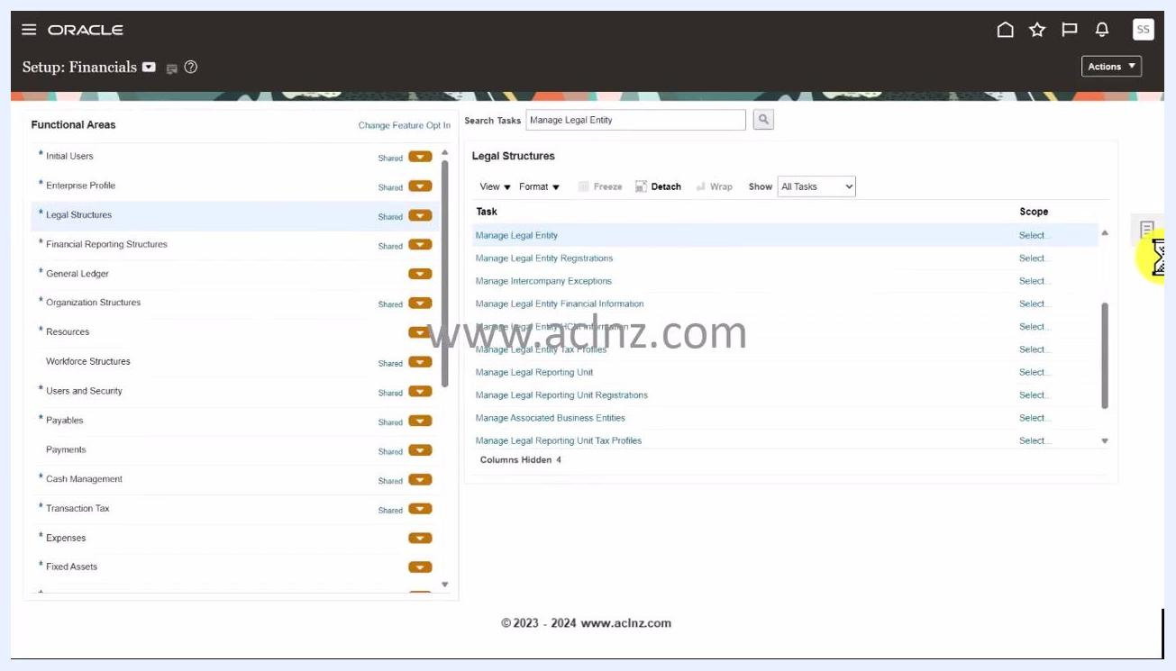
Oracle Create Legal Entity screen with a Confirmation dialog stating "Your changes were saved" and an OK button

Summary
After clicking OK, you return to the Setup: Financials dashboard. The screen displays the Functional Areas menu on the left and the Legal Structures task list on the right, with the Manage Legal Entity task highlighted. This confirms that you have successfully created a legal entity in Oracle Fusion and returned to the main setup area.

