How to Create and Post a Revenue Accrual Journal Entry in Oracle
This guide walks you through the complete process of creating a manual journal entry in Oracle General Ledger, from accessing the Navigator menu to entering journal lines and posting the final entry. The example used throughout is a revenue accrual transaction.

Prerequisites
- You must be logged into Oracle with access to the main dashboard.
- You need access permissions for General Accounting and Journals in the General Ledger (GL) module.
- Confirm you know the correct accounting period for your entry (e.g., March 2020).

Step 1: Access the Oracle home page
Ensure you are logged into Oracle and on the main dashboard. The dashboard displays a welcome message, navigation tabs (Sales, Service, Me, My Team, Procurement, Help Desk, Product Management), and app tiles (Workspace, Assets, Price Books, Competitors, Business Plans). Your username appears in the top right corner.
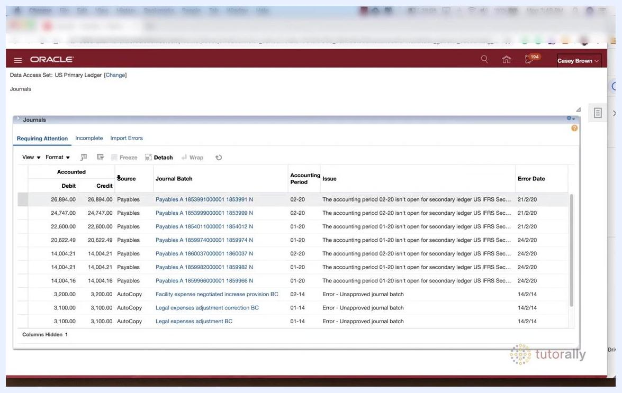
Oracle dashboard showing navigation tabs and app tiles.

Step 2: Open the Navigator menu
Locate and click the Navigator button (three horizontal lines or a similar icon) in the upper left corner, next to the Oracle logo.
Navigator button highlighted on the Oracle dashboard.

Step 3: Navigate to General Accounting
In the Navigator menu, scroll down and select General Accounting. Under General Accounting, click Journals.

Step 4: Open the Journals task pane
On the Journals page, locate the Tasks icon (usually a small icon on the right or top of the screen) and click it to open the list of available functions in General Ledger (GL).
Journals page showing the Tasks icon and journal list.

Step 5: Select "Create Journal"
In the Tasks pane, find and click Create Journal under the Journals section. This opens the Create Journal form.
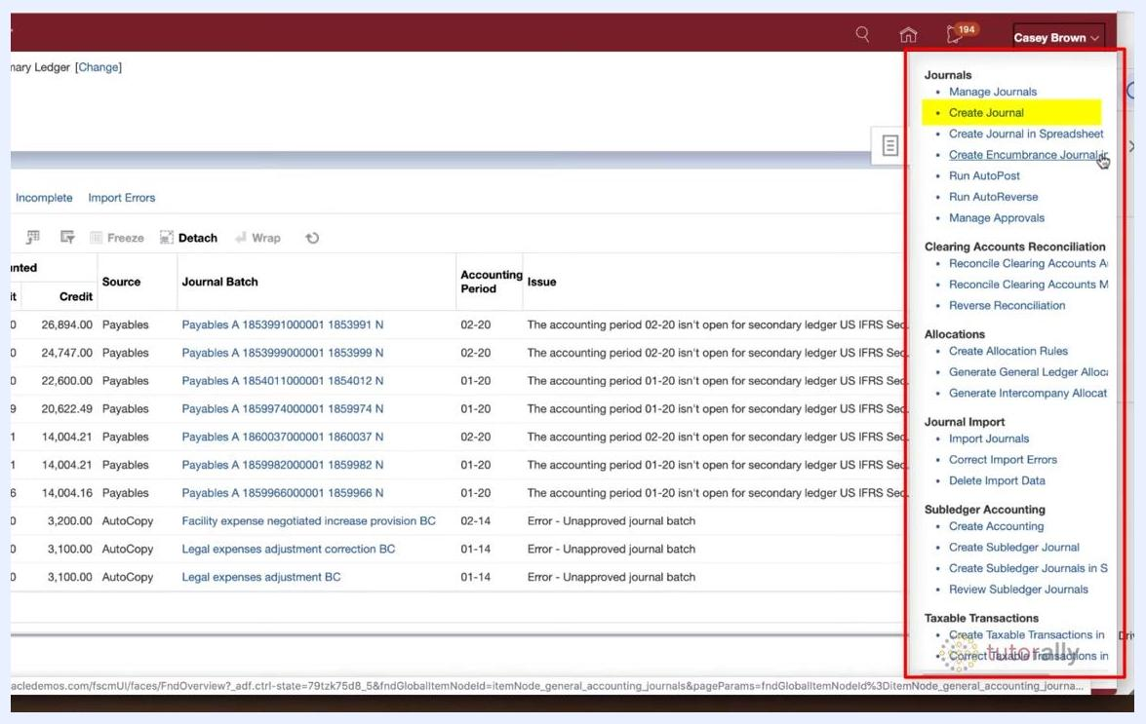
Tasks pane open with "Create Journal" highlighted.

Step 6: Enter journal header information
In the Create Journal form, fill in the required header fields:
- Journal Batch: Leave blank to let Oracle auto-generate the batch name, unless your organization requires a specific naming convention. If so, enter the batch name according to your organization's standards.
- Description: Enter a description summarizing the purpose of the entire batch.
- Balance Type: Set to "Actual."
- Accounting Period: Set to "03-20" (March 2020).
- Attachments: Add relevant attachments if needed.
Confirm the following statuses on the right side of the form:
- Source: Manual
- Approval Status: Required
- Funds Status: Not attempted
- Batch Status: Unposted
- Completion Status: Incomplete
Create Journal form highlighting the Journal Batch, Description, Balance Type, and Accounting Period fields.

Step 7: Follow organizational naming conventions
If your organization has specific naming conventions for journal batches, follow them. Otherwise, leave the Journal Batch field blank so Oracle generates it automatically.
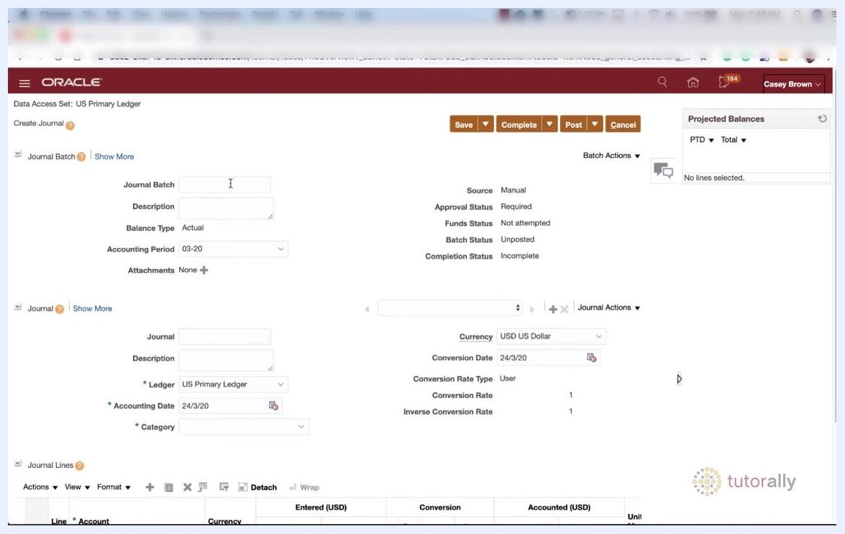
Journal Batch section with blank fields for batch name and description.

Step 8: Verify the source and accounting period
Confirm that Source is set to "Manual," indicating you are manually creating a journal entry in the General Ledger (GL). Also confirm the Accounting Period is set to "03-20."
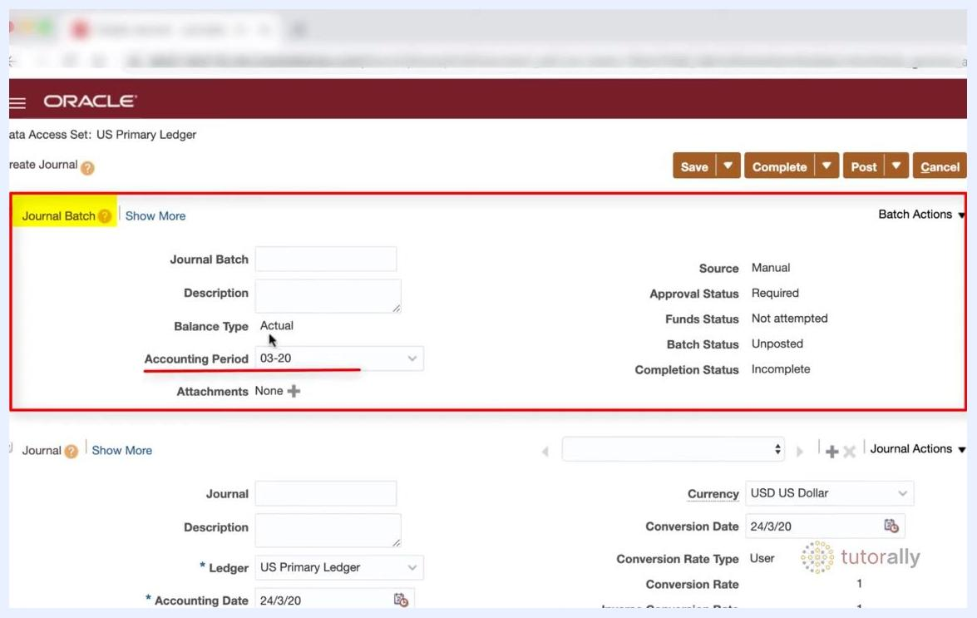
Journal Batch section with Balance Type set to Actual and Accounting Period set to 03-20.
At this point, you have started the journal entry with all required header information entered according to best practices and organizational standards.

Step 9: Enter journal details
In the Journal section, fill in the following fields:
- Journal: Enter a descriptive name, for example Revenue Accrual - CL (where "CL" represents your initials).
- Description: Optionally enter a description. If left blank, the journal name defaults into this field. Whatever you enter here also defaults onto each journal line, though you can change it later for individual lines.
- Ledger: Leave at the default value (e.g., US Primary Ledger) unless you need to select a different ledger.
- Accounting Date: Defaults to the current date (e.g., 24/3/20). If you change it, ensure the date falls within the accounting period specified in the journal header (e.g., between 1/3/20 and 31/3/20).
- Category: Specify the type of journal entry. For an accrual, type accrual and select Accrual from the filtered list.
The currency defaults to USD US Dollar, and conversion details auto-populate unless you need to adjust them.
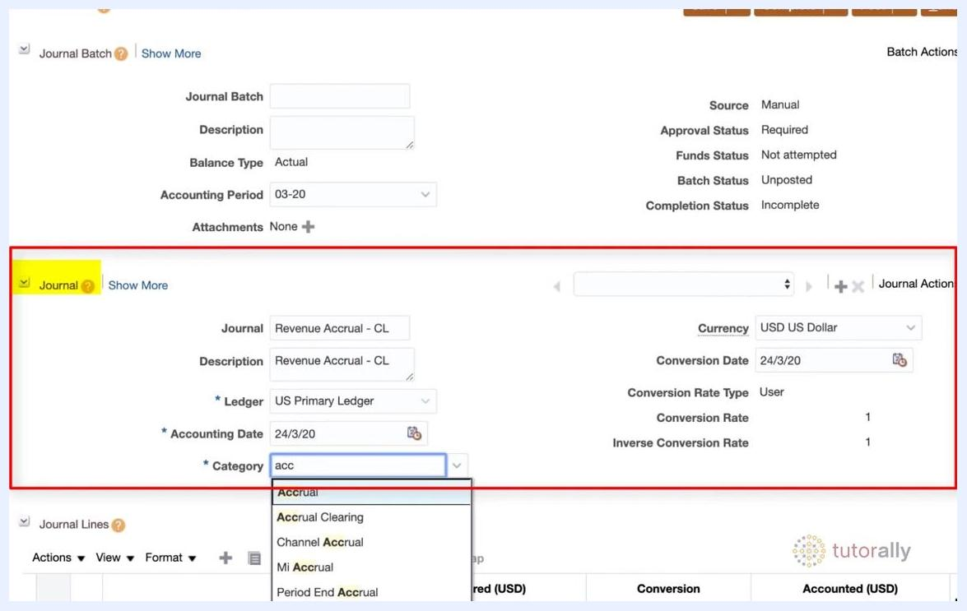
Create Journal form with Journal, Description, Ledger, Accounting Date, and Category fields being filled for a Revenue Accrual entry, with the Category dropdown filtered by "acc."
Tips:
- Use the Tab key to move quickly between fields.
- You can add notes to individual journal lines after completing the header.
- Always ensure the accounting date matches the period in the journal header to avoid errors.

Step 10: Review currency and conversion settings
The Currency field defaults to the operational currency of your ledger (e.g., USD US Dollar). Only change the currency if you are entering a foreign currency journal entry. If you do change it:
- Conversion Date defaults to the current date (e.g., 24/3/20).
- Conversion Rate Type defaults to User.
- Conversion Rate and Inverse Conversion Rate are calculated automatically.
If your ledger and journal entry use the same currency (e.g., USD), no conversion adjustments are needed.
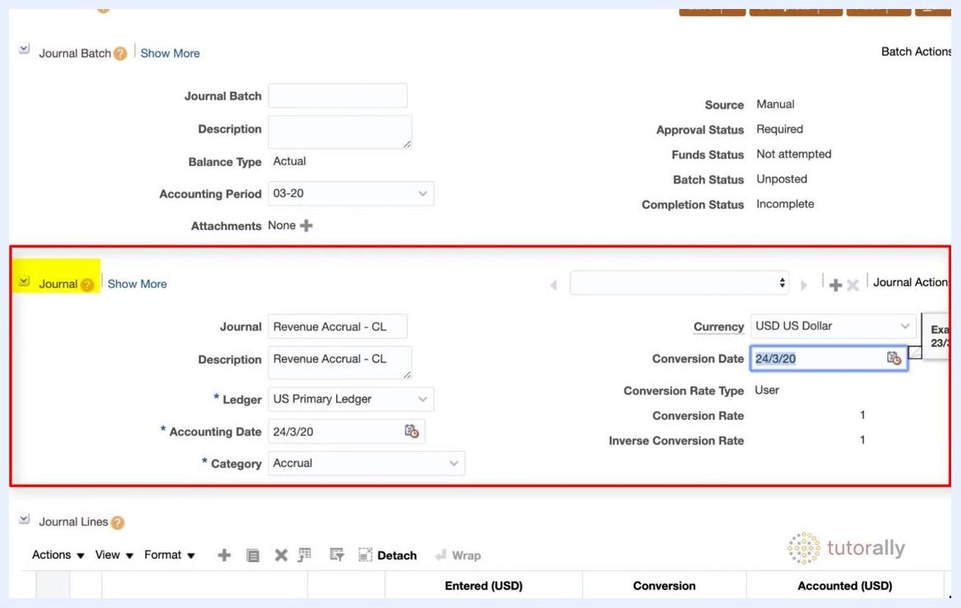
Create Journal form showing Currency, Conversion Date, Conversion Rate Type, Conversion Rate, and Inverse Conversion Rate auto-filled for USD.

Step 11: Begin entering journal lines
Scroll down to the Journal Lines section and click into the first blank line under the Account column. If needed, resize the columns to the right to reveal the Account selection icon (a magnifying glass or list icon), then click it to open the account code combination selector.
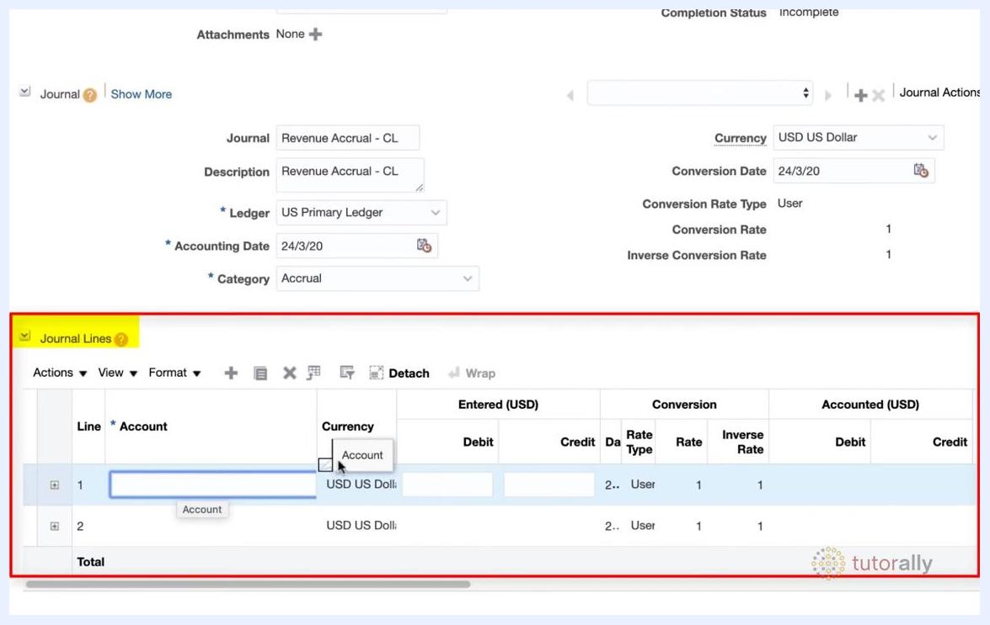
Journal Lines section with the Account selection icon highlighted.

Step 12: Select or enter an account code combination
In the account code selector dialog, you have two options:
- Select a pre-created alias: Use the dropdown to choose from frequently used code combinations, such as SF CH Utilities-Elect..., SF Cars, SF Asset Clearing, or SF Misc Revenue.
- Manually enter account details: Leave the alias field blank and manually enter the required account segments (Company, Line of Business, Account, Cost Center, Product, Intercompany).
Use the Search option at the bottom of the selector to find a specific code combination if needed.
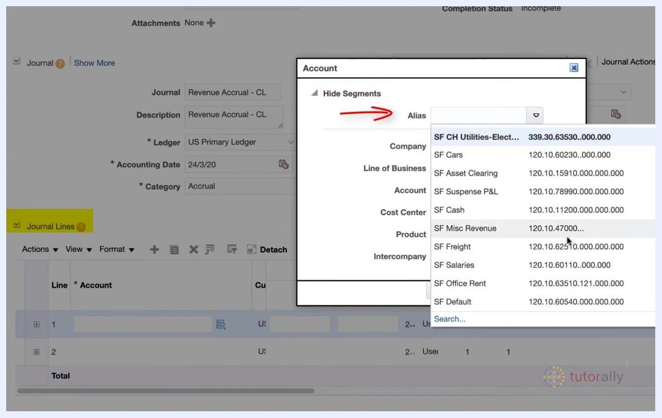
Account code selector dialog showing available aliases and account segment fields.

Step 13: Understand account aliases
The Account code selector displays a list of available aliases—frequently used or pre-created account code combinations that speed up manual entry and reduce errors. Examples include:
- SF CH Utilities-Elect... (code: 339.30.63530..000.000)
- SF Cars (code: 120.10.60230..000.000)
- SF Asset Clearing (code: 120.10.15910..000.000)
- SF Suspense P&L (code: 120.10.78990..000.000)
- SF Cash (code: 120.10.11200..000.000)
- SF Misc Revenue (code: 120.10.47000..000.000)
- SF Freight (code: 120.10.62510..000.000)
- SF Salaries (code: 120.10.60110..000.000)
- SF Office Rent (code: 120.10.63510.12000.000.000)
- SF Default (code: 120.10.60540.000.000.000)
To use an alias, click the dropdown under the Alias field and select the desired alias to automatically populate all account segment fields (Company, Line of Business, Account, Cost Center, Product, Intercompany). If the required alias is not listed, use the Search... option at the bottom of the list. This feature is especially useful for manual journal entries that repeat frequently.
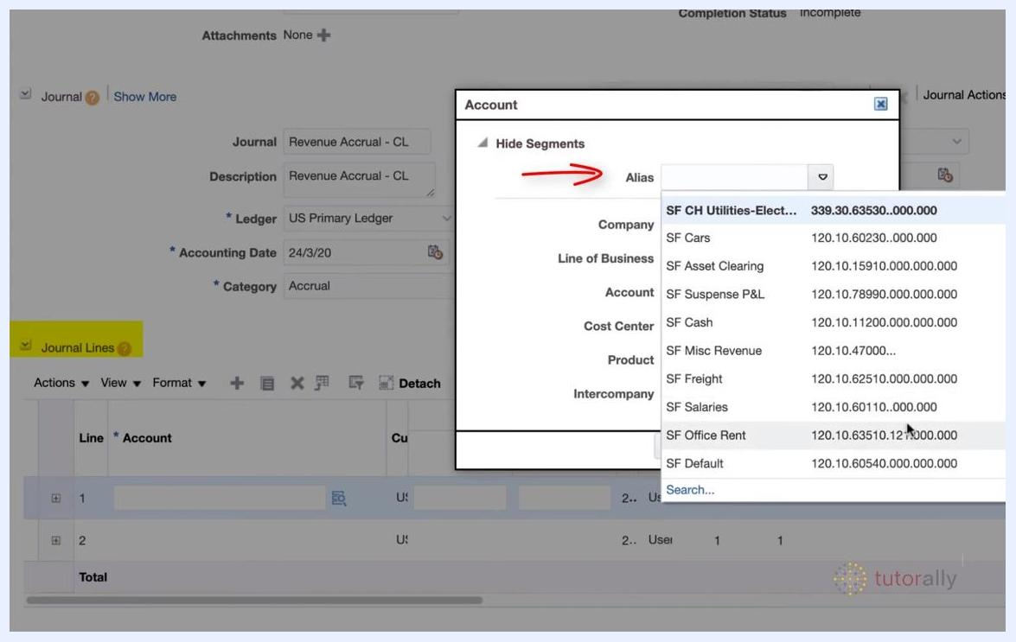
Account code selector dialog showing a list of frequently used aliases, account segment fields, and a Search option.

Step 14: Search for the debit account
In the Journal Lines section, click the account search icon for the first line. In the search dialog, enter revenue in the Description field and click Search to display all accounts containing "revenue" in the description, including:
- 12104: Revenue Clearing
- 41000: Revenue Domestic
- 41100: Revenue Performance Obligations
- 41110: Revenue Price Variance
- 42000: Revenue International
- 43000: Revenue I/C
- 44000: Revenue Intra EU
- 45000: Revenue Deductions
- 46000: Revenue Services
- 47000: Revenue Miscellaneous
Double-click 12104 Revenue Clearing to select it.
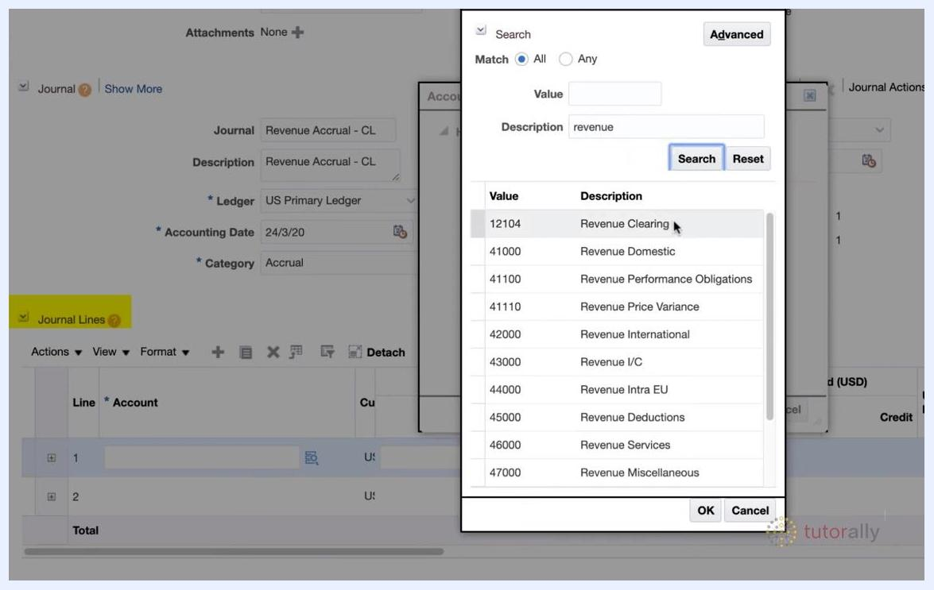
Account search dialog with "revenue" entered in the Description field, showing the list of revenue accounts with 12104 Revenue Clearing highlighted.

Step 15: Enter the debit amount
The selected account (101.10.12104.000.000.000) populates the Account field for line 1. In the Entered (USD) Debit field, enter 1,000.00. You may leave the Additional Information field blank or add a note if needed.
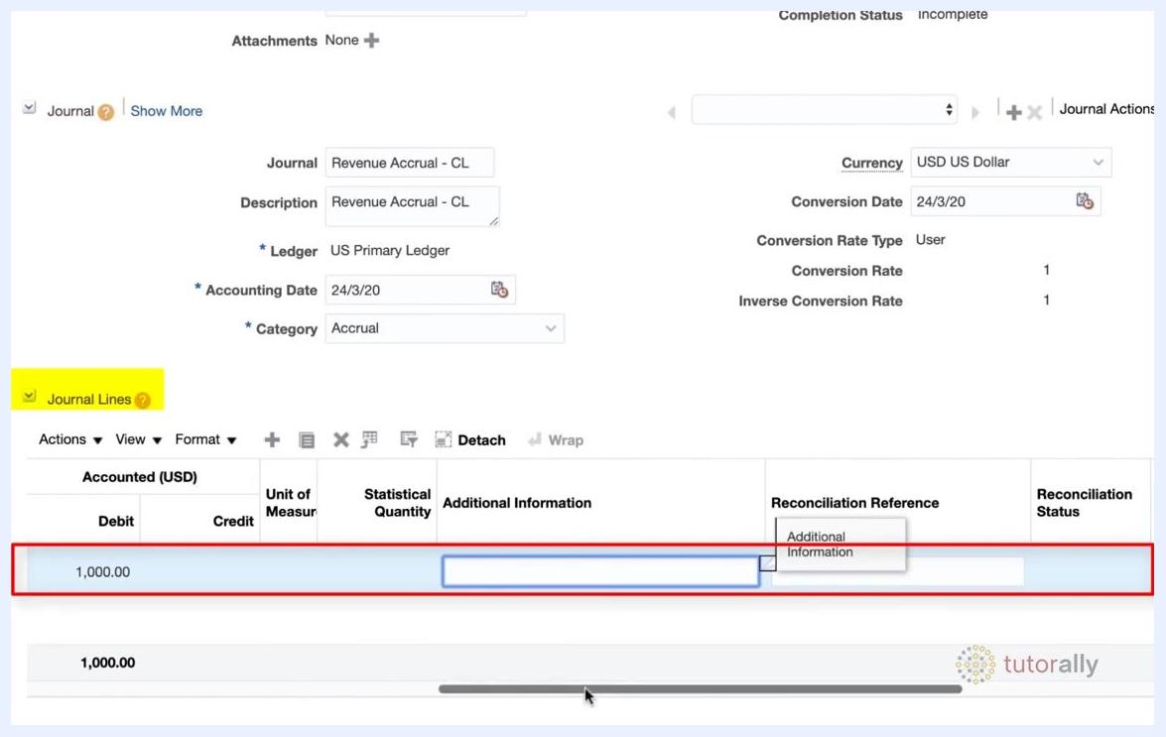
Journal line 1 showing account 101.10.12104.000.000.000, USD currency, Debit 1,000.00, and the Additional Information field.

Step 16: Add optional notes for the debit line
If required, add relevant notes in the Additional Information field for the journal line. This field can be left blank if no additional details are necessary.
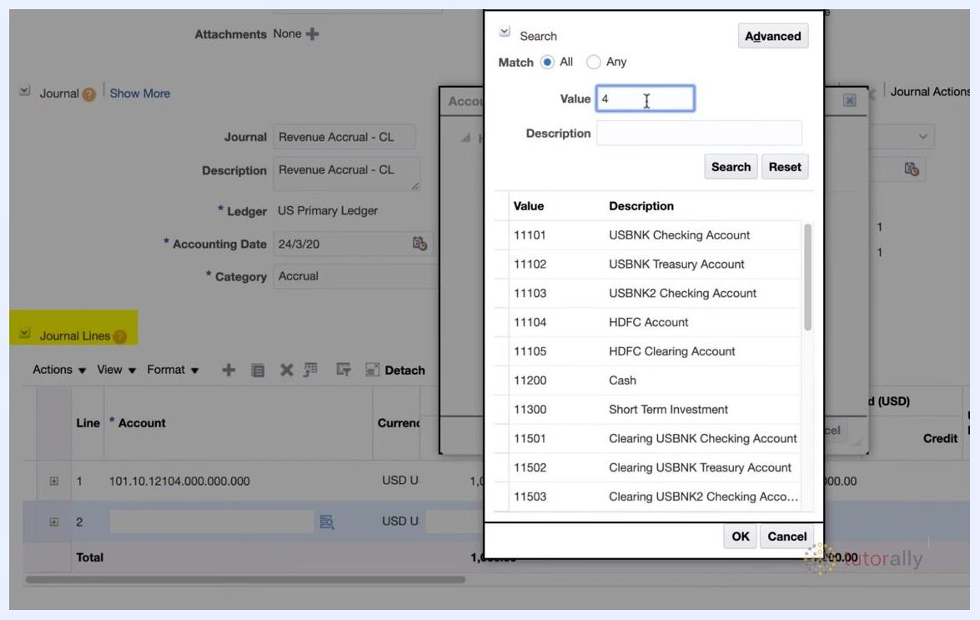
Journal line 1 with Debit 1,000.00 and the Additional Information field available for input.

Step 17: Select the account for the credit line
Click the Account field for line 2 (the credit line), then click the account search icon to open the list of values.
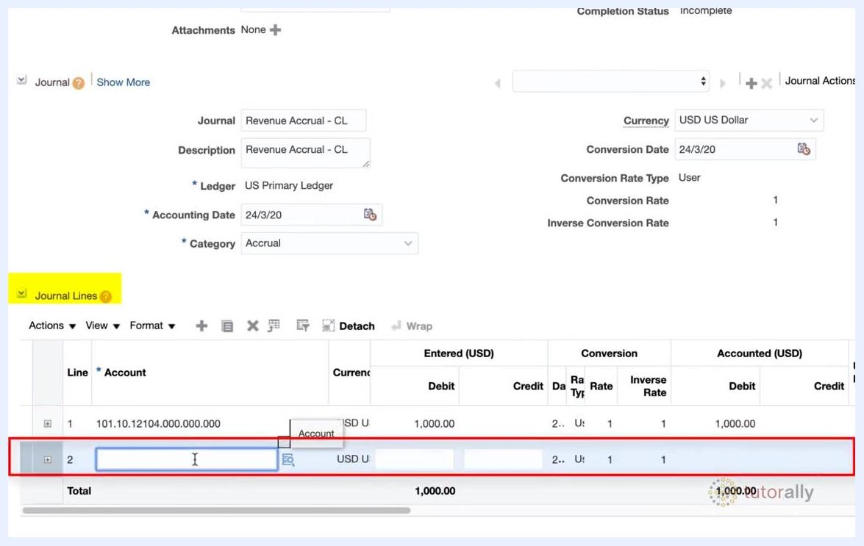
Journal line 2 selected, with the Account field ready for input and search icon highlighted.

Step 18: Search for the credit account
In the search dialog, enter 4 in the Value field to filter accounts starting with 4, then click Search. The filtered list displays accounts such as:
- 41000: Revenue Domestic
- 41100: Revenue Performance Obligations
- 41110: Revenue Price Variance
- 41200: LI Insurance Premium Revenue
- 41300: LI Insurance Premium Due Revenue
- 42000: Revenue International
- 43000: Revenue I/C
- 44000: Revenue Intra EU
- 45000: Revenue Deductions
Account search dialog with "4" entered in the Value field, showing accounts starting with 4.

Step 19: Select the Revenue Domestic account
From the filtered list, select 41000 Revenue Domestic and click OK to confirm.
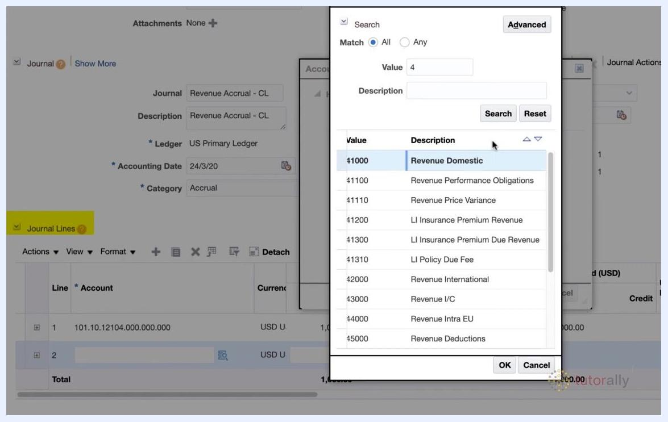
Account search dialog with 41000 Revenue Domestic highlighted, ready for selection.

Step 20: Enter the credit amount
The selected account (101.10.41000.000.000.000) populates the Account field for line 2. In the Entered (USD) Credit field, enter 1,000.00.
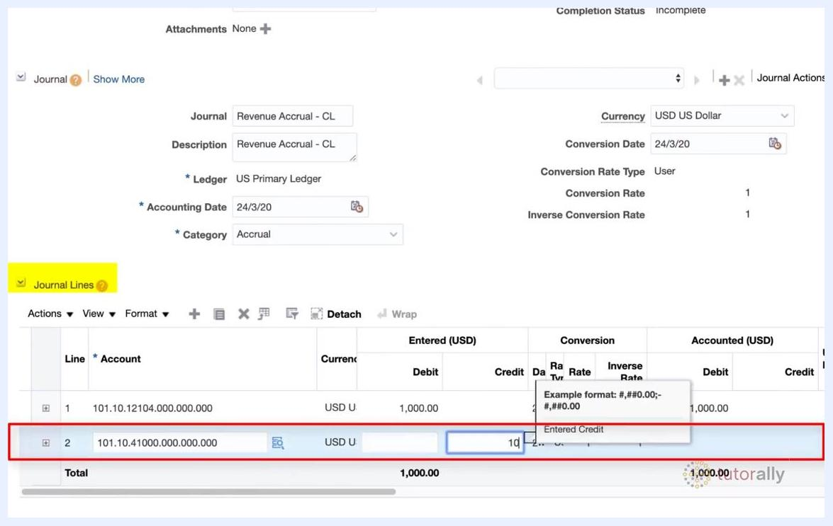
Journal line 2 showing account 101.10.41000.000.000.000, USD currency, Credit 1,000.00, and the Additional Information field.

Step 21: Add optional notes for the credit line
If prompted, enter additional information for the credit line. This field can be left blank if no further details are required.
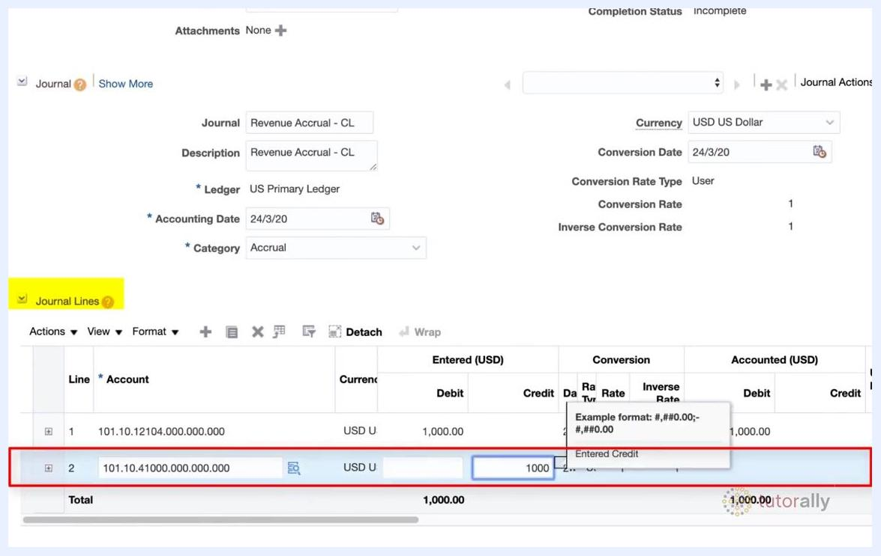
Journal line 2 with Credit 1,000.00 and the Additional Information field available for input.
At this point, both the debit and credit lines for the revenue accrual journal entry are correctly entered with the appropriate accounts and amounts.

Step 22: Save the journal entry
Click Save at the top right of the screen. After saving, a "Last Saved" timestamp appears on the screen confirming the save action (e.g., "Last Saved 24/3/20 2:28 AM"). The journal batch name updates to include the save timestamp (e.g., "Revenue Accrual - CL 24-MAR-2020 02:28:40"). The Completion Status will still show "Incomplete" at this stage.
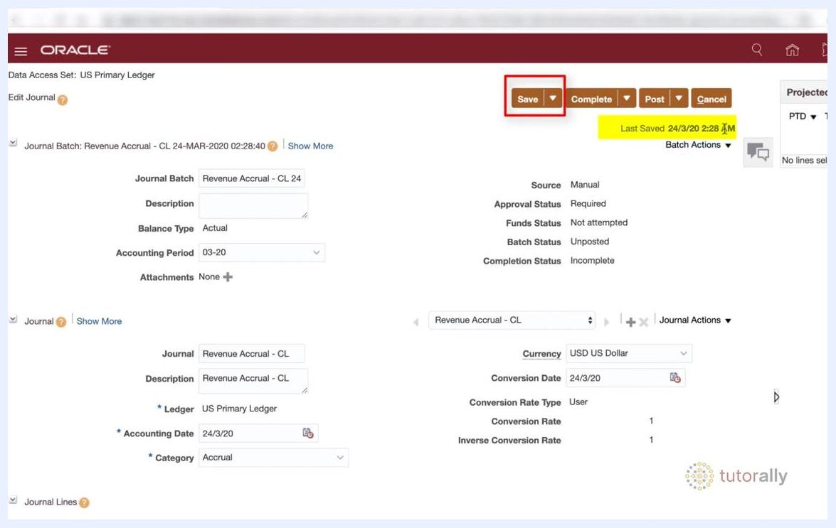
Create Journal screen after saving, showing the Save button, Last Saved timestamp, and updated Journal Batch name.

Step 23: Complete the journal entry
Click Complete next to the Save button to mark the journal entry as complete. Verify that the Completion Status field updates to "Complete" on the right side of the screen. Ensure the Batch Status remains "Unposted" and the Approval Status is "Required" (if applicable).
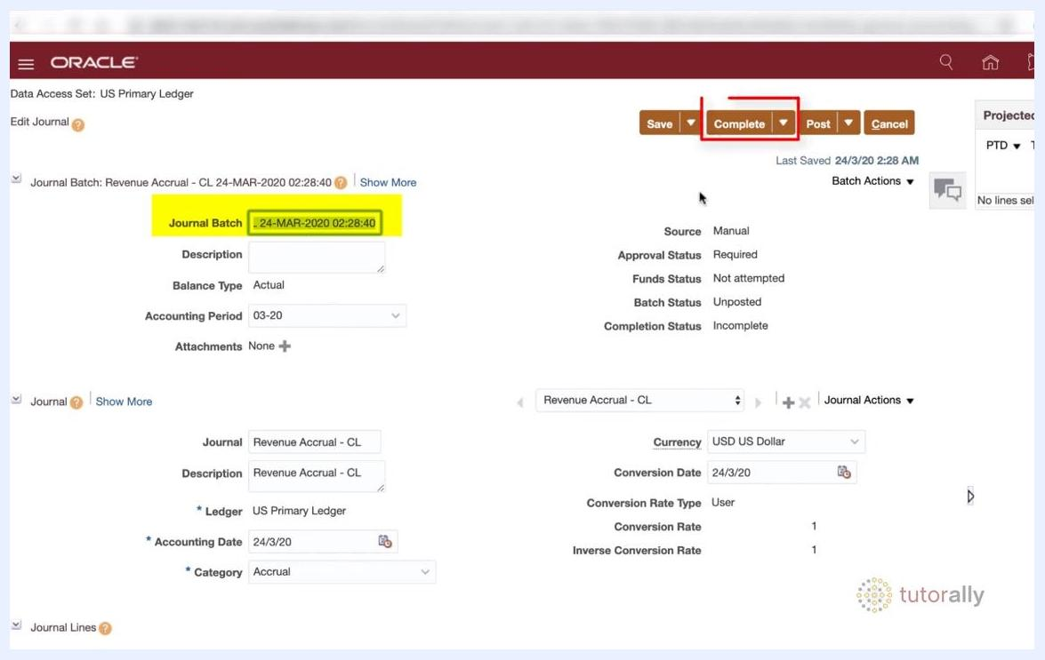
Edit Journal screen with the Complete button highlighted and Completion Status set to Complete.

Step 24: Review the completion status
Confirm the Completion Status now displays "Complete" in the status section. The journal entry is ready for posting.
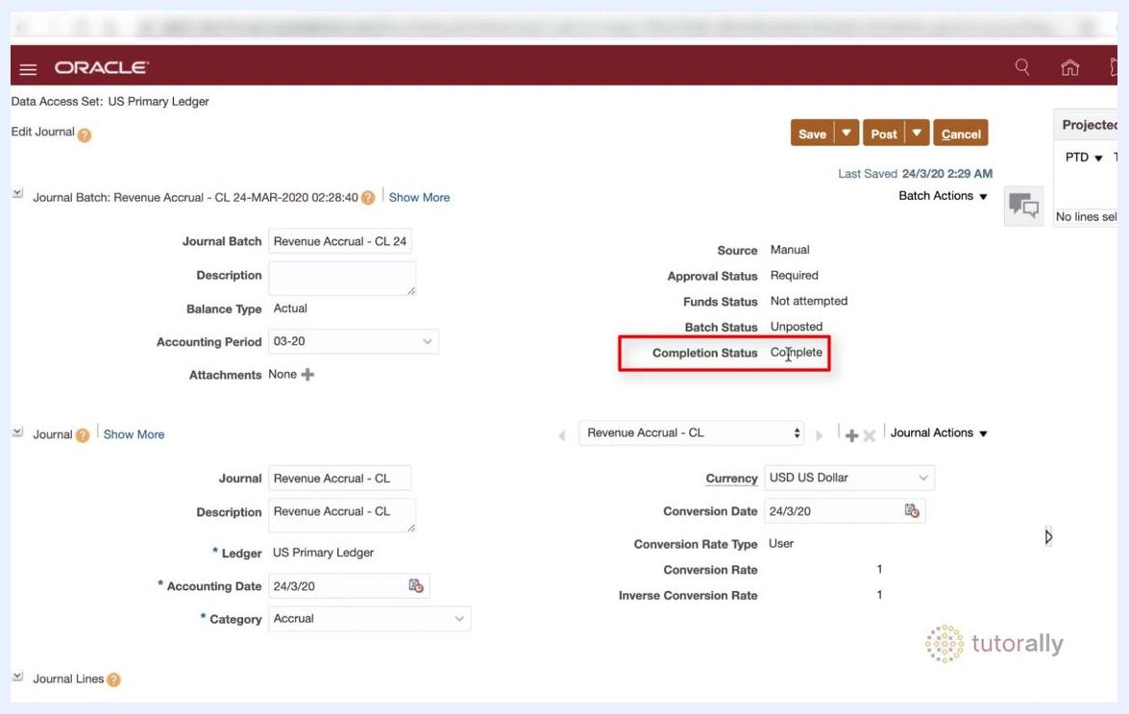
Edit Journal screen with the Completion Status field highlighted as Complete.

Step 25: Post the journal entry
Click Post at the top right of the screen to finalize and post the journal entry. This submits the journal for posting in the ledger, completing the revenue accrual process.
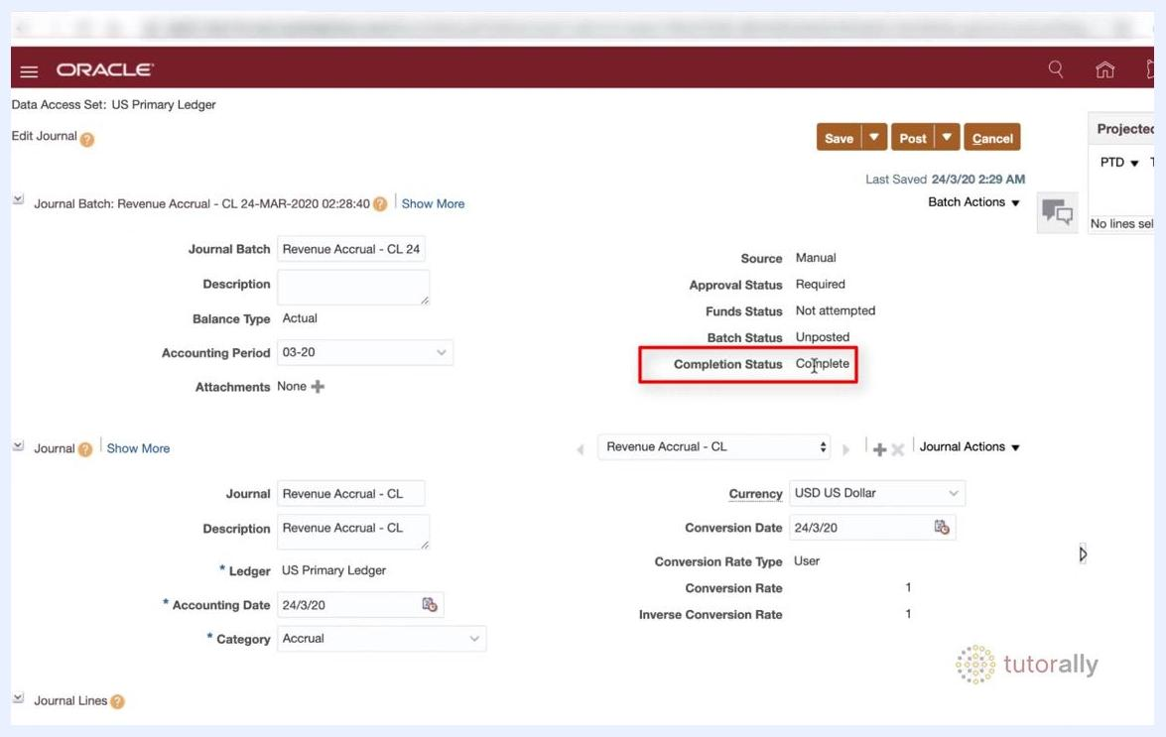
Edit Journal screen with the Post button visible and Completion Status set to Complete.

Summary
By following these steps, you have created a journal entry in Oracle, entered the header information and journal lines for a revenue accrual, and saved, completed, and posted the entry to the ledger—finalizing the transaction in Oracle General Ledger.

