How to Create a Business Unit in Oracle Fusion
This guide walks you through how to create a business unit in Oracle Fusion, from setting up a supporting location to assigning business functions. You will create a location, use it to configure a new business unit, assign a default reference data set, and enable the business functions that the unit will support.

Prerequisites
- Access to Oracle Fusion Applications with permissions to use Setup and Maintenance.
- An existing Implementation Project if you plan to assign business unit business functions (this task cannot be reached through global search alone).
- Knowledge of the address or ZIP code for the location you want to associate with the business unit.

Understanding business units in Oracle Fusion
A business unit in Oracle Fusion is the equivalent of an operating unit in Oracle E-Business Suite (EBS). It can represent a division, department, or any specific business area within your organization.
There are no strict rules for defining a business unit — you should configure it according to your organization's business requirements.

Part 1: Create a location
Before creating a business unit, you need a location to associate with it.

Step 1: Open Setup and Maintenance
Log in to Oracle Fusion Applications. From the home screen, open the Settings and Actions menu in the top right, then select Setup and Maintenance under Administration.
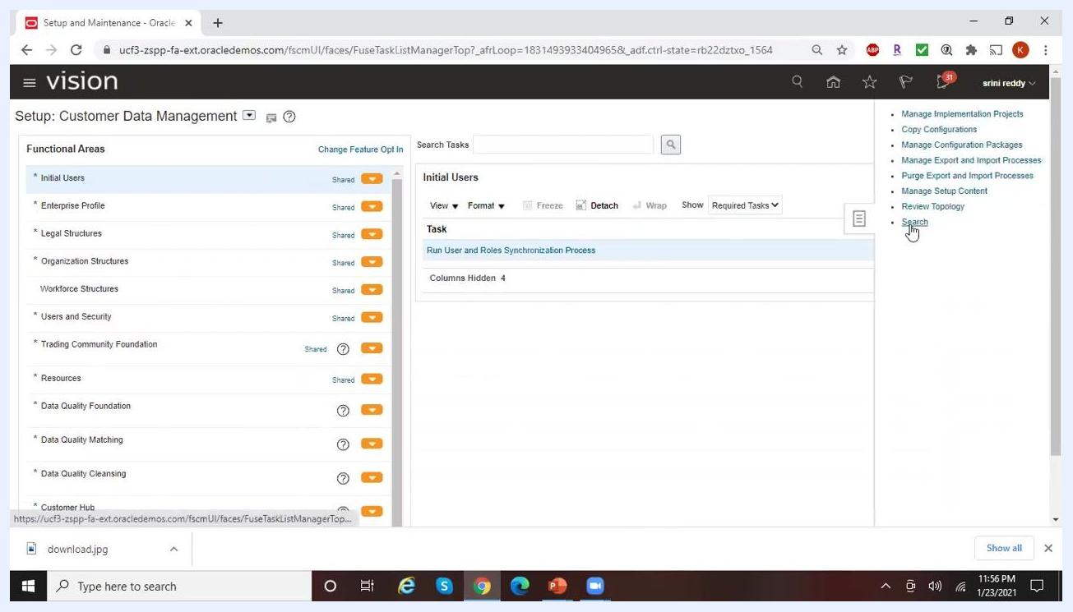
Oracle Fusion Applications home screen with the Settings and Actions menu open, highlighting Setup and Maintenance under Administration, with app tiles such as Workspace, Activities, and Contacts visible in the background.

Step 2: Search for the Manage Locations task
In the Setup and Maintenance area, locate the Search Tasks field and enter Manage Locations. Press Enter or click the search icon, then select Manage Locations from the list of results.
Setup and Maintenance screen with the task search field open, about to search for Manage Locations.

Step 3: Open the Manage Locations screen
On the Manage Locations screen, click Create to add a new location.

Step 4: Enter the location name and code
In the Manage Locations form, enter the following values:
- Name: Irving_Texas
- Code: Irving_Texas
- Leave Description blank unless additional details are required.
- Set Status to Active.
- Confirm Location Set is Common Set.
- Leave Inventory Organization, Attachments, LocationLatitude, and LocationLongitude blank unless needed.
- Under Main Address, confirm Country is set to United States.
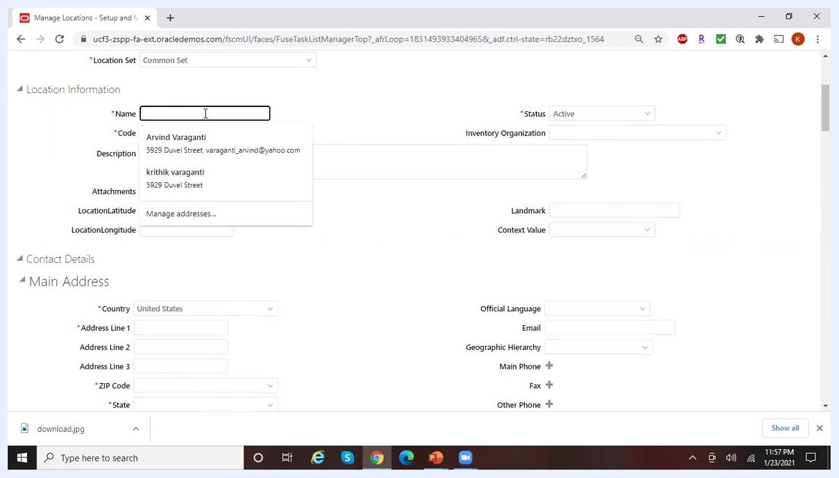
Manage Locations form with Name and Code fields being filled in as "Irving_Texas," with autocomplete suggestions visible.

Step 5: Use the ZIP code to auto-populate address details
If you do not have the complete address, enter the ZIP code to automatically fill in the city, state, and county. Enter 75014 in the ZIP Code field — State (TX), City (Irving), and County (Dallas) populate automatically. Leave Tax District and Time Zone Code blank unless required.
Main Address section showing the ZIP Code field set to 75014, with State, City, and County fields automatically filled in.

Step 6: Enter the street address (optional)
If you have the street address, enter it in Address Line 1. If not, leave it blank or select from the available suggestions if one matches your intended address.
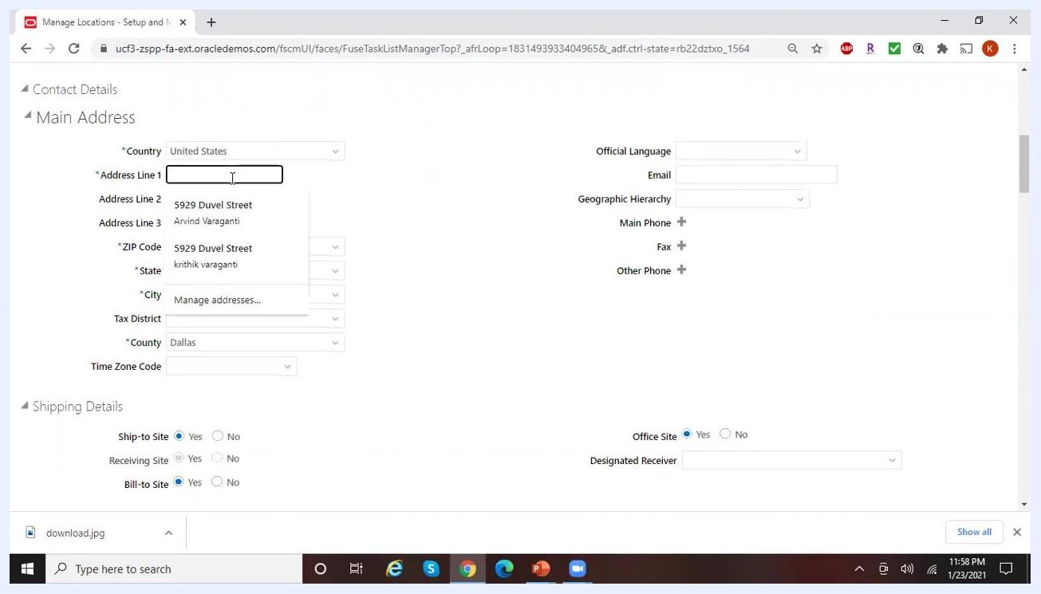
Address Line 1 field being edited, showing autocomplete suggestions for previously entered addresses.

Step 7: Review the shipping details
In the Shipping Details section, leave the default options as is unless your business requires changes:
- Ship-to Site: Yes
- Receiving Site: Yes
- Bill-to Site: Yes
- Office Site: Yes
Leave Designated Receiver blank unless specified.

Step 8: Save the location
Click Save. If you see an error stating "Enter a unique location code (PER-1530467)," the code you entered is already in use.
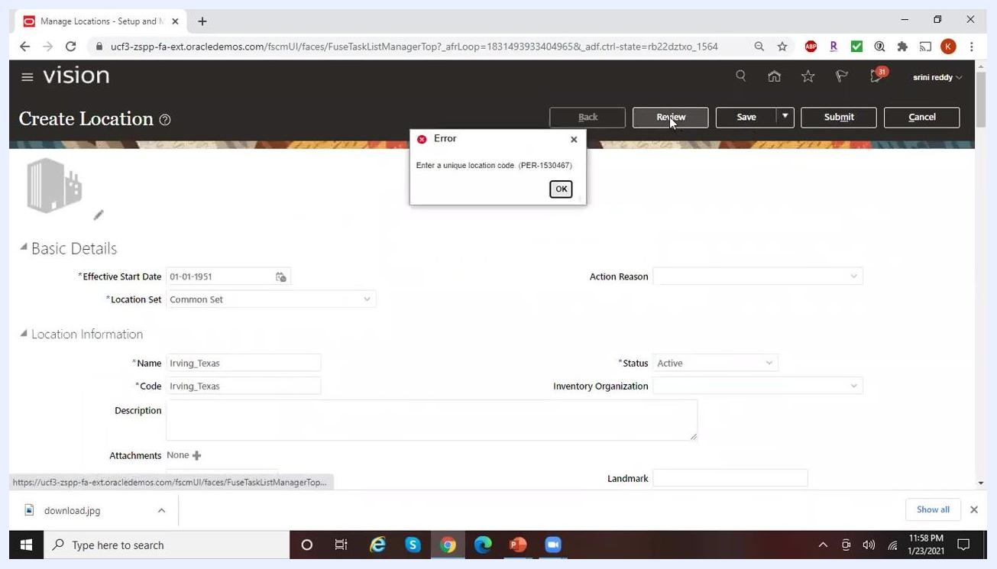
Error dialog reading "Enter a unique location code (PER-1530467)" after attempting to save with a duplicate code.

Step 9: Correct the code and resave
Change the Name to Irving1_Texas and ensure the Code is also unique (for example, Irving1_Texas). Click Save again.
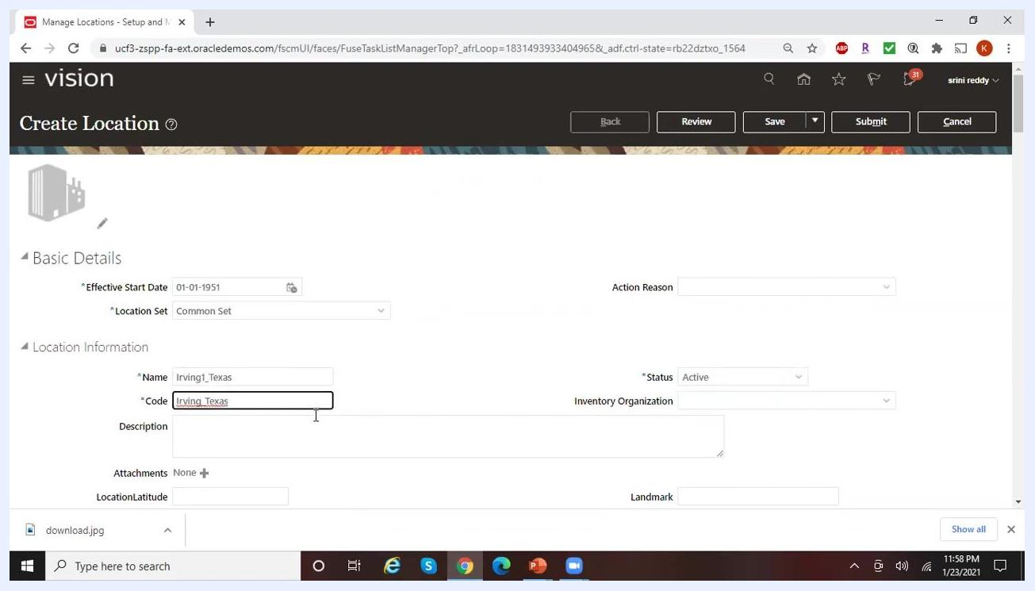
Location form with the Name field updated to "Irving1_Texas" and the Code field being corrected before saving.

Step 10: Review and submit the location
Click Review to check your entered details on the Create Location: Review screen. Verify the Name, Code, Status (Active), Location Set (Common Set), and other fields. Click Submit to finalize the creation of the location — a background job runs to process the new entry.
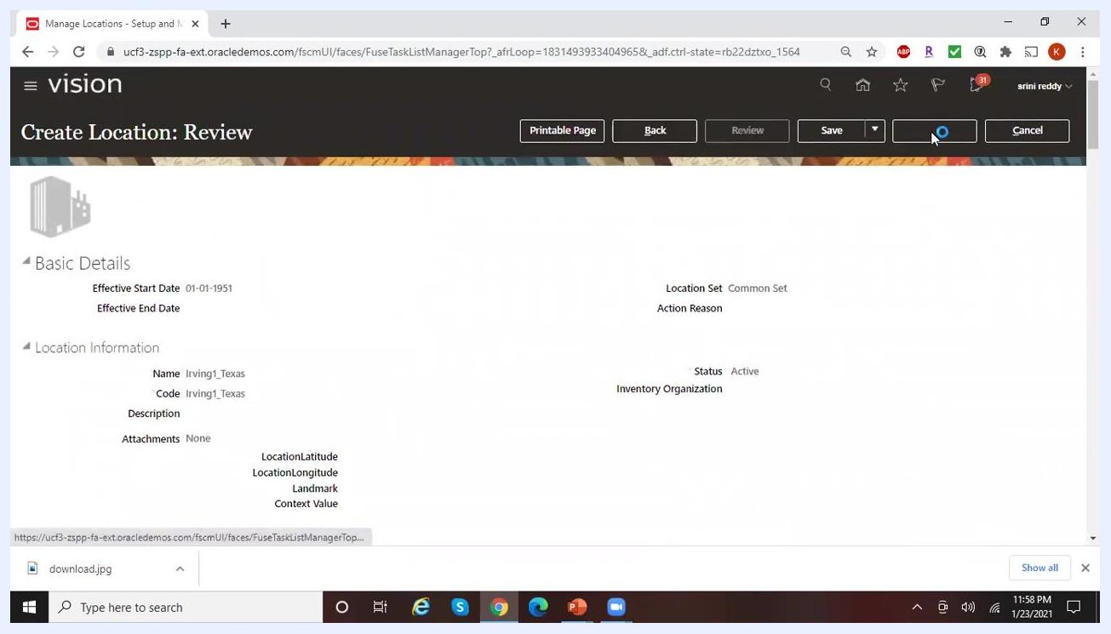
Create Location: Review screen showing all entered details, with the Submit button being selected.

Step 11: Exit the location setup
Click Done to exit the location creation process and return to the Manage Locations screen.

Part 2: Create the business unit

Step 12: Search for the Manage Business Unit task
In Setup and Maintenance, type Manage% in the search bar to display all tasks starting with "Manage." Select Manage Business Unit from the list to proceed.
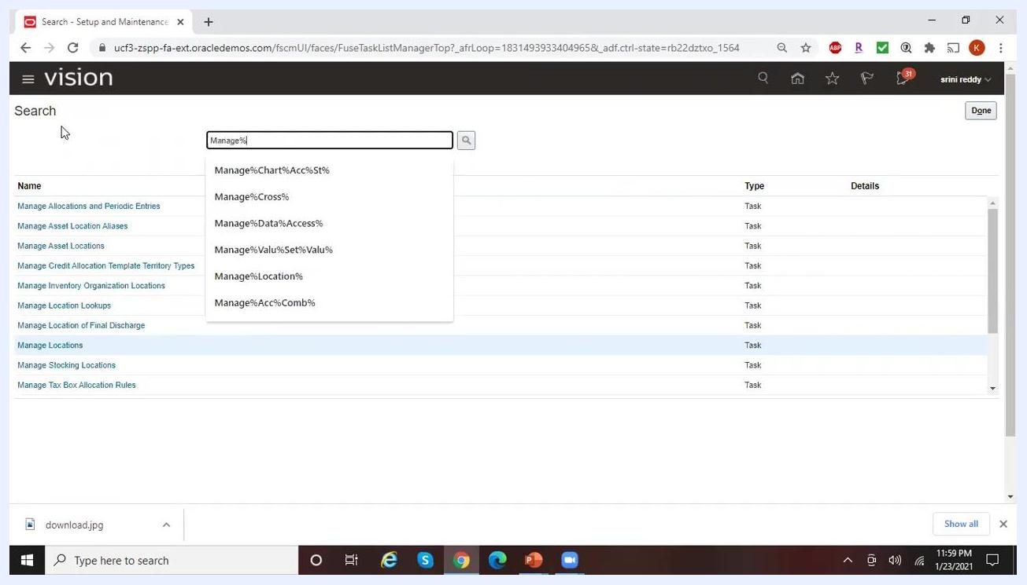
Setup and Maintenance search screen with "Manage%" entered in the search bar and a list of matching tasks displayed.

Step 13: Start a new business unit
Click the plus (+) button to open the Create Business Unit form.

Step 14: Enter the business unit name and manager
In the Create Business Unit form, enter Reliance Telecomm in the Name field. The Manager field is optional — select a manager from the dropdown suggestions (for example, "Arvind Varaganti" or "krithik varaganti") or leave it blank. Ensure the Active checkbox is selected.
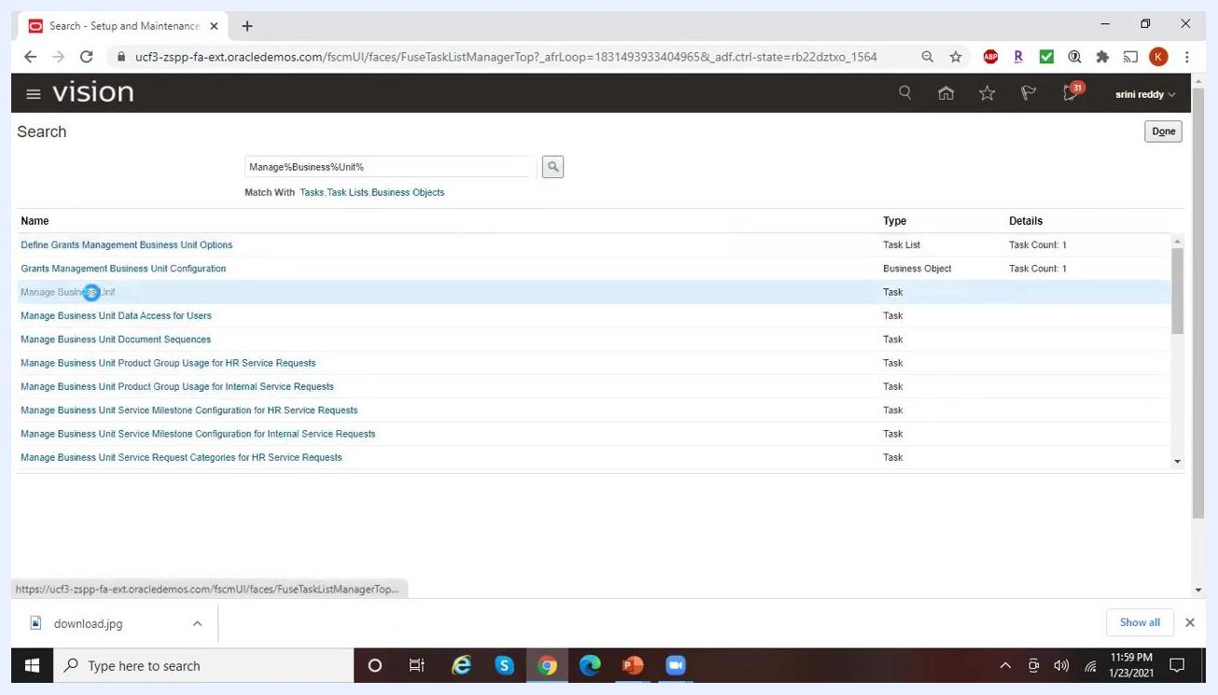
Create Business Unit form with the Name field being filled in and Manager dropdown suggestions visible.

Step 15: Assign a location to the business unit
Click the Location dropdown. If the location is not immediately visible, click Search at the bottom of the dropdown. In the Search and Select: Location dialog, enter the location name you created earlier (for example, Irving1_Texas) in the Name field, set Status to Active, and click Search. Select the correct location from the results and click OK. Confirm the Location field now displays Irving1_Texas.
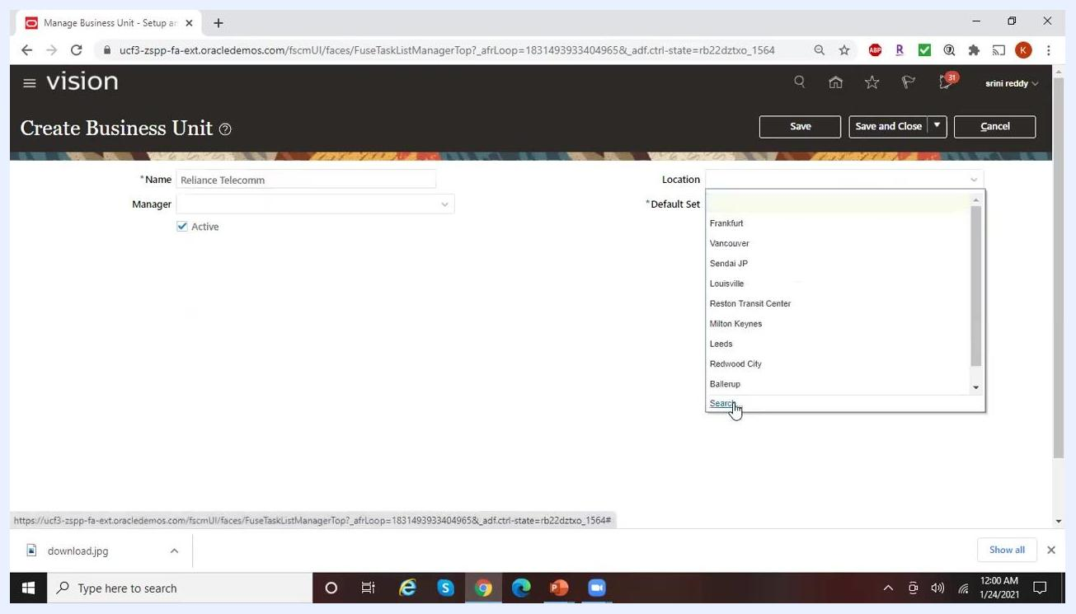
Search and Select: Location dialog with "Irving1_Texas" entered in the Name field.

Step 16: Choose a Default Set
Click the dropdown for the Default Set field. A list of available reference data sets appears, including options such as:
- 04SALES (04 Sales)
- ACL RDS (ACL RDS)
- ANUSRDS (ANUSRDS)
- DZBUSET (Algeria Business Unit Set)
- ARBUSET (Argentina Business Unit Set)
At the bottom of the dropdown, you can select Search to find more sets or Create to define a new one.
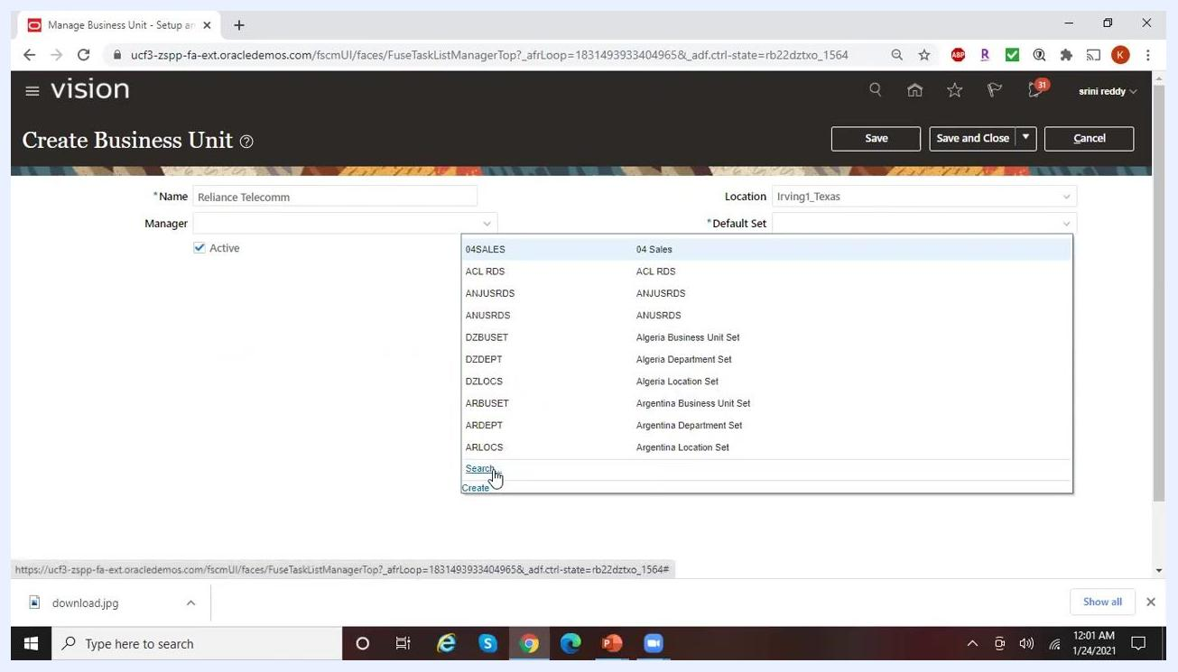
Dropdown list of available Default Sets, including 04SALES, ACL RDS, DZBUSET, and ARBUSET, with options to Search or Create.
To find a specific set, click Search, then in the Search and Select: Default Set dialog enter a Reference Data Set Code such as Common% and click Search. Select the desired set (for example, Reference Data Set Code: COMMON, Reference Data Set Name: Common Set) and click OK. The Default Set field now displays COMMON.

Step 17: Understand the role of the Default Set
The Default Set determines which reference data — such as payment terms and locations — is available to this business unit. If a specific configuration (for example, a 30-day payment term) is not included in the assigned Default Set, it will not be available for use in this business unit. The same Default Set can be assigned to multiple business units, allowing shared reference data across them.
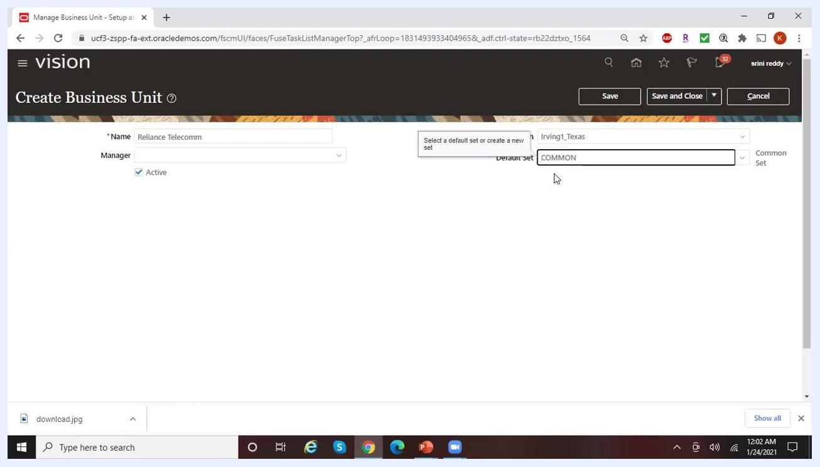
Create Business Unit screen showing COMMON selected as the Default Set, illustrating shared use across multiple business units.

Step 18: Review your entries
Before saving, confirm all required fields are filled in:
- Name: Reliance Telecomm
- Location: Irving1_Texas
- Default Set: COMMON
- Active: Checked
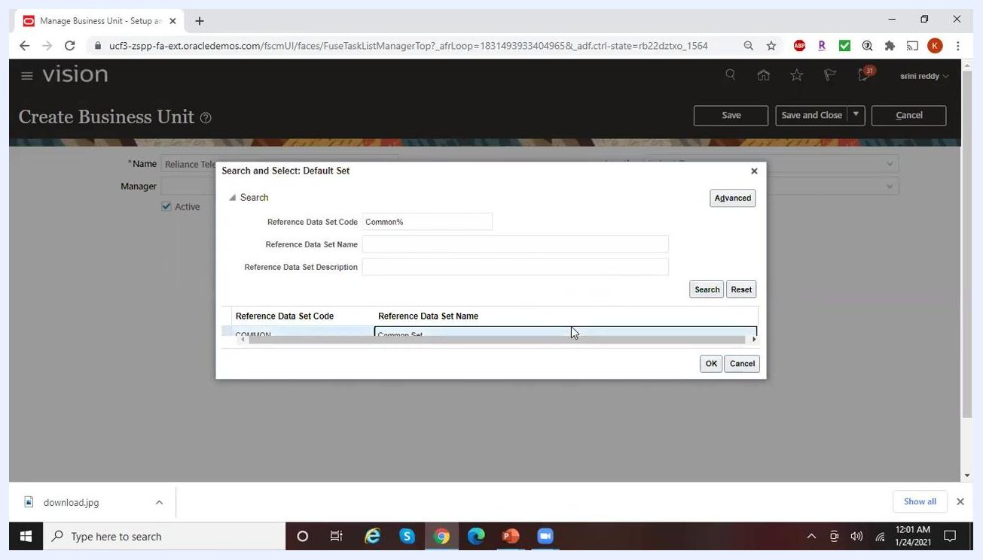
Create Business Unit screen with all fields completed, Default Set set to COMMON, ready for saving.

Step 19: Resolve a duplicate name error
When you attempt to save, if the business unit name is already in use, an error dialog appears: "An object of type Business Unit with the name Reliance Telecomm already exists. Enter a unique name." Click OK to close the dialog.
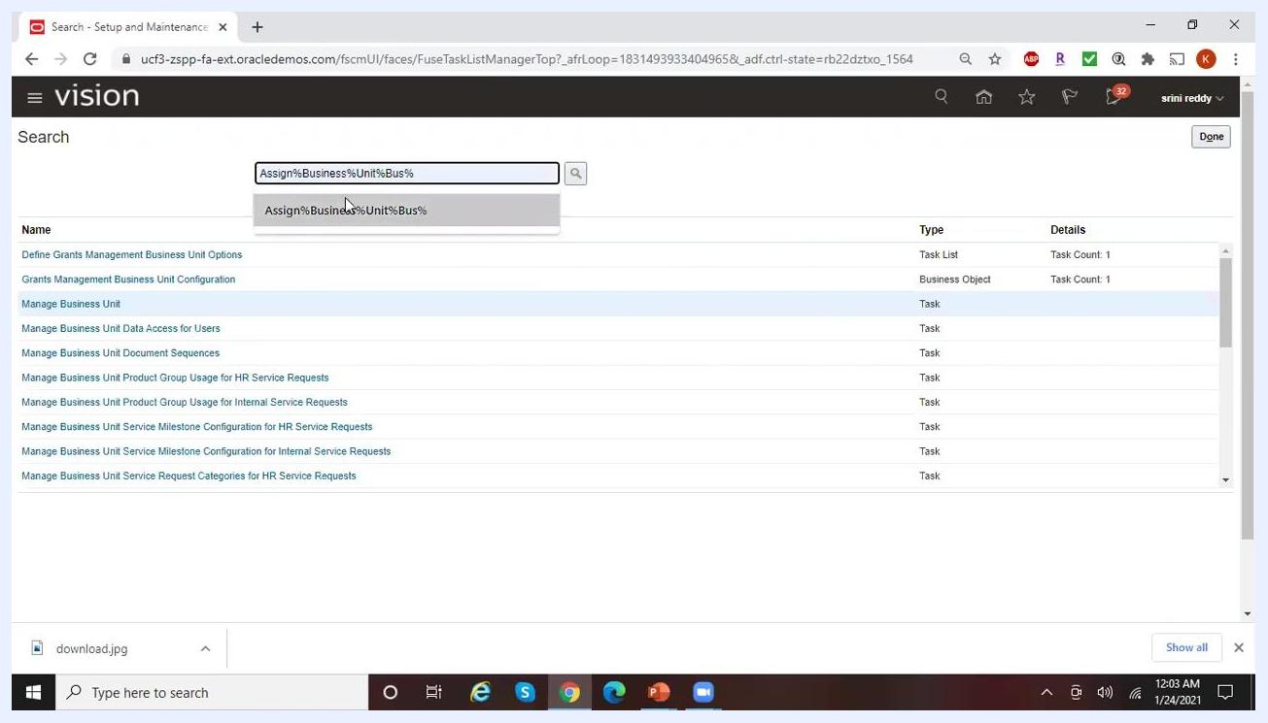
Error dialog stating that a Business Unit named "Reliance Telecomm" already exists and a unique name is required.
Update the Name field to a unique value, such as Reliance Telecomm 1, and confirm that Location (Irving1_Texas), Default Set (COMMON), and Active remain correctly set.

Step 20: Save the business unit
Click Save to keep the form open for further edits, or Save and Close to save your changes and return to the previous screen.

 | Note: Certain reference data sets, such as the Default Set, are not specific to an Operating Unit and may be shared across multiple business units.

Part 3: Assign business unit business functions
Business functions must be assigned through an implementation project rather than through global search, since direct access to this task can result in scope or ID errors.

Step 21: Open your implementation project
Navigate to the Manage Implementation Projects screen. In the Search Results section, find and select your implementation project (for example, "Arvind_Fusion_Implementation"). The project list shows columns for Name, Status, Assigned To, Start Date, Finish Date, Last Updated, and Last Updated By. Click on your project to open it.
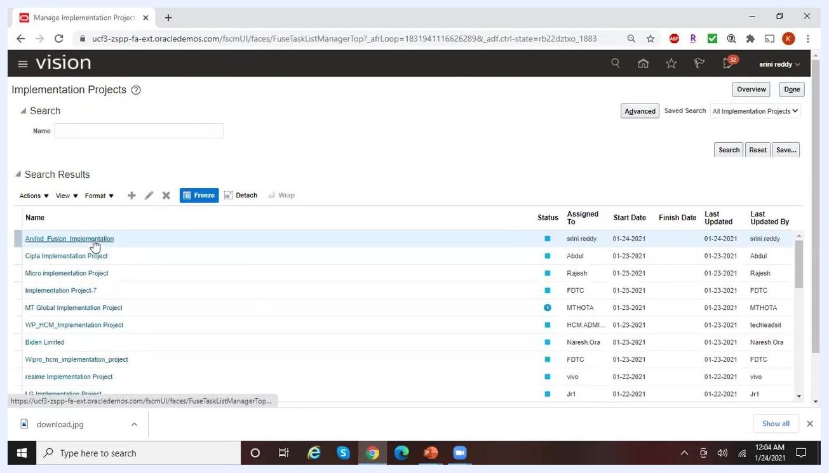
Implementation Projects screen with "Arvind_Fusion_Implementation" selected, showing project details.

Step 22: Wait for the project to load
After clicking your project, wait for the project details to load. The system may display a loading indicator while it processes your selection.
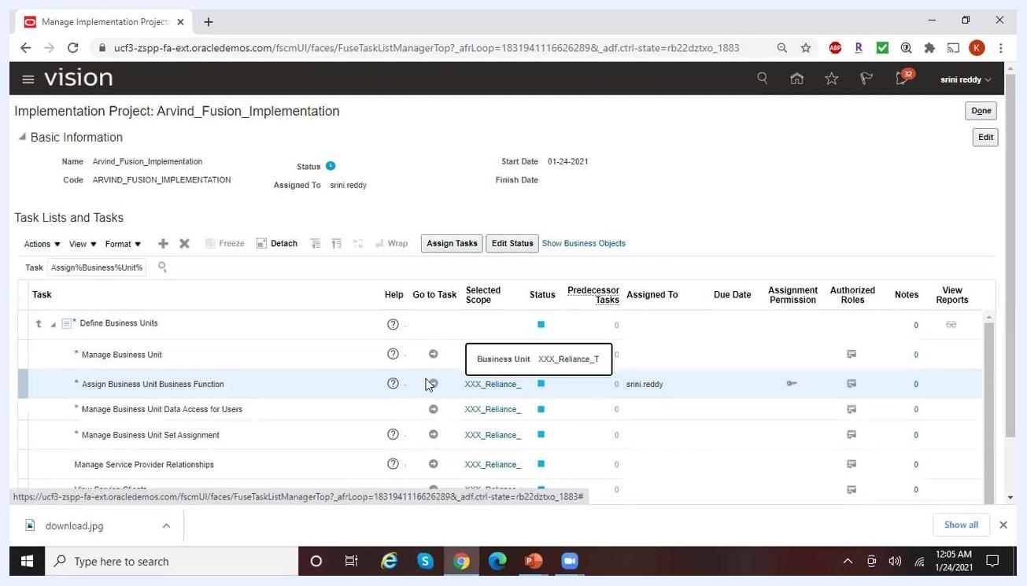
Implementation Projects screen displaying a loading indicator after selecting a project.

Step 23: Search for the task
Within the opened project, locate the Task Lists and Tasks section. In the task search field, enter Assign%Business%Unit%Bus% and click the search icon to filter the tasks. The filtered list displays matching tasks, such as "Assign Business Unit Business Function."
Implementation Project details with the task search field filled with "Assign%Business%Unit%Bus%" and filtered results shown.

Step 24: Select the task
In the filtered task list, select Assign Business Unit Business Function. The Selected Scope column may display a business unit code (for example, "XXX_Reliance_"). Click the scope link or icon to specify or change the business unit.
Assign Business Unit Business Function task selected, with the Selected Scope column showing a business unit code.

Step 25: Set the task scope
In the Select Scope dialog, confirm Assign Business Unit Business Function is selected. In the Business Unit dropdown, choose the appropriate business unit (for example, "XXX_Reliance_T"). Click Apply and Go to Task to proceed.
Select Scope dialog with "Assign Business Unit Business Function" and business unit "XXX_Reliance_T" selected.

Step 26: Search for and confirm the business unit
If the Manage Business Units window appears, use the search fields to locate your business unit — enter the name (for example, Reliance%Tele%1) and optionally the location (for example, Irving1_Texas). Click Search and confirm that the correct business unit, such as "Reliance Telecomm1," appears with the right location and active status.
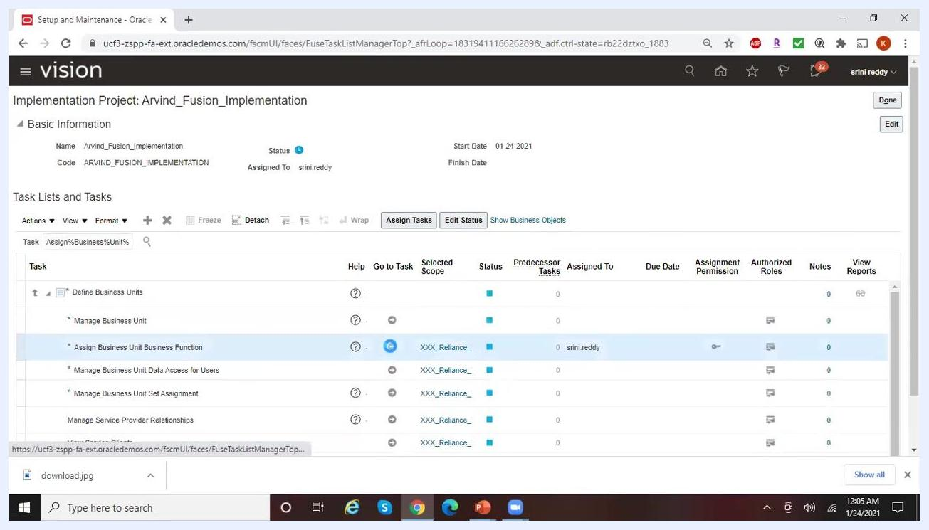
Manage Business Units dialog showing a search for "Reliance%Tele%1" with the result "Reliance Telecomm1" and location "Irving1_Texas."

Step 27: Verify the scope selection
If the business unit shown is not the one you intend to use, return to the previous screen and repeat the search or selection process. Confirm that the Selected Scope in the task list matches your intended business unit before proceeding.
Implementation Project task list with "Assign Business Unit Business Function" and the selected scope "XXX_Reliance_" highlighted.

Step 28: Open the Assign Business Functions screen
After selecting your business unit, the screen title changes to "Assign Business Functions: Reliance Telecomm1." You see a list of available business unit functions on the left and financial reporting options on the right. Available functions include Billing and Revenue Management, Collections Management, Customer Contract Management, Customer Payments, Expense Management, Incentive Compensation, Lease Accounting, Materials Management, Payables Invoicing, Payables Payment, and Procurement.
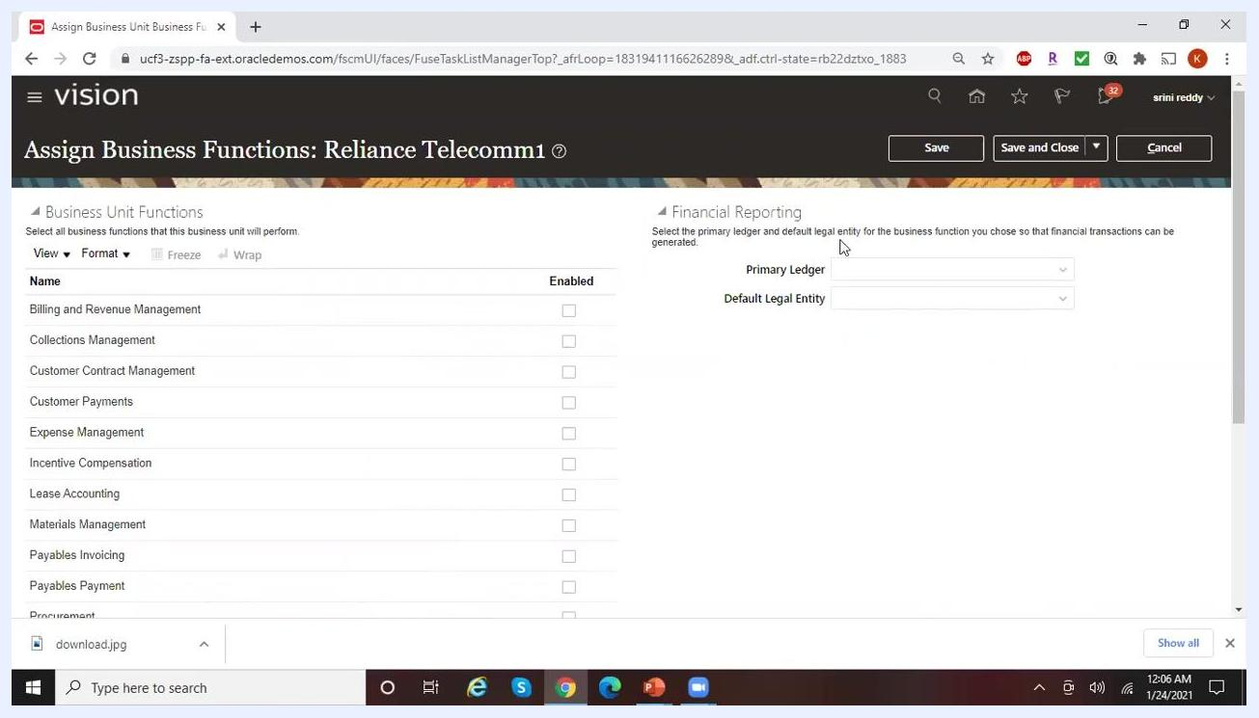
Assign Business Functions screen for Reliance Telecomm1, showing a list of business unit functions and financial reporting fields.

Step 29: Review financial reporting requirements
Under Financial Reporting on the right, note that you must select a Primary Ledger and Default Legal Entity for the business unit. These fields are mandatory, marked with an asterisk (*), and must be filled before saving. The system prompts: "Select the primary ledger and default legal entity for the business function you chose so that financial transactions can be generated."
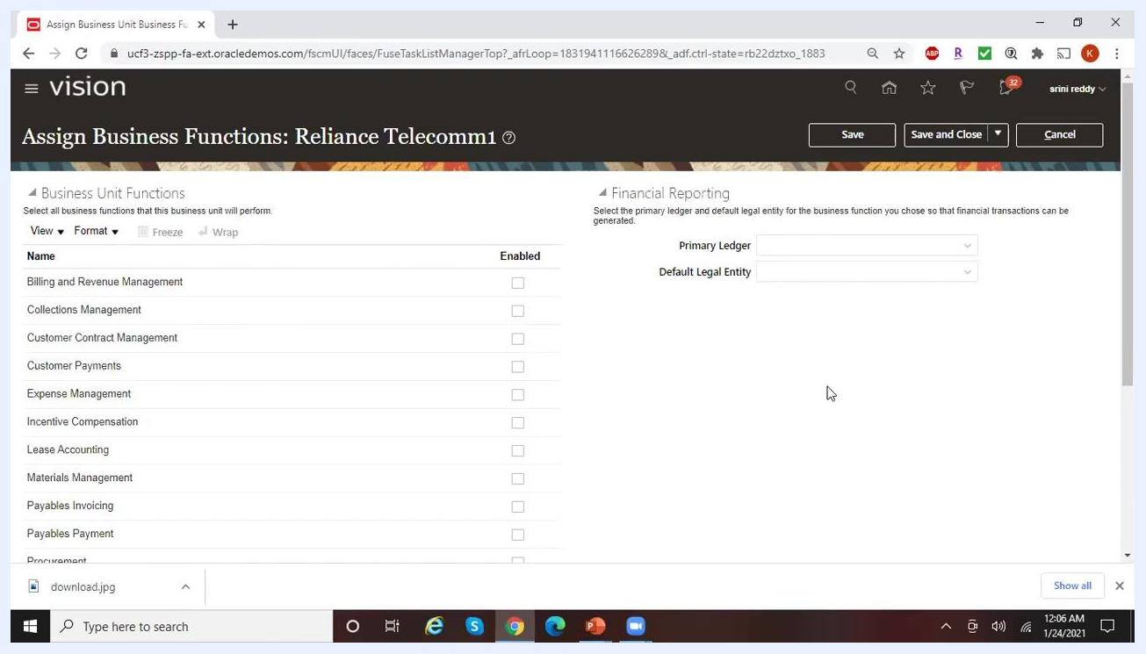
Assign Business Functions screen showing empty required fields for Primary Ledger and Default Legal Entity.

Step 30: Enable the required business functions
Check the corresponding boxes in the Enabled column for the functions you want this business unit to support. For example, to use Reliance Telecomm1 only for Accounts Payable, check Payables Invoicing and Payables Payment, and leave other functions unchecked. As you check these boxes, the required financial reporting fields remain highlighted until filled in.
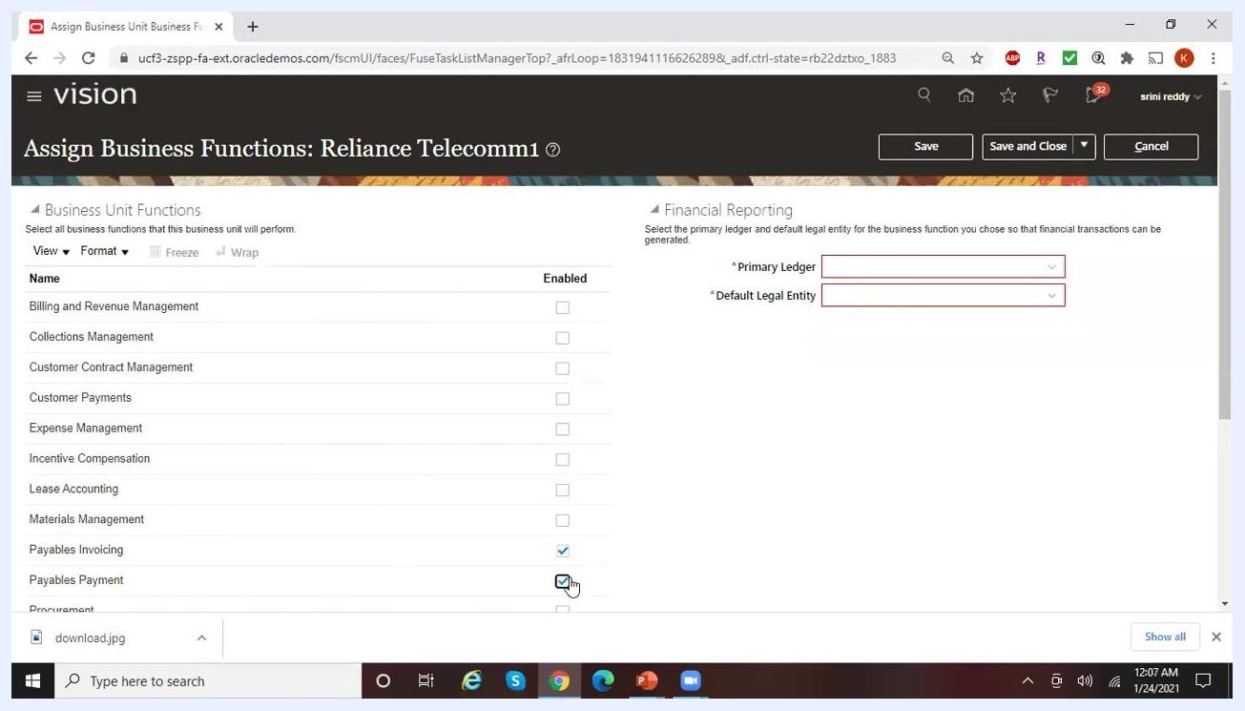
Payables Invoicing and Payables Payment functions checked, with the required Primary Ledger and Default Legal Entity fields highlighted in red.

Step 31: Select the Primary Ledger
In the Financial Reporting section, click the dropdown for Primary Ledger. A list of available ledgers appears, including options such as "14Ledger US," "19Ledger US," "ACE US Ledger," "AH Ledger US," and "Reliance Ledger US." Select Reliance Ledger US as the primary ledger for this business unit.
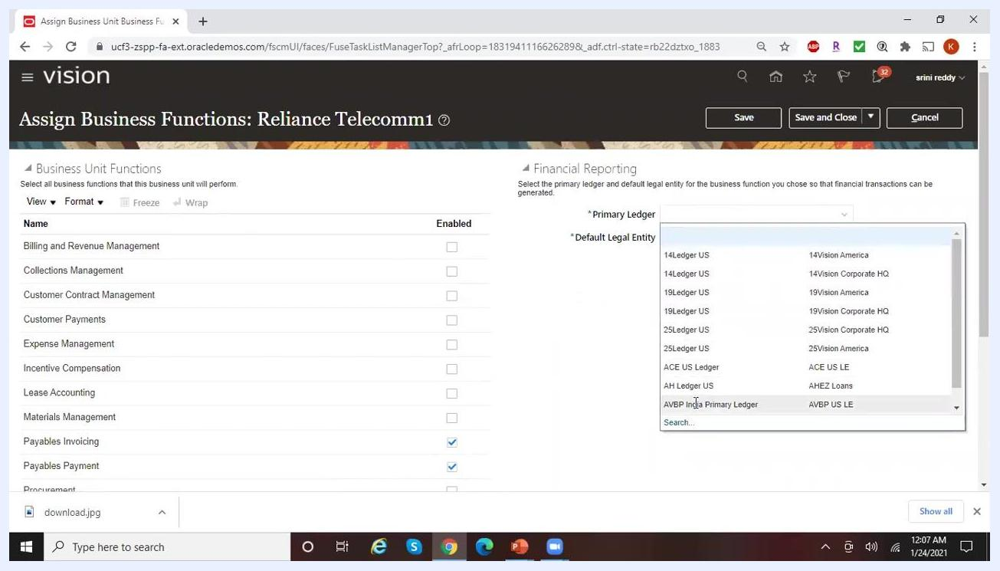
Primary Ledger dropdown open, showing multiple ledger options including Reliance Ledger US, with Payables Invoicing and Payables Payment enabled.

Step 32: Confirm the Default Legal Entity
After selecting the primary ledger, the Default Legal Entity field auto-populates, or you can select the appropriate entity. For Reliance Telecomm1, ensure the default legal entity is set to Reliance Telecomm. Both required fields should now be filled, and the enabled business functions remain checked.
Primary Ledger set to Reliance Ledger US and Default Legal Entity set to Reliance Telecomm, with the Save and Save and Close buttons visible.

Step 33: Save the configuration
Click Save and Close at the top right of the screen to save your business unit function assignments and financial reporting configuration. This finalizes the setup for Reliance Telecomm1.

What's next
With the business unit created and its business functions assigned, you can continue configuring additional settings, such as additional reference data sets, legal entity associations, or further financial reporting options, as required by your business processes.

