How to register a form in Oracle EBS
Registering a custom form in Oracle E-Business Suite involves several stages: transferring the form file to the application server, compiling it, and then registering the form, its function, menu, and responsibility within Oracle Applications. This guide walks you through how to register a form in Oracle EBS from start to finish, using a sample custom form (XXTEST2) as an example.

Prerequisites
Before you begin, make sure you have:
- SSH access to the application server (for example, via Xshell).
- FTP access to the server (for example, via Xftp) to transfer the form file.
- The custom form file (.fmb) ready on your local machine.
- Login credentials for Oracle Applications with the SYSADMIN user or equivalent access to Application Developer responsibilities.

Transfer the custom form to the application server

1. Connect to the application server
Open an SSH terminal emulator and connect to the application server (for example, 192.168.0.192). Navigate to the forms directory using the following commands:
- cd $AU_TOP — changes to the application top directory.
- cd forms — changes to the forms directory.
- cd US — changes to the US subdirectory.
The terminal prompt confirms you are in the correct directory.
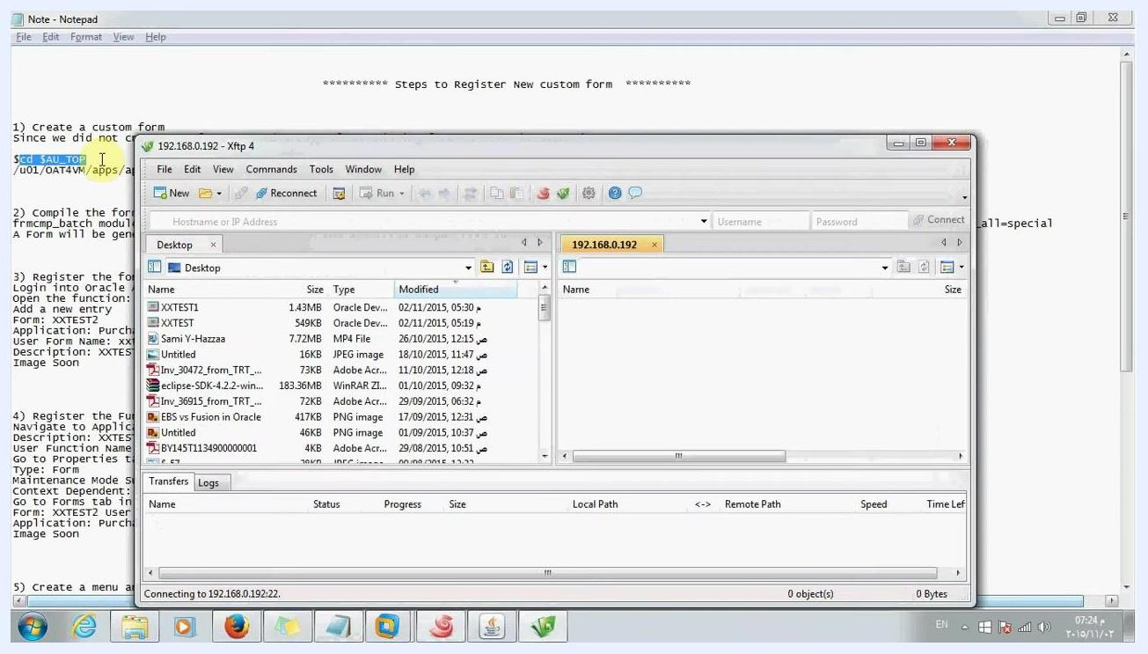
Terminal session connected to the application server, showing the navigation commands cd $AU_TOP, cd forms, and cd US, with a reference notepad visible in the background.

2. Select and transfer the custom form file
In your FTP client, select the custom form file in the local pane (for example, XXTEST2.fmb). Drag and drop it, or initiate a transfer, to the remote directory /u01/OAT4VM/apps/apps_st/appl/au/12.0.0/forms/US.
You can monitor the transfer progress at the bottom of the FTP window, which shows the file name, size, and both the local and remote paths.
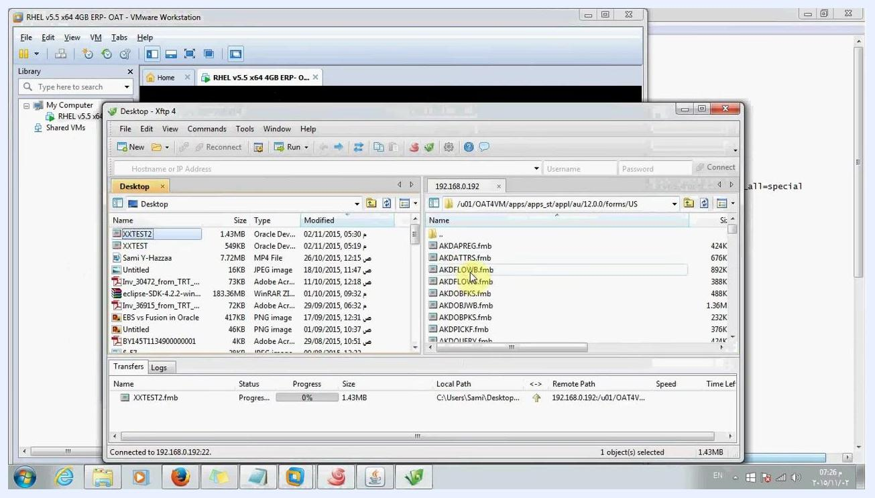
FTP client window with XXTEST2.fmb selected for transfer, showing the progress bar at 0% and both local and remote directory paths.

3. Confirm the file transferred successfully
In the FTP client, check the remote directory /u01/OAT4VM/apps/apps_st/appl/au/12.0.0/forms/US to confirm that the transferred form file (for example, XXTEST2.fmb) now appears alongside the other .fmb files on the server.
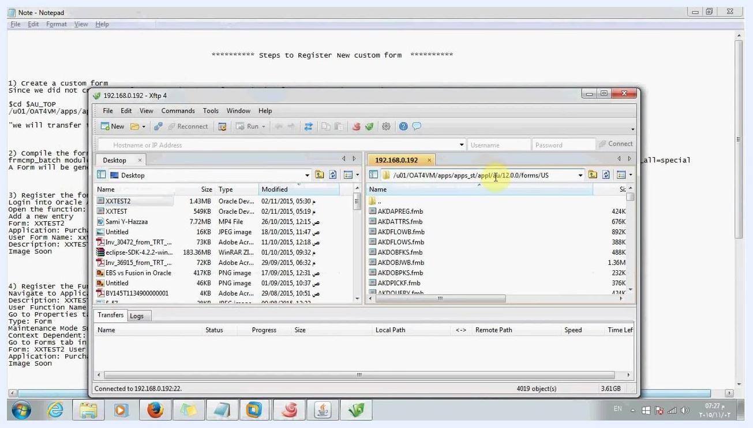
FTP client window showing the remote directory with the newly transferred XXTEST2.fmb file listed among other Oracle form files.

Compile the custom form

4. Review the compilation command
Before compiling, review the instructions for the frmcmp_batch utility, which compiles the form. The command used is:

frmcmp_batch module=XXtest2.fmb userid=apps/apps output_file=/u01/OAT4VM/apps/apps_st/appl/po/12.0.0/forms/US/XXTEST2.fmx module_type=form compile_all=special
This command generates the form at the specified output file location without errors.
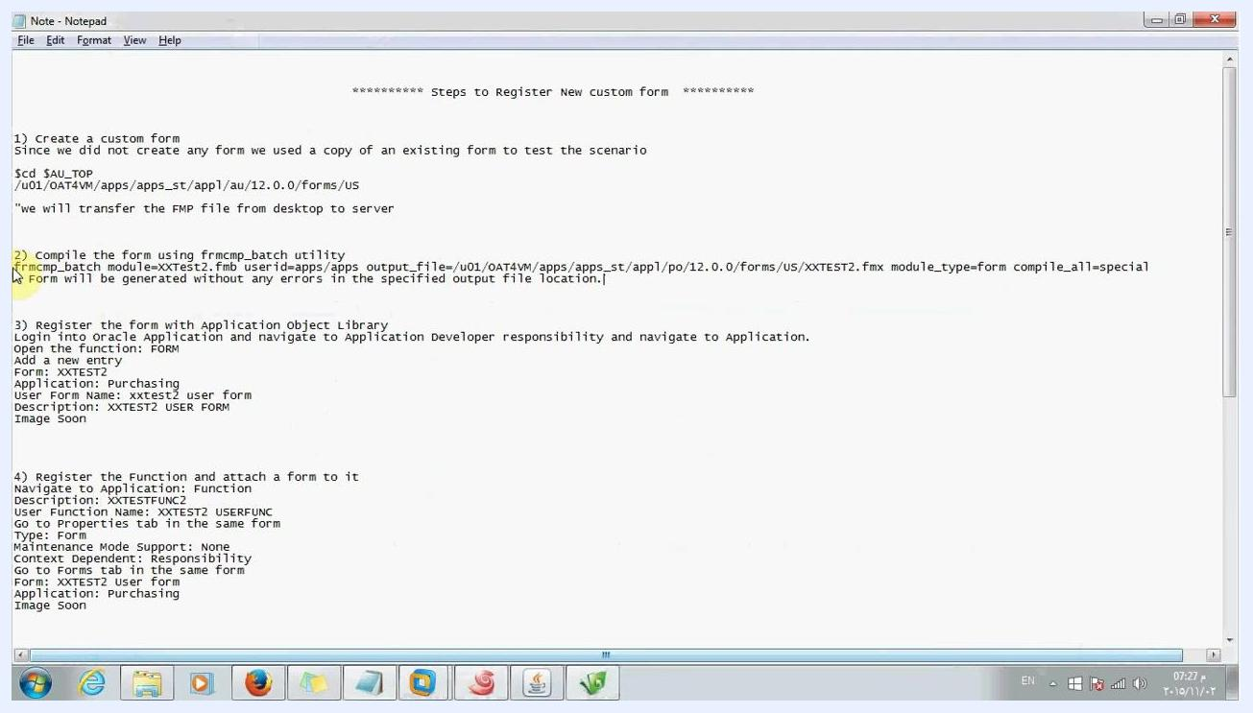
Reference notes listing the step-by-step instructions for compiling and registering a custom Oracle form, with the frmcmp_batch command highlighted.

5. Enter the compilation command in the terminal
In your SSH terminal, connected to the application server and navigated to the correct directory (cd $AU_TOP, then cd forms), type or paste the compilation command exactly as shown:

frmcmp_batch module=XXtest2.fmb userid=apps/apps output_file=/u01/OAT4VM/apps/apps_st/appl/po/12.0.0/forms/US/XXTEST2.fmx module_type=form compile_all=special
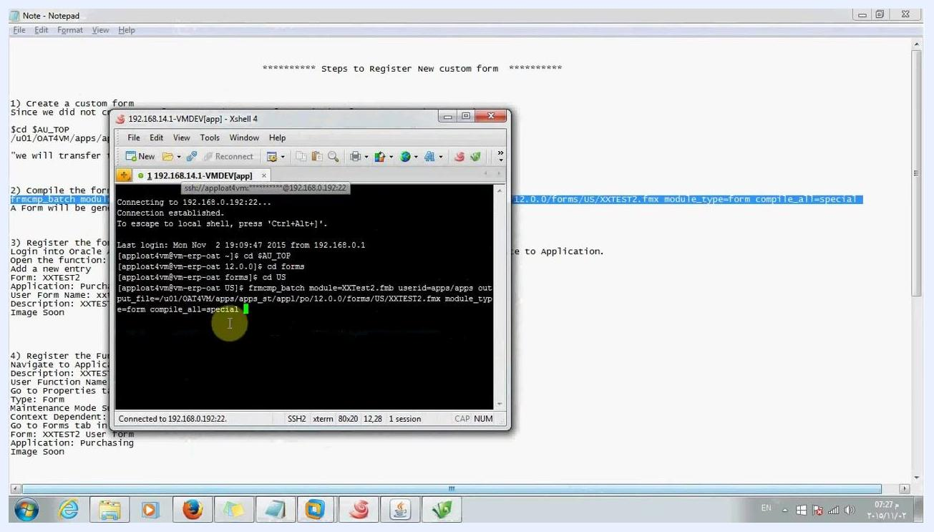
Terminal window with the frmcmp_batch command entered and ready to run, with reference notes visible in the background.

6. Run the compilation command
Press Enter to execute the frmcmp_batch command. The cursor moves to the next line as the command begins processing, and you can wait for the compilation to complete.
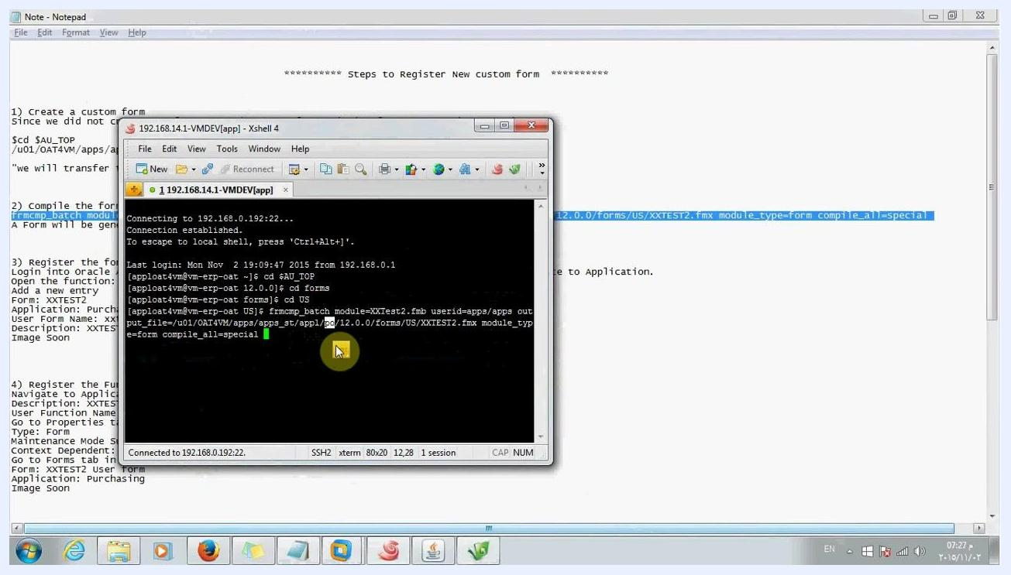
Terminal window showing the frmcmp_batch command running, with the cursor positioned on the next line.

7. Monitor the compilation progress
Watch the terminal output as the form compiles. You should see messages such as:
- "Compiling PRE-INSERT trigger on PROCUREMENT_PLAN_INFORMATIONS data block..."
- "No compilation errors."
Similar messages appear for each trigger and block, confirming the form is compiling without issues.
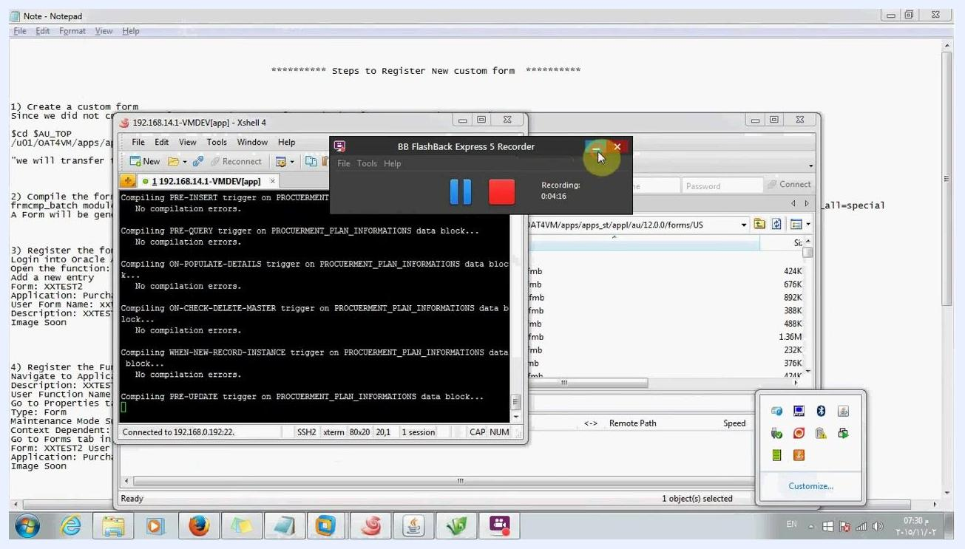
Terminal window displaying compilation progress messages, including "No compilation errors" for several triggers.

8. Confirm the compilation completed successfully
At the end of the process, the terminal displays a confirmation message:

Created form file /u01/OAT4VM/apps/apps_st/appl/po/12.0.0/forms/US/XXTEST2.fmx
The command prompt returns, confirming the .fmx file has been generated and the form is ready for registration.
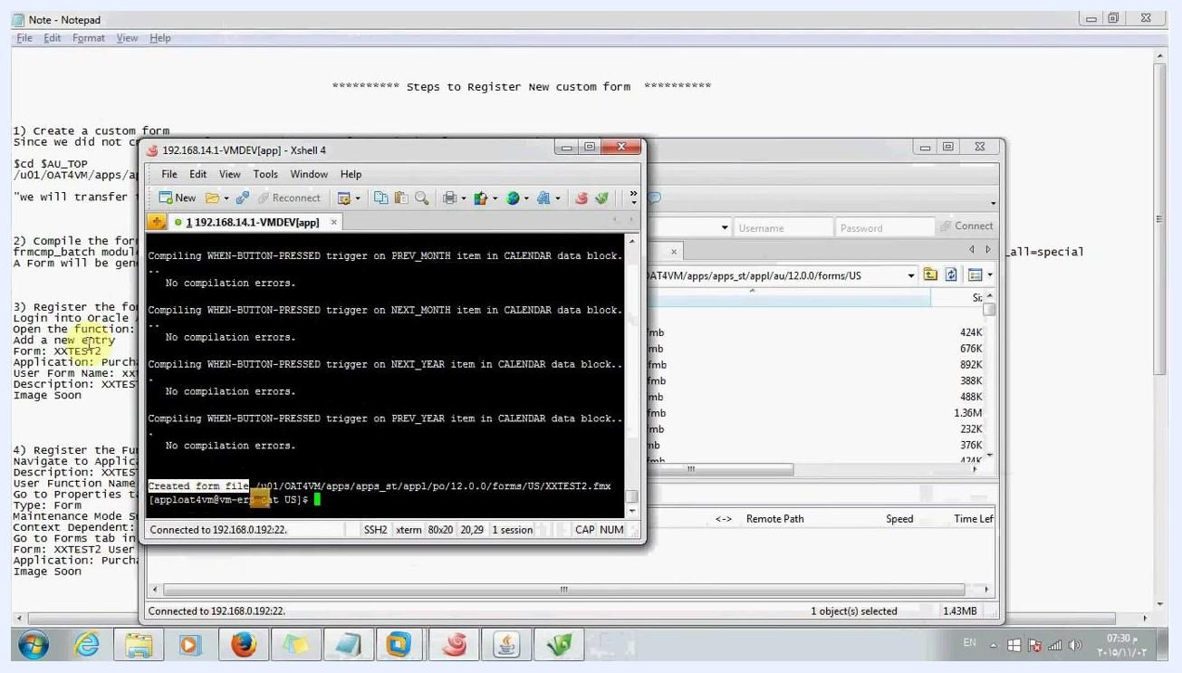
Terminal window showing the message "Created form file" confirming successful compilation of the custom form.

Register the form with Application Object Library

9. Log in and navigate to Application Developer
Open a web browser and go to the Oracle Applications login page. Log in as the SYSADMIN user. On the Oracle Applications Home Page, expand the Application Developer menu from the Main Menu to access the form registration functions.
Oracle Applications Home Page with the Main Menu expanded to show Application Developer, Form, and related options, with the Worklist panel visible on the right.

10. Open the Register option
Under Application Developer, locate and select the Register submenu to proceed with registering the form.

11. Register the form with Application Object Library
Navigate to the Application Developer responsibility, then go to the Application section and open the Form function. Add a new entry with the following details:
- Form: XXTEST2
- Application: Purchasing
- User Form Name: xxtest2 user form
- Description: XXTEST2 USER FORM
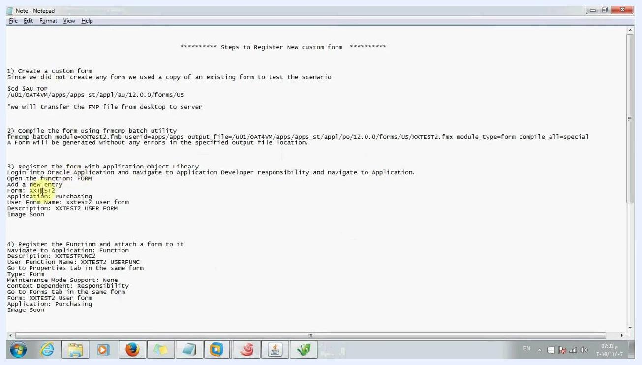
Forms registration screen in Oracle Applications showing the Form, Application, User Form Name, and Description fields filled in for XXTEST2.

12. Register the function and attach the form
Navigate to Application: Function and enter the following details:
- Description: XXTESTFUNC2
- User Function Name: XXTEST2 USERFUNC
On the Properties tab of the same form, set:
- Type: Form
- Maintenance Mode Support: None
- Context Dependent: Responsibility
On the Forms tab of the same form, enter:
- Form: XXTEST2 user form
- Application: Purchasing
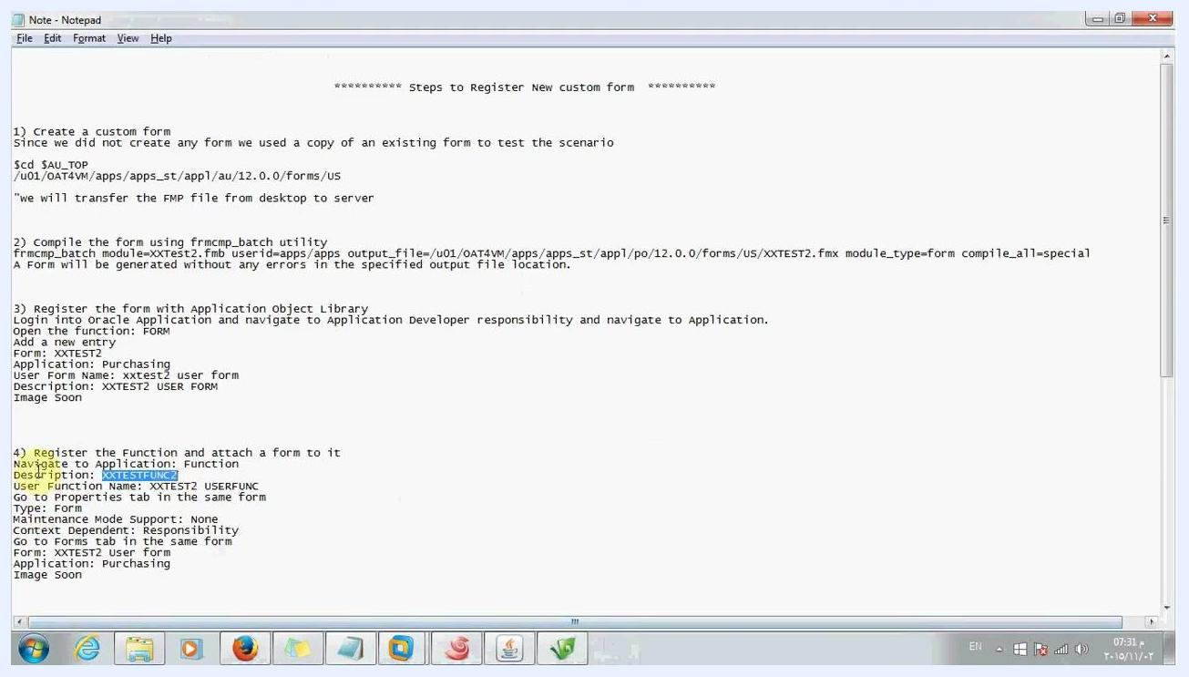
Form Functions registration screen in Oracle Applications showing the Function, User Function Name, and Description fields completed for XXTEST2.

Create a menu and add the function

13. Create a new menu
Navigate to the Application section and select Menu. Create a new menu with the following details:
- Menu: Custom Menu2
- User Menu Name: User Custom Menu2
- Menu Type: Standard
Add a new entry to the menu:
- Seq: 1
- Prompt: user menu2
- Function: XXTEST2 USERFUNC
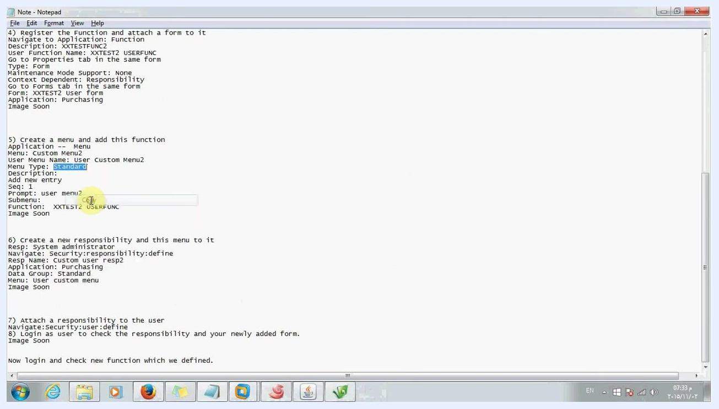
Reference notes listing the step to create a menu and add the function, with details for Menu, User Menu Name, Menu Type, Prompt, and Function.

Create a responsibility and assign the menu

14. Create a new responsibility
Navigate to the Responsibilities form in Oracle Applications and enter the following details:
- Responsibility Name: Custom user resp2
- Application: Purchasing
- Responsibility Key: CUSTOM USER RESP2
- Effective Dates: From 02-NOV-2015
- Data Group Name: Standard
- Menu: User Custom Menu
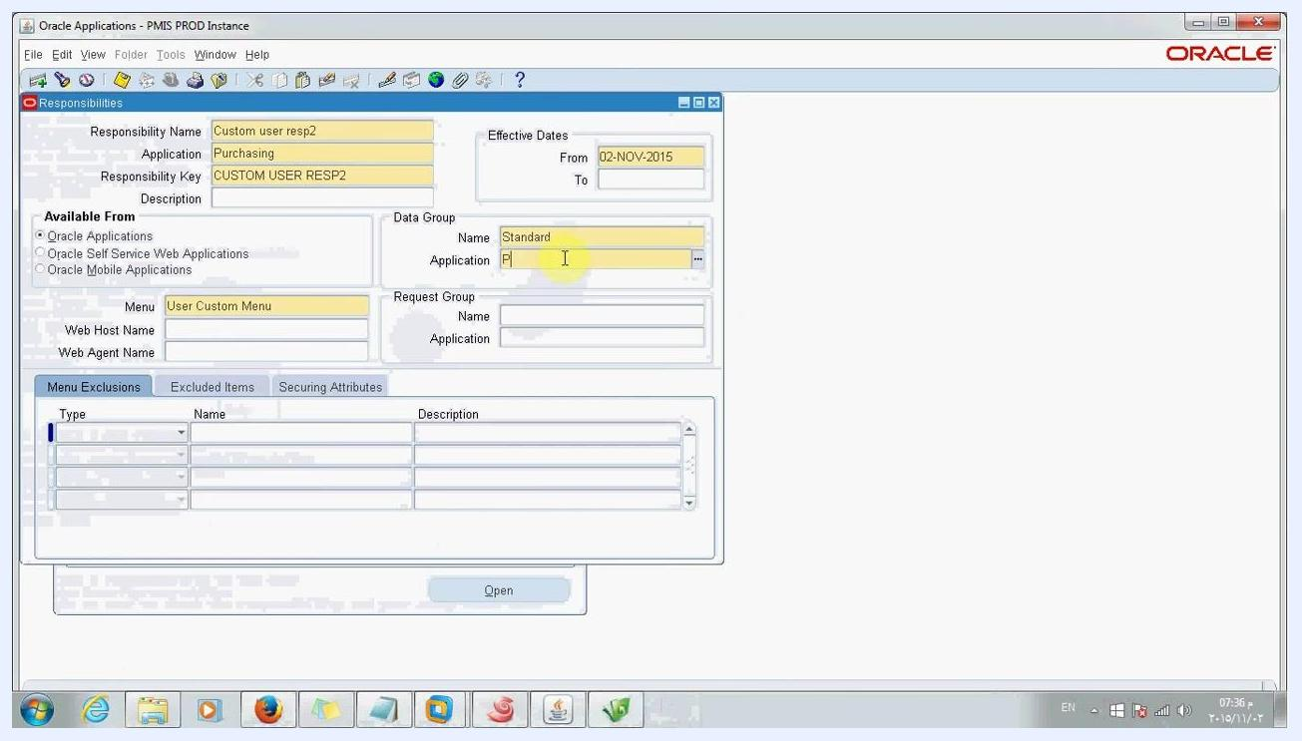
Responsibilities form in Oracle Applications with fields filled in for a new responsibility named Custom user resp2.

15. Select the Data Group Application
In the Data Group Application field, type "Pur" to filter the list of applications. In the pop-up window, select Purchasing, then click OK to confirm the selection.
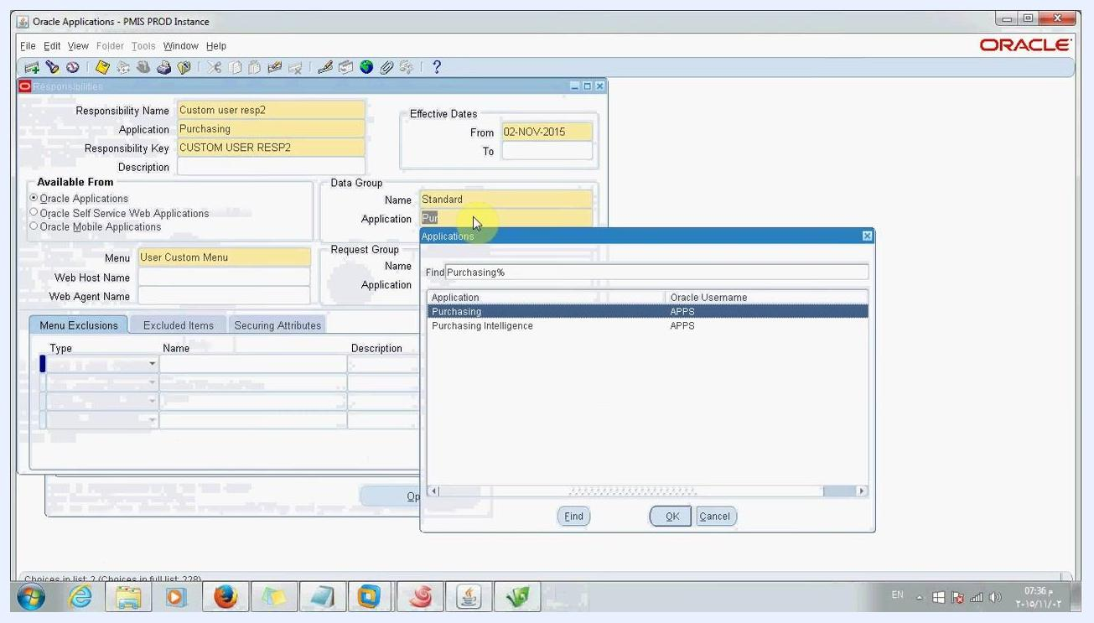
Pop-up window in Oracle Applications for selecting the Data Group Application, with Purchasing highlighted.

16. Save the new responsibility
Confirm that all fields are correctly filled in:
- Responsibility Name: Custom user resp2
- Application: Purchasing
- Data Group: Standard / Purchasing
- Menu: User Custom Menu
- Effective Dates: From 02-NOV-2015
Save the record to complete the responsibility setup.
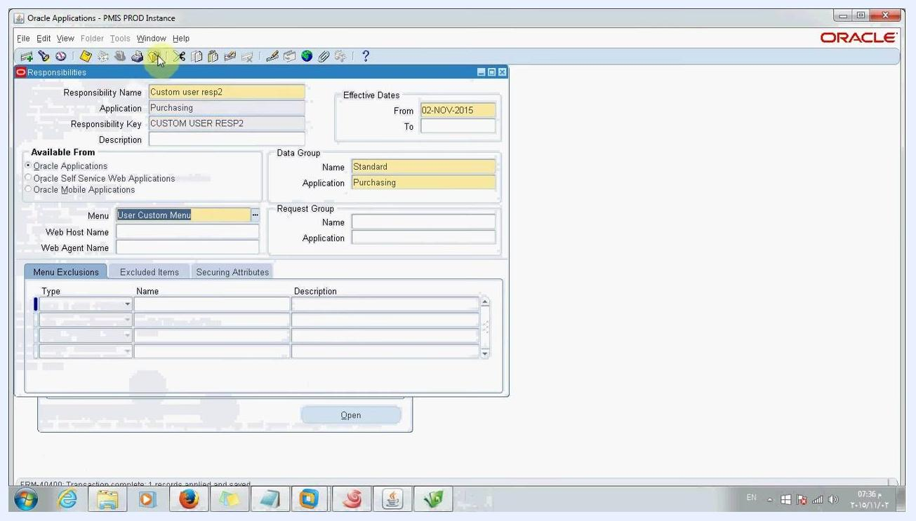
Responsibilities form in Oracle Applications with all fields completed and the record saved.

Attach the responsibility to a user

17. Open the Users form
Navigate to the Users form in Oracle Applications. In the User Name field, enter the username (for example, SYSADMIN). Confirm the user details are visible, then go to the Direct Responsibilities tab.
Users form in Oracle Applications, ready for assigning a responsibility to a user.

18. Add the custom responsibility to the user
In the Direct Responsibilities section, add a new row with the following details:
- Responsibility: Custom user resp2
- Application: Purchasing
- Security Group: Standard
- Effective Dates: From 02-NOV-2015
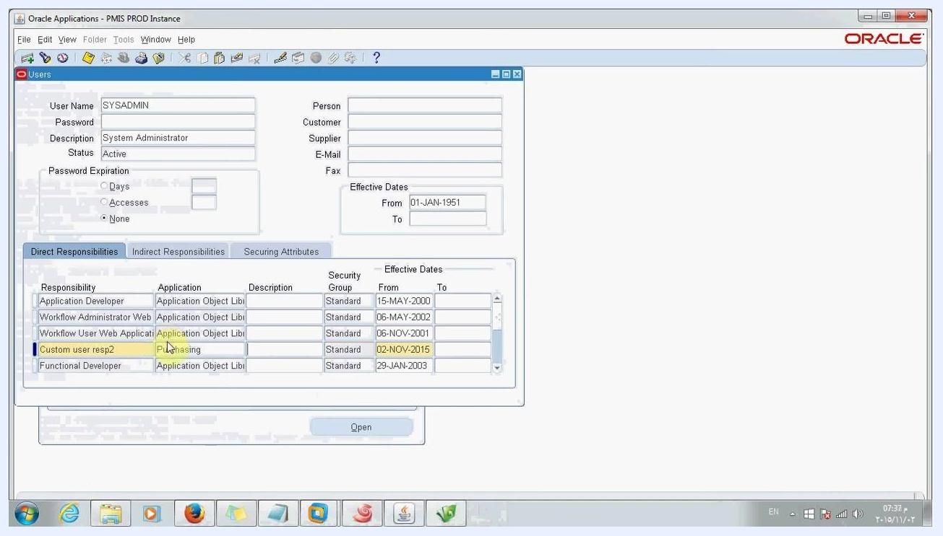
Users form in Oracle Applications with the Custom user resp2 responsibility assigned to SYSADMIN, effective from 02-NOV-2015.

19. Save the responsibility assignment
Confirm that Custom user resp2 now appears in the list of direct responsibilities for the user, then save the changes.
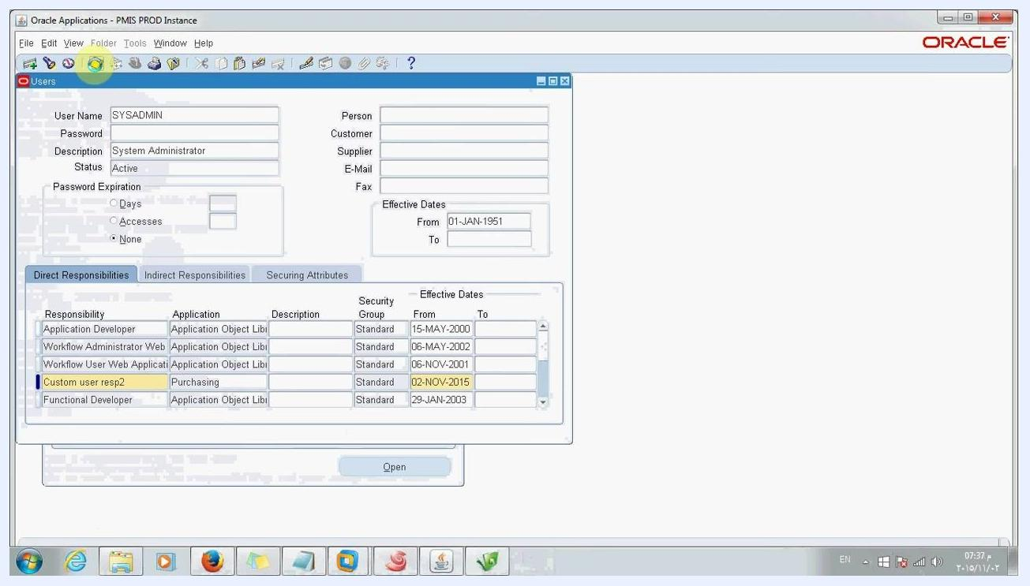
Users form in Oracle Applications showing Custom user resp2 assigned to SYSADMIN and highlighted in the responsibilities list.

Verify the registered form

20. Verify the responsibility and custom form
Log in as the user to whom you assigned the new responsibility. Check that the new responsibility (Custom user resp2) and the newly registered function (XXTEST2 USERFUNC) are available, and confirm that you can access the custom form through the menu.

Summary
You have now completed the full process of how to register a form in Oracle EBS: transferring the form file to the application server, compiling it with frmcmp_batch, registering the form and its function, creating a menu, assigning the menu to a new responsibility, and attaching that responsibility to a user. Logging in with the assigned responsibility confirms the custom form is accessible and ready for use.

