How to Set Up an Approval Workflow in Odoo
This guide shows you how to set up an approval workflow in Odoo using the Approvals app. You will learn how to review pending requests, approve or track them as a manager, monitor your own submissions, and audit the full history of approved and refused requests across your organization.

Prerequisites
- Access to the Odoo Approvals app.
- Approval categories already configured (for example, Business Trip, Contract Approval, Borrow Items, Car Rental Application, General Approval, or Job Referral Award).
- Manager-level access if you need to review and approve requests submitted by others.

Part 1: Reviewing approval categories and pending requests

Step 1: Access the Approvals dashboard
Open the Approvals app to view all the approval categories configured in your system. Each category displays a To Review indicator showing how many requests are currently pending (for example, "Business Trip" shows "To Review: 2" and "Contract Approval" shows "To Review: 1").
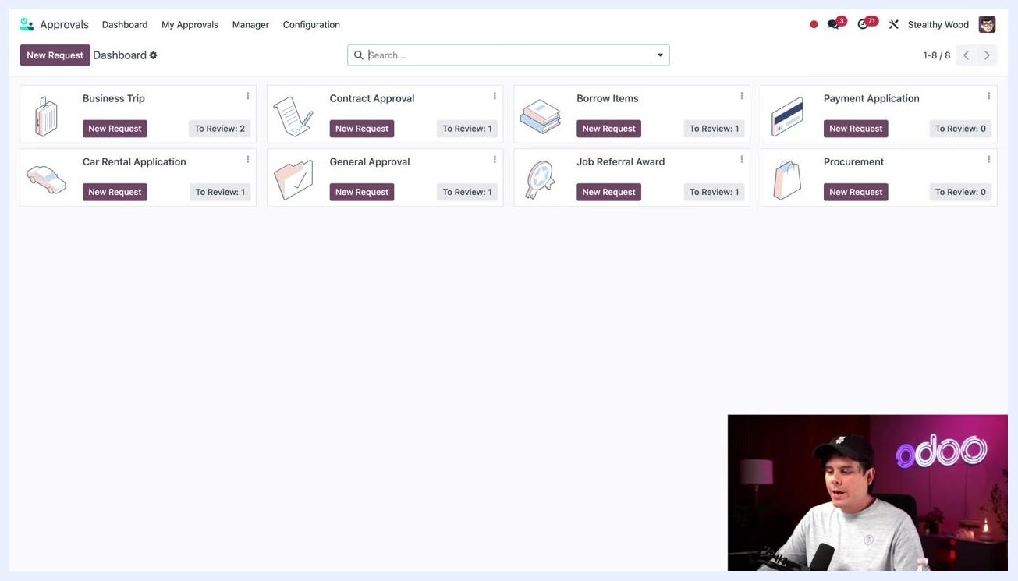
Odoo Approvals dashboard showing categories, new request buttons, and pending review counts

Step 2: Open the requests awaiting your action
Click To Review on a specific category, such as "Contract Approval," to see the list of requests waiting to be approved. Each row shows the Approval Subject, Request Owner, Category, Request Start, Request To, and Request Status. In this example, all listed requests are in "Submitted" status, including items such as Amazon Voucher, Borrow Screwdriver, Car Rental - Client Visits, London Furniture Show, New Marketing Partnership, Training Class - Accounting, and Use Lathe Station After Hours.
List of approval requests with details such as subject, owner, category, dates, and status

Step 3: Review a request's details
Click on a specific request, such as "New Marketing Partnership" submitted by Anita Oliver, to open its details. You will see the Approval Subject, Request Owner, Category, Contact, Amount (3,000.00), Reference (FurnitureReviewsPlus), Description, and Status ("Submitted").

Step 4: Check the required approvers
Click the Approver(s) tab to see who must approve the request. In this example, both Mitchell Admin and Carol Smith are required approvers, and both currently show the status "To Approve."
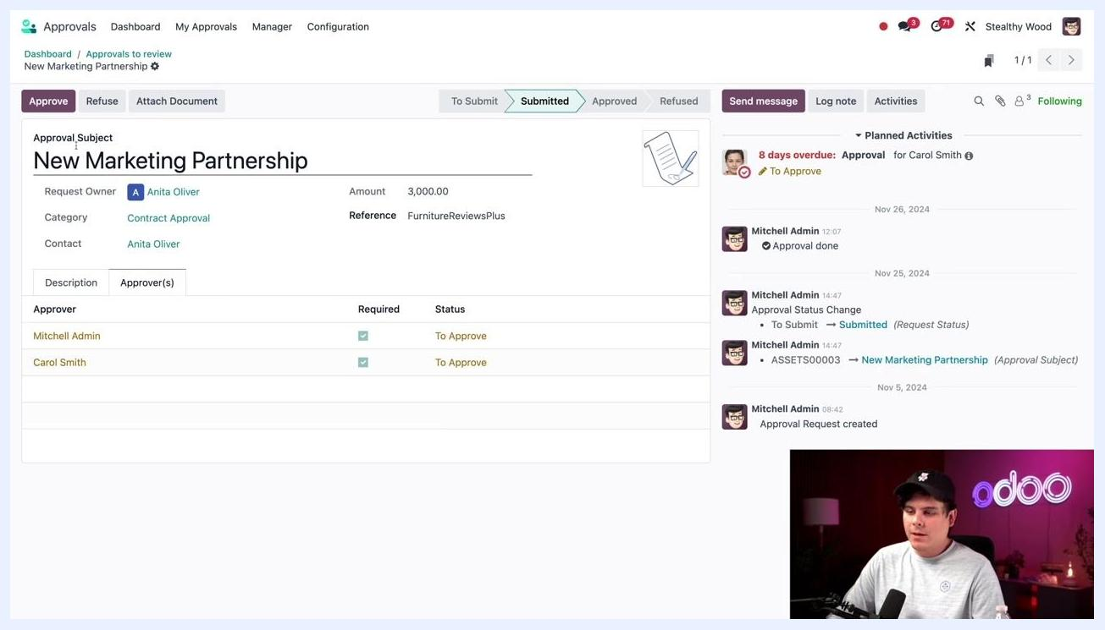
Approval request details with approvers tab showing required approvers and their statuses

Step 5: Approve the request
Click Approve in the top left corner to approve the request on your behalf. Your status changes to "Approved," while any other required approver, such as Carol Smith, remains listed as "To Approve" until they act.
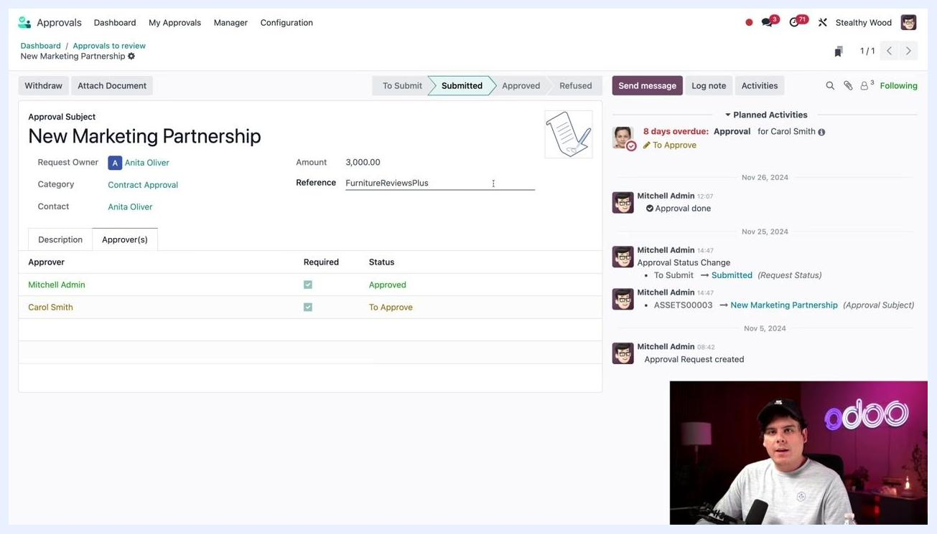
Approval request details after one approver has approved, showing updated status

Part 2: Tracking your own requests

Step 6: Open My Requests
To check the status of requests you submitted yourself, select My Approvals, then My Requests from the navigation menu.

Step 7: Review your requests in List view
By default, your requests appear in Kanban view. Click the List icon in the top right corner to switch to List view. Each request shows its status clearly, for example "Submitted" in orange or "Approved" in green. Sample entries include "Borrow Hand Cart" (Category: Borrow Items, Status: Submitted, 12/18/2024 06:00:00 to 14:00:00) and "Client Trip - Los Angeles" (Category: Car Rental Application, Status: Approved, 10/09/2024 12:00:00 to 10/13/2024 12:00:00).
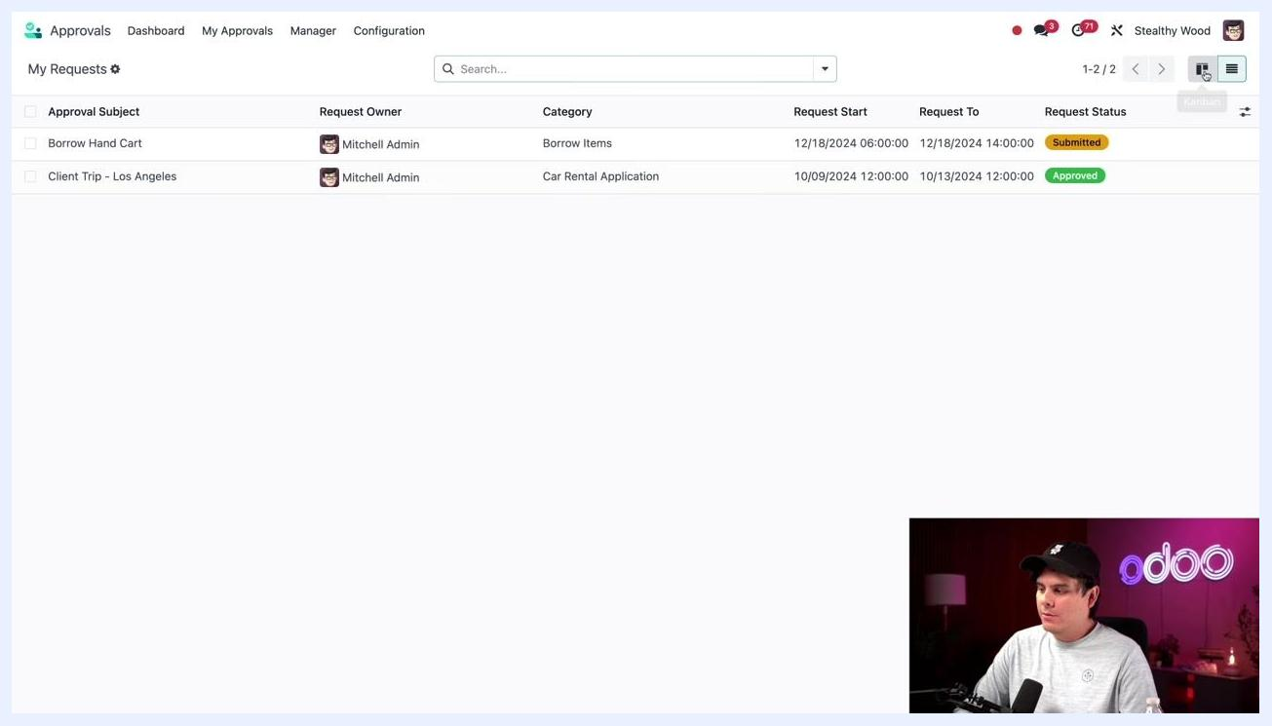
Odoo Approvals - My Requests in List view showing request subjects, owners, categories, dates, and statuses

Step 8: Review your requests in Kanban view
Switch back to Kanban view to see a visual summary grouped by status: To Submit, Submitted, Approved, Refused, and Canceled. For example, "Borrow Hand Cart" appears under Submitted, while "Client Trip - Los Angeles" appears under Approved. If no action is required on your part, simply wait for further updates.
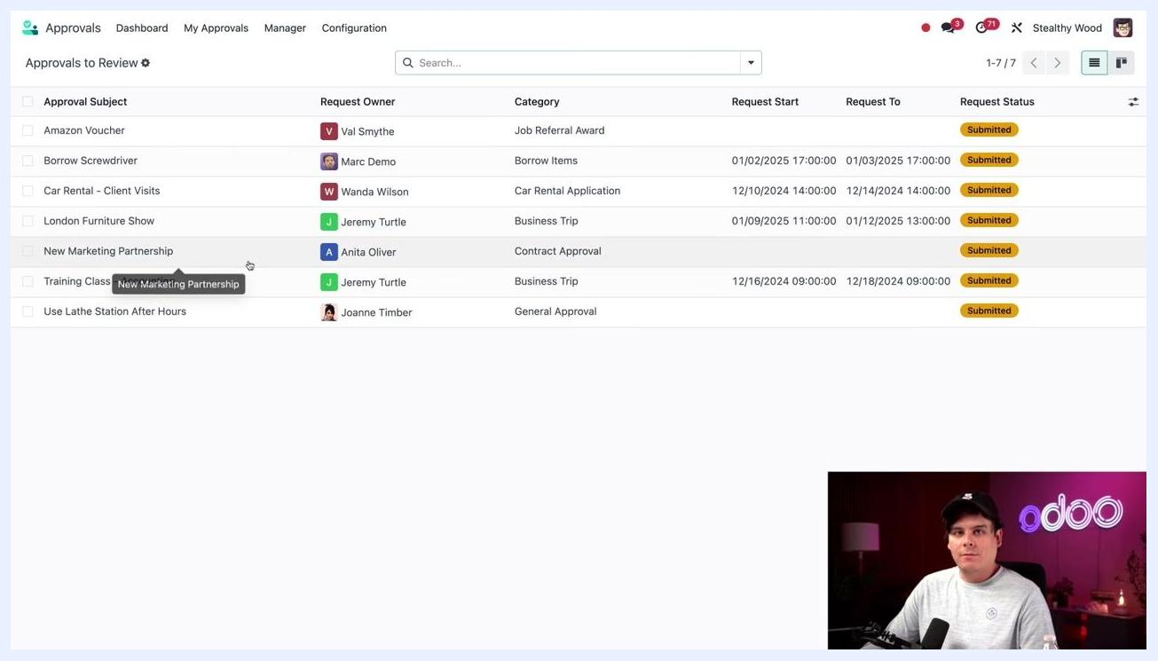
Odoo Approvals - My Requests in Kanban view grouped by status

Part 3: Manager review of approvals

Step 9: Open Approvals to Review
To see all requests waiting for your approval as a manager, select Manager from the top navigation, then click Approvals to Review. Each row in the list displays the Approval Subject, Request Owner, Category, Request Start, Request To, and Request Status. All example requests shown are in "Submitted" status, including Amazon Voucher, Borrow Screwdriver, Car Rental - Client Visits, London Furniture Show, New Marketing Partnership, Training Class - Accounting, and Use Lathe Station After Hours.
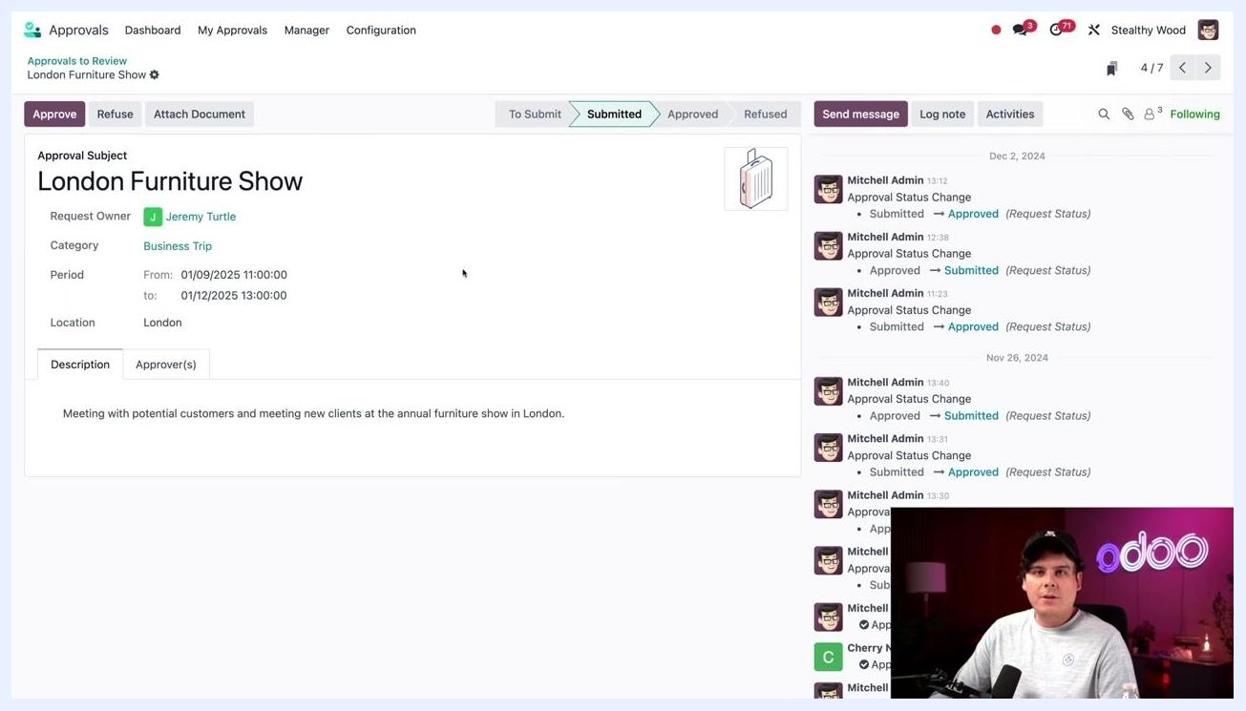
Approvals to Review list showing all requests awaiting approval with details

Step 10: Review a specific request's details
Select a request to review, for example "London Furniture Show" submitted by Jeremy Turtle. The detail view shows the Approval Subject, Request Owner, Category (Business Trip), Period (01/09/2025 11:00:00 to 01/12/2025 13:00:00), Location (London), and a Description explaining the purpose of the trip. Use the Description and Approver(s) tabs for more information.
Approval request details for London Furniture Show, showing subject, owner, category, period, location, and description

Step 11: Check approval requirements
Open the Approver(s) tab to see which approvers are required and their current status. In this example, Jerry Nelson has already approved, and only your approval remains pending.
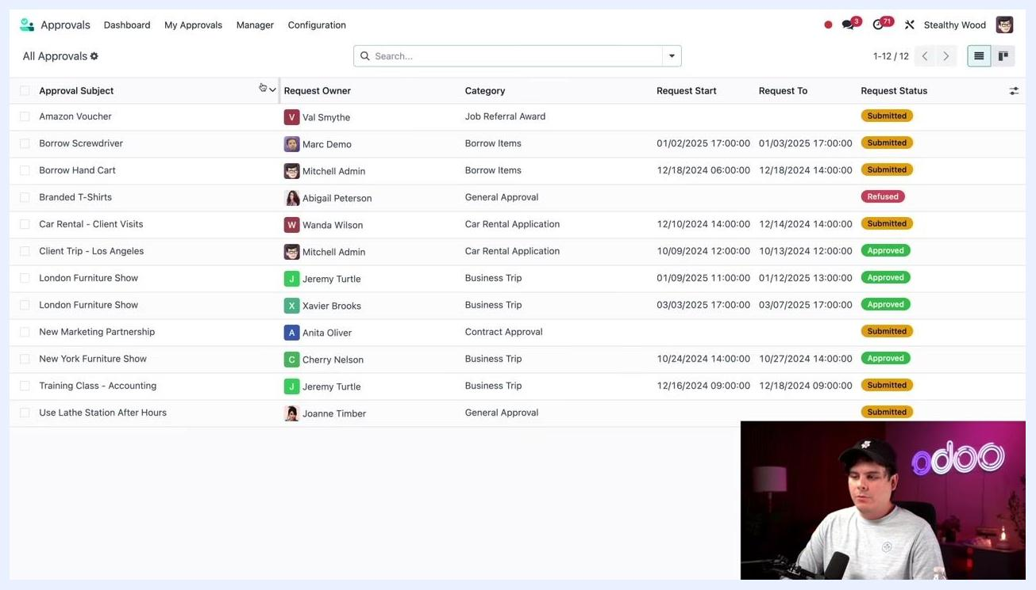
Approval request details with Approver(s) tab showing required approvers and their statuses

Step 12: Approve or withdraw the request
Click Approve at the top of the request detail view. Once approved, both required approvers—for example, Mitchell Admin and Cherry Nelson—show as "Approved." If you need to reverse your decision, click Withdraw.
Approval request showing both approvers have approved, with option to withdraw

Part 4: Reviewing all approvals and refused requests

Step 13: Open All Approvals
To view every approval request regardless of status, select Manager, then All Approvals from the navigation menu. Each row shows the Approval Subject, Request Owner, Category, Request Start, Request To, and Request Status, including Submitted, Approved, and Refused statuses. Example entries include "Branded T-Shirts" (Abigail Peterson, General Approval, Refused), "London Furniture Show" (Jeremy Turtle, Business Trip, Approved), "New Marketing Partnership" (Anita Oliver, Contract Approval, Submitted), and "Use Lathe Station After Hours" (Joanne Timber, General Approval, Submitted).
All Approvals list showing all requests with various statuses and details

Step 14: Locate a refused request
Find the request titled "Branded T-Shirts" with Request Owner Abigail Peterson. Its status appears as "Refused," highlighted in red. Other details include Category: General Approval, Request Start: 12/16/2024 14:00:00, and Location: Anytown, NY. Click the row to open the request's details.
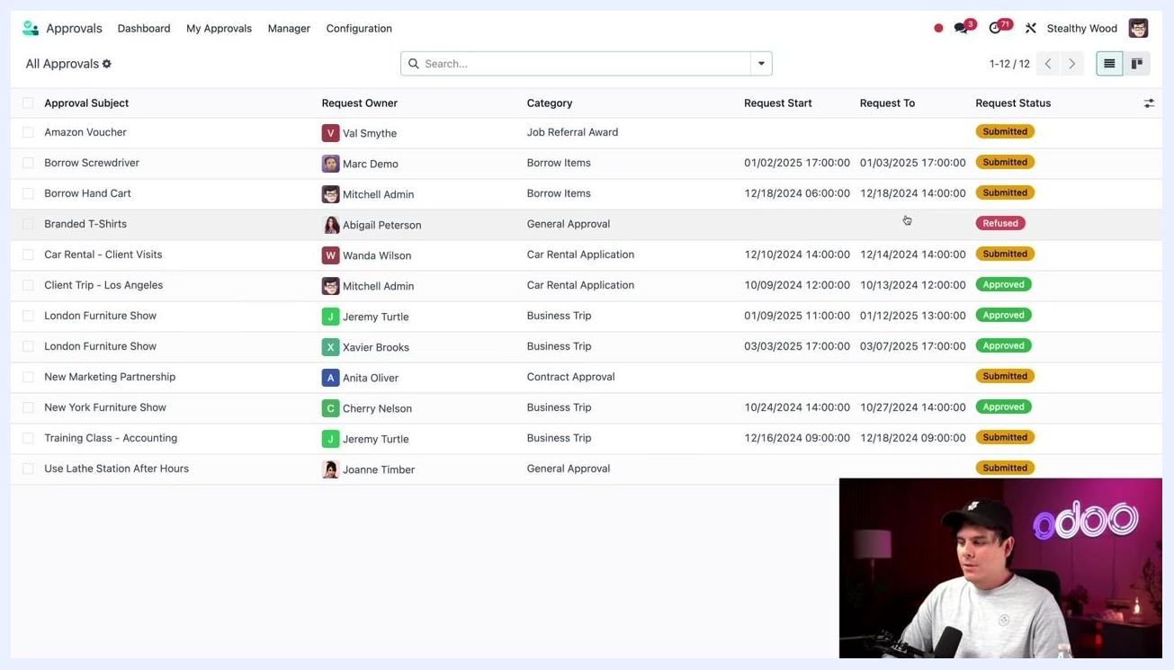
Odoo Approvals - All Approvals list with 'Branded T-Shirts' by Abigail Peterson highlighted as Refused

Step 15: Review the refused request's details
The detail view shows the Approval Subject (Branded T-Shirts), Request Owner (Abigail Peterson), Amount (678.25), Category (General Approval), Date (12/16/2024 14:00:00), and Location (Anytown, NY). The Description tab reads: "I found a sale on custom shirts. I thought these would be great for our annual staff gift." An attached document, shirt.png, shows the Custom Printed T-Shirt Order Form on the right, and the Status tab at the top is highlighted as "Refused."
Approval request details for 'Branded T-Shirts' showing description, refusal status, and attached order form

Step 16: Check the Chatter for the refusal reason
Review the communication history in the Chatter section to understand why the request was refused. In this example, Mitchell Admin left a message on Nov 26, 2024, at 13:33: "Hi @Abigail Peterson - we already picked out our annual employee gift, which are branded fleece jackets. But thanks for your work researching this!" This explains that the company had already decided on a different gift.
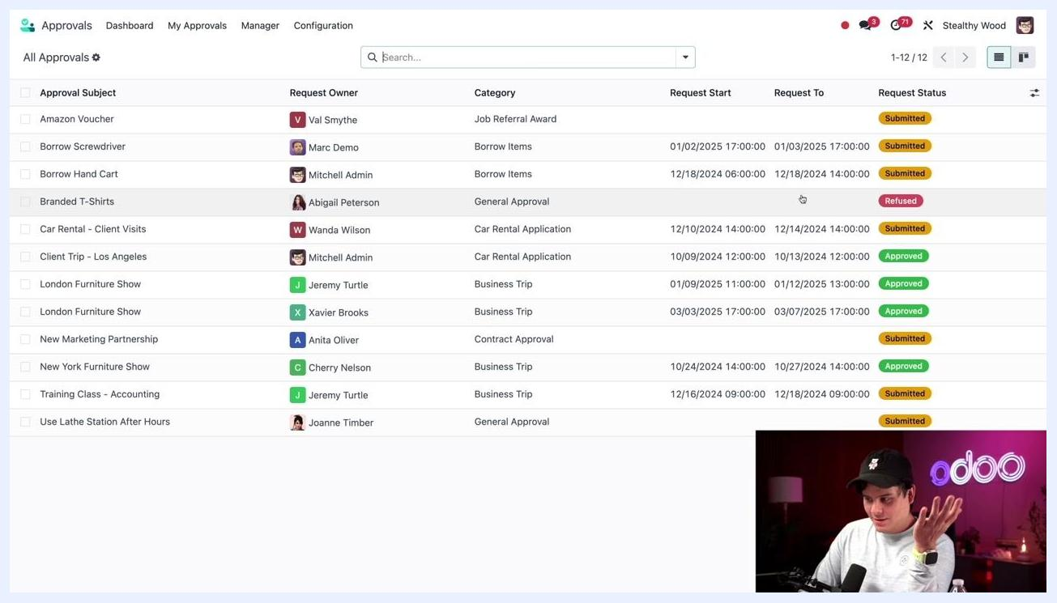
Approval request details with Chatter showing refusal reason and communication
All communications and decisions are recorded in the Chatter section, so you can always return to a request to review its decision history and comments. This keeps the approval workflow transparent and accountable.
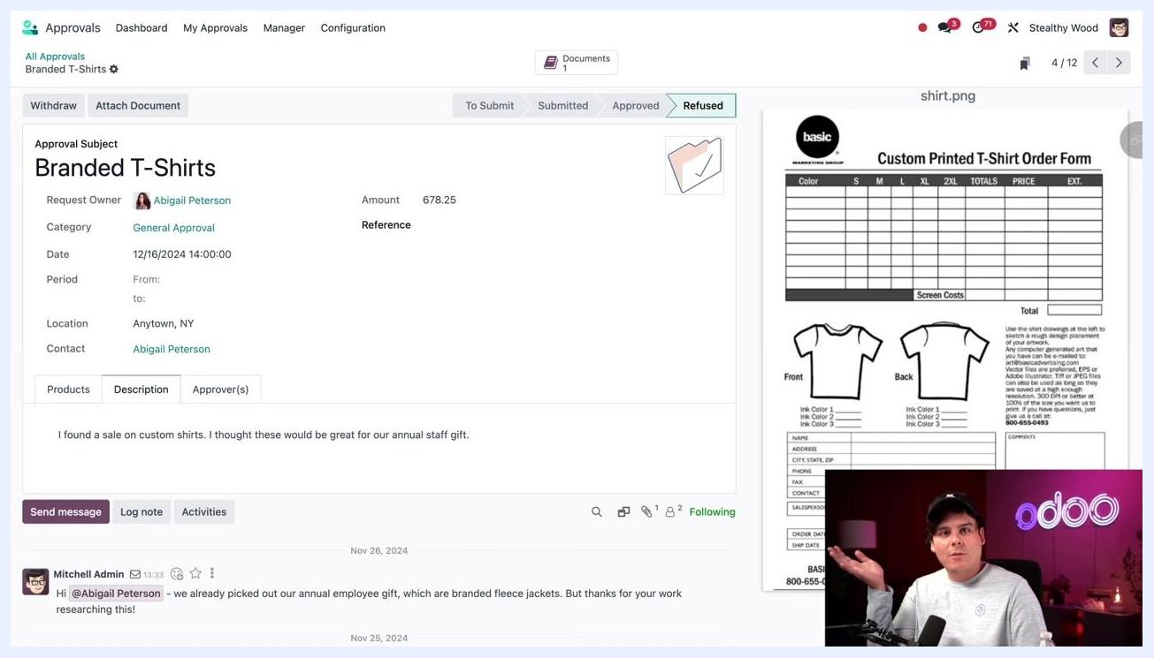
Approval request details with Chatter and description tab visible, showing full decision history

What's next
By following these steps, you can efficiently manage your own requests, review and approve requests awaiting your action, and monitor all approval activity within the Odoo Approvals app. This workflow ensures transparency and accountability for every business process that requires approval.

