How to Create a Custom Role in NetSuite
Every NetSuite user needs access to the data required for their job, but no more than that. This guide shows you how to create a custom role in NetSuite so you can precisely control what each user can see and do, improving both security and operational efficiency.

Why custom roles matter
NetSuite users across your company need access tailored to their specific job functions, without being granted more data visibility than necessary.
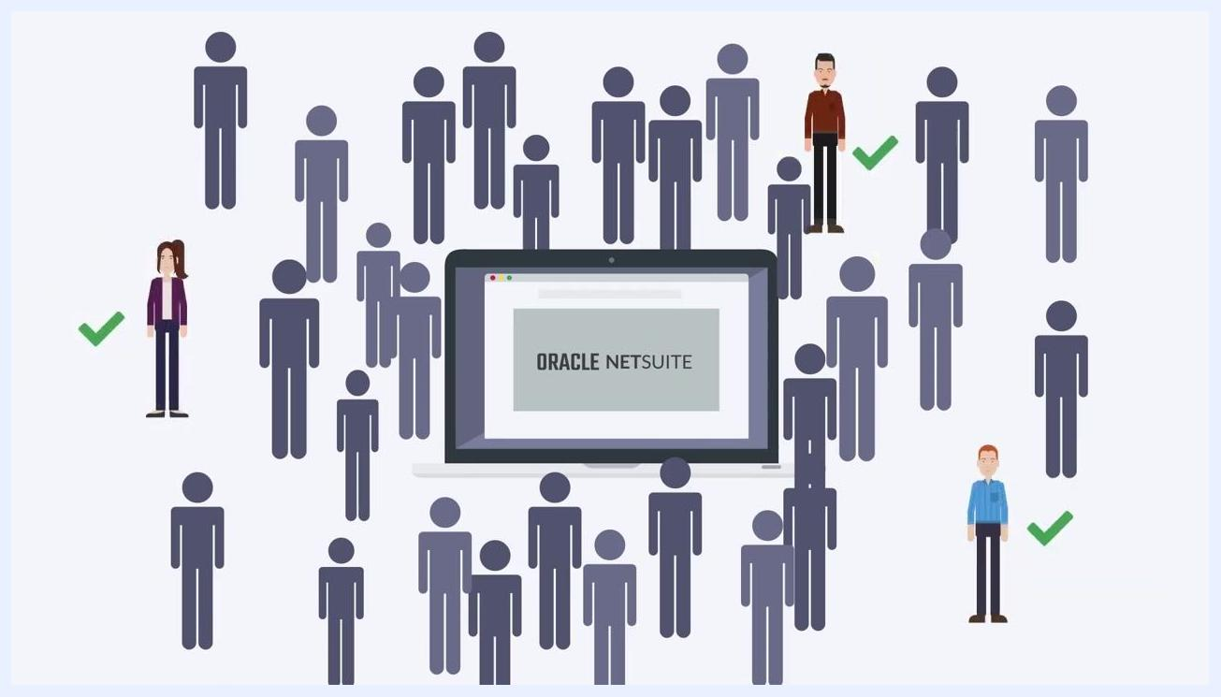
Illustration of multiple generic user icons surrounding a laptop displaying "Oracle NetSuite," representing the many users in a company
You assign permissions so that each user has exactly the access they need and nothing more. Only the appropriate users should be granted access to a given area of data.
User icons marked with check marks, showing which users in a group have been granted correct access around a laptop displaying "Oracle NetSuite"
NetSuite ships with standard roles, such as Administrator, Accountant, Marketing Manager, and Warehouse Manager, each with a predefined set of permissions.
Blue screen introducing the topic with the text "What are custom roles in NetSuite?"
Four illustrated characters labeled Administrator, Accountant, Marketing Manager, and Warehouse Manager, representing NetSuite's standard roles
A custom role is created by modifying the permissions and restrictions of a standard role so it matches your company's unique needs. Standard roles carry a fixed set of permissions, while custom roles let you tailor that set precisely. For clarity and precision, it's best practice to build custom roles rather than relying on standard roles alone.
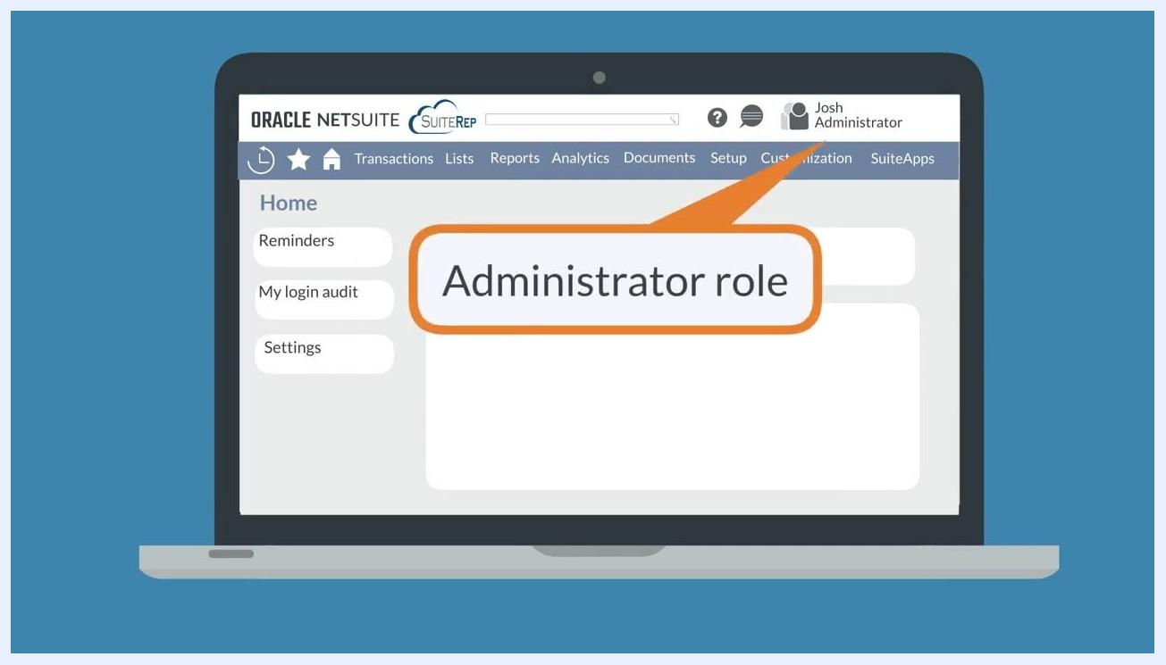
Side-by-side comparison of "Standard Role Permissions" and "Custom Role Permissions" using green grids, showing that custom roles follow a unique permission pattern

Prerequisites
- Administrator access to your NetSuite account, since role management features require this level of access.
- A clear understanding of the job function the new role needs to support.

Step 1: Log in as Administrator
Log in to NetSuite using the Administrator role. This gives you access to role management features.
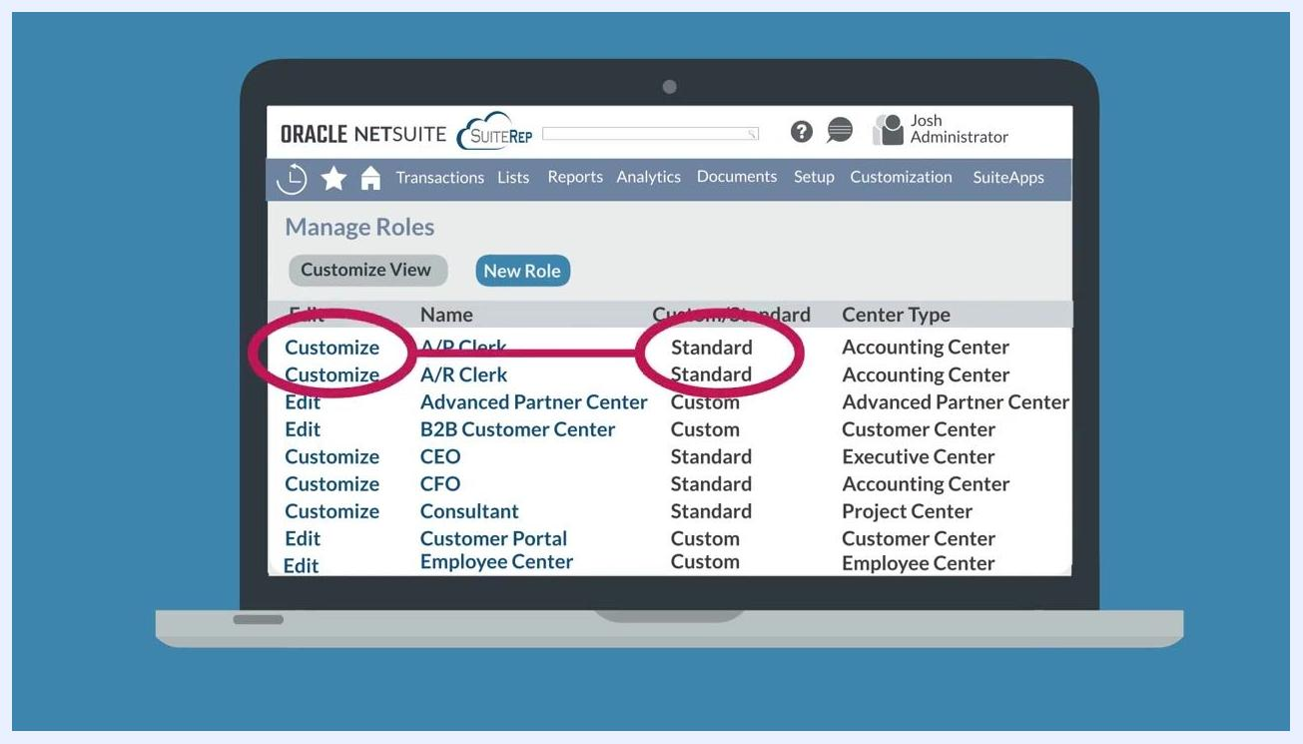
NetSuite interface showing a user logged in as "Josh Administrator" with the Administrator role highlighted

Step 2: Open the Manage Roles page
Navigate to Setup > Users/Roles > User Management > Manage Roles. From here, you can customize standard roles or edit roles you've previously customized. Roles labeled "Standard" in the Custom/Standard column are the built-in roles you can base a custom role on.
NetSuite Manage Roles screen listing roles, with the "Customize" options circled for standard roles and the "Standard" label highlighted

Step 3: Create a custom role by customizing a standard role
Find the standard role that most closely matches the custom role you want to create, then click Customize next to it.
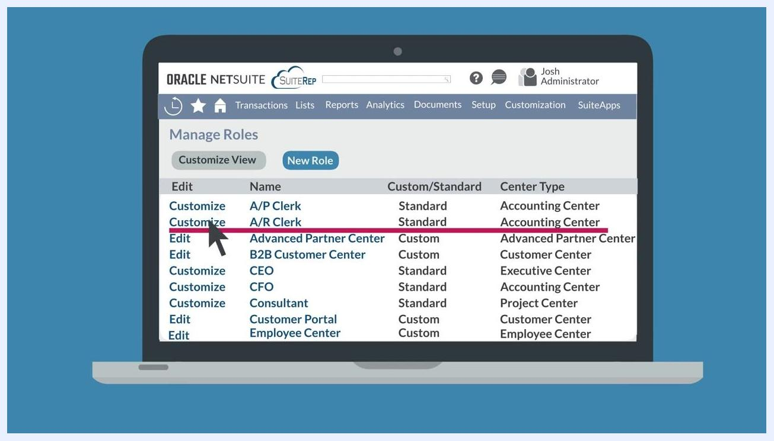
Cursor pointing to the "Customize" link next to the "A/R Clerk" standard role in the Manage Roles list

Step 4: Open the role customization page
Clicking Customize takes you to the role customization page, where you name your new custom role and set its specific restrictions and permissions. Note that the center type, such as Accounting Center or Customer Center, cannot be changed once you start customizing the role.
Cursor clicking "Customize" for the "A/R Clerk" role, with the interface transitioning to the role customization page

Step 5: Choose the appropriate role center
Select a standard role whose center type fits your custom role, since the center type determines the navigation and features available to users assigned to it. For example, when creating a custom A/R Clerk role, make sure the standard role uses the Accounting Center.
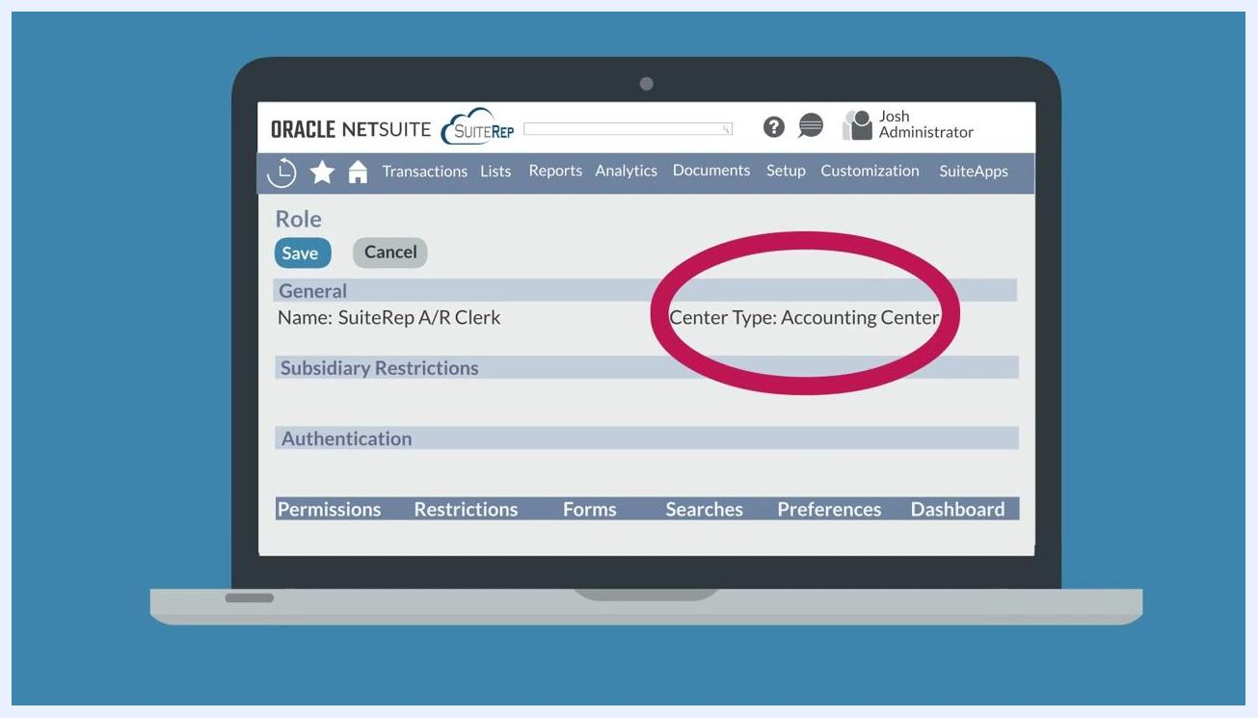
NetSuite role customization screen with "Center Type: Accounting Center" circled, and the role named "SuiteRep A/R Clerk"

Step 6: Review the top field groups
The General, Subsidiary Restrictions, and Authentication field groups at the top of the page give you broad control options for the role.
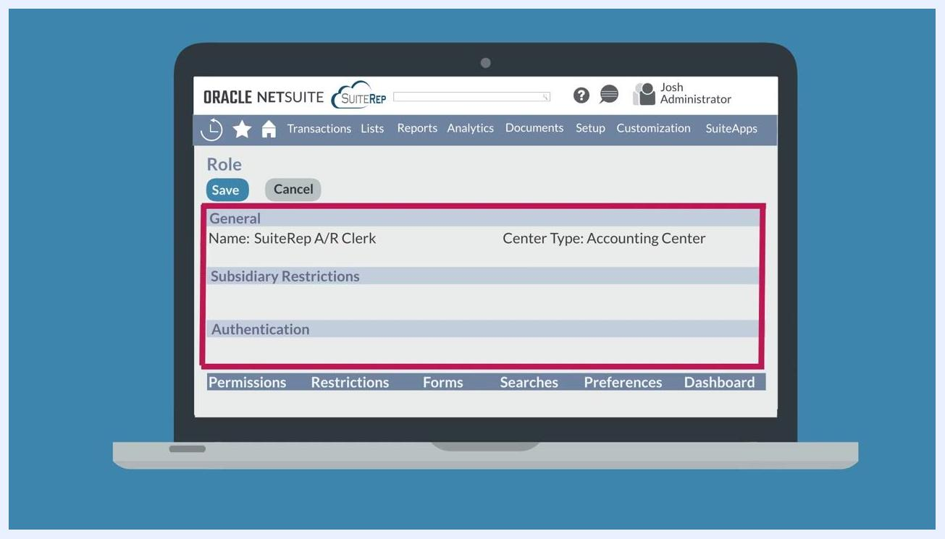
NetSuite role customization screen with the General, Subsidiary Restrictions, and Authentication fields highlighted
Click any field name to open its field help and read a detailed explanation of what that control does before changing it.
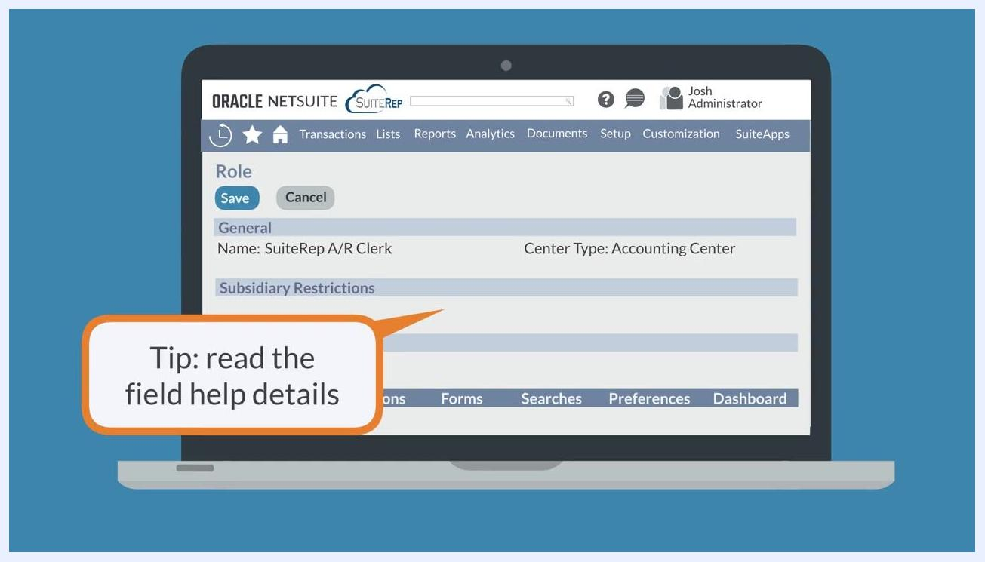
Tip bubble reading "Tip: read the field help details" on the NetSuite role customization screen

Step 7: Set subsidiary restrictions
Use Subsidiary Restrictions to limit the role based on the subsidiary assigned to each user. Two users with the identical custom role can end up with access limited to their own respective subsidiaries.
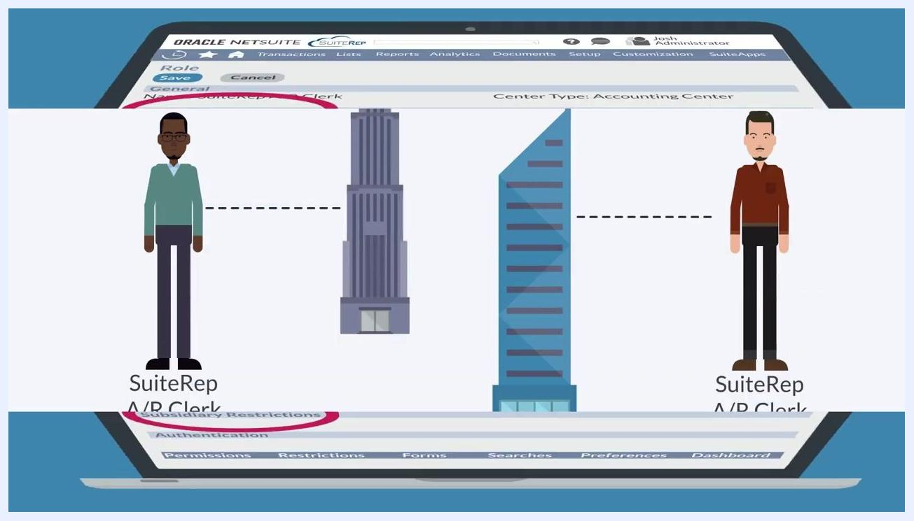
Illustration of two users, each linked to a different building and labeled "SuiteRep A/R Clerk," representing subsidiary-based restrictions

Step 8: Configure authentication settings
Under the Authentication section, choose how NetSuite authenticates users when they sign in with this role.
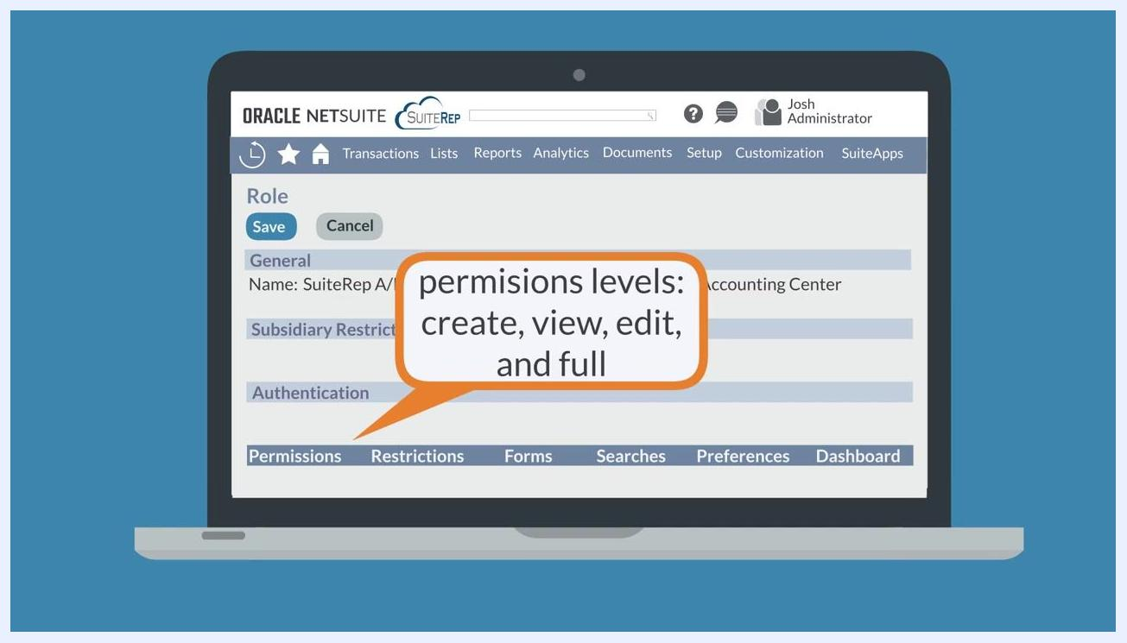
NetSuite role customization screen with the Authentication section circled

Step 9: Refine access using the subtabs
The subtabs at the bottom of the role customization page let you fine-tune the role further:
- Permissions: Set permission levels (Create, View, Edit, Full) for transactions, reports, and lists.
- Restrictions: Limit access by department, type, or location.
- Forms: Enable or restrict specific NetSuite forms for the role.
- Searches: Restrict access, use, and visibility of specific search results.
- Preferences: Set default preferences for users assigned to the role; users can override these individually.
- Dashboard: Assign a pre-configured dashboard to the role.
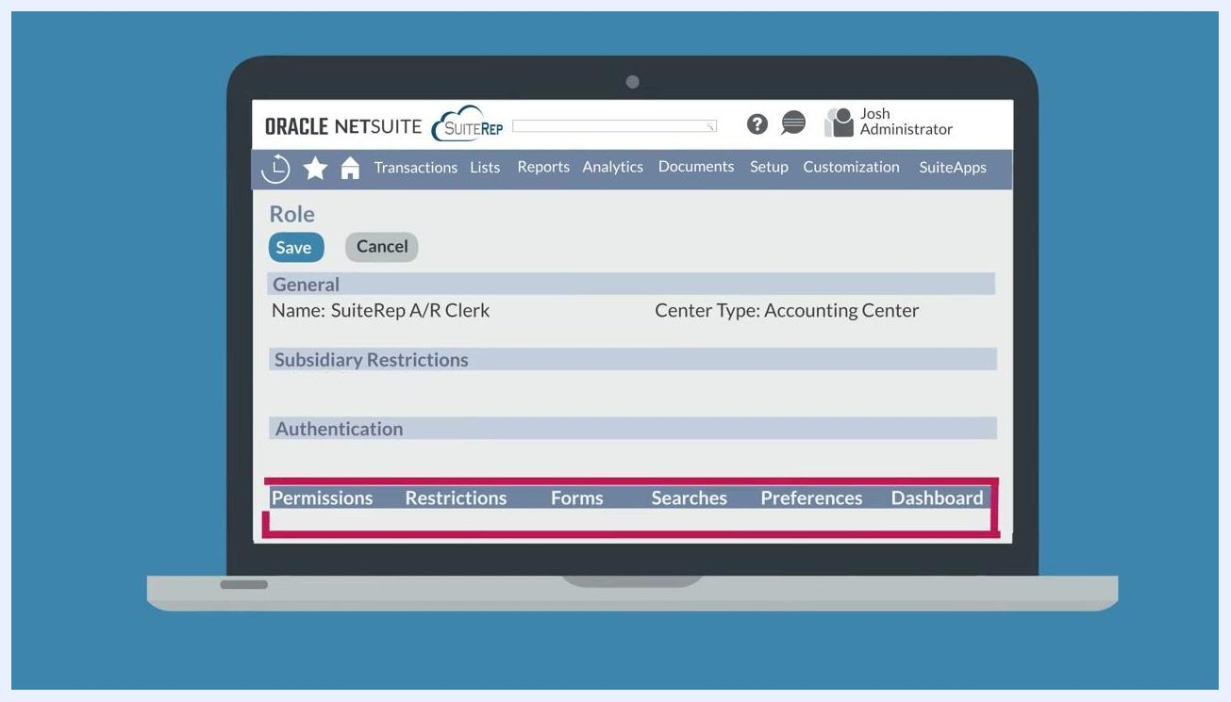
NetSuite role customization screen with the Permissions, Restrictions, Forms, Searches, Preferences, and Dashboard subtabs highlighted

Step 10: Adjust permission levels
Under the Permissions subtab, set the permission level for each item to Create, View, Edit, or Full, adjusting these to either grant broader access or restrict it further.
Speech bubble reading "permission levels: create, view, edit, and full" on the NetSuite role customization screen

Step 11: Restrict search results
Under the Searches subtab, restrict the access, use, and visibility of specific search results for the role.
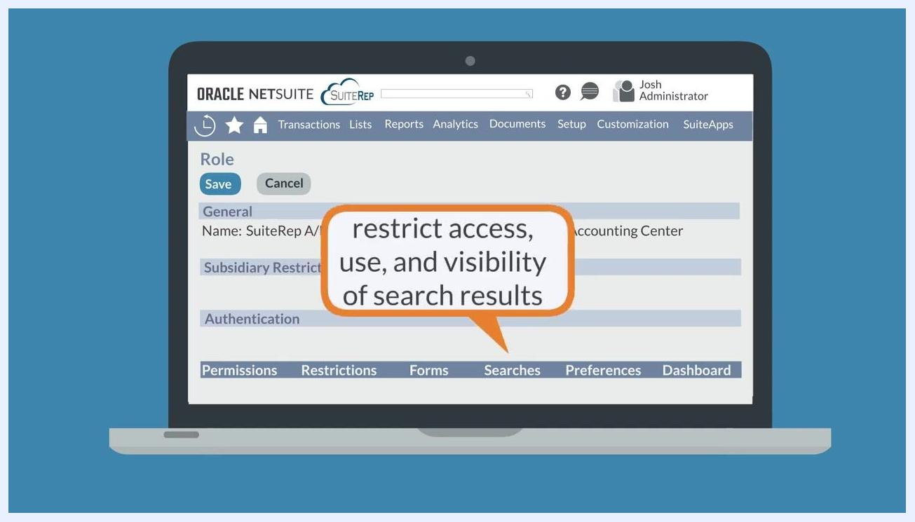
Speech bubble reading "restrict access, use, and visibility of search results" on the NetSuite role customization screen

Step 12: Set default preferences
Use the Preferences subtab to set default preferences for users assigned to the role. Users can change these defaults individually by selecting Set Preferences while logged in.
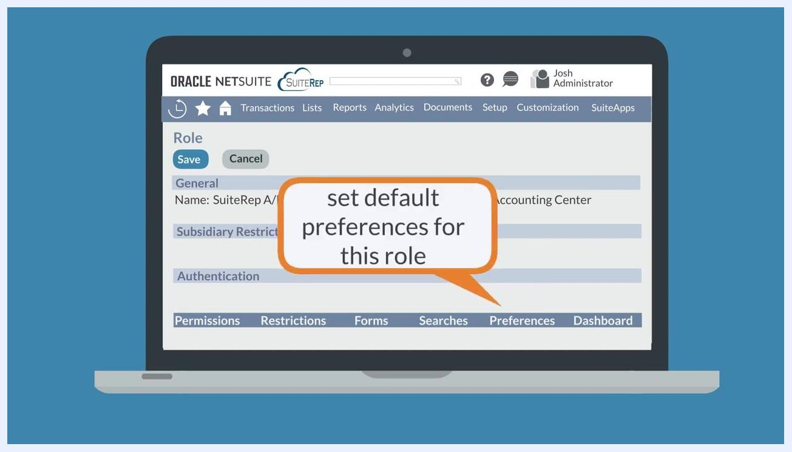
Speech bubble reading "set default preferences for this role" on the NetSuite role customization screen

Auditing and testing your custom roles
After you create a custom role in NetSuite, review it periodically to keep access accurate and secure.

Audit role permissions regularly
Periodically review the access and permissions assigned to each role and confirm they still align with each user's current job function. Remove unnecessary permissions to reduce security risks, and tailor roles to actual job responsibilities rather than forcing job functions to fit standard NetSuite roles.
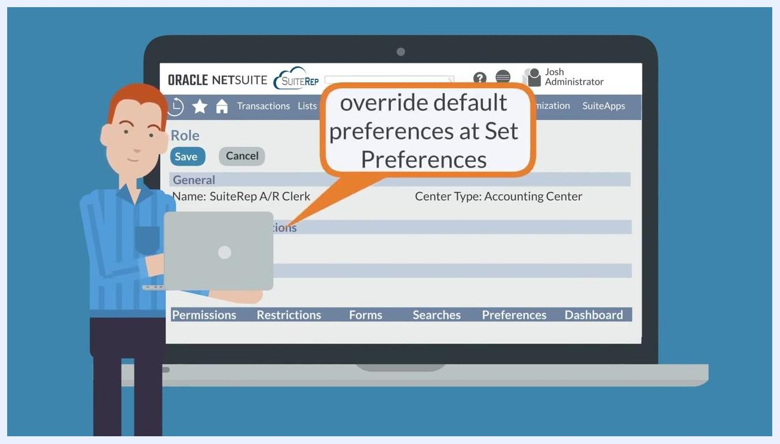
Two illustrated users, one shown with a grid of squares representing permissions, alongside the text "Regular Audits of Roles"

Segregate processes and transactions
Assign processes and transactions across multiple users so no single person has full control over a process. This segregation of duties reduces the risk of fraud or error.
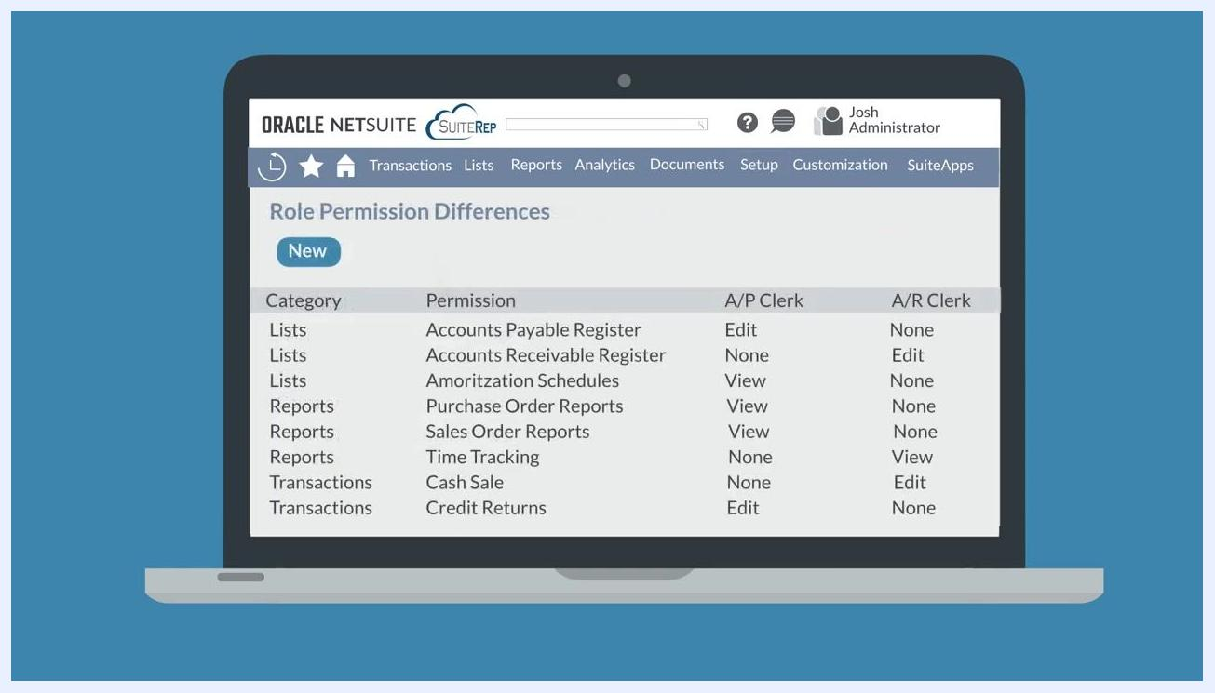
Illustration of process segregation showing multiple users around a circular flow with icons for money, a checklist, and a package, labeled "Process Segregation"

Compare roles with the Role Permission Differences tool
Navigate to Setup > Users/Roles > User Management > Show Role Differences to open the Role Permission Differences page. Use this tool to compare permissions between two roles side by side, which is especially useful when auditing similar roles for discrepancies or unnecessary access. For example, you can compare the "A/P Clerk" and "A/R Clerk" roles to see differences such as the Accounts Payable Register permission (Edit vs. None) and the Accounts Receivable Register permission (None vs. Edit).
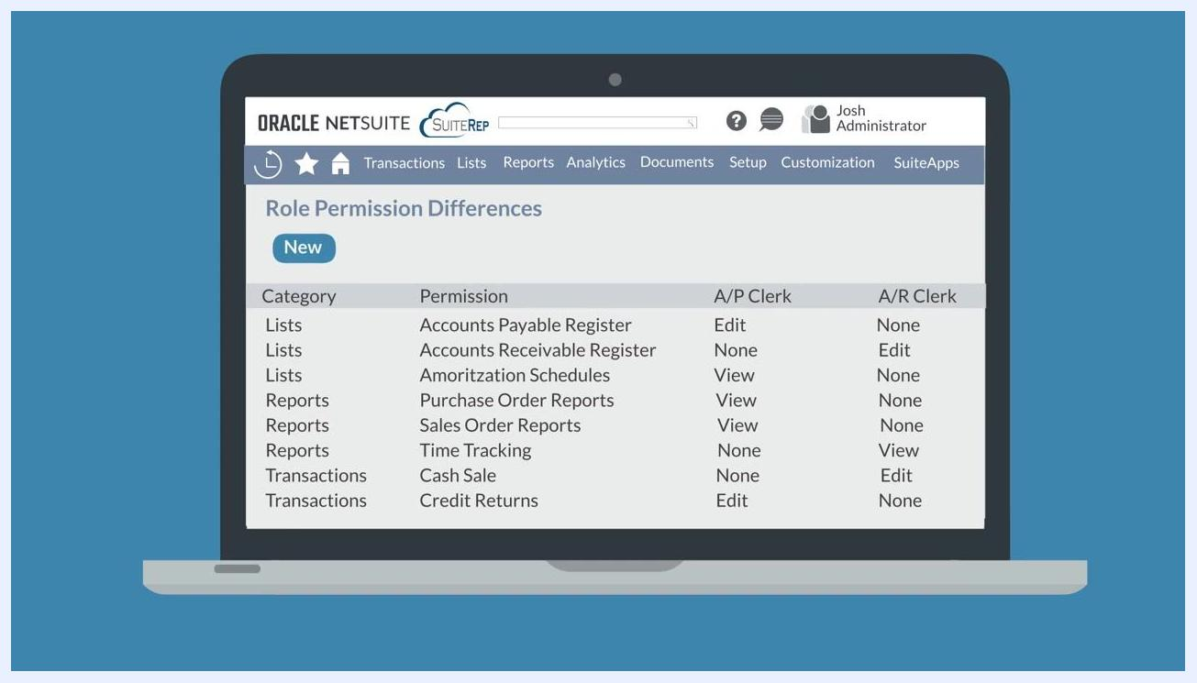
NetSuite Role Permission Differences screen showing a side-by-side comparison of permissions for the A/P Clerk and A/R Clerk roles

Allow users to override default preferences
Users can override the default preferences you set for their role by navigating to Set Preferences while logged in, without affecting the overall role configuration.
NetSuite role customization screen with a speech bubble reading "override default preferences at Set Preferences"

Test controls on the custom role
After configuring a custom role, log in as a user assigned to it and verify that the permissions, restrictions, and preferences behave as intended.
Blue screen with the text "How to test controls on a custom role?"

What's next
With these steps, you can ensure every NetSuite user has access only to the data they need, while keeping your roles secure, up to date, and aligned with actual job responsibilities. For additional guidance or support with NetSuite roles and permissions, visit SuiteRep at .
SuiteRep website displayed on a laptop screen with the text "Trusted NetSuite Experts" and a "LET'S CHAT" button

