How to Set Out of Office in Outlook
Setting an out of office reply in Outlook lets people who email you while you're away know when to expect a response. This guide walks you through how to set out of office in Outlook using the desktop app (Office 365 and earlier versions), how to test that it's working, and how to set it up in Outlook on the web.

Prerequisites
- A computer with Outlook installed, or access to Outlook on the web.
- An active Outlook account signed in.
- A second email account (such as Gmail) if you want to test your automatic reply.

Step 1: Prepare your workspace
Sit down at your computer and make sure Outlook is installed and ready to open.
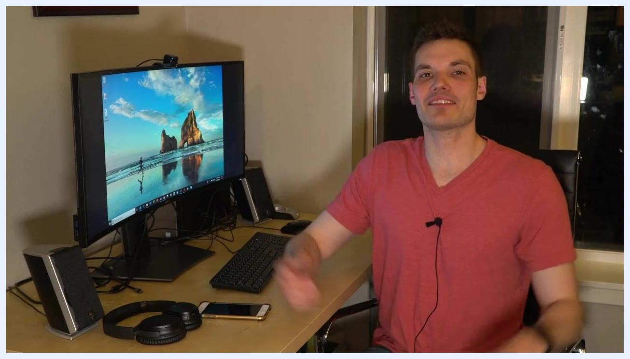
A person sitting at a desk with a monitor displaying the Windows desktop, along with a keyboard, mouse, headphones, and a smartphone in a home office setting.

Step 2: Open Outlook
Launch the Outlook application from your desktop or start menu and wait for your inbox to load.
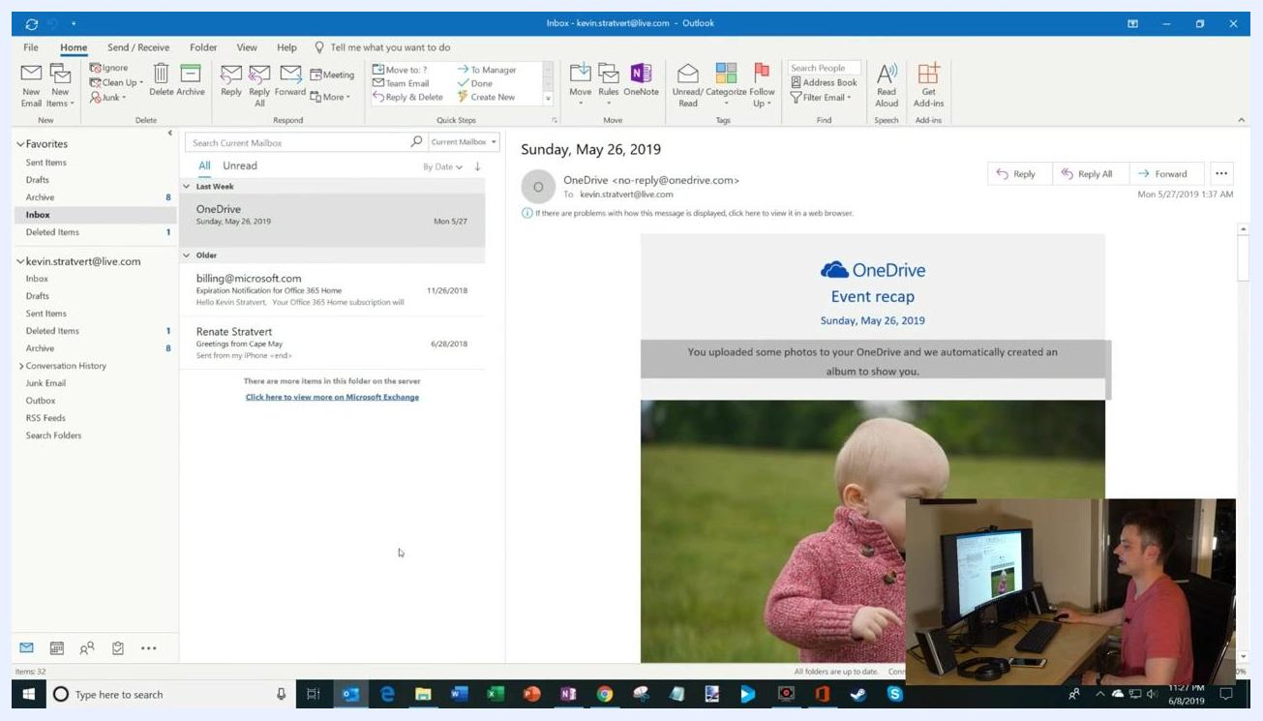
A person gestures toward a monitor showing the Windows desktop before opening Outlook.

Step 3: Navigate to your inbox
Confirm you're in the main inbox view. You should see your list of emails alongside the standard Outlook ribbon at the top.
The Outlook inbox is open, with folders on the left, emails in the center pane, and the selected email's content on the right.

Step 4: Access the File menu
Click the File tab in the upper-left corner of the Outlook window.
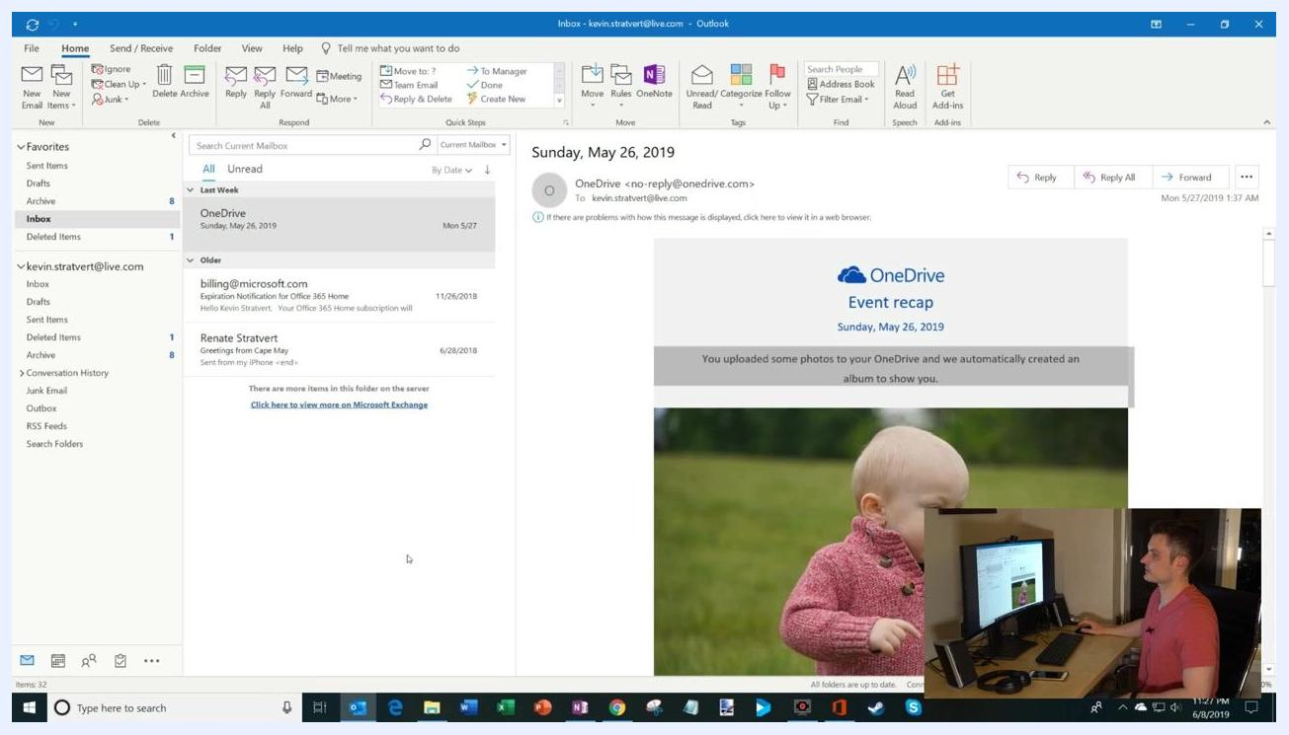
The Outlook inbox is open, ready for the user to click the File tab.

Step 5: Open Automatic Replies
From the Account Information view, click Automatic Replies.
The Account Information screen shows the Automatic Replies button on the left, with the Automatic Replies dialog open beside it.

Step 6: Turn on automatic replies and set a date range
In the Automatic Replies dialog, select Send automatic replies. If you want your reply to run only for a specific period, check Only send during this time range and set:
- Start time: for example, 6/8/2019, 11:00 PM
- End time: for example, 6/9/2019, 11:00 PM (adjust to match your own absence)
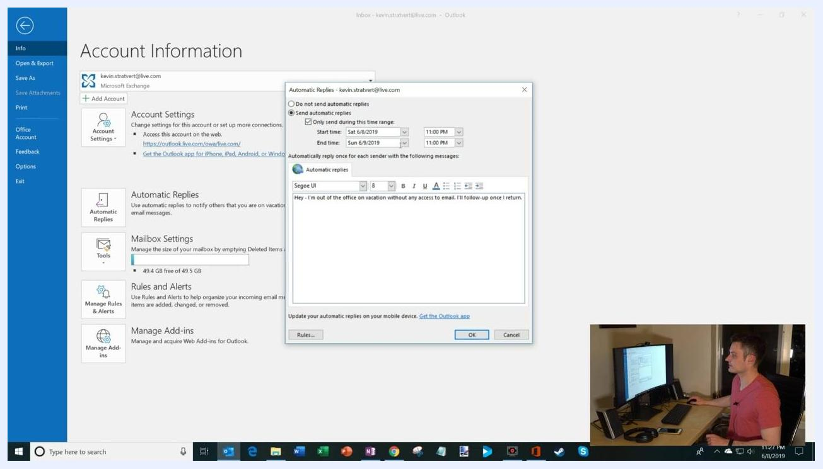
The Automatic Replies dialog with "Send automatic replies" selected and a date range set from 6/8/2019 11:00 PM to 6/9/2019 11:00 PM, along with a sample message.

Step 7: Write your out of office message
Type your message in the message box. For example:
- "Hey – I'm out of the office on vacation without any access to email. I'll follow-up once I return."

Step 8: Adjust the end time if needed
Use the dropdown menu to pick a different end time for your automatic replies if the default doesn't fit your schedule.
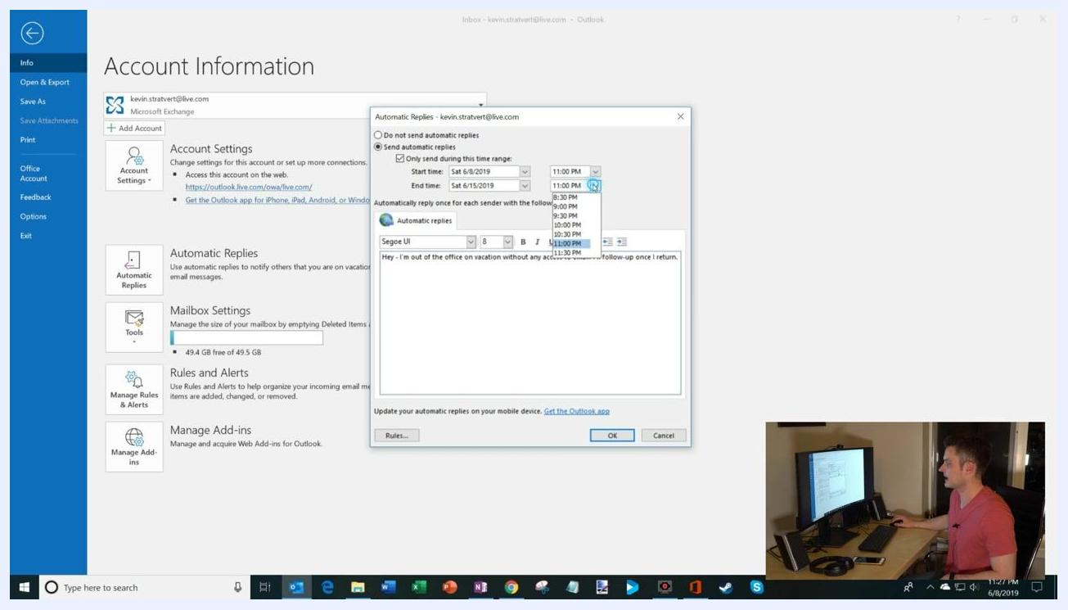
The Automatic Replies dialog with the end time dropdown expanded, showing time options from 9:00 PM to 11:30 PM.

Step 9: Customize your message and set internal/external options
Personalize your message however you like. For example:
- "Hey – I'm out of the office on vacation without any access to email. I'll follow-up once I return, or maybe not, depending on how much email I receive."
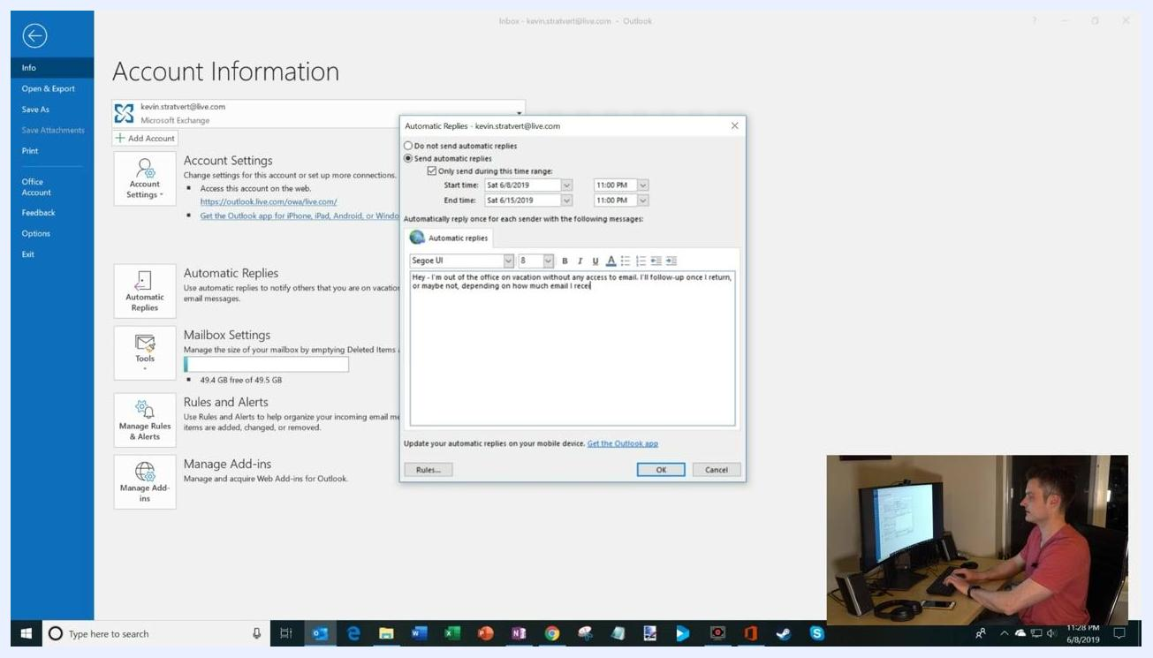
The Automatic Replies dialog with the custom message entered, shown against the Account Information screen in the background.
If you're using a work or school account, you'll see two tabs in the dialog:
- One tab for replies sent to people inside your organization.
- Another tab for replies sent to people outside your organization.
You can set different messages for each audience, for example:
- Internal: "Contact [Colleague Name] for urgent matters."
- External: "I am currently out of the office and will respond upon my return."
If you're using a personal account, you'll only see one message box and can't set separate internal and external messages.

Step 10: Set up rules for automatic replies (optional)
Click Rules... in the Automatic Replies dialog to add custom handling for incoming emails while you're away.
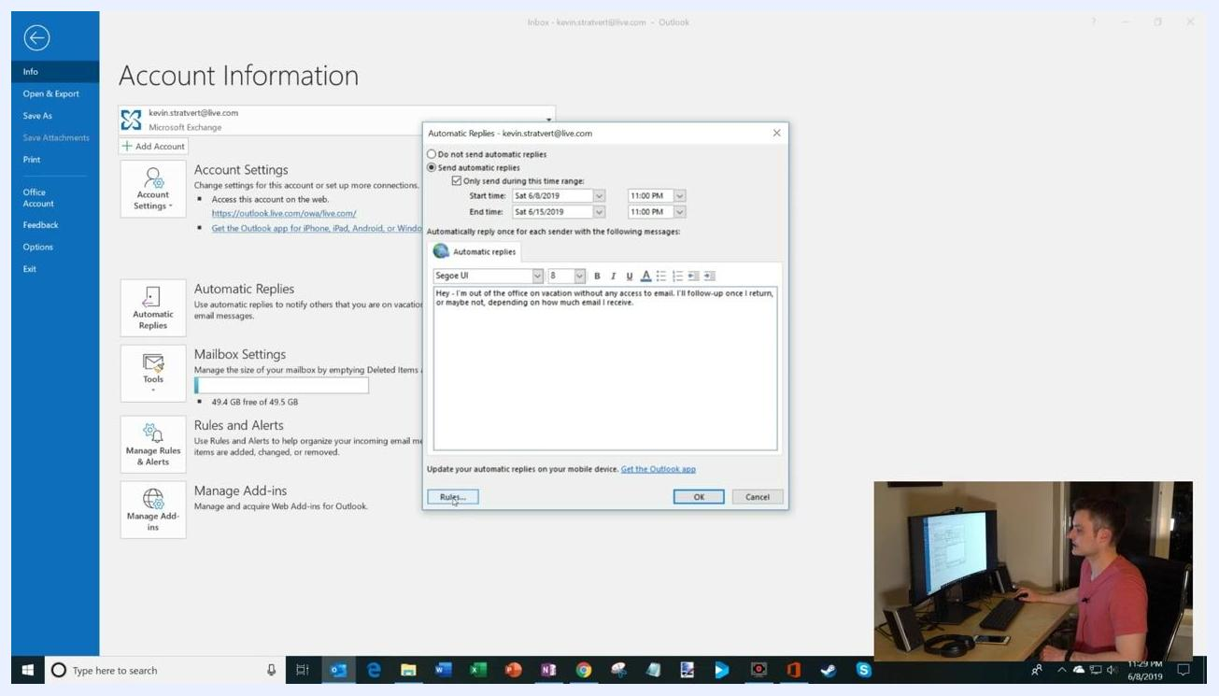
The Automatic Replies dialog with the Rules button highlighted, ready to add custom rules for the out-of-office period.
In the Edit Rule window, configure rules to match your needs:
- Specify conditions, such as emails from a certain person (like your manager) or with a specific subject.
- Choose actions, such as moving emails to a folder, forwarding them, or replying with a custom template.
- Example: let emails from your manager bypass the automatic reply or forward to another address.
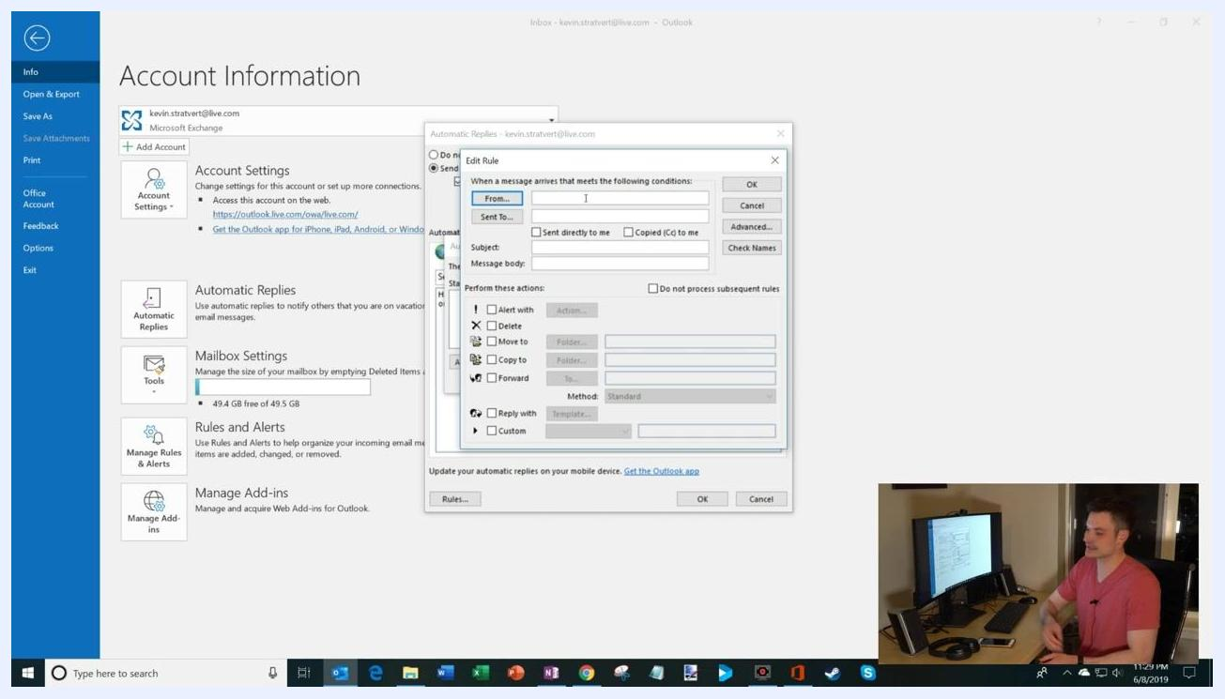
The Edit Rule dialog showing options to filter emails by sender, recipient, or subject, and actions such as alert, delete, move, copy, forward, or reply with a template.
Click OK to save your rules, or Cancel if you don't want to add any.

Step 11: Activate your out of office response
Review your message, date range, and any rules you've set, then click OK to turn on your out-of-office reply.
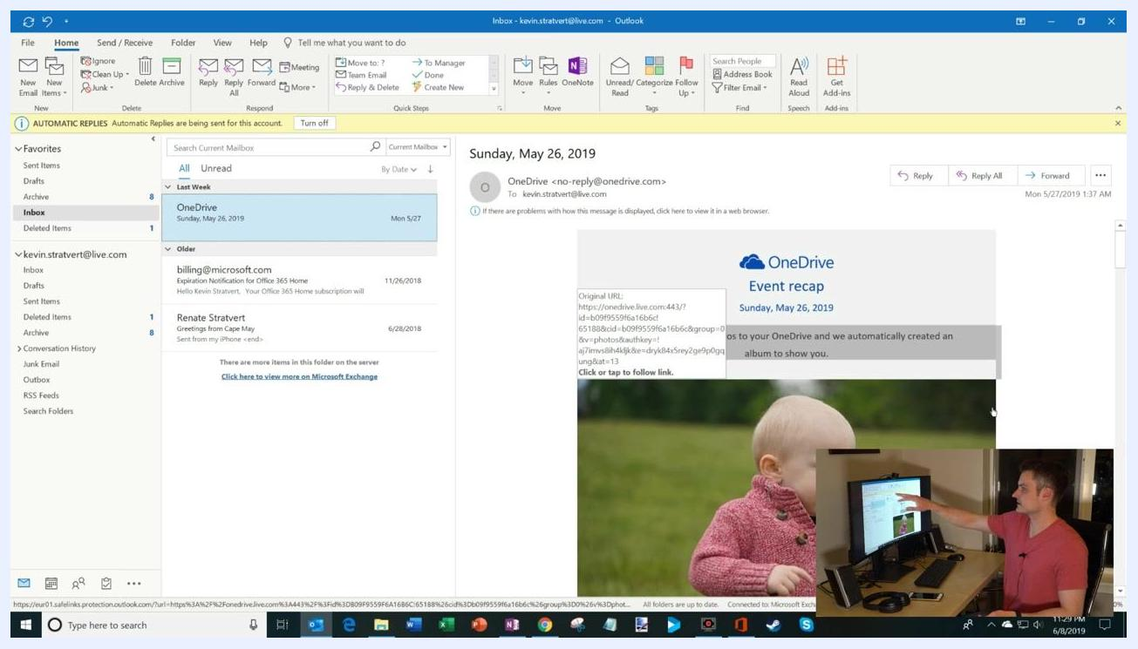
The Automatic Replies dialog ready for the user to confirm and activate the out-of-office response.

Step 12: Confirm automatic replies are active
Return to your Outlook inbox and look for a yellow notification bar at the top stating: "AUTOMATIC REPLIES Automatic Replies are being sent for this account." This confirms your out-of-office response is active. You can click Turn off on this bar anytime to disable automatic replies.
The Outlook inbox with a yellow notification bar confirming that automatic replies are being sent, with the user pointing to it.

Step 13: Test your out of office setup
Open a separate email account, such as Gmail, and compose a new message to your Outlook address. For example:
- Subject: "Please send me the report by tomorrow! Extremely urgent."
- Body: "So please send me the reports by tomorrow. Extremely urgent."
Send the email to your Outlook account.
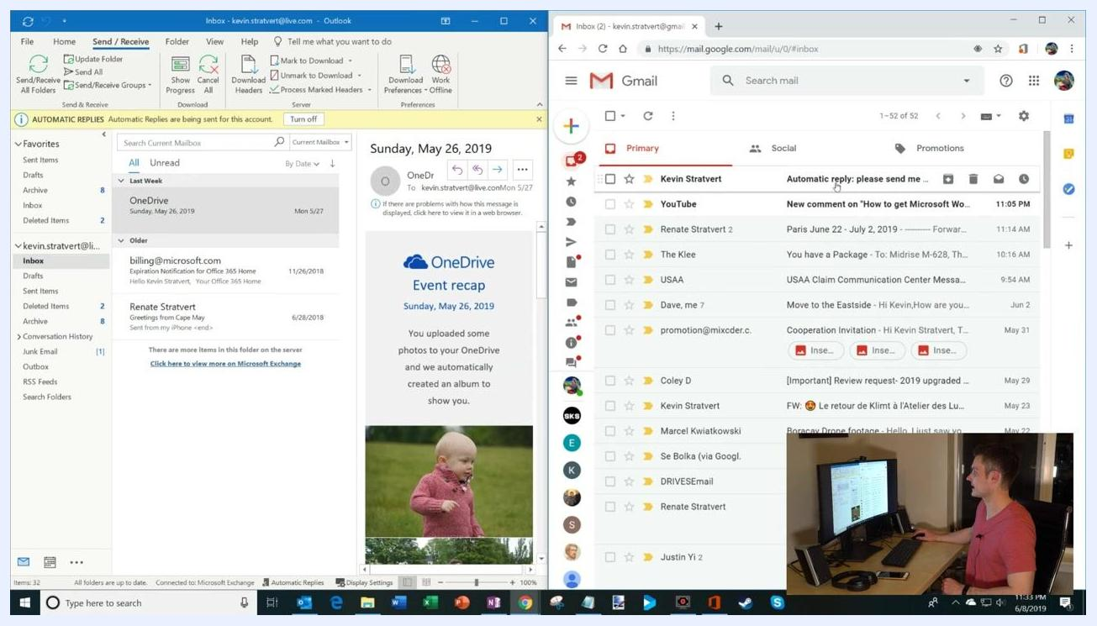
Outlook on the left and Gmail on the right, with a new message being composed to the Outlook address.
Wait for the automatic reply to arrive in your Gmail inbox, then open it and confirm it contains your out-of-office message, such as:
- "Hey – I'm out of the office on vacation without any access to email. I'll follow-up once I return, or maybe not, depending on how much email I receive."
The Gmail inbox showing the automatic reply message from the Outlook account, with Outlook visible on the left.
Also check that the original message you sent from Gmail appears in your Outlook inbox.

Step 14: Set up out of office in Outlook on the web
Open your browser and go to the Outlook web app (for example, https://outlook.live.com), then sign in if prompted. Click the Settings (gear) icon in the upper-right corner, then use the search box in the Quick Settings pane to type "out of office" or "automatic replies" and select Automatic replies from the results.
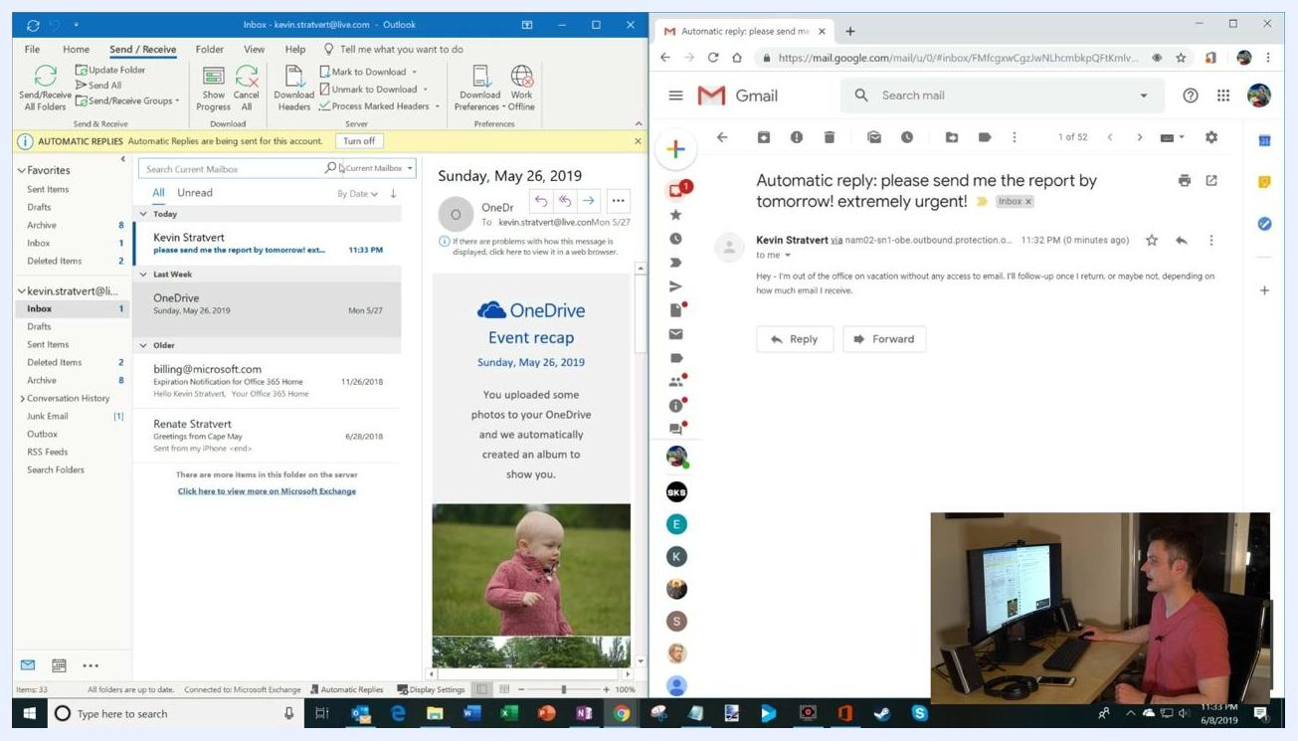
Outlook on the web with the Quick Settings pane open and the search box ready for input.
Turn on Automatic replies by toggling the switch. Optionally, check Send replies only during a time period and set your start and end dates/times, for example: Start time 6/8/2019, 11:00 PM; End time 6/9/2019, 11:00 PM. You can also select:
- Block my calendar for this period – prevents new meetings from being scheduled.
- Automatically decline new invitations for events that occur during this period – declines new meeting requests.
- Decline and cancel my meetings during this period – cancels existing meetings during your absence.
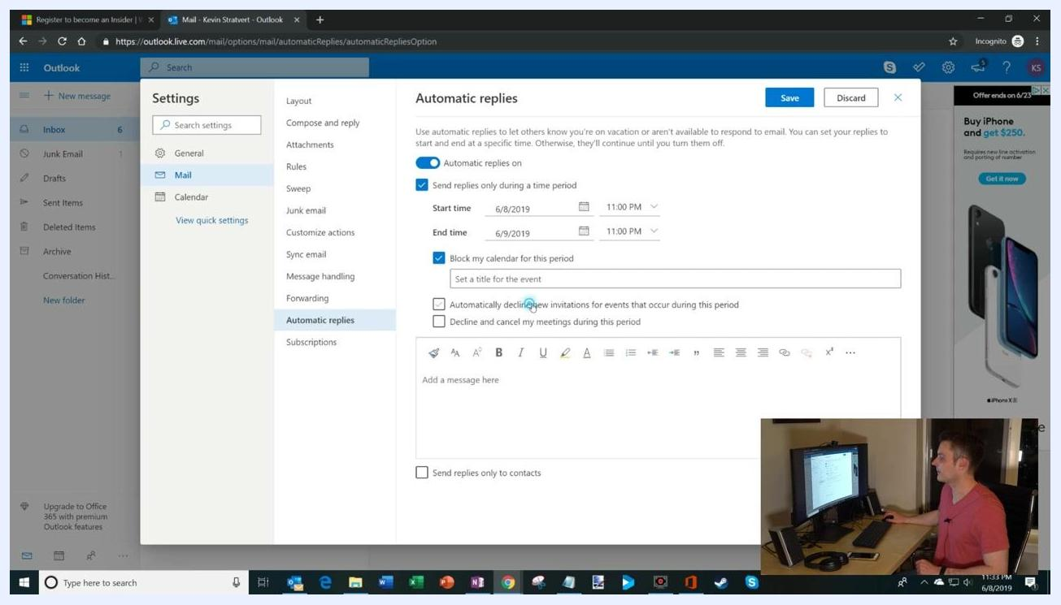
The Automatic Replies settings page in Outlook on the web, showing time period, calendar-blocking, and meeting-decline options along with the message box.
Enter your out-of-office message in the message box. Optionally, check Send replies only to contacts to limit replies to people in your contacts list, or leave it unchecked to reply to everyone.
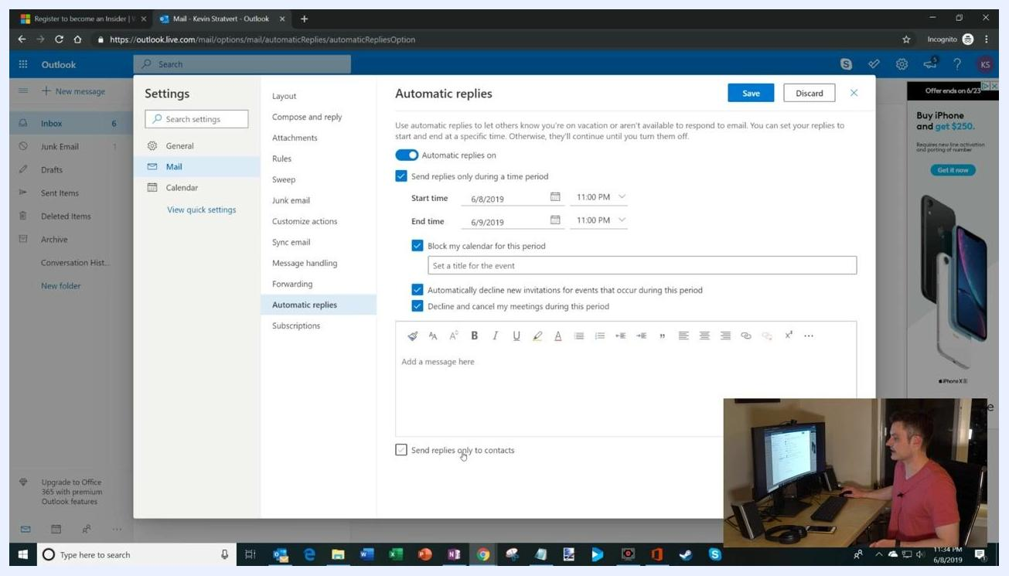
The Automatic Replies settings page in Outlook on the web with "Send replies only to contacts" checked.
Click Save to activate your automatic replies.

What's next
You now know how to set out of office in Outlook using both the desktop app and Outlook on the web, including how to customize messages for internal and external contacts, set rules for specific emails, and verify your setup with a test message. Be sure to:
- Activate your out-of-office reply before you leave so colleagues and contacts are informed of your absence.
- Choose whichever method — desktop app or web — best fits your workflow and device.
- Revisit the steps above or consult Outlook's help documentation if you need further assistance.
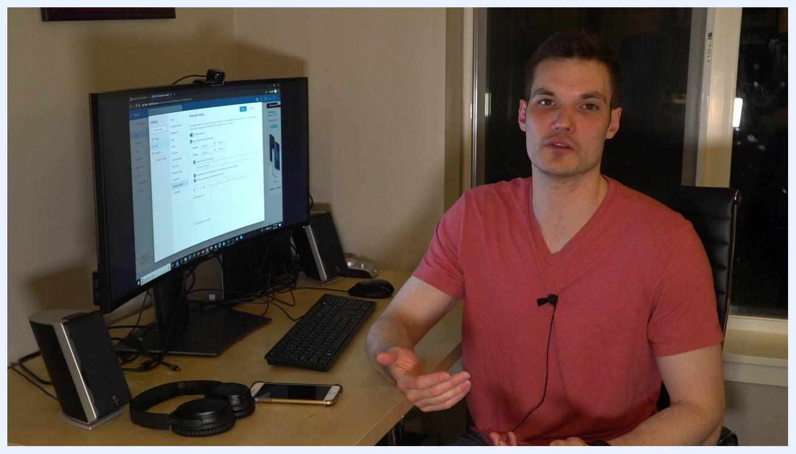
A person sits at a desk in a home office environment, facing the camera and waving with a smile. On the desk are a curved monitor displaying the Outlook web app's Automatic Replies settings, a keyboard, mouse, headphones, smartphone, and speakers. The room is warmly lit, and the presenter appears to be wrapping up the video.

