How to Send a Secure Email in Outlook
This guide shows you how to send a secure email in Outlook using the desktop version of Microsoft Outlook with a Microsoft 365 account. You'll configure S/MIME encryption in the Trust Center and then apply it to a new message before sending.
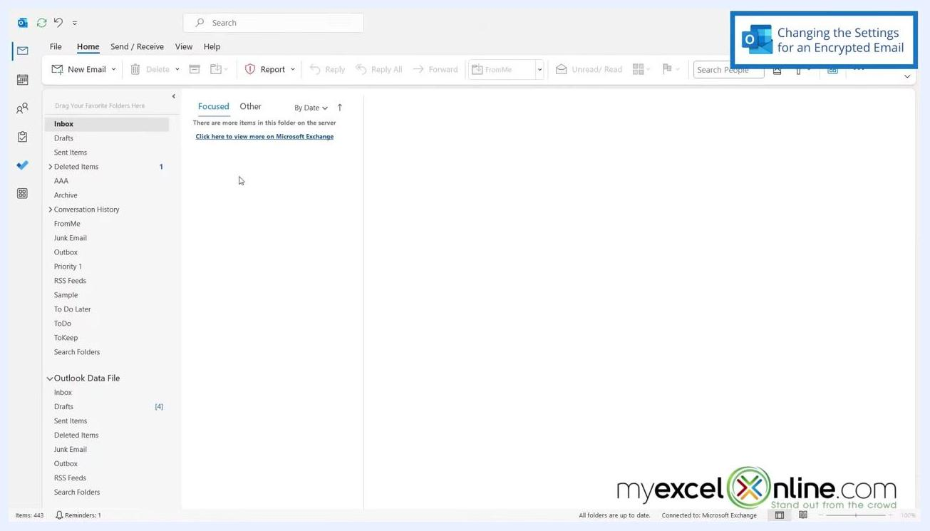
Title screen with Outlook logo and text: "How to Send Encrypted Microsoft Outlook Emails". myexcelonline.com branding at the bottom right.

Prerequisites
- You need Microsoft Outlook (desktop version) connected to a Microsoft 365 account.
- Your recipient must also use Outlook 365. Both sender and recipient need Outlook 365 for encrypted messages to work correctly.
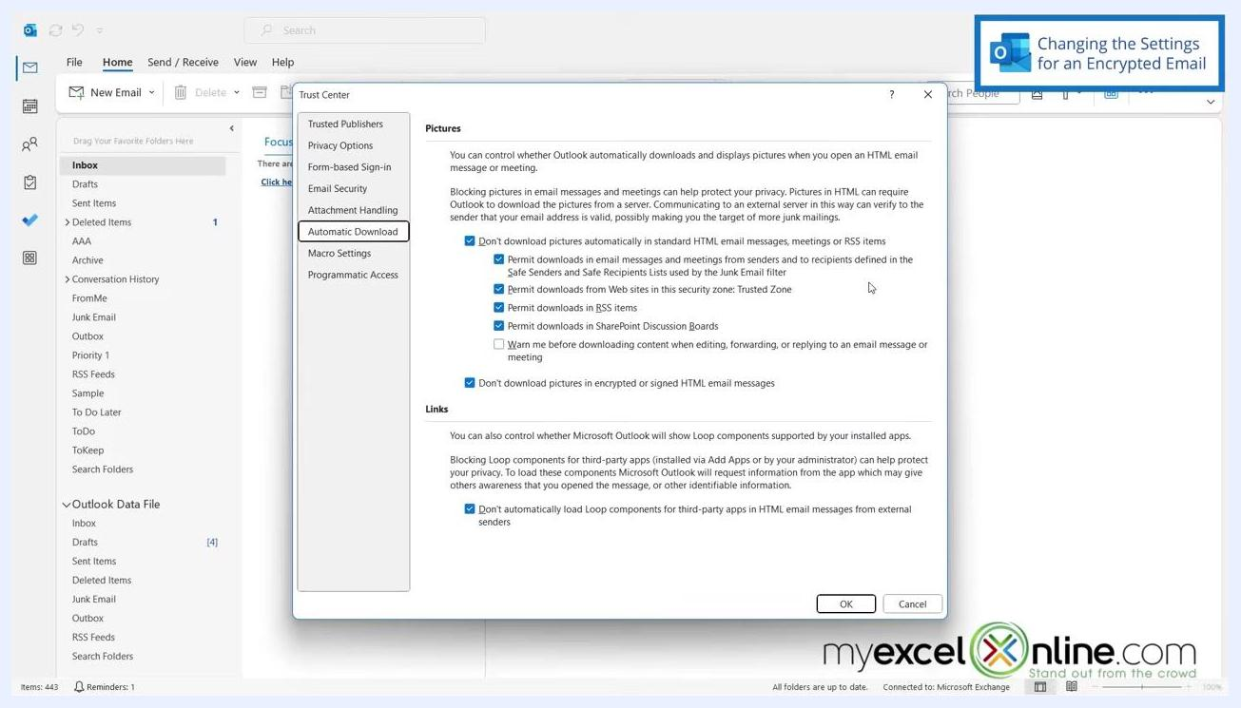
Trust Center dialog with Email Security selected, highlighting the Settings button for encrypted email.

Configuring the settings for an encrypted email
Before you can send a secure email in Outlook, you need to set up your encryption preferences in the Trust Center.

- Open File in the top-left corner of Outlook.
- Select Options to open the Outlook Options dialog.
- In the left sidebar, select Trust Center.
- Click Trust Center Settings to open the Trust Center dialog.
- In the Trust Center dialog, select Email Security from the left sidebar.
- Under the "Encrypted email" section, click Settings....
- In the Change Security Settings dialog, configure the following:
- Enter a name in the Security Settings Name field (for example, "MEO").
- Set Cryptography Format to S/MIME.
- Confirm or select your Signing Certificate and Encryption Certificate (for example, "Microsoft Your Phone").
- Set Hash Algorithm to SHA1.
- Set Encryption Algorithm to AES (256-bit).
- Make sure the checkbox for "Send these certificates with signed messages" is checked.

- Click OK to save your settings.
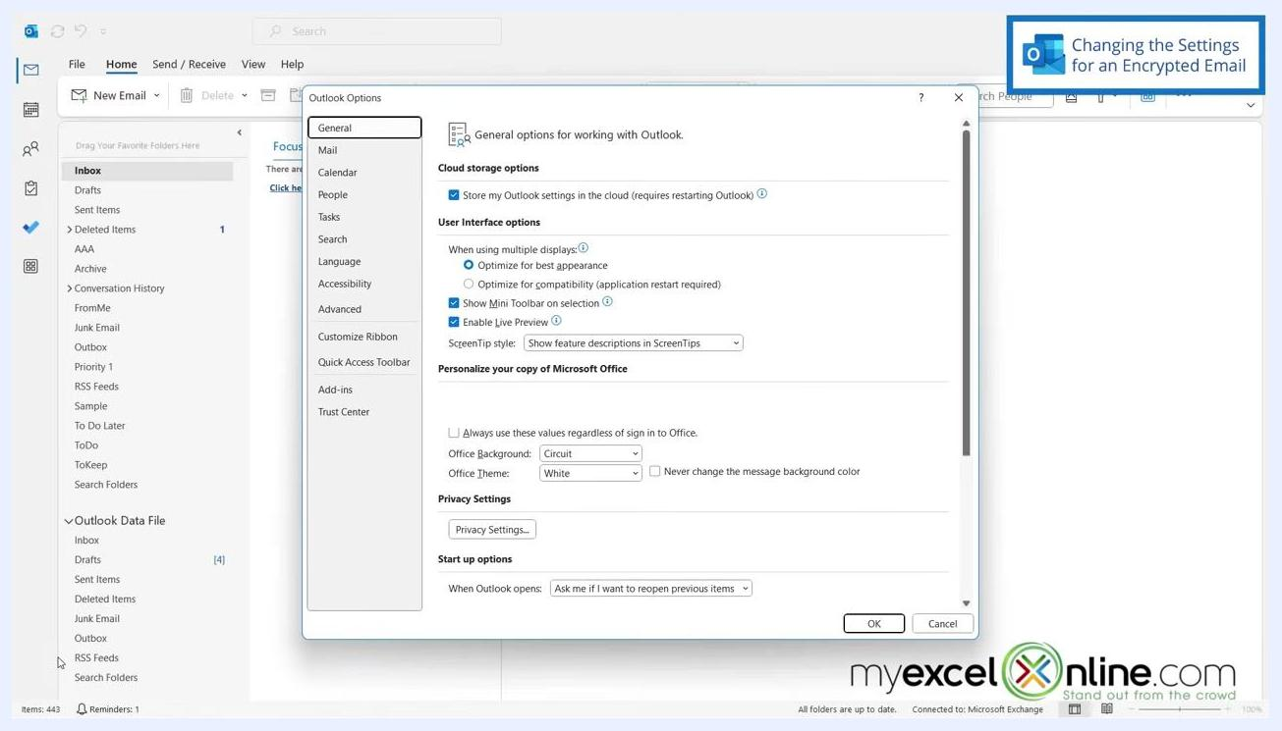
Outlook main window showing the Inbox, folder list, and a focused/other tabbed message list.
Outlook Options dialog open, showing various settings categories on the left, with Trust Center selected.

- Back in the Trust Center dialog, confirm that your new setting (for example, "MEO") now appears under Default Setting.
- Click OK to close the Trust Center dialog, then click OK again to close the Outlook Options dialog.
Outlook main window, identical to previous, emphasizing the need for both sender and recipient to use Outlook 365.
With these settings saved, Outlook is now configured to send encrypted emails using your chosen security settings.
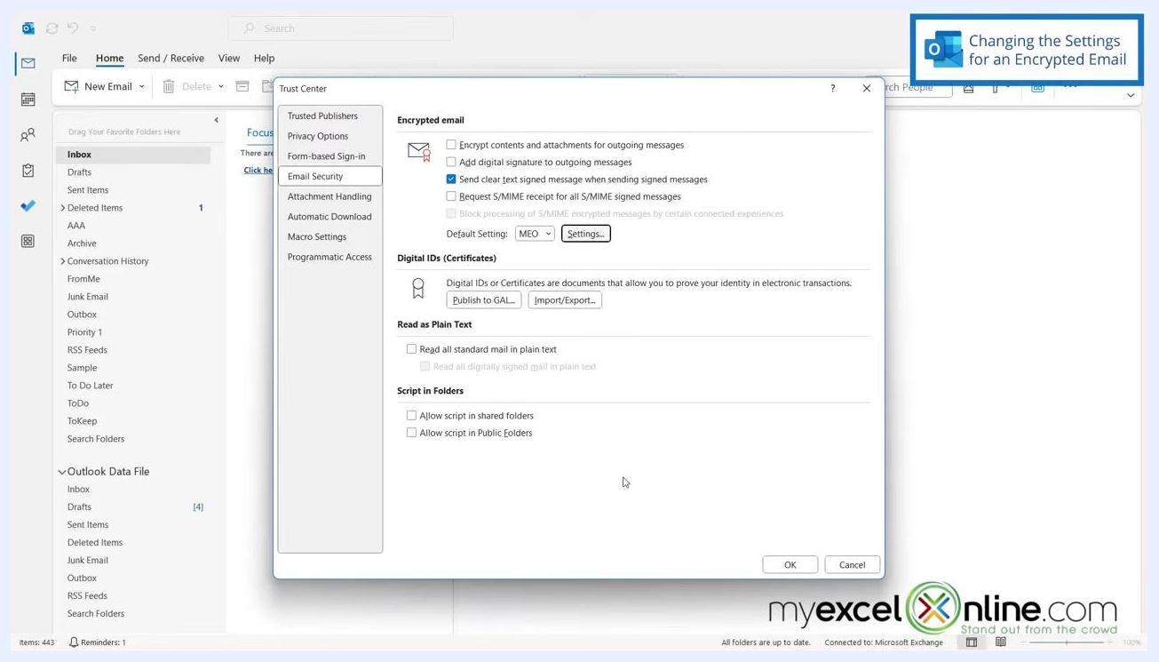
Trust Center dialog showing "Default Setting: MEO" under Encrypted email, ready to confirm with OK.

Writing and sending a secure email in Outlook

- Return to the main Outlook window and click New Email to open a new message.
- In the new message window, go to the Options tab on the ribbon.
New email window open in Outlook, with the Options tab visible and ready to select Encrypt.

- Under the Encrypt section, click the Encrypt button to open the encryption options dropdown.
- Select Encrypt with S/MIME from the dropdown menu. A tooltip may appear stating "Encrypt this message using S/MIME."
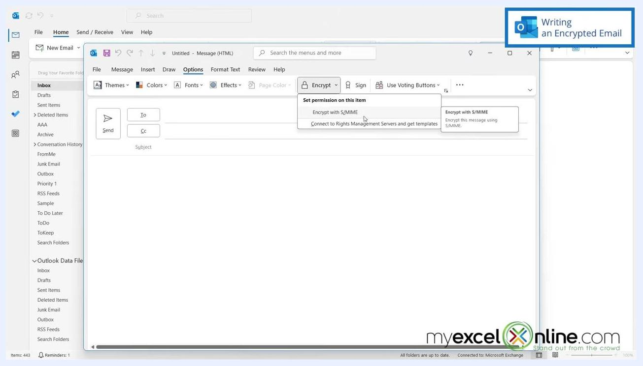
Outlook new message window with the Options tab selected, Encrypt dropdown open, and "Encrypt with S/MIME" highlighted with a tooltip visible.

- Confirm that the Encrypt button is now highlighted, which indicates encryption is enabled for this message.
- Compose your email as usual. It will be sent encrypted.
Outlook new message window with the Options tab open and the Encrypt button highlighted, ready to compose an encrypted email.

What's next
- To learn more about Microsoft Excel and Office, you can explore the MyExcelOnline Academy, which offers over 1,000 video training tutorials.
- A promotional offer of 60% off all courses is available, covering topics such as Intro to Excel, Formulas & Functions, Pivot Tables, Macros & VBA, Power Query, Power Pivot, Power BI, Charts, Data & Analysis, Financial Modeling, and Dashboards.
Outlook new message window, Options tab, Encrypt button highlighted, "Conclusion" label in top right.
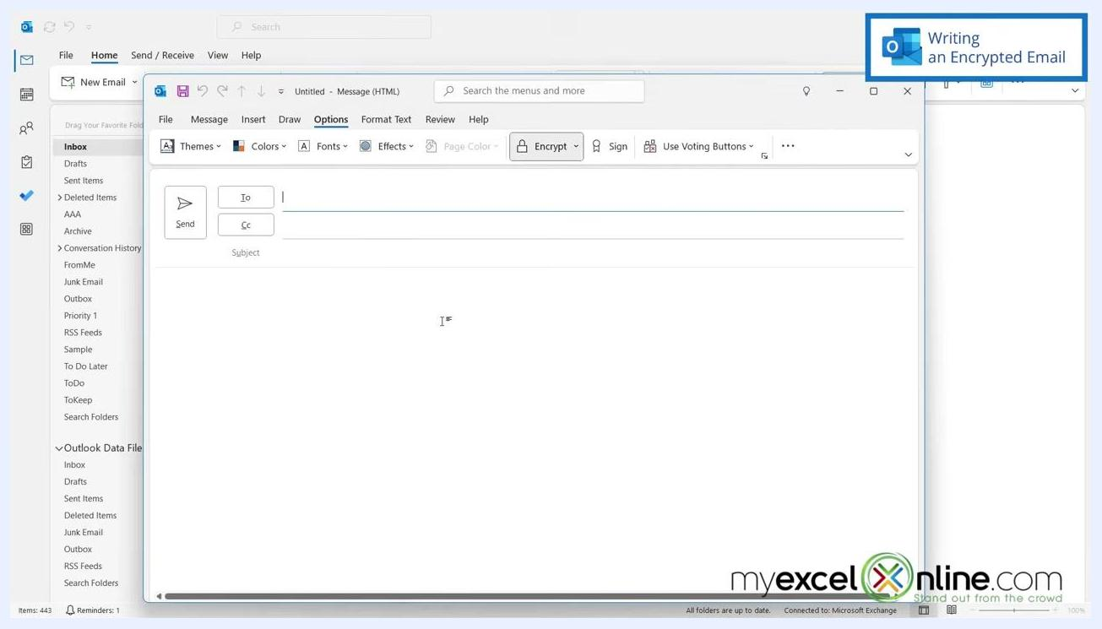
Promotional graphic showing "GET 60% OFF ALL COURSES!" alongside various Excel and Office course categories.
- Courses are also available for other Microsoft products, including Visio, Teams, SharePoint, Project, Power Automate, Power Apps, PowerPoint, Word, Outlook, Access, OneNote, and Forms.
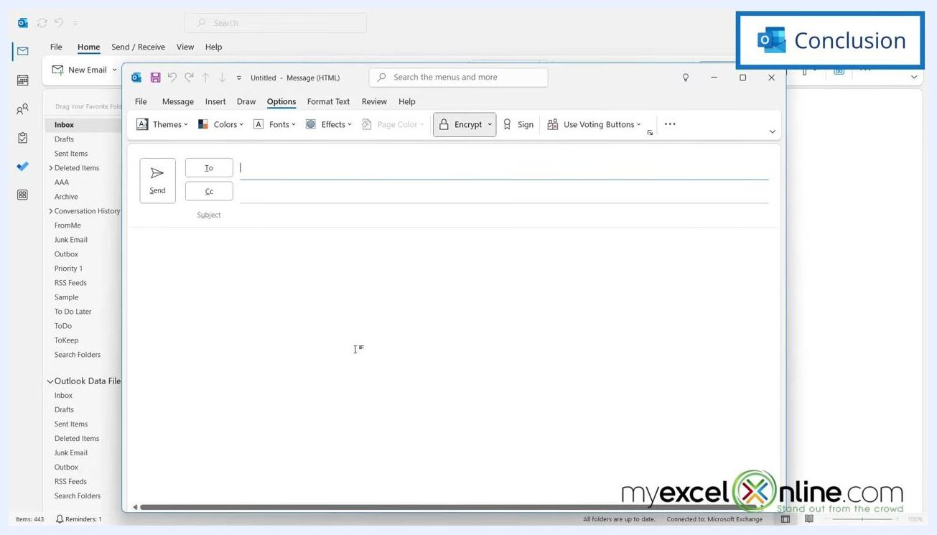
Promotional graphic showing "GET 60% OFF ALL COURSES!" alongside various Microsoft product course categories.

Summary
By following these steps, you've configured Outlook's Trust Center settings and learned how to send a secure email in Outlook using S/MIME encryption. Once your security settings are saved as the default, you can apply encryption to any new message from the Options tab before sending.
Change Security Settings dialog with "MEO" entered as the Security Settings Name, S/MIME format, SHA1 hash, AES (256-bit) encryption, and certificates selected.

Presenter in front of myexcelonline.com logo, "GET NOTIFIED" button and notification bell icon visible.
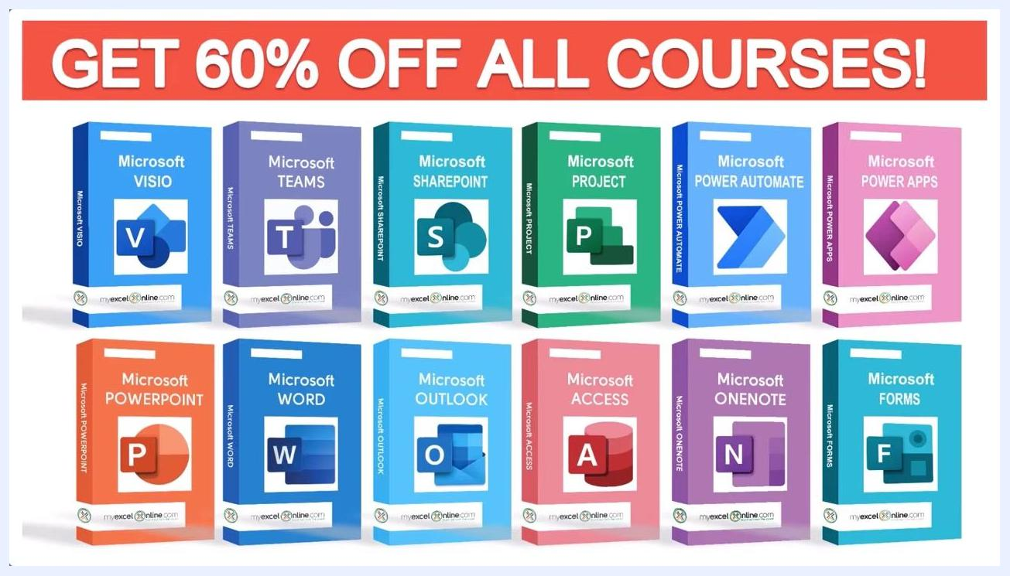
End screen with MyExcelOnline logo, subscribe button, and social media/contact information.

