How to recall mail in Outlook: recall, undo, or delete a sent email
If you've ever sent an email by mistake, you'll want to know how to recall mail in Outlook before the recipient reads it. This guide walks you through recalling a sent message, understanding when recall will and won't work, and setting up delayed delivery and undo send features so you have extra time to catch mistakes before an email actually leaves your outbox.
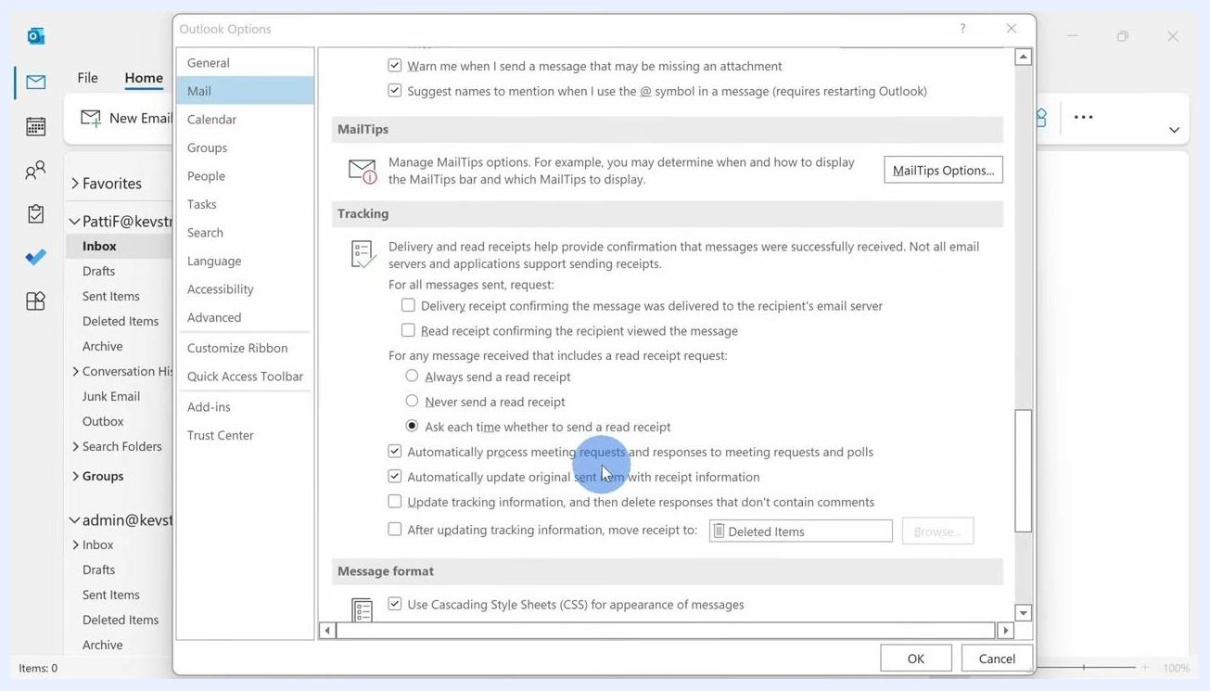
A close-up of the recall notification email stating that the sender would like to recall the message "YouTube Videos & Revenue."

Prerequisites
Before you try to recall a message, confirm the following:
- You and the recipient must both use Microsoft 365 or Microsoft Exchange accounts within the same organization or tenant. Recall does not work for external addresses, such as Gmail, or for recipients in a different company.
- The recipient must not have read the email yet.
- The recipient must be using the Outlook desktop application. If they use Outlook on the web or mobile, they will see both the original message and a notification that you tried to recall it, which can draw more attention to the message.
- The recipient's Outlook must have the default tracking setting enabled to automatically process this type of request. You can verify this under File > Options > Mail > Tracking, where "Automatically process meeting requests and responses to meeting requests and polls" should be checked.
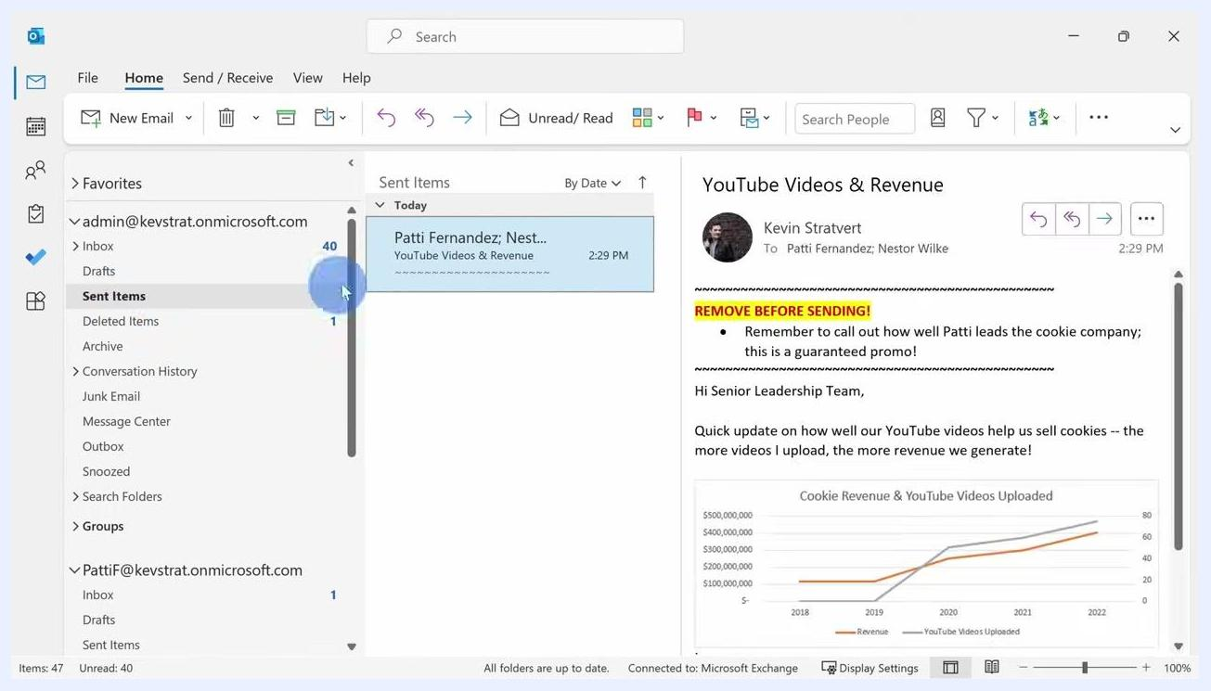
The Sent Items folder is selected, showing a sent email titled "YouTube Videos & Revenue" addressed to Patti Fernandez and Nestor Wilke. The email body is visible on the right, including a highlighted note reading "REMOVE BEFORE SENDING!"
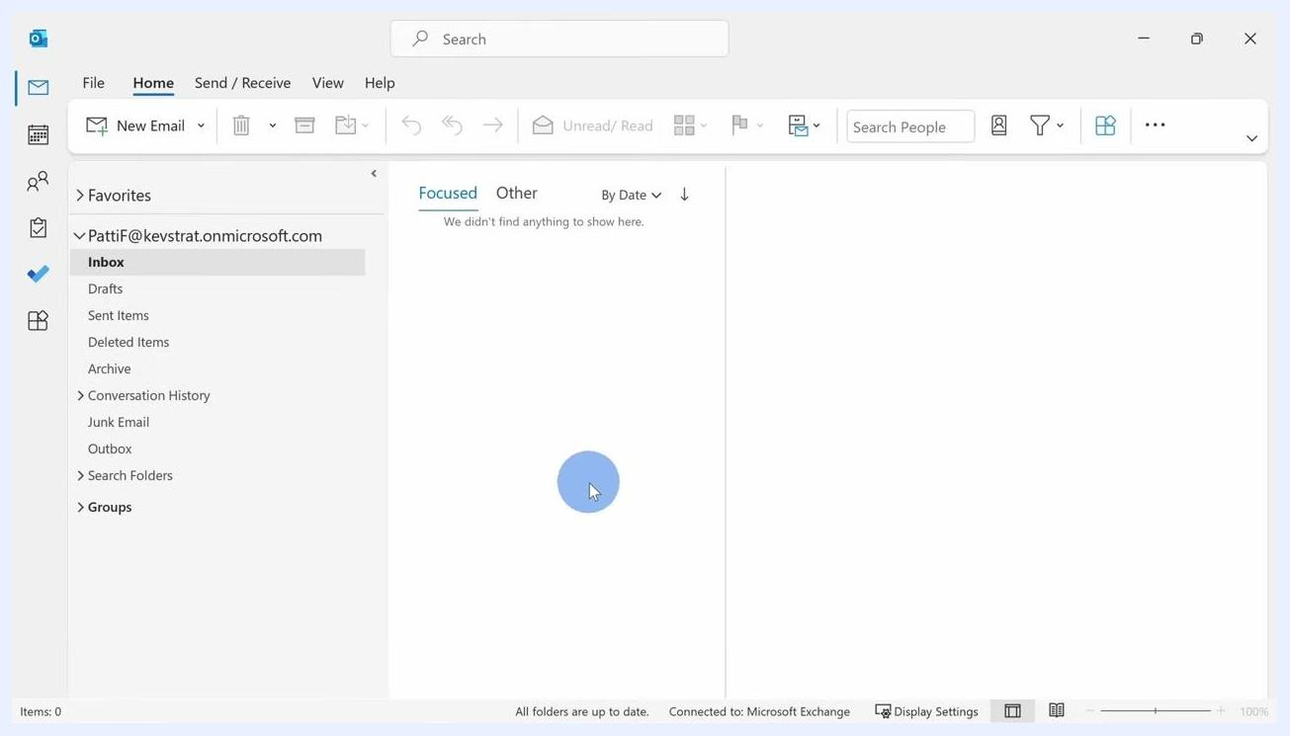
A presenter with a highlighted box on screen reading "MICROSOFT 365 OR EXCHANGE"
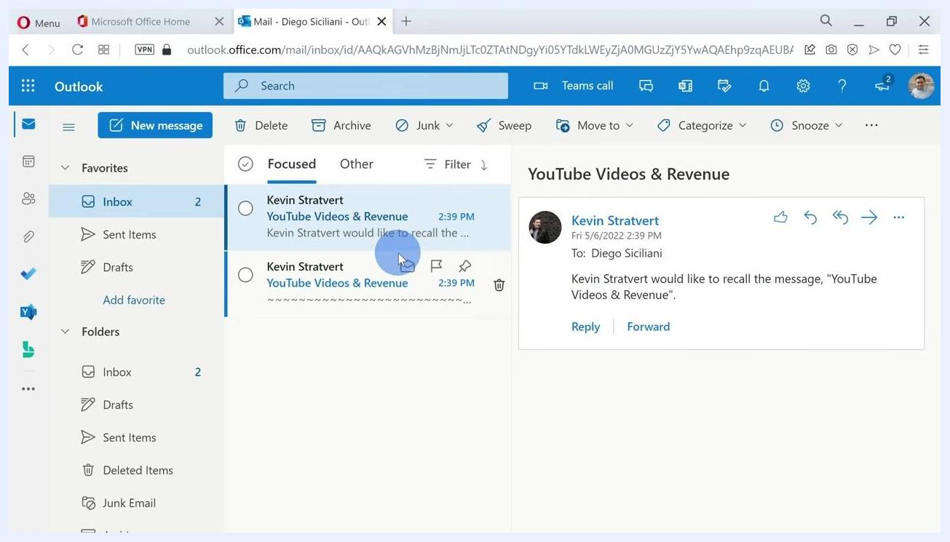
Presenter with a highlighted box reading "MICROSOFT 365 OR EXCHANGE" and "SAME ORGANIZATION OR TENANT"
Nighttime cityscape with multiple office buildings, representing different companies/tenants
The Outlook Options dialog is open to Mail > Tracking, showing the checkboxes that control automatic processing of recall requests.

How to recall a sent email in Outlook desktop
Follow these steps to recall, undo, or delete a message you've already sent.

1. Open Outlook and locate the sent email
Go to your Outlook application and click the Sent Items folder in the left navigation pane. Find the email you want to recall, then double-click it to open it in a new window.

2. Access the recall feature
In the opened email window, look at the top ribbon and locate the Actions menu (this may appear under "More Move Actions" depending on your Outlook version). Click Actions, then select Recall This Message... from the dropdown.
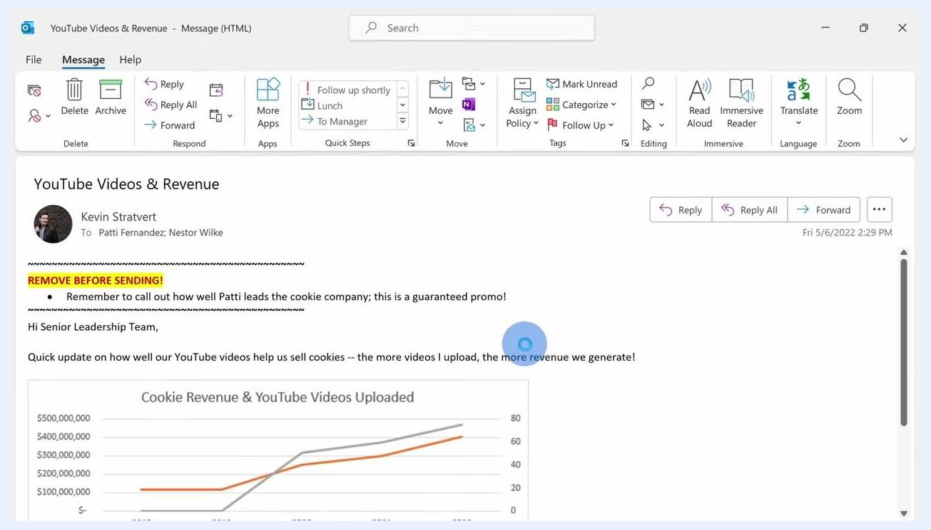
An opened email with a confirmation banner at the top stating that a recall attempt was made on a specific date and time. The original email content and the "REMOVE BEFORE SENDING!" note remain visible.

3. Choose your recall option
A prompt appears with two choices:
- Delete unread copies of this message
- Delete unread copies and replace with a new message
Select Delete unread copies of this message if you simply want to remove the email, then click OK.

4. View the recall confirmation
After you attempt the recall, a confirmation banner appears at the top of the email indicating that Outlook tried to recall the message, for example: "You tried to recall this message on Friday, May 6, 2022 2:32 PM."

Presenter smiling at the camera with the same pie chart visible, reinforcing the message about checking for errors in email

5. Use the alternative method with a simplified ribbon
If you're using the simplified ribbon and don't see the Actions menu, click the ellipsis (three dots) on the far right of the ribbon to open the overflow menu. Look for the Actions category in the dropdown and select Recall This Message... from there.
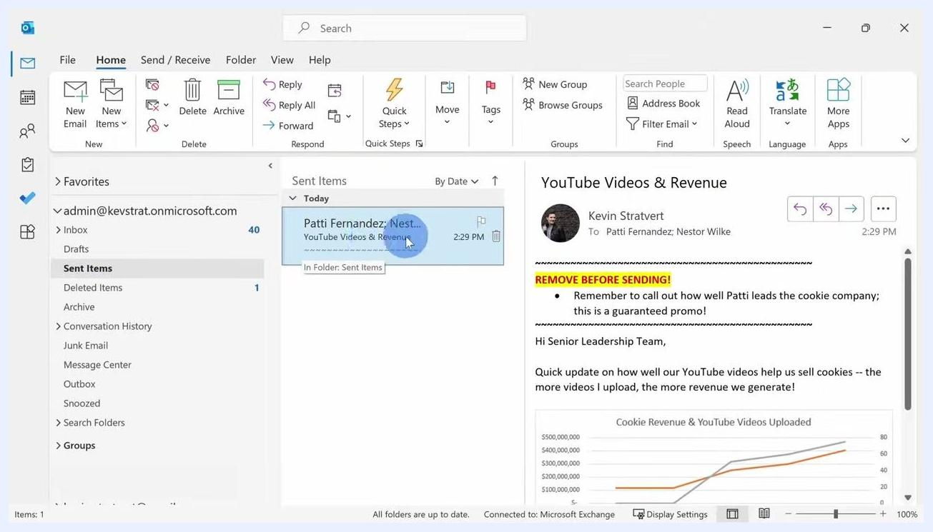
The Actions dropdown menu is open in the ribbon, with "Recall This Message..." highlighted. A tooltip explains that message recall can delete or replace copies of the message in recipient inboxes if it has not been read.

Why recall might not work
Recall only succeeds when specific conditions are met. Review these limitations before relying on it:
- Both you and the recipient must be on Microsoft 365 or Microsoft Exchange within the same organization or tenant.
- The email must still be unread by the recipient.
- The recipient must be using the Outlook desktop app; web or mobile users will see a recall notification alongside the original message instead of a clean removal.
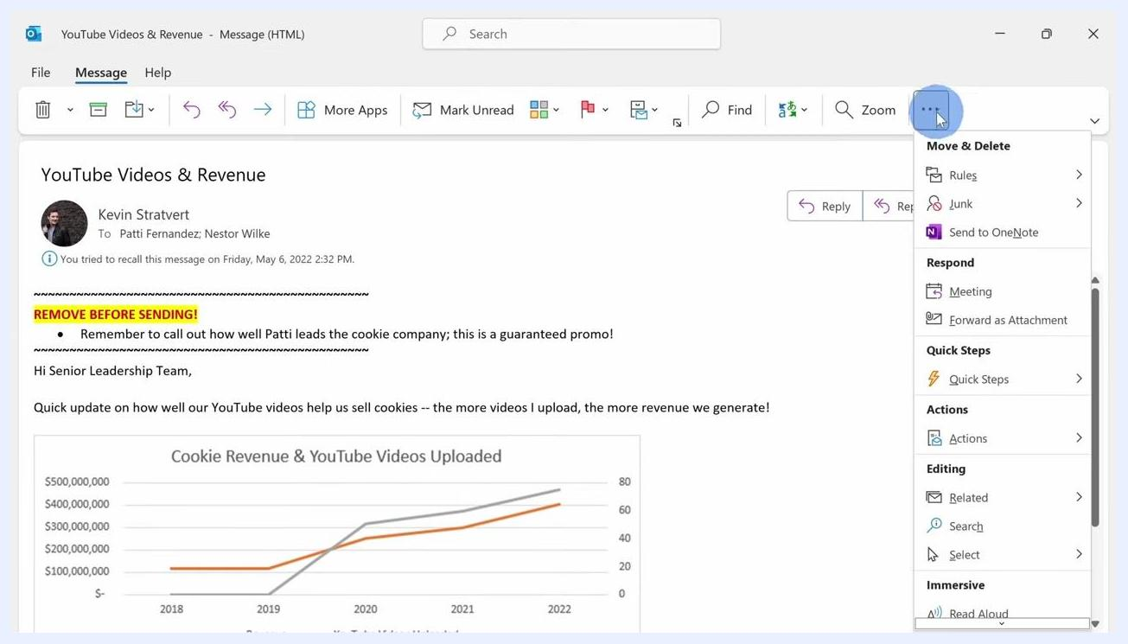
The overflow menu, opened by clicking the ellipsis, shows the Actions category with recall options.
Outlook on the web shows two messages in the inbox: the original email and a separate recall notification for "YouTube Videos & Revenue."
Even when every requirement is satisfied, recall is not guaranteed to succeed for other technical reasons. Because of this, it's worth setting up additional safeguards, such as delayed delivery.

Prevent mistakes with delayed email delivery
Setting a delay on outgoing messages gives you a window to catch and fix mistakes before an email is actually sent.

1. Compose your message
In Outlook, click New Email and draft your message as usual.
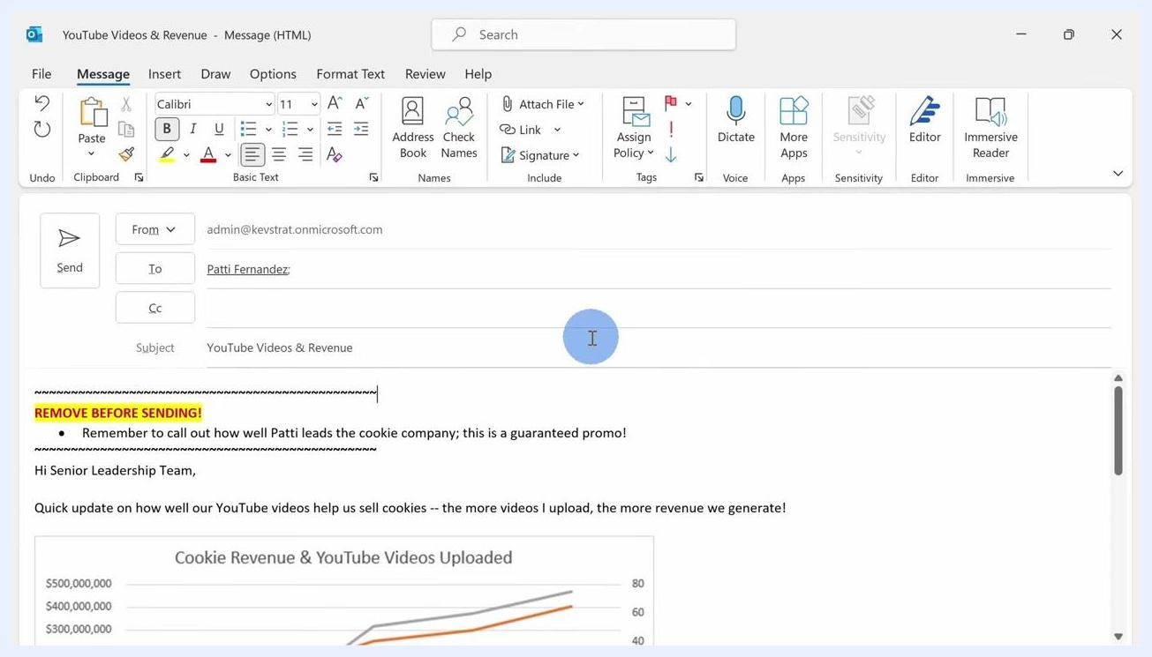
A new message window shows a subject line, a recipient, and a highlighted note reading "REMOVE BEFORE SENDING!"

2. Set a delivery delay
Go to the Options tab in the message ribbon and click Delay Delivery. In the Properties dialog, under Delivery options, check Do not deliver before and set the date and time you want the email to be sent. Click Close to save the settings.
The Properties dialog shows "Do not deliver before" checked, with a specific date and time set for delayed delivery.

3. Send the email
Click Send as usual. The email stays in your Outbox until the specified delivery time, giving you a chance to make changes or delete it before it actually goes out.

Animated outro screen with large 3D text 'KEVIN STRATVERT' on a dark, colorful background

Edit a delayed email before it sends
If you need to make changes after clicking Send but before the delivery time arrives, click the Outbox folder in the left navigation pane and locate your delayed message. Double-click it to open, make your edits, and click Send again to re-queue it. The message won't go out until the scheduled delivery time is reached.
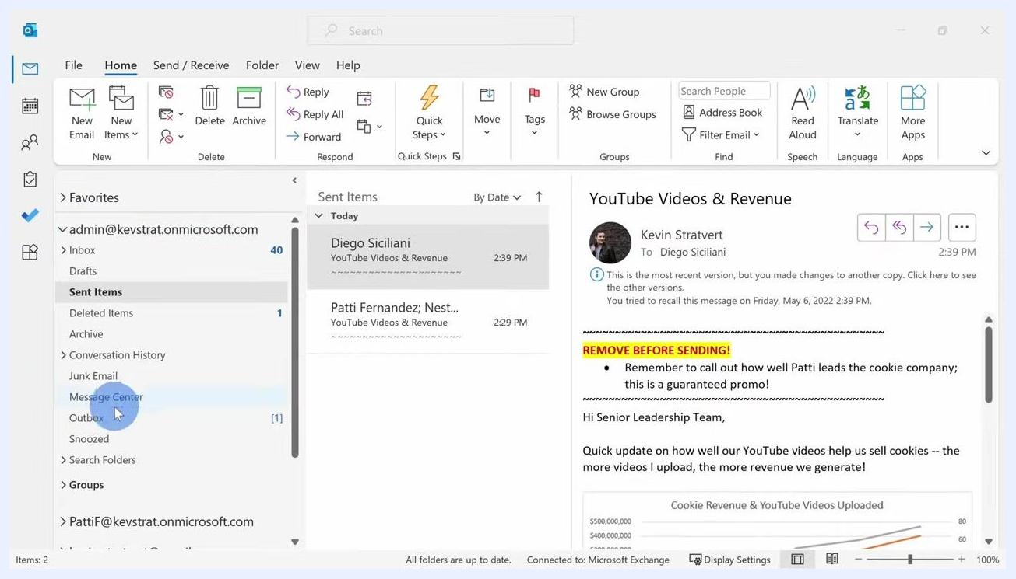
The Outbox folder is selected, showing a delayed message that is still available for editing before it is finally sent.

Automatically delay all outgoing emails
You can set up a rule so every email you send is automatically delayed, giving you a consistent buffer to catch mistakes.
Blue and white end screen with 'Subscribe' text and two empty rectangles for video suggestions

1. Open the Rules Wizard
Click the Home tab in the ribbon, then click Rules in the middle of the ribbon and select Manage Rules & Alerts. In the Rules and Alerts dialog, click New Rule.
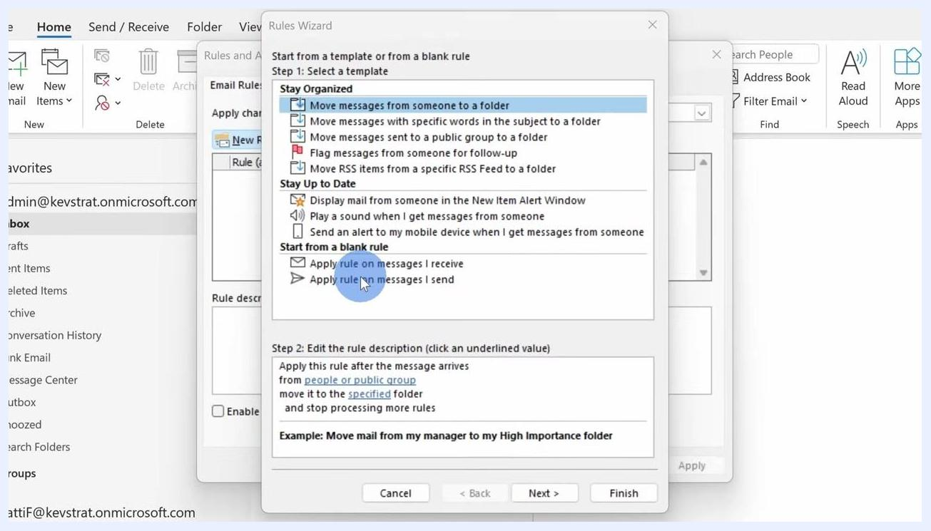
The Rules Wizard shows "Apply rule on messages I send" selected as the starting point for a new rule.

2. Apply the rule to messages you send
Under "Start from a blank rule," select Apply rule on messages I send, then click Next.
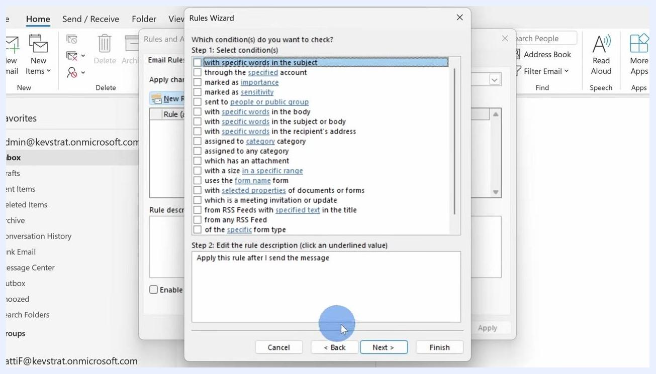
The Rules Wizard conditions screen has no conditions selected, so the rule will apply to all outgoing messages.

3. Skip conditions to apply the rule to all messages
On the conditions screen, leave all boxes unchecked so the rule applies to every outgoing message. Click Next, and if prompted to confirm the rule will apply to all messages, click Yes.
The Outlook Home tab is shown with Inbox selected, ready to begin creating a new rule.

4. Choose the defer delivery action
On the actions screen, check the box for defer delivery by a number of minutes.
The Rules Wizard actions screen lists available actions, including "defer delivery by a number of minutes."

5. Set the delay duration
Click the underlined "a number of minutes" link in the rule description. In the Deferred Delivery dialog, enter your desired delay, for example 2 minutes, and click OK.
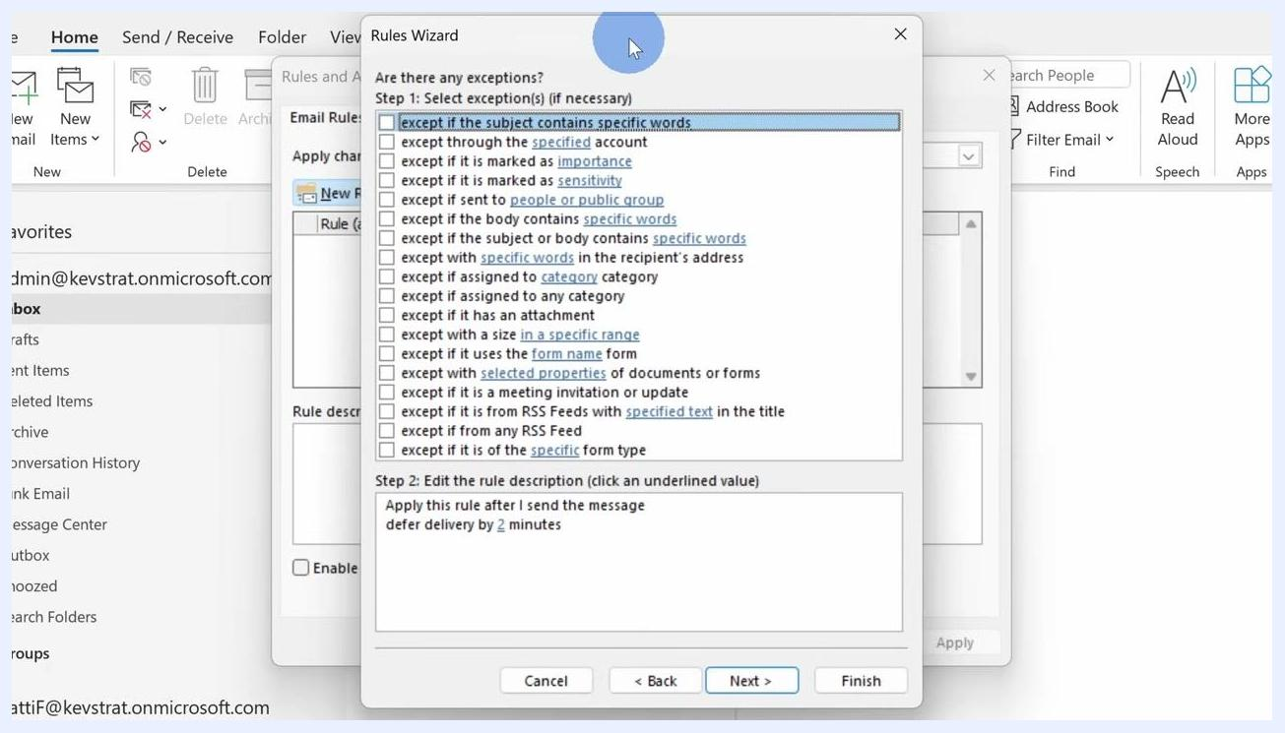
The Rules Wizard finish setup screen shows the rule named "Delay Sending emails," ready to be activated.

6. Skip exceptions
When the wizard asks, "Are there any exceptions?" leave all options unchecked if none are needed, then click Next.

7. Name and finish the rule
On the "Finish rule setup" screen, enter a name such as Delay Sending emails. Make sure Turn on this rule is checked, then click Finish.
This rule only applies to emails sent from the Outlook desktop app; it will not affect emails sent from other devices or from webmail.
The Deferred Delivery dialog shows "2" entered in the minutes field, with the OK button highlighted.

8. Test the rule
Send a test email. After clicking Send, the message appears in the Outbox folder. While it's there, you can open it to make changes or corrections before it actually sends.
The Rules Wizard exceptions screen shows no exceptions selected.
If you make changes, click Send again; the message will go out after the delay period you configured (in this example, 2 minutes).
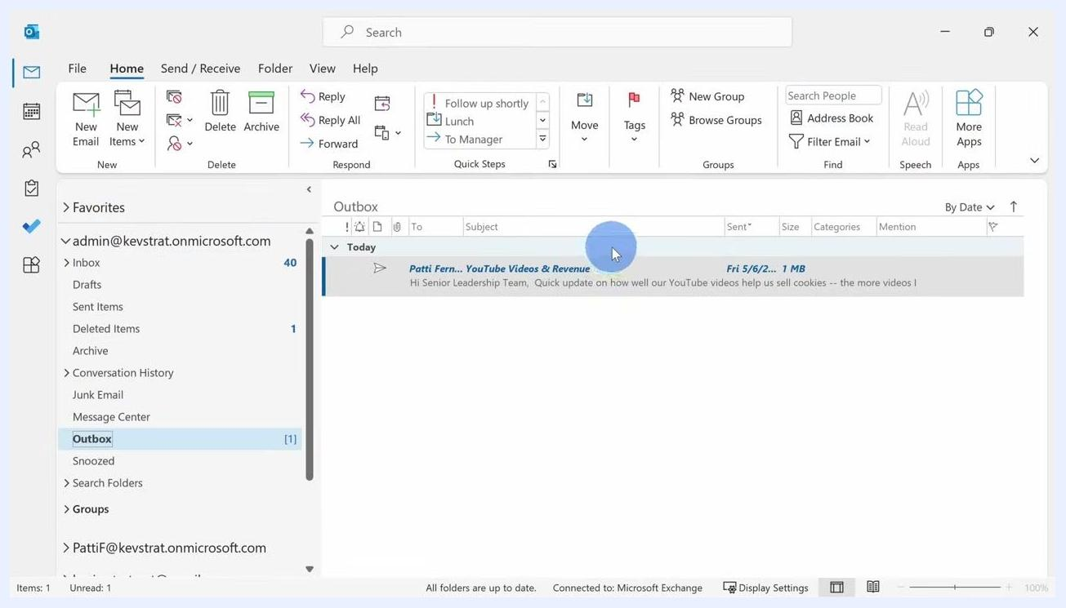
The Outbox folder shows a delayed message that is ready to be opened and edited.
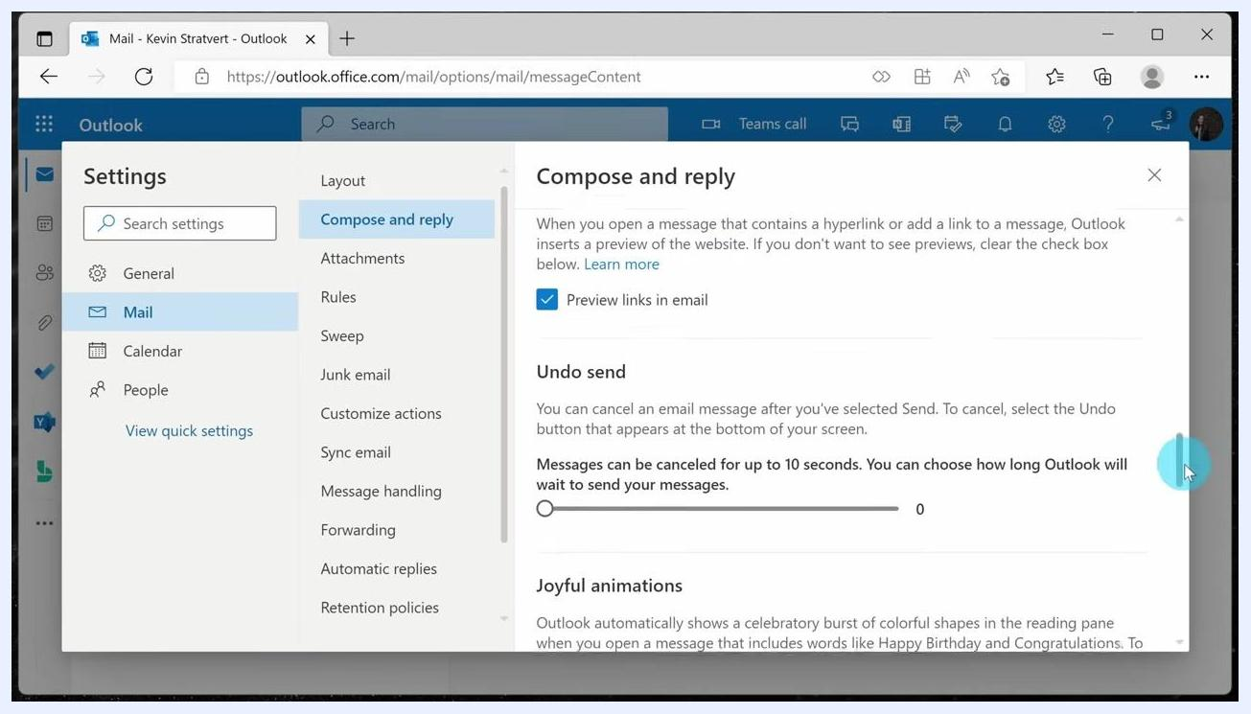
The Outbox shows the delayed message highlighted, ready to be sent once the 2-minute delay has passed.

Configure Undo Send in Outlook on the web
Outlook on the web offers a shorter, simpler alternative to the desktop delay rule.
An Outlook Web compose window shows a draft email ready to be sent, after which an Undo prompt will appear.

1. Open compose settings
Click the Settings icon and select View all Outlook settings. In the left pane, select Mail > Compose and reply.

2. Set your undo send buffer
Find the "Undo send" section and adjust the slider to set a buffer time of up to 10 seconds for canceling a sent message. This is a shorter window than the desktop delay rule.
Outlook Web settings show the "Compose and reply" section selected.

3. Cancel a message after sending
When you send an email in Outlook on the web, a prompt appears in the bottom-left corner. Click Undo within your configured buffer time to cancel sending the message.
The Undo Send slider in Outlook Web settings allows a buffer of up to 10 seconds.

Why this matters
Research from Kevin Cookie Company shows that most people check for errors in their emails after sending, rather than before. This is why recall, delayed delivery, and undo send are valuable safeguards: they give you a chance to catch mistakes during the window between sending a message and its actual delivery.
Presenter on camera, discussing the impact of sending emails at odd hours
Presenter pointing at a pie chart titled 'WHEN DO YOU CHECK FOR ERRORS IN EMAIL?' showing most errors are noticed after sending, with source cited as 'KEVIN COOKIE COMPANY RESEARCH'

What's next
Now that you know how to recall mail in Outlook, consider combining these approaches for the strongest protection against email mistakes:
- Use Recall This Message for one-off situations when a message has already been sent and the recipient meets the requirements.
- Set up an automatic delay rule in Outlook desktop so every message gives you a built-in buffer before it leaves your outbox.
- Enable Undo Send in Outlook on the web for a quick, short-window safety net when composing from a browser.
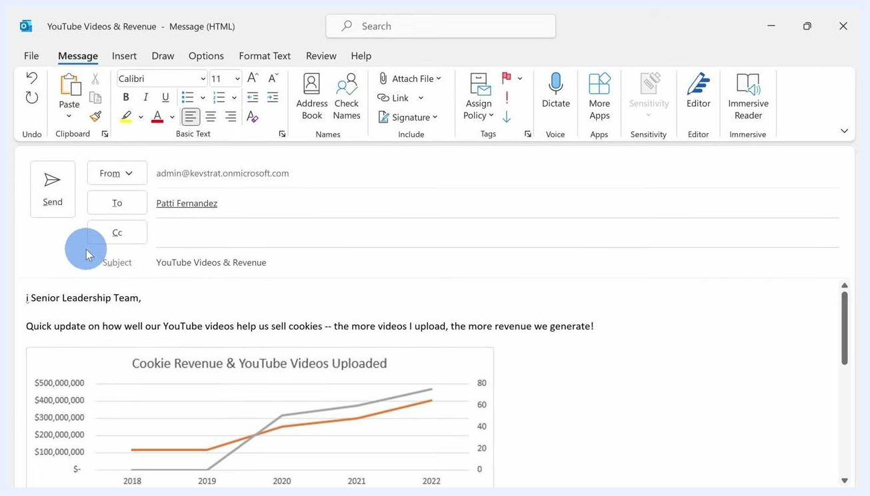
Office team gathered around a table, illustrating teamwork and work-life balance
Rules Wizard window with 'defer delivery by a number of minutes' selected

