How to Set Up and Manage a Team in Microsoft Teams
This guide walks you through creating a team in Microsoft Teams, adding members (including guests), setting up channels, and customizing your team's settings for effective collaboration.

Prerequisites
- Access to Microsoft Teams.
- Permission to create a team within your organization.
- Email addresses for any guests you want to invite from outside your organization.
- Note: You must be a team owner to invite guests. If you create the team, you are automatically assigned as the owner.

Creating your team

Step 1: Open Microsoft Teams and navigate to Teams
Launch Microsoft Teams and select the Teams icon from the left sidebar to view your existing teams and channels. You will see a list of existing teams and channels, along with options to add people or create more channels.
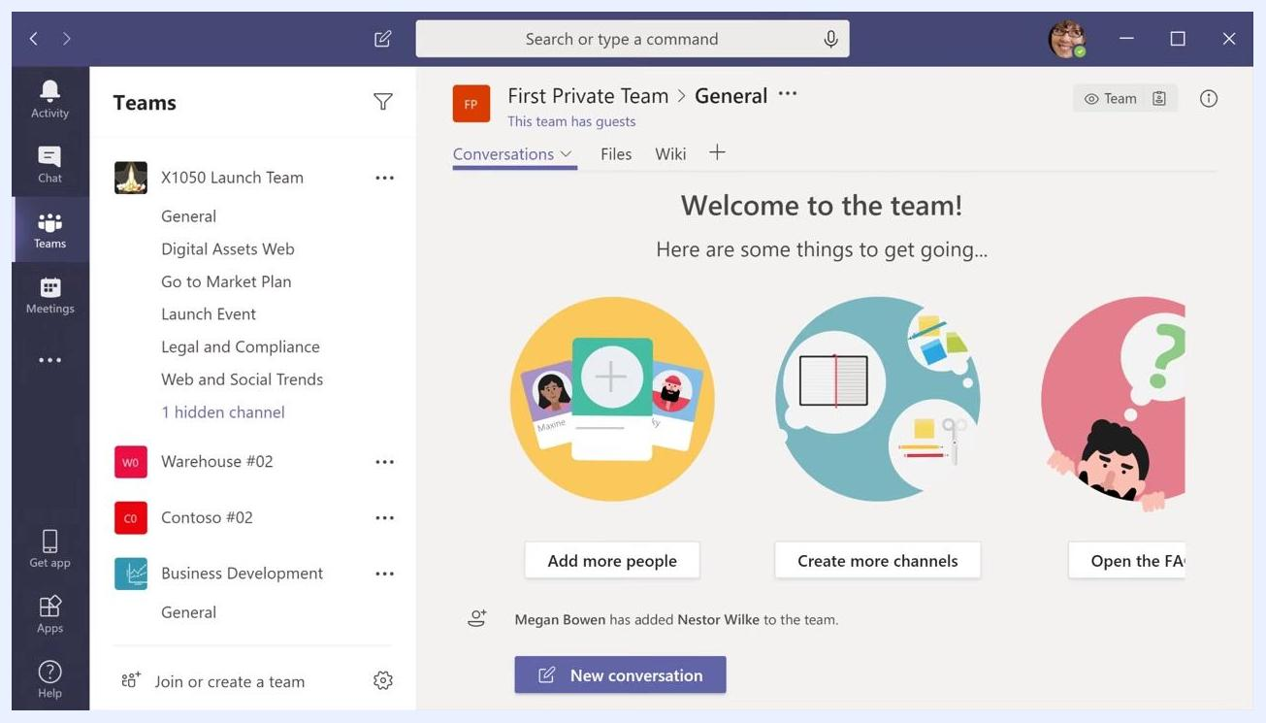
Microsoft Teams main interface showing the Teams tab selected, a list of teams and channels, and options to add people or create channels

Step 2: Join or create a team
At the bottom of the Teams list, select Join or create a team.
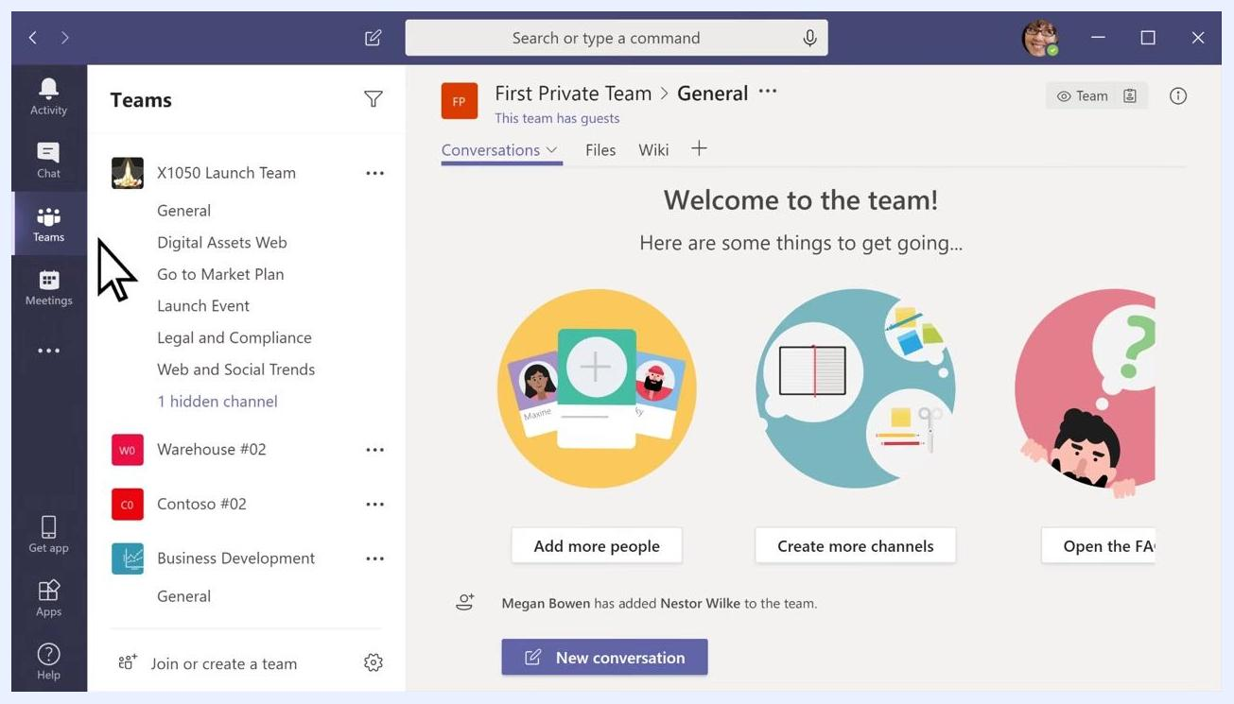
Cursor pointing to the Teams tab, highlighting navigation to join or create a team

Step 3: Create a new team
Select Create a new team, then choose whether to build the team from scratch or from an existing group.

Step 4: Set team privacy
Decide on the privacy level for your team:
- Private: People need permission to join.
- Public: Anyone in your organization can join.
- Org-wide: Everyone in your organization automatically joins.
Select the option that best fits your needs.
Dialog box asking "What kind of team will this be?" with options for Private, Public, and Org-wide teams

Step 5: Name and describe your team
Enter a team name and an optional description, then select Create to finalize the team setup.

Adding members and guests

Step 6: Add members to your team
In the "Add members" dialog, start typing names, distribution lists, or security groups to add people from your organization. To invite people from outside your organization, type their email addresses to add them as guests.
Add members dialog showing internal members being added to the team

Step 7: Add guests and set display names
For each guest, you can edit their display name for clarity. Click the pencil icon next to the guest's name, enter a friendly display name, and confirm the change.
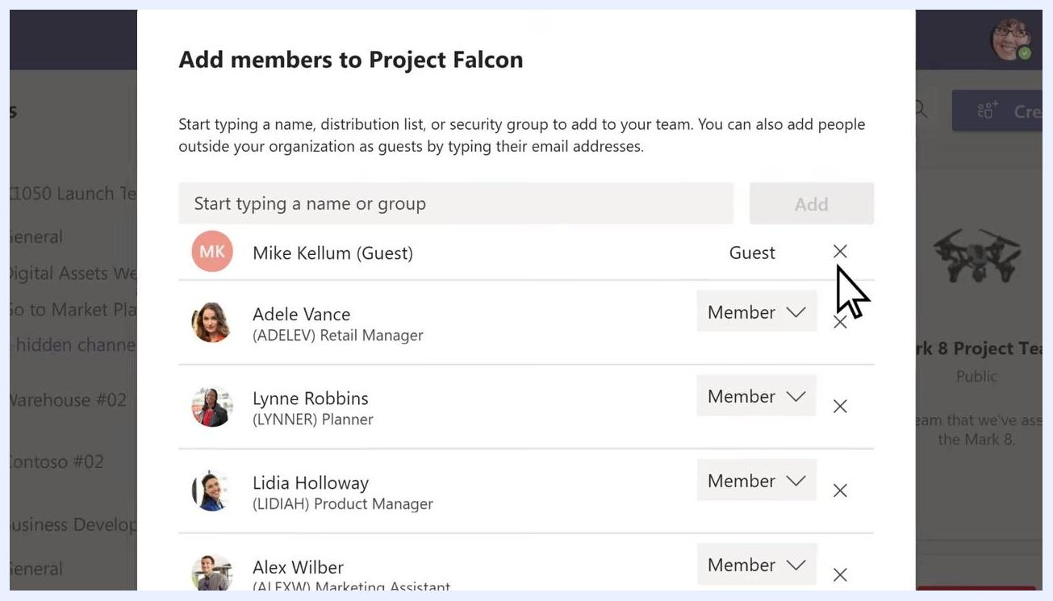
Edit guest information dialog with a guest's display name being set

Step 8: Review team members and roles
Review the list of added members and their assigned roles (Member or Guest), and adjust roles if necessary.
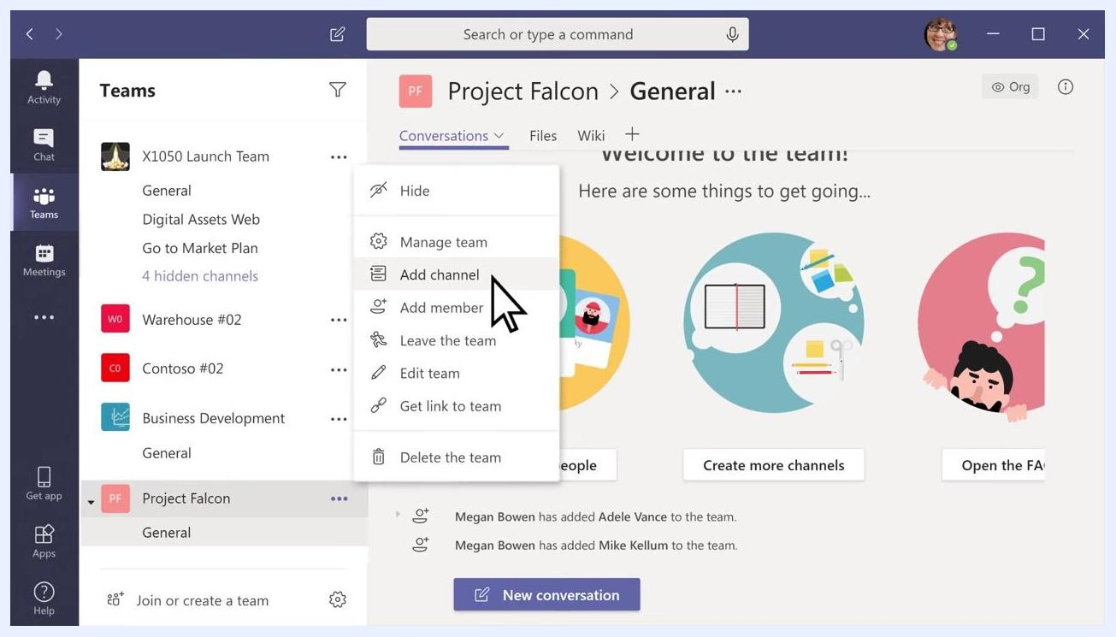
List of team members showing names, roles (Member/Guest), and the option to remove members

Setting up channels

Step 9: Understand default channels
Every new team automatically includes a General channel. Use this channel for information and announcements relevant to the whole team.
Project Falcon team interface showing the General channel and options to add people or channels

Step 10: Add additional channels
To create a new channel, select the three dots (More Options) next to your team name, then choose Add channel from the dropdown menu.
Dropdown menu with "Add channel" highlighted under More Options for the team

Step 11: Configure channel details
Enter a channel name (letters, numbers, and spaces are allowed) and, optionally, a description to help others understand the channel's purpose. Set the privacy level for the channel (Standard makes it accessible to everyone on the team), and decide whether it should automatically appear in everyone's channel list by checking the corresponding box.
Create a channel dialog with fields for channel name, description, privacy, and an option to automatically show the channel

Step 12: Finalize channel creation
For example, enter "Product Specs" as the channel name and "Specifications for Project Falcon" as the description. Ensure "Standard – Accessible to everyone on the team" is selected for privacy, and check "Automatically show this channel in everyone's channel list" if you want it visible by default. Click Add to create the channel.
Create a channel dialog filled out with "Product Specs" as the channel name, description, privacy set to Standard, and the automatic show option checked
By completing these steps, you will have created a team, added members (including guests), and set up channels tailored to your team's needs.

Managing and customizing your team
After setting up your team and channels, you can further personalize and manage it using the following options.

Step 13: Access more options for your team
Locate your team in the Teams list (for example, "Project Falcon") and click the three dots (More Options) next to your team name. A dropdown menu appears with several management options, including:
- Manage team
- Add channel
- Add member
- Leave the team
- Edit team
- Get link to team
- Delete the team
Select Manage team to access all management and customization features in one place.
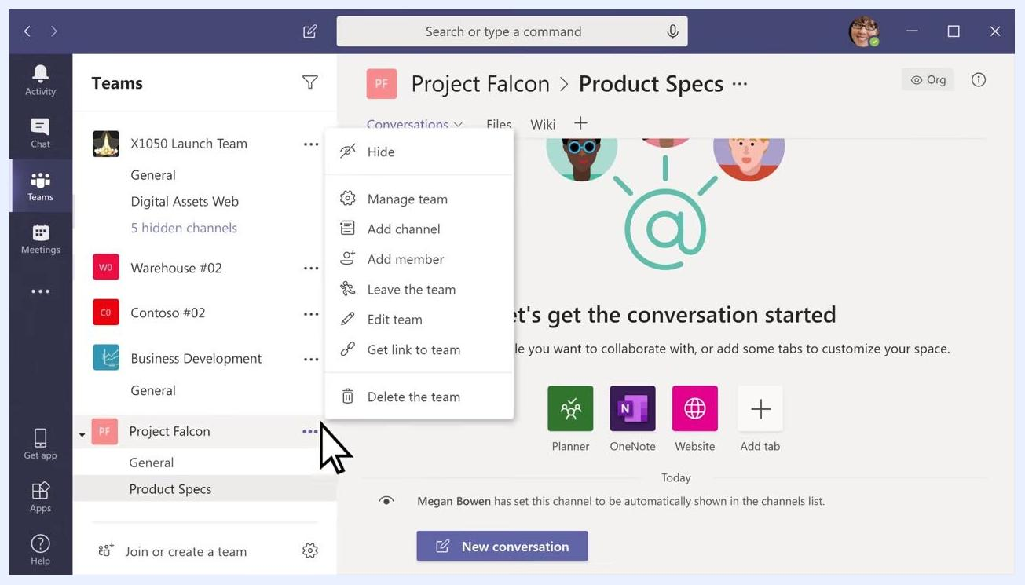
Teams interface with the More Options menu open for "Project Falcon", showing options like Manage team, Add channel, Add member, Edit team, and Delete the team

Step 14: Customize team settings
In the Manage Team view, select the Settings tab. Here, you can configure several options:
- Team picture: Add or change a team picture to give your team some personality.
- Member permissions: Enable or restrict channel creation, app additions, and more for team members.
- Guest permissions: Control whether guests can create channels.
- @mentions: Choose who can use @team and @channel mentions.
- Team code: Generate a code for others to join the team directly.
- Fun stuff: Allow or restrict emojis, memes, GIFs, or stickers.
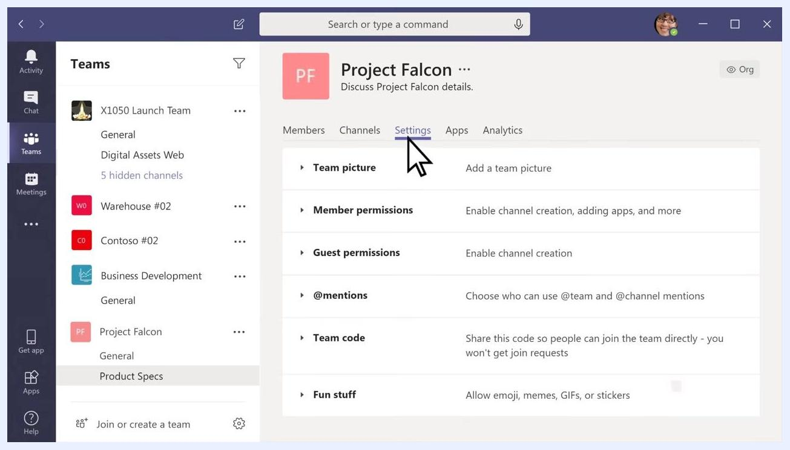
Manage Team Settings tab open for "Project Falcon", showing options for Team picture, Member permissions, Guest permissions, @mentions, Team code, and Fun stuff

Step 15: Add or change a team picture
Under the Team picture section, click Change picture and upload or select an image to represent your team. The new team picture will appear next to your team name in the Teams list and in the team header.
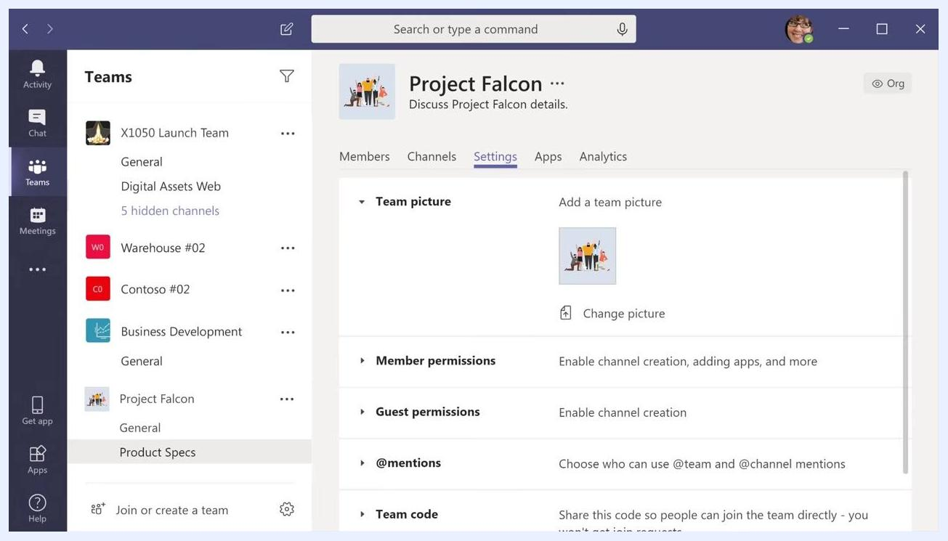
Team picture successfully added for "Project Falcon" in the Settings tab, with the new image displayed

Summary
With a team name, added members and channels, and a personalized team picture, your team setup is complete and ready for collaboration. Following these steps ensures your Microsoft Teams environment is both functional and tailored to your team's needs.

