Updating Excel Tables from Microsoft Power Automate
This guide walks you through automating updates to an Excel table stored in OneDrive using Microsoft Power Automate. You'll build an instant flow that collects user input and adds it as a new row to your Excel table, then verify the results directly in the spreadsheet.

Prerequisites
- Access to Microsoft Power Automate with an organizational account.
- An Excel file stored in OneDrive containing a formatted table.
- Basic familiarity with the Power Automate interface.

Step 1: Access Microsoft Power Automate
Open your web browser and navigate to Microsoft Power Automate. Make sure you are logged in with your organizational account.
The home screen displays navigation options such as Home, Action items, My flows, Create, Templates, Connectors, Data, AI Builder, Solutions, and Learn in the left sidebar. The main area includes a search bar, template collections, and popular services like SharePoint, Office 365 Outlook, OneDrive, Twitter, Dropbox, Outlook.com, Dynamics 365, Yammer, Excel Online (Business), and Wunderlist.

Microsoft Power Automate home screen showing the navigation sidebar, search bar, featured template collections, and icons for popular connected services

Step 2: Prepare your Excel sheet in OneDrive
Create a simple Excel sheet in OneDrive with the following columns: ID, Name, and Sale.
Enter sample data to start the table:
- ID: 1
- Name: Angela
- Sale: 7000
Save the Excel file in OneDrive once your table is set up.
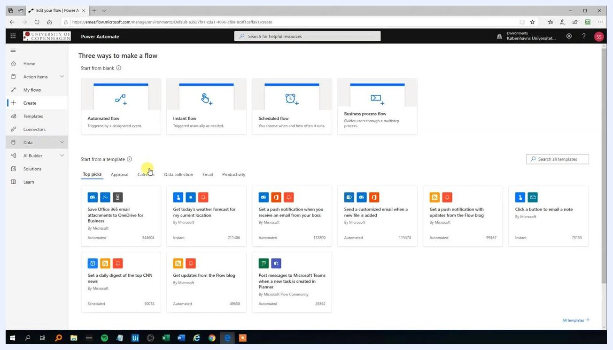
Excel Online sheet in OneDrive with columns ID, Name, and Sale, containing sample data: 1, Angela, 7000

Step 3: Start creating a new flow
Return to Microsoft Power Automate and click Create in the left sidebar. Under "Three ways to make a flow," select Instant flow, which is triggered manually as needed.
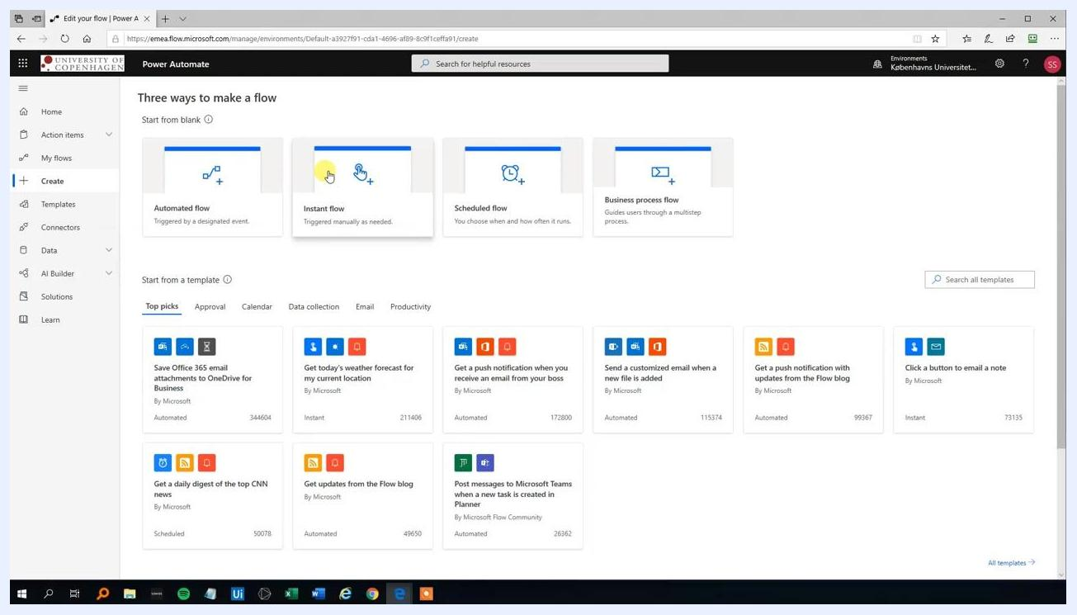
Power Automate "Create" screen displaying flow type options: Automated flow, Instant flow, Scheduled flow, and Business process flow, with Instant flow highlighted

Step 4: Configure the flow trigger
In the "Build an instant flow" dialog, enter the flow name UpdateExcelTable and choose Manually trigger a flow as the trigger. Click Create to proceed.
Dialog for building an instant flow, showing the flow name "UpdateExcelTable" with "Manually trigger a flow" selected

Step 5: Add user input fields
In the flow editor, under Manually trigger a flow, add input fields to capture user data. Click Text to add the first input field and name it ID to serve as the unique identifier.
Add the remaining input fields as needed:
- Name (Text)
- Sale (Number)
Power Automate flow editor showing "Manually trigger a flow" with options to add input fields: Text, Yes/No, File, Email, Number, and Date

Step 6: Configure input field details
For each input field, specify the label and data type:
- ID: Text
- Name: Text
- Sale: Number
Ensure each field is clearly labeled so users know exactly what data to enter.
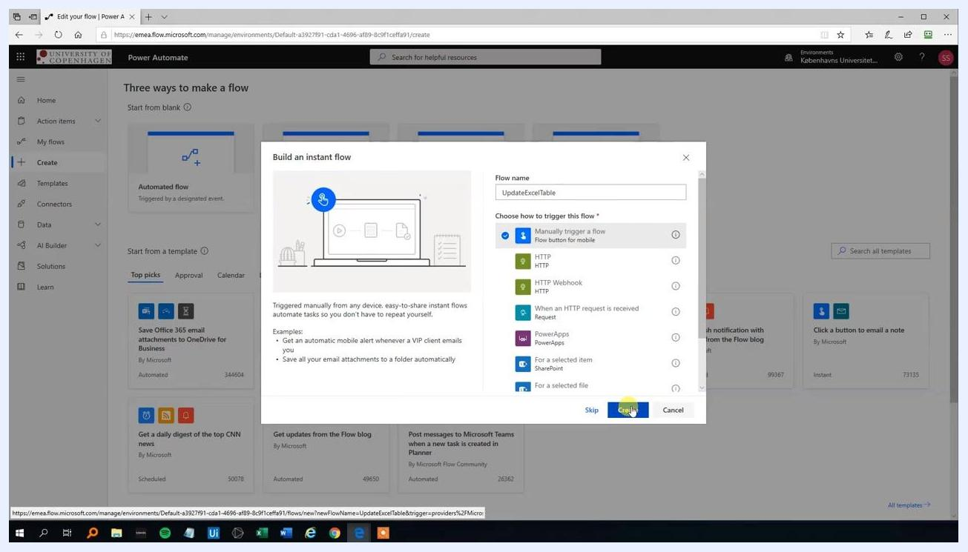
Power Automate flow editor with the "ID" input field added, along with options to add further input fields

Step 7: Add the "Add a row into a table" action
Once your input fields are configured, users will be prompted to enter ID, Name, and Sale data when running the flow. Click + New step to add the next action.
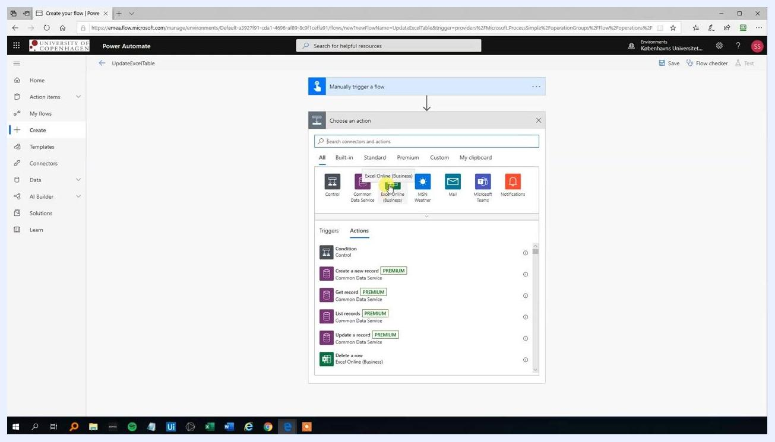
Power Automate flow editor showing "Manually trigger a flow" with input fields for ID, Name, and Sale, plus the "+ New step" and "Save" buttons below
In the "Choose an action" screen, search for Excel Online (Business) and select it from the list of connectors.
Action selection screen in Power Automate with Excel Online (Business) highlighted among the available connectors
Under the Actions tab, scroll down and select Add a row into a table.
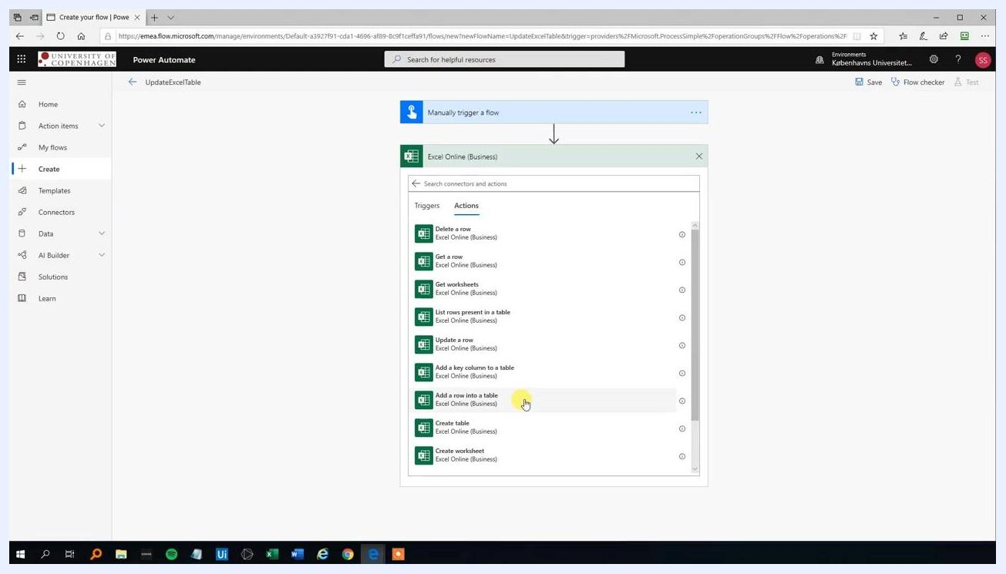
Excel Online (Business) actions list with "Add a row into a table" highlighted

Step 8: Configure the Excel table details
In the "Add a row into a table" action, configure the following fields:
- Location: Select OneDrive for Business from the dropdown.
- Document Library: Choose OneDrive.
- File: Browse to and select your Excel file. In this example, the file path is /Anders_PowerAutomate/Sales.xlsx.
- Table: Select the table where data will be added. In this example, choose PersonalSales from the dropdown.
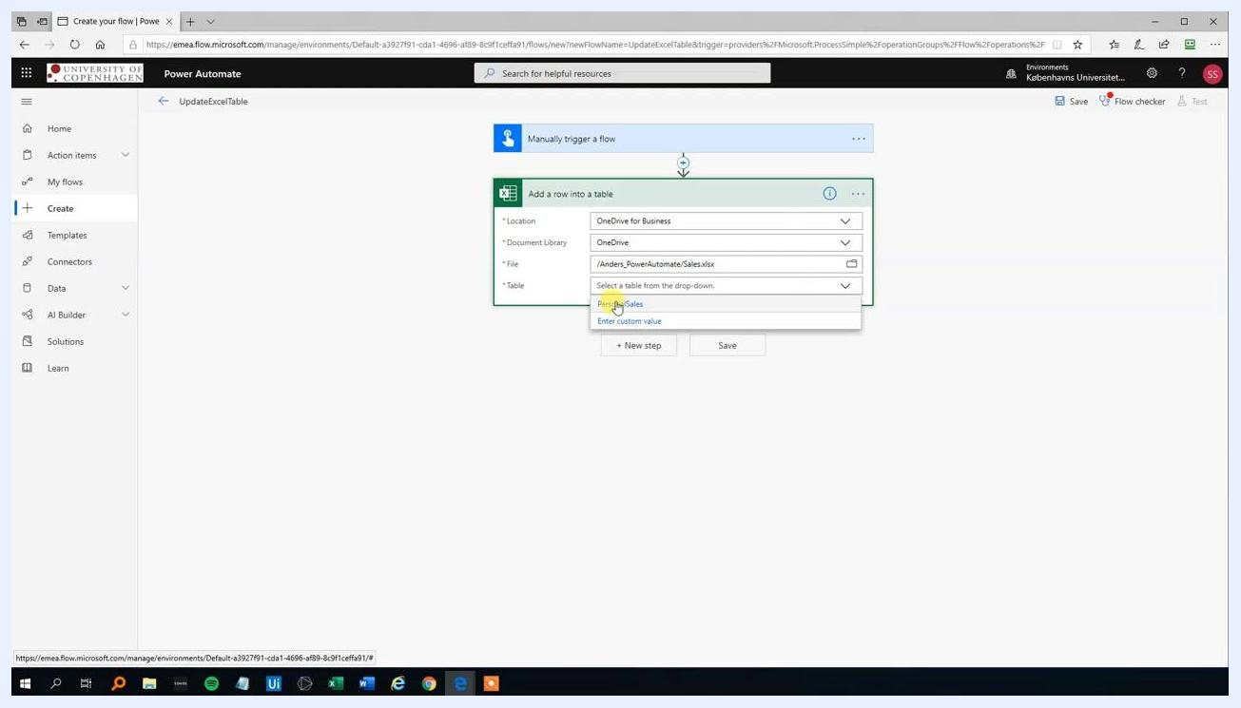
Power Automate "Add a row into a table" action with Location set to OneDrive for Business, Document Library set to OneDrive, File set to /Anders_PowerAutomate/Sales.xlsx, and the Table dropdown showing PersonalSales

Step 9: Map user input fields to Excel table columns
Map each user input field to the corresponding Excel table column:
- Set ID to the dynamic content ID.
- Set Name to the dynamic content Name.
- Set Sale to the dynamic content Sale.
Double-check that all fields are correctly mapped before proceeding.
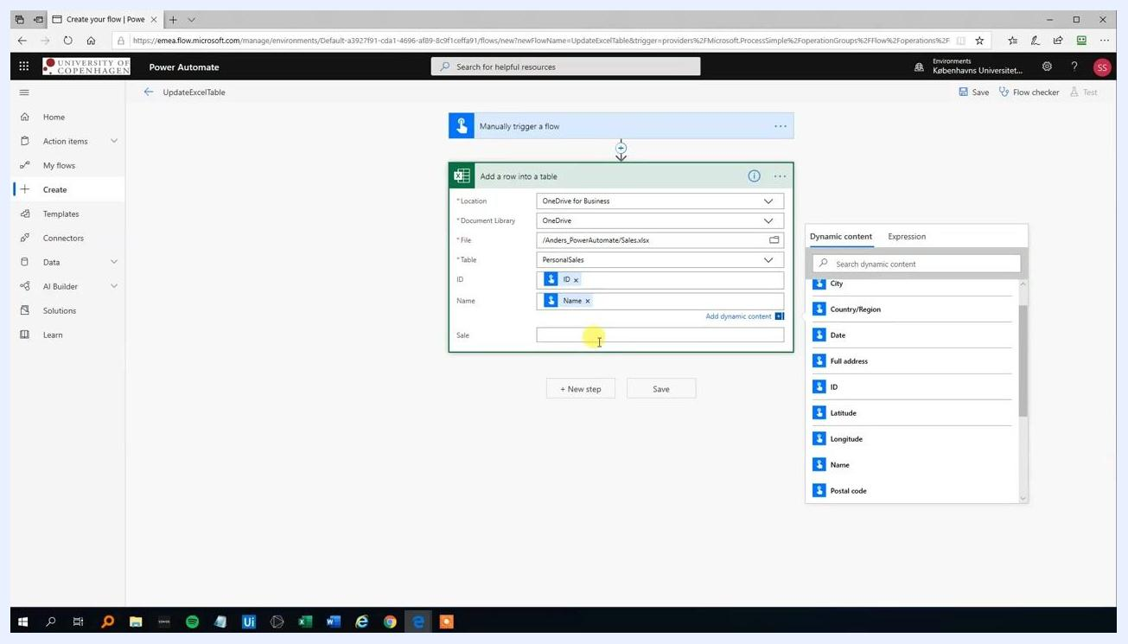
Power Automate "Add a row into a table" action with ID, Name, and Sale fields mapped to dynamic content, with the dynamic content panel open on the right

Step 10: Save and test the flow
Click Save to store your flow configuration, then click Test to run the flow manually. If prompted, confirm that you are signed in to Excel Online (Business); a green checkmark indicates you're ready to proceed.
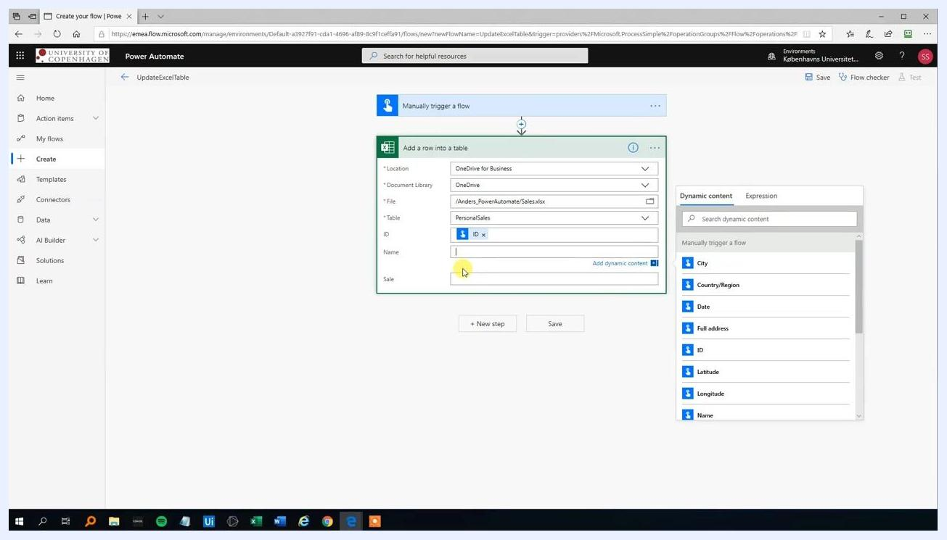
Power Automate flow editor with the "Add a row into a table" action fully mapped and the "Run flow" panel open, showing the Excel Online (Business) connection status
Click Continue to proceed to the input form.

Step 11: Enter test data and run the flow
Enter the following test data in the input form:
- ID: 2
- Name: Anders
- Sale: 1000
Click Run flow to execute the flow with the provided data.
Power Automate "Run flow" panel prompting for ID, Name, and Sale input values
Wait for the confirmation message indicating the flow ran successfully.
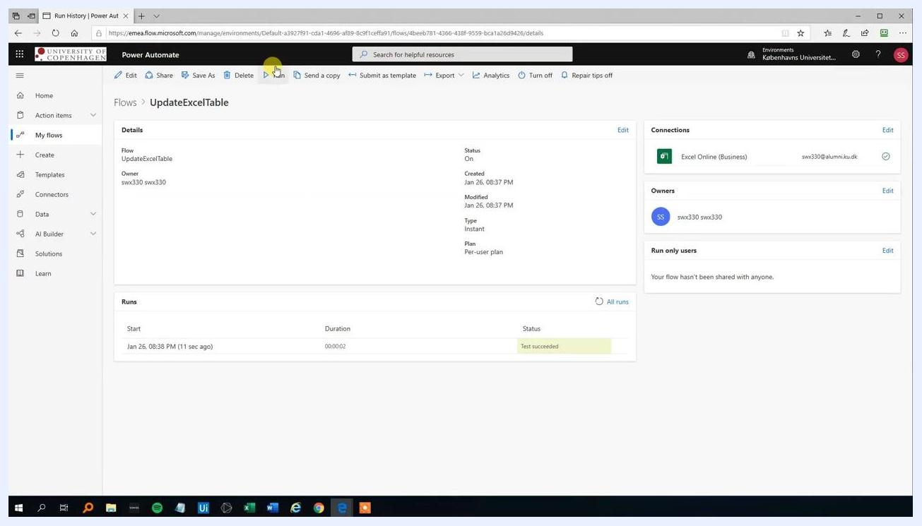
Power Automate flow run confirmation displaying the message "Your flow ran successfully"

Step 12: Run the flow multiple times with different data
Repeat the process to add more rows to your Excel table using different sample values:
- Example 1: ID 3, Name John, Sale 11000
- Example 2: ID 4, Name Hillary, Sale 6000
- Example 3: ID 5, Name Meta, Sale (enter the appropriate sale value)
For each run, enter the new data and click Run flow. Check the status of each run in the "Runs" section — successful runs will show "Succeeded" or "Test succeeded".
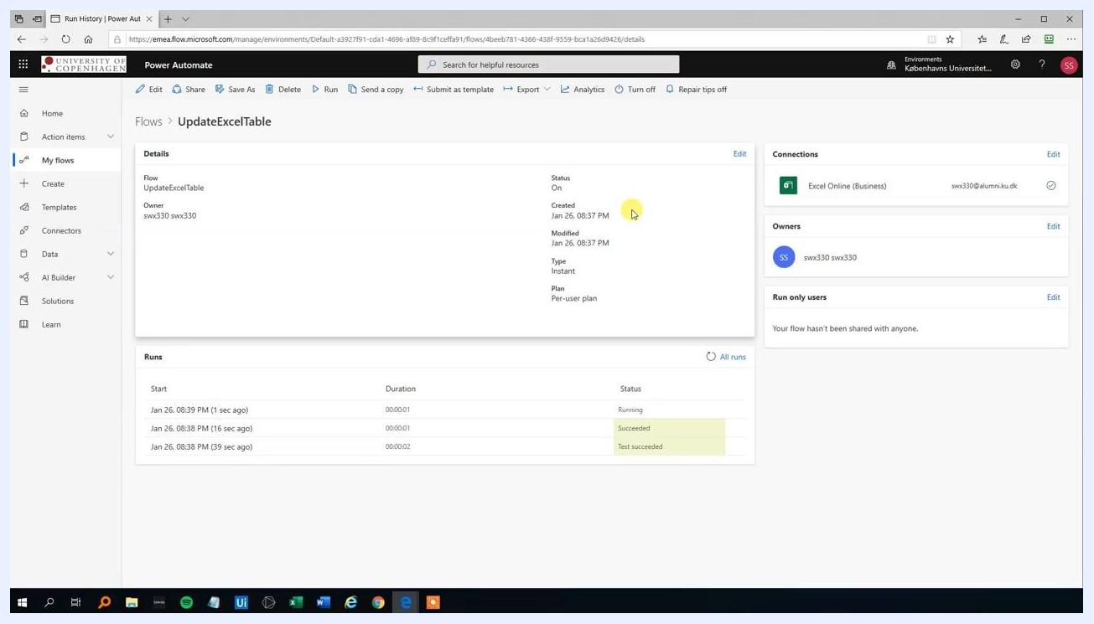
Power Automate flow run history showing multiple successful runs with timestamps and status

Step 13: Verify data in the Excel file
After running the flow multiple times, switch to your Excel file to confirm that all submitted data has been added correctly. Open the Sales.xlsx file in Excel Online and review the table to ensure each row matches the data entered via the flow:
- ID: 1, Name: Angela, Sale: 7,000.00
- ID: 2, Name: Anders, Sale: 1,000.00
- ID: 3, Name: Bill, Sale: 11,000.00
- ID: 4, Name: Hillary, Sale: 6,000.00
- ID: 5, Name: Mette, Sale: 4,500.00
Confirm that the Excel table reflects all data provided through the Power Automate flow.
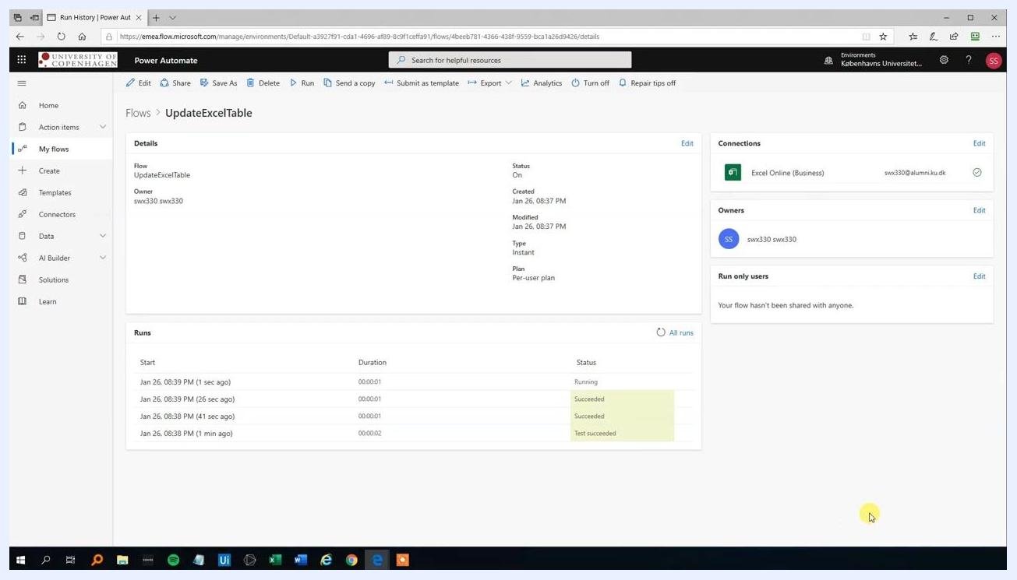
Excel Online displaying the Sales.xlsx file with a table containing ID, Name, and Sale columns, filled with five rows of test data entered via the flow

Summary
You have successfully automated the process of adding rows to an Excel table using Power Automate. The Excel sheet reflects all entries made through the flow, confirming that the integration between Power Automate and Excel Online works as expected.
This concludes the demonstration of updating an Excel table with Power Automate.

