How to Create a Channel in Microsoft Teams
Channels in Microsoft Teams let you organize conversations, files, and collaboration around specific topics or projects within a team. This guide walks you through how to create a channel in Microsoft Teams, configure its privacy settings, manage its members, and use tags to communicate efficiently with groups.

Prerequisites
Before you begin, make sure you have the following:
- Access to a team in Microsoft Teams where you want to add a new channel.
- A clear purpose for the channel (for example, budget discussions, documentation, or a go-to-market plan).
- Awareness of which teammates should have access, especially if the topic is sensitive.

Understanding teams and channels
Teams and channels create a centralized hub for your work group. Organize your work by creating separate channels for different topics or projects, such as documentation, a go-to-market plan, or digital assets. Assign different members to each channel so that only relevant people are included in each conversation.

Step 1: Identify the need for a new channel
Determine when a new channel is needed—for example, when you need to communicate with a specific department, such as the finance team. Decide on the purpose of the new channel, such as budget discussions, before you create it.

Step 2: Start creating a new channel

- In Microsoft Teams, locate your team in the left sidebar.
- Click the three dots (ellipsis) next to your team name to open the context menu.
- Select Add channel from the menu.
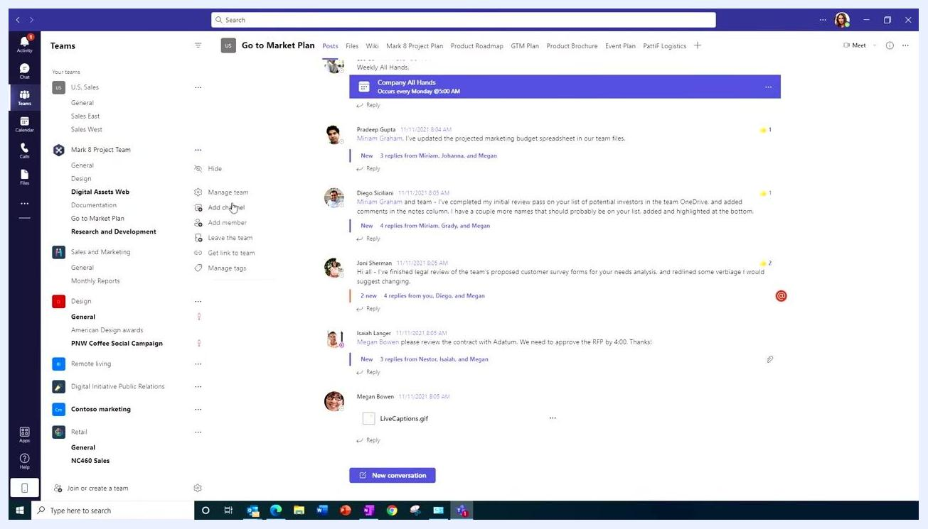
Microsoft Teams interface showing the context menu with "Add channel" highlighted for the selected team.

Step 3: Configure the channel details
In the "Create a channel" dialog, enter the following details:
- Channel name: Enter a descriptive name, such as "Budget."
- Description (optional): Add a description to clarify the channel's purpose, such as "This channel is for all budget conversations."
Then choose a privacy setting for your channel:
- Standard: Everyone on the team has access to the channel. Use this setting for team-wide announcements and conversations.
- Private: Only specific teammates have access. Use this setting for sensitive topics, such as budget discussions or confidential projects.
Dialog box for creating a new channel, showing fields for channel name, description, and privacy options (Standard and Private).

Step 4: Select the appropriate privacy setting
For sensitive discussions, such as budget topics, select Private – Specific teammates have access. Invite only the relevant stakeholders to the private channel so the conversation stays limited to the right people.
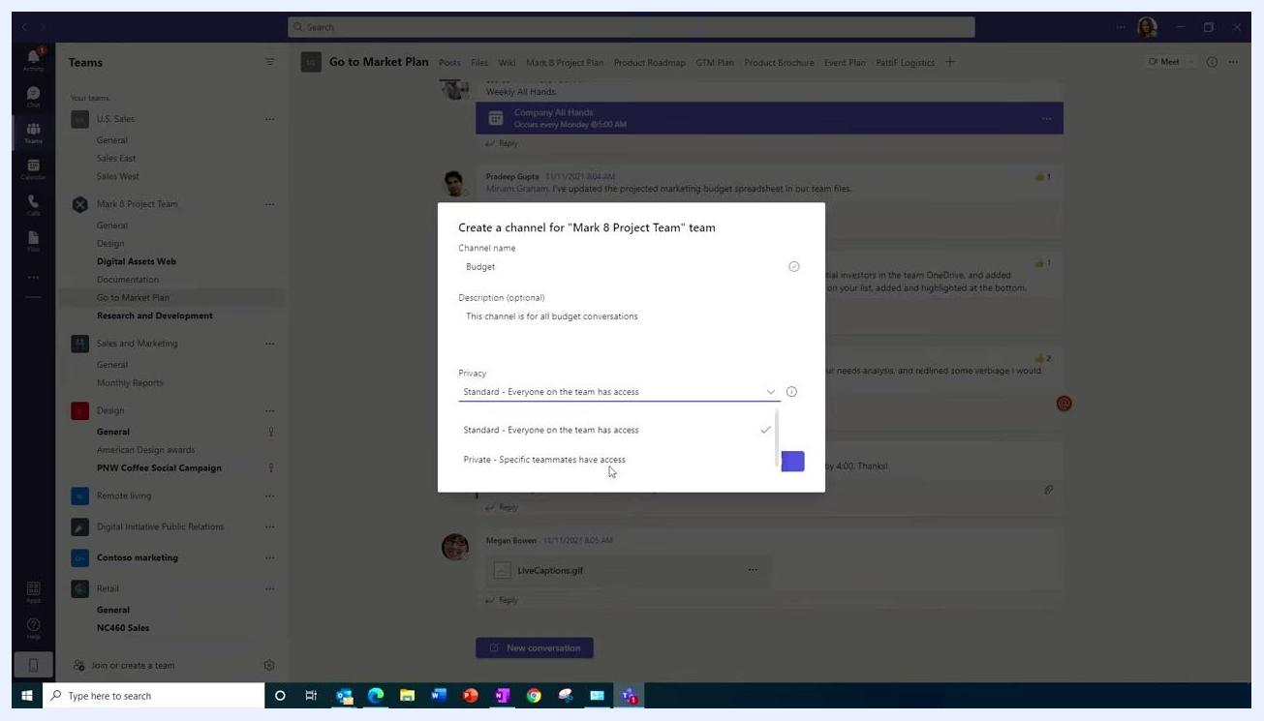
Dialog box for creating a new channel with the "Private – Specific teammates have access" option selected.

Step 5: View and manage channel members
Open the channel you created, such as "Budget." Locate the "About" section on the right side of the screen to see the list of current channel members. Click the Add members icon (a person with a plus sign) to add or remove members as needed.
- The member list displays all current participants, such as Adele Vance, Grady Archie, Megan Bowen, Johanna Lorenz, and Isaiah Langer.
- Updates about member changes, such as "Adele Vance has added Johanna Lorenz to the channel," appear below the member list.
If you are not a team owner or admin, your request to add a new member is sent to the team owner for approval. If you are the team admin, you can add or remove channel members directly without needing approval.
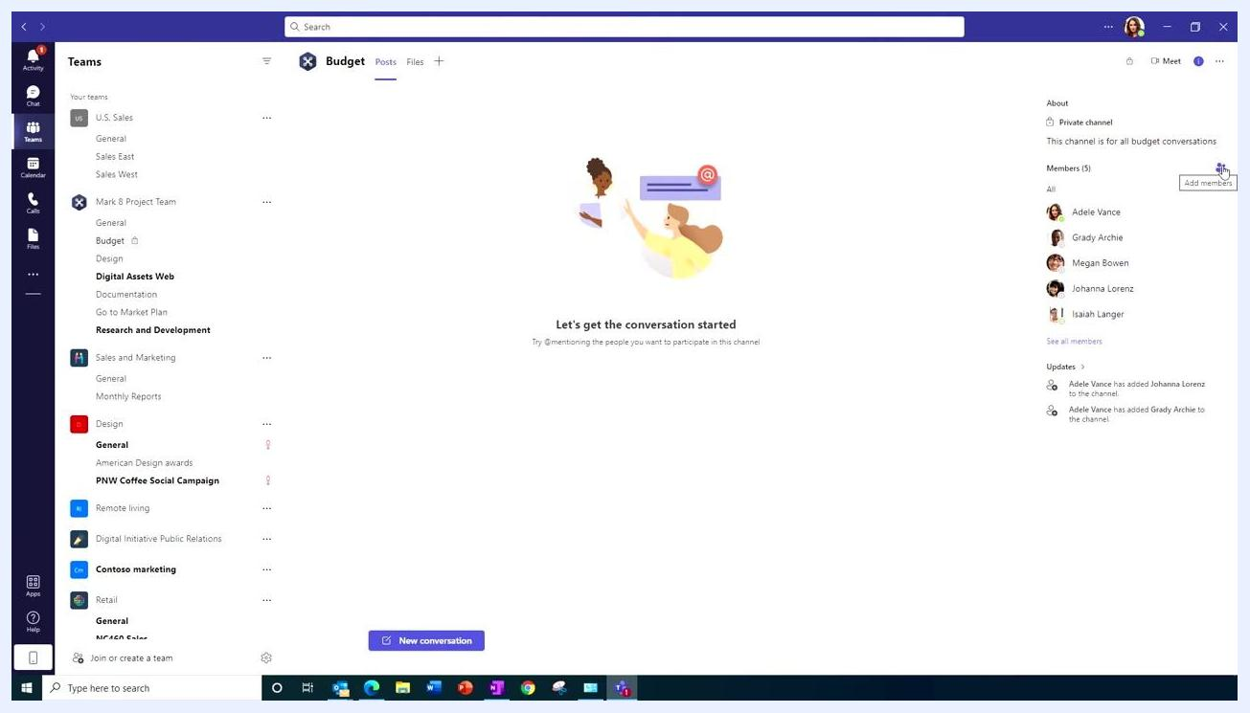
Microsoft Teams channel view showing the member list, the "Add members" button, and updates about member additions.

Step 6: Start a conversation in the channel
Once all necessary members are added, begin your conversation. Click the New conversation button at the bottom of the channel window, then type your message in the text box that appears. Use @mentions to notify specific people directly in the conversation.
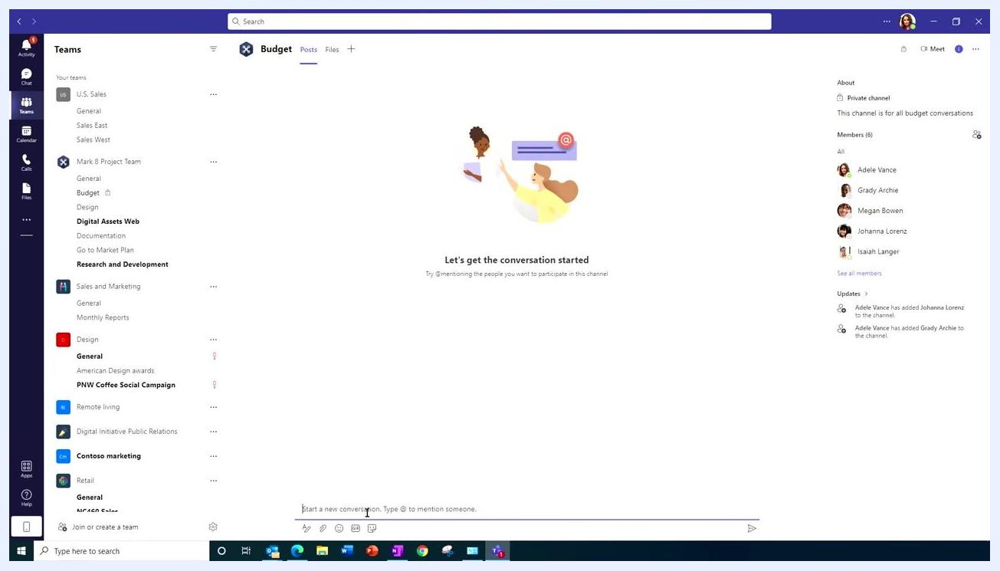
Microsoft Teams channel with the conversation input box active, ready to start a new conversation.

Step 7: Open the tags tab to create a group tag
To communicate efficiently with a group, such as the finance team, set up a tag:

- Move your mouse to the team name in the left sidebar.
- Right-click the team name to open the context menu.
- Select Manage Team.
- Go to the Tags tab at the top of the Manage Team window.
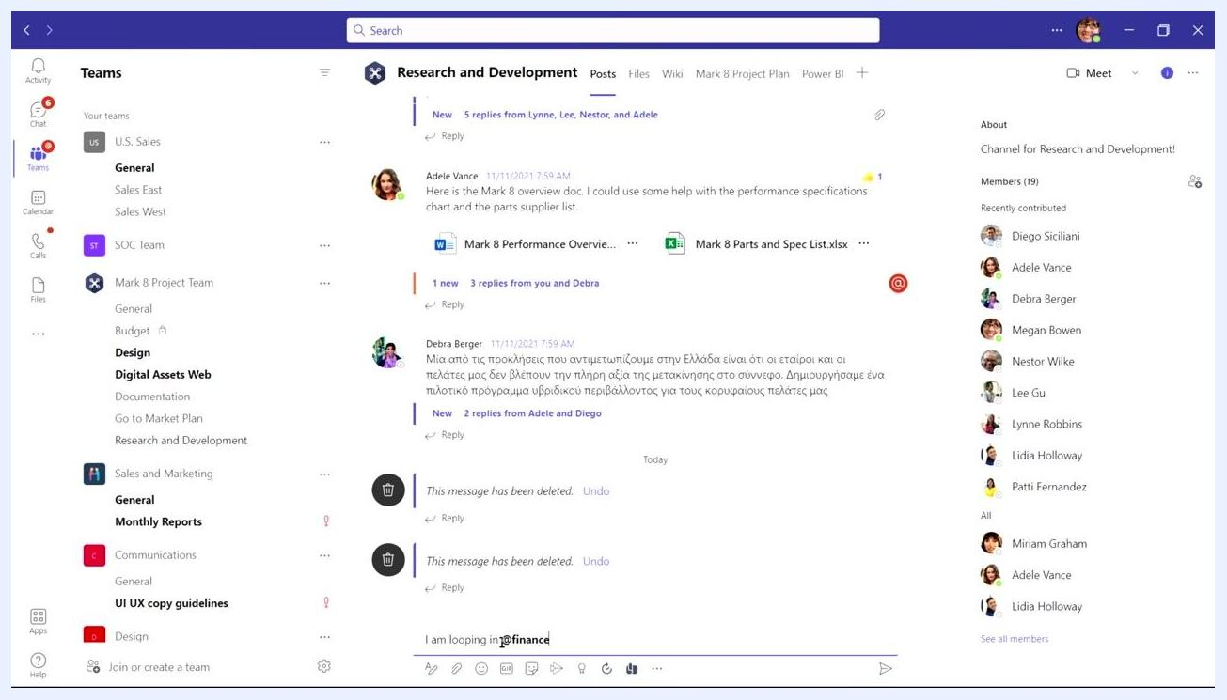
Manage Team window in Microsoft Teams with the "Tags" tab selected.

Step 8: Create the tag

- Click Create a tag.
- In the "Create a new tag" dialog, enter the following:
- Tag name: Finance
- Tag description: This is the finance team
- Add people: Select the relevant members, such as Isaiah Langer, Adele Vance, and Johanna Lorenz.

- Click Create to finalize the tag.
Dialog for creating a new tag in Microsoft Teams, with "Finance" as the tag name, a description, and selected members.

Step 9: Use tags to notify groups
In any channel conversation, type @ followed by the tag name, such as @Finance, to mention the entire group. All members assigned to the tag are notified, just as if you had mentioned them individually. For example, typing "I am looping in @Finance" in the message box notifies all finance team members at once.
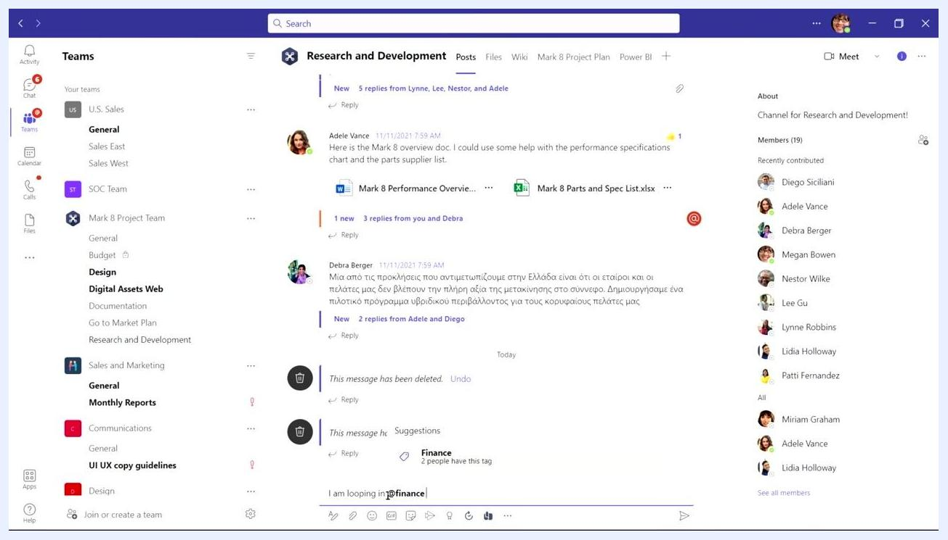
Channel conversation in Microsoft Teams showing the use of the "@Finance" tag to notify the group.

Step 10: Invite external users to expand collaboration
To further enhance teamwork, you can invite external users, such as suppliers or partners, to your workgroup or channel:

- Open the desired team or channel where you want to add external users.
- Click the Add members icon.
- Enter the email address of the external user, such as a supplier's email.
- Assign appropriate permissions and roles to ensure they have access to the necessary resources.
External users receive an invitation to join your team or channel and can collaborate securely within the defined boundaries.

What's next
You now know how to create a channel in Microsoft Teams, configure its privacy settings, manage members, and use tags to communicate with groups efficiently. With external users invited as needed, your team can collaborate with all relevant stakeholders, internal and external, in one organized environment.

Presenter standing at a desk with a laptop, explaining how to invite external users to a Microsoft Teams workgroup. The background is a geometric purple and white pattern.
Screen with the text "Subscribe today" on a purple background and "Watch more videos" on a white background, encouraging users to stay informed and continue learning.

