How to Create a Purchase Requisition in IBM Maximo
This guide shows you how to create a purchase requisition in IBM Maximo when a work order requires materials that are not available in stock. You will learn how to check inventory availability from a work order, raise a purchase requisition for missing items, route it through approval, and convert it into a purchase order.

Overview of supply chain management in Maximo
Maximo includes supply chain management processes that support work management by providing the materials and services your teams need. Three modules work together to deliver this process:
- Inventory module
- Purchasing module
- Contract module
These modules support the standard supply chain management process used across your organization's staff, from identifying a material need on a work order through to receiving and issuing the item.
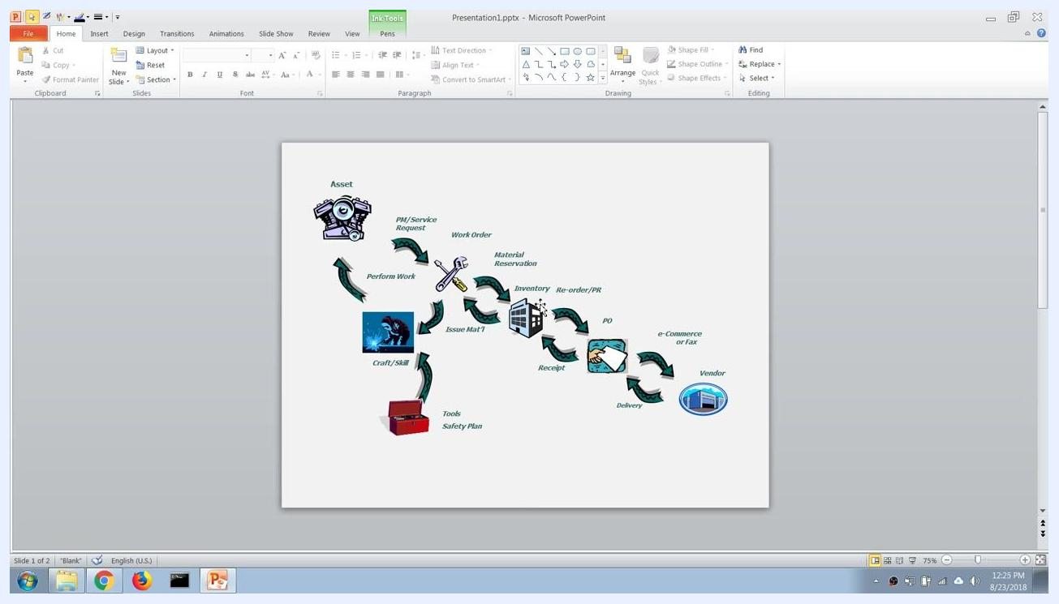
A PowerPoint slide showing a flowchart of the supply chain management process in Maximo, including steps such as Asset, PM/Service Request, Work Order, Material Reservation, Inventory, Re-order/PR, PO, e-Commerce or Fax, Vendor, Delivery, Receipt, Issue Mat'l, Craft/Skill, Tools, Safety Plan, and Perform Work. Each step is illustrated with icons and arrows showing the process flow.

Prerequisites
- A work order already created in Maximo that requires spare parts or materials.
- Access to the Work Orders, Purchasing, and Inventory applications in Maximo.
- Knowledge of the work order number you want to check for material shortages.

Step 1: Open Work Order Tracking
Use the navigation panel on the left to select Work Orders, then choose Work Order Tracking from the dropdown menu. This takes you to the screen where you can search for and review a specific work order.
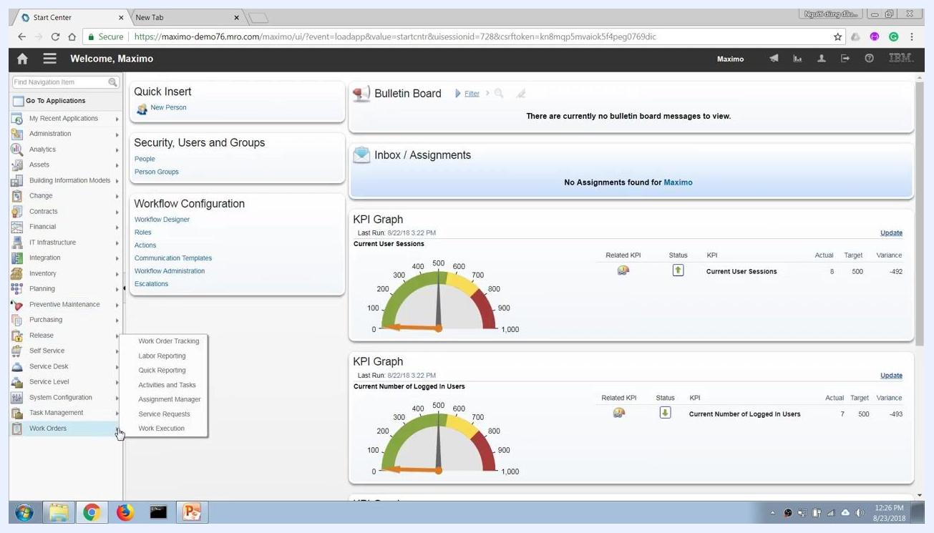
The Maximo Start Center dashboard is displayed. The left navigation menu is open, with the cursor hovering over Work Orders and a dropdown showing options like Work Order Tracking, Labor Reporting, and Quick Reporting. The main dashboard shows KPI graphs, workflow configuration, and security/user options.

Step 2: Find the work order
Use the Find Work Order search field at the top left of the screen to quickly locate the work order you need. Enter the work order number (for example, 1412) and press Enter.
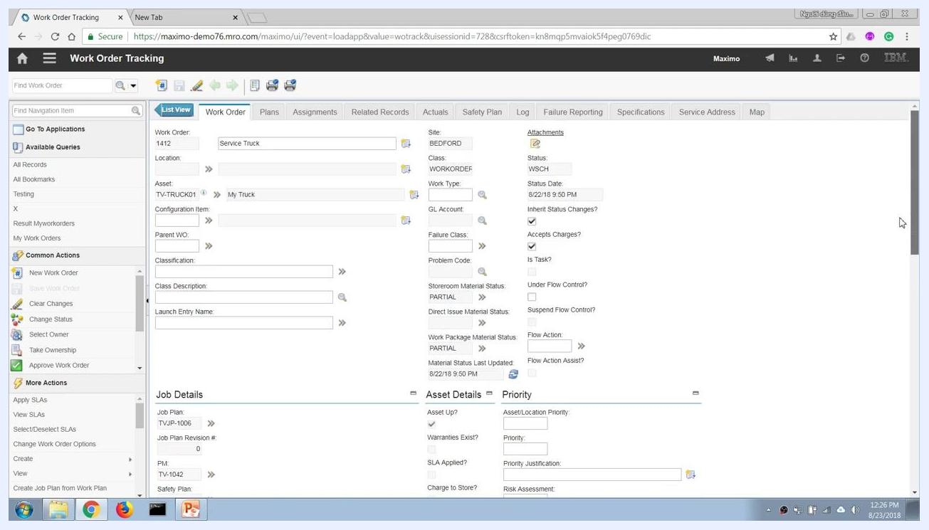
The Maximo Work Order Tracking screen with the Find Work Order search field highlighted, ready for input. No work orders are currently listed in the results.

Step 3: Review the work order details
Confirm you are viewing the correct record by checking the work order number, asset, and description (for example, Work Order 1412, Asset TV-TRUCK01, Service Truck). Check the Storeroom Material Status field, which may show PARTIAL if not all required materials are currently available, and note the job plan and other relevant details.
The Work Order Tracking screen displaying details for Work Order 1412, including asset, job plan, and storeroom material status set to PARTIAL.

Step 4: Review tasks and materials on the Plans tab
Click the Plans tab at the top of the work order screen to view the tasks and materials required for the job.
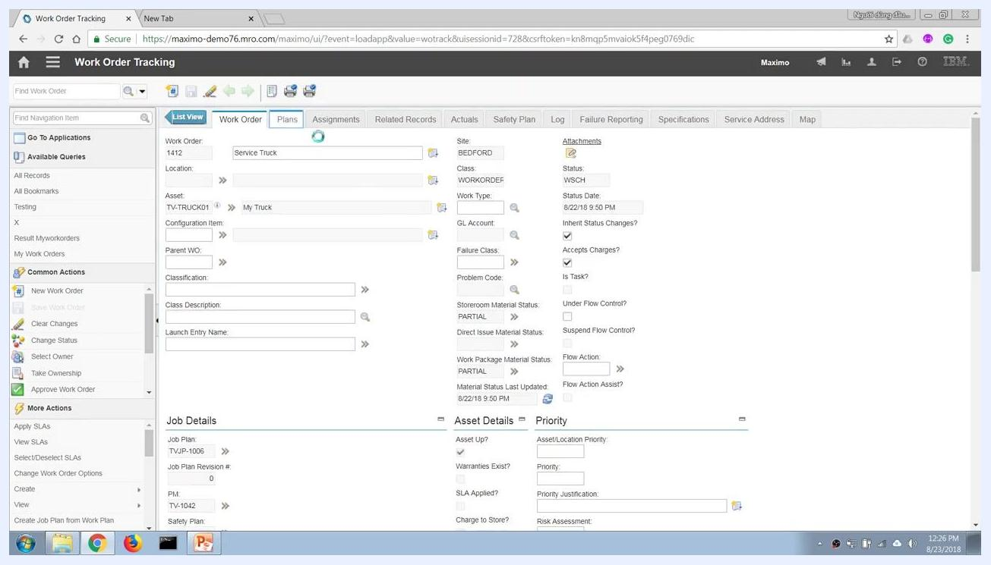
The cursor is about to select the Plans tab in the Work Order Tracking screen, with work order details visible.
Under Tasks for Work Order 1412, review each task, such as light checks, tire pressure check, oil change, wiper change, and tire change. In the Materials section, review the required items, their quantities, unit costs, line costs, and storeroom locations. For example:
- TVI-1005: Oil, Engine — Quantity 2.00, Storeroom CENTRAL
- TVI-1006: Wiper, Truck — Quantity 2.00, Storeroom CENTRAL
- TVI-1007: Wheel, Truck — Quantity 4.00, Storeroom CENTRAL

Step 5: Check item availability
Right-click or use the dropdown menu on an item row and select View Item Availability to confirm stock levels. For example, checking "Oil, Engine" (TVI-1005) confirms that the storeroom has sufficient stock, such as 9 units available against a requirement of 2.
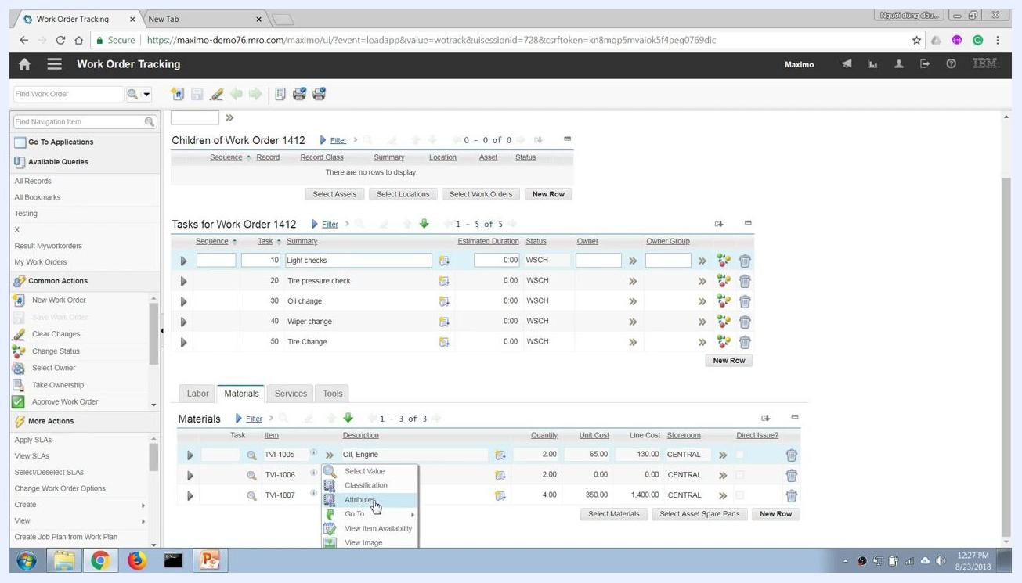
The Materials tab is open, showing a dropdown menu for Oil, Engine (TVI-1005) with the View Item Availability option highlighted.
Repeat the View Item Availability check for each required item. If an item, such as "Wiper, Truck" (TVI-1006), shows zero units available in the storeroom, this material is not in stock and must be procured through a purchase requisition.
The Materials tab is open, showing the View Item Availability option for Wiper, Truck (TVI-1006), indicating a check for stock shortages.

Step 6: Identify the item to procure
Open the Materials tab if it is not already open and locate the item with zero stock, such as TVI-1006: Wiper, Truck. Note the item number and description, since you will need this information to raise the purchase requisition.
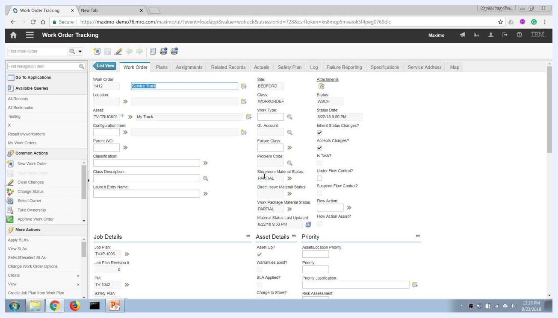
The Work Order Tracking screen with the Materials tab open, ready to retrieve the item number for procurement.

Step 7: Open the Purchase Requisitions application
Open the Go To Applications menu, hover over or click Purchasing to expand the submenu, and select Purchase Requisitions from the dropdown list.
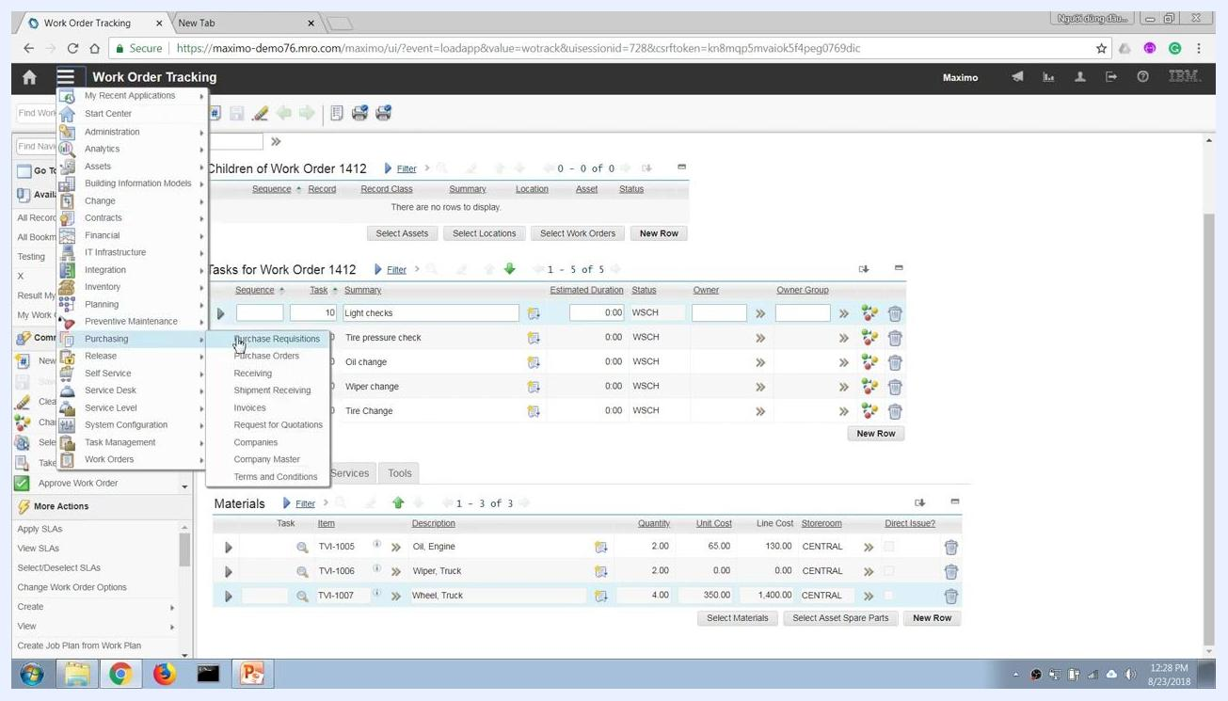
The Maximo Work Order Tracking screen with the Go To Applications menu open, Purchasing expanded, and Purchase Requisitions highlighted.
In the Purchase Requisitions application, click the option to create a new purchase requisition, such as New Purchase Requisition under Common Actions. A new purchase requisition form opens.

Step 8: Enter the purchase requisition details
In the PR tab, enter a brief description in the Description field (for example, "Buy tire to replace on Truck1"). Confirm the PR number is auto-generated (for example, 1063) and that the Site field is set correctly (for example, BEDFORD).
The Status should be set to WAPPR (Waiting for Approval). The Requested By field may auto-populate (for example, MAXIMO). Enter or confirm the Requested Date and Status Date as needed.
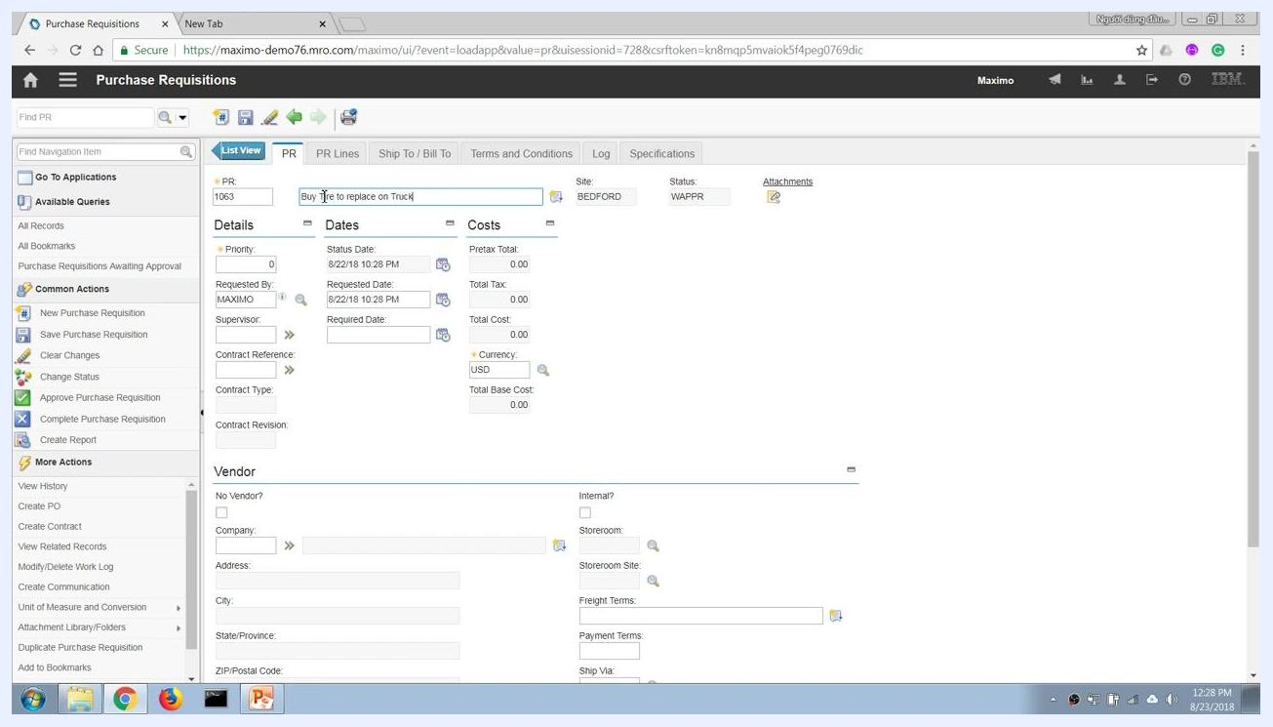
The Purchase Requisitions screen with the PR tab open, description entered as "Buy tire to replace on Truck1", and other details visible.

Step 9: Indicate whether a vendor is specified
If you do not want to specify a vendor, check the No Vendor? checkbox in the Vendor section and leave the vendor fields, such as Company and Address, blank.
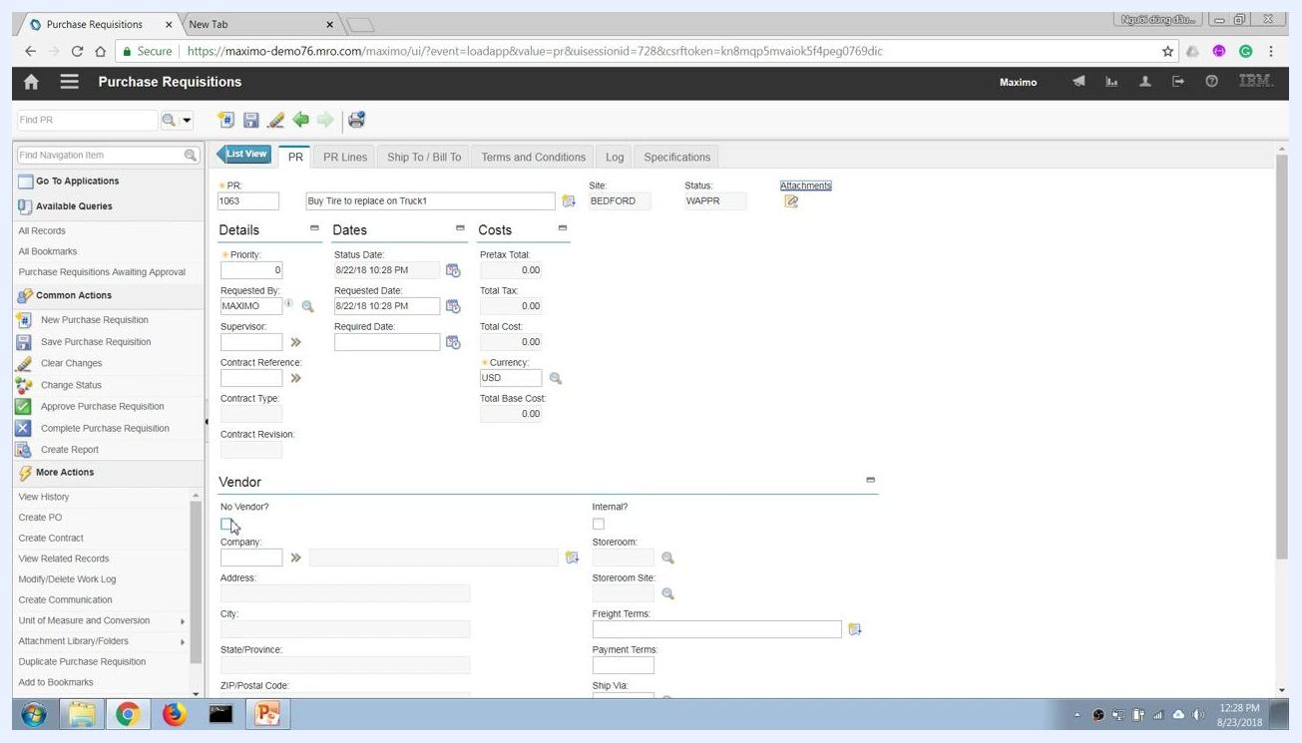
The Purchase Requisitions screen with No Vendor? checkbox selected and vendor fields left blank.
If the item is available in another internal storeroom or warehouse, you can select Internal? instead of No Vendor?. Click the lookup icon next to the Storeroom field to choose from available storerooms, such as PKG, MACHSHOP, GARAGE, CENTRAL, or R_CENTRAL. For an external purchase, leave Internal? unchecked.
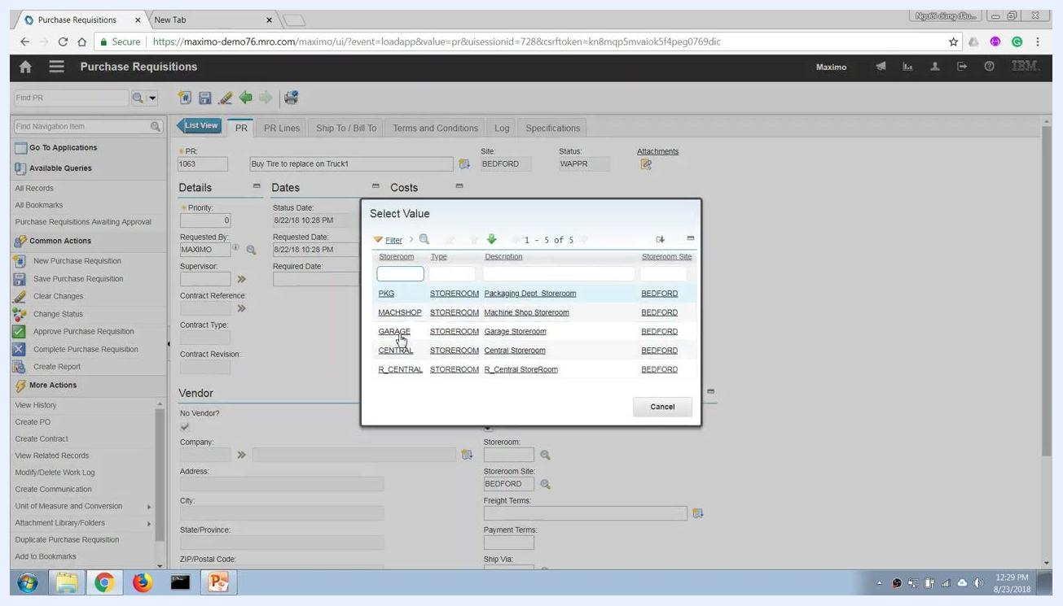
The Purchase Requisitions screen with the Select Value dialog open, listing available storerooms such as PKG, MACHSHOP, GARAGE, CENTRAL, and R_CENTRAL.

Step 10: Add PR line items
Click the PR Lines tab at the top of the purchase requisition form to add line items, then click New Row to add a new item to the requisition. Specify the item number (for example, TVI-1007 for "Wheel, Truck") and the required quantity (for example, 4), filling in additional fields such as description, unit cost, or storeroom as prompted.
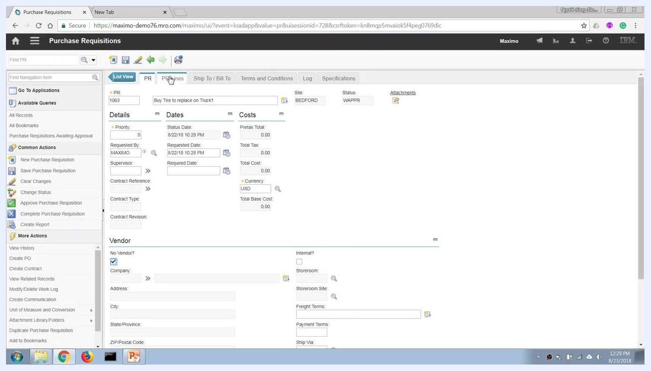
The Purchase Requisitions screen with the PR Lines tab about to be selected, ready to add new items to the requisition.

Step 11: Define the item and quantity
Enter the item number as TV-1007 and the item description as "Wheel, Truck." Set the quantity to 4.00, the order unit and issue unit to EACH, and the unit cost to 350.00. The line cost calculates automatically as 1,400.00, and the category should be set to STK.
Leave the condition code, catalog number, commodity group, and commodity code blank unless specified, along with remarks, classification, and class description. Maximo automatically populates the remaining required information.
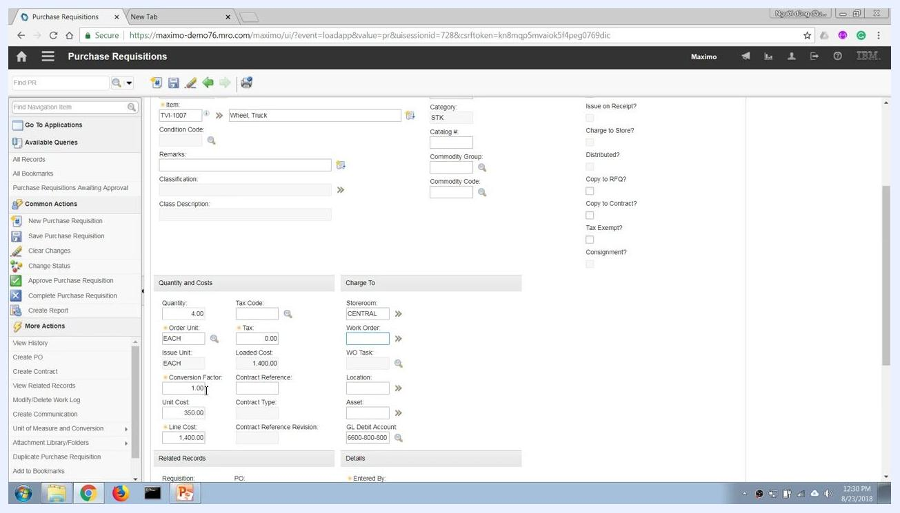
Purchase Requisitions screen showing item TV-1007 (Wheel, Truck), quantity 4, unit cost 350, line cost 1,400, and category STK. Charge To section shows storeroom CENTRAL.

Step 12: Specify the delivery location
In the Charge To section, set the Storeroom field to CENTRAL to indicate the item will be delivered to the CENTRAL storeroom. Leave the Work Order, WO Task, Location, and Asset fields blank unless the item should be charged directly to a work order or asset.
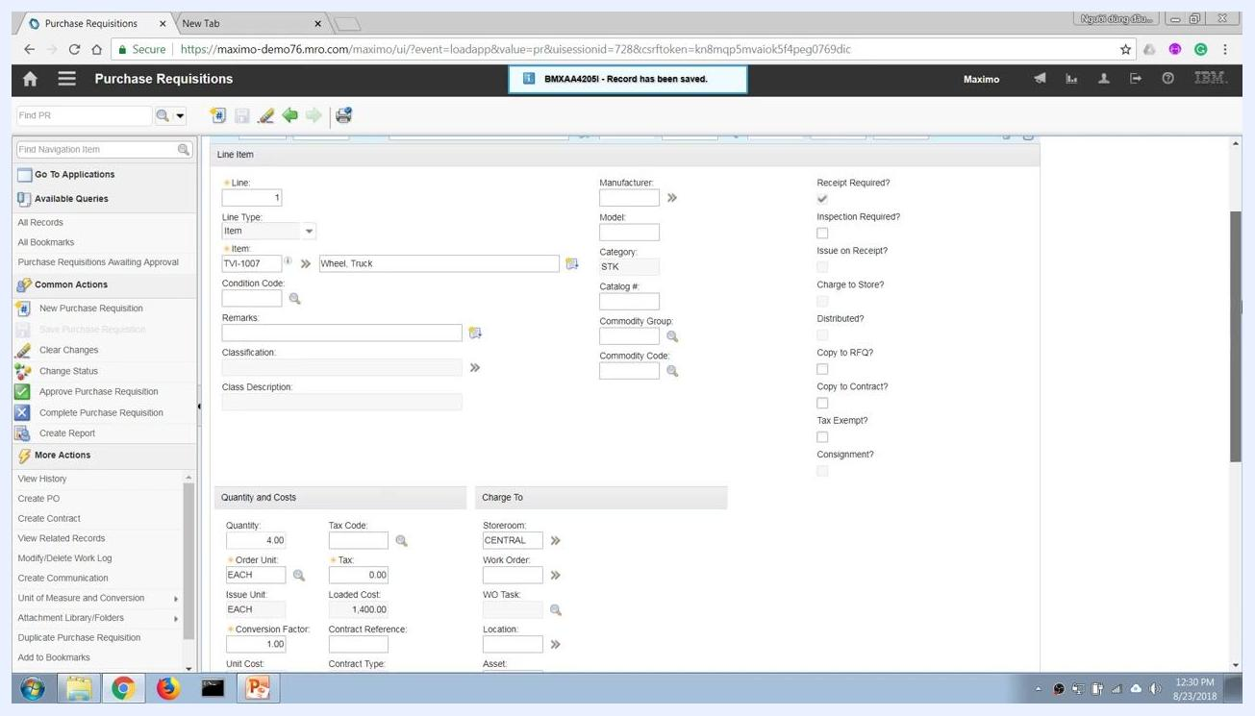
Purchase Requisitions screen with storeroom set to CENTRAL, indicating delivery location.

Step 13: Choose direct issue to a work order (optional)
If you do not want the item to go through the storeroom, leave the Storeroom field blank and enter the Work Order number (for example, 1412) to issue the item directly to the work order. When a work order is specified and the storeroom is left blank, the storeroom field locks, indicating a direct issue that becomes a direct expense to the work order or project.
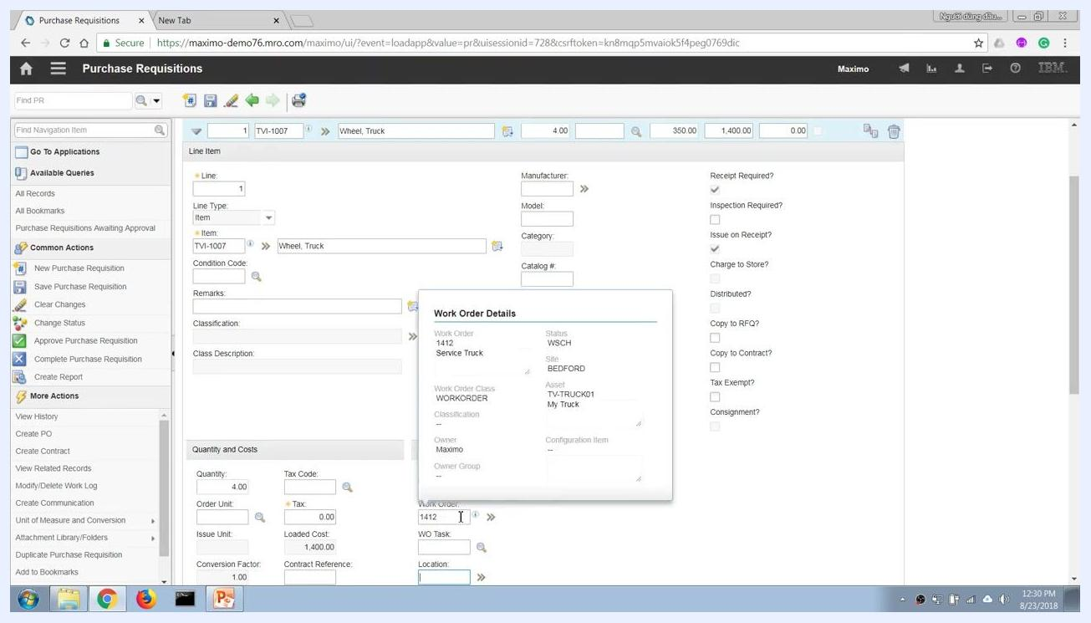
Purchase Requisitions screen with storeroom blank and work order 1412 entered. Work Order Details popup is visible.
Review the financial implications of your choice: items bought into the storeroom are treated as a capital expenditure (capex), while items issued directly to a work order or project are treated as a direct expense (opex). Review the GL Debit Account and other financial fields as needed.
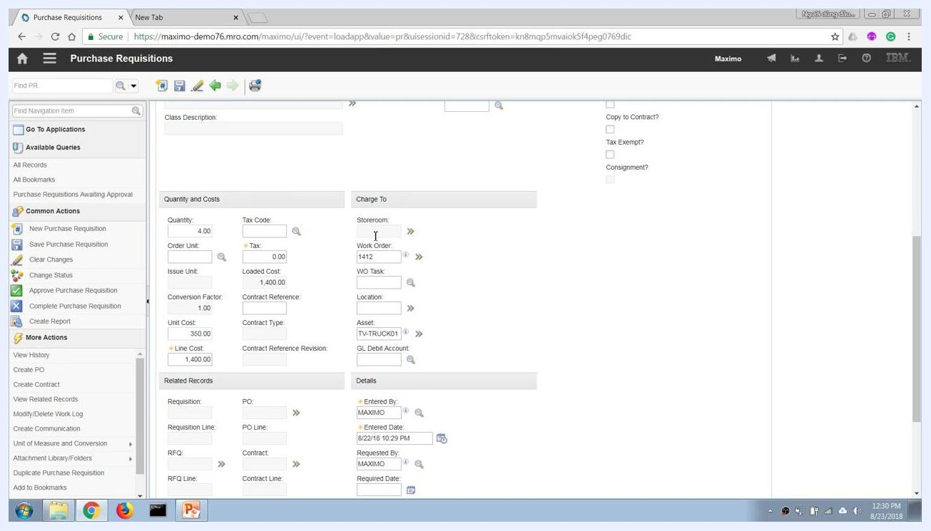
Purchase Requisitions screen showing Charge To section with storeroom blank, work order 1412, and asset TV-TRUCK01.

Step 14: Check related inventory details
In the PR Lines section, use the context menu on the item (TV-1007), hover over Go To, and select either Inventory or Item Master to view more details about the item. This lets you check stock levels or item attributes before proceeding.
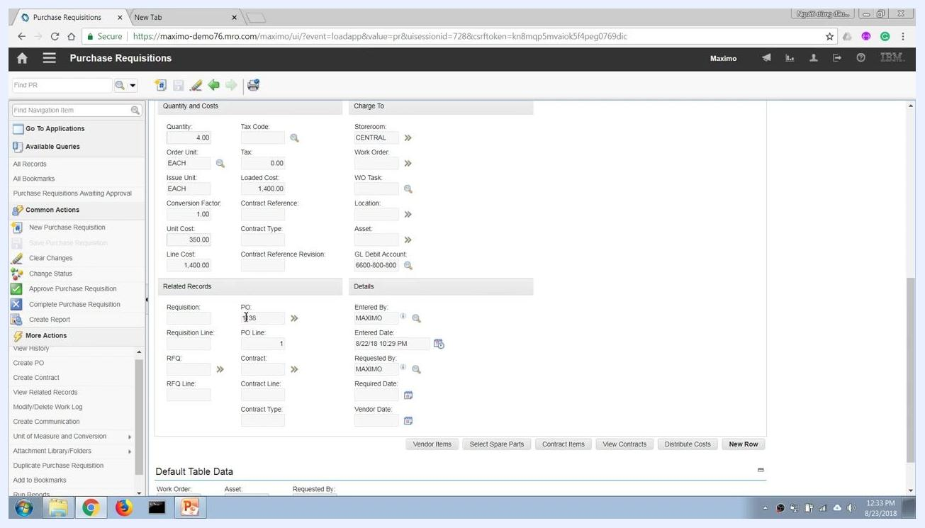
Context menu open on PR Lines item, showing Go To > Inventory and Item Master options.

Step 15: Save the purchase requisition
Click the save icon (diskette) in the toolbar to save your purchase requisition. Confirm that the record has been saved successfully by checking for a confirmation message such as "Record has been saved."
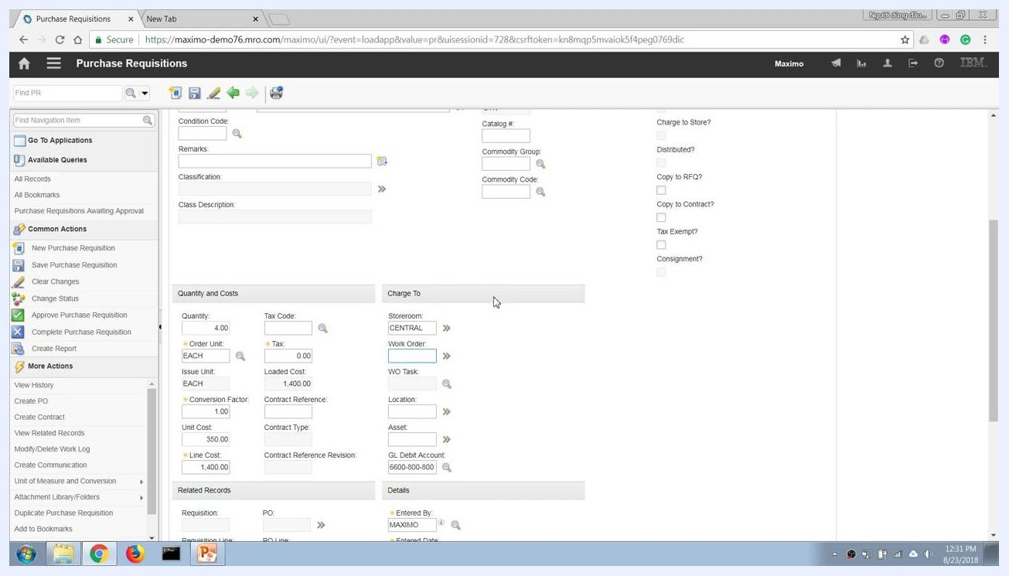
Purchase Requisitions screen with all fields filled and ready to save.
By completing these steps, you have created a purchase requisition in Maximo, specified delivery to a storeroom or directly to a work order, and understood the financial implications of each option.

Step 16: Submit the purchase requisition for approval
Before submitting, confirm all required information is entered for your PR, such as PR 1063 for "Buy Tire to replace on Truck1." Ensure the item details — TV-1007, Wheel, Truck, Quantity 4, Unit Cost 350.00, Line Cost 1,400.00 — are correct, and verify the status is set to WAPPR (Waiting on Approval).
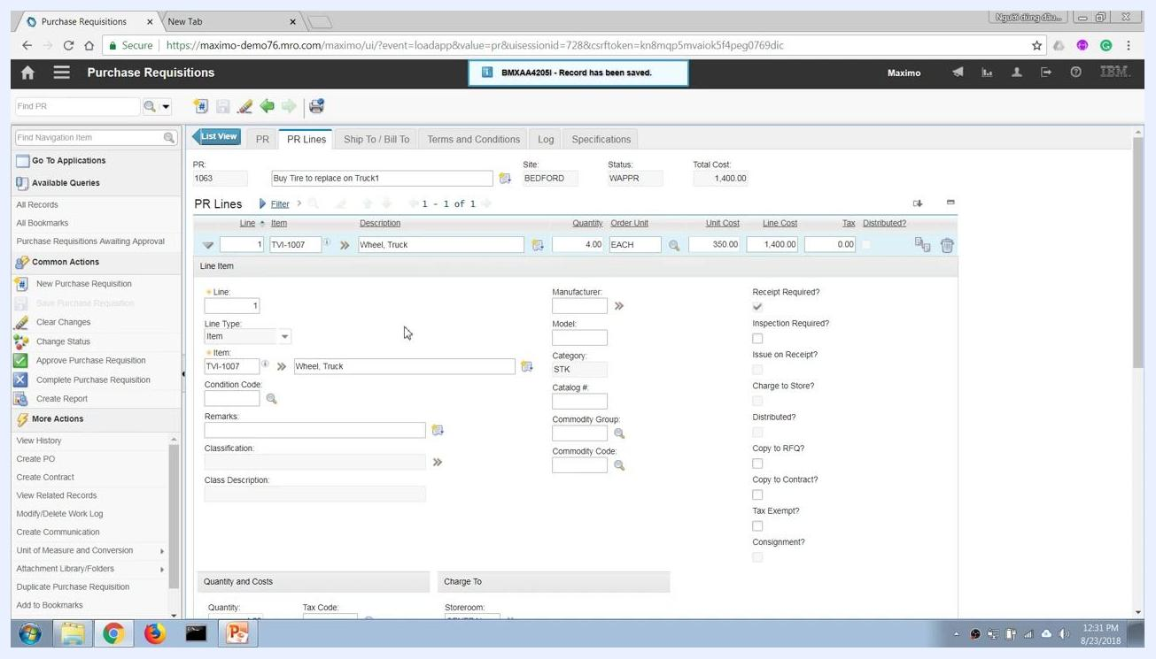
Purchase Requisitions screen showing PR 1063, item TV-1007, all line details, and status WAPPR.
Click Change Status from the left sidebar under Common Actions. In the Change Status dialog, review the current status (WAPPR) and PR details, select Approved from the New Status dropdown, set the Status Date as needed (for example, 8/22/18 10:31 PM), and optionally enter a memo for audit or tracking purposes. Click OK to confirm the status change.

Step 17: Understand the approval workflow
After submitting for approval, the PR may pass through several workflow steps, including:
- Supervisor review
- Procurement department review
- Financial department review for budget approval
- Final approval by authorized personnel
The PR status updates to APPR (Approved) once all workflow steps are completed.
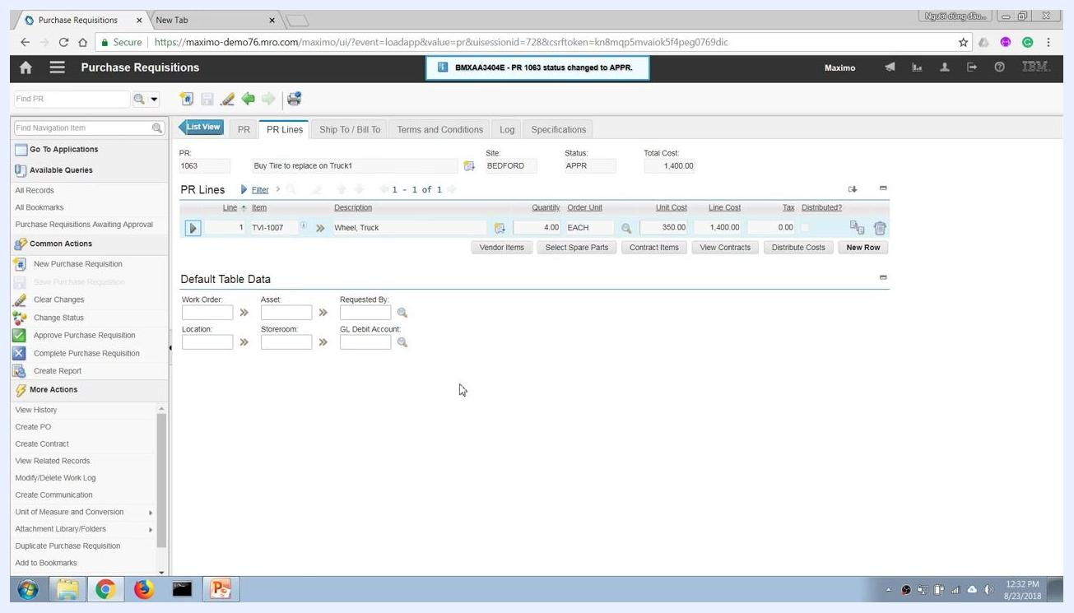
Purchase Requisitions screen showing PR 1063 with status APPR and confirmation message.

Step 18: Convert the approved PR to a purchase order
Once a PR is approved, procurement staff or authorized users can convert it into a work order or purchase order. To create a purchase order, click More Actions in the left sidebar and select Create PO. This action generates a PO number and moves the process forward.
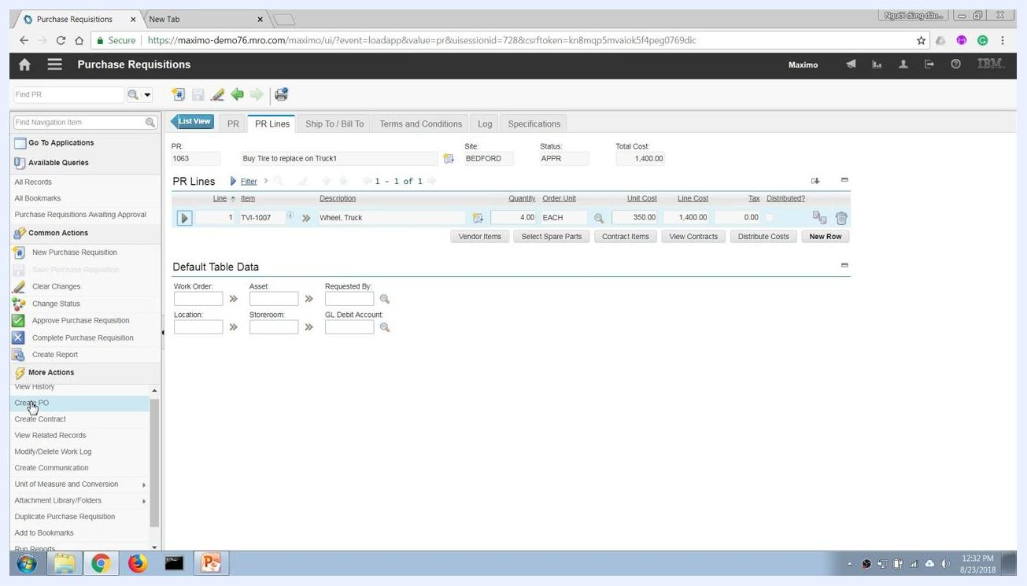
Purchase Requisitions screen with More Actions menu open and Create PO highlighted.

Step 19: Verify the PR line association with the purchase order
In the PR details, check the Related Records section to confirm that the PR line has been brought over to PO 1138, PO Line 1. Review associated fields such as Quantity 4.00, Unit Cost 350.00, Line Cost 1,400.00, GL Debit Account 6600-800-800, Entered By MAXIMO, and Entered Date 8/22/18 10:29 PM. Click Go To Purchase Orders to navigate directly to the related PO.
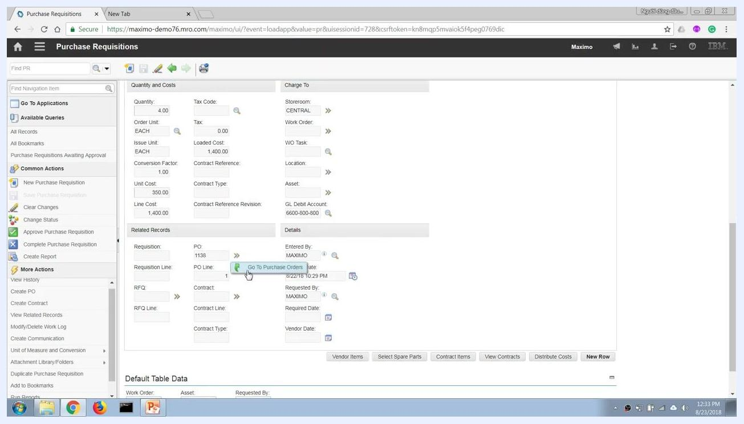
Related Records section showing PO 1138 and Go To Purchase Orders option.

Step 20: Understand automatic status reversal on PO cancellation
If a PR line is copied to a PO and the PO is later cancelled, Maximo automatically reverses the PR status from CLOSE back to APPR (Approved). This ensures the PR can be processed again if the PO is not completed, and the PR Lines and details remain visible for review.
Purchase Requisitions screen showing PR 1063 with status CLOSE and PR Lines.
In the Purchase Orders application, remove the line item that was copied from the PR. Maximo updates the PR status accordingly, and you will see a notification such as "BMXAA43404E - PR 1063 status changed to APPR." The PR returns to APPR (Approved) status and can be processed again.
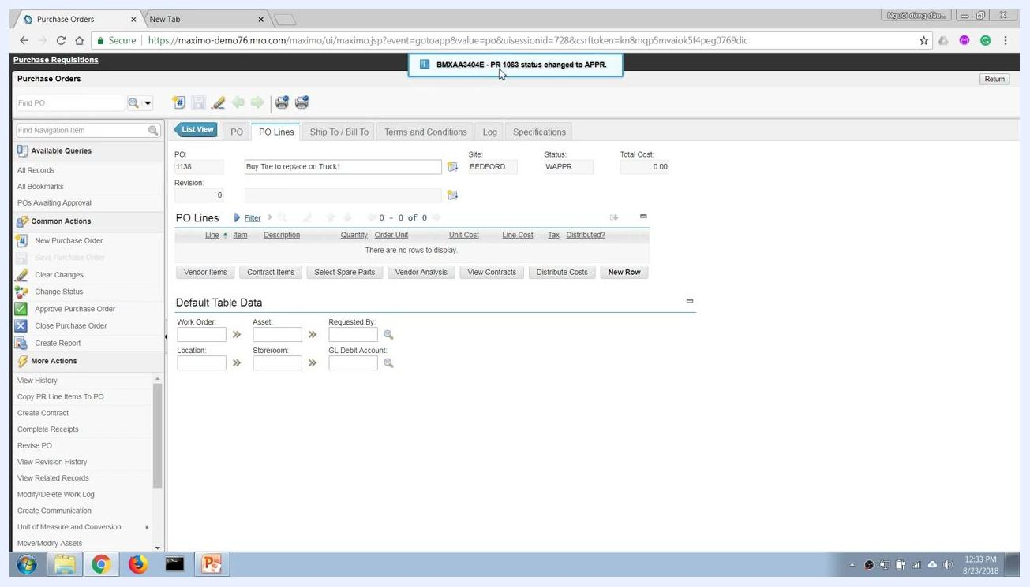
Purchase Orders screen with notification that PR 1063 status changed to APPR.

Step 21: Create a new purchase order from scratch
Open the navigation menu and go to Purchasing > Purchase Orders to create a new PO independently of any PR. The PR Lines screen remains available for reference.
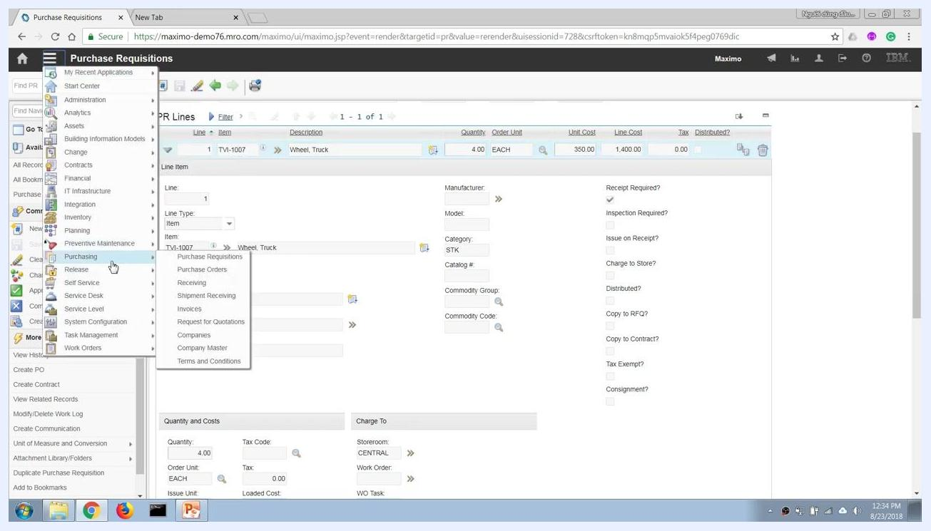
Navigation menu open, highlighting Purchasing > Purchase Orders.

Step 22: Enter new purchase order details
In the Purchase Orders application, enter the following details:
- PO Number: 1139 (auto-generated or entered)
- Description: Purchase_Tire
- Site: BEDFORD
- Status: WAPPR (Waiting on Approval)
- Type: STD
- Status Date: 8/22/18 10:34 PM
- Ordered Date: 8/22/18 10:34 PM
- Currency: USD
Fill in additional fields such as Buyer, Vendor, and Costs as needed.
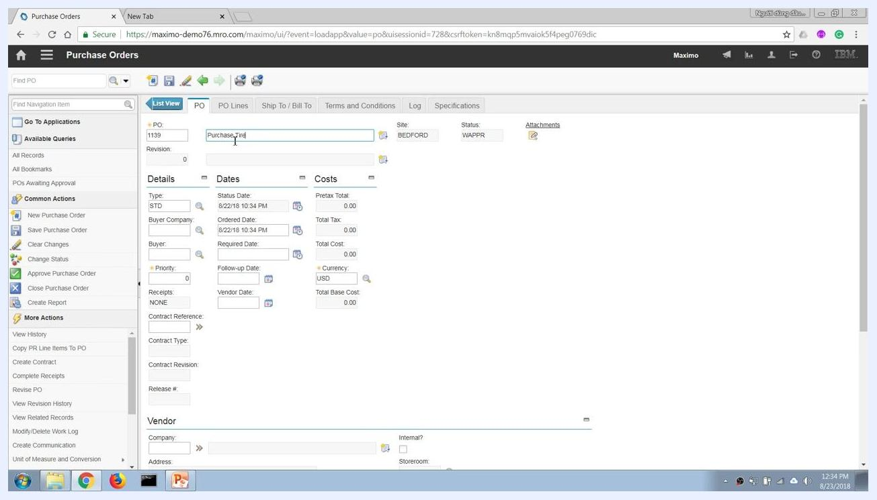
Purchase Orders screen with new PO 1139, description "Purchase_Tire", and status WAPPR.

Step 23: Specify delivery location and financial transaction type
Determine where the ordered items should be delivered. To deliver to a storeroom, enter the storeroom information in the Storeroom field (for example, CENTRAL); Maximo automatically populates related fields based on your entry, such as ordering 4 units of item TV-1007 (Wheel, Truck) to the CENTRAL storeroom.
If you want a direct issue to a work order or project that bypasses the storeroom, enter the work order or project number in the Work Order field. The Storeroom field becomes locked, indicating a direct issue. This changes the financial transaction type: delivery to a storeroom is treated as capital expenditure (CAPEX), while a direct issue to a work order or project is treated as operational expenditure (OPEX). Save the purchase order record after entering all required information.
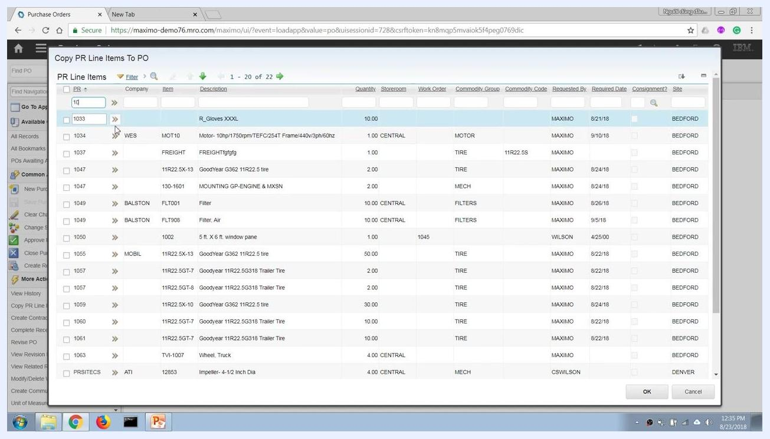
Purchase Orders screen with PO 1139, showing fields for delivery location, storeroom, and work order.

Step 24: Copy PR line items to the purchase order
Use the Copy PR Line Items to PO function to add items from existing purchase requisitions to your purchase order. In the dialog, search for the relevant PR line items (for example, by entering "1033" in the PR field) and review the list of available items, including Company, Item, Description, Quantity, Storeroom, Work Order, Commodity Group, Requested By, Required Date, and Site. Select the items to copy and click OK to confirm.
Copy PR Line Items to PO dialog showing a list of PR line items with details and selection options.

Step 25: Review and confirm PO line details
After copying PR line items, review the PO Lines tab to confirm the item (for example, TV-1007, Wheel, Truck), quantity (4.00 EACH), unit cost (350.00), and line cost (1,400.00), as well as the storeroom and other default table data.
Watch for the notification at the top of the screen: "BMXAA43404E - PR 1063 status changed to CLOSE." This indicates that all actions on the PR line items have been completed and the PR is now closed.
PO Lines tab showing item details and notification that PR 1063 status changed to CLOSE.

Step 26: Finalize and save the purchase order
Ensure all PO line details are accurate and complete, then save the purchase order to finalize the transaction. The PO is now ready for subsequent processes such as receiving, material issue, and transfer.
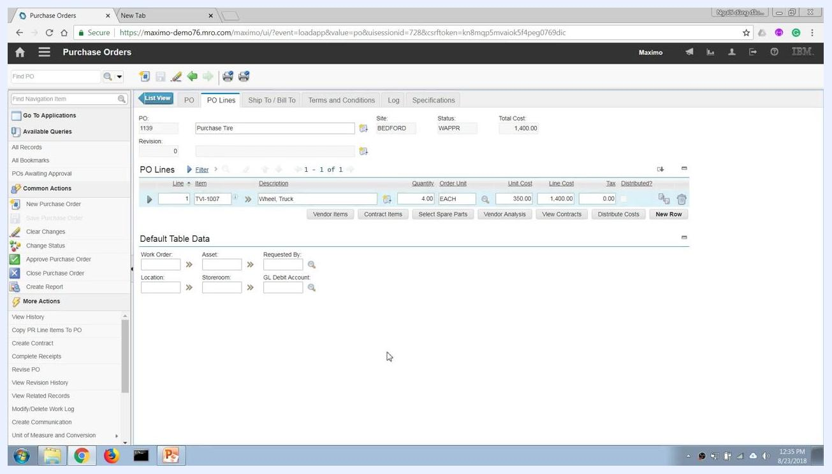
PO Lines tab with finalized item details for PO 1139, ready for further processing.

What's next
With your purchase order saved, you can proceed to downstream logistics operations such as receiving the ordered items, issuing materials to the work order, and transferring stock between storerooms. This complete workflow — from checking inventory availability, through creating a purchase requisition in Maximo, to approving and converting it into a purchase order — supports both CAPEX and OPEX procurement scenarios and ensures accurate tracking throughout your supply chain process.

