How to Create a Job Plan in IBM Maximo
Learning how to create a job plan in IBM Maximo helps you standardize recurring maintenance work and save significant time during planning. A job plan is a template stored in the Maximo library that can be applied to Preventive Maintenance (PM) records, routes, or work orders. Once applied, all the information in the job plan—tasks, labor, materials, and assets—is copied directly to the work order. This guide walks you through creating a basic job plan and assigning it to a work order.

Understanding the purpose of a job plan
Before you begin, it helps to understand what a job plan does:
- A job plan is a template stored in Maximo.
- You can apply it to a PM, a route, or a work order.
- All information from the job plan is copied to the work order, which saves significant planning time.
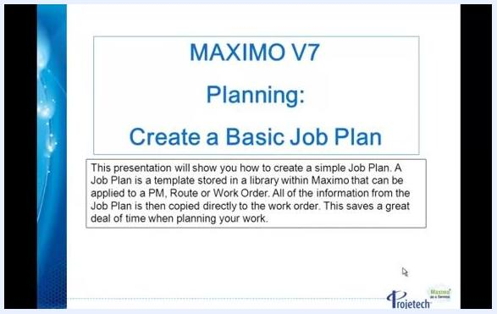
Introductory slide for Maximo V7 Planning showing that a job plan is a template stored in Maximo, applicable to PM, Route, or Work Order, with all information copied to the work order to save time.

Creating a basic job plan

1. Navigate to the Job Plans section
Open the Go To menu in Maximo, hover over the Planning module, and slide across to select Job Plans from the dropdown menu.
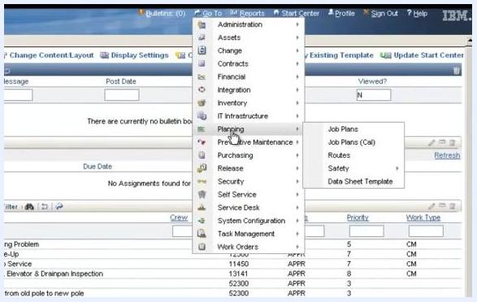
Maximo "Go To" dropdown menu expanded, with the cursor highlighting Planning > Job Plans alongside other modules such as Administration, Assets, and Contracts.

2. Create a new job plan record
Click New Record at the top of the Job Plans screen to start a new job plan.

3. Enter a unique job plan identifier
In the Job Plan field, enter a unique identifier for your job plan (for example, JM8746A).

4. Provide a description
Tab to the Description field and enter a basic description for the job plan.

5. Set organization and site
Organization and Site settings control who can use the job plan:
- Leaving both fields blank allows anyone in the Maximo instance to use the job plan.
- Entering an Organization restricts use to that organization.
- Entering both Organization and Site restricts use to that specific site within the organization.
For this example, enter BEDFORD in the Site field. When you tab out of the field, the Organization field auto-populates (for example, EAGLENAT).
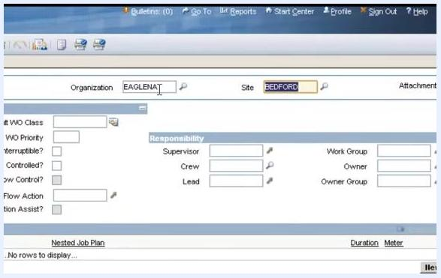
Job Plan creation screen showing the Organization field populated as EAGLENAT, the Site field populated as BEDFORD, and the Responsibility section below, with the cursor in the Site field.

6. Assign a crew or group
Avoid entering individual names—such as a Supervisor, Lead, or Owner—in the Responsibility section. Using names can create maintenance issues if personnel change, since every affected job plan would then need to be updated. Instead, use group values such as Crew, Work Group, or Owner Group, which remain stable over time.
In the Crew field, enter CREW1 and tab out of the field to save the value. Leave the other fields (Supervisor, Lead, Work Group, Owner, Owner Group) blank unless a group assignment is appropriate.
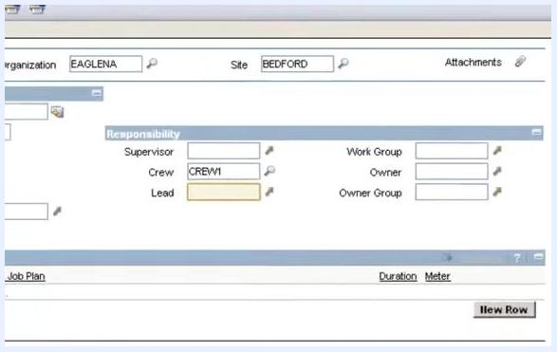
Responsibility section with the Crew field filled in as CREW1 and the remaining fields left blank; Site is BEDFORD and Organization is EAGLENA.

7. Add job plan tasks
Locate the Job Plan Tasks section below the Responsibility area and click New Row to add your first task. Tasks are automatically numbered in increments of 10 (10, 20, 30, and so on).
For Task 10, confirm the Task field shows 10 and enter ISOLATE COMPRESSOR in the Description field.
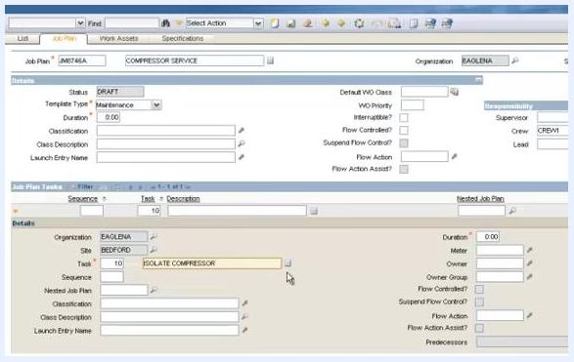
Job Plan Tasks section with Task 10 entered and the Description field showing "ISOLATE COMPRESSOR."

8. Add a long description to a task (optional)
Click the Long Description button (the notepad icon) to the right of the Description field. In the popup window, enter additional details, such as FOLLOW ALL PLANT SAFETY PRECAUTIONS, then click OK to save and close the window. The Long Description button turns orange, indicating that additional information is present.
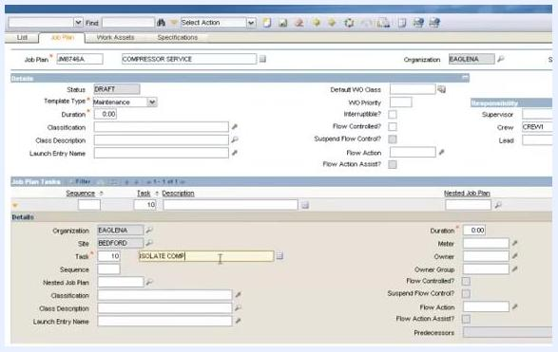
Long Description popup for Task 10 showing the text "FOLLOW ALL PLANT SAFETY PRECAUTIONS" entered.

9. Add the remaining tasks
Repeat the process to add further tasks:
- Click New Row, confirm the Task field shows 20, and enter REPLACE BELT in the Description field.
- Click New Row, confirm the Task field shows 30, and enter REPLACE GASKET in the Description field.
- Click New Row, confirm the Task field shows 40, and enter RETEST in the Description field.
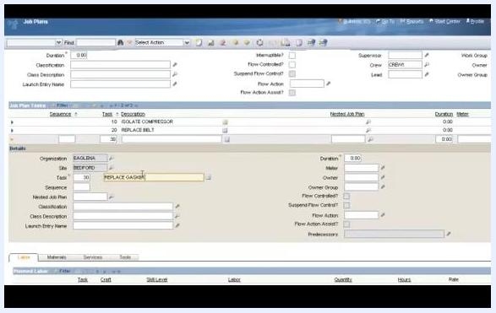
Job Plan Tasks section showing three tasks listed: 10 ISOLATE COMPRESSOR, 20 REPLACE BELT, and 30 REPLACE GASKET.

Adding labor and materials

10. Collapse task details to conserve screen space
Click the orange detail button to the left of the task list to collapse the expanded task detail section. This is especially useful when a job plan contains many tasks.
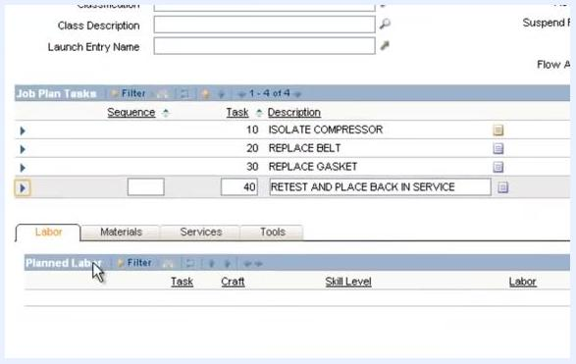
Job Plan screen with the task detail section expanded, showing the orange detail button located to the left of the task list.

11. Open the Labor sub tab
Below the Job Plan Tasks section, click the Labor tab to switch to the labor assignment area.
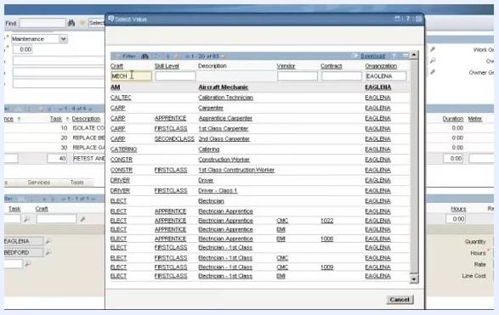
Labor sub tab selected, displaying the Planned Labor section below the Job Plan Tasks.
Click New Row in the Planned Labor section to add a new labor entry.

12. Assign labor using a craft code
Rather than entering a specific person's name, enter a craft code. In the Craft field, enter MECH to indicate a mechanic, then click the Select Value icon (magnifying glass) next to the field to open the craft selection window.
Planned Labor section with a new row added, the Craft field ready for input, and the Select Value icon visible.
In the craft selection window, type MECH in the filter box to display all mechanic-related craft codes. Review the list, which includes both internal and external labor options—codes associated with a vendor are typically external labor, and a value in the Contract column indicates an active labor contract for that craft. Select the desired craft (for example, MECH or FIRSTCLASS) by clicking the appropriate row.

13. Complete the labor assignment details
Leave the Task field blank if the labor applies to the entire job plan rather than a specific task. In the Quantity field, enter 1 to indicate one mechanic is required, and in the Hours field, enter 4 to estimate four hours of work. The Rate field auto-populates if configured—review it for accuracy.
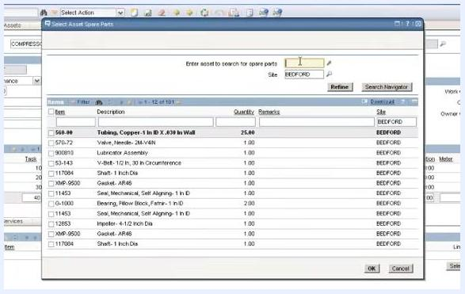
Planned Labor row filled in with Craft "MECH," Description "Mechanic," Quantity 1, Hours 4, and an auto-filled Rate.

14. Select spare parts for the job plan
Click the Materials tab next to the Labor tab, then click Select Spare Parts to open the spare parts selection window. In the Enter asset to search for spare parts field, type the asset identifier (for example, COMPRESSOR), and confirm the Site field shows the correct site (for example, BEDFORD). Click Refine to filter the list of available spare parts for that asset and site.
Review the list of spare parts, including item numbers, descriptions, quantities, and site information. Check the boxes for the parts you need, then click OK to add the selected spare parts to your job plan.
Select Asset Spare Parts window with asset and site fields populated, showing a list of available spare parts for site BEDFORD.

Finalizing the job plan

15. Add locations, assets, or items to the job plan
Under the Work Assets and Safety Plans tab, click New Row to add a new asset, location, or item. Enter the asset as 11300UM, fill in any other relevant fields, and save the entry. You can add multiple assets or locations to specify exactly what the job plan applies to.
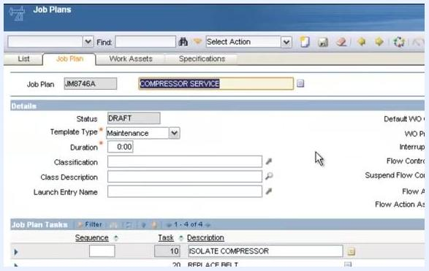
Job plan screen with the Work Assets tab active, showing fields for location, asset, and item, with the asset field filled in as 11300UM.
Confirm that the asset and location details are correct—for example, Asset: 11300UM, Description: Reciprocating Compressor - Air Cooled/100 CFM, Organization: EAGLENA, Site: BEDFORD—and ensure all required fields are filled in.

16. Activate the job plan
Return to the Job Plan tab and change the status from DRAFT to ACTIVE. In the Change Status dialog, select Active as the new status and click OK.
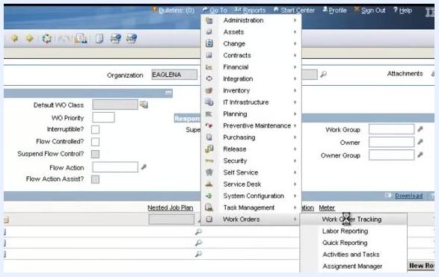
Change Status dialog for a job plan, showing the transition from DRAFT to ACTIVE with the OK button highlighted.

Assigning the job plan to a work order

17. Create a new work order
Click the Go To menu, navigate to Work Orders > Work Order Tracking, and click New Work Order. Fill out the basic work order information, such as:
- Work Order: 1193
- Description: COMPRESSOR SERVICE
- Location: BR300
- Asset: 11300UM
- GL Account: 6210-325-000
- Site: BEDFORD
- Class: WORKORDER
Dropdown navigation menu with the cursor positioned over Work Order Tracking under Work Orders.

18. Select the work type for the work order
In the Work Order Tracking screen, locate the Work Type field and click the arrow next to it to open the Select Value dialog. Review the available options—for example, CAL (Calibration), CM (Corrective Maintenance), CT (Calibration Test), CR (Control Report), and EM (Emergency Maintenance)—then select CM and click OK to confirm.
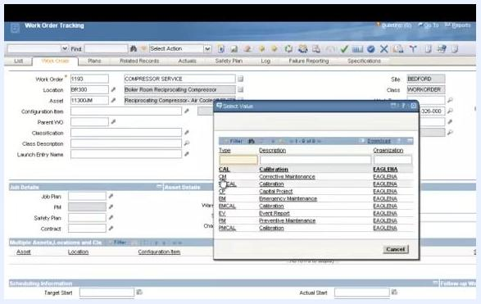
Select Value dialog open in the Work Order Tracking screen, listing work types such as CAL, CM, CT, CR, and EM, with CM being selected for Corrective Maintenance.

19. Assign a job plan to the work order
In the Job Details section, click the arrow next to the Job Plan field to open the Select Value dialog for job plans. The dialog offers filter checkboxes, including:
- Show Job Plans for the Work Order's Asset and Location Only?
- Show Job Plans with No Classes Defined?
By default, these checkboxes may be selected to show only job plans relevant to the asset and location. The list may display options such as JM171546 (compressor service), JM245124 (COMPRESSOR BELT REPLACEMENT), and JM67546 (COMPRESSOR SERVICE). Uncheck the filter boxes if you want to view a broader list of job plans.
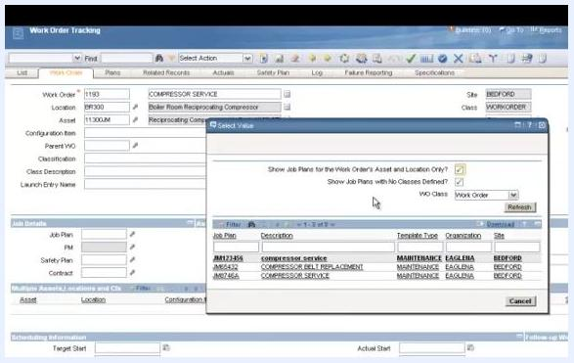
Select Value dialog for job plans, showing filter checkboxes and a list of job plans with descriptions, template types, organizations, and sites.

20. Select and apply the desired job plan
Click to select the job plan you want to assign (for example, JM67546: COMPRESSOR SERVICE), then click OK to apply it to the work order. The job plan is now linked to your work order.
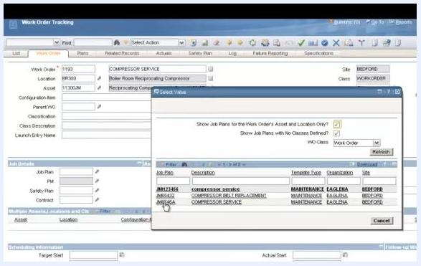
User selecting the job plan JM67546 (COMPRESSOR SERVICE) from the list in the Select Value dialog.
Confirm that the selected job plan now appears in the Job Plan field of the work order, displaying the job plan code (for example, JM67546).
Work Order Tracking screen showing job plan JM67546 assigned in the Job Plan field, confirming successful assignment.

21. Review the work plan tasks pulled from the job plan
Navigate to the Plans tab of the work order to review the tasks automatically populated from the job plan. Example tasks include Isolate Compressor, Replace Belt, Replace Gasket, and Restart and Place Back in Service. Each task includes details such as sequence number, summary, estimated duration, and status.
Any changes made to these tasks within the work order affect only that specific work order—the original job plan remains unchanged.
Plans tab of the work order showing a list of tasks—Isolate Compressor, Replace Belt, Replace Gasket, and Restart and Place Back in Service—along with sequence, summary, estimated duration, and status details.
Using job plans pulls all relevant tasks and materials automatically into the work order, streamlining the planning process and ensuring consistency while saving time on repetitive data entry.

Work order Plans tab illustrating the efficiency gained through job plan inheritance.

What's next
Now that you know how to create a job plan in IBM Maximo and assign it to a work order, you can apply the same process to build job plans for other recurring maintenance tasks, link them to Preventive Maintenance records or routes, and continue refining labor, materials, and asset assignments to match your organization's workflows.

