How to Write an 8D Report: A Step-by-Step Guide
An 8D report is the standard tool for addressing and resolving quality issues that arise in a product or process. Learning how to write an 8D report means working through eight structured disciplines, typically labeled D0 through D8, that take a team from problem definition all the way to closure and prevention. This guide walks through each discipline using a real corrosion-defect example, showing exactly what information belongs in each field of the report.
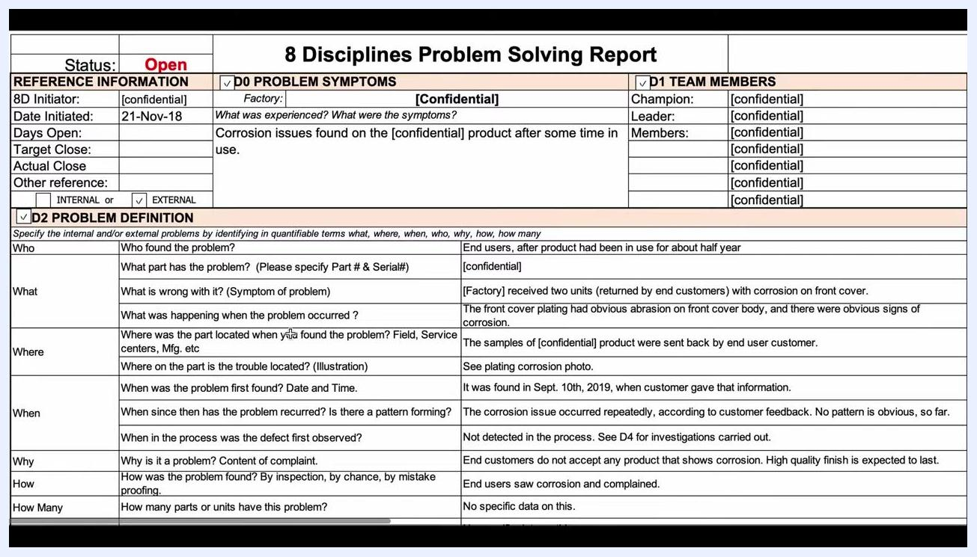
Screen capture of the fully completed problem definition table summarizing Who, What, Where, When, Why, How, How Many, and How Often.

Prerequisites
Before starting the disciplines themselves, set up the report's basic reference information. This ensures accountability and gives everyone a shared reference point for tracking progress.
- Status – mark the report as Open until the issue is fully closed.
- 8D Initiator – the person responsible for starting the report.
- Date Initiated – the date the report was opened (e.g., 21-Nov-18).
- Days Open – a running count of how long the report has been active.
- Target Close – a deadline for closing the report, which is especially important when working with suppliers or internal teams.
- Actual Close – left blank until the issue is resolved.
- Other Reference – any additional identifiers needed.
- Internal/External – whether the issue originates internally or externally.
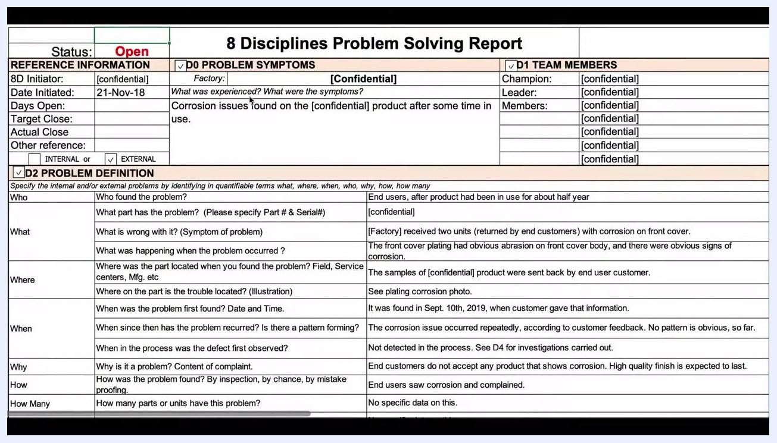
Screenshot of the 8 Disciplines Problem Solving Report template, showing fields for status, reference information, problem symptoms, team members, and problem definition. Fields include Status (Open), 8D Initiator, Date Initiated (21-Nov-18), Days Open, Target Close, Actual Close, Other reference, Internal/External, Factory, Champion, Leader, Members, and a detailed table for D2 Problem Definition (Who, What, Where, When, Why, How, How Many).
Use a dashboard to track all open and closed 8D reports so that relevant parties can see that progress is being actively monitored.
Once the basic information is in place, describe the problem in the problem symptoms field using simple, clear language — for example, "Corrosion issues found on the [confidential] product after some time in use" — and specify the product using its SKU number or another identifier.

D1 team
Assemble a team that is highly knowledgeable about the process involved. Aim for diversity of expertise and specialties so the analysis benefits from multiple perspectives.
- Champion – oversees the report and provides sponsorship.
- Leader – manages the day-to-day 8D process.
- Members – typically include the quality manager, production manager, process engineer, and supplier representatives when the issue involves an external supplier.
Assigning these roles up front ensures the right people are contributing to each discipline as the report progresses.

D2 problem description
Complete the D2 Problem Definition table by answering the Five Ws and the Two or Three Hs in specific, quantifiable, and factual terms. Avoid assumptions — document facts and observations explicitly, even if some points seem obvious.
Fill out each field as follows:
- Who found the problem? End users, after the product had been in use for about half a year.
- What part has the problem? The specific part number and serial number (confidential in this example).
- What is wrong with it? Factory received two units, returned by end customers, with corrosion on the front cover.
- What was happening when the problem occurred? The front cover plating had obvious abrasion on the front cover body, along with obvious signs of corrosion.
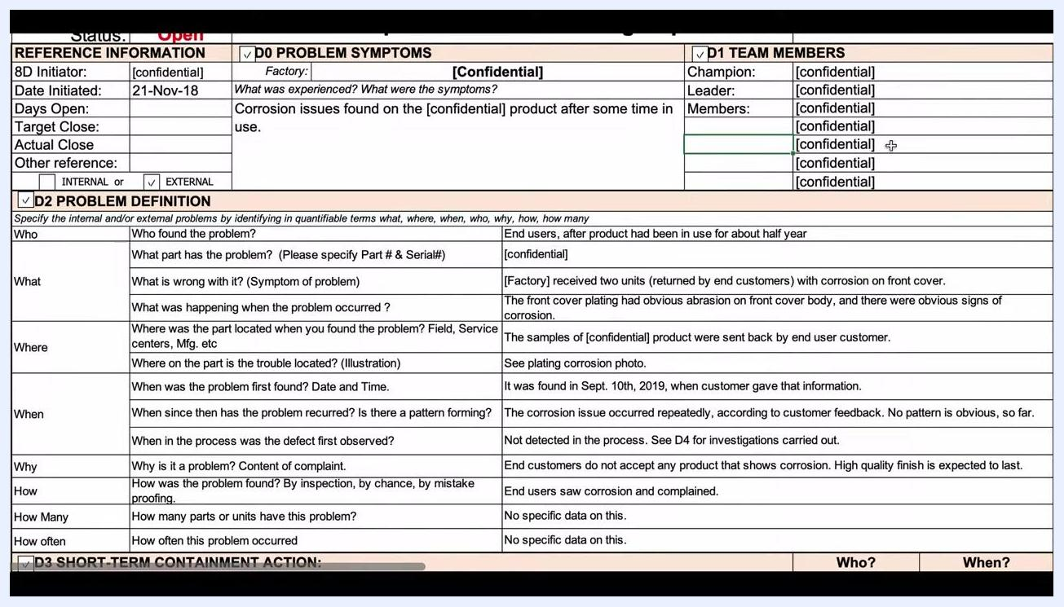
Screen capture of the 8D report during team assembly, showing the fields for assigning Champion, Leader, and Members.
- Where was the part located when found? Samples of the product were sent back by the end user customer.
- Where on the part is the trouble located? See the plating corrosion photo for illustration.
- When was the problem first found? September 10th, 2019, when the customer provided that information.
- When has the problem recurred? The corrosion issue occurred repeatedly according to customer feedback; no obvious pattern has emerged so far.
- When in the process was the defect first observed? Not detected in the process — see D4 for the related investigations.
- Why is it a problem? End customers do not accept any product that shows corrosion; a high-quality finish is expected to last.
- How was the problem found? End users saw the corrosion and complained.
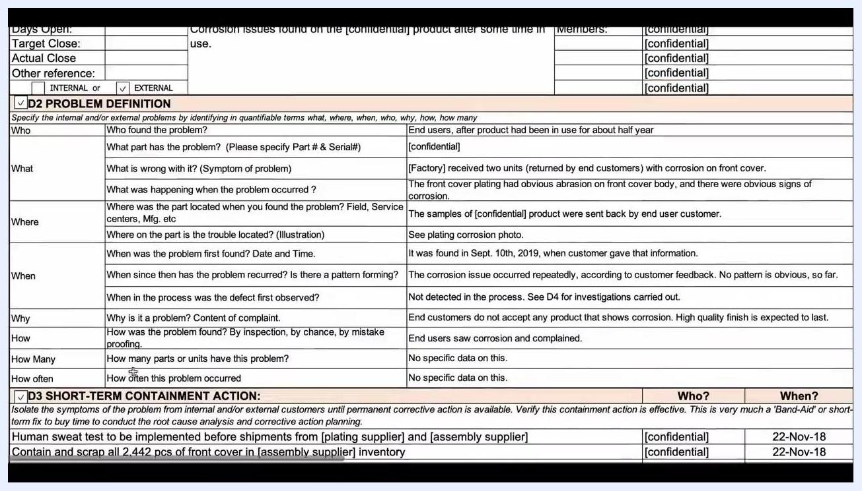
Close-up of the 8 Disciplines Problem Solving Report template, focusing on the D2 Problem Definition section. The table includes detailed questions and example answers for Who, What, Where, When, Why, How, and How Many.
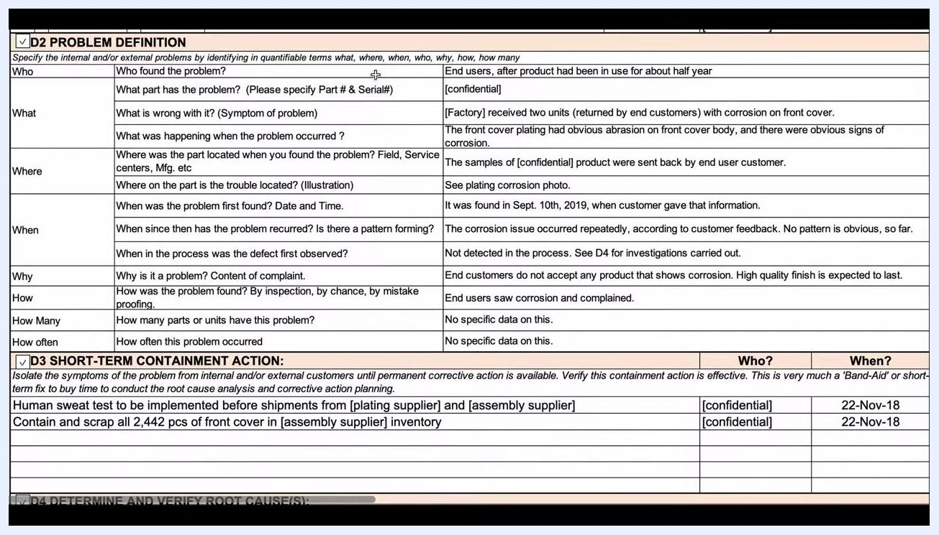
Screen capture showing the "what was happening" field of the D2 table describing abrasion and corrosion on the front cover.
- How many parts or units have this problem? No specific data available.
- How often did this problem occur? No specific data available.
Attach or reference supporting evidence, such as photos of the defect, to give all stakeholders visual context. Once every field is complete, review the section for clarity and completeness so that someone not directly involved in the process can still understand the problem.
For a final recap, the completed problem-definition table reads: Who — end users after roughly half a year of use; What — corrosion on the front cover of the confidential part; Where — samples returned by the end user; When — first found September 10th, 2019, recurring without a clear pattern, not detected during the process; Why — end customers reject any corrosion; How — found through end-user complaints; How Many / How Often — no specific data available on either.
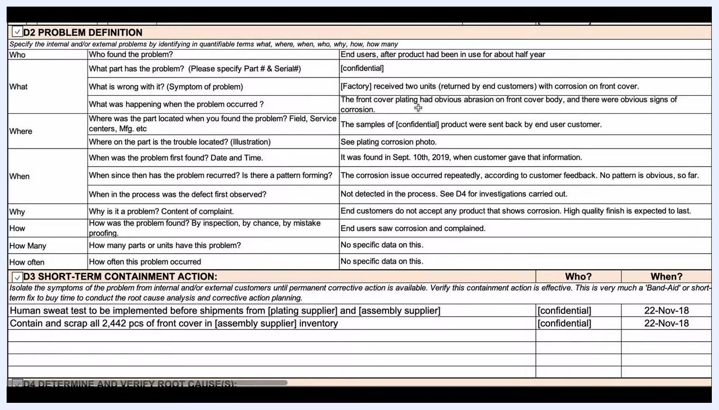
Screen capture showing the "how was the problem found" field, noting that end users saw corrosion and complained.
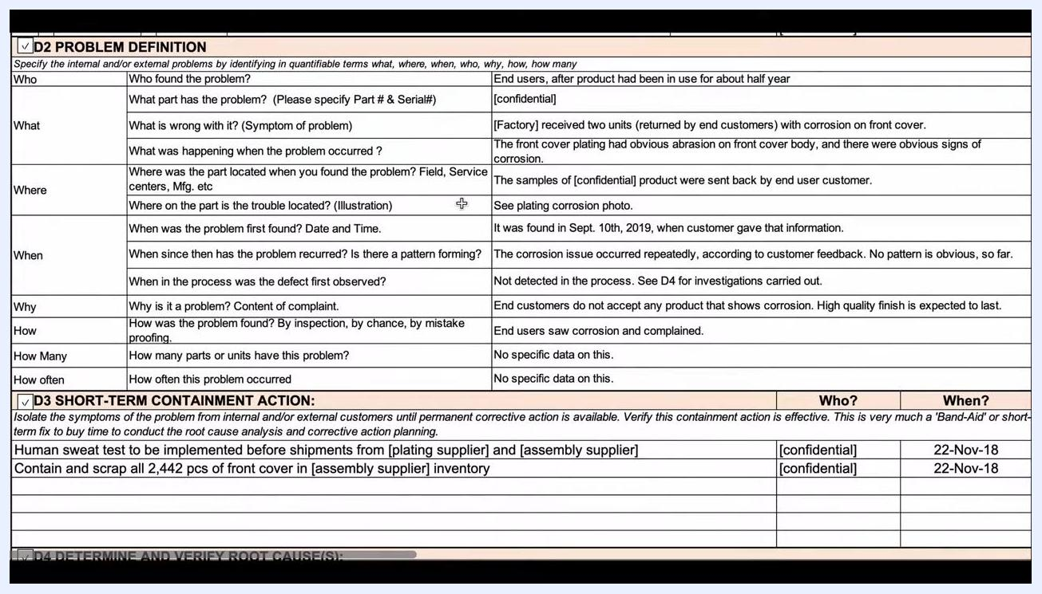
Screen capture showing a review pass over the completed D2 table, checking each field for clarity and specificity.
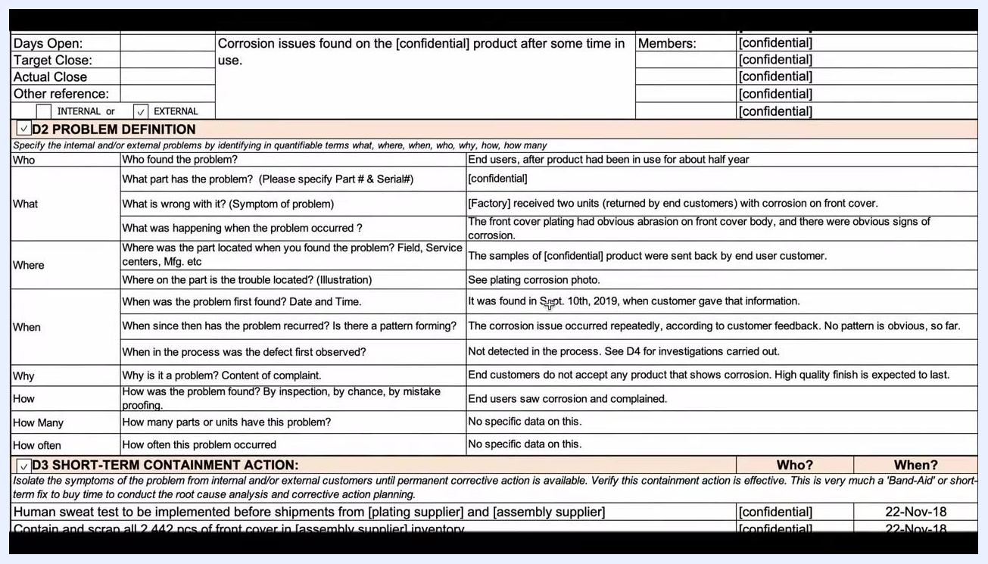
Screen capture showing the detailed problem symptoms and definition fields fully documented in the report.

D3 containment
Before root cause work is complete, take immediate action to isolate the symptoms of the problem from internal and/or external customers. First, revisit how the problem was found, how many parts are affected, and how often it occurs; if quantitative data is available, plot it to look for patterns.
Spend at least 10–20 minutes reviewing and visualizing the data, investing more time if additional data collection is needed. While analyzing, decide what immediate steps can contain the problem — for example, halting shipments if products are still being manufactured and more information is still needed.
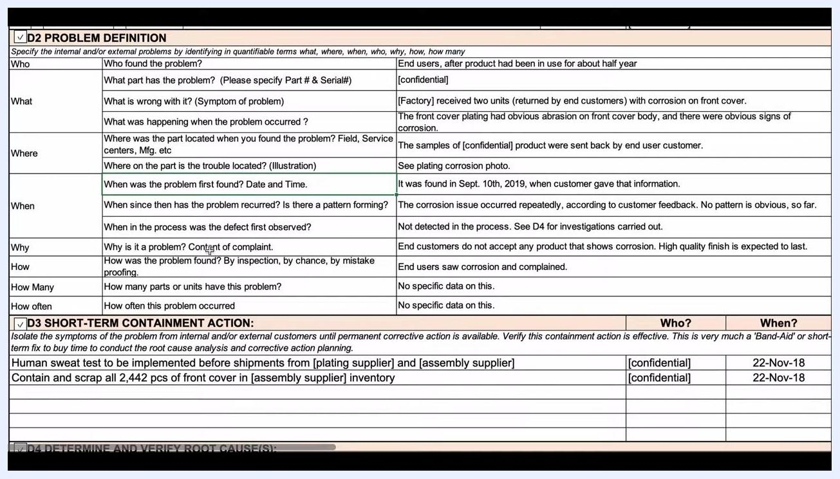
Screen capture reviewing the "how found," "how many," and "how often" data as part of the first-level analysis before containment.
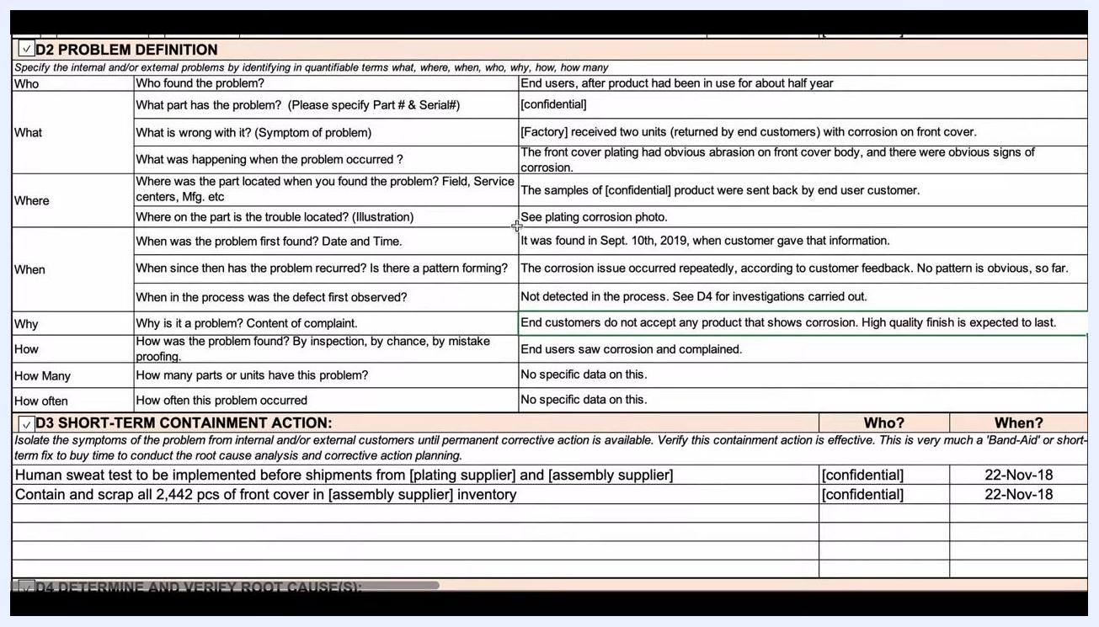
Screen capture showing consideration of halting shipments as an immediate containment measure while analysis continues.
Document the specific containment actions taken, along with the responsible party and date:
Containment action | Responsible | Date
Implement a human sweat test before shipments from the plating supplier and the assembly supplier | [confidential] | 22-Nov-18
Contain and scrap all 2,442 pieces of front cover in the assembly supplier's inventory | [confidential] | 22-Nov-18
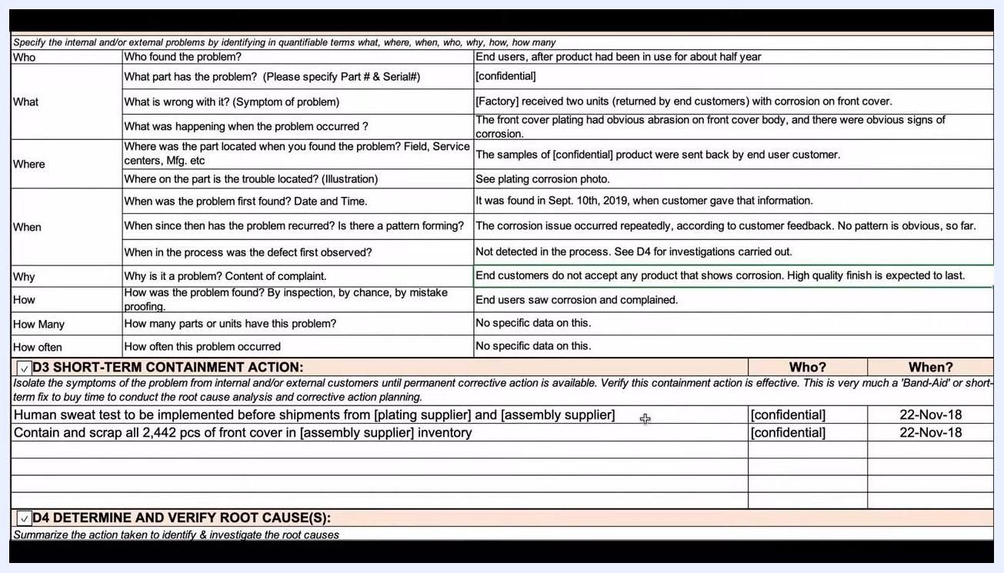
Screen capture showing ongoing data collection and testing to replicate the failure mode during the containment phase.
Treat these actions as temporary measures until a permanent corrective action is identified. Continue collecting data and add extra tests, such as the human sweat test, to replicate the failure mode as containment continues.
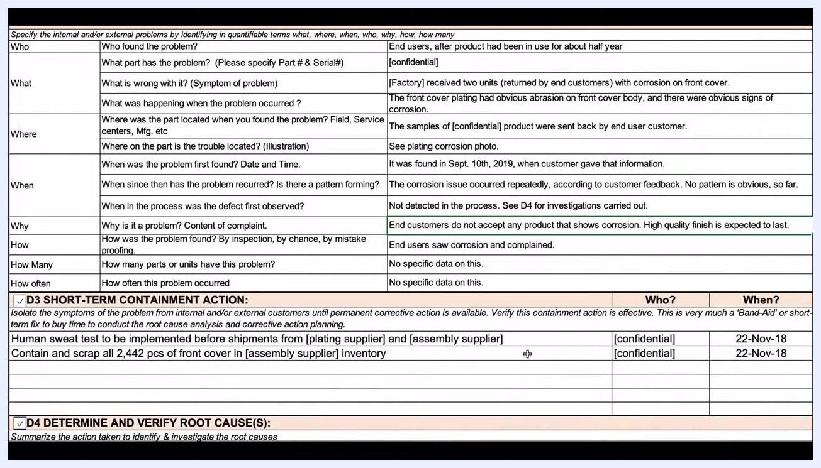
Screen capture showing the completed problem definition table together with the D3 short-term containment action section listing the human sweat test and inventory scrap actions.
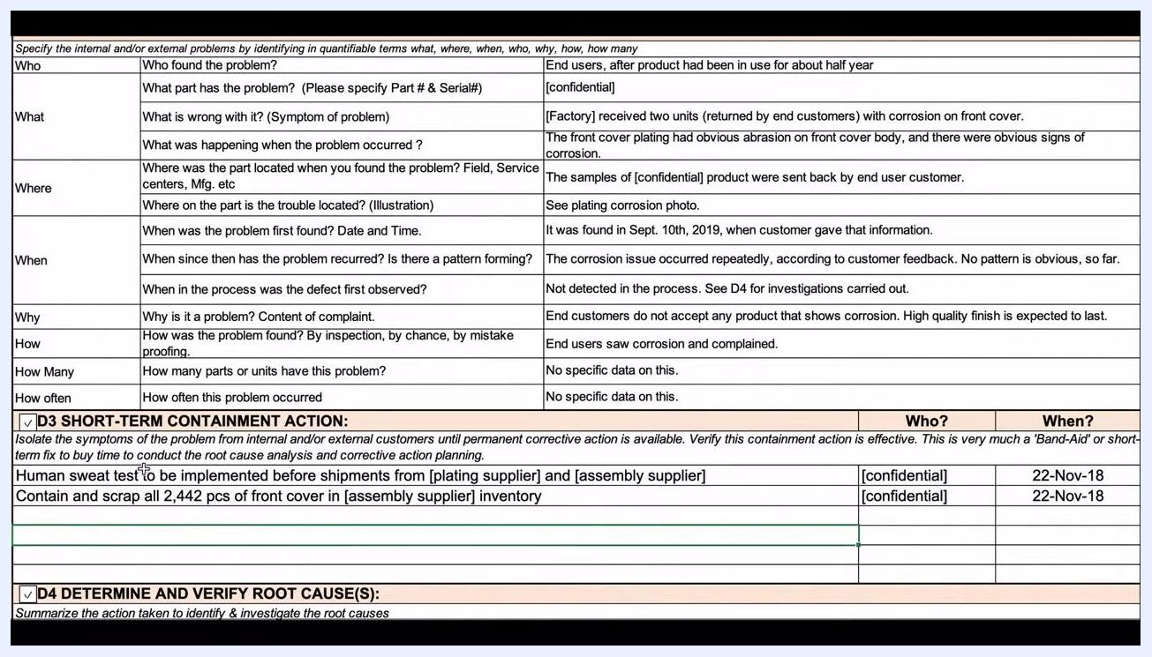
Screen capture of the problem identification and containment table with all fields filled, including Who, What, Where, When, Why, How, How Many, and How Often, with D3 short-term containment actions listed below.
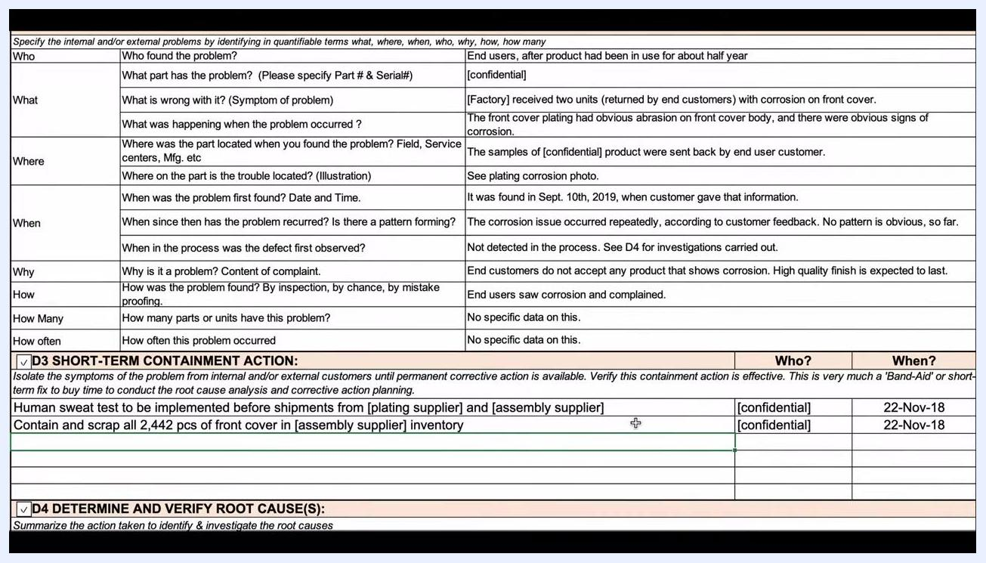
Screen capture listing the short-term containment actions — human sweat test implementation and inventory scrap — with responsible parties and dates.

D4 root cause
Investigate the root cause by combining reliability testing with a review of the supplier's process. In the assembly factory, ten front cover samples were pulled and sent for the following reliability tests:
Test | Target | Result
Alcohol abrasion resistance test | Target life 500 cycles | Passed
Surface coating cross-cut tape adhesion test | No plating peels off | Passed
RCA abrasion test (2 samples) | Target life 20 cycles | Passed
Salt spray test | Pass 24 hours without corrosion | Passed
At the plating factory, the investigation produced two key findings:
- Finding 1: Plating thickness (Cu+Ni) cannot pass the human sweat corrosion resistance requirement.
- Finding 2: Plating process key parameters — electrolyte concentration, current, and others — are out of control, and records are incomplete.
From these findings, three root causes were identified:
Root cause | Description
Root cause 1 | Plating (Cu+Ni), as processed, is not suitable for avoiding corrosion in the end-use environment
Root cause 2 | Plating process is unstable; plating thickness and adhesive force are inconsistent, leading to unavoidable corrosion
Root cause 3 | The assembly supplier did not perform an appropriate evaluation of the plating process during NPI (New Product Introduction)
Screen capture of the root cause analysis section showing reliability test results, plating factory findings, and a summary of root causes.
The report also captures the escape point through two dedicated questions:
- Why made? Plating process key parameters are out of control, and the process as designed is not suitable.
- Why shipped? Only the salt spray and alcohol adhesive tests were performed by the assembly and plating suppliers; human sweat corrosion was never tested, so the gap was not caught before shipment.
Recognize that thinner plating with lower adhesive force accelerates corrosion, underscoring the need for proper plating evaluation during NPI. The problem spans two levels: the plating factory's process control and plating suitability, and the assembly supplier's lack of evaluation during product introduction.
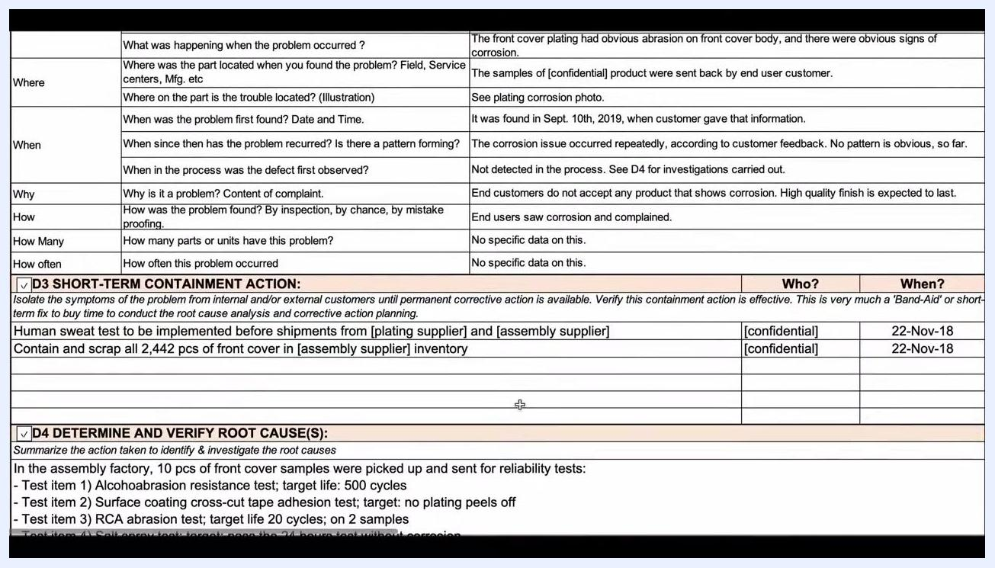
Screen capture showing the D3 short-term containment actions alongside the D4 root cause analysis fields.

D5 corrective action
Based on the confirmed root causes, define permanent corrective actions that resolve the issue without introducing undesirable side effects. Each action should be specific and thoroughly defined.
Corrective action | Responsible | Due date | Completion date
Cancel the existing plating specification document and issue a new one requesting Cu+Ni+Cr plating for the front cover to improve corrosion resistance | [confidential] | 30-Nov-18 | —
Add human sweat corrosion test requirements to the assembly supplier's incoming QC inspection documents | [confidential] | 30-Nov-18 | —
Check plating key parameters randomly to confirm the plating process remains in a steady state | [confidential] | 23-Dec-18 | —
Ensure all concerned production staff are aware of the new Cu+Ni+Cr process during production | [confidential] | 30-Nov-18 | —
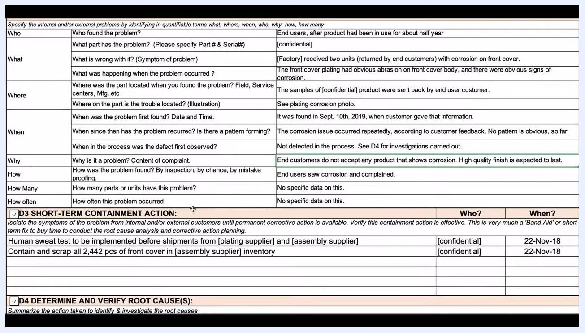
Screen capture showing the human sweat test containment action recorded with its responsible party and date.
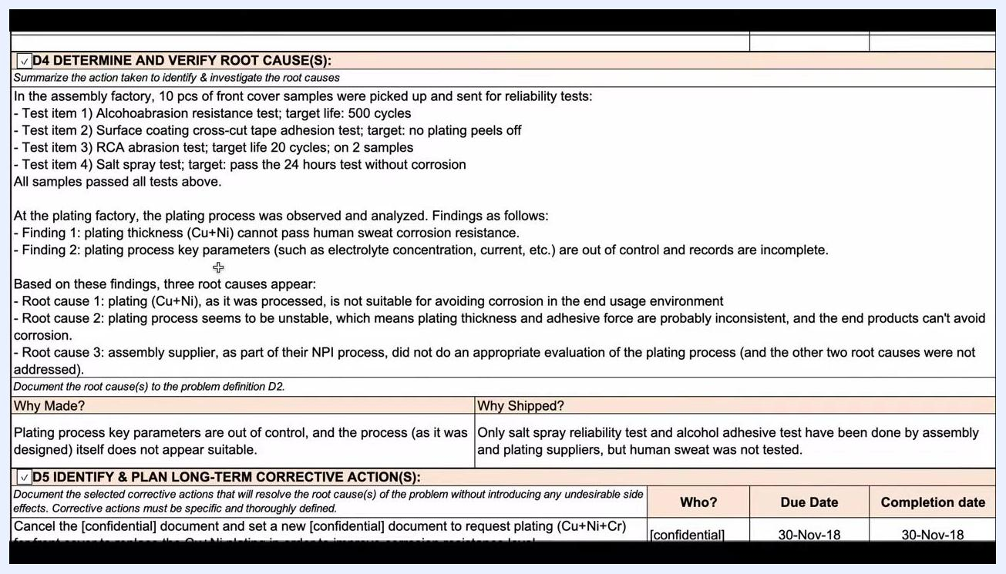
Screen capture of the long-term corrective action plan section, showing the change to the plating specification, responsible party, and due and completion dates.
For complex reports, it can help to duplicate the corrective action file for each discipline — creating separate, clearly named files for D5, D6, D7, and D8 — so every team member can follow the process without confusion.
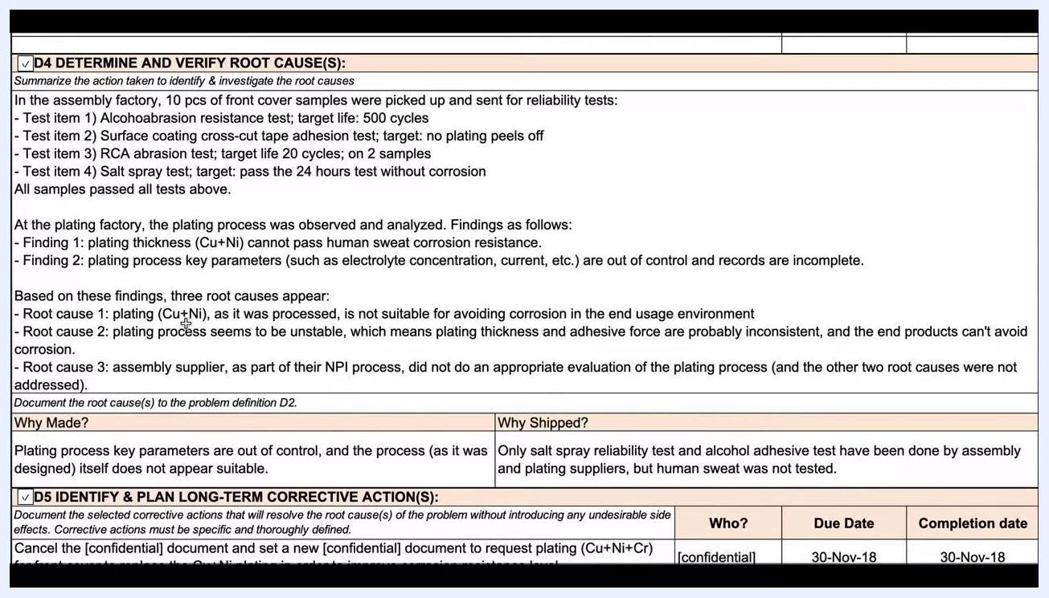
Screen capture of a corrective action report showing D4 root cause analysis alongside D5 corrective action planning, with all technical fields filled in.
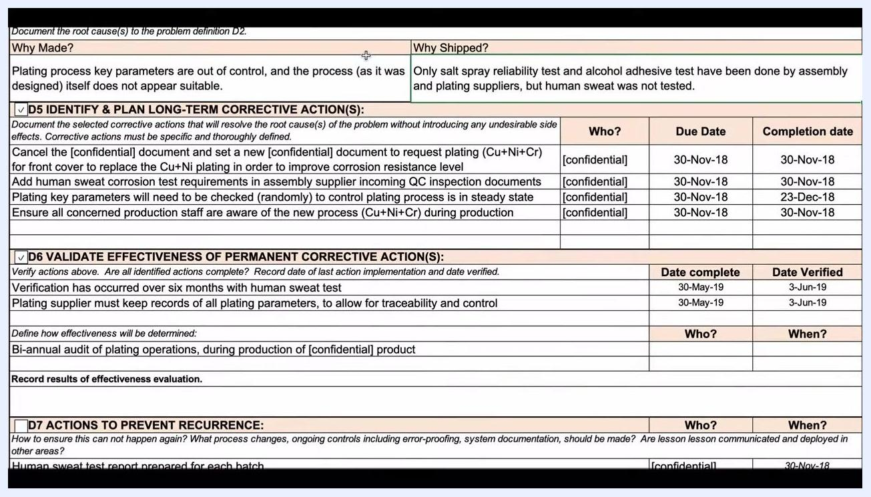
Screen capture of the D5 corrective actions covering the new plating specification, human sweat test requirement, random parameter checks, and staff awareness, with responsible parties and due dates.
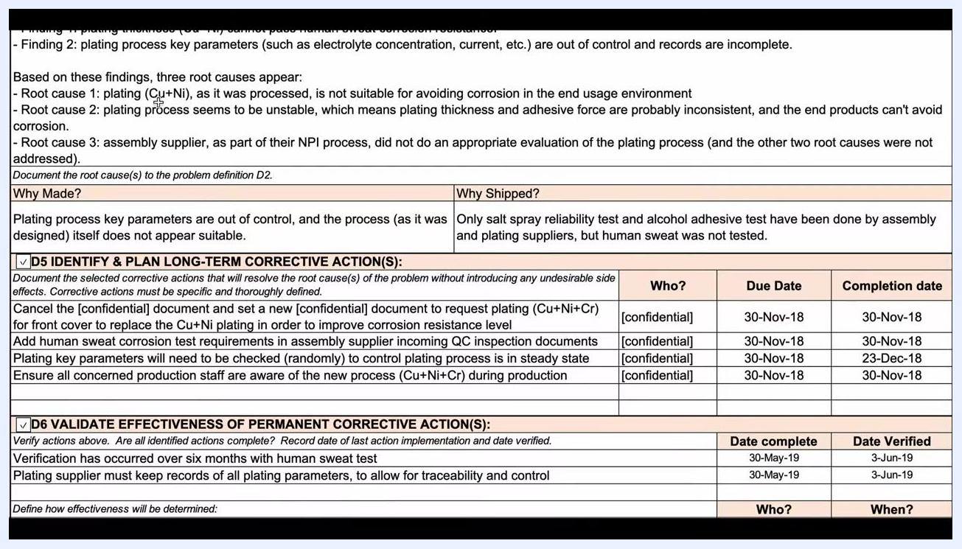
Screen capture of the D5 and D6 corrective action tables, illustrating how duplicating files for each discipline keeps the process organized.

D6 validation
Verify that all corrective actions listed in D5 are complete and effective before considering the issue resolved.
Validation check | Detail | Date
Human sweat test verification | Conducted over six months to confirm the new plating resists corrosion | Complete: 30-May-19; Verified: 3-Jun-19
Plating parameter record-keeping | Plating supplier must keep records of all plating parameters for traceability and control | Ongoing
Bi-annual audit | Audit of plating operations during production of the confidential product, used to define ongoing effectiveness | Ongoing
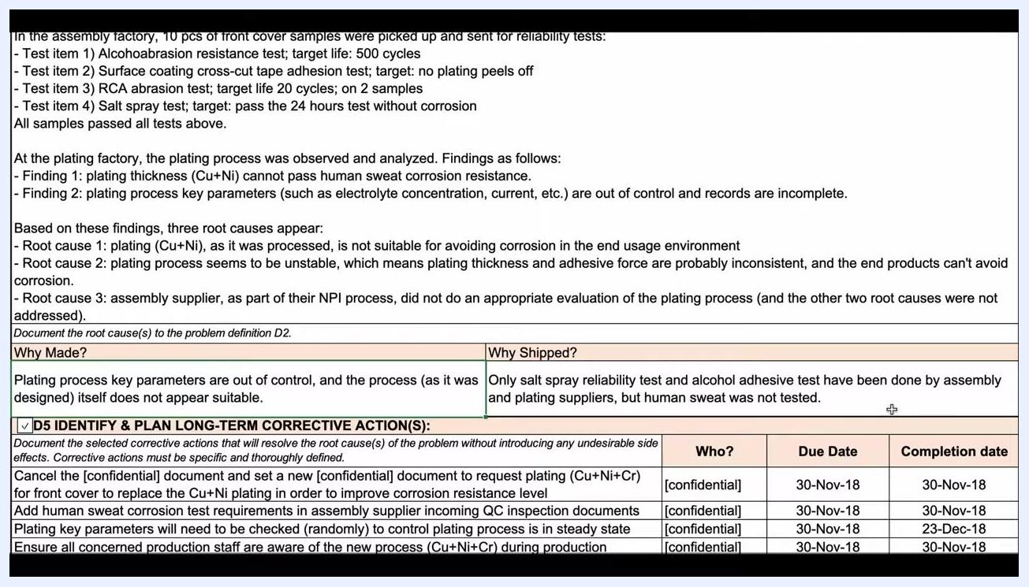
Screen capture of the "Why Shipped?" field noting that human sweat testing was never performed by the suppliers, highlighting the escape point.
Keep the documentation simple and clear so it remains easy to review even as the report grows in complexity; separate files per discipline can help when multiple corrective actions are tracked simultaneously.
The source material does not describe an explicit customer sign-off step within D6; when your team reaches this point, record any customer confirmation of the fix alongside the audit and test results above.
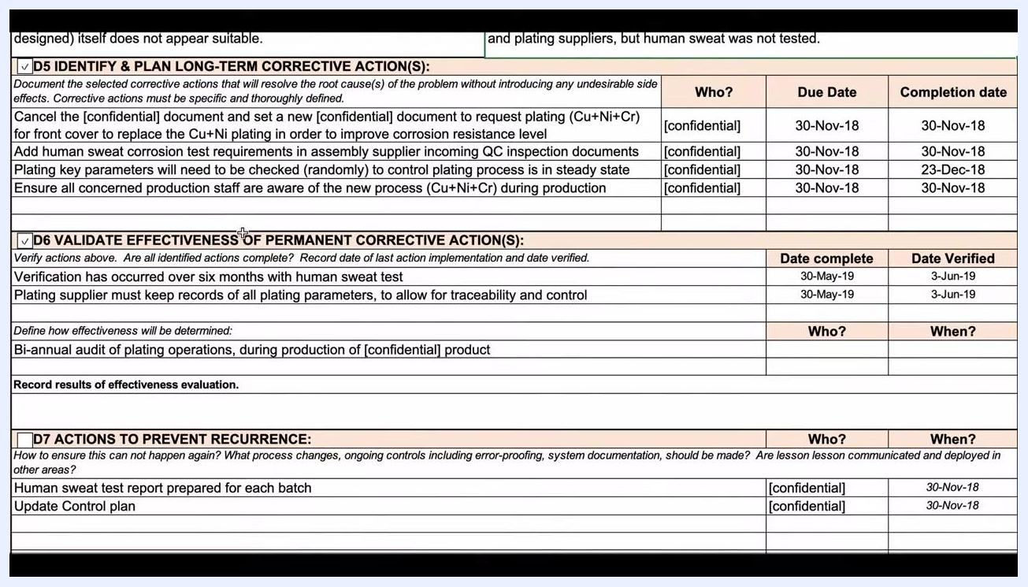
Screen capture of the D6 validation section showing six months of human sweat testing, record-keeping requirements, and the bi-annual audit plan.
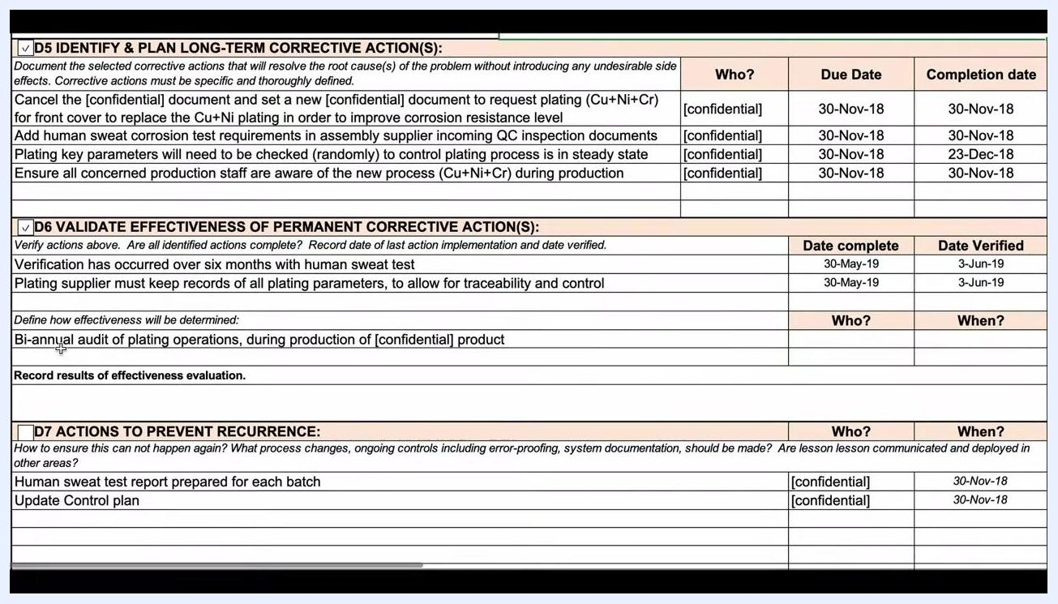
Screen capture of the D6 section confirming completion and verification dates for the corrective actions.
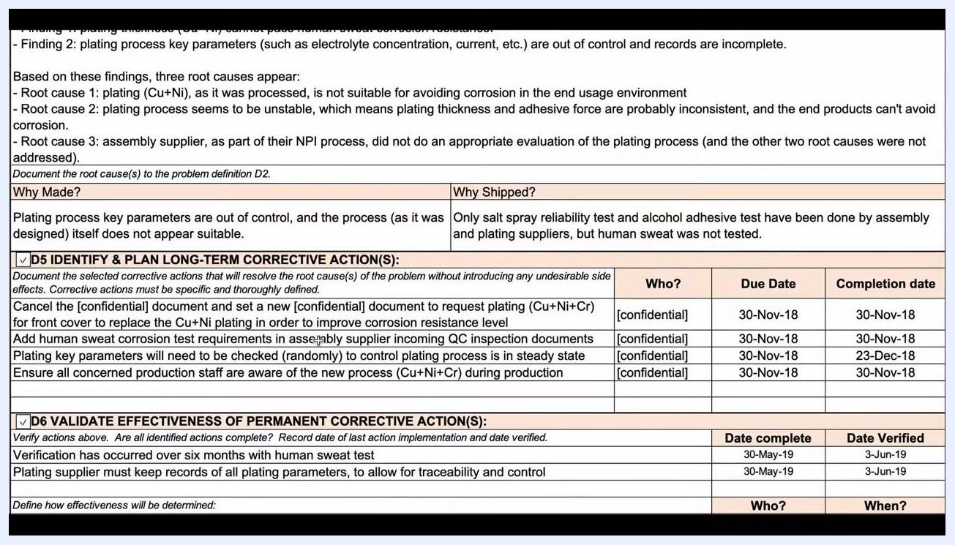
Screen capture of the D5 and D6 tables emphasizing clarity and simplicity in documentation as the report grows in complexity.

D7 prevention
Define ongoing controls so the issue does not recur, and update the relevant documents to reflect the new process.
Preventive action | Responsible | Due date | Document updated
Prepare a human sweat test report for each batch | [confidential] | 30-Nov-18 | Control plan
Update the control plan | [confidential] | 30-Nov-18 | Control plan, process/work instruction
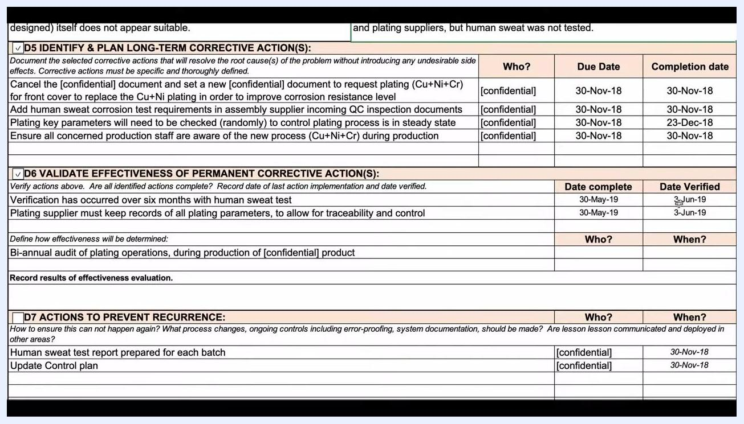
Screen capture of the D5 corrective actions with responsible parties, due dates, and completion dates recorded as actions are finished.
Mark whether the Control Plan and Process or Work Instruction documents require updates, and check the corresponding boxes in the report.
Consider adding an extra audit layer so suppliers do not overlook or forget implemented changes, and assign a dedicated person experienced in root cause analysis to oversee follow-up and documentation. This helps maintain high standards and prevents the issue from recurring.
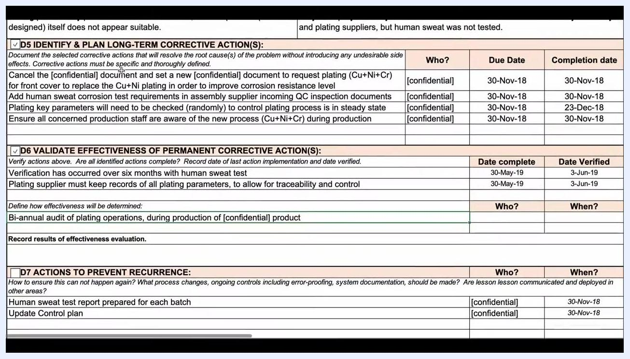
Screen capture of the D7 actions to prevent recurrence, including responsible parties, completion dates, and document update checkboxes.
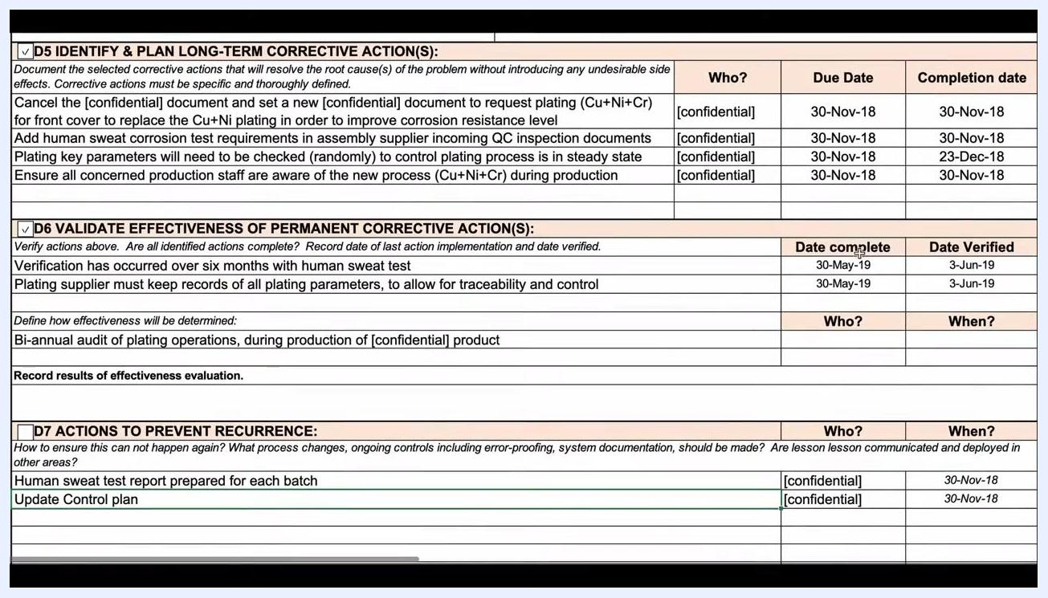
Screen capture of the D6 validation section alongside the D7 preventive actions, showing audit and documentation requirements together.

D8 closure
Once D5 through D7 are validated, use the D8 section to recognize the collective efforts of the team for their contributions to the corrective action process.
The material reviewed here does not capture an explicit customer acceptance record or a final closure date field; when your report reaches this stage, record the customer's formal acceptance and the date the report is officially closed alongside the team recognition notes.
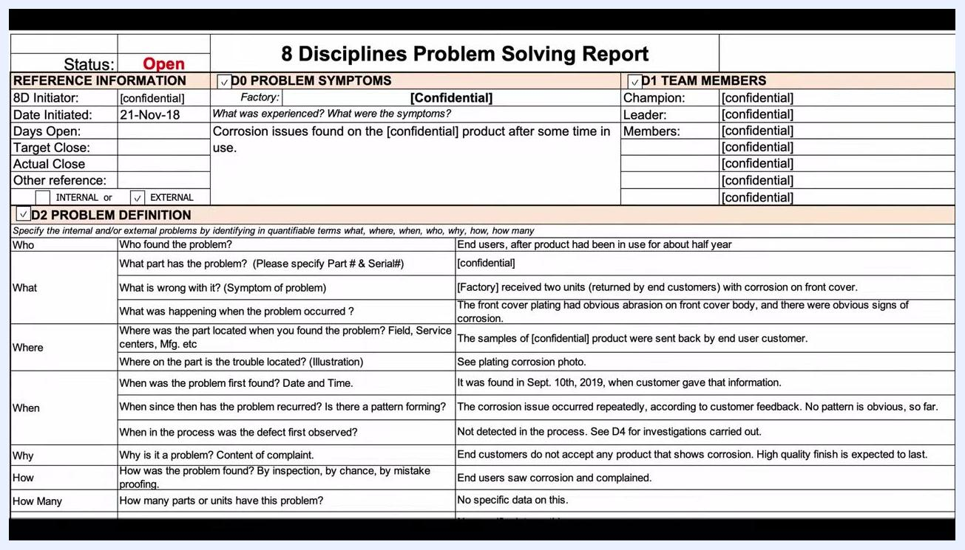
Screen capture of the completed 8 Disciplines Problem Solving Report with all fields filled, including status, initiator, team members, problem symptoms, and detailed problem definition.

What's next
With the report complete, continue to monitor the bi-annual audits and batch-level human sweat test reports defined in D6 and D7 to confirm the corrective actions hold over time. If you have questions about applying this process to an issue in your own supply chain, reach out to your quality team for guidance, and consult QualityInspection.org for further practical advice on quality inspection and supply chain management.
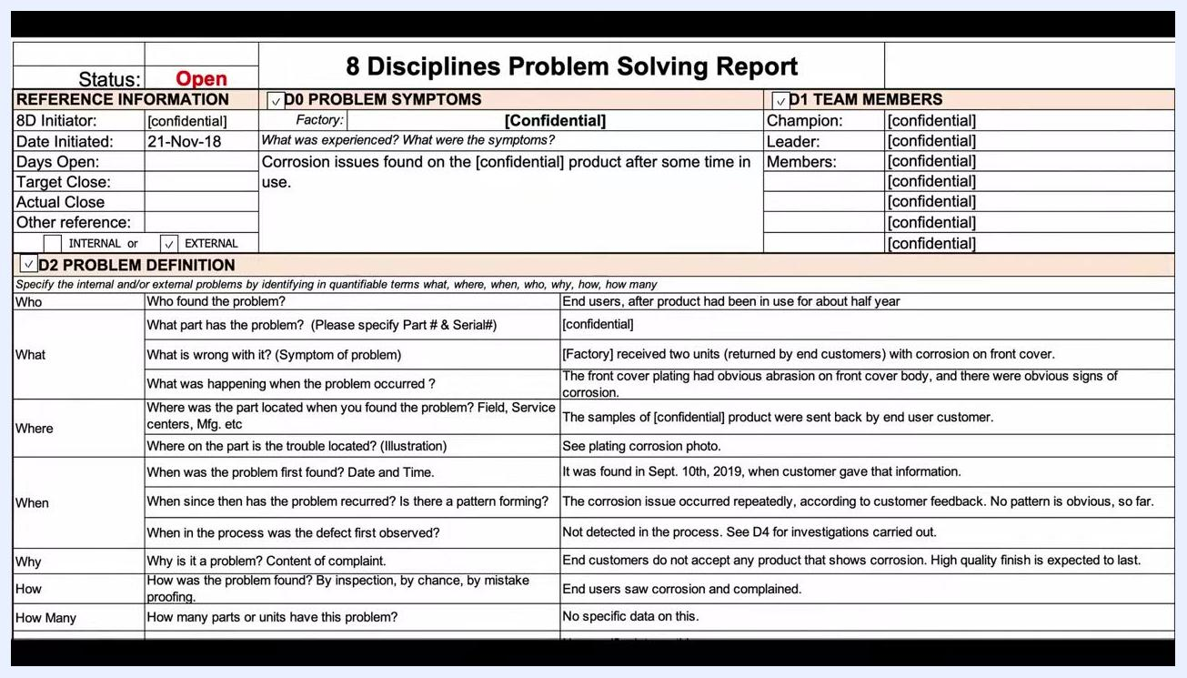
Screen displaying the QualityInspection.org logo and tagline: "Practical Advice for Importers in China"

