How to Use Feeler Gauges to Measure Engine Component Clearances
This procedure explains how to use feeler gauges (also known as feeler blades) to accurately measure clearances between engine components, such as valve lash on a cylinder head. You will learn how to select the correct blade thickness, develop a proper sense of "feel" for resistance, and confirm your measurement against a known specification.

Purpose
This SOP provides step-by-step guidance on how to use feeler gauges correctly when measuring clearances on engine components. It covers selecting the right blade, understanding the resistance you should feel, and applying the technique to a real-world example: measuring valve lash clearance on a Toyota 1FZ cylinder head.

Scope
This procedure applies to any situation requiring precise clearance measurement on engine components using a feeler gauge set, including camshaft and valve train clearances. The example in this SOP demonstrates the technique on the exhaust valve of cylinder number one on a Toyota 1FZ cylinder head.

Required equipment
- A standard feeler gauge set with hardened steel blades
- Blades marked with thickness in both metric (mm) and imperial (inch) units
- A Toyota 1FZ cylinder head (or other engine component to be measured), mounted on a stable workbench
- Two glossy magazines and a sheet of A4 printer paper (for the resistance practice exercise)

Step-by-step procedure

1. Gather your feeler gauge set
Collect a standard feeler gauge set that includes a range of hardened steel blades. Confirm the set is complete and in good condition before use.
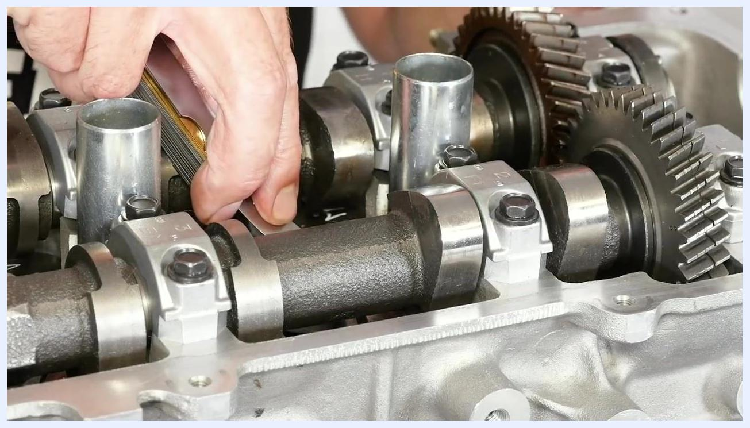
A hand holds a set of feeler gauges while inserting one between camshaft components in an engine. The camshaft, gears, and bolts are visible.

2. Inspect the thickness markings
Open the set and check the markings on each blade to identify its thickness. Confirm that both metric and imperial units are marked, so you can work in your preferred measurement system.
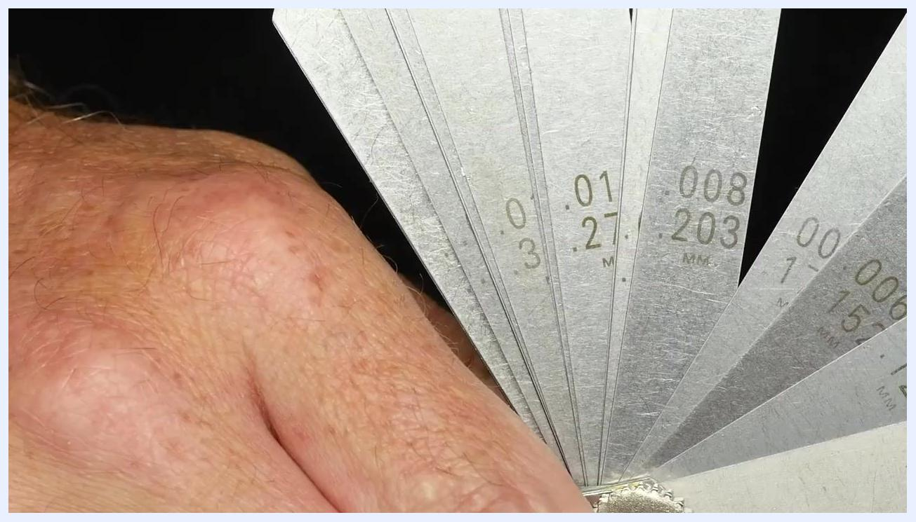
A close-up of several feeler gauges fanned out, showing thickness markings in both metric and imperial units. A hand holds the set.

3. Understand the concept of resistance
Proper use of feeler gauges depends on knowing the expected resistance as you slide a blade through the gap being measured. A blade that is too thin produces no friction or resistance. A blade that is too thick can be forced through but will meet significant resistance.
The instructor stands at a workbench explaining the concept of resistance when using feeler gauges.

4. Practice sensing correct resistance
Before measuring real components, build a feel for correct resistance using a simple exercise: place a sheet of A4 printer paper between two glossy magazines and hold down the corner of the magazines to keep them steady.

The instructor holds a sheet of A4 paper, with two glossy magazines on the bench, preparing to demonstrate the resistance exercise.

5. Perform the resistance test
Gently pull the sheet of paper out from between the magazines while holding them down. Note the amount of resistance you feel — this simulates the resistance you should expect when using the correct-thickness feeler gauge.

6. Note the safety reminder for oversized blades
If you use a feeler gauge that is too large for the gap, you will feel noticeably more resistance than in the paper test. Never force an oversized blade into a clearance, as this can produce an inaccurate reading or damage components.

The instructor stands behind the magazines and paper, explaining the importance of correct resistance when using feeler gauges.

7. Prepare the cylinder head for measurement
Set up the Toyota 1FZ cylinder head on a stable workbench. For this example, identify the exhaust valve on cylinder number one as the point to be measured.
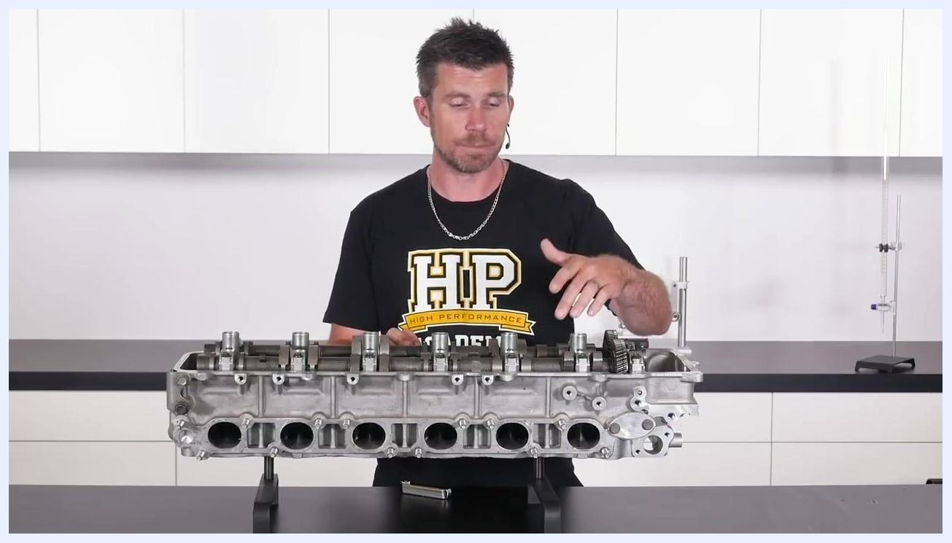
The instructor stands behind a Toyota 1FZ cylinder head, pointing to the area where the exhaust valve clearance will be measured. The cylinder head is mounted on a bench.

8. Locate the measurement point
Find the base circle of the camshaft lobe and the bucket (lifter) it sits on. This is the location where you will insert the feeler gauge to measure the clearance.
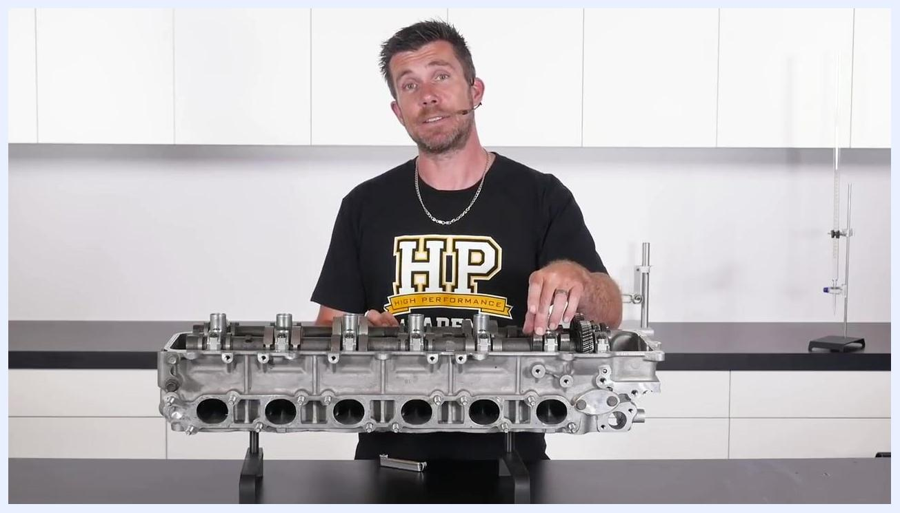
The instructor points to the camshaft lobe and bucket area on the cylinder head, preparing to demonstrate where the feeler gauge will be inserted.

9. Select and insert the initial feeler gauge
For this type of mechanical valve mechanism, a typical cold clearance is about 0.010 inches (10 thousandths of an inch). Select the 0.010 inch feeler gauge and carefully slide it between the base circle of the camshaft and the top of the bucket or lifter.
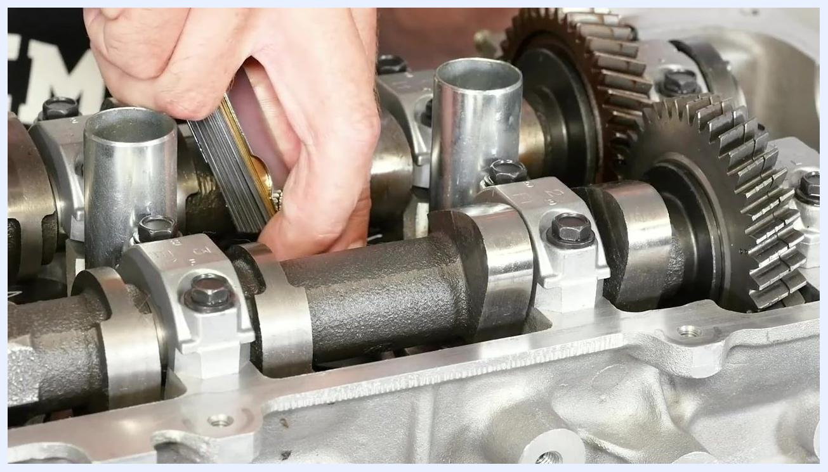
A close-up shows hands inserting a 0.010 inch (0.254 mm) feeler gauge between the camshaft lobe and the bucket on the cylinder head. The blade's thickness marking is visible.
- If the blade slides through with absolutely no resistance, the clearance is larger than 0.010 inches and the blade is too small for an accurate reading.

10. Step up to the next blade size
Select the next size up, a 0.012 inch (12 thou) feeler gauge, and repeat the insertion at the same measurement point.
A close-up shows hands selecting and preparing to insert a thicker, 12-thou feeler gauge between the camshaft and bucket. The feeler gauge set is visible.
- If you feel a reasonable amount of resistance with the 0.012 inch blade, this likely matches the actual clearance.

11. Verify with the next size up
To confirm your reading, try inserting a 0.013 inch (13 thou) feeler gauge at the same location.
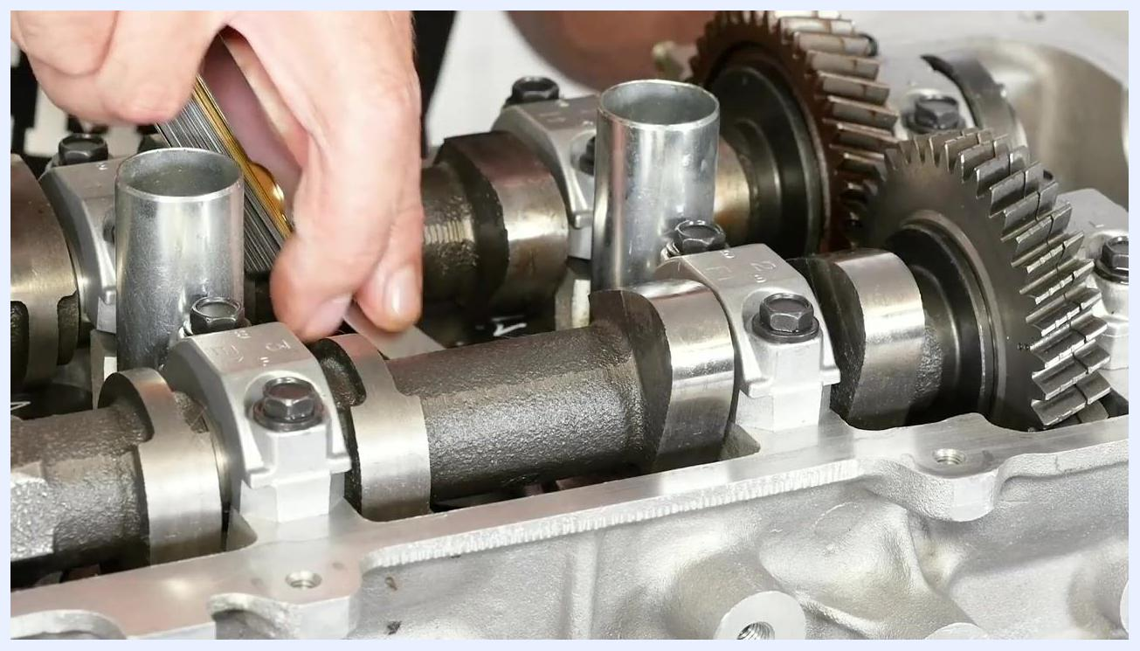
A close-up shows hands inserting a 0.013 inch feeler gauge between the camshaft and bucket, checking for resistance to confirm the correct clearance.
- If the 0.013 inch blade does not fit, or fits only with excessive resistance, the actual clearance is approximately 0.012 inches.
- Do not force the blade; excessive resistance means the blade is too thick for an accurate measurement.

12. Confirm the final clearance reading
Return to the 0.012 inch (12 thou) feeler gauge and attempt to insert it between the camshaft and the bucket. If it requires a reasonable amount of effort to insert, this confirms the clearance is correct — in this example, 0.012 inches.
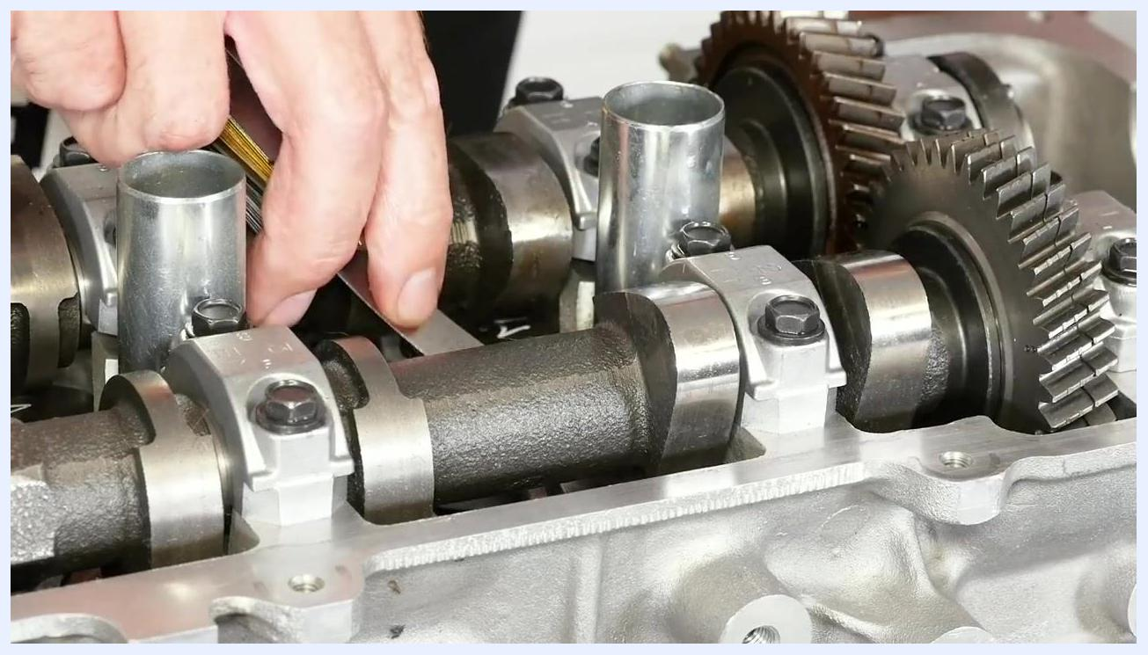
A close-up shows a hand inserting a feeler gauge between the camshaft lobe and the bucket on the cylinder head. The camshaft, cam caps, gears, and part of the feeler gauge set are visible.

Verification and summary
To confirm you have used the correct feeler gauge:
- Confirm the blade fits with a reasonable, moderate amount of resistance — not free-sliding and not forced.
- Confirm the next size up either does not fit or fits only with excessive resistance.
- Record the confirmed measurement for reference.
Developing an accurate feel for feeler gauge resistance takes practice. With experience, you will quickly recognize the correct amount of resistance when checking clearances on any engine component.

What's next
For a deeper understanding of engine assembly and measurement techniques, consider further training in engine building. Relevant topics include:
- Engine anatomy
- Essential engine machining processes
- How to select and measure critical clearances
- Engine long block assembly
- Procedures for breaking in a fresh engine

