How to Use a Torque Multiplier to Remove Stubborn Lug Nuts

Purpose
This standard operating procedure explains how to use a torque multiplier to remove stubborn or rusted lug nuts from large vehicle tires, such as those found on an RV. It also covers why standard lug wrenches often fail on tight nuts and what alternative methods you may try before reaching for the torque multiplier.

Scope
This procedure applies to any technician or vehicle owner who needs to loosen lug nuts that will not release with a standard lug wrench, particularly on RVs and other large vehicles.

Required equipment
- Torque multiplier device with matching sockets
- Handle/bar for leverage
- Extension bar
- Blue carrying case (for kit storage and organization)
- Standard lug wrench and bar (if attempting initial removal)
- Heavy-duty ratchet and a three-foot extension pipe (optional intermediate step)
- Car jack or jack stand

Step 1: Inspect the torque multiplier kit
Open the torque multiplier kit and inspect its contents before starting work. Confirm the kit includes the torque multiplier device, multiple large sockets, a handle/bar for leverage, an extension bar, and the blue carrying case used to keep everything organized.
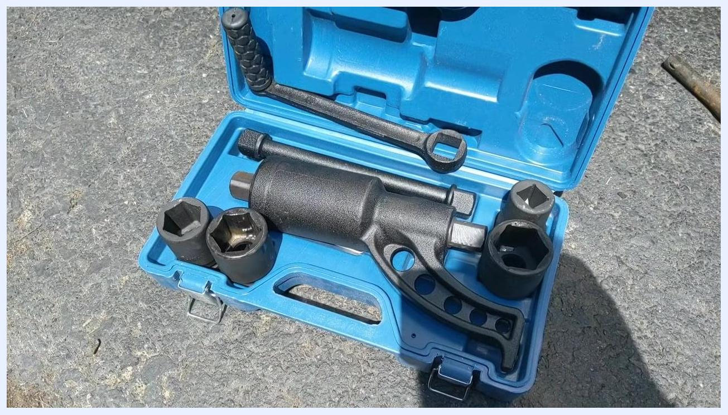
Open blue torque multiplier kit on the pavement, showing the torque multiplier, sockets, handle, and extension bar neatly arranged in molded slots

Step 2: Understand the limitations of standard lug wrenches
Standard RV lug wrenches, often dating back to the 1970s, consist of a simple bar that fits into the end of the wrench. Recognize that these wrenches may not provide enough leverage to break loose stubborn or rusted lug nuts, which is why an alternative approach is often needed.

Step 3: Stabilize the lug wrench for maximum torque
Place the lug wrench on the lug nut and rest it against a jack stand. This keeps the wrench square on the nut and prevents it from tipping, allowing you to apply more torque safely.
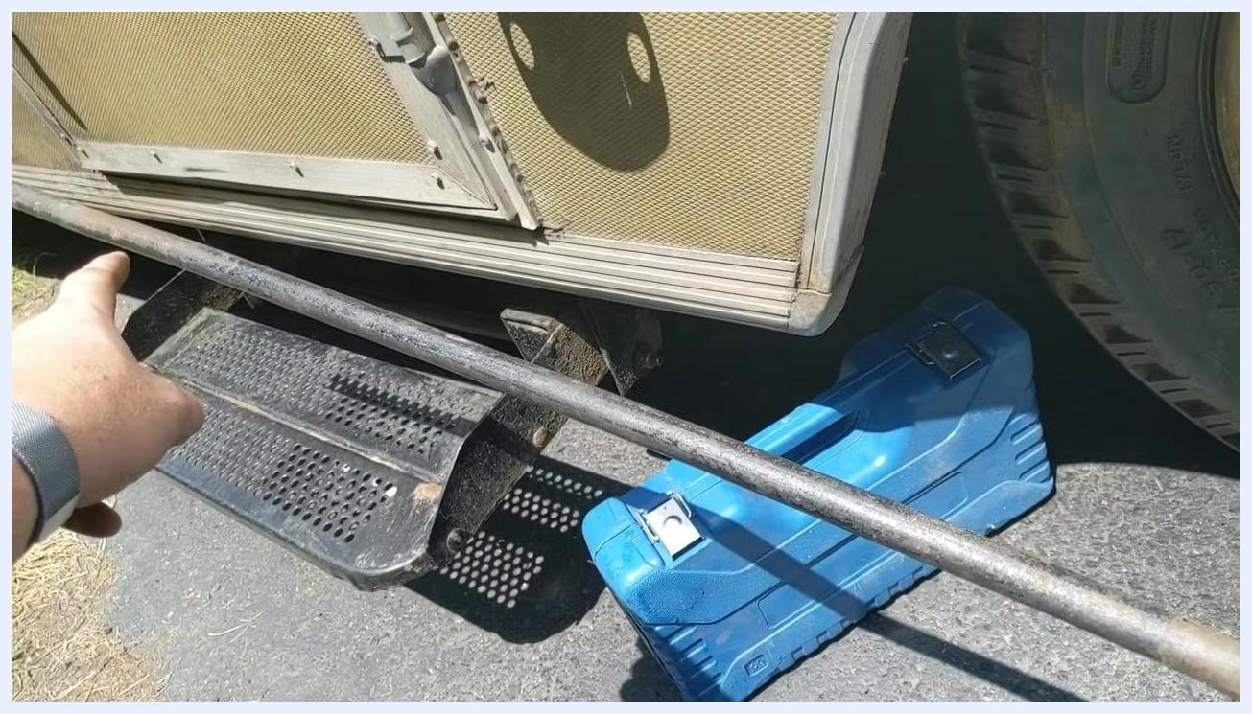
Lug wrench positioned on a lug nut, supported by a jack stand for stability, with the blue tool case visible in the background

Step 4: Attempt to loosen the nut with the standard bar
Attach the bar to the end of the lug wrench and apply force. If the nut is very tight, you may need to use your body weight against the bar.
Safety note: Excessive force can bend the bar. Inspect the bar afterward for damage before reusing it.
Long metal bar attached to a lug wrench, bent from excessive force, with a hand pointing at the bend and an RV step visible

Step 5: Try a heavy-duty ratchet and extension pipe
If the standard bar fails to loosen the nut, retrieve a heavy-duty ratchet from your toolbox and attach a three-foot extension pipe for additional leverage. Apply your weight to the end of the pipe to attempt loosening the nut. If the nut still does not break free, proceed to the torque multiplier.
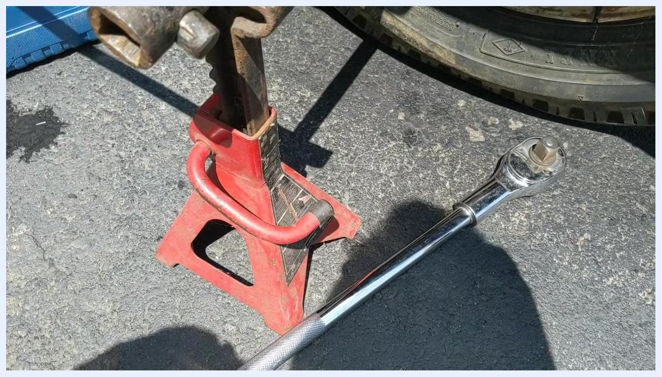
Red jack stand supporting a lug wrench, with a large chrome ratchet and extension pipe lying on the ground nearby

Step 6: Prepare the torque multiplier kit
Retrieve the torque multiplier kit from storage, open the case, and confirm that all components are present and undamaged before use.
Blue torque multiplier kit open on the ground, showing the torque multiplier, sockets, and handle arranged in their slots

Step 7: Identify the stubborn lug nut
Locate the lug nut that has not yet been loosened and confirm it is as tight as the others that required the torque multiplier.
Hand pointing at a rusty wheel with several lug nuts, with the blue torque multiplier kit and jack stand visible below

Step 8: Select the correct socket and attach it to the multiplier
Find the socket in the kit that fits the lug nut, then attach the correct socket to the torque multiplier device.
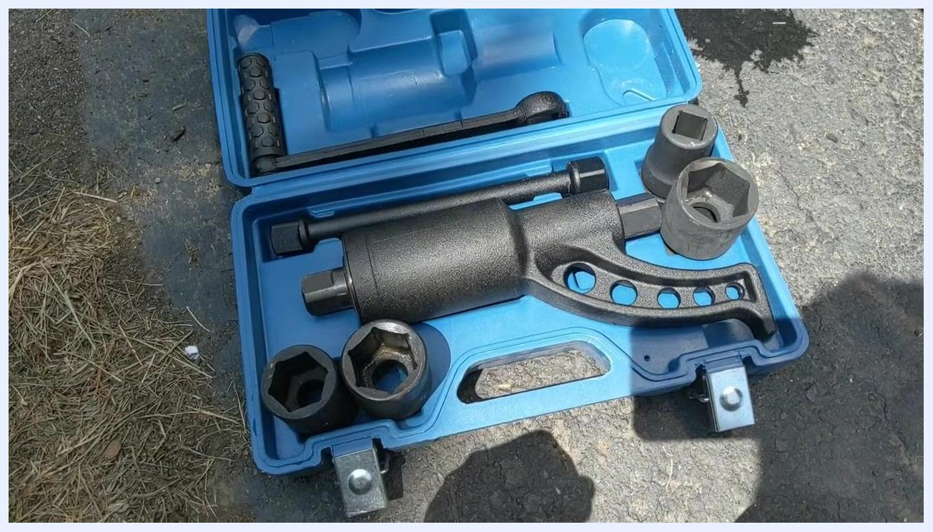
Hand reaching toward a rusty wheel with lug nuts, with the blue torque multiplier kit open, sockets and multiplier visible below

Step 9: Attach and position the torque multiplier
Insert the selected socket, already attached to the torque multiplier, onto the stubborn lug nut. Ensure the torque multiplier is aligned straight with the nut for maximum efficiency.
Place the torque multiplier's stabilizer foot so it rests securely against an adjacent lug nut. This prevents the tool from rotating and directs torque onto the stuck nut. Set a car jack or jack stand underneath the torque multiplier to support its weight and keep it level during use.
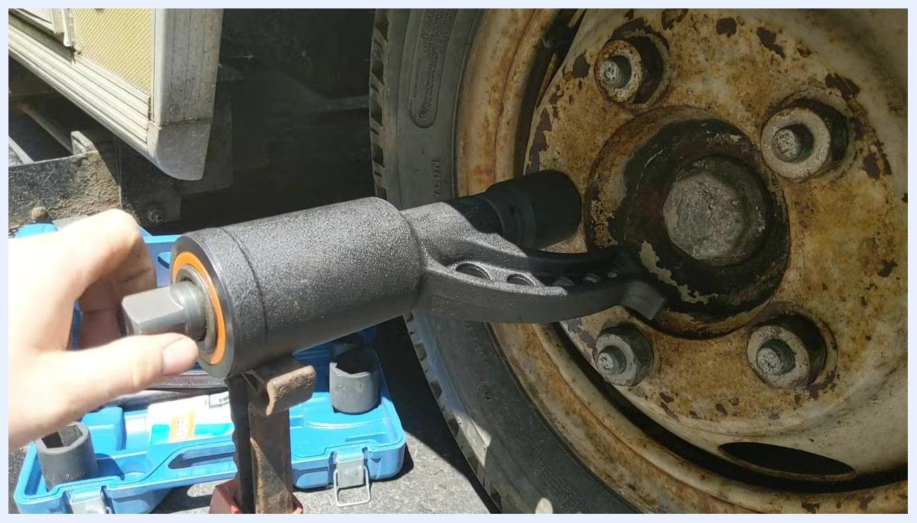
Torque multiplier socket attached to a rusty lug nut on a large vehicle wheel, blue tool case open on the ground, jack stand supporting the tool, and additional sockets visible

Step 10: Insert the handle and begin loosening
Insert the provided short handle into the input of the torque multiplier and turn it counterclockwise to loosen the lug nut. Note that a full rotation of the handle produces only a small movement of the socket — this is the torque amplification effect at work.
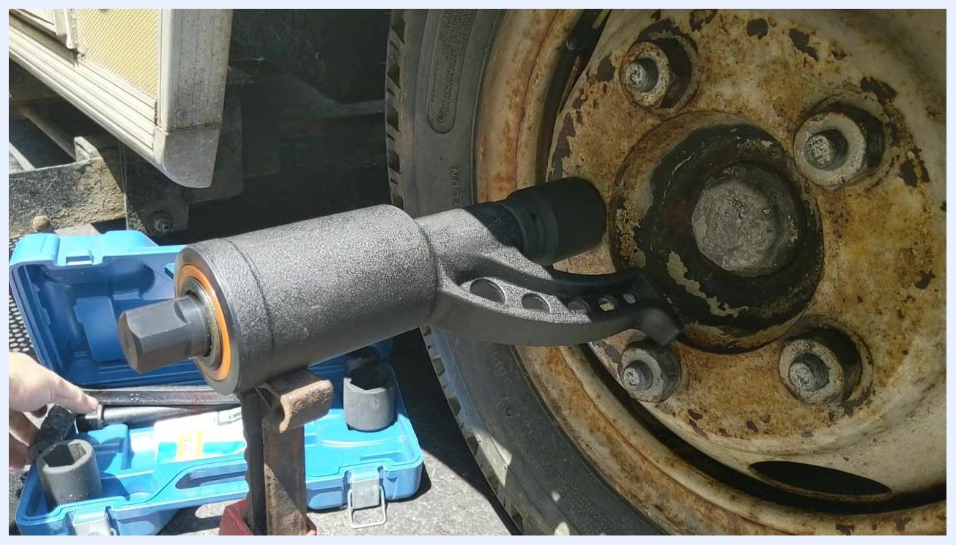
Hands positioning the torque multiplier onto the lug nut, with the blue case and jack stand visible and the handle about to be inserted

Step 11: Ensure proper foot placement
As you turn the handle, confirm that the stabilizer foot remains firmly pressed against the adjacent lug nut.
Safety note: Correct foot placement is critical, as it prevents the tool from slipping or rotating unexpectedly during operation.
Torque multiplier fully engaged on a lug nut, stabilizer foot braced against an adjacent nut, hand adjusting the tool, blue case and jack stand below

Step 12: Use the short handle to apply torque
Use the included handle to turn the torque multiplier, applying steady force. Despite its short length, the tool is designed to multiply your input torque, making it possible to break loose even very tight nuts.
Hand reaching for the short handle in the blue case, with the torque multiplier in place on the lug nut and the jack stand supporting the tool

Step 13: Loosen the lug nut
Continue turning the handle. The nut may begin to move after just one full rotation. Keep turning until the lug nut is visibly loosening — it will turn slowly, but with minimal effort compared to standard tools.
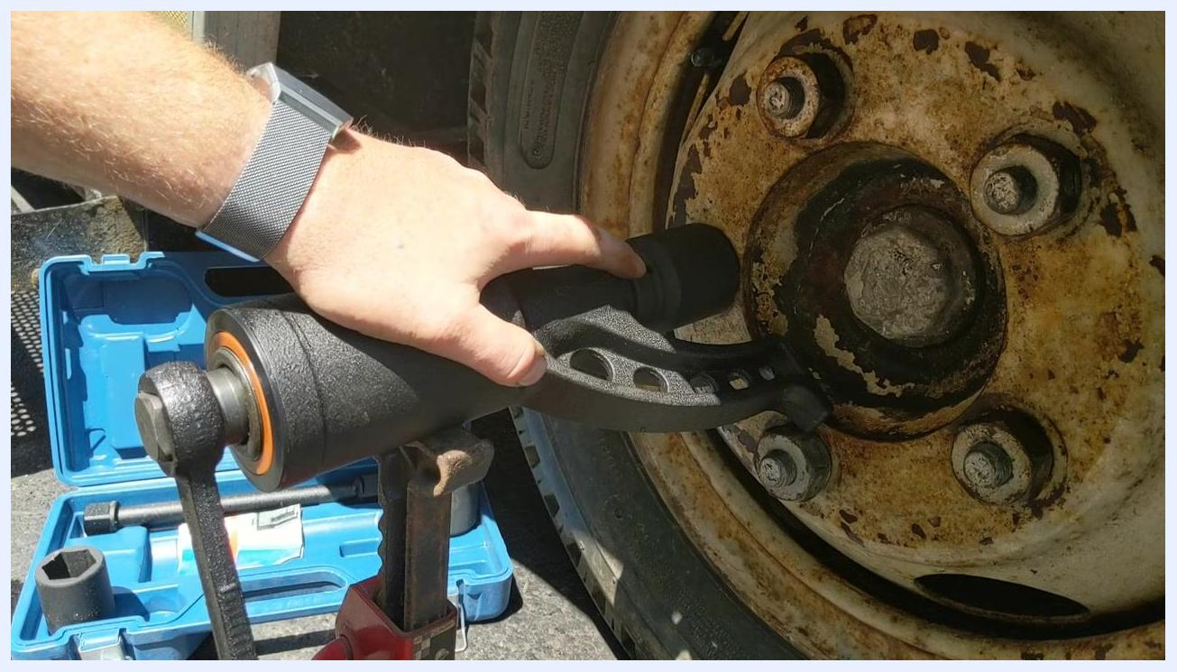
Hand turning the torque multiplier handle as the nut begins to loosen, with the blue case and jack stand visible

Step 14: Confirm the nut is loose
Once the nut is loose, stop turning the handle and remove the torque multiplier and socket from the lug nut. The nut should now be easy to remove by hand or with a standard wrench.
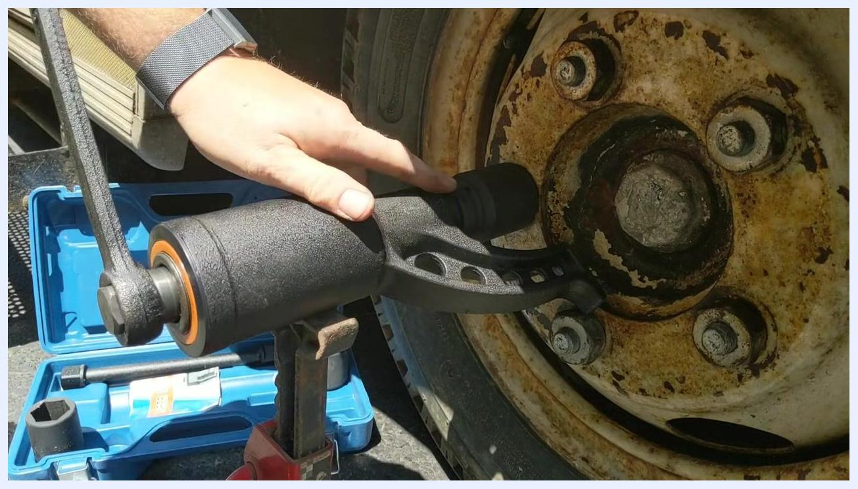
Hand holding the torque multiplier with the nut visibly loosened, blue case and jack stand below

Step 15: Store the torque multiplier kit
After use, disassemble the torque multiplier and socket and place all components back into the blue carrying case. Keep the kit in your vehicle for future use, as it makes tire changes significantly easier.
Hand resting on the torque multiplier, still attached to the wheel, blue case open on the ground and jack stand supporting the tool

Verification and summary
Confirm that the previously stubborn lug nut now turns freely by hand or with a standard wrench, and that all torque multiplier components are accounted for and returned to the blue case.
Always carry the torque multiplier kit in your vehicle, especially for RVs or large vehicles prone to stubborn lug nuts. This tool is simple and effective, and can save significant time and effort during roadside repairs.
Hand on the torque multiplier, still engaged on the wheel, blue case and jack stand visible
You have now successfully used a torque multiplier to remove a stubborn lug nut. Store your tools and ensure your vehicle is ready for the road.

