How to Use a Thread Gauge to Measure Bolts, Nuts, and Screws
Knowing how to use a thread gauge lets you quickly and accurately identify the diameter, thread pitch, and length of any bolt, nut, or screw. This SOP walks you through a combination thread gauge that measures both inch and metric fasteners and features raised thread grooves for pitch identification. For example, a bolt labeled "5/8"-11x2"" has a 5/8" diameter, 11 threads per inch, and a 2" length. Diameter is the width of the shank, thread pitch is the number of threads per inch (or the distance between threads for metric fasteners), and length is measured from the bottom of the head to the end of the bolt.
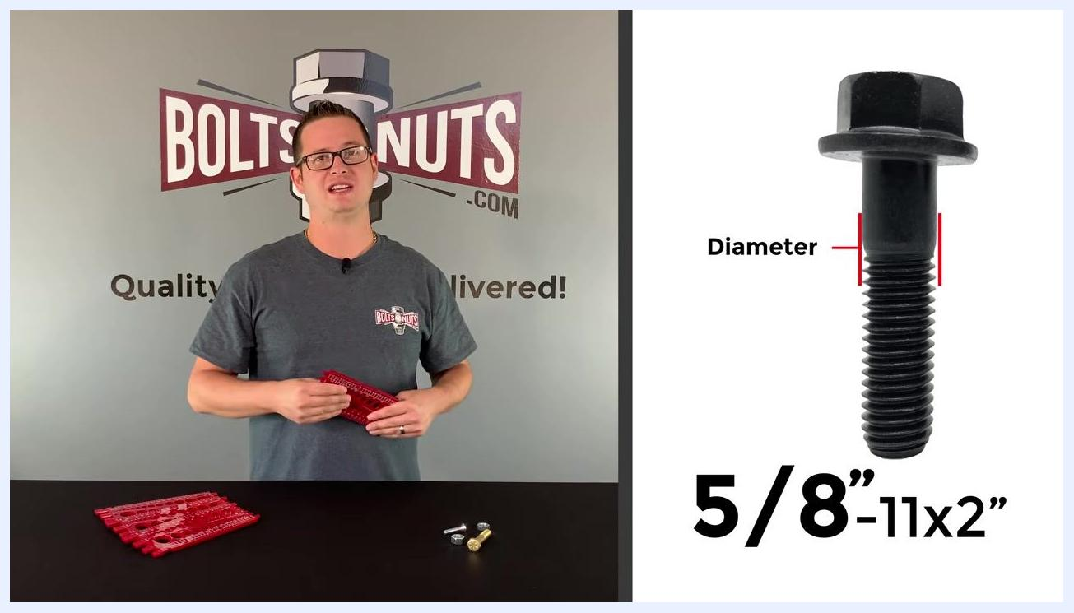
Split-screen view of a red thread gauge on the left and a close-up of a bolt labeled "5/8”-11x2”" on the right, with the diameter marked in red.

Purpose
This procedure explains how to use a combination thread gauge to determine the diameter, thread pitch, and length of bolts, nuts, and flathead machine screws, ensuring a correct and snug fit for your hardware applications.

Scope
This procedure applies to anyone measuring inch or metric fasteners—bolts, nuts, and screws—using a combination thread gauge such as the BoltsandNuts.com exclusive gauge.

BoltsAndNuts.com logo with various fasteners (bolts, nuts, washers, cotter pins) arranged around it. The text "Subscribe for More Fastener Content!" is prominently displayed.

Required equipment
- Miscellaneous fasteners for measurement (bolts, nuts, flathead machine screws)
- A combination thread gauge that measures both inch and metric sizes and includes raised thread grooves on the back for thread pitch identification (available for purchase at BoltsandNuts.com)
- A flat, stable surface to work on
- A printable thread pitch chart, if your gauge does not already include one (available at BoltsandNuts.com)
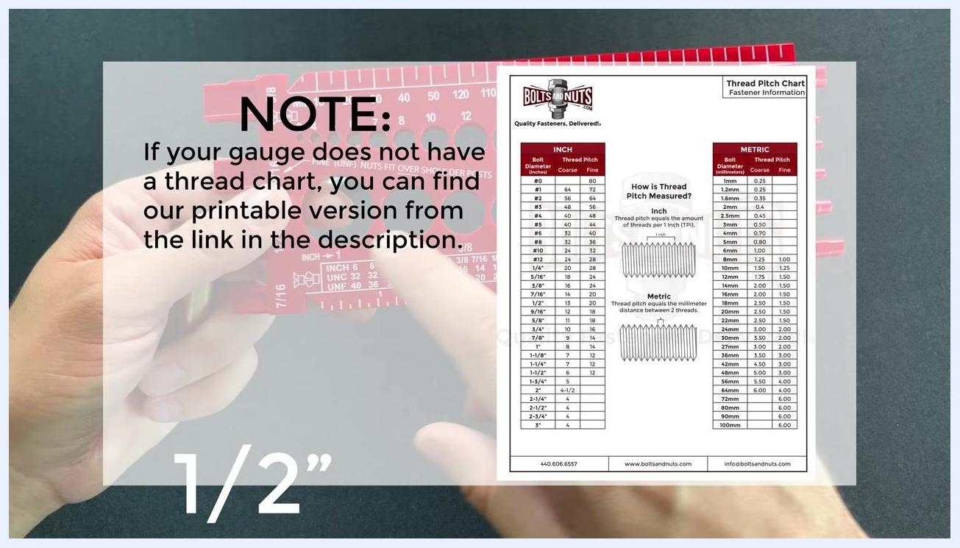
Overlay showing a printable thread pitch chart for both inch and metric fasteners, referencing where to find it.

Procedure

Step 1: Identify the parts of the thread gauge
Place the gauge on a flat surface and observe its physical features, including the side posts and holes. The gauge is split into two sections: the top for metric measurements and the bottom for inch measurements.
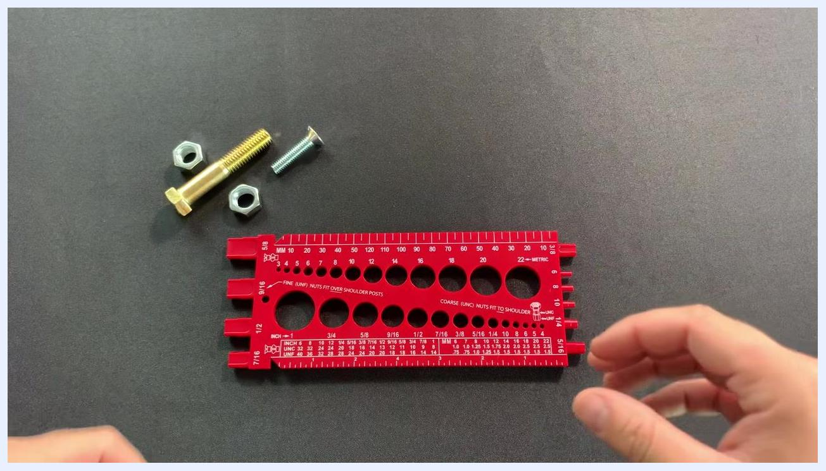
Hands holding the red thread gauge, showing both the metric (top) and inch (bottom) measurement holes and rulers, with bolts and nuts visible in the background.

Step 2: Examine the metric and inch sides of the gauge
The top section contains metric diameter holes (labeled, for example, 4, 5, 6, 8, 10, 12, 14, 16, 18, 20, and 22 mm) along with a millimeter ruler. The bottom section contains inch diameter holes (labeled, for example, 1/4, 5/16, 3/8, 7/16, 1/2, 9/16, 5/8, and 3/4) along with an inch ruler.
Close-up of the red thread gauge on a table, showing diameter holes labeled in both metric (mm) and inch sizes, with two bolts and nuts nearby.
Hold the gauge so you can easily access both the metric and inch sides, and familiarize yourself with the labeled holes and rulers before you begin measuring.

Step 3: Examine the back of the gauge
Flip the gauge over to view the indents used for measuring thread pitch. Note the side posts, which are used specifically for measuring inch nuts and will indicate whether a nut is coarse (UNC) or fine (UNF) thread. Hold the gauge in both hands with the back side facing up for clear visibility.
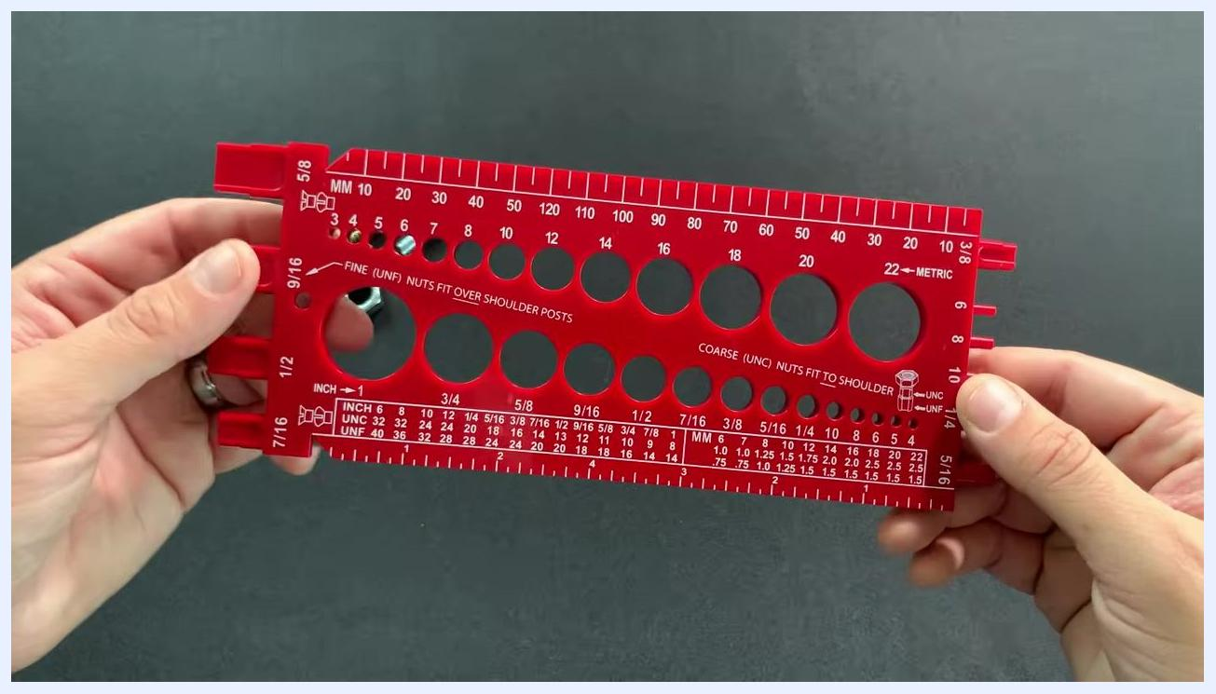
Back of the red thread gauge, highlighting indents for thread pitch measurement and side posts for nut measurement, with the labels "FINE (UNF) NUTS FIT OVER SHOULDER POSTS" and "COARSE (UNC) NUTS FIT TO SHOULDER" visible.

Step 4: Select the bolt to measure
Place the gauge on a flat surface with bolts and nuts nearby, then select the bolt you want to measure. Hold the gauge so you can easily access the diameter holes and reference labels.
The red bolt gauge held up by both hands, centered in the frame, with no nuts or bolts inserted and all measurement holes and labels clearly visible.

Step 5: Test the bolt diameter in the gauge holes
Try to fit the bolt into the various diameter holes on the gauge. Start with the metric holes (for example, 12 mm and 14 mm) and note whether the bolt fits or is loose, then move to the inch holes (for example, 5/8", 9/16", and 1/2") and test for a snug fit.
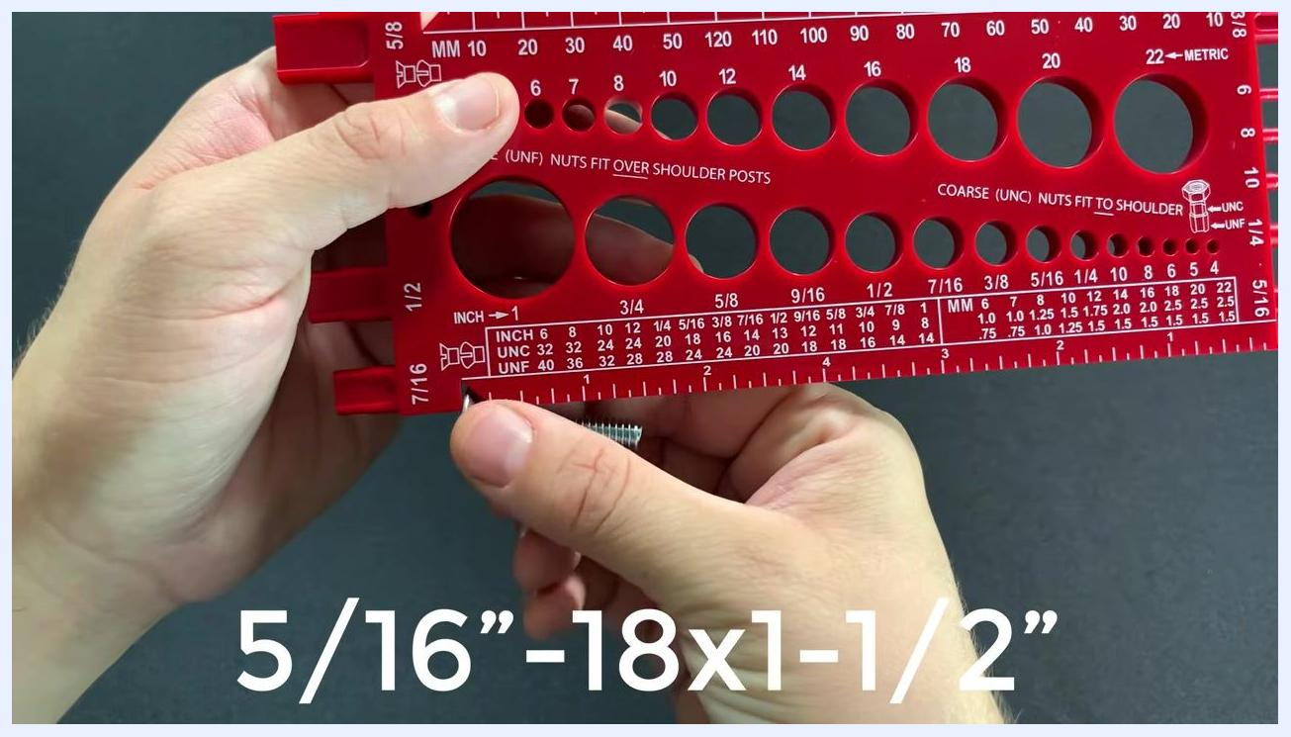
A nut being inserted into the gauge holes to determine its size, held with both hands, with a bolt visible on the side.

Step 6: Identify the correct diameter
Continue testing holes until you find one where the bolt fits snugly, without excess play or tightness. In this example, the bolt fits perfectly in the 1/2" hole, confirming its diameter is 1/2".
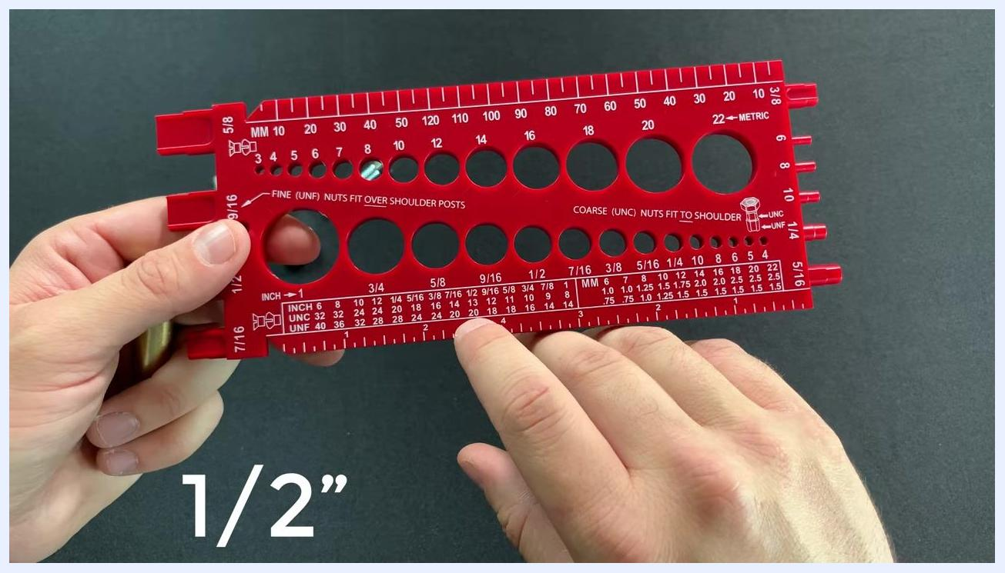
The back of the gauge with a finger pointing to the raised thread pitch grooves labeled "United States Thread Pitch" and "Metric Thread Pitch," with the 1/2 inch bolt ready for pitch measurement.

Step 7: Confirm the measured diameter
Once the bolt fits snugly, note the measurement. The gauge display confirms the reading, in this case 1/2".

Step 8: Reference the thread pitch chart
Check the thread chart on the gauge to determine possible thread pitches for the identified diameter. For a 1/2" bolt, the common thread pitches are 13 threads per inch (coarse) and 20 threads per inch (fine). If your gauge does not have a thread chart, refer to a printable version available at BoltsandNuts.com.
A hand holding a gold bolt above the red thread gauge, preparing to insert it into the diameter holes, with other fasteners visible on the table.

Step 9: Locate the thread pitch section on the gauge
Find the area on the gauge labeled for thread pitch, typically marked with UNC (coarse) and UNF (fine) for inch fasteners. For a 1/2" bolt, identify the 13 TPI (UNC) and 20 TPI (UNF) options.

Step 10: Access the raised thread pitch grooves
Turn the gauge over to the back, where raised thread grooves are labeled for both United States (inch) and metric thread pitches. Locate the 13 and 20 TPI grooves under United States Thread Pitch, and prepare to match the bolt threads to these grooves.
The gold bolt inserted into the 1/2 inch hole of the red thread gauge, demonstrating a snug fit.

Step 11: Match the bolt threads to the gauge grooves
Hold the bolt and align its threads with the raised thread pitch grooves on the back of the gauge. Attempt to fit the bolt into the 20 TPI groove; if it does not fit snugly, try the 13 TPI groove. In this example, the bolt fits perfectly in the 13 TPI groove, indicating it is a 1/2"-13 (coarse thread) bolt.
The bolt fully inserted into the 1/2 inch hole of the gauge, with "1/2”" text overlaid for emphasis, held with both hands.
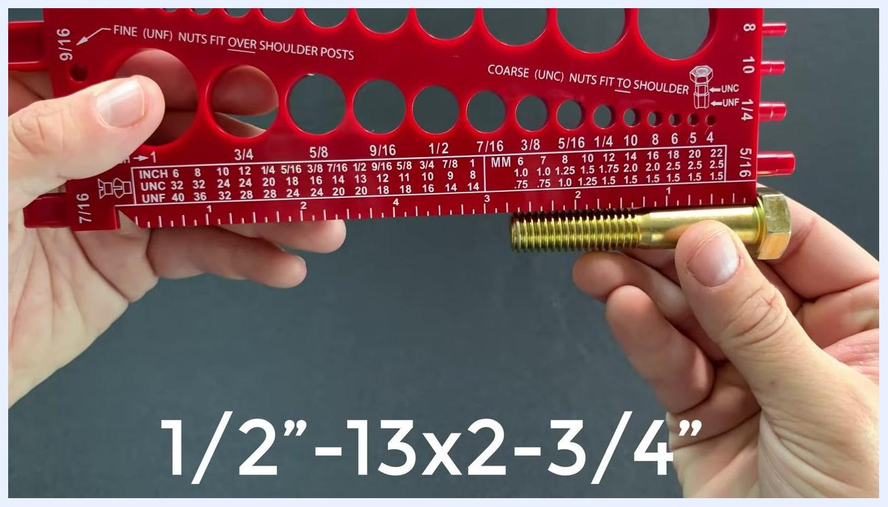
The gold bolt aligned with the ruler on the red gauge, showing a length of 2-3/4 inches, with the text "1/2”-13x2-3/4”" overlaid.

Step 12: Prepare to measure the bolt length
Hold the identified 1/2"-13 bolt and the gauge so the ruler edge is visible. For a hex bolt, only measure the portion that will go inside the hole—from the underside of the head to the end of the threads.
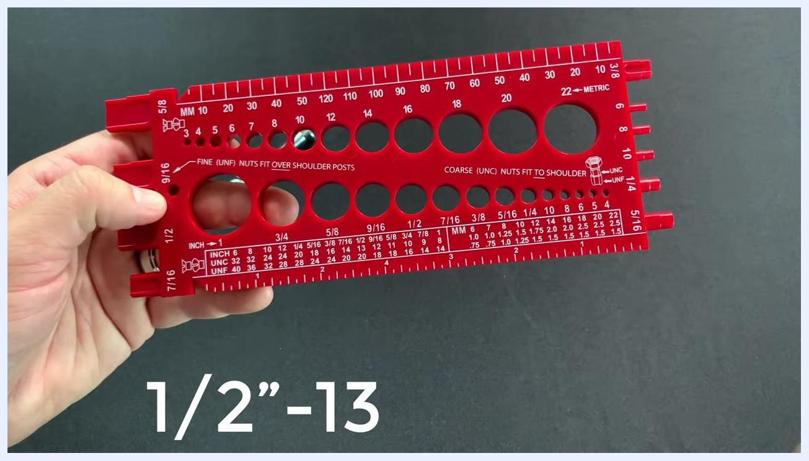
The red gauge held with the ruler edge visible and the gold bolt positioned for length measurement, aligned from the underside of the head.

Step 13: Measure the bolt length from the correct starting point
Place the bolt against the ruler on the gauge, aligning the underside of the hex head with the zero mark, then extend the bolt along the ruler. Do not include the hex head in the measurement—measure only from the underside of the head to the tip.
A hand holding a gold bolt and aligning its threads with the raised thread pitch grooves on the red gauge, testing the fit against labeled thread pitch values.

Step 14: Read and record the bolt length
Observe where the end of the bolt aligns on the ruler. In this example, the bolt measures exactly 2-3/4 inches long, giving a full identification of 1/2"-13 x 2-3/4".
A gold hex bolt held above the red gauge, positioned to show the ruler edge, ready to be measured for length.

Step 15: Identify the flathead screw type
Select a flathead machine screw (slotted). Hold the screw and the gauge in preparation for measuring its length.

Step 16: Understand the measurement rule for flathead screws
Unlike hex bolts, a flathead screw—including its head—is installed flush with the surface. When measuring this type of fastener, include the full length of the screw from the tip to the top of the head.
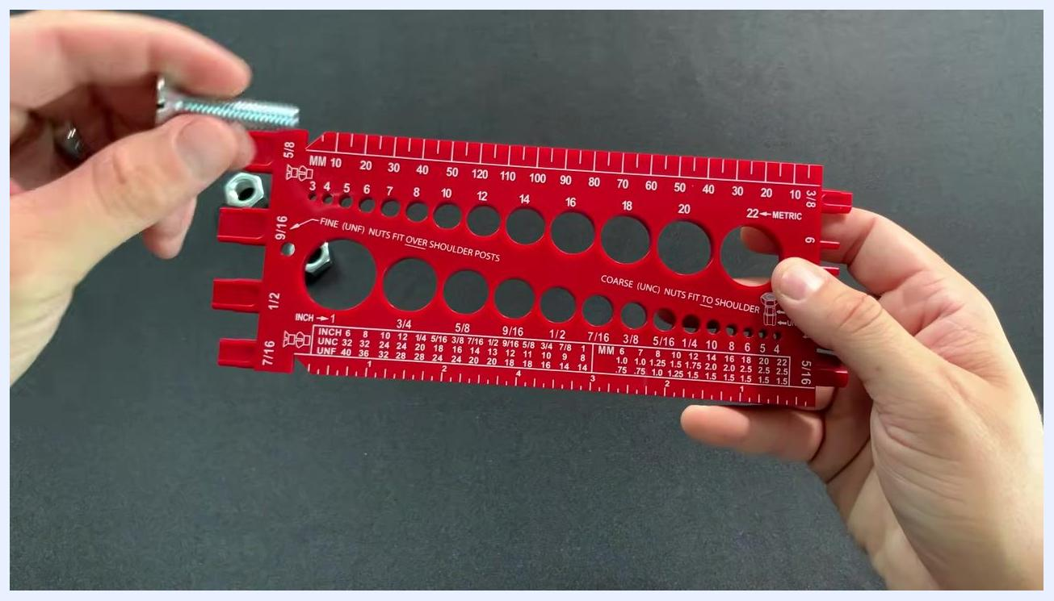
A hand holds a slotted flathead machine screw above a red combination thread gauge displaying multiple diameter holes labeled in metric (MM) and inch sizes, with a nut visible on the table.

Step 17: Prepare to measure flathead screw diameter
Begin determining the diameter by testing the screw in the metric holes on the gauge. Note whether the screw is loose in holes such as M8 or M10, and continue testing inch holes (for example, 7/16") to find the correct fit.
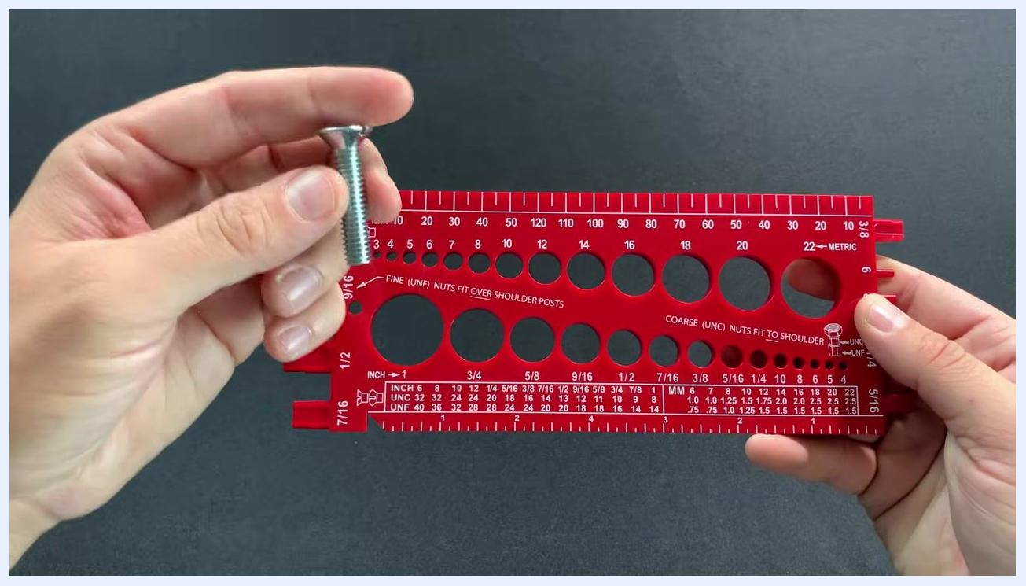
A hand holds a slotted flathead machine screw above the red gauge, preparing to insert it into the diameter holes, with a nut visible on the table.

Step 18: Test the flathead machine screw in the metric diameter holes
Hold the gauge in one hand and the screw in the other. Insert the screw into the M8 hole and observe that it is loose, indicating a diameter smaller than 8 mm. Attempt the M10 hole and confirm it is definitely too loose, meaning the screw is much smaller than 10 mm. Continue testing the 7/16" hole, noting that this size is also not a match, and visually inspect the gauge for other possible holes until you find a snug fit.
A hand holds a slotted flathead machine screw above the red gauge, ready for measurement.
Key details:
- The gauge is clearly labeled with both metric (MM) and inch (INCH) diameter holes.
- The gauge also includes thread pitch information, ruler markings, and nut fitment guides.
- Test systematically, starting with metric sizes and moving to inch sizes, until you find a snug fit.
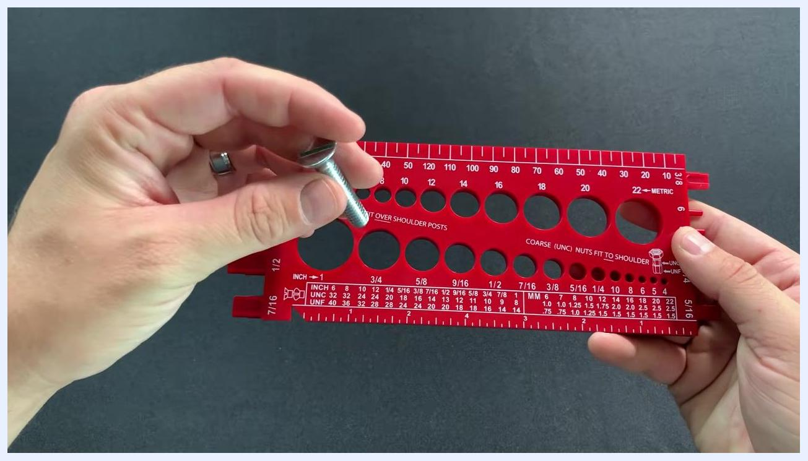
A slotted flathead machine screw held above the red gauge, with the head clearly visible, indicating the entire length will be measured.

Step 19: Identify a second bolt's diameter
Select another bolt to measure. Insert it into the holes on the gauge labeled with different diameters and find the hole where it fits snugly without excess play. In this example, the bolt fits perfectly in the 5/16" hole.
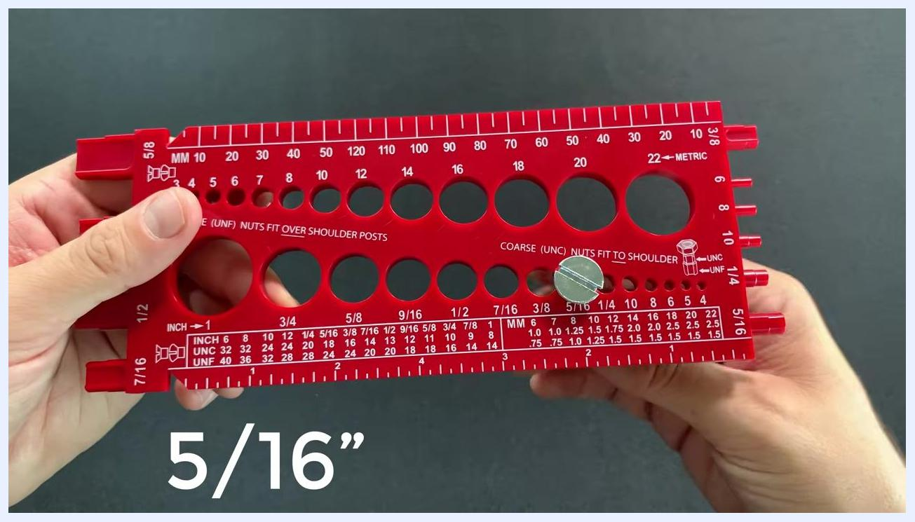
The bolt aligned with the thread pitch section of the gauge, being checked for a snug fit at the 18 TPI marking, with "5/16”" text overlaid.

Step 20: Determine the thread pitch for the second bolt
Refer to the gauge's thread pitch chart for the 5/16" bolt size. Note the two common thread pitches for this size: coarse (18 threads per inch, UNC) and fine (24 threads per inch, UNF). Flip the gauge over to access the thread pitch measuring section, locate the 5/16" section, and compare the bolt's threads to the gauge's markings.
The red thread gauge placed on a table with a gold bolt and a nut nearby, held in one hand and ready for measurement.

Step 21: Test for a snug fit at the coarse thread marking
Align the bolt's threads with the 18 TPI marking for coarse threads and observe if it fits snugly, indicating a match. Confirm that the bolt is a 5/16"-18 (coarse thread) bolt.
The bolt fully inserted into the gauge, with the head at the top and the length being measured, showing "5/16”-18x1-1/2”" text overlaid.

Step 22: Check bolt head fit and application
Confirm that the entire head of the bolt fits into the corresponding hole and sits flush, simulating how it will fit in your application. This step ensures the bolt will seat properly once installed.
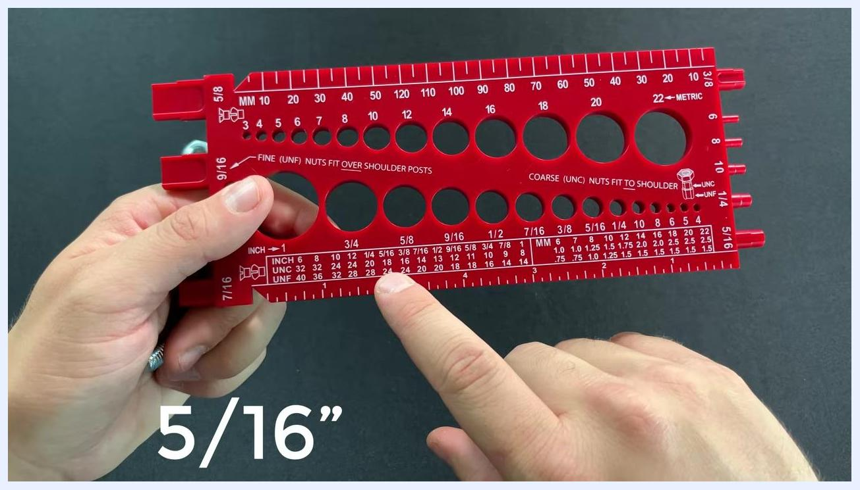
The gauge flipped over with a finger pointing to the 5/16 inch section on the thread pitch chart, displaying both coarse and fine thread options, with "5/16”" text overlaid.

Step 23: Use the tapered area for additional measurement
Insert the bolt into the tapered area of the gauge to further verify the fit, matching the bolt head up to the top of the tapered section to confirm the bolt's length and fit.

Step 24: Measure the bolt length using the tapered area
With the bolt head at the top of the gauge, read the measurement at the end of the bolt to determine its length. In this example, the bolt measures 1-1/2" in length.
The bolt inserted into the gauge with the head fitting flush in the hole, the gauge held horizontally, and "5/16”-18x" text overlaid.

Step 25: Identify nut size and thread type
Insert the nut into the holes labeled for nut sizes. Start with the first hole and continue trying larger sizes until the nut fits snugly.
BoltsAndNuts.com logo with a bolt and nut graphic. The slogan "Quality Fasteners, Delivered!" is displayed below.

Step 26: Confirm nut fit and thread type
When the nut pushes all the way down into the hole, this indicates a correct fit. The gauge also indicates whether the nut is fine thread (UNF) or coarse thread (UNC). In this example, the nut fits in the 1/2" hole and is identified as fine thread.
A red bolt gauge held with both hands, with a bolt inserted into the 5/16 inch hole confirming its diameter, and "5/16”" text overlaid.
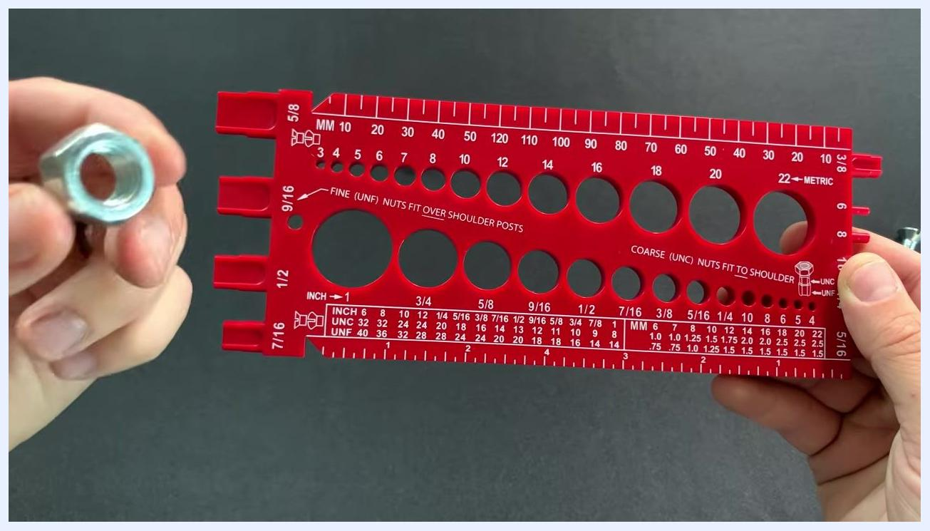
A nut held in the left hand next to the red bolt gauge, not inserted, indicating it did not fit all the way down in the coarse section.

Step 27: Verify fine thread nut fit
Insert the nut into the 1/2" hole on the gauge, specifically in the section labeled for fine (UNF) threads. Observe whether the nut goes all the way down over the shoulder post; if it fits completely, it is a fine thread (UNF) nut.
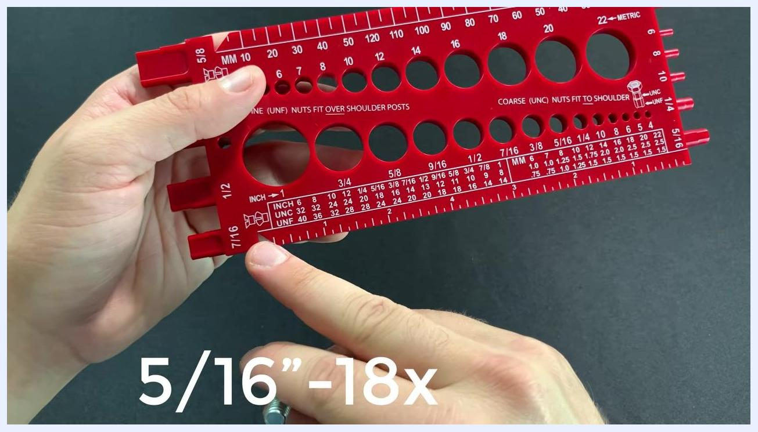
The bolt placed into the tapered area of the gauge with the head aligned at the top, and "5/16”-18x" text overlaid.

Step 28: Identify a coarse thread nut
Remove the nut and inspect its fit in the coarse (UNC) section of the 1/2" hole. If the nut does not go all the way down, it is a coarse thread (UNC) nut. Confirm the nut as a 1/2" coarse thread type.
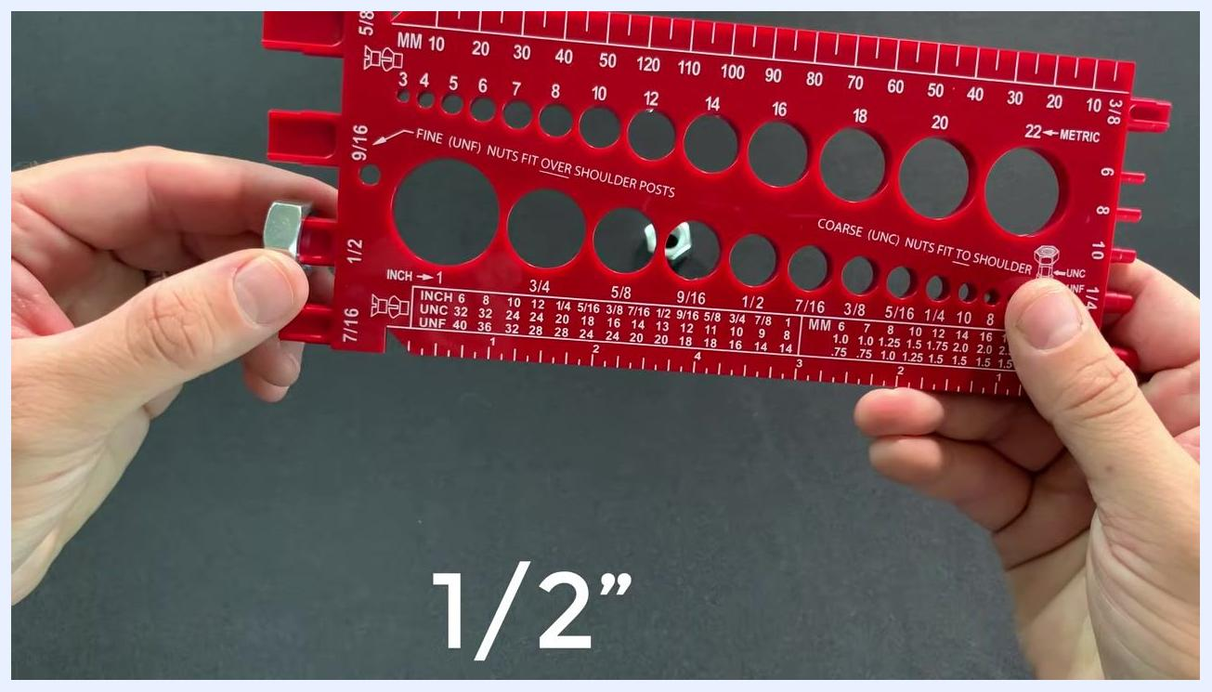
A nut fully inserted into the 1/2 inch hole of the gauge, confirming its size and thread type, with "1/2”" text overlaid.

Step 29: Determine thread pitch for the coarse nut
Reference the gauge's chart for the 1/2" coarse thread. Note that a 1/2" coarse thread corresponds to 13 threads per inch, labeled as 1/2"-13. Confirm the nut as a 1/2"-13 (UNC) nut.
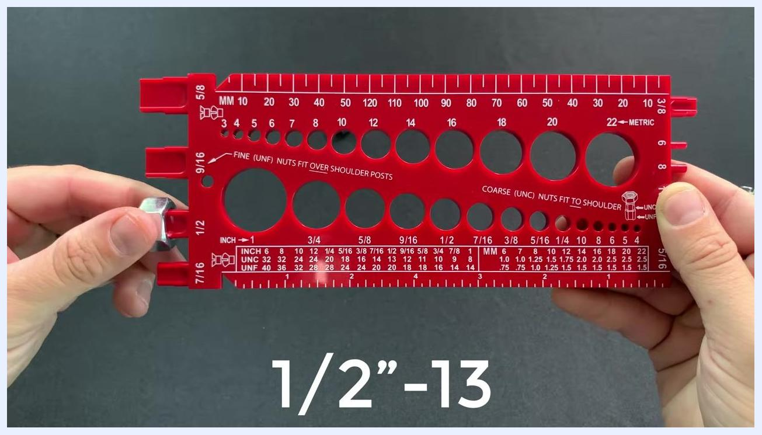
A nut inserted into the 1/2 inch coarse thread hole of the red bolt gauge, with "1/2”-13" text overlaid, held with both hands.

Step 30: Compare with a fine thread nut
Place the fine thread nut aside for comparison. Note that this nut is a 1/2"-20 (UNF) nut, as it fits over the fine thread shoulder post. This comparison demonstrates the difference between coarse (UNC) and fine (UNF) thread nuts.
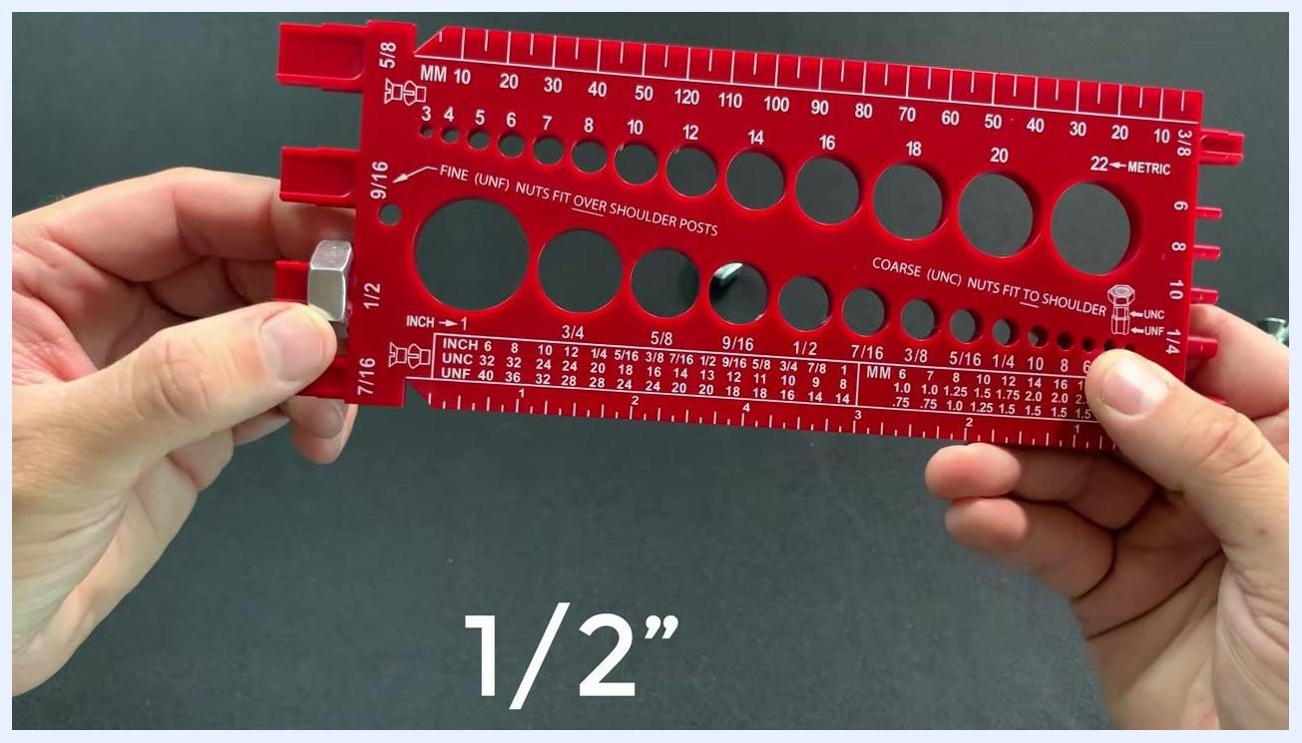
A nut fully inserted into the 1/2 inch fine thread hole of a red bolt gauge, held with both hands, with "1/2”" text overlaid.
The red bolt gauge held horizontally with a nut inserted in the 1/2 inch hole, and another nut placed on the table to the left for comparison between coarse and fine thread nuts.

Verification
Once you have completed the measurements, hold the gauge up for a final review and confirm that all fastener sizes and thread types have been identified correctly using the gauge's holes, rulers, thread pitch charts, and grooves.

BoltsAndNuts.com logo with fasteners and the message "Subscribe for More Fastener Content!" displayed. Various bolts, nuts, and washers are visible.

Summary
By following this procedure, you can accurately determine:
- The diameter of a bolt, nut, or screw using the gauge's metric and inch holes
- The thread pitch of a fastener using the thread pitch chart and raised grooves, distinguishing coarse (UNC) from fine (UNF) threads
- The correct length of hex bolts (measured from under the head to the tip) and flathead screws (measured over the full length, including the head)
- The size and thread type of nuts using the gauge's nut-fit holes and shoulder posts
A finger points to the thread pitch chart on the gauge at the 1/2 inch row, showing both UNC (13 TPI) and UNF (20 TPI) options.
This ensures a perfect, snug fit for your hardware applications every time you use a thread gauge.

What's next
For fasteners not covered by your gauge's built-in chart, refer to the printable thread pitch chart available for both inch and metric fasteners at BoltsandNuts.com. You can also purchase the combination thread gauge itself directly from BoltsandNuts.com.

BoltsAndNuts.com logo with fasteners and the message "Subscribe for More Fastener Content!" displayed. Various bolts, nuts, and washers are visible.

