How to Use a Tap and Die Set: Step-by-Step SOP
This procedure explains how to use a tap and die set to create or clean internal and external threads on metal workpieces. Threading adds functionality to your projects—such as building more complex or easier-to-use jigs—and the process is not difficult to learn once you understand the tools and the correct technique.

A drill press is set up with a metal workpiece clamped in place, ready for drilling

Purpose
This SOP provides the standard method for drilling a hole, tapping it to create internal threads, and using a die to cut or clean external threads on a rod or bolt. It also covers special handling for tapered pipe thread taps.

Scope
This procedure applies to anyone using a tap and die set on metal workpieces, including general-purpose threading (plug style taps and standard dies) and pipe fitting threading (National Pipe Thread taps).

Required equipment
- Drill press
- Correctly sized drill bit (matched to the tap you plan to use)
- Tap and die set, including a plug style tap, an NPT tap, and a standard die
- Tap handle or ratcheting tap handle
- Die handle
- Cutting oil (such as 3-IN-ONE oil)
- Clamps or a vise to secure the workpiece
- Tap drill size reference chart (available in the reference section of newmetalworker.com)
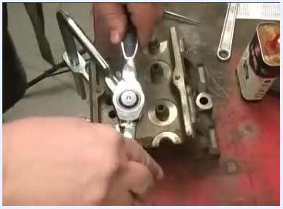
A ratcheting tap handle being used to turn a tap into a metal workpiece, with tools and oil visible on the workbench

Preparing the hole
Step 1: Drill a straight, consistent hole.
Use a properly set up drill press for best results, and ensure the workpiece is securely clamped before drilling.
Step 2: Drill the correct size hole for the tap you plan to use.
Refer to a tap drill size chart for accuracy. The reference section of newmetalworker.com provides several charts with the correct drill sizes for different taps.
Title screen with "USING TAPS & DIES" text overlayed on a background of metal parts and threading tools

Identifying your taps and dies
Step 3: Recognize the common types of taps and dies.
- Plug Style Tap: The most common type, typically used for general threading.
- National Pipe Thread (NPT) Tap: Common for pipe fittings, but requires special attention (see the special considerations section below).
- Standard Die: Used for cutting external threads on rods or bolts.
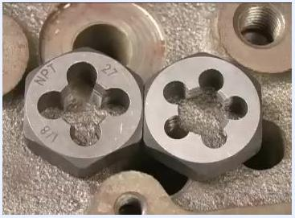
Close-up of two dies, one with the bottom side showing the marking "NPT 1/8 27" facing up
Step 4: Identify the parts of a die before installing it.
The bottom side of the die usually has writing (for example, "NPT 1/8 27"). The cutting threads taper out to nothing on one side (bottom) and are full on the other (top). When installing the die into a holder, make sure the bottom (with writing) faces out.
Close-up of a plug style tap showing the tapered end and cutting threads
Step 5: Examine the plug style tap before use.
Notice the tapered end, which helps you start the tap in the hole. Keep in mind that this taper means threads will not reach all the way to the bottom of a blind hole.
Step 6: Account for the tapered section when determining hole depth.
Most threaded holes have an unthreaded space at the bottom to collect debris or scale, preventing interference with the bolt.
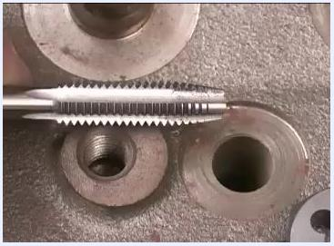
Cross-section of a threaded hole showing the unthreaded space at the bottom relative to the tap's taper

Tapping a hole
Step 7: Start the tap in the hole.
Insert the tap into the correctly sized hole. The tapered end helps you get it started straight. Focus on keeping the tap perfectly aligned with the hole for the first few turns.
Step 8: Apply cutting oil to the tap.
Add a small amount of oil to the tap before you begin cutting. The oil helps the tap cut cleanly and keeps chips from clogging the flutes.
Step 9: Cut the threads using a forward-and-back motion.
Turn the tap about a half to one full turn forward, then back it up a quarter to a half turn to break the chips. Repeat this forward-and-back motion until the tap is fully through the hole or reaches the desired depth. This prevents chips from binding and ensures clean threads.
A tap partially inserted into a metal hole, with visible oil and metal chips around the entry point
Step 10: Use a ratcheting tap handle if available.
A ratcheting tap handle makes tapping easier and straighter, since it lets you keep the tap aligned without repositioning your hands. Once the tap is well established in the hole, you can spin it more easily, similar to a regular handle. Use the directional lever to switch between cutting and backing up to break chips.
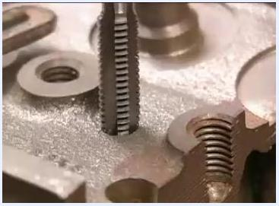
A tap being carefully aligned and started into a drilled hole in a metal workpiece, with several threaded and unthreaded holes visible on the workpiece
Step 11: Clean the threads after cutting.
Remove the tap from the hole and clean the flutes to remove all chips. Add a little more oil and run the tap through the threads a couple more times to ensure they are clean and smooth.
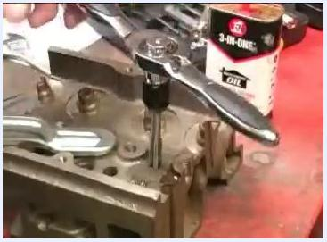
A ratcheting tap handle positioned above a threaded hole, with a can of 3-IN-ONE oil on the workbench nearby
Step 12: Test the threads.
Screw the intended piece, such as a bolt, into the newly threaded hole to check the fit and quality of the threads.

Using a die to cut or clean external threads
Step 13: Start the die on the rod or bolt.
Place the die onto the end of the rod or bolt, ensuring it is square to the workpiece. Proper alignment is crucial whether you are cutting new threads or cleaning up old ones.
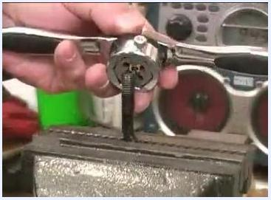
A die being started onto a rod held in a vise, using a die handle to turn it
Step 14: Cut or clean the threads.
Turn the die handle to cut or clean the threads. As with tapping, periodically back up the die to break chips and prevent binding.
A close-up of a die handle being turned by hand to cut or clean threads on a rod held in a vise
Step 15: Perform a final cleaning pass.
After threading, run the die up and down the threads a couple of times to ensure they are clean and smooth.

Special considerations for tapered pipe thread taps
Step 16: Understand the purpose of the taper.
A National Pipe Thread (NPT) tap is tapered along its full length. This taper is designed so that when threading a pipe or plug, the threads seal as the plug is tightened, preventing leaks.
Step 17: Stop tapping before passing completely through the hole.
Do not thread all the way through the hole with a tapered tap. Stop threading with several threads—typically six to eight—still visible above the hole. This ensures the plug or pipe will tighten and seal before passing completely through. Try fitting the plug after stopping to check for proper engagement and sealing.

A hand holding a tapered pipe thread tap above a machined hole, showing the taper and the threads that should remain visible above the hole once tapping is complete

Safety notes
Always read, understand, and follow all instructions provided with your tools. Prioritize safety by wearing appropriate personal protective equipment and working in a well-ventilated area. Refer to manufacturer guidelines for specific tool use and maintenance.
A safety reminder stating: "Work Safely! Always read, understand and follow the instructions that came with your tools!"

Summary and verification
- Use a drill press for straight, consistent holes.
- Always drill the correct size hole for your tap, using reference charts.
- Identify and use the correct tap or die for your application.
- Install dies with the bottom (writing side) facing out in the holder.
- Allow for the tapered end of the tap when determining hole depth.
- Leave a small unthreaded space at the bottom of blind holes for debris.
- For tapered pipe thread taps, stop with six to eight threads still visible above the hole and verify the plug fits and seals properly.
- Verify internal threads by screwing in the intended bolt, and verify external threads by checking fit on the mating part.
A freshly tapped threaded hole in a metal workpiece, with oil and metal chips visible around the hole

What's next
Once you have confirmed clean, well-fitting threads, you can proceed with assembling your project using the newly threaded parts. Always keep oil on hand, work chips loose frequently, and follow manufacturer safety guidance each time you use a tap and die set.

