How to Use a Drill Press: A Complete Step-by-Step Guide
This guide explains how to use a drill press for common woodworking tasks, from understanding its basic mechanics to performing advanced operations such as sanding curves, drilling through-holes, and cutting perfectly circular openings. Follow the steps below in order to set up your machine correctly, work safely, and achieve accurate, repeatable results.
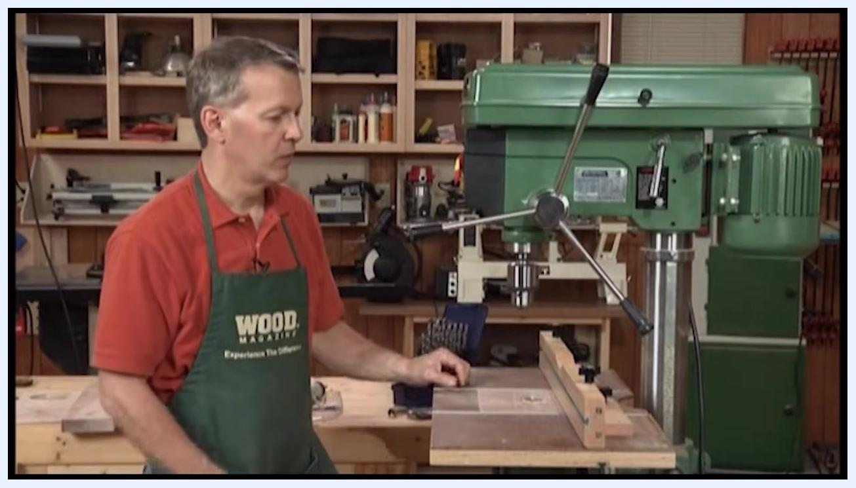
A person in a red shirt and green apron standing beside a drill press, discussing the benefits of using a drill press compared to a hand-held drill.

Purpose
This document provides step-by-step instructions for operating a drill press, including adjusting speed and depth, securing workpieces, using accessories such as fences and drum sanders, and applying safety practices for different drilling and cutting attachments.

Scope
This procedure applies to both floor-standing and benchtop drill presses used in woodworking. It covers standard drilling operations, table and fence adjustments, drum sanding, hole saw use, and circle cutting.

Required equipment
- Drill press (floor-standing or benchtop)
- Drill bits appropriate to your material
- Chuck key (if your model uses a keyed chuck)
- Woodworking drill press table with adjustable fence (optional upgrade)
- Stop blocks and clamps
- Scrap wood (backer board)
- Drum sander attachment
- Circle cutter attachment
- Hole saw attachment

A person in a red shirt and green "WOOD MAGAZINE" apron stands beside a large green drill press in a well-equipped woodworking shop. The drill press table is set up with a wooden fence and clamp. Shelves with woodworking tools and supplies are visible in the background.

Step 1: Understand the purpose and components of the drill press
A drill press is a machine primarily used for drilling precise holes in various materials. Before operating it, take time to identify its main parts and how they work together.

- Locate the motor at the back of the machine, which powers the drill press.
- Note that the motor connects to a series of pulleys and belts.
- Understand that changing the belt arrangement on the pulleys adjusts the speed of the drill bit.
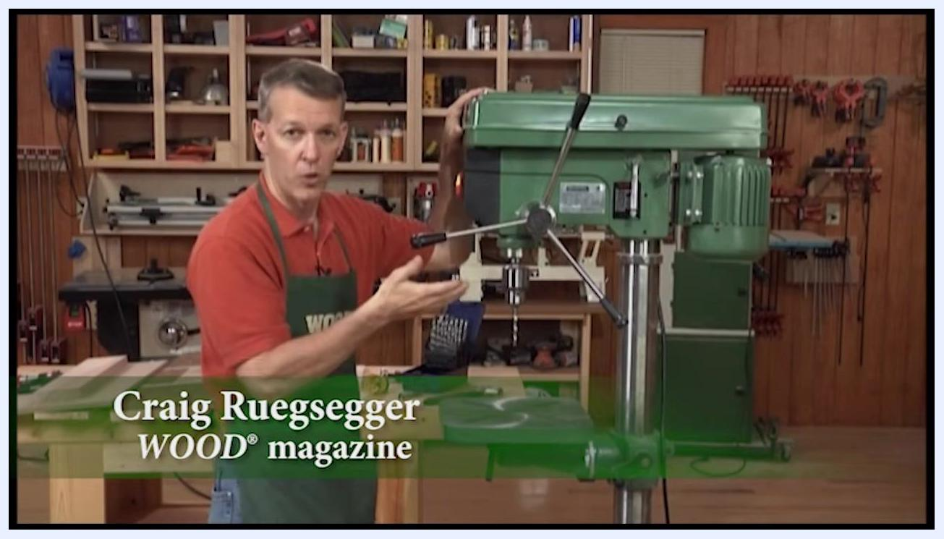
Close-up of the spindle speed chart showing RPM values and corresponding belt positions for 50Hz and 60Hz operation

Step 2: Consult the speed chart
Use the speed chart, typically located inside the drill press cover, to determine the correct belt and pulley arrangement for your desired spindle speed.
- Speed range example: 340 RPM to 2800 RPM.
- 340 RPM corresponds to belt position A-1.
- 2800 RPM corresponds to belt position A-3.
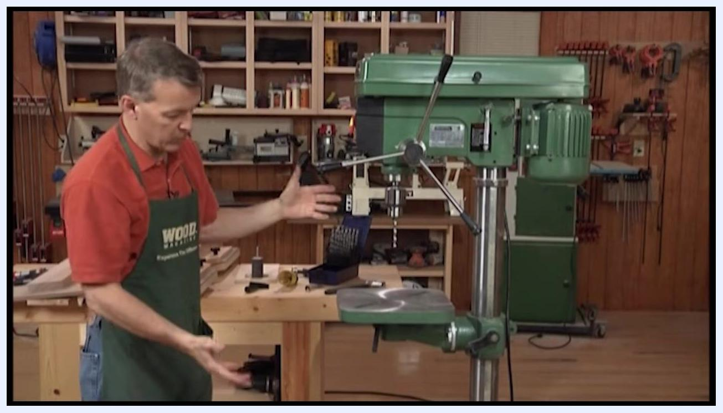
Full view of a floor-standing drill press, illustrating its base and overall structure

Step 3: Insert and secure the drill bit in the chuck
Locate the chuck below the spindle; this component holds the drill bit.
- If your model uses a keyed chuck, insert the drill bit and tighten it with the key until it is snug and secure.
- If your model uses a keyless chuck, tighten it by hand instead.

Step 4: Raise and lower the quill assembly
Use the handle on the side of the drill press to raise and lower the quill assembly. This moves the drill bit vertically so you can drive it straight down into your workpiece.

Step 5: Set the depth stop
Locate the screw-type depth stop on the column to the left of the drill press. Adjust it to set a specific drilling depth, which prevents the bit from passing all the way through the material. This feature is useful for creating counterbores or holes of limited depth.
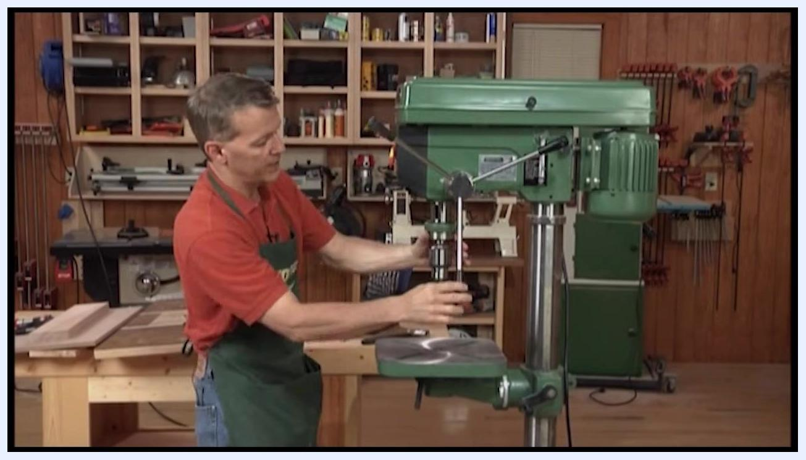
Operator raising and lowering the quill assembly using the side handle of the drill press

Step 6: Identify your drill press type
There are two main types of drill presses:
- Floor-standing drill press: Sits directly on the floor and offers greater capacity for larger workpieces.
- Benchtop drill press: Has a shorter column and sits on a workbench, making it more affordable and suitable for most woodworking tasks.
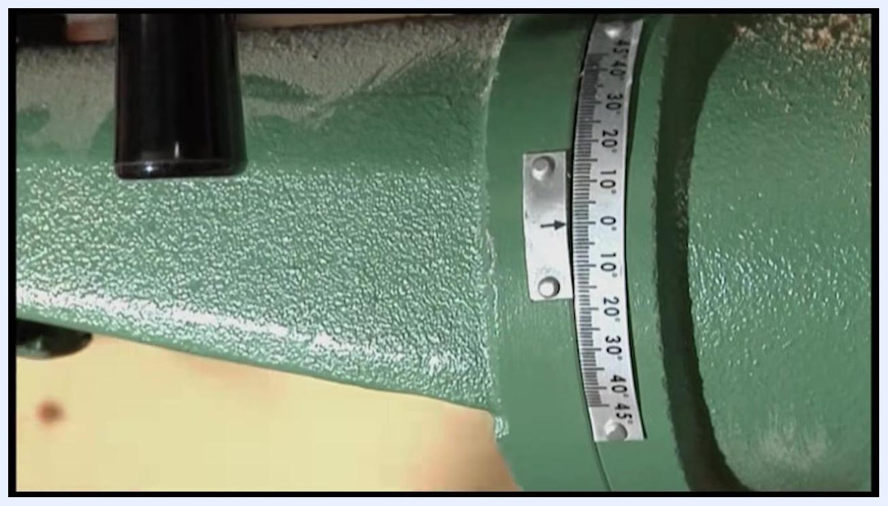
Close-up of the drill press table tilt gauge showing degree markings and an indicator arrow
Choose a benchtop model if you primarily do woodworking with limited space or budget, or a floor-standing model if you need more capacity between the table and the drill bit.

Step 7: Adjust the table height
Locate the geared assembly and handle on the side of the drill press column.

- Spin the handle to raise or lower the table to the desired height.
- Tighten the handle to lock the table securely in place.

Step 8: Pivot, tilt, and rotate the table
- Loosen the locking bolt beneath the table to pivot it horizontally out of the way if needed.
- Loosen the appropriate bolt to tilt the table for angled drilling operations, referencing the built-in gauge (typically marked from 0° to 45°) to set the angle accurately.
- Use the pinch bolt or knob located under the table to rotate the table around the column, then tighten it to secure the position.
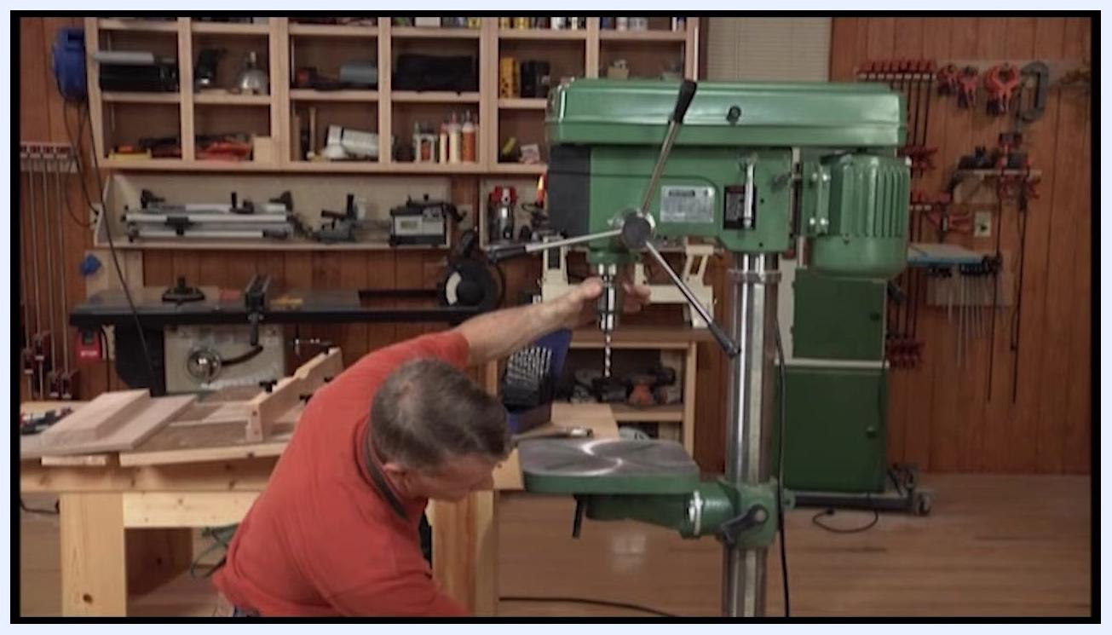
Operator adjusting the drill press table height using the geared handle on the column
The table can be raised or lowered for different workpiece thicknesses, pivoted out of the way, tilted for angled drilling, and rotated for optimal positioning. Keep in mind that the standard metal table is a legacy from metalworking; for improved woodworking performance, consider upgrading it with woodworking-specific accessories.

Step 9: Install a woodworking drill press table
Install a woodworking-specific drill press table onto your machine and ensure it is securely fastened and level. This upgrade provides a much larger work surface, making it easier to support large workpieces such as cabinet sides, and improves stability and control during drilling.
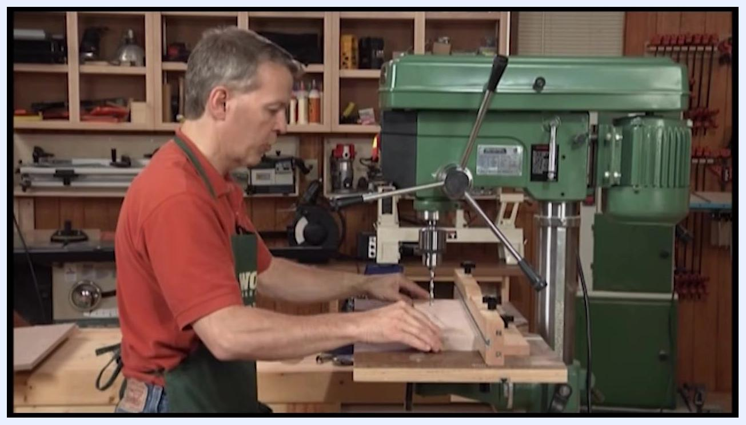
Operator positioning a workpiece against the adjustable fence for consistent hole spacing

Step 10: Use the adjustable fence for consistent drilling

- Attach the included fence to the table.
- Clamp the fence in position as needed.
- Move your workpiece along the fence to drill holes that are consistently spaced from the edge.
This setup lets you drill multiple holes at the same distance from the edge, improving accuracy and repeatability.
Safety note: Press the workpiece firmly against the fence while drilling. If the drill bit catches the workpiece, the fence prevents it from spinning, reducing the risk of injury.
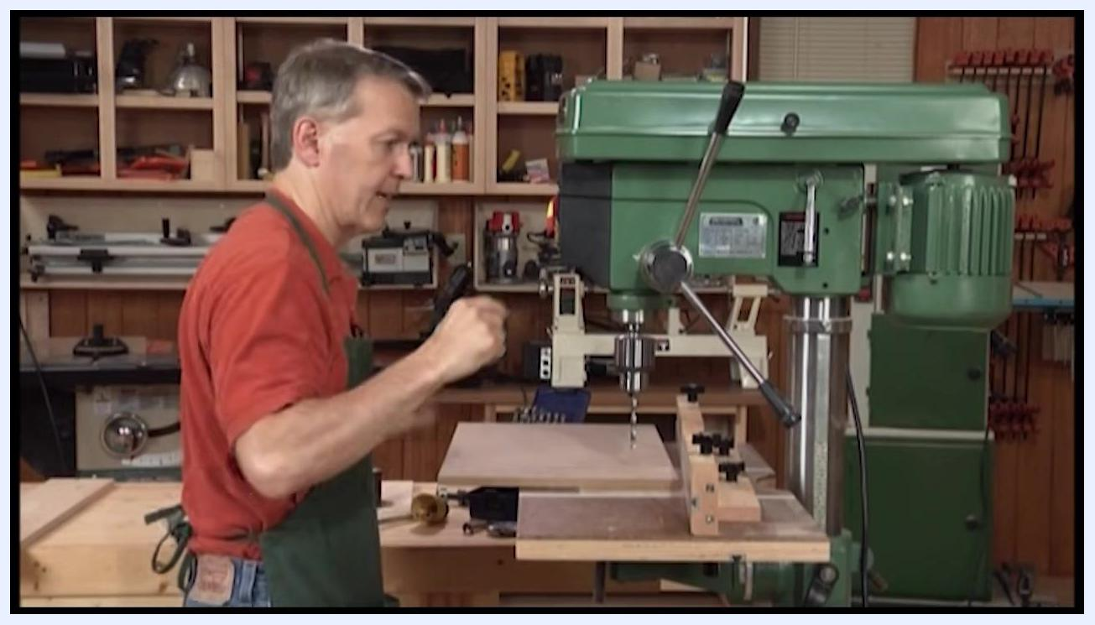
Operator positioning the workpiece under the drill bit with the handle removed, aligned with the fence and stop blocks

Step 11: Extend the table wings and add stop blocks
Extend the table wings to increase support for very large workpieces. Clamp stop blocks to the fence or table so you can repeatedly position workpieces for drilling holes in the same location on multiple pieces.
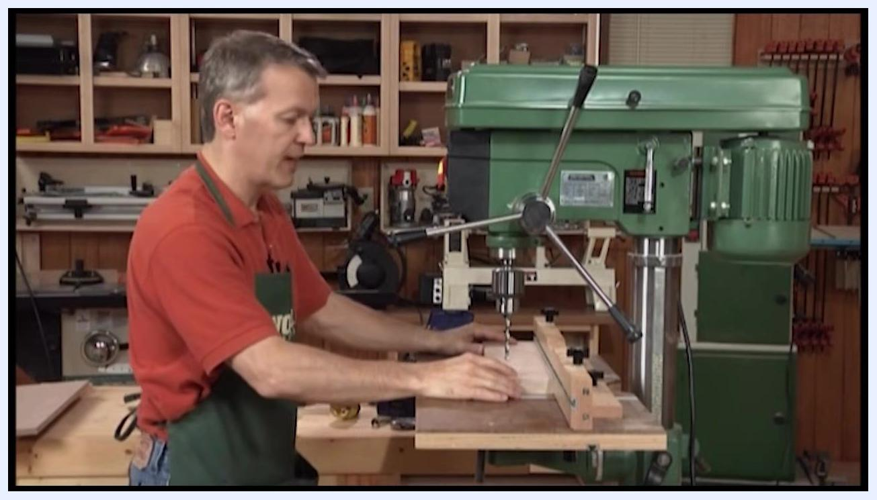
Operator holding a workpiece against the fence to demonstrate improved drilling safety

Step 12: Position the workpiece for drilling
Place your workpiece (for example, a cabinet side) on the table, aligning it with your measured marks for shelf pins or other features. Position the first mark under the drill bit, using the fence and stop blocks for alignment.
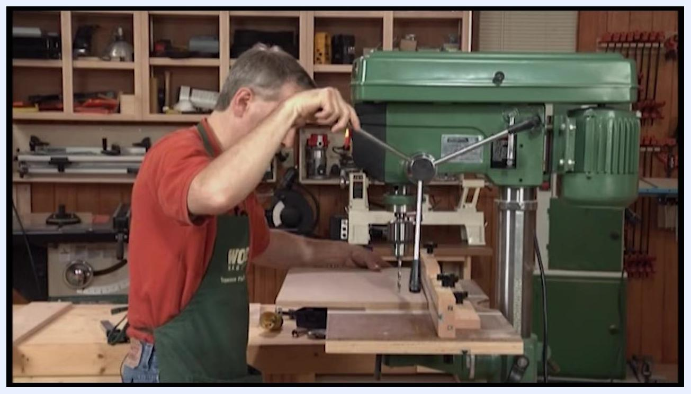
Operator resolving a handle clearance issue by unscrewing the handle to allow full travel of the drill press

Step 13: Resolve handle clearance issues
If the drill press handle interferes with the fence or table during operation, unscrew and remove the handle as needed. Set it aside and continue with your drilling operation, ensuring you have the necessary travel for the drill bit.
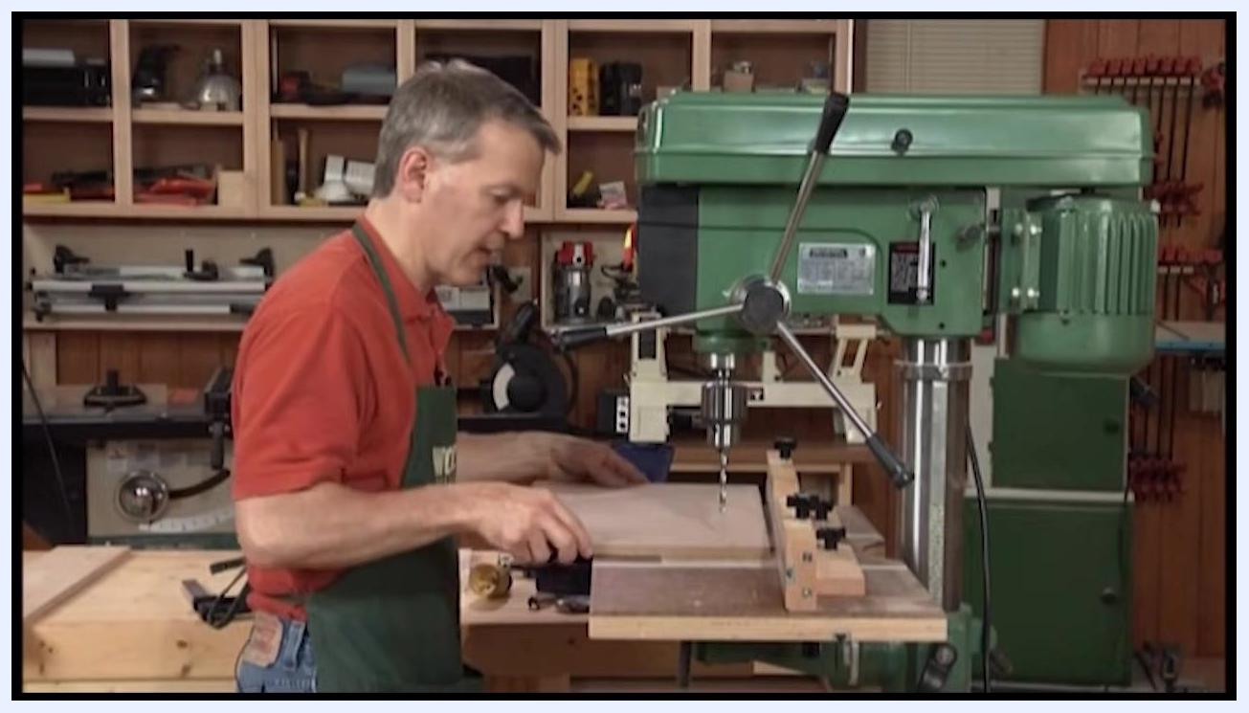
Operator positioning a marked workpiece under the drill bit using the fence for alignment

Step 14: Resume drilling after resolving handle clearance
With the handle removed, confirm that you now have the necessary travel for the drill bit to reach your workpiece. Position your workpiece so the first marked drilling location sits directly under the drill bit, keeping it aligned with the fence and any stop blocks for accuracy and repeatability.
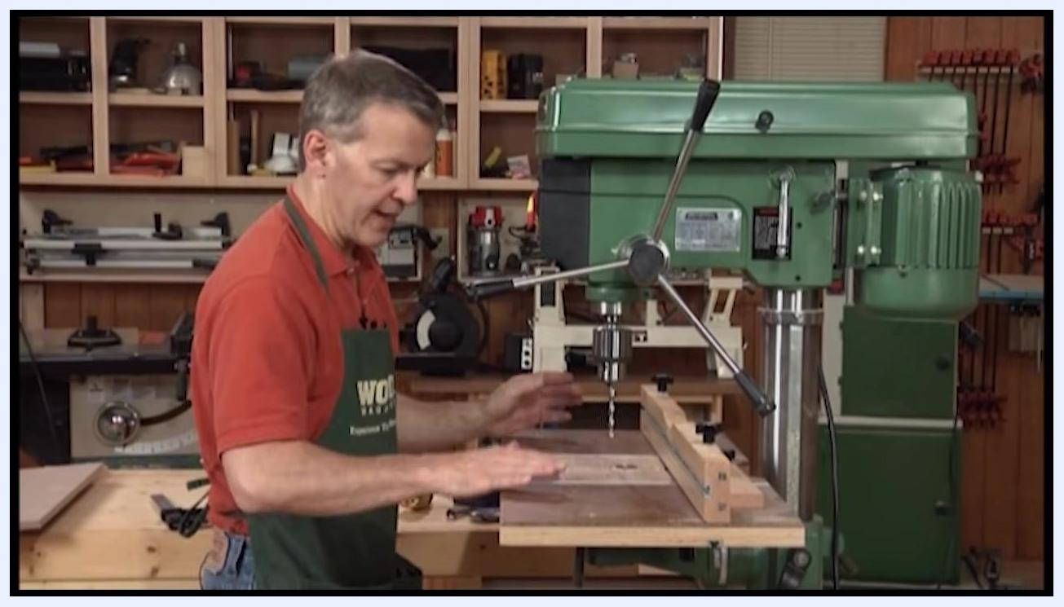
Large woodworking drill press table with fence and accessories installed on the drill press

Step 15: Set up and lock the fence
Position the fence on the drill press table so your workpiece will be properly aligned for drilling, then lock it in place using the locking knobs or clamps on the fence assembly. Confirm the fence is secure and will not move during drilling.
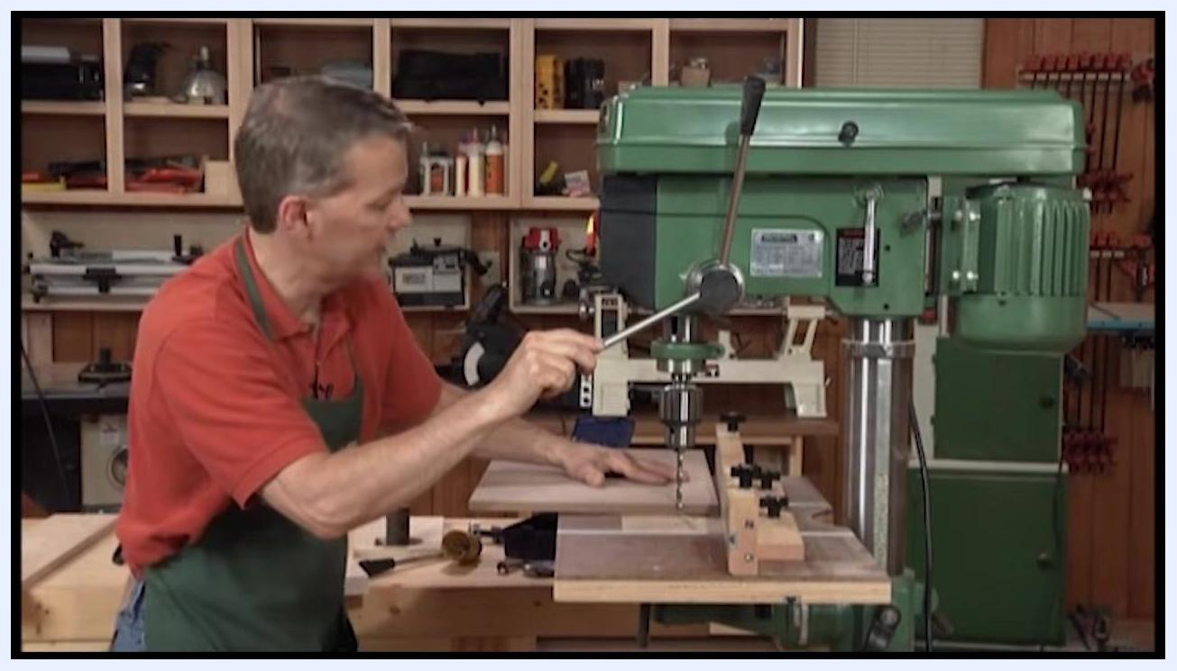
Operator monitoring the drilling process to ensure consistent hole depth

Step 16: Begin drilling holes
Place your workpiece against the locked fence. Lower the drill press handle to bring the drill bit into contact with the workpiece, then start drilling holes at the desired locations along your workpiece.
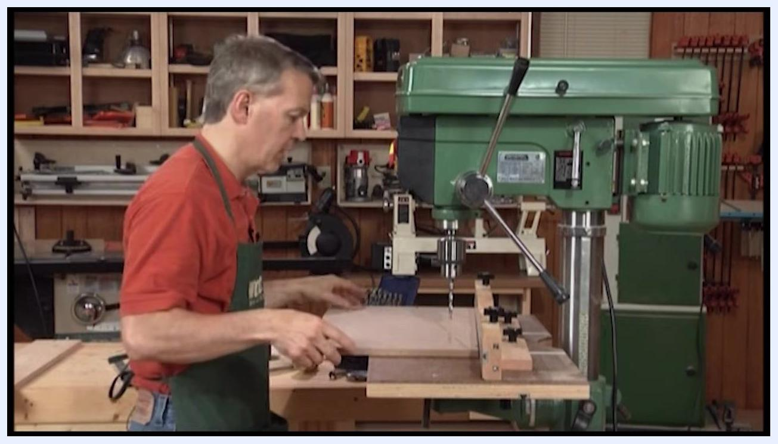
Close-up of a drill bit creating a hole in a piece of wood, with wood shavings accumulating around the hole

Step 17: Maintain consistent hole depth
Use the drill press depth stop to control how deep the drill bit goes into the workpiece. Drill each hole to the same depth for uniformity, observing the depth stop mechanism and adjusting it if necessary.
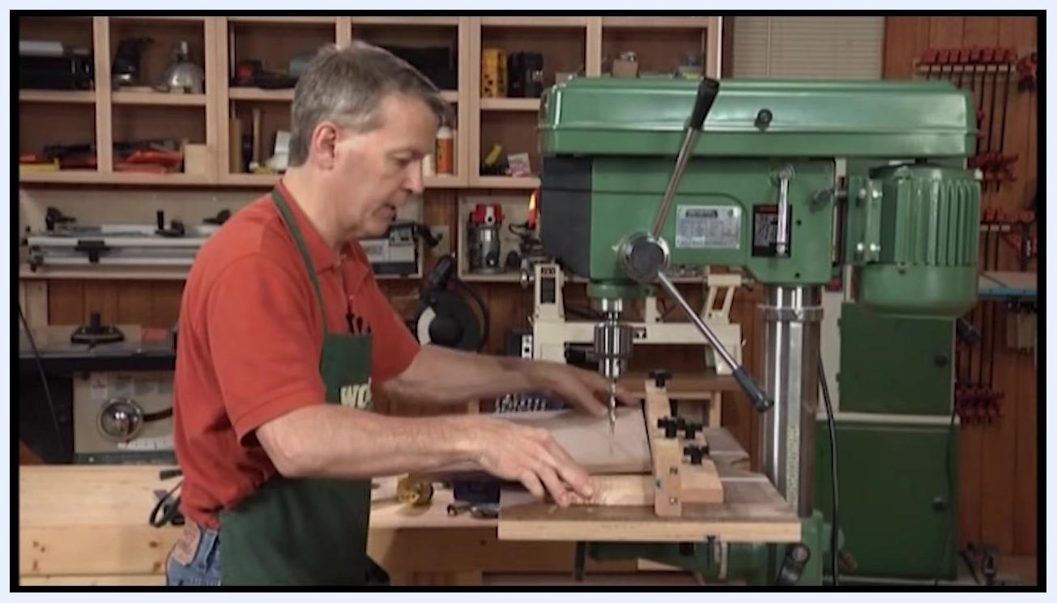
Operator drilling through a workpiece with scrap wood underneath to protect the table

Step 18: Observe the drilling process
Watch as the drill bit creates clean holes in the workpiece, noting the wood shavings produced as the bit penetrates the material.

Step 19: Continue drilling along the marked line
Move the workpiece along the fence to the next marked position and drill additional holes, maintaining alignment and depth. Repeat this process for all required holes.
Operator placing a piece of scrap wood underneath the workpiece before drilling through it

Step 20: Prepare for through-holes
If you need to drill completely through the workpiece, raise the depth stop so it is out of play, and place a piece of scrap wood underneath your workpiece to protect the drill press table from damage.
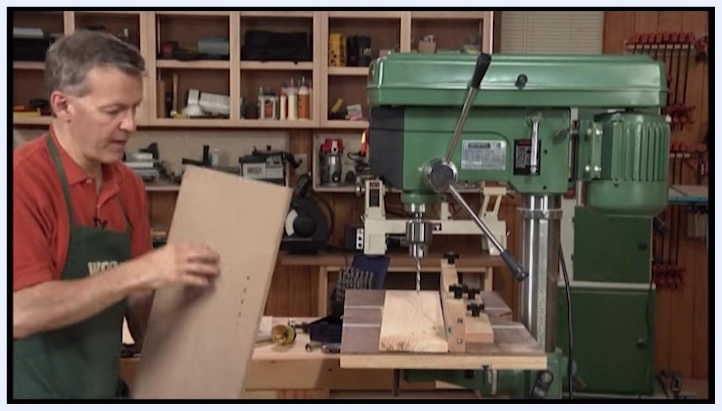
Operator holding up a workpiece with a line of drilled holes to inspect the results

Step 21: Drill through the workpiece
Drill through the workpiece, allowing the bit to pass into the scrap wood below. This prevents damage to the drill press table and ensures a clean exit hole.
Note: The scrap wood (backer board) also helps produce a clean back on your workpiece by minimizing tear-out as the bit exits. Ensure the backer board is properly positioned under the drilling area.
Close-up of multiple holes drilled in a straight line, with wood shavings visible around each hole

Step 22: Inspect your work
Remove the workpiece and examine the line of holes for consistency and cleanliness before moving on to the next operation.

Step 23: Install a drum sander attachment for sanding curves
Install a drum sander—a cylindrical sanding accessory designed for smoothing and shaping curved edges—into the drill press chuck.

Step 24: Prepare the workpiece for sanding
Place the workpiece with a curved cutout near the drum sander on the drill press table. Ensure the drum sander is securely installed and the drill press is set to an appropriate speed for sanding.
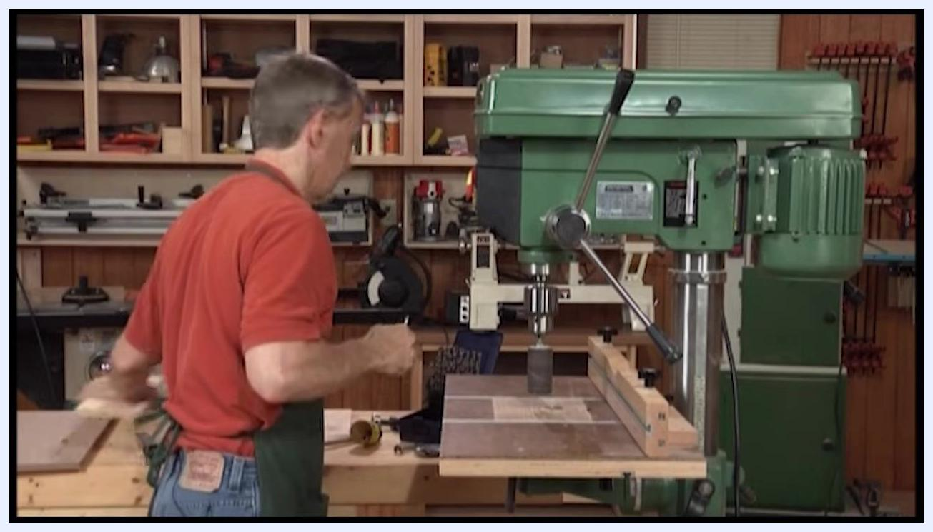
Operator aligning a wooden workpiece with a curved cutout against the drum sander, with the pencil line visible

Step 25: Align the workpiece with the sanding drum
Hold the workpiece so the curved edge to be sanded is adjacent to the drum sander, using the pencil line marking the desired curve to guide the sanding process.
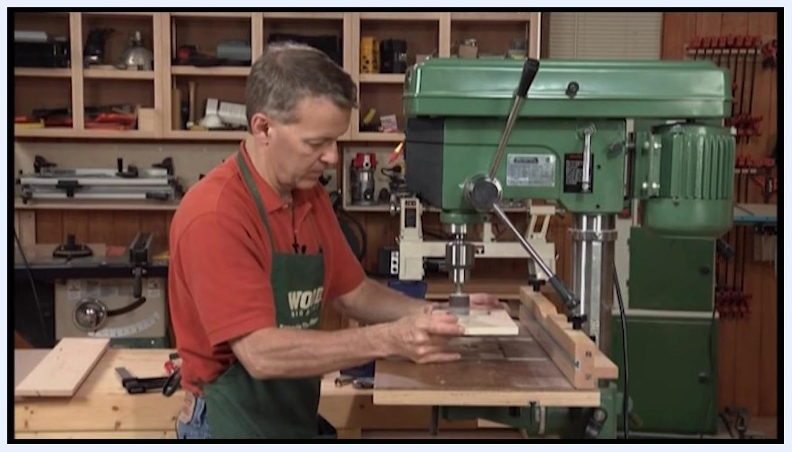
Operator holding the workpiece against the spinning drum sander to sand the inside curve

Step 26: Check the layout before sanding
Examine the workpiece closely to confirm the pencil line is visible and the cutout is ready for sanding.

Step 27: Begin sanding the curve
Turn on the drill press and gently bring the workpiece into contact with the spinning drum sander. Move the workpiece along the drum, following the pencil line to achieve a smooth, even curve. Use a freehand motion to utilize the full surface of the sanding drum for even wear.
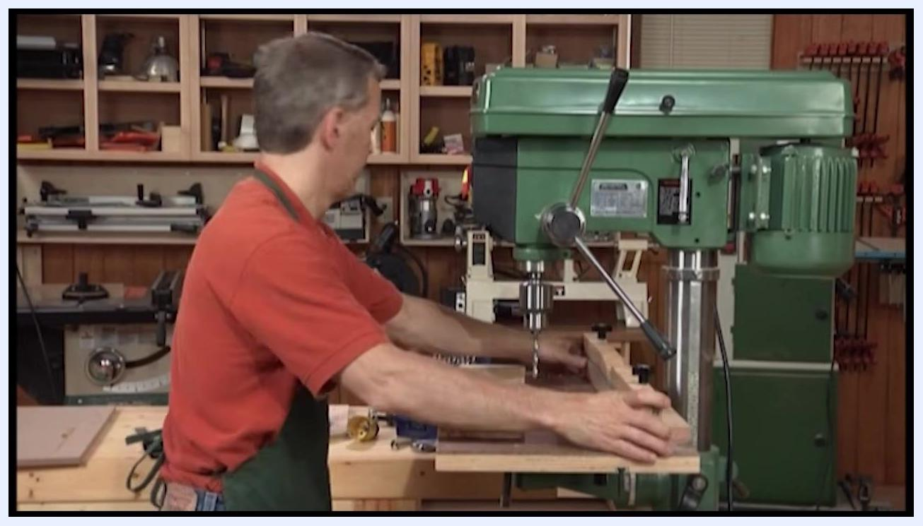
Drum sander attachment installed in the drill press chuck, with the fence visible on the table

Step 28: Refine the curve near the layout lines
Continue sanding until you are very close to the pencil layout lines, freehanding the workpiece to use the entire surface of the sanding drum for even sanding.

Step 29: Prepare to control sanding depth
To avoid sanding past the layout line, plan to clamp a scrap block just in front of the sanding drum. This will act as a stop, preventing the workpiece from being pushed too far into the drum.
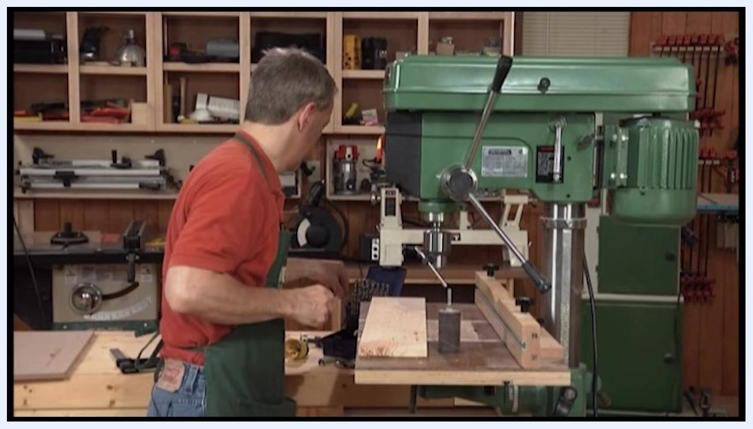
Operator preparing a rectangular wooden workpiece with a curved cutout for sanding with the drum sander
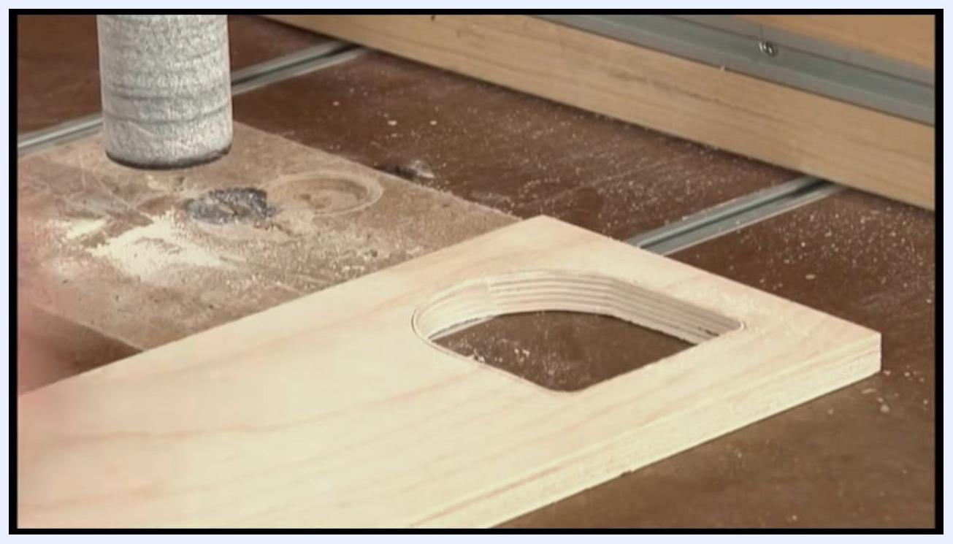
Hands positioning a wooden workpiece with a curved cutout near the drum sander, preparing to add a stop block

Step 30: Clamp a scrap block as a stop
Place a scrap block on the drill press table directly in front of the sanding drum and secure it with a clamp. This acts as a physical stop, ensuring precise sanding up to the layout line without over-sanding.
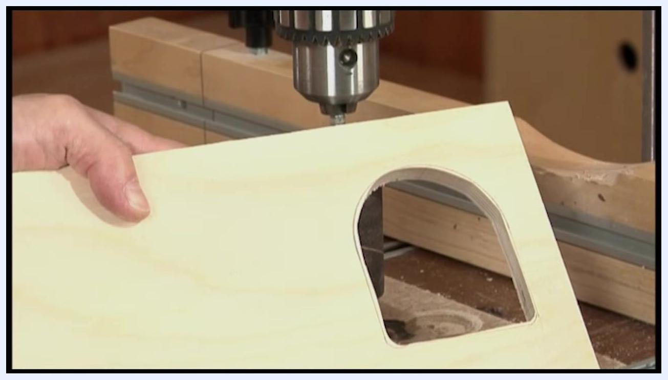
Close-up of a hand holding a wooden workpiece with a curved cutout near the drum sander, with the pencil line visible
Wooden workpiece positioned near the drum sander with a scrap block clamped in front of the drum as a stop

Step 31: Position the workpiece and adjust the table height
Slide the wooden workpiece into position on the drill press table, aligning it with the sanding drum or drill bit as needed. Begin raising the table so the workpiece just makes contact with the drum or bit, ensuring it remains flat and stable on the table surface.
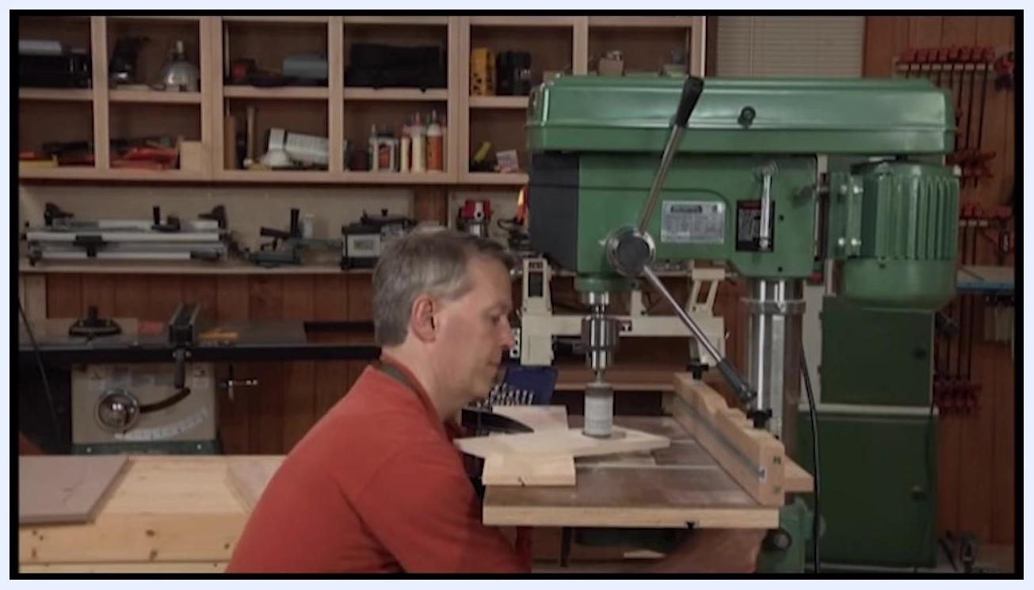
Hands positioning a wooden workpiece on the drill press table, with the sanding drum and wood dust visible

Step 32: Fine-tune the table height for precise contact
Use the table adjustment handle to carefully raise the table until the workpiece just touches the sanding drum or bit, confirming that it is properly aligned and supported.
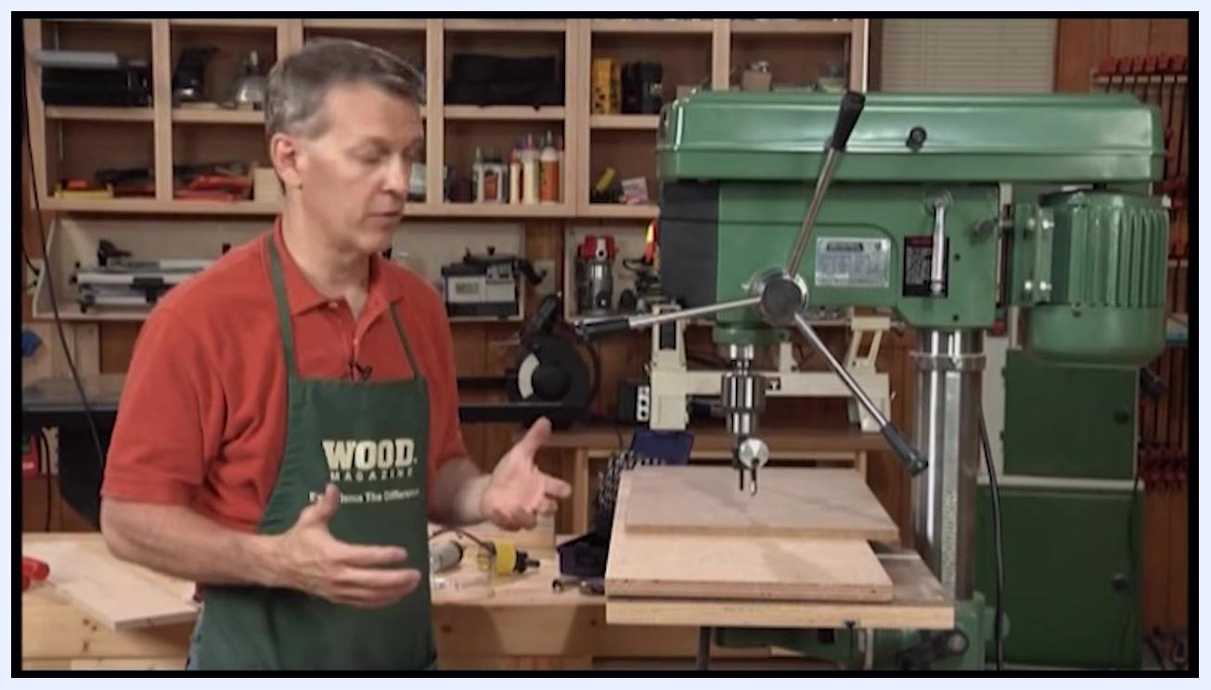
A person in a red shirt and green apron stands next to a green drill press, explaining its features. The drill press table has a large wooden board on it. The background shows a woodworking shop with shelves and tools.

Step 33: Begin sanding or drilling the workpiece
Hold the workpiece securely and bring it into contact with the spinning drum sander or drill bit. Move the workpiece as needed to sand or drill, maintaining control and following any layout lines.
Close-up of the workpiece being moved along the drum sander to refine the curved cutout
Safety note: Keep your hands clear of the spinning drum or bit at all times.

Step 34: Handle workpieces too large for the fence
If a workpiece extends too far back on the table, the fence cannot be used to brace it. In this case, position the workpiece on the table so it remains stable even without the fence.
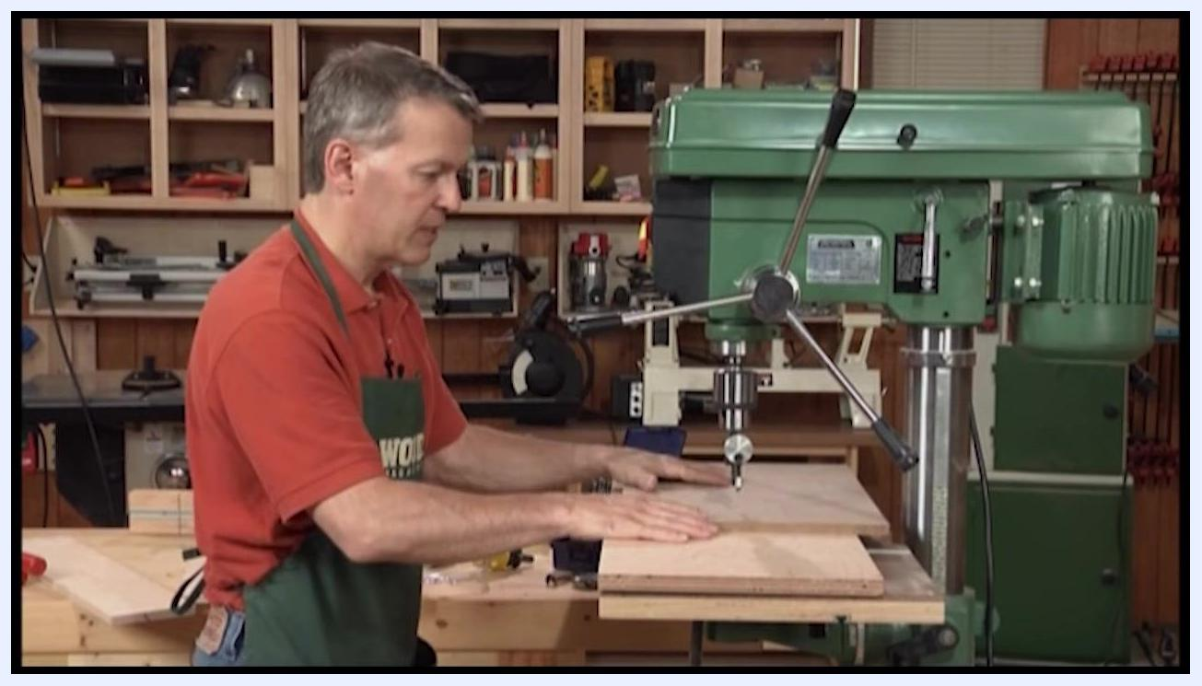
Large wooden board positioned on the drill press table, extending beyond the fence

Step 35: Keep hands away from the spinning bit
Ensure the workpiece is held securely in place, especially when the fence cannot be used, and avoid placing your hands near the spinning bit or drum to prevent injury.
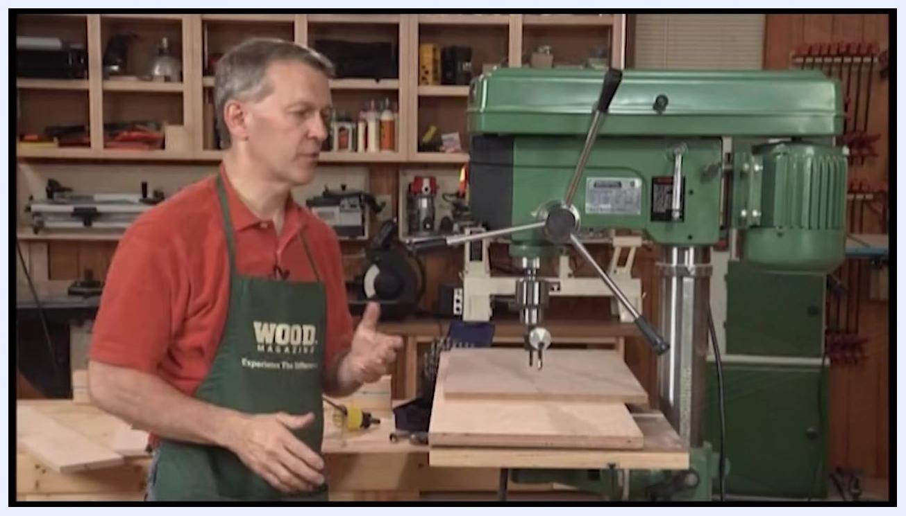
Operator adjusting the drill press table height with the workpiece positioned under the drum sander
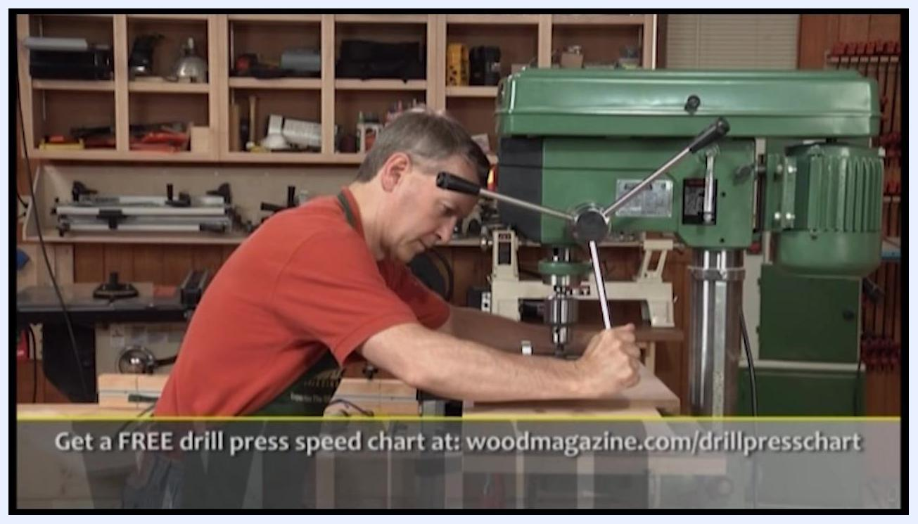
Demonstration of safe hand placement on a large board at the drill press, keeping hands away from the spinning bit

Step 36: Use a backer board to protect the table
Place a backer board between the drill press table and the workpiece. This prevents damage to the table when the drill bit pokes through the workpiece.
Backer board and clamps positioned under a large board on the drill press table

Step 37: Clamp the workpiece and lock the table
Secure the workpiece in place using clamps to prevent movement during drilling or sanding, and double-check that the drill press table is locked in position to avoid accidental shifting.
Hands holding a wooden workpiece with a square cutout against a spinning drum sander on the drill press
Workpiece clamped to the drill press table with the table locked in place

Step 38: Lock the fence for controlled drilling
Adjust the fence on the drill press table so it is aligned with your drilling layout, then lock it securely in place to ensure consistent hole placement and prevent movement during drilling.
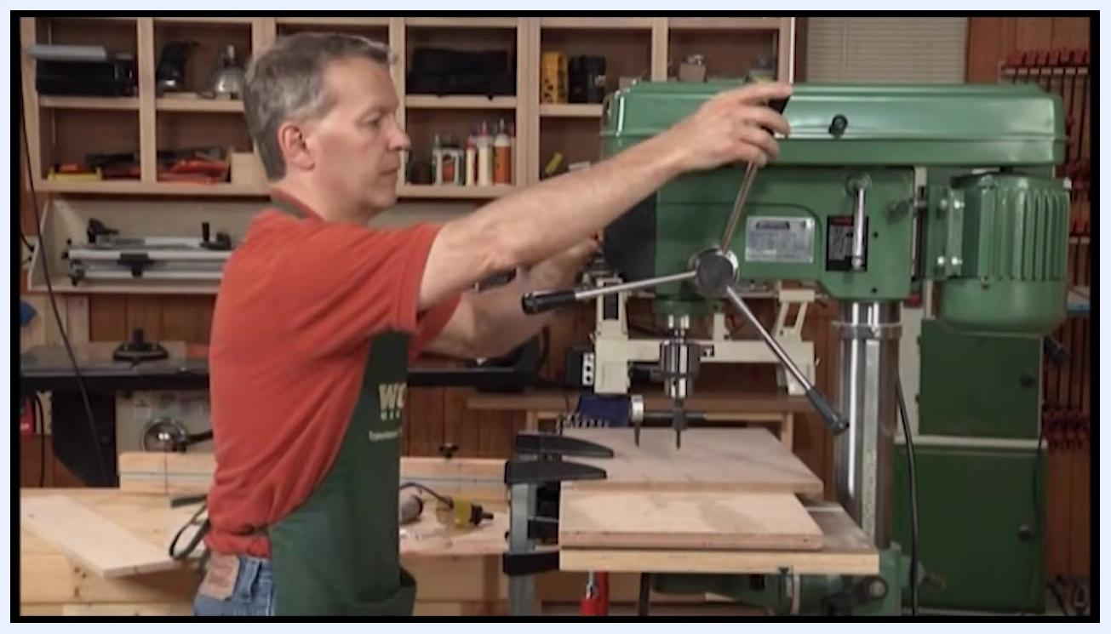
Operator adjusting and locking the fence on the drill press table with the workpiece clamped in place

Step 39: Set the depth stop for consistent hole depth
Decide how deep you want your holes to be (for example, 1/4 inch deep) and adjust the depth stop mechanism on the drill press to limit the downward travel of the drill bit. Lower the drill bit to visually confirm the maximum drilling depth, then ensure the stop is firmly tightened so all holes will be drilled to the same depth.
Operator adjusting the screw-type depth stop on the drill press column

Step 40: Drill holes with the depth stop engaged
Start drilling holes along your marked line, using the locked fence as a guide. Lower the drill bit until it contacts the depth stop, ensuring each hole is exactly the depth you set. Move the workpiece as needed to drill additional holes, maintaining alignment with the fence for accuracy.
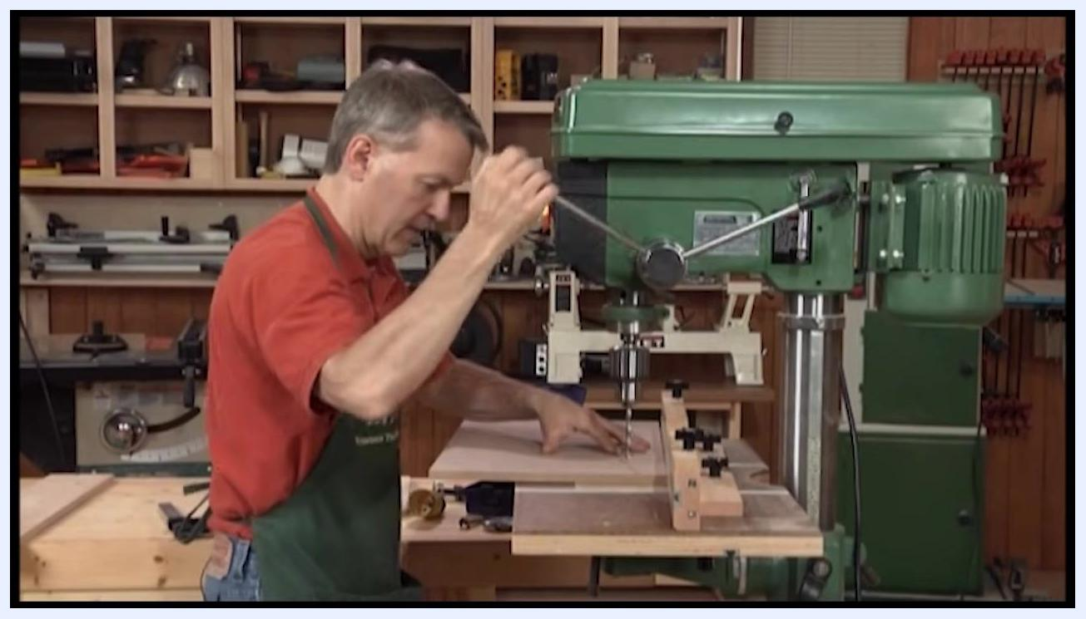
Operator lowering the handle to start drilling into a piece of wood positioned against the locked fence

Step 41: Adjust for through-holes if needed
If you need to drill holes all the way through the workpiece, raise or remove the depth stop so it does not limit the drill bit's travel. Place a piece of scrap wood (backer board) underneath your workpiece to protect the table from damage when the bit breaks through, ensuring the backer board is flat and fully supports the drilling area.
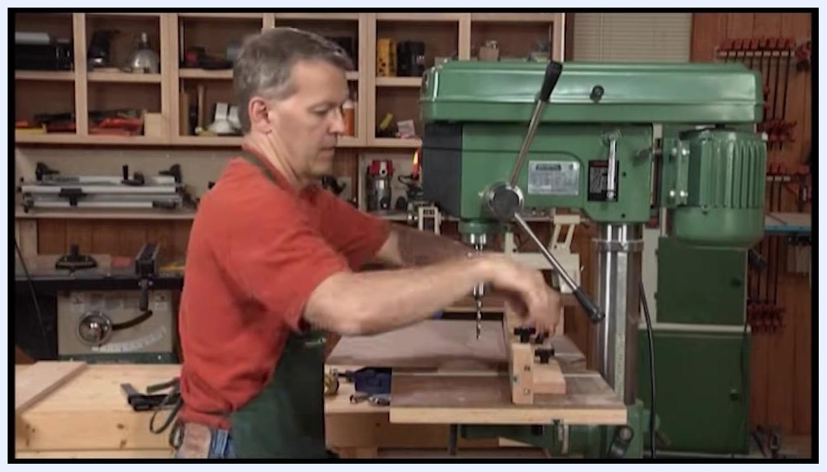
Operator adjusting and locking down a wooden fence on the drill press table

Step 42: Drill through-holes safely
Drill through the workpiece, allowing the bit to pass into the scrap wood below. The backer board prevents splintering on the back side of your workpiece and protects the table surface. Always use a backer board when drilling through-holes to maintain workpiece quality and prolong the life of your equipment.
Close-up of a hand holding the workpiece steady as the drill bit approaches, with a backer board visible underneath

Step 43: Cut a circular opening
Secure a piece of wood on the drill press table and attach a circle cutter to the drill press. Lower the spinning cutter into the wood to start cutting a circular groove, observing the cutter as it rotates and removes material to form a circle.
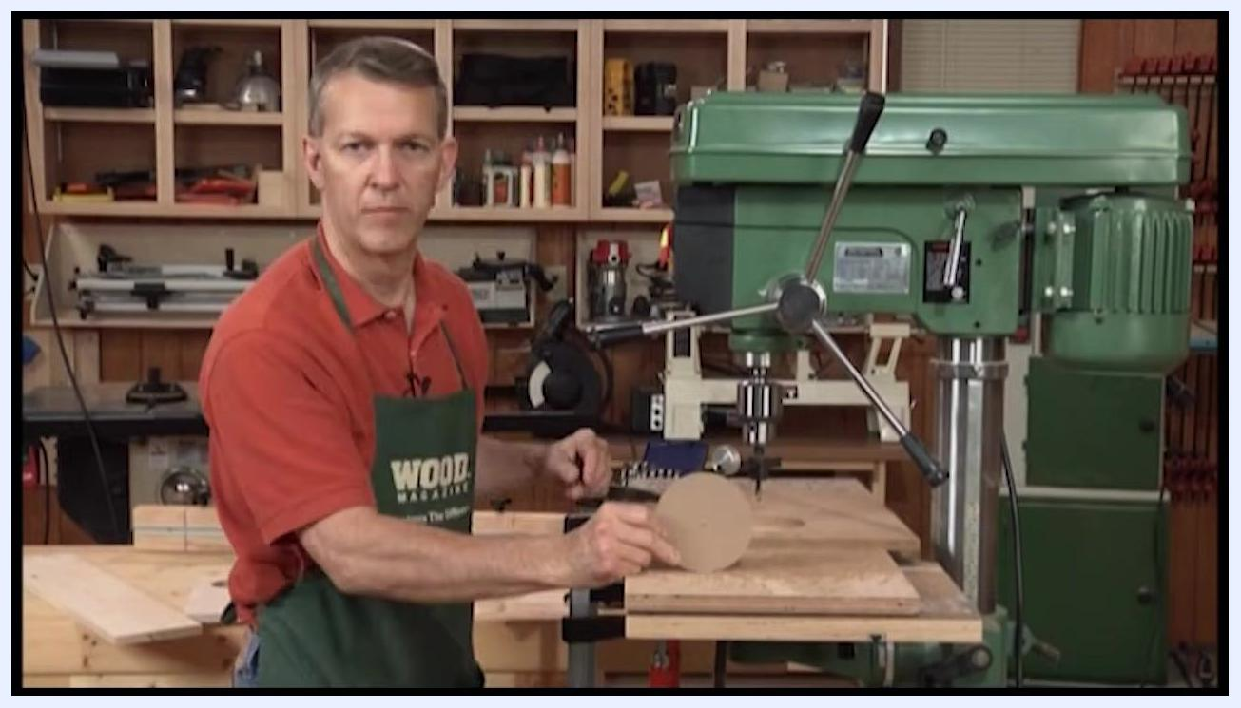
Hand lifting a perfectly cut wooden circle from the opening, with the circle cutter still attached to the drill press

Step 44: Remove the cut circle
Once the cut is complete, stop the drill press. Carefully lift the circular wooden cutout from the opening by hand and inspect the result to confirm both the opening and the cutout are perfectly circular. This method is ideal for making wheels or circular cutouts for toy projects.
Spinning circle cutter attached to the drill press, cutting a circular groove into a piece of wood
Finished circular wooden cutout held up beside the drill press

Step 45: Verify the finished cutout
Hold up the circular cutout to confirm the result is a perfectly circular piece suitable for your woodworking project.

Step 46: Understand hole saw limitations
Hole saws are not adjustable; they only cut at fixed diameters. Keep this in mind when selecting the appropriate attachment for your project.
Safety note: The aggressive teeth on a hole saw can grab the workpiece, creating a risk of the workpiece spinning if it is not clamped down securely.
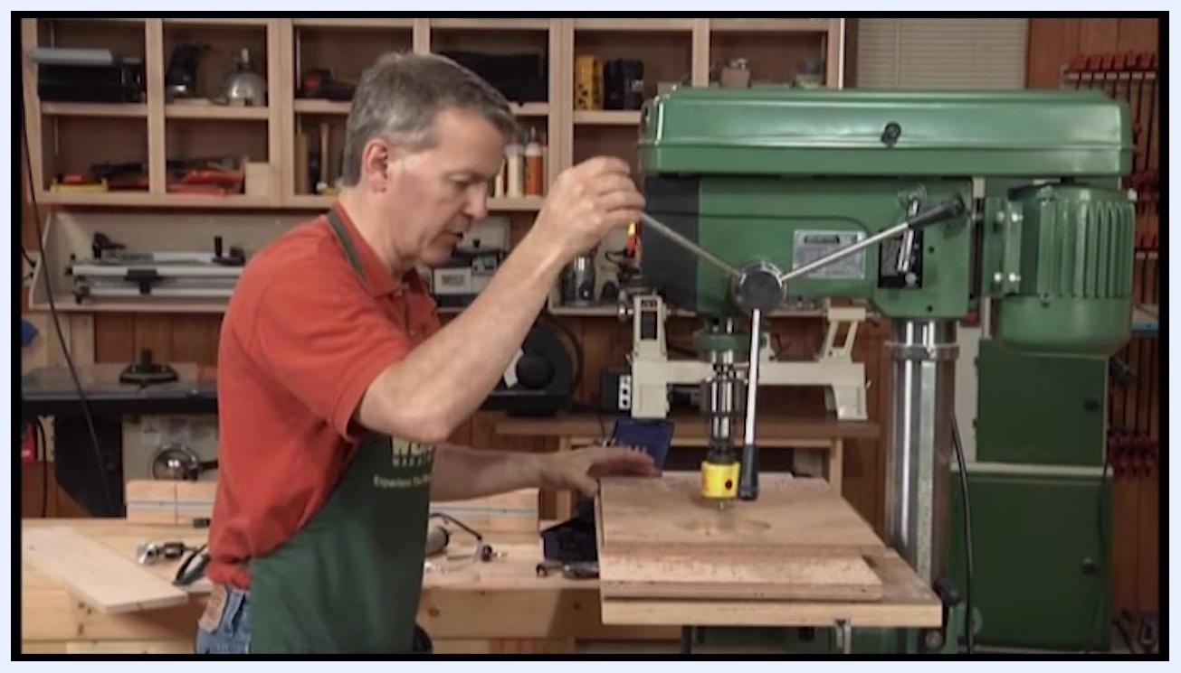
Wooden workpiece clamped to the drill press table with a yellow hole saw attached

Step 47: Clamp the workpiece securely for hole saw use
Use a clamp to secure the wooden workpiece to the drill press table, ensuring it cannot move or spin during drilling. Lower the drill press handle to position the hole saw above the clamped workpiece.
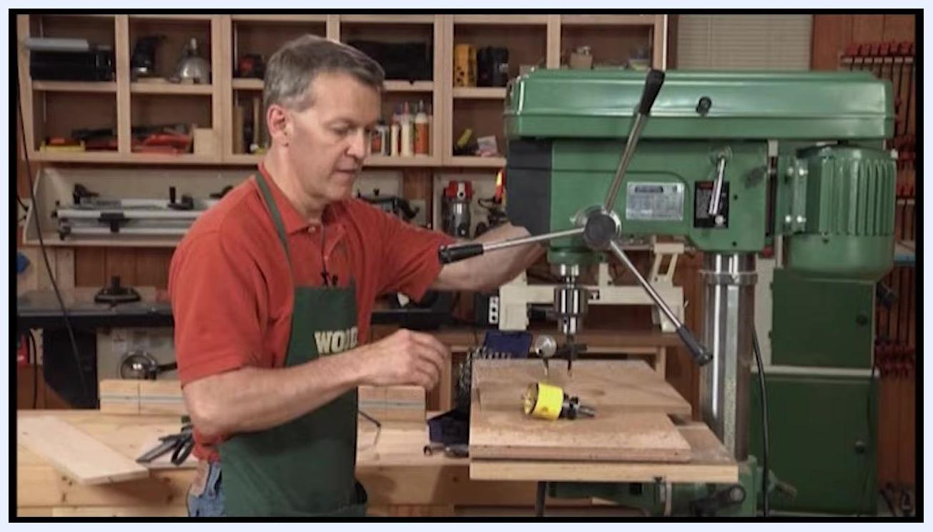
Hole saw attachment showing its fixed diameter
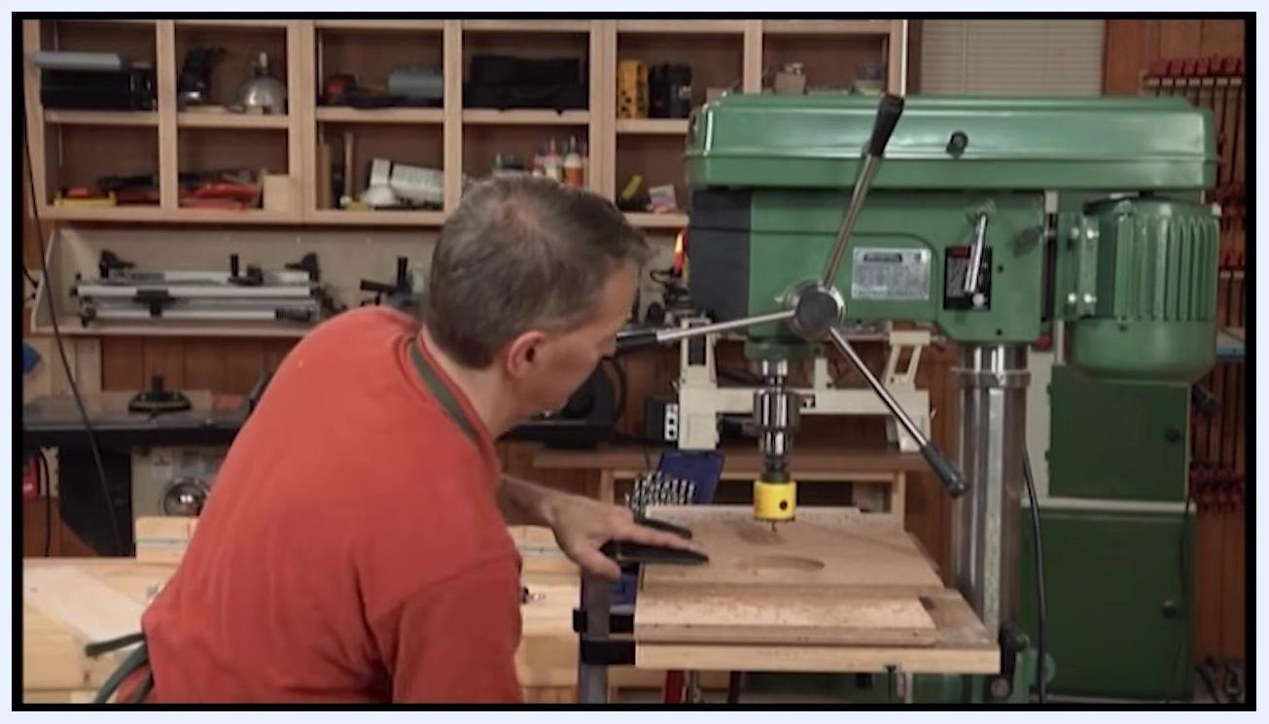
Drill press operating with a yellow hole saw, with the workpiece clamped and the machine set to slow speed

Step 48: Double-check the clamping and setup
Inspect the setup from different angles to confirm the workpiece is firmly clamped, making any necessary adjustments to the clamp or workpiece position.
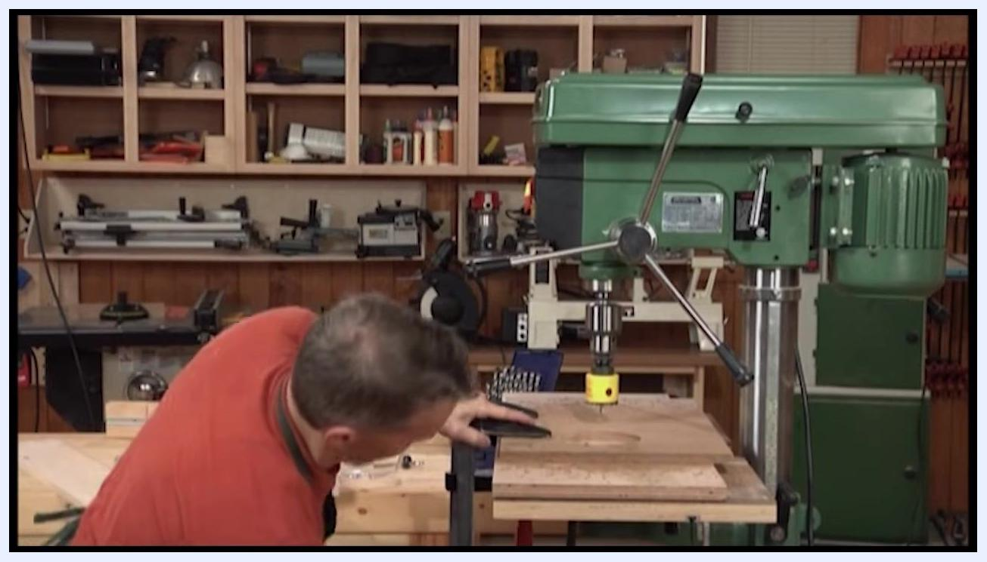
Close inspection of the clamped workpiece and hole saw setup on the drill press

Step 49: Operate the hole saw at slow speed
When using a hole saw, always run the drill press at a slow speed to prevent grabbing and ensure safety. Begin drilling only after confirming all safety precautions are in place.
Preparing to clamp a wooden workpiece with a yellow hole saw attached to the drill press

Summary
By following this procedure, you have learned how to use a drill press for a full range of woodworking tasks:
- Adjusting spindle speed using the belt and pulley arrangement and the speed chart.
- Securing drill bits in the chuck and controlling drilling depth with the depth stop.
- Adjusting the table height, tilt, pivot, and rotation for different operations.
- Installing and using a woodworking table with a fence, stop blocks, and extendable wings for consistent, repeatable, and safe drilling.
- Using a backer board to protect the table and produce clean through-holes.
- Installing and using a drum sander to shape curved edges, including clamping a stop block to control sanding depth.
- Cutting perfectly circular openings with a circle cutter.
- Understanding the fixed-diameter limitation of hole saws and clamping workpieces securely to prevent them from spinning during use.
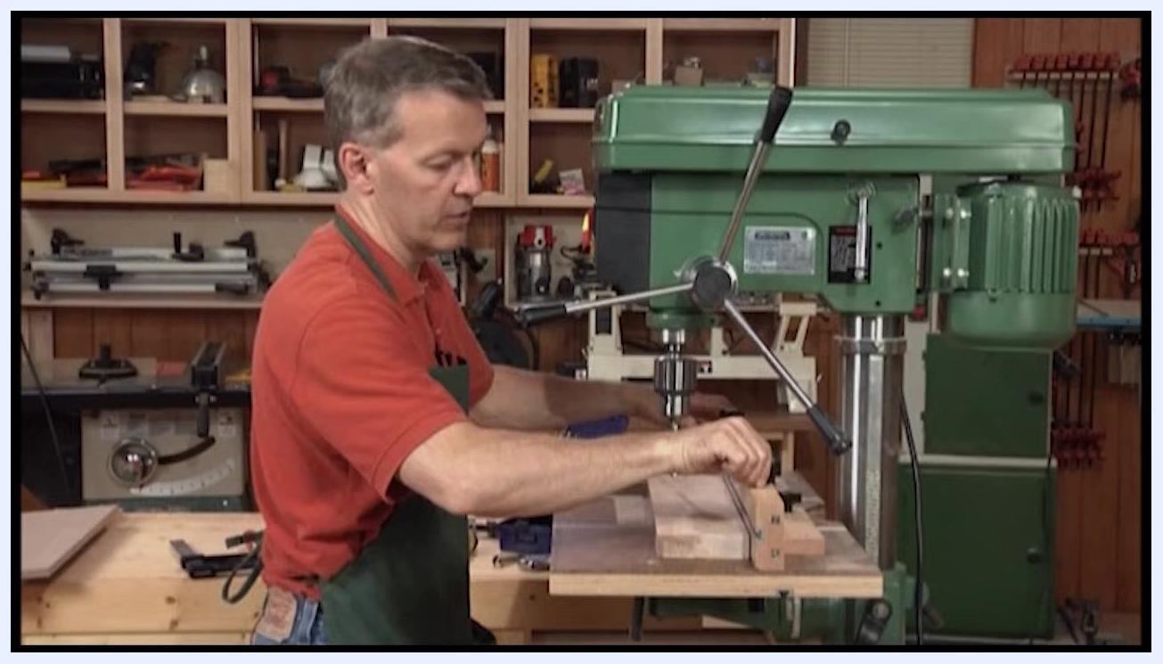
Operator extending the table wings and adjusting stop blocks for repetitive drilling tasks
A drill press offers greater precision, safety, and control than a hand-held drill, particularly for circular cuts, repetitive tasks, and operations involving bits and accessories—such as drum sanders and circle cutters—that would be unsafe or impractical with a hand-held tool. Its robust construction and adjustable features make it well suited for accurate, repeatable woodworking operations.
A black screen with the bold yellow and white text "WOOD Videos" centered, indicating the end of the video.
A black screen with the bold yellow and white text "WOOD Videos" centered, indicating the end of the video.

