How to Use a Dial Indicator to Measure Brake Rotor Runout

Purpose
This standard operating procedure explains how to use a dial indicator to measure lateral runout on a brake rotor. It covers attaching the dial indicator to a rigid fixture, taking accurate runout measurements, and identifying the correction plate needed if runout exceeds specification.

Scope
This procedure applies to technicians measuring brake rotor runout as part of a brake service or diagnostic inspection. It covers setup of the dial indicator assembly through selection of the correct brake align correction plate.

Required equipment
- Dial indicator with flex arm and contact tip
- Vise grip clamp
- Brake align correction plates
- Brake align application chart
- Marker (for marking high spot locations)

Step 1: Secure the vise grip to the vehicle
Clamp the vise grip securely onto a rigid part of the vehicle's suspension or knuckle. Adjust the knurled knob in the vise grip handle to ensure a tight, stable grip. Confirm that the vise grip does not move when you lightly push or pull it.
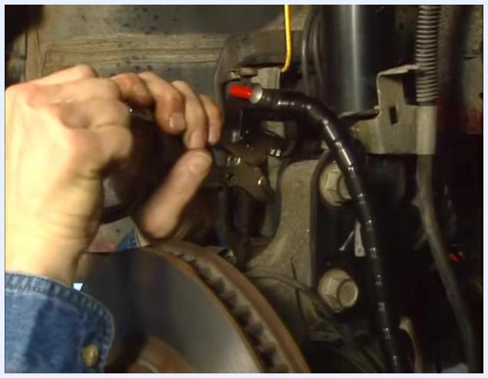
Hands adjusting the knurled knob on a vise grip clamped to a vehicle suspension component, with a brake rotor visible in the foreground.

Step 2: Position the vise grip near the rotor
Ensure the vise grip is located close enough to the brake rotor so that the flex arm and dial indicator gauge can reach and make contact with the rotor's friction surface. The flex arm should extend comfortably from the vise grip to the rotor.
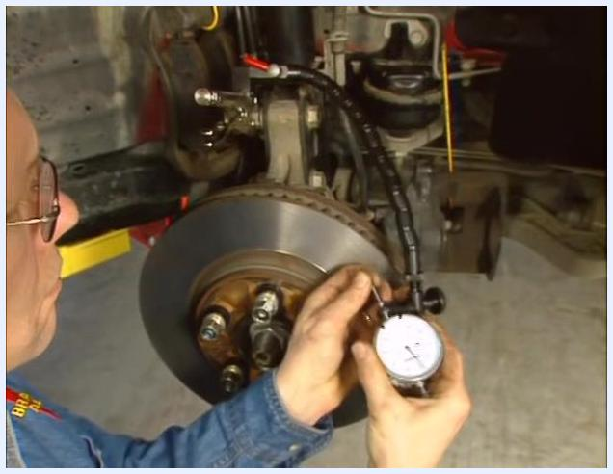
Person positioning the dial indicator and flex arm near the brake rotor, ensuring the setup can reach the rotor's friction surface.

Step 3: Tighten the contact tip
Check that the contact tip of the dial indicator is tightened securely. Use your fingers to confirm the tip does not wobble or move.
Person checking and tightening the contact tip of the dial indicator, with the flex arm and rotor visible.

Step 4: Set the dial indicator position
Adjust the flex arm so the dial indicator gauge contacts the rotor's friction surface approximately half an inch from its outermost diameter. Rotate the knurled ring at the end of the flex arm clockwise to remove any slack, holding the dial indicator in the desired position.
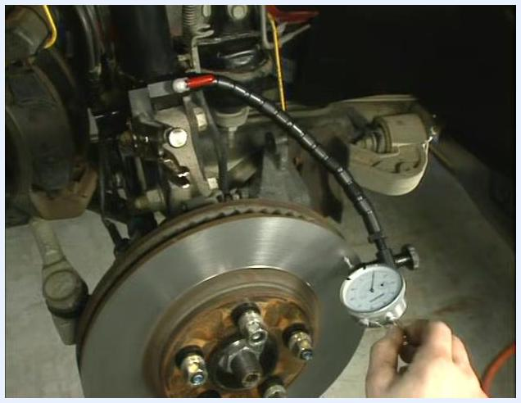
Person rotating the knurled ring at the end of the flex arm to remove slack, with the dial indicator positioned near the rotor.

Step 5: Lock the flex arm and gauge in place
With the slack removed, turn the cam lever to secure the flex arm and dial indicator rigidly in place. The cam lever should be in line with the flex arm when fully tightened.
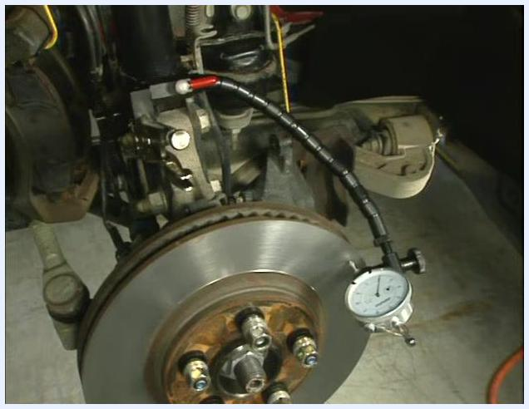
Close-up of a hand turning the red cam lever to lock the flex arm and dial indicator in place.

Step 6: Verify contact and stability
Lift the spring-loaded needle of the dial indicator up off the rotor a few times. Ensure the tip of the needle makes good contact with the rotor's friction surface each time, and confirm there is no movement in the dial indicator or flex arm during this process.
Person lifting the dial indicator needle off the rotor, checking for proper contact and stability.

Step 7: Check for flex arm and gauge movement
Observe the setup to ensure the dial indicator and flex arm remain stable and do not shift when the needle is lifted and released.
Dial indicator and flex arm setup shown in a stable position, with the needle contacting the rotor.

Step 8: Rotate the rotor and observe the gauge
Always rotate the rotor in the clockwise direction when checking for lateral runout. Watch the dial indicator gauge as it oscillates back and forth between the high and low points on the rotor. The lowest reading on the gauge indicates the lowest spot on the rotor.
Close-up of the dial indicator gauge showing needle movement as the rotor is rotated.

Step 9: Zero the gauge at the low spot
Once you find the low spot, gently push the gauge to bring the needle to top dead center, pointing directly at the rotor. Rotate the face of the gauge so the needle points to zero at this location, then rotate the rotor again to confirm the low spot is exactly at zero.
Dial indicator gauge being zeroed at the low spot, with the needle pointing to zero.

Step 10: Confirm the zero setting
Double-check the gauge to ensure the needle remains at zero when the rotor is at the low spot.
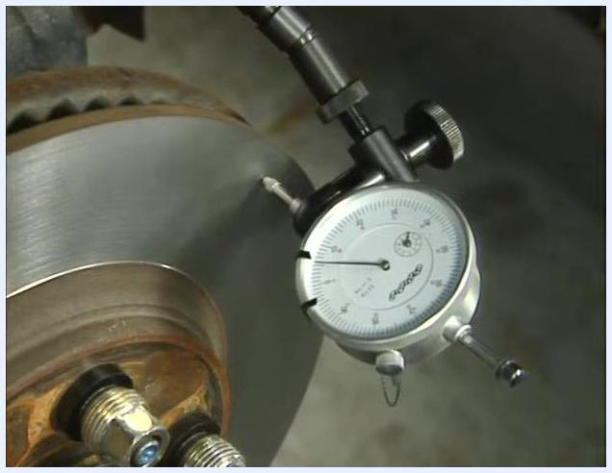
Close-up of the dial indicator gauge with the needle set at zero, confirming the zero setting.
At this point, the dial indicator is securely attached and properly set up to measure rotor runout accurately.

Step 11: Rotate the rotor to find the high spot
With the dial indicator zeroed at the low spot, continue rotating the rotor clockwise. Observe the gauge as you rotate to identify the highest reading, which indicates the high spot, or maximum lateral runout. Note the amount of runout at the high spot, measured in thousandths of an inch. In this example, the runout exceeds the manufacturer's specification of 0.002" (two thousandths); the measured runout is 0.006" (six thousandths).
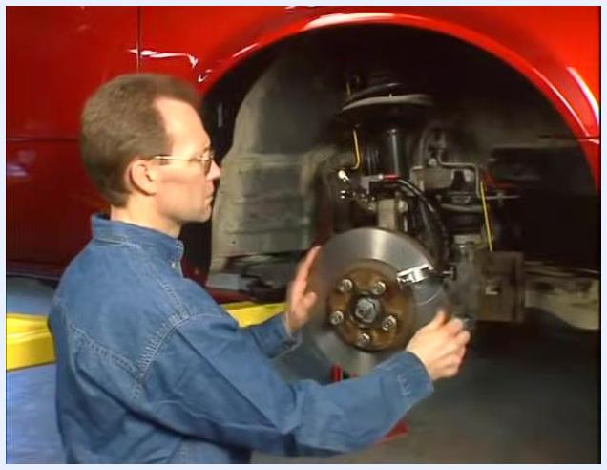
Technician rotating the brake rotor by hand while observing the dial indicator to find the high spot.

Step 12: Record the high spot reading
Stop rotating the rotor when the dial indicator needle reaches its highest reading. The location where the needle contacts the rotor at this point is the exact high spot.
Technician closely monitoring the dial indicator as the rotor is rotated to the high spot.

Step 13: Prepare for correction
Recognize that lateral runout exceeding specification will require correction using brake align correction plates. Identify and prepare the appropriate correction plate for the next steps.
Close-up of a brake align correction plate with multiple bolt holes, ready for use.

Step 14: Mark the high spot on the rotor and wheel stud
Using the supplied marker, mark the exact location of the high spot on both the rotor and the closest wheel stud. Marking both points is critical for accurate alignment during correction.

Hand using a marker to mark both the rotor and the nearest wheel stud at the high spot.

Step 15: Bring the high spot to top dead center
Rotate the rotor so that the marked high spot is positioned at the 12 o'clock (top dead center) position. This orientation assists in the installation of the correction plate.
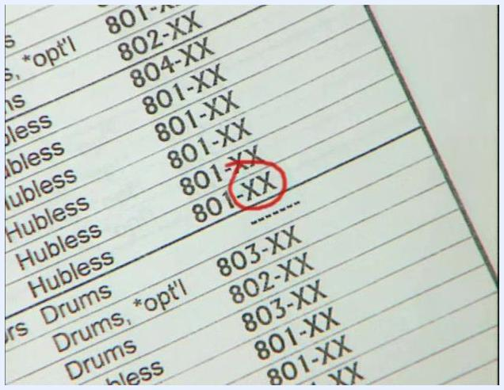
Rotor with a visible mark at the top dead center position, ready for correction plate installation.

Step 16: Consult the brake align application chart
Locate the year and model of the vehicle you are servicing in the brake align application chart. For a 1999 Cadillac Seville STS, the chart identifies that an 801 correction plate is required.
Finger pointing to the '99–'00 Seville entry in the brake align application chart.

Step 17: Identify the correct correction plate part number
Note that the correction plate part number includes "XX," which specifies the amount of taper or correction needed. Refer to the chart to determine the exact part number for your application.
Correction plate part number 801-XX circled in the application chart, indicating the need to select the correct taper.

Verification and summary
By following this procedure, you will have securely attached the dial indicator, measured lateral runout at the low and high spots of the rotor, marked the high spot on both the rotor and the nearest wheel stud, and identified the correct correction plate for your vehicle application.

What's next
Proceed to install the correction plate as specified in the next section of the guide.

