How to Read a Micrometer: Standard Operating Procedure

Purpose
This SOP explains how to read a micrometer accurately, with a focus on the metric outside micrometer that measures to the nearest 0.01 millimeters. It covers identifying the tool's parts, reading the barrel scale, reading the thimble scale, and combining both readings into a final measurement. Following this procedure will help you take precise measurements with confidence.
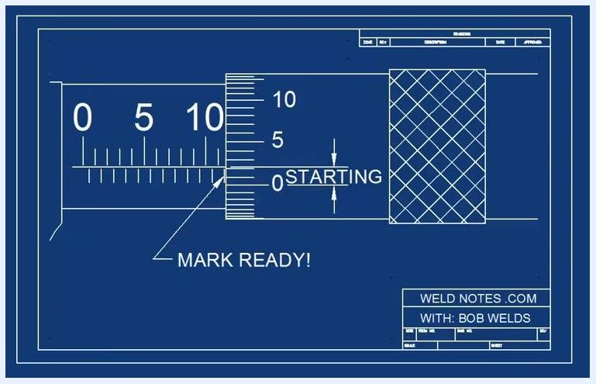
A blueprint-style drawing of a stick figure and a dog, with the text 'WELD NOTES .COM WITH: BOB WELDS' in the corner.

Scope
This procedure applies to metric micrometers marked 0-25mm 0.01mm. Micrometers also come in other forms — inside micrometers, outside micrometers, depth micrometers, and inch-based versions — but this SOP addresses only the metric outside micrometer.

Required equipment
- A metric micrometer with a 0-25mm 0.01mm range and precision marking
- A part or object to measure (for practical application)

Procedure

- Understand the purpose of the micrometer
Recognize that a micrometer is a precision measuring tool. This guide covers a metric micrometer that measures down to 0.01 millimeters, as indicated by the 0-25mm 0.01mm marking on the tool.
- Identify the spindle and the anvil
Locate the spindle, which moves when you turn the knurled thimble, and the anvil, which stays stationary. Turning the knurled section opens or closes the gap between these two parts.
- Locate the barrel scale
Find the barrel scale, the fixed scale on the sleeve of the micrometer. It has two sets of marks: marks above the line represent whole millimeters, and marks below the line represent half-millimeters.
- Locate the thimble
Identify the thimble, the rotating part of the micrometer. The edge of the thimble is the reference point for reading against the barrel scale.
- Read the barrel scale
Align your view with the edge of the thimble and read the number of millimeters and half-millimeters visible to the left of that edge.
- Confirm a first example reading
In this example, the barrel scale reads 12 millimeters. Use the thimble edge as your reference point to verify the value.
- Verify the labeled reading
The barrel scale reading of 12 mm is confirmed and clearly labeled for reference.
- Practice with a second example
Observe another barrel scale reading. In this case, the scale reads 14 millimeters.
- Confirm the second reading
Check that the thimble edge aligns with the 14 mm mark to confirm the reading of 14 millimeters.
- Practice reading a half-millimeter value
Pause and determine the reading before checking. When the thimble edge falls between 11 and 12 with a half-millimeter mark visible, the correct reading is 11.5 millimeters.
- Recognize the half-millimeter mark
The half-millimeter mark sits between the whole millimeter marks on the barrel scale and represents an additional 0.5 mm beyond the last whole millimeter mark.
- Understand the limits of barrel scale precision
The micrometer measures down to 0.01 millimeters, but the barrel scale itself cannot physically display increments that fine — such marks would be too close together to read practically.
- Interpret the half-millimeter mark as a fraction
Each small mark on the barrel scale equals 0.5 millimeters, which can also be written as 1/2 MM.
- Interpret the half-millimeter mark as a decimal
The same half-millimeter value can also be expressed as 0.50 MM.
- Learn the thimble scale
The thimble is divided into 50 marks. As you rotate it, it counts from 1 to 50, and each mark equals 0.01 millimeters — this is where the fine-precision measurement comes from.
- Observe the thimble divisions
Note the multiple horizontal lines around the thimble, which represent its 50 individual divisions.
- See how the thimble aligns with the barrel
The thimble's 50 divisions allow you to read precise values between the half-millimeter marks on the barrel scale.
- Combine the barrel and thimble readings
Start by reading the barrel scale to the left of the thimble edge — in this example, it reads 12 millimeters. The final measurement equals this barrel value plus the value shown on the thimble.
- Calculate the total measurement
The decimal portion of the measurement comes from the thimble scale. In this example, the barrel reads 12 mm and the thimble reads .33, for a total measurement of 12.33 millimeters.
- Practice a trickier example with a half-millimeter mark
First read the barrel scale, noting whether a half-millimeter mark is visible (in this case, 11.5 mm). Then read the thimble scale (in this case, .22). Add the two values together: 11.50 + 0.22 = 11.72 millimeters.
- Confirm the calculation
Double-check your addition. The correct final measurement for this example is 11.72 millimeters.
- Handle high thimble readings near the end of the scale
Since the thimble scale only goes up to 49, a reading near 47 tells you that you are close to the end of a full rotation. Check the thimble's position carefully rather than relying only on whether a mark is visible.
- Caution: do not count a mark that is only barely visible
If a mark is only partially showing and not fully aligned, do not count it. In this example, the display shows 0.47 mm with the mark not fully aligned, meaning it is ending rather than starting.
- Identify which side of zero you are on
Before you have reached zero, confirm you are not mistakenly counting a mark that is not fully aligned. The scale will indicate the mark is ending and not yet ready to count.
- Wait until the mark is fully aligned before counting it
Once a mark is fully aligned with zero, it is ready to be counted. The scale will indicate the mark is starting and ready.
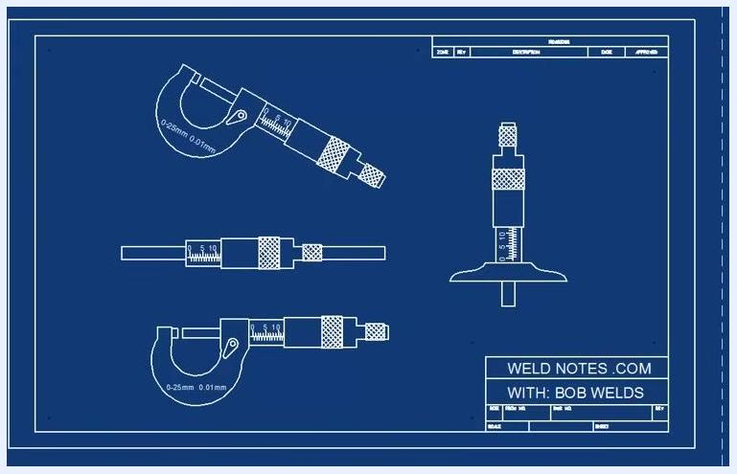
Blueprint diagram showing different types of micrometers, including outside and depth micrometers, all labeled "0-25mm 0.01mm"
Close-up diagram of a micrometer with the spindle and anvil labeled, and the scale visible
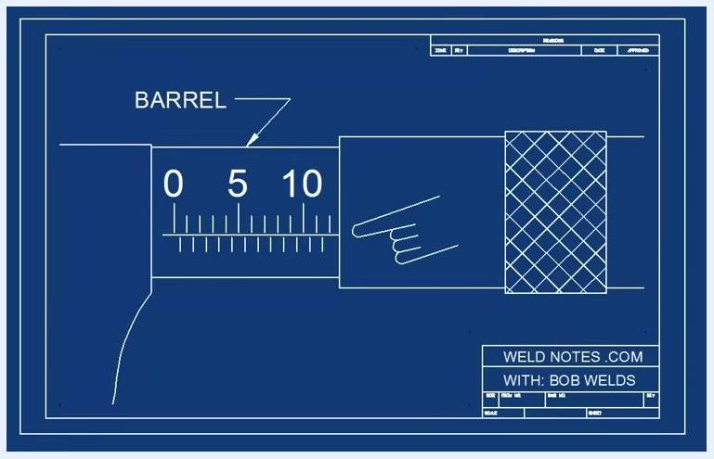
Close-up of the barrel scale with a finger pointing to it, labeled "BARREL"
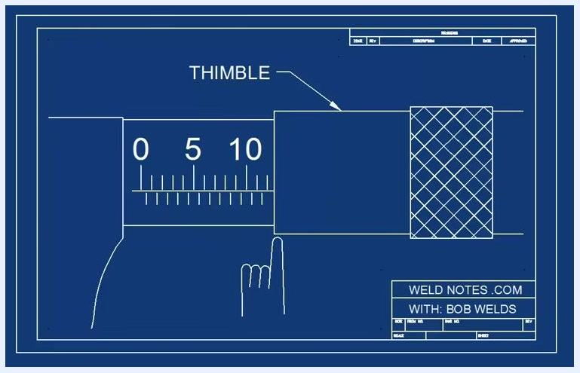
Close-up of the thimble with a finger pointing to it, labeled "THIMBLE"
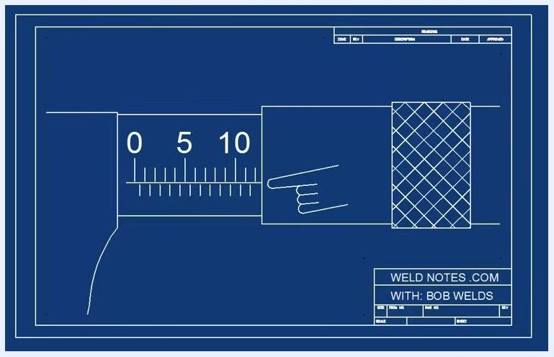
Close-up of the barrel scale with a finger pointing to the reading position
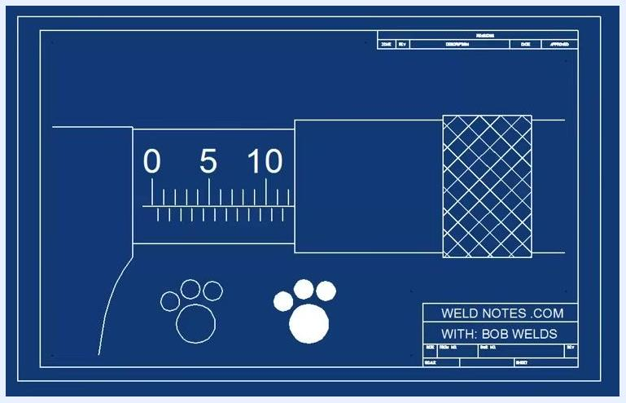
Barrel scale with a pointer indicating a reading of 12 millimeters
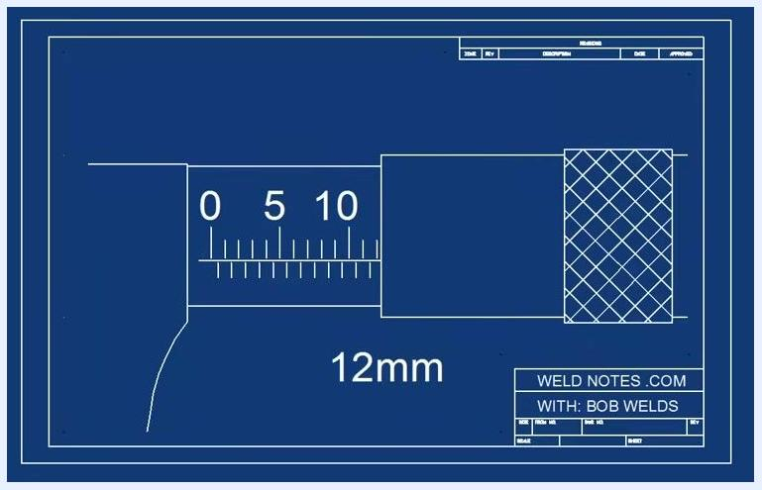
Barrel scale with "12mm" clearly labeled as the reading
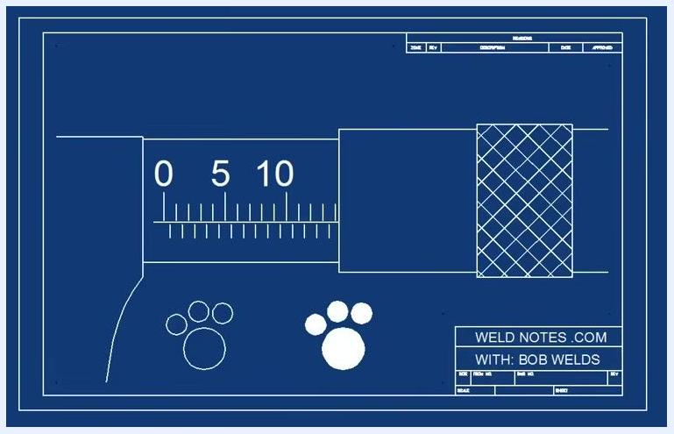
Barrel scale with a pointer indicating a reading of 14 millimeters
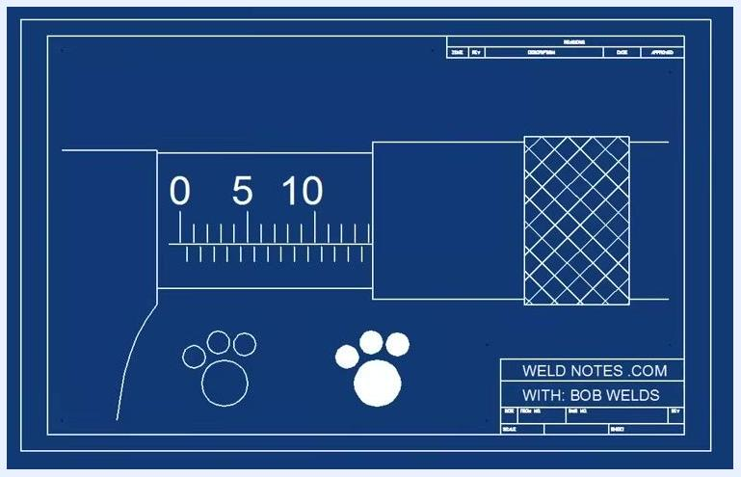
Barrel scale with pointer confirming a reading of 14 millimeters
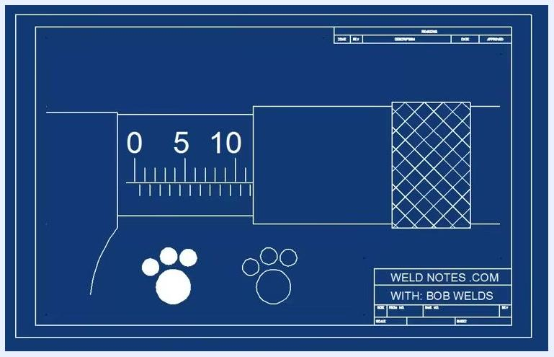
Barrel scale with pointer indicating a reading of 11.5 millimeters
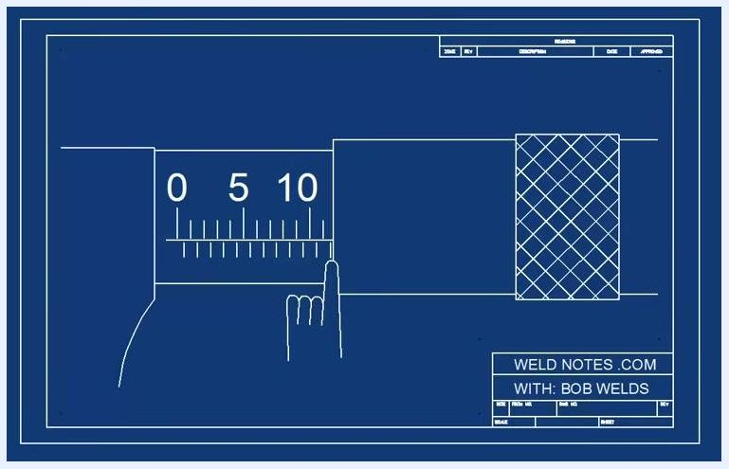
Barrel scale with a finger pointing to the half-millimeter mark
Diagram showing a dense cluster of tiny marks on a scale, illustrating the impracticality of 0.01 mm marks
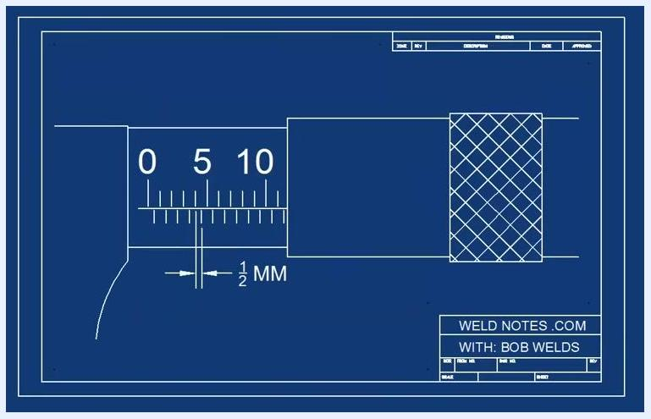
Barrel scale with an arrow and label showing "1/2 MM"
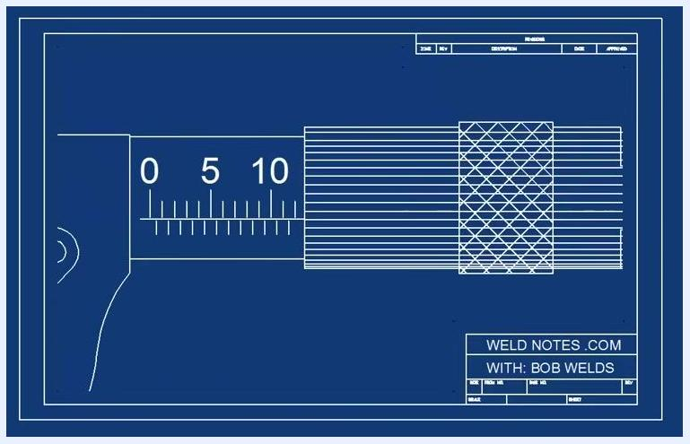
Barrel scale with an arrow and label showing "0.50 MM"
Barrel scale with "0.50 MM" and "FIFTY" labeled
Micrometer with thimble showing multiple horizontal lines, illustrating thimble divisions
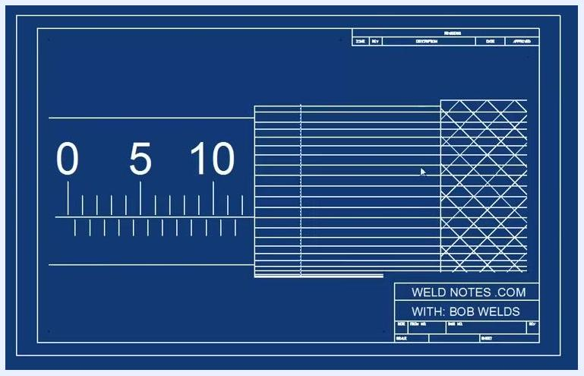
Micrometer with thimble and barrel, showing alignment of thimble divisions with barrel scale
Close-up of micrometer showing barrel at 12 mm and thimble scale with numbers 30, 35, 40
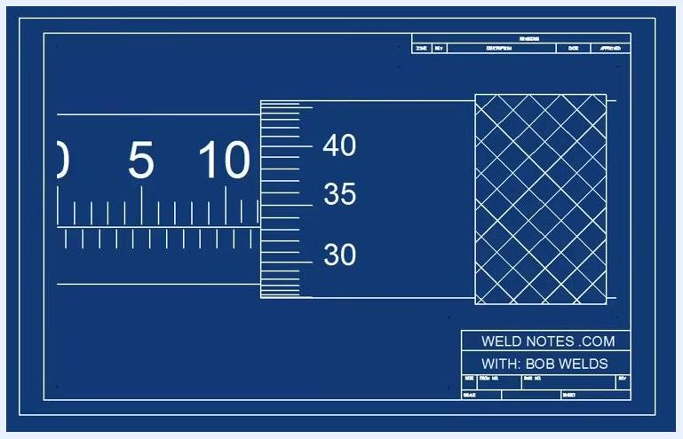
Micrometer diagram showing barrel at 12 mm and thimble at 33
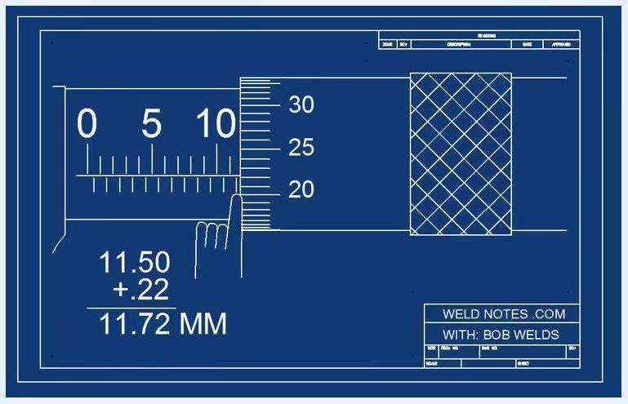
Micrometer diagram showing barrel at 11.5 mm, thimble at 22, and calculation breakdown
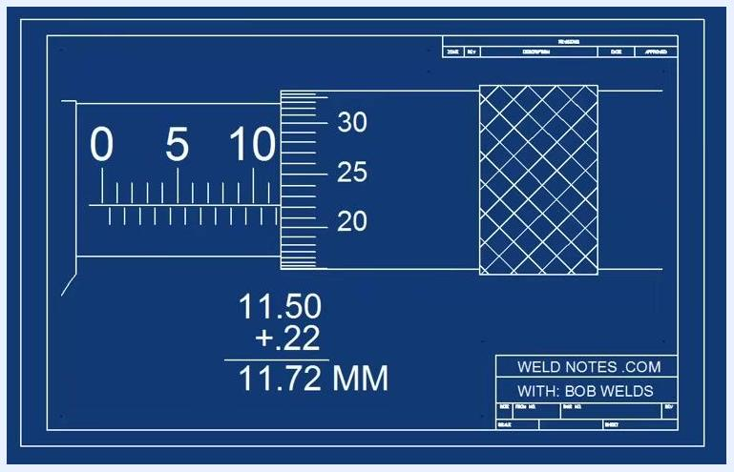
Micrometer diagram with calculation 11.50 + .22 = 11.72 MM
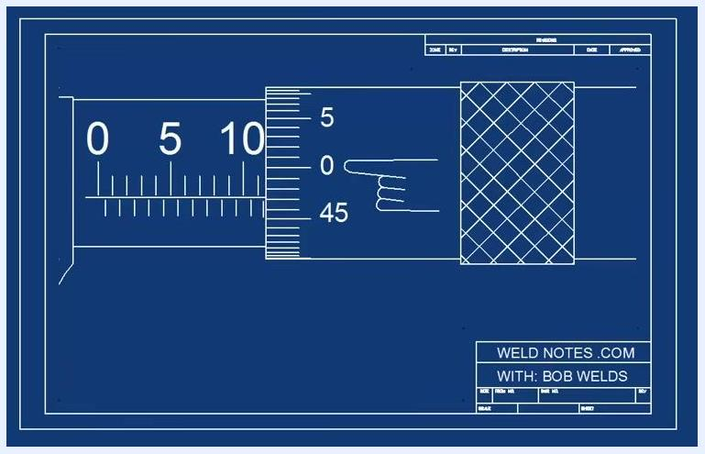
Micrometer diagram with finger pointing to barrel and thimble at 47
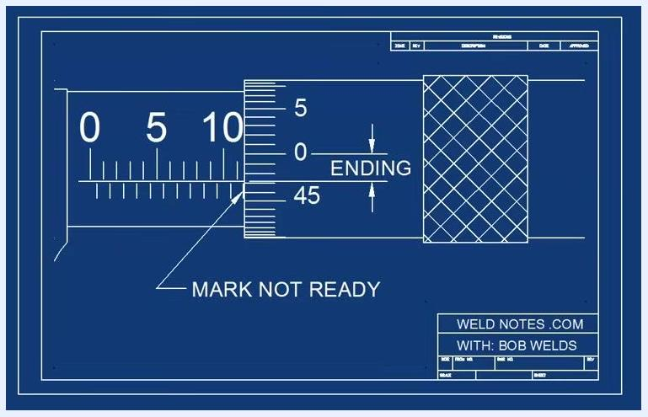
Diagram showing a measurement scale and vernier scale labeled "ending" and "mark not ready"
Diagram showing a measurement scale and vernier scale labeled "starting" and "mark ready"

Verification
- Confirm the barrel scale reading (whole and half millimeters) to the left of the thimble edge.
- Confirm the thimble scale reading (0 to 49, in 0.01 mm increments).
- Add the barrel and thimble values together for the final measurement.
- Only count a mark once it is fully aligned and clearly starting — never count a mark that is only partially visible or ending.
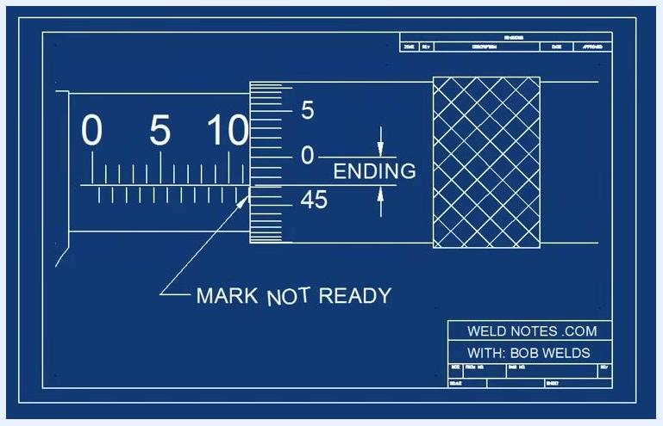
Diagram showing a measurement scale and a vernier scale reading 0.47 MM, with a hand pointing to an incomplete alignment labeled "mark not ready"

What's next
Continue practicing with different barrel and thimble readings, including examples with half-millimeter marks and readings near the end of the thimble scale, to build confidence and accuracy in reading a micrometer.
Blueprint-style diagram showing a micrometer labeled "HOW TO READ A METRIC MICROMETER", with "0-25mm 0.01mm" and "WELD NOTES .COM WITH: BOB WELDS"
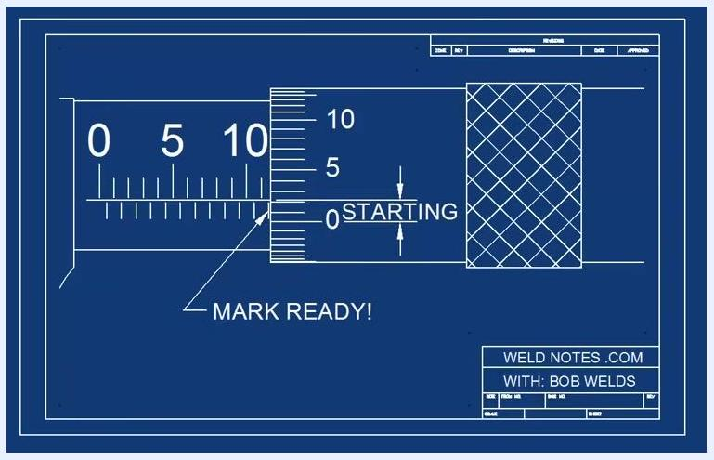
A blueprint-style screen with a dog illustration, a legal disclaimer, and the license 'CCL-BY-SA' displayed.

