Lockout Tagout (LOTO) Procedure

Purpose
This document describes the six-step lockout tagout (LOTO) process used to safely de-energize, isolate, and re-energize machinery or equipment before servicing or maintenance. Following these steps ensures that hazardous energy sources — electrical, gravitational, mechanical, or stored — are properly controlled to protect all personnel working on or near the equipment.

Scope
This procedure applies to any machine or piece of equipment that must be shut down, isolated, and locked out before service or maintenance work begins. While specific equipment and hazards may vary, every LOTO operation follows the same six essential steps, from initial preparation through final re-energization.
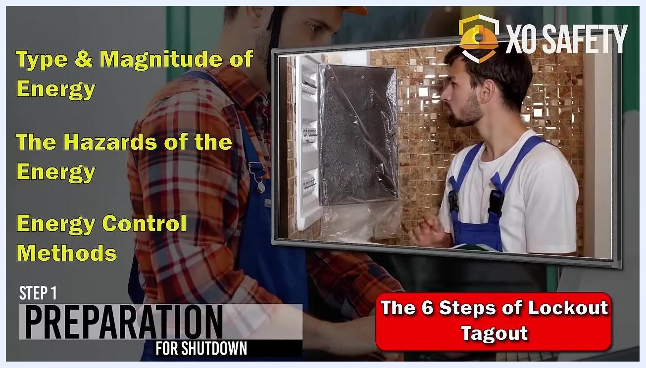
Title screen showing "The Six Steps of Lockout Tagout" with XO Safety logo and lockout tagout icons

Required equipment and PPE
Based on the equipment and personnel shown throughout this procedure, the following items are typically involved:
- Safety gear (as required for the specific work area)
- Hard hat
- Gloves
- Safety glasses
- Lab coat or apron (where applicable)
- Lockout devices and padlocks
- Facility-specific LOTO documentation and equipment manuals
- Clipboard for inspection records

Step-by-step procedure

Step 1: Preparation for shutdown

- Gather information on the machine or equipment.
- Identify the specific machine or equipment to be serviced.
- Collect all relevant documentation, such as manuals or procedures.
- Determine the type and magnitude of hazardous energy present (for example, electrical or gravitational energy).
- Example: For a pump motor, identify electrical energy and gravitational energy from stored fluid in a fermenting tank.
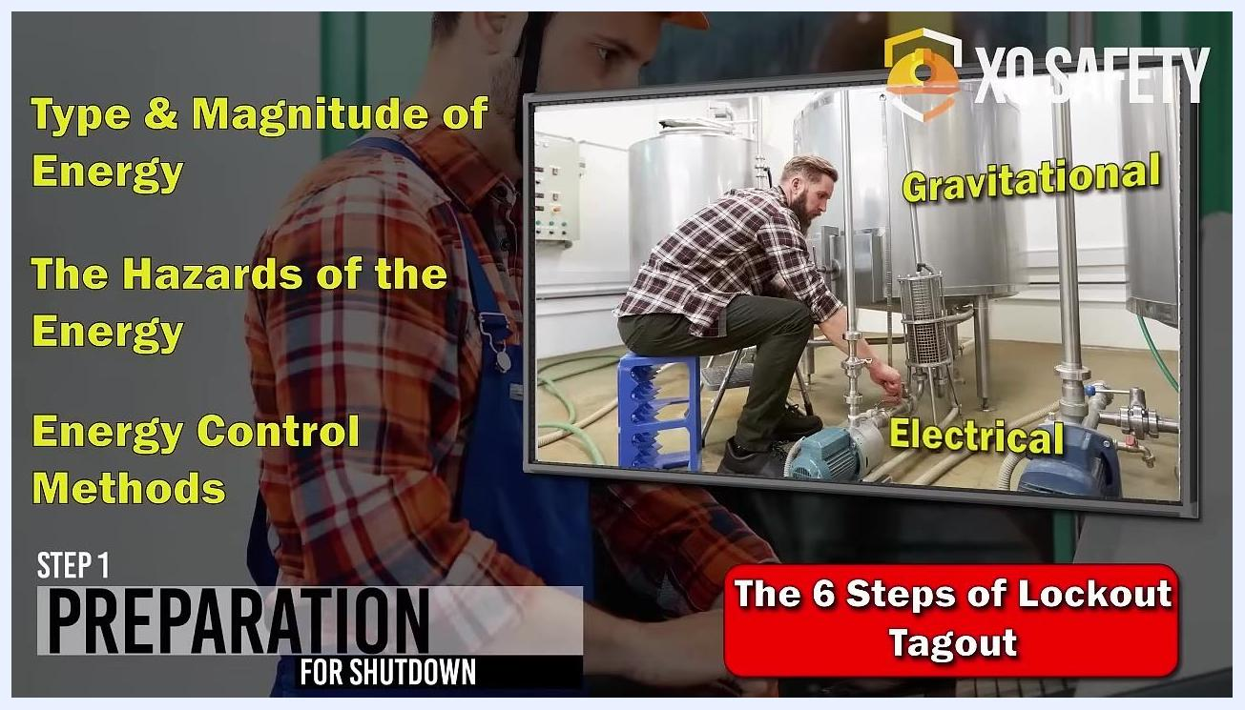
Worker in safety gear reviewing documentation, with overlay text reading "Gathering information on the machine or equipment" and "Step 1: Preparation for Shutdown."
Worker inspecting an electrical panel, with overlay text listing "Type & Magnitude of Energy," "The Hazards of the Energy," and "Energy Control Methods."

- Assess energy hazards and control methods.
- Identify the type and magnitude of energy involved (electrical, gravitational, etc.).
- Identify the hazards associated with each energy type.
- Identify the methods available for controlling each energy source.

- Locate and evaluate energy sources.
- Physically inspect the equipment to confirm all energy sources, such as electrical panels and fluid tanks.
- Example: Identify both gravitational and electrical hazards in a pump system.
Worker inspecting industrial equipment, with tanks and pumps labeled "Gravitational" and "Electrical."

Step 2: Shutdown of equipment

- Shut down the equipment according to procedure.
- Follow the manufacturer's or facility's shutdown procedure for the specific equipment.
- Ensure the shutdown is orderly and controlled to prevent additional hazards.
Worker pressing a shutdown button while another worker in a hard hat monitors the equipment, with overlay text reading "Shutdown must be orderly and safe" and "Step 2: Shutdown of Equipment."

Step 3: Isolation of equipment

- Isolate all hazardous energy sources.
- Operate energy isolating devices, such as circuit breakers or valves, to eliminate hazardous energy.
- Confirm that the device used is specifically designed for energy isolation, not merely for normal operation.
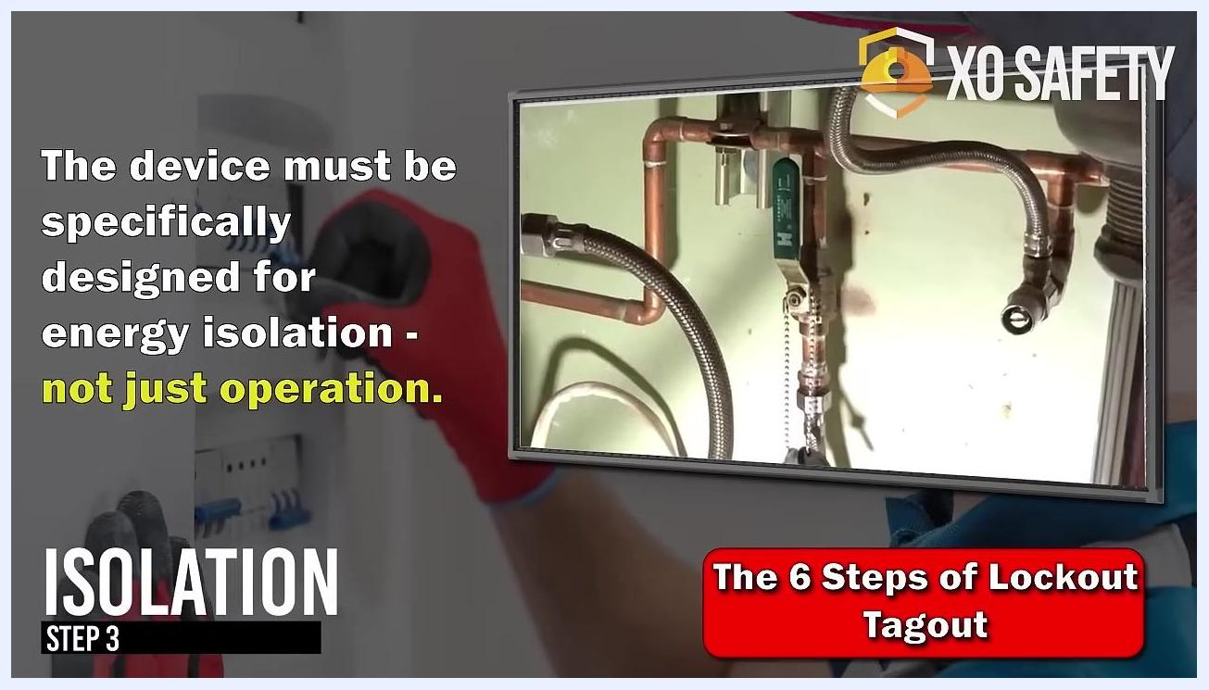
Worker operating an isolation device with a tool, alongside a close-up of a valve and piping. Overlay text reads "The device must be specifically designed for energy isolation — not just operation" and "Step 3: Isolation."

Step 4: Application of lockout tagout devices

- Notify affected employees.
- Inform all affected employees that LOTO devices will be applied to the equipment.
- Notification must occur before the devices are applied.
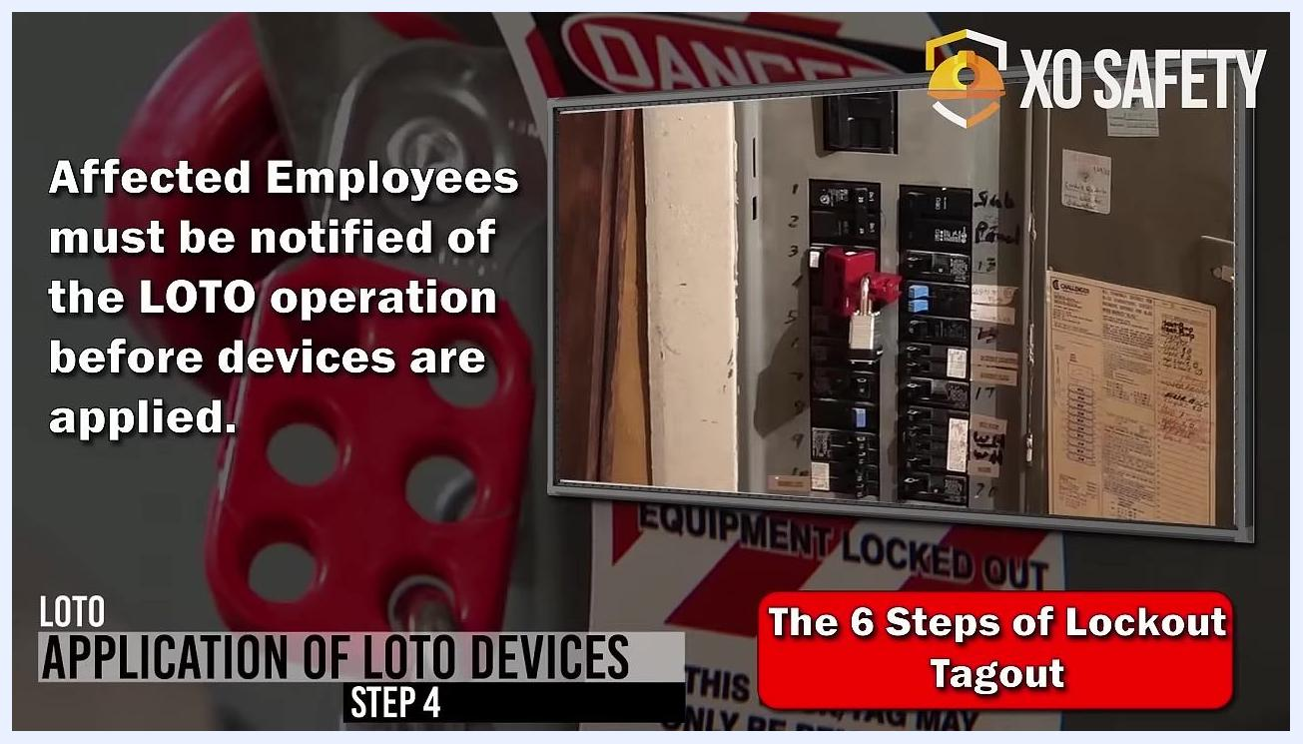
Lockout device and padlock applied to a circuit breaker, with overlay text reading "Affected employees must be notified of the LOTO operation before devices are applied" and "Step 4: Application of LOTO Devices."

- Apply lockout tagout devices.
- Attach lockout devices to energy isolating devices to hold them in the safe or off position.
- Ensure devices are secure and cannot be removed without proper authorization.
Supervisor speaking with employees in a factory setting, with overlay text reading "Affected employees must be notified of the LOTO operation before devices are applied" and "Step 4: Application of LOTO Devices."

Step 5: Removal of stored energy

- Remove residual or stored energy.
- After isolation and application of LOTO devices, eliminate any residual or stored energy in the system.
- Common sources include capacitors, batteries, coils, hydraulic accumulators, and fluid piping systems.
- Mechanical energy sources, such as gears, pulleys, and rotating equipment, must also be addressed.
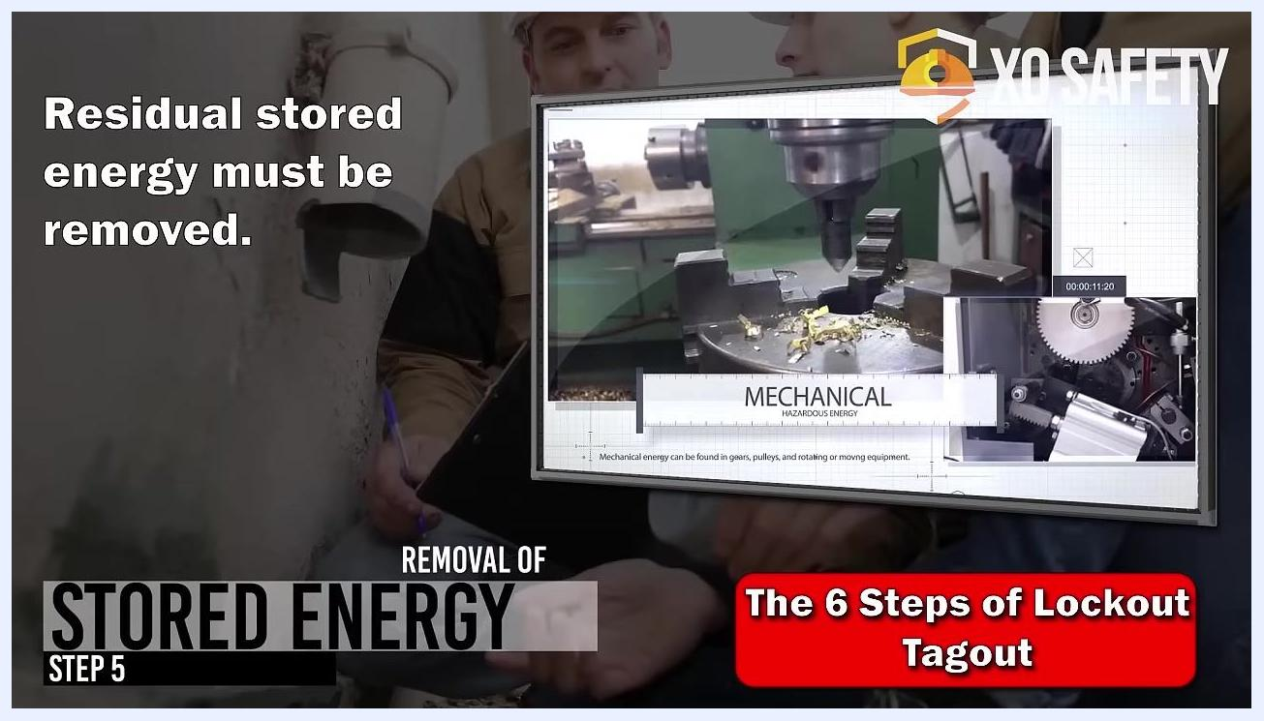
Workers reviewing equipment, with overlay text reading "Residual stored energy must be removed" and "Step 5: Removal of Stored Energy," alongside an inset image of mechanical equipment labeled "Mechanical Hazardous Energy."

- Identify stored energy in the system.
- Recognize that fluid in the piping downstream of the isolation valve may contain hazardous stored energy.
- Common sources of stored energy include capacitors, batteries, coils, accumulators, and piping systems.
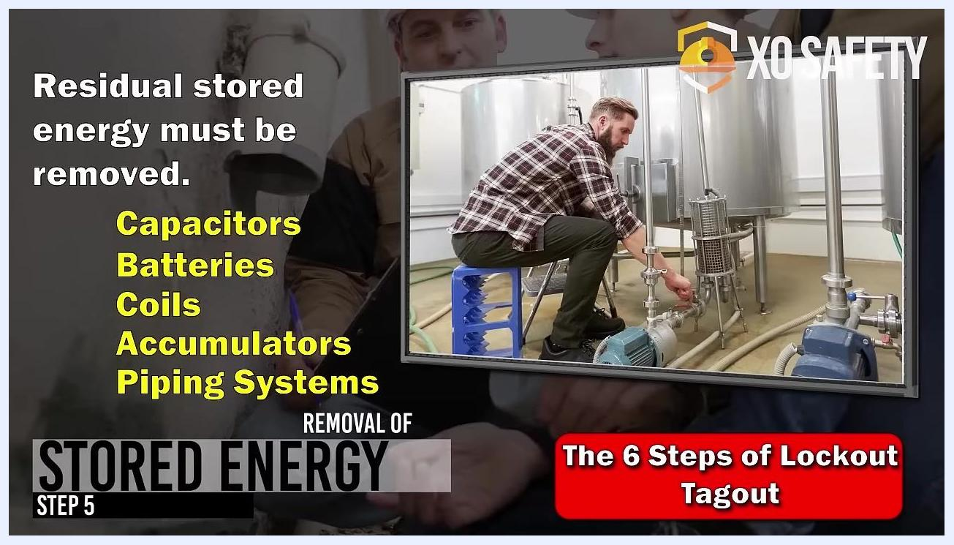
Technician seated on a stool, opening a valve on stainless steel piping connected to tanks and pumps. Overlay text lists types of stored energy and emphasizes their removal.

- Eliminate stored energy.
- Open a downstream valve to drain the piping system and safely release any residual energy.
- Ensure all stored energy is fully removed before proceeding.
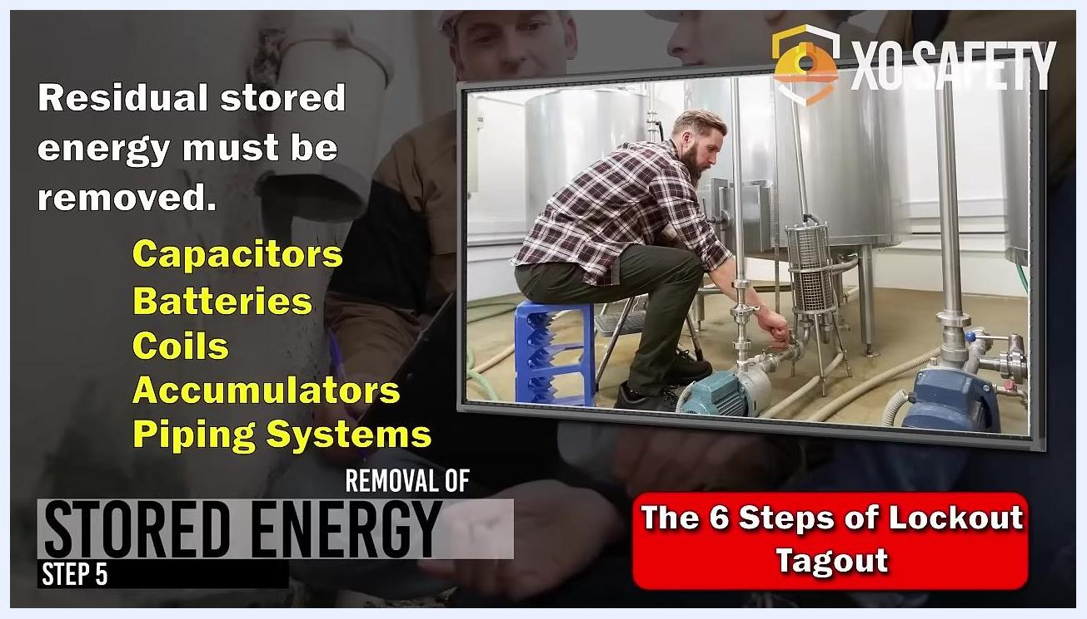
Close-up of a drain or sump with fluid flowing in, indicating that the piping system is being drained. Overlay text lists types of stored energy and emphasizes their removal.

- Verify complete drainage.
- Visually confirm that the piping system has been drained by checking the appropriate drain or sump.

Step 6: Verification of isolation

- Verify isolation before starting work.
- The authorized employee must confirm that all hazardous energy sources are isolated before beginning maintenance or service.
- The most common verification method is attempting to start the equipment using the normal control switch.
- In some cases, verification may require electrical readings or more complex analysis.
Gloved hand pressing a green control button on an industrial control panel that also includes an emergency stop button. Overlay text reads "Consult the LOTO procedure for isolation verification methods" and "Step 6: Verification of Isolation."

- Use multiple verification methods if needed.
- Attempt to start the pump at the control switch.
- Check the system pressure gauge to ensure no pressure remains.
- Consult your facility's LOTO procedure for the specific verification methods required for your equipment.
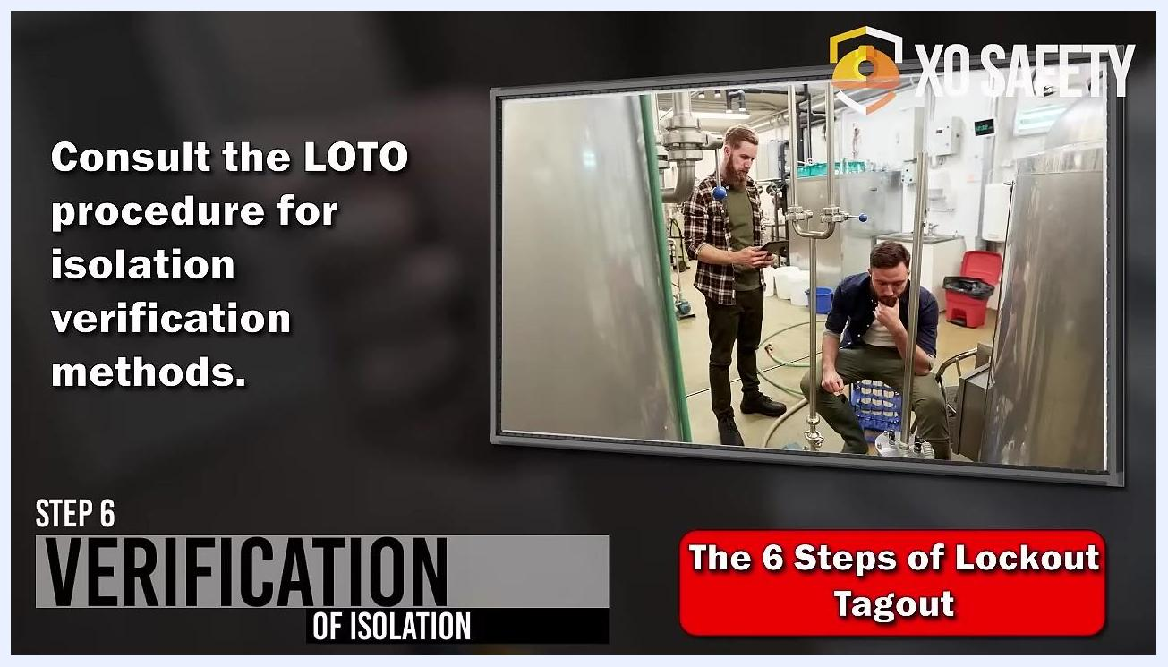
Two technicians in an industrial plant observing equipment and checking gauges or controls. Overlay text reads "Consult the LOTO procedure for isolation verification methods" and "Step 6: Verification of Isolation."

Step 7: Release from lockout tagout

- Inspect the work area before release.
- When work is complete, inspect the work area to ensure all non-essential items have been removed and equipment components are intact.
- Only authorized employees should perform this inspection.
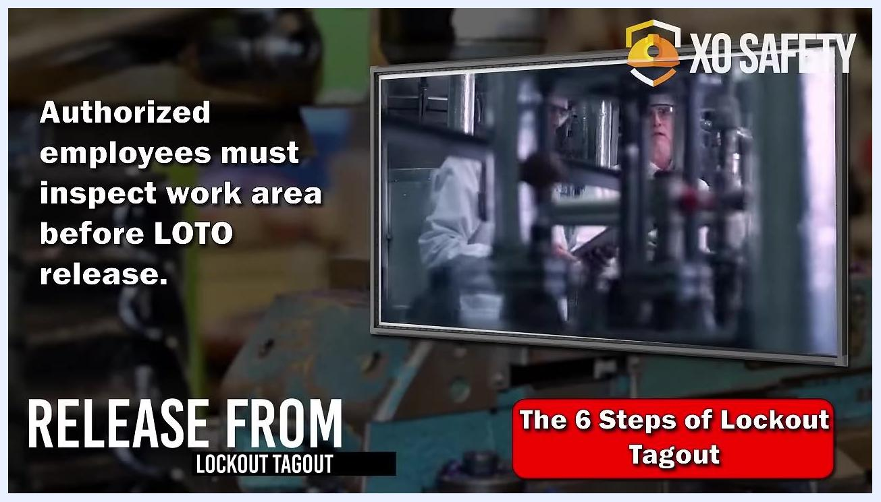
Two employees in aprons, one holding a clipboard, standing in front of industrial tanks and communicating about the upcoming LOTO release. Overlay text reads "Affected employees must be notified of release of LOTO" and "Release from Lockout Tagout."

- Ensure employee safety during release.
- Confirm that all employees are safely positioned or removed from the area before releasing lockout/tagout devices and re-energizing the equipment.

- Notify affected employees of LOTO release.
- Before removing lockout or tagout devices and re-energizing equipment, notify all affected employees that the release is about to occur.

Re-energization

- Prepare for re-energization.
- Confirm that all previous steps have been completed:
- All tools and non-essential items have been removed from the work area.
- All equipment components are intact and properly reassembled.
- All employees are safely positioned or have left the area.
- All affected employees have been notified that re-energization will occur.

Screen reference marking the re-energization step of the procedure.

- Remove lockout/tagout devices.
- Only authorized employees may remove lockout/tagout devices.
- Follow your facility's specific procedures for device removal.

- Restore energy to the equipment.
- Use the appropriate controls or switches to restore power, pressure, or other energy sources to the equipment.
- Monitor the equipment for proper startup and operation.

- Confirm safe operation.
- Observe the equipment to ensure it is functioning correctly and safely after re-energization.
- Be prepared to respond immediately to any abnormal conditions.

Verification and summary
By following these steps — removing stored energy, verifying isolation, inspecting the work area, notifying employees, and safely re-energizing equipment — you ensure a safe and compliant lockout tagout (LOTO) process before servicing or maintaining equipment. Always consult your facility's specific LOTO procedures for additional requirements, and prioritize safety by confirming the area is clear, all employees are informed, and equipment is monitored throughout startup.
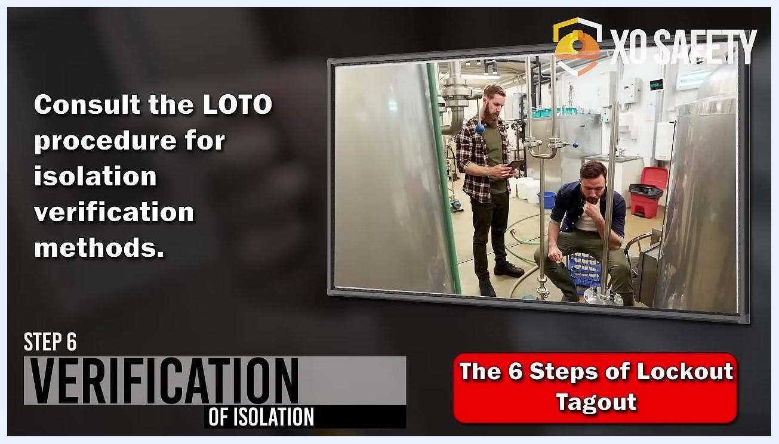
Worker in a lab coat and safety glasses inspecting equipment while holding a clipboard. Overlay text reads "Authorized employees must inspect work area before LOTO release" and "Release from Lockout Tagout."

