Standard Operating Procedure: Understanding Injection Molding Machine Operation

Purpose
This SOP documents the fundamental operating principles of an injection molding machine, based on training material from the Orange Plastics Academy. It covers the machine's core components, the sequential steps of the injection molding cycle, and the key calculations used to determine required clamping pressure. This documentation also explains how material properties and production volume affect project planning.

Scope
This procedure applies to anyone seeking to understand how injection molding machines function, including the injection cycle sequence, clamping pressure requirements, and considerations for planning a production run. It is intended as foundational training content rather than a hands-on operating manual for a specific machine model.

Prerequisites
- Access to the Orange Plastics Academy training material as the reference source.
- Basic familiarity with plastic manufacturing terminology (mold, sprue, cavity, hopper).
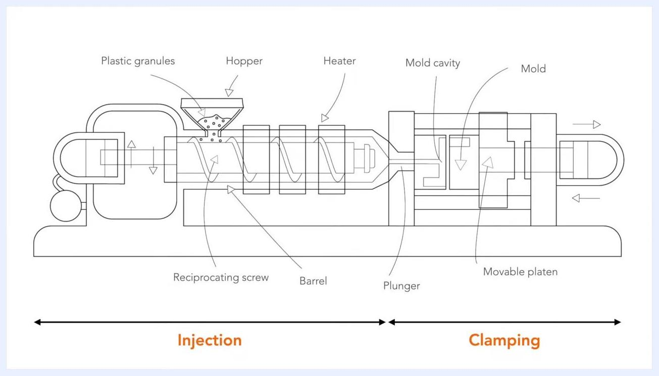
Orange Plastics Academy logo and website URL on an orange background

Step-by-step instructions

1. Understand the basic function of the injection molding machine
An injection molding machine functions as a large-scale press. Its primary role is to hold the mold shut while injecting liquid plastic into the sprue.
Injection molding machine with visible mold and mechanical parts in an industrial setting, with a person in the background

2. Identify the main components of the machine
The machine consists of three general parts:
- Material hopper
- Heating unit
- Injection ram or screw-type plunger
A labeled diagram further identifies the plastic granules, hopper, heater, reciprocating screw, barrel, plunger, mold cavity, mold, and movable platen. The overall process is divided into two phases: Injection and Clamping.
Labeled diagram of an injection molding machine showing the hopper, heater, reciprocating screw, barrel, plunger, mold cavity, mold, movable platen, and process phases

3. Follow the injection molding cycle
Execute the following sequence to produce a plastic part:
Step 1 — Close the mold. The cycle begins when the machine closes the mold.
Injection molding machine with the mold in the closed position, showing pipes, control panels, and the surrounding workspace
Step 2 — Inject the liquid polymer into the mold cavity.
Step 2: Injecting polymer into the mold cavity, diagram of the injection molding machine with the mold cavity highlighted
Step 3 — Maintain holding pressure after the cavity is filled. This step is essential to compensate for material shrinkage.

 | Note: Sufficient holding pressure must be maintained at this stage; inadequate pressure can lead to defects caused by material shrinkage.
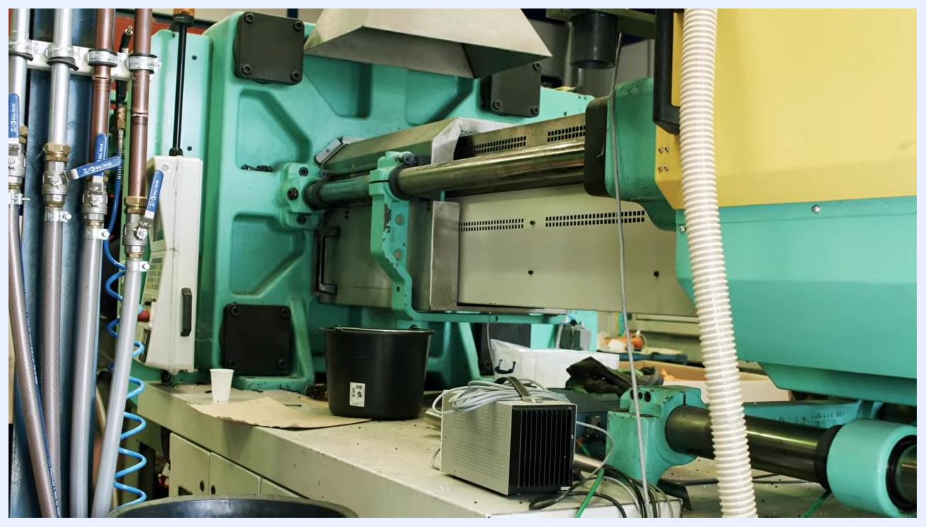
Step 3: Maintaining holding pressure, diagram of the injection molding machine with the pressure zone highlighted
Step 4 — Prepare the next shot. The screw turns and retracts as the next shot is prepared. (This step is described in the source narration but is not visually depicted in the available frames.)
Step 5 — Open the mold and repeat. Once cooling is complete, the mold opens and the ejector rod pushes the ejector plate up to prepare for the next shot. The cycle then repeats.
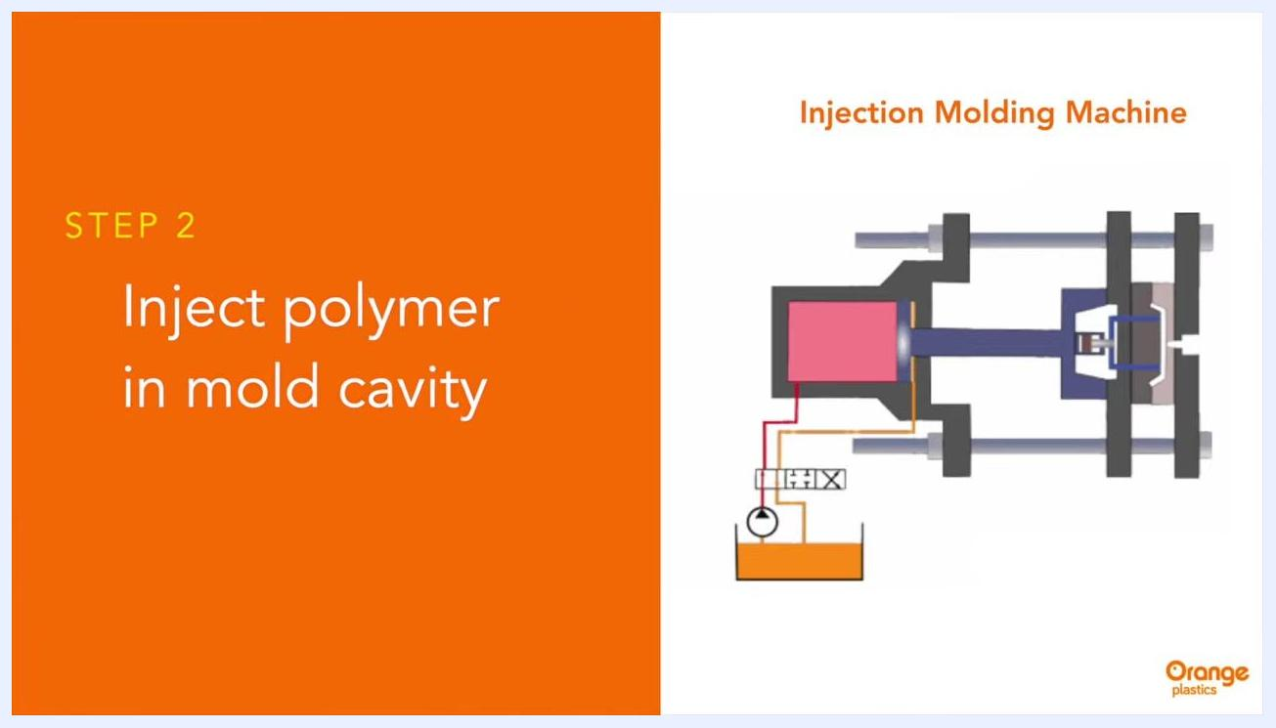
Step 5: Opening and repeating, diagram of the injection molding machine with the mold open and the ejector mechanism highlighted
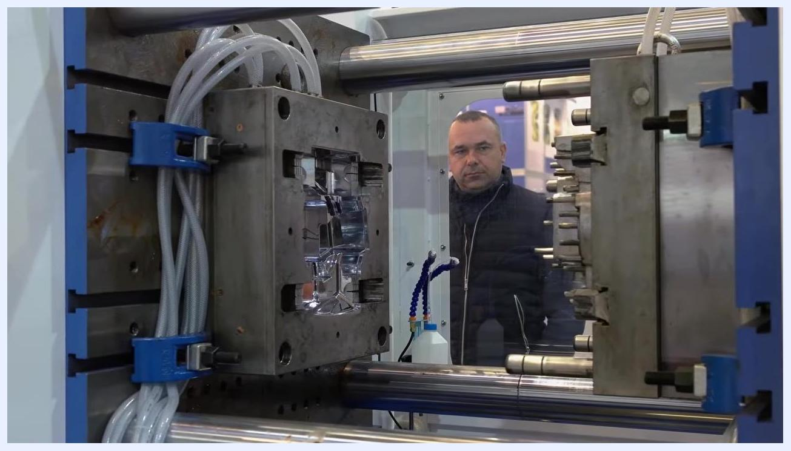
Step 5: Opening and repeating, diagram of the injection molding machine with the mold open

4. Understand differences between injection molding machines
The main difference between machines lies in the amount of clamping pressure they can apply. Clamping pressure keeps the mold closed during injection.

Safety/Quality Note: Machines range from 5 tons to over 3,000 tons of clamping pressure. The clamping pressure must always be sufficient to keep the mold closed; insufficient pressure will result in production problems.
Two green ENGEL injection molding machines in a factory, labeled with numbers and control panels, with a conveyor system visible
Close-up of an injection mold with hoses and a person observing, illustrating the importance of proper mold clamping

5. Determine the required clamping pressure
Calculate the required clamping pressure using the projected area of the custom part:
- Multiply the surface area of the part (in square inches) by 2.5.
- Add a 10% safety factor to the result.
Example: For a part with a projected area of 20 square inches:
- 20 × 2.5 = 50
- 50 + (10% of 50) = 55 tons of required clamping pressure.
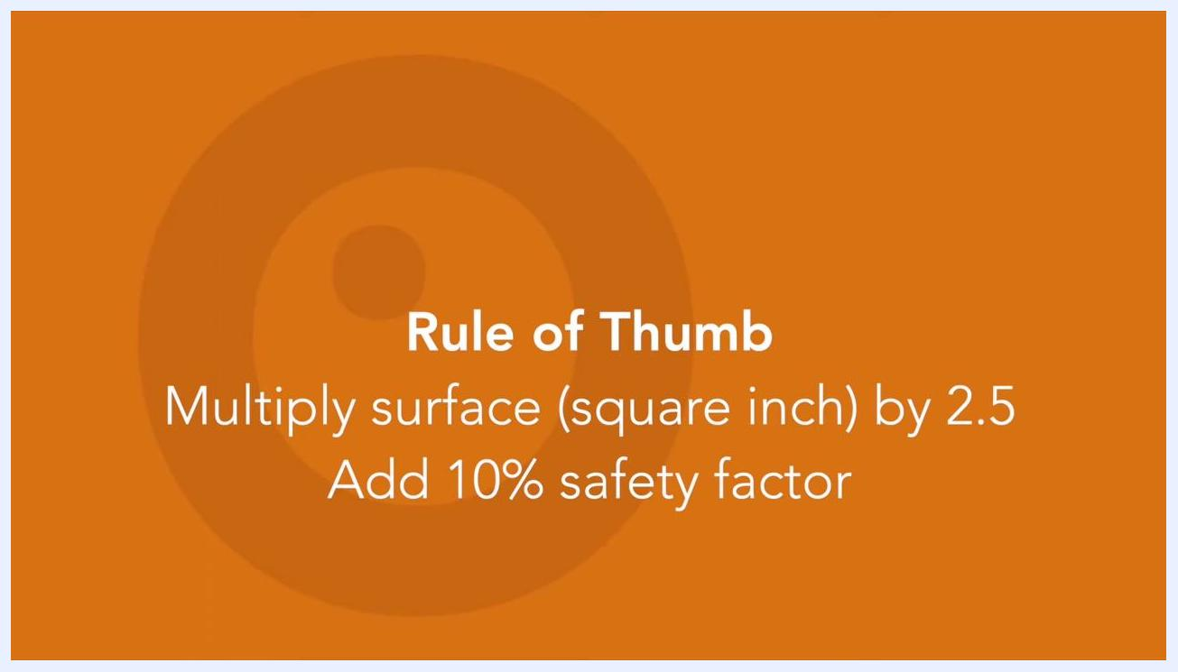
Orange background with text: "Rule of Thumb. Multiply surface (square inch) by 2.5. Add 10% safety factor"

6. Consider raw material properties
The type of plastic material significantly affects the required injection pressure. Materials that are very stiff or highly viscous require more injection pressure to fill the mold successfully.
Orange background with text: "High viscous products require more pressure"

7. Understand the economics of production volume
Injection molding is best suited for manufacturing large volumes of identical products at high speed. While the initial mold investment is substantial, the average cost per product decreases as production volume increases.
Modern injection molding companies can now efficiently handle low-volume production runs. It is possible to start a project with as few as 1,000 units, rather than requiring millions of units to break even. Your injection molding partner will help select the optimal mold, design, and material for your required production volume.
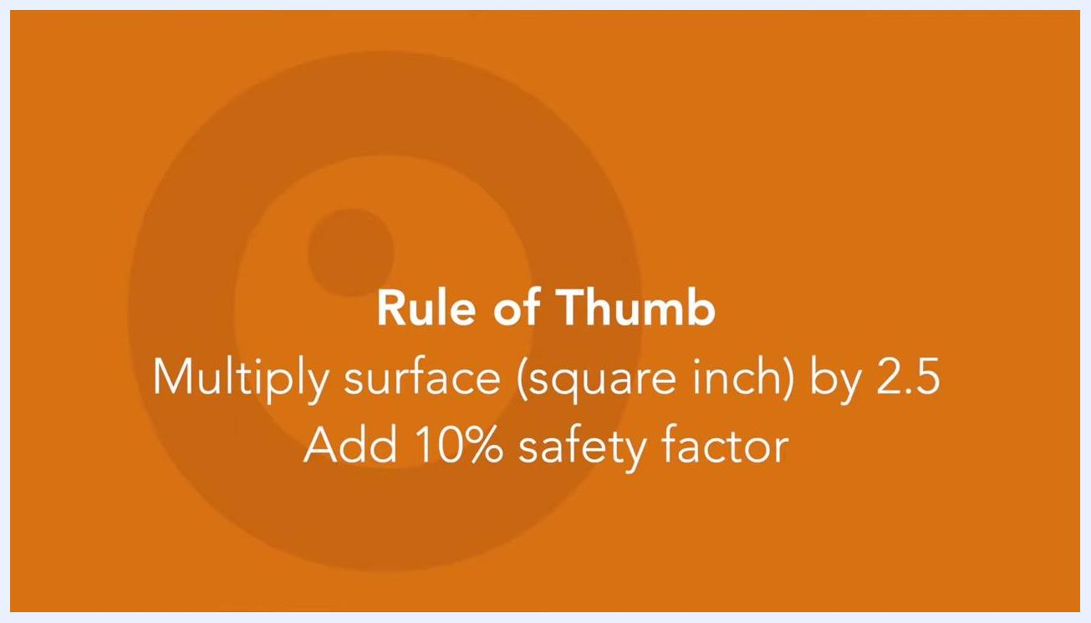
Close-up of the injection molding machine with blue hoses, bolts, and mechanical parts, with a blurred person in the background

ENGEL injection molding machine with control panel and conveyor system in a factory setting

ENGEL injection molding machine with a conveyor leading to a box labeled "Orange plastics" in a warehouse

8. Leverage expert support
Rely on your injection molding partner to help select the proper mold, design, and material tailored to your production needs.
Orange Plastics logo with the tagline "Your Partner in Injection Molding"
Orange Plastics logo, tagline "Your Partner in Injection Molding," and website URL www.orangeplastics.com

Verification and summary
By following this procedure, you will understand:
- The structure and main components of an injection molding machine.
- The five-step sequence of the injection molding cycle (close mold, inject, hold pressure, prepare next shot, open and repeat).
- How to calculate the required clamping pressure using the surface area rule of thumb, including the 10% safety factor.
- How material viscosity affects required injection pressure.
- How production volume and mold investment relate to per-unit cost, and how a molding partner supports mold, design, and material selection.

What's next
Consult your injection molding partner to apply these principles to your specific part design, target production volume, and material selection.

