MIG Welding Basics and Technique: Standard Operating Procedure

Purpose
This SOP provides a structured procedure for setting up MIG welding equipment and developing proper welding technique. It covers machine setup, grounding, material preparation, and the three key technique variables — stick out (distance), gun angle, and movement — that determine weld quality. Following this procedure will help you build the muscle memory needed for consistent, high-quality MIG welds.

Scope
This procedure applies to anyone performing MIG welding, from beginners setting up their first machine to welders looking to refine technique through structured practice. It covers welding setup, dry-run practice, angle control, travel speed, weaving techniques, and identification of common weld defects.

Required equipment and materials
- MIG welder (e.g., 115 Volt Wire Welder) with a settings chart
- Solid wire for MIG welding
- Shielding gas: 75% argon / 25% CO2 blend, or straight CO2 (aluminum cylinders, such as those used for soda fountains, are a cost-effective option for straight CO2)
- Ground (work clamp)
- Welding table with a solid ground connection
- Clean base material
- Practice plates for dry runs and technique comparison
- Safety equipment: fire extinguishers and properly stored gas cylinders in the welding area

Procedure

Step 1: Understand the three key focus areas
Focus on only three main aspects of your welding technique to achieve good results: stick out (distance), gun angle, and movement. Break down each aspect and concentrate on one at a time for effective learning.

Step 2: Prepare your welding setup
Use solid wire for MIG welding. Set your shielding gas to a blend of 75% argon and 25% CO2, or alternatively use straight CO2 — aluminum cylinders (such as those used for soda fountains) can be a cost-effective option. The argon/CO2 blend is slightly better but not essential for beginners.

Step 3: Ensure proper grounding
Attach your ground (work clamp) directly to your material, or ensure a solid connection through the welding table. Safety note: Improper grounding can negatively affect MIG welding performance more than it does with stick or TIG welding.

Step 4: Clean your material
Make sure the material you are welding is clean to ensure a quality weld.

Step 5: Set your machine according to material and wire
Adjust your welder settings based on the thickness of your material and the diameter of your wire, using the settings chart on your machine for guidance. Do not overthink the settings — set them according to the chart and focus on improving your technique first. Fine-tune the settings only after you have mastered the basic technique. For more detailed information on settings, refer to the dedicated video on the creator's channel.
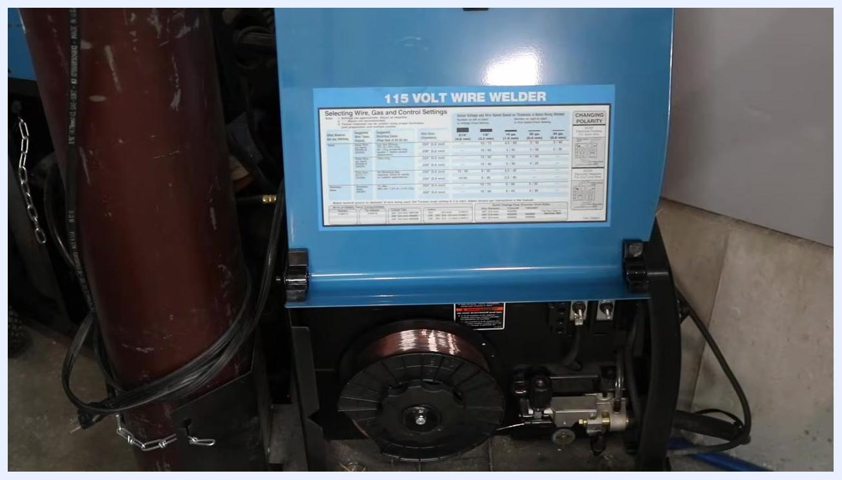
Close-up of a 115 Volt wire welder with the settings chart visible inside the open panel, showing wire, gas, and control settings for different material thicknesses and wire diameters

Step 6: Set the correct stick out (distance)
Monitor your distance from the workpiece, also known as "stick out" — how far the welding wire extends from the contact tip. Maintain a stick out of approximately 3/8 inch to 1/2 inch for most MIG welding applications.
Demonstration of proper stick out distance, showing the welder holding the MIG gun with the wire extending from the contact tip above a metal work table

Step 7: Maintain consistent stick out while welding
As you weld along your joint, keep the stick out consistent. Use your free hand to steady the MIG gun when possible: prop your hand vertically on the work surface and rest the MIG gun or your welding hand on it to stabilize movement. This technique can be adapted for various welding positions and geometries, including overhead or inside corner joints.
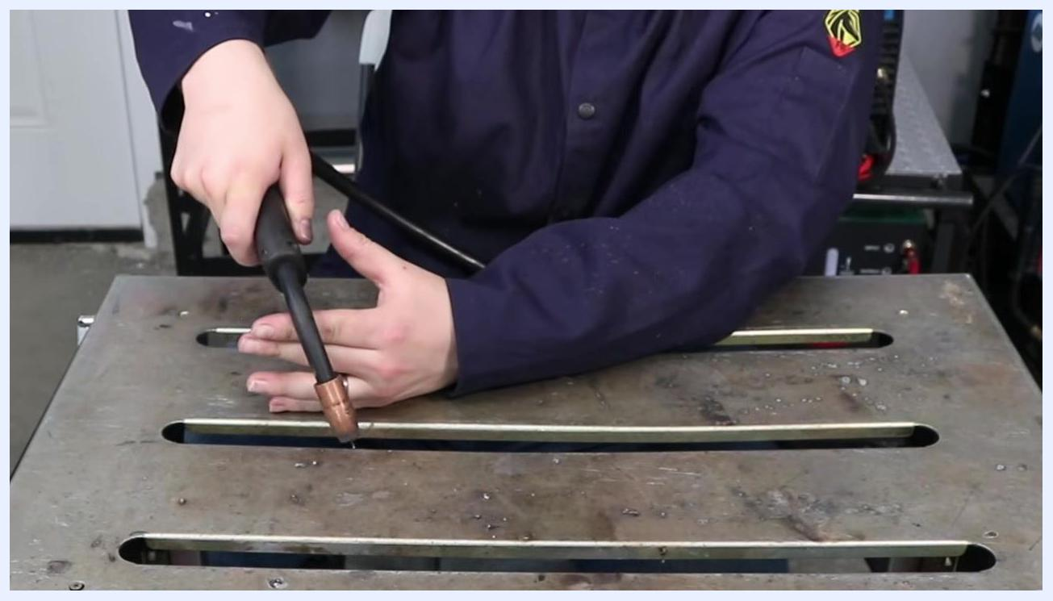
Welder demonstrating how to prop their hand vertically on the work table and use the other hand to guide the MIG gun, maintaining a steady stick out distance along the joint
Note: In some situations, such as welding upside down or in tight spaces, you may not be able to use both hands for support. Adjust your grip and technique as needed to maintain control and stick out.

Step 8: Recognize the effects of incorrect stick out
If the MIG gun is too far from the workpiece, the weld will not run smoothly, the wire acts as a resistor and reduces voltage at the arc, and reduced shielding gas coverage increases the risk of porosity. If the gun is too close, the wire may burn back into the contact tip, welding itself to the tip and causing a mess. Safety/quality note: Always aim for a stick out of approximately 3/8 inch to 1/2 inch.
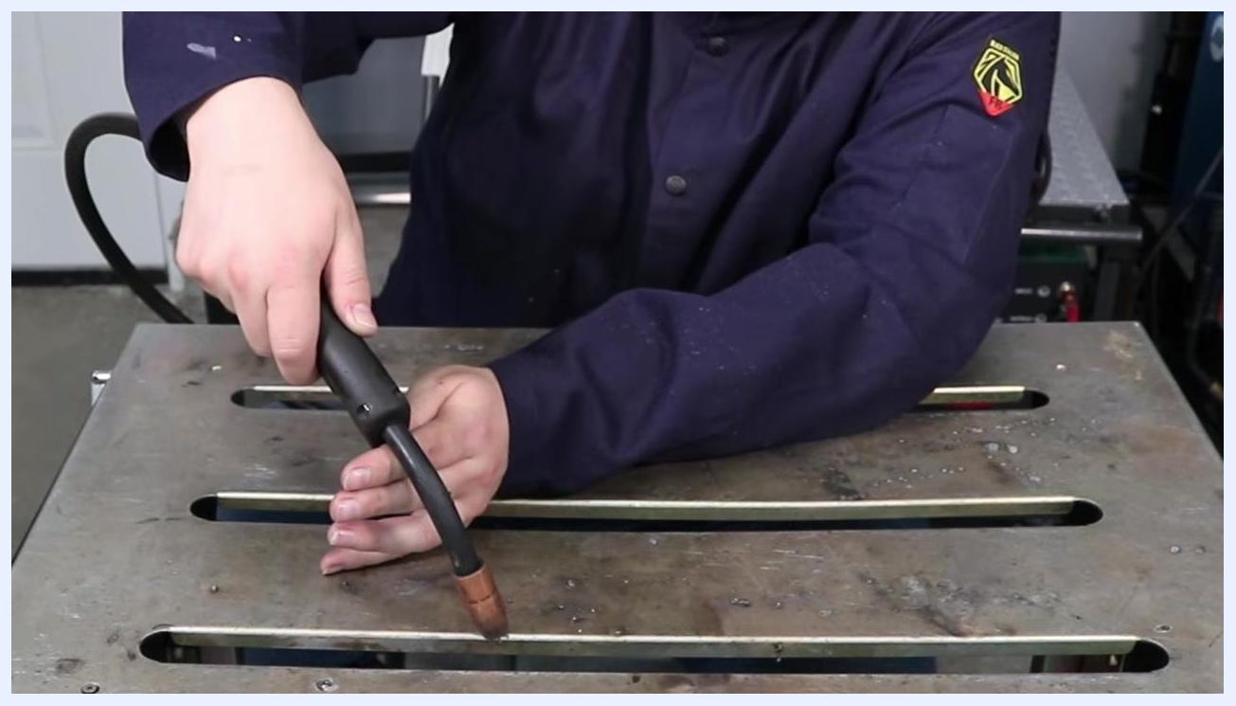
Welder demonstrating the MIG gun held too close to the workpiece, illustrating the risk of burning the wire back into the contact tip

Step 9: Practice stick out with dry runs
Before starting to weld, perform dry runs along your intended weld path without pulling the trigger. Focus on holding the correct distance consistently as you move along the joint. Only begin welding once you are confident you can maintain the proper stick out throughout the weld.
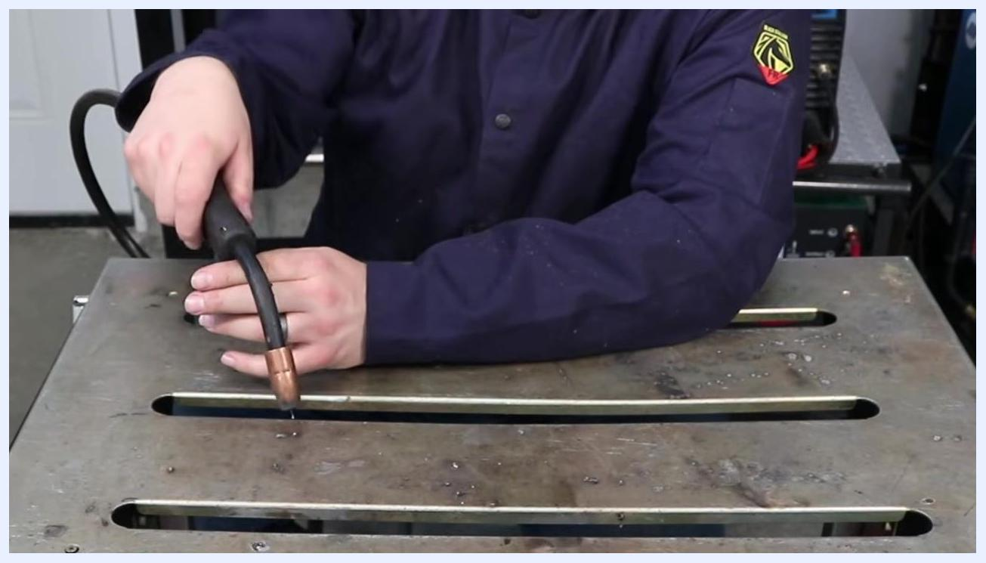
Welder performing a dry run, moving the MIG gun along the joint without activating the trigger to practice maintaining consistent stick out

Step 10: Begin welding and monitor stick out
After practicing with dry runs, start welding and pay close attention to maintaining the correct stick out. Make adjustments as needed to keep your weld quality high.
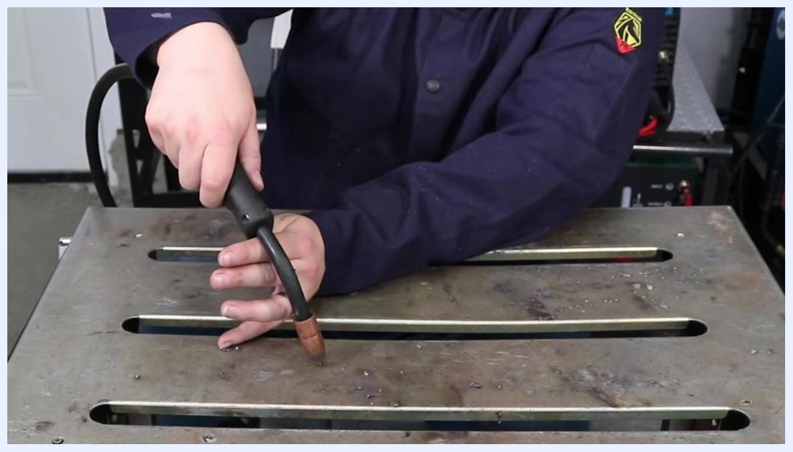
Welder starting to weld, maintaining proper stick out and using their hand for support along the joint

Step 11: Identify and set the work angle
The work angle is the angle of the MIG gun relative to the workpiece, perpendicular to the direction of travel. For a butt joint (two plates side by side), hold the MIG gun straight up and down, perpendicular to the plate. For a T-joint (one plate vertical to another), set the gun at approximately a 45-degree angle to the joint, adjusting slightly as needed while staying close to 45 degrees. Maintain this angle consistently as you weld.
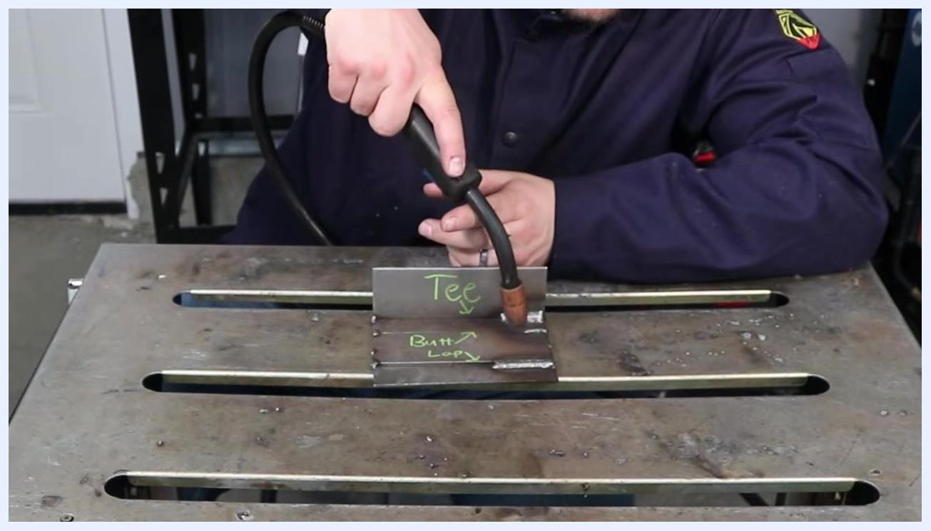
Welder demonstrating the correct work angle for a T-joint, holding the MIG gun at approximately 45 degrees to the joint, with labeled plates "Tee" and "Butt" visible on the work table

Step 12: Set the travel angle
The travel angle is the forward or backward tilt of the MIG gun in the direction of welding. Aim for a travel angle between 10 degrees pushing (gun tilted away from the weld pool) or 10 degrees dragging (gun tilted toward the weld pool). Dragging generally provides more penetration, while pushing is recommended for aluminum to avoid soot. As a beginner, choose whichever technique feels most comfortable.

Step 13: Practice both angles with dry runs
Before welding, perform dry runs along the joint without pulling the trigger. Focus on keeping both the work angle and travel angle steady throughout the movement. Avoid rocking or changing the angle as you move — many beginners unintentionally end up parallel to the plate by the end of the weld. Repeat dry runs until you can confidently maintain both angles from start to finish.
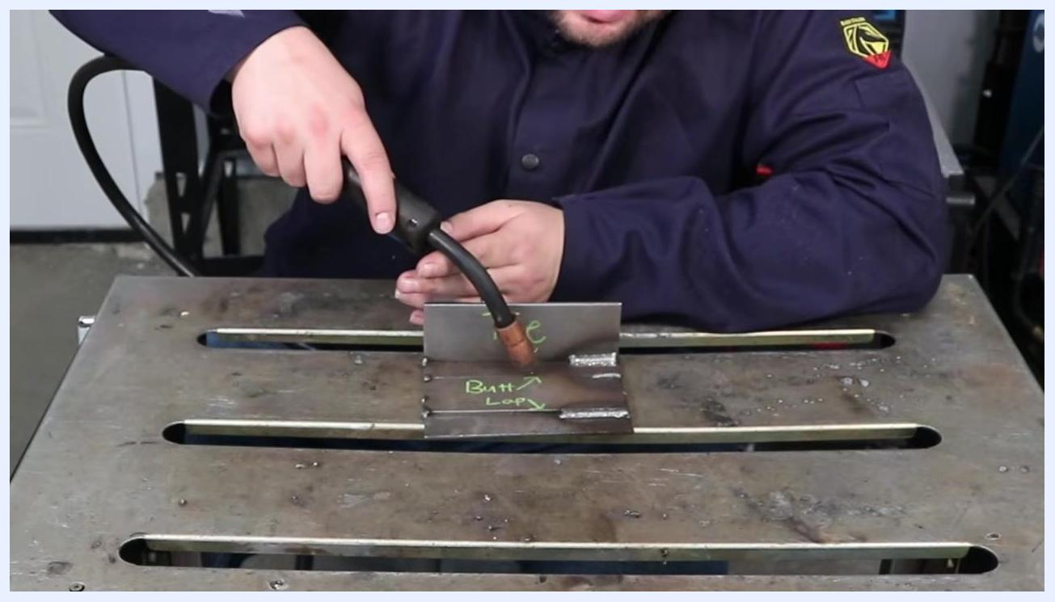
Welder performing a dry run along a T-joint, maintaining both the correct work angle of 45 degrees and a slight push travel angle, with the MIG gun positioned over the labeled plates

Step 14: Verify angle consistency across the entire joint
Ensure you are able to maintain the correct angles all the way across the joint, not just at the start. Continue practicing dry runs until you feel comfortable and consistent.
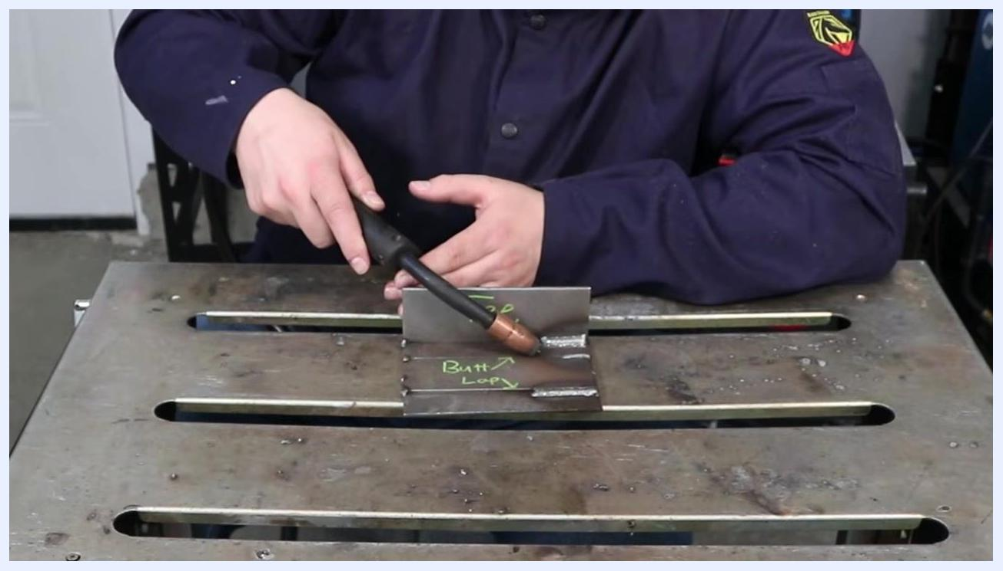
Welder demonstrating the MIG gun at the end of a dry run, showing consistent angle across the T-joint with labeled plates "Tee" and "Butt" visible

Step 15: Practice dry runs on the workbench
Hold the MIG welding gun in your hand and position it over the workpiece without pulling the trigger. Perform dry runs by moving the gun along the intended weld path to practice motion and angles. Repeat this process to build muscle memory and ensure smooth, controlled movements. Reference the labeled metal pieces on the workbench: "Tee" (vertical plate) and "Butt/Loop" (horizontal plate).
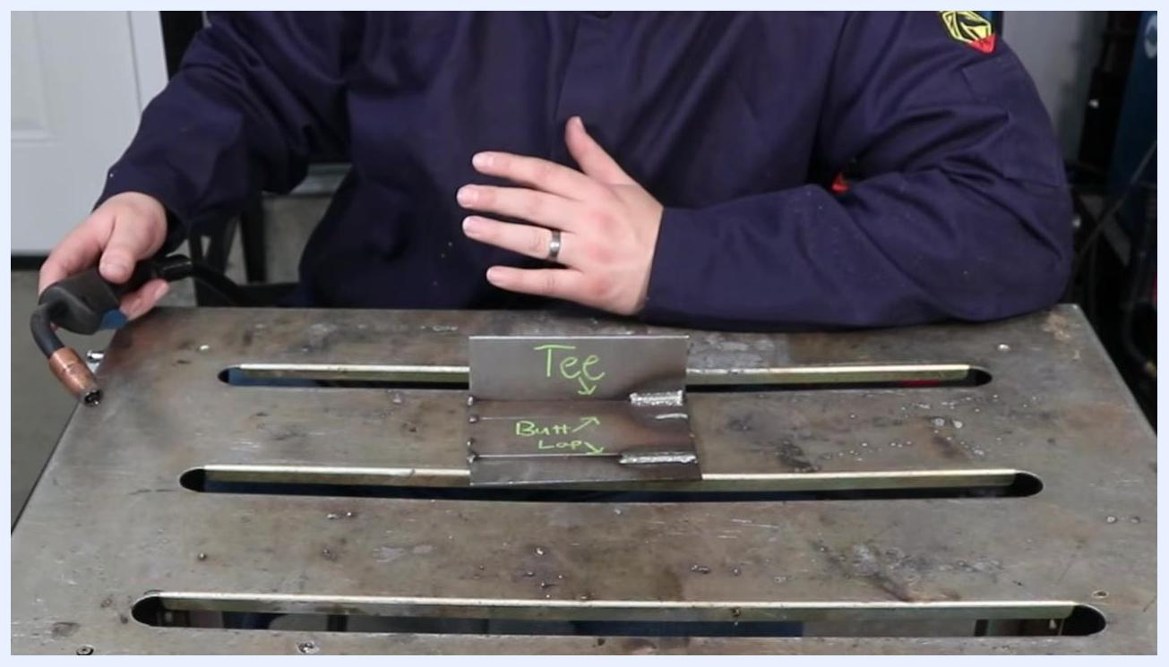
Person in a welding jacket holding a MIG gun above two labeled metal plates, "Tee" and "Butt/Loop," on a metal workbench, demonstrating dry run practice

Step 16: Watch for excessive gun angles
Safety/quality note: Be cautious with your welding gun angles — excessive angles can cause excessive spatter and create a messy weld.
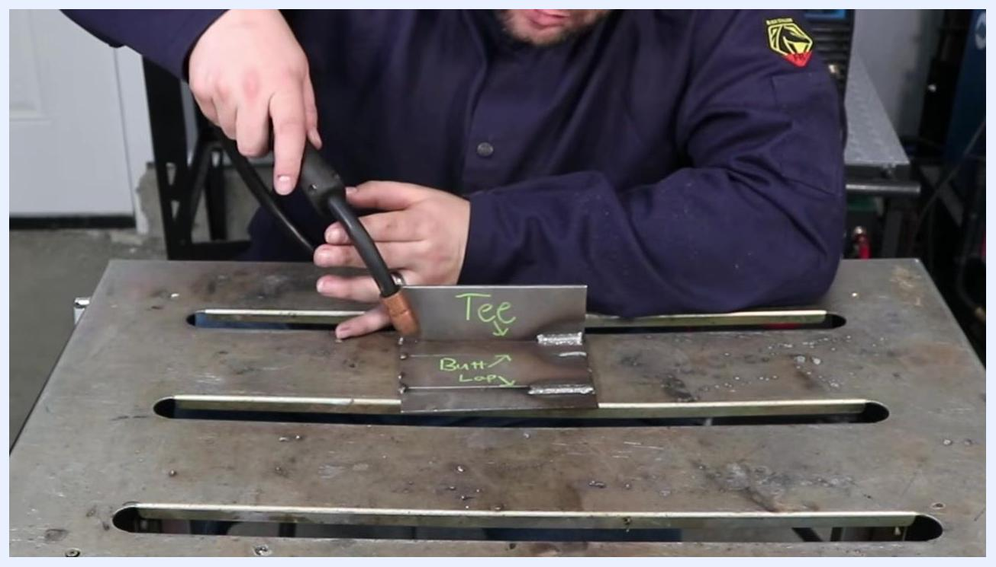
Person demonstrating MIG gun angle toward the "Tee" joint, emphasizing the importance of correct angles to avoid spatter

Step 17: Apply extra care to angle when welding out of position
When welding out of position, such as vertical or overhead, maintaining the correct gun angle becomes even more critical. Incorrect angles can lead to poor weld quality and increased difficulty.
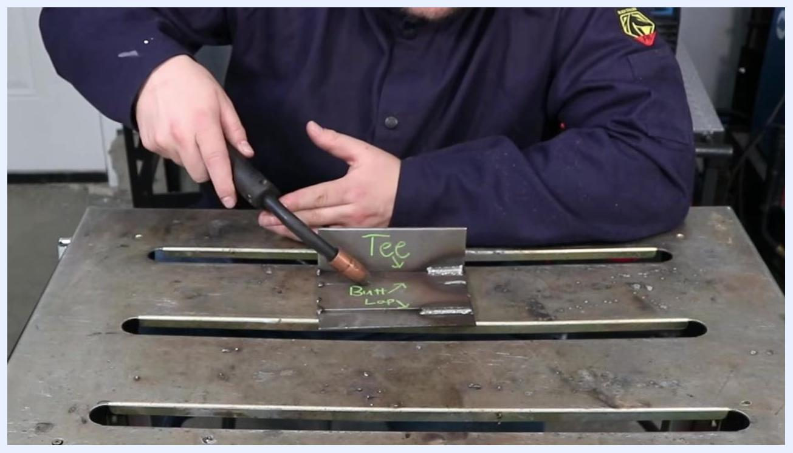
Person holding the MIG gun at an angle over the "Tee" and "Butt/Loop" plates, discussing angle importance in out-of-position welding

Step 18: Adjust gun position for vertical and overhead welding
For vertical or overhead welds, tilt the MIG gun upward slightly to maintain proper control of the weld pool. Pick up and reposition the workpiece as needed to simulate different welding positions.
Person lifting the metal workpiece labeled "Tee" and "Butt/Loop" while holding the MIG gun, preparing to demonstrate vertical/overhead welding

Step 19: Focus on travel speed and motion pattern
Movement consists of two aspects: travel speed (how fast you move the gun along the joint) and the motion pattern you use. Hold the MIG gun steadily and prepare to practice different movement techniques.
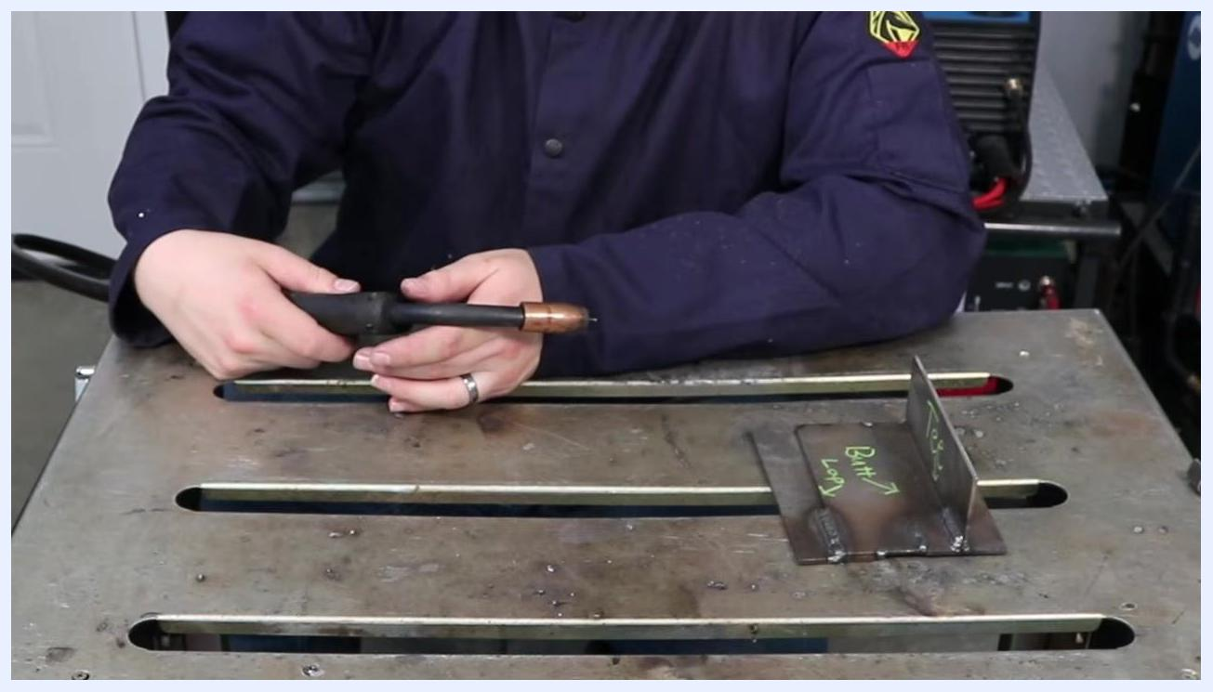
Person holding the MIG gun with both hands, workpiece set up for welding, emphasizing travel speed and movement

Step 20: Monitor your travel speed
Quality note: If you move too slowly, the weld bead will become too wide and may burn through the material. Observe the weld pool closely to maintain a consistent width and avoid excessive penetration.
Close-up of an active welding arc and molten weld pool, illustrating the effect of travel speed on bead width and penetration

Step 21: Experiment with weaving techniques
Try different weaving motions: back-and-forth movement, small curly cues, or a curved weave. Touch the front end of the weld puddle for best results, but avoid excessive side-to-side movement.
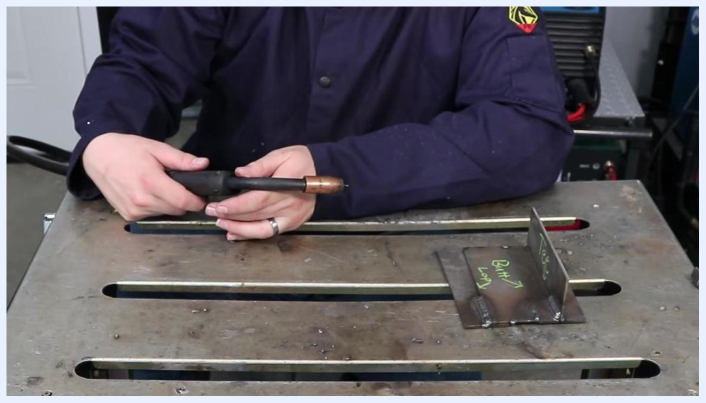
Welding arc with visible blue and yellow light, demonstrating a weaving technique during welding

Step 22: Stay centered on the joint
Keep the welding arc centered on the joint, especially when joining materials of different thicknesses. Avoid touching the sides excessively — focus on a steady, central path for even heat distribution.
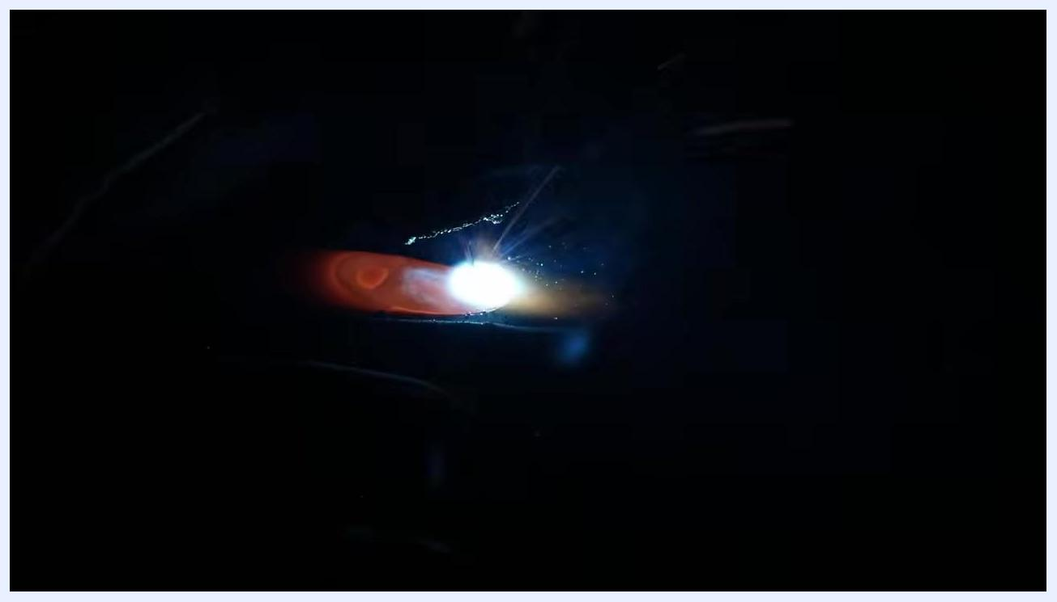
Welding arc with visible sparks, emphasizing the importance of staying centered on the joint during welding

Step 23: Explore weaving options for weld beads
Hold the MIG welding gun securely and practice weaving techniques. Weaving gives you flexibility in bead shape and coverage, but avoid excessive or erratic movement.
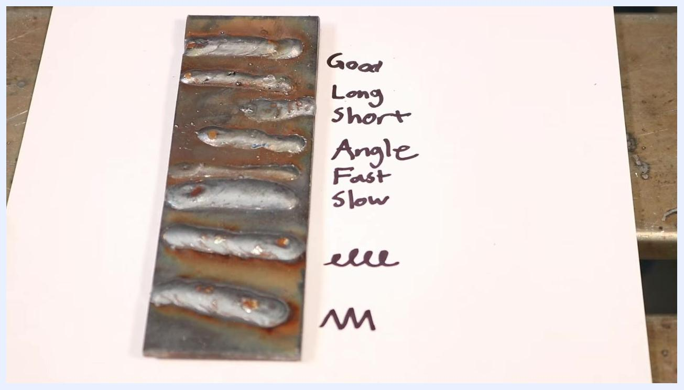
Person in a welding jacket holding a MIG gun above a metal workbench, with labeled metal pieces "Tee" and "Butt/Loop" nearby, demonstrating weaving technique options

Step 24: Maintain control during weaving
Begin weaving, but keep your movements controlled and deliberate. Quality note: Do not get carried away with wide or inconsistent weaves, as this can negatively affect weld quality.
Person holding the MIG gun in both hands, demonstrating a controlled weaving motion above the workbench

Step 25: Review and compare weld beads
Examine a sample plate with multiple weld beads, each labeled according to the technique or parameter used:
- Good — example of a proper weld bead
- Long — weld with a long arc length
- Short — weld with a short arc length
- Angle — weld performed with an incorrect gun angle
- Fast — weld with excessive travel speed
- Slow — weld with slow travel speed
- E-pattern — weaving in an "e" pattern
- M-pattern — weaving in an "M" pattern
Use this comparison to understand how each variable affects the final weld appearance and quality.
Close-up of a metal plate with multiple weld beads, each labeled: Good, Long, Short, Angle, Fast, Slow, E-pattern, M-pattern

Step 26: Identify weld defects — porosity
Notice welds with visible porosity (small holes or a sponge-like appearance), which indicate poor weld quality. Excessive arc length can cause porosity, resulting in a weak, non-solid weld. Use the labeled plate to visually identify these defects.
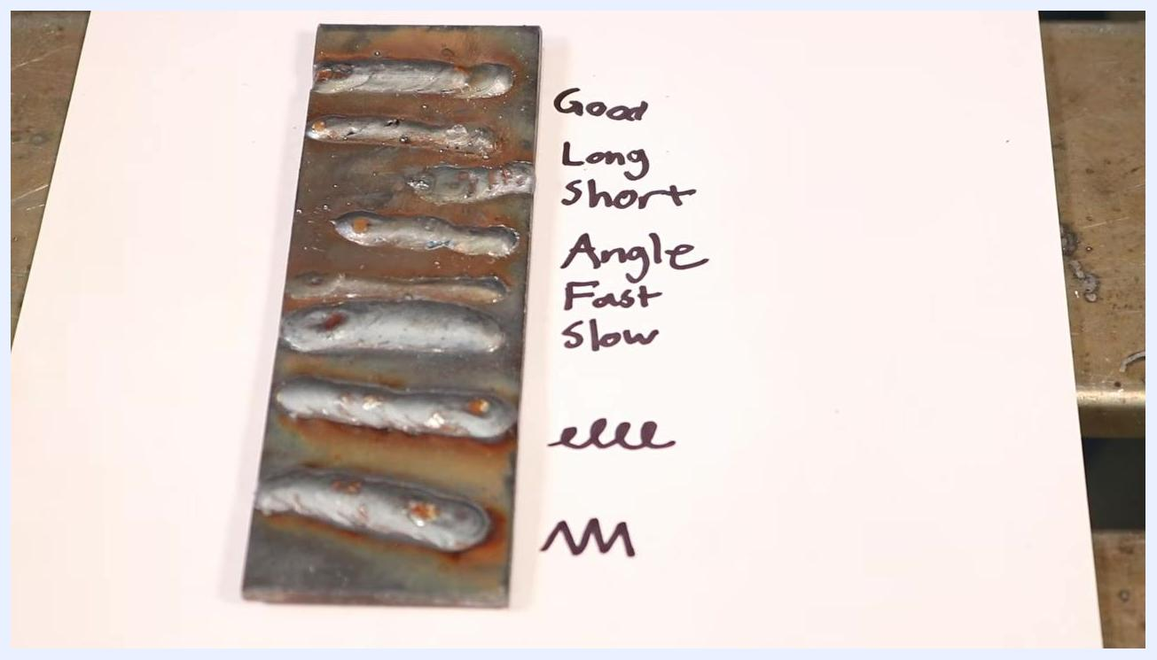
Close-up of a weld bead plate showing porosity and other defects, with handwritten labels for each weld type

Step 27: Understand the effects of arc length and spatter
Increasing arc length not only causes porosity but also increases spatter and makes the weld harder to control. Refer to the labeled plate to see the impact of improper arc length and technique.
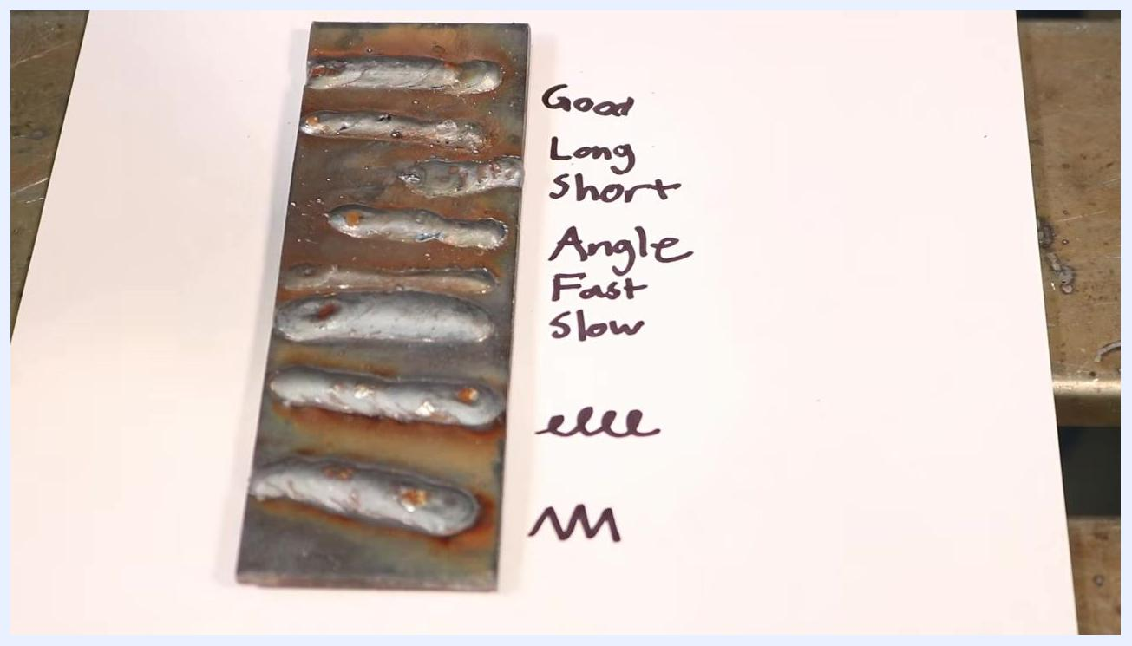
Close-up of a weld bead plate, highlighting the effects of arc length and spatter on weld quality

Step 28: Avoid burn-through on thin material
Safety/quality note: Be cautious when welding thin materials — moving too slowly or using excessive heat can burn through the workpiece. Use the sample plate to observe the results of improper speed or technique.
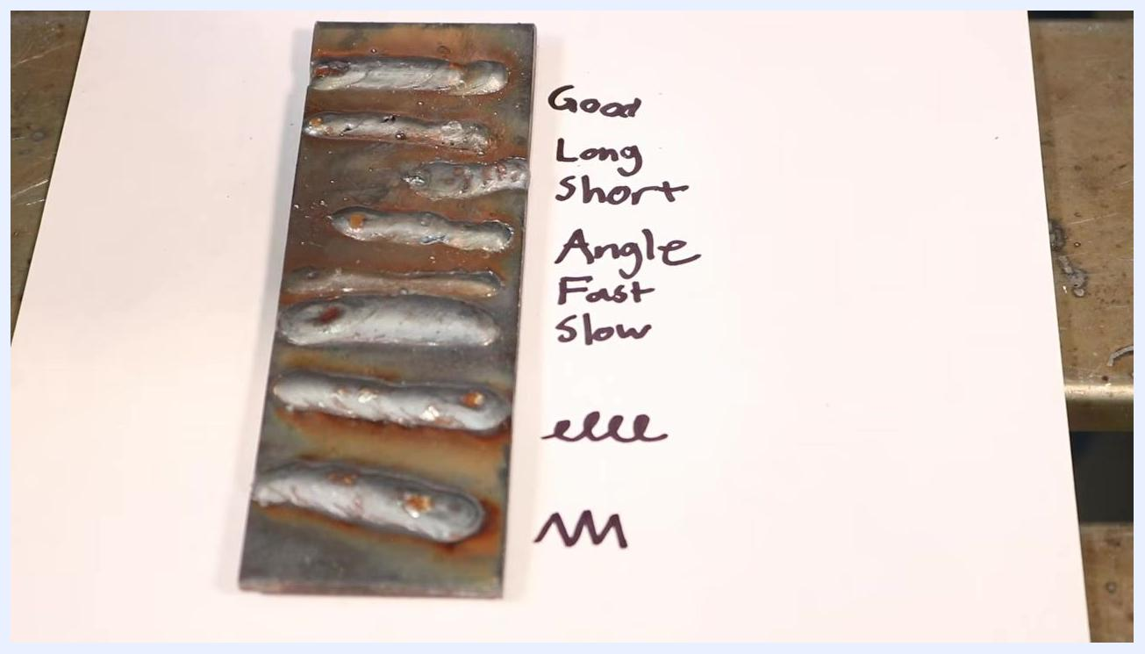
Close-up of a weld bead plate, illustrating burn-through and other issues caused by incorrect technique

Step 29: Practice and tune your technique at the bench
Before starting your actual project, spend time at the workbench practicing and tuning your welding technique. Adjust your settings and motions based on the results you observe on your practice pieces. This accelerates learning and helps you achieve better results on your final work.
Instructor standing in a welding workshop with fire extinguishers, gas cylinders, and welding machines visible, emphasizing the importance of practice and tuning technique at the bench

Step 30: Master one welding variable at a time
Focus on running a weld bead while paying attention to only one variable at a time. Start by mastering the correct distance between the MIG gun and the workpiece, then concentrate on maintaining the proper gun angle once comfortable. Practice each variable separately to build muscle memory and consistency. Safety note: Work in a well-equipped welding area with safety equipment (fire extinguishers, gas cylinders, welding machines) readily accessible.
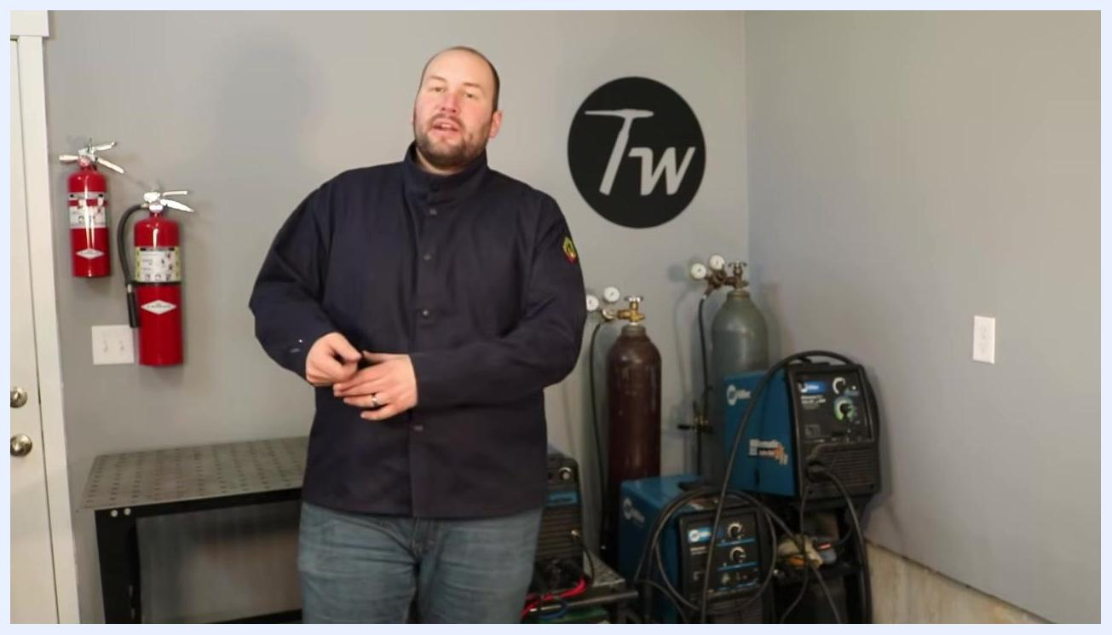
Instructor in a welding workshop, standing near fire extinguishers, gas cylinders, and welding machines, emphasizing the importance of mastering one welding variable at a time

Verification and summary
Confirm the following before considering your setup and technique complete:
- Machine is set correctly according to material thickness and wire diameter, per the settings chart
- Ground connection is solid and direct
- Material is clean prior to welding
- Stick out is maintained consistently at approximately 3/8 inch to 1/2 inch
- Work angle and travel angle are held steady across the full length of the joint
- Travel speed produces a consistent bead width without burn-through
- Weld beads are compared against sample plates to confirm absence of porosity, excessive spatter, or angle-related defects
Repeat the process, focusing on one aspect of your technique during each practice session. With consistent practice, isolating and mastering each critical variable — stick out, angle, and movement — will produce noticeable improvement in your welding skills in a short period.

What's next
Continue practicing dry runs and live welds in a safe, well-equipped environment, focusing on one variable at a time. For more detailed information on machine settings, refer to the dedicated video on the creator's channel. To stay updated on further welding tips and tutorials, consider subscribing to the channel or resource for ongoing support.
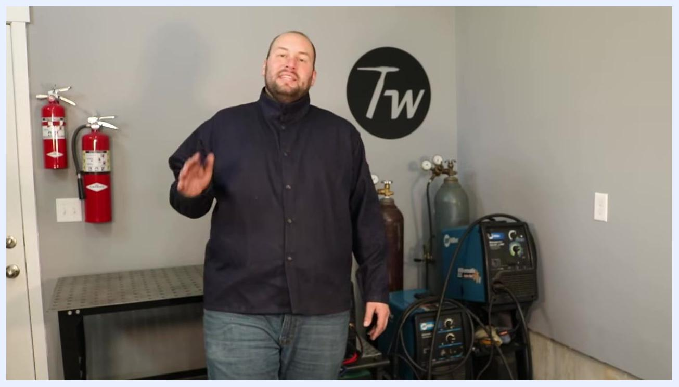
Instructor in a welding workshop, gesturing with hand, encouraging viewers to subscribe and continue learning

