Instrument Calibration Log: How to Calibrate Calipers (Dial and Digital)
This log documents how to calibrate calipers in accordance with the American National Standard ASME B89.1.14. It covers the general calibration method demonstrated with a digital caliper and an important supplemental consideration for dial calipers, where checking the angular position of the dial pointer is essential to detect gear-related errors that a standard test-point sequence may otherwise miss.

Instrument Details
Field | Digital Caliper | Dial Caliper
Instrument ID | To be recorded per lab asset numbering | To be recorded per lab asset numbering
Model | Not specified in source; record manufacturer/model here | Not specified in source; record manufacturer/model here
Serial Number | To be recorded at time of calibration | To be recorded at time of calibration
Location | Metrology training lab with calibration fixture | Metrology training lab with calibration fixture
Owner | Not specified in source | Not specified in source
Intended Use | General demonstration of the outside jaw, inside jaw, depth bar, and step measurements used for caliper calibration | Full outside, inside, depth, and step measurements, with additional attention to dial pointer position

Calibration Schedule
Calibration frequency, due dates, formal procedure numbers, and the responsible role are not specified in this session and should be recorded per your lab's internal calibration schedule. The calibration method itself follows the general procedure outlined in ASME B89.1.14, which this log references as the governing standard for both digital and dial calipers.

Standards Used
Standard | Nominal Value | Certificate / Lot Number | Expiration Date | Traceability
Gauge block | 1 inch (Mitutoyo) | To be recorded | To be recorded | To be recorded
Gauge block | 0.125 inch | To be recorded | To be recorded | To be recorded
Gauge block | 0.150 inch | To be recorded | To be recorded | To be recorded
Gauge blocks rung together | 0.275 inch (0.125" + 0.150") | To be recorded | To be recorded | To be recorded
Ring gauge | 0.200 inch | To be recorded | To be recorded | To be recorded
Certificate numbers, lot numbers, expiration dates, and formal traceability statements were not shown; record these details from your standards' calibration certificates when performing the actual log entry.

Calibration Results

General procedure: how to calibrate calipers with a digital caliper
Begin the demonstration with a digital caliper for a brief review of the general calibration method. Precision is not the focus of this portion; the goal is to summarize the sequence of measurements.
For the outside jaws, take a series of measurements across the caliper's measuring range at 1 inch, 2 inches, 4 inches, and 6 inches, varying the position across the jaws for each measurement.
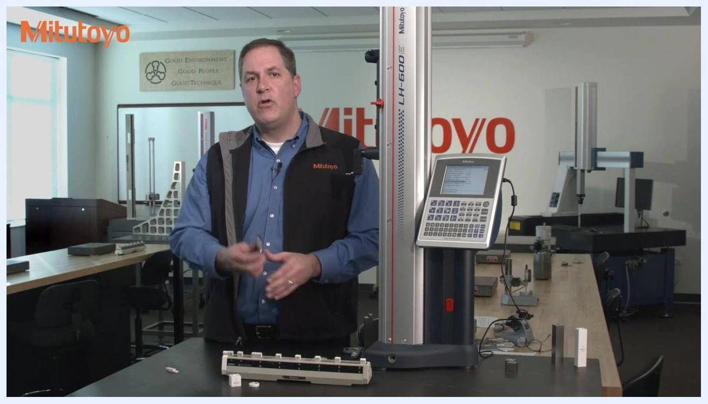
Close-up of hands using a digital caliper to measure a 1-inch Mitutoyo gauge block; the digital display reads 1.271, with the calibration fixture and gauge block visible
For the inside jaws, perform an inside measurement at 1 inch using the calibration fixture.
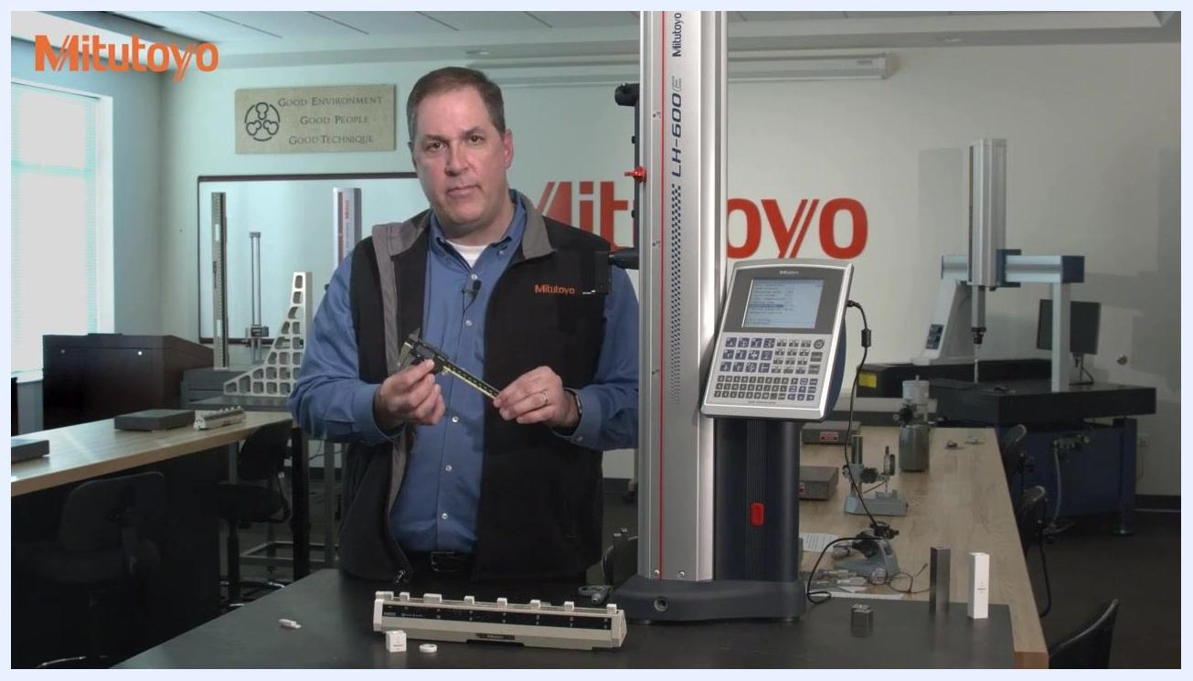
Hands using the inside jaws of a digital caliper to measure across a calibration fixture marked "INSIDE," with a 1-inch Mitutoyo gauge block visible
For the depth bar, use the depth bar of the caliper to take a measurement on the fixture.
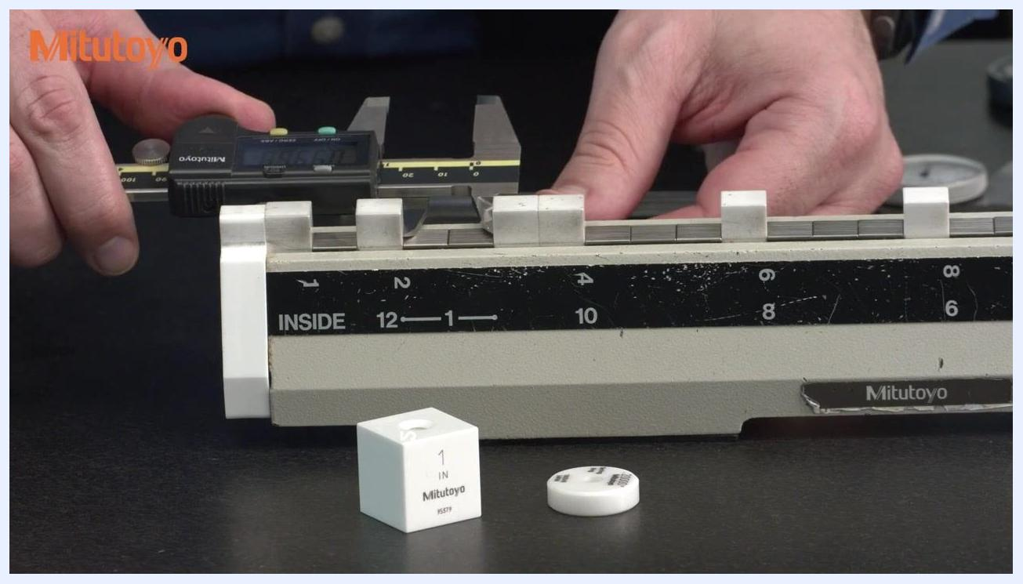
Hands using the depth bar of a digital caliper to measure on a calibration fixture, with a 1-inch Mitutoyo gauge block and calibration reference visible
If the caliper has a step function, perform a measurement using the step function as part of the calibration sequence.

Dial caliper calibration and pointer position checks
Before repeating the general sequence with a dial caliper, measure a 0.200-inch (200 thousandths) ring gauge using the inside jaws to confirm there are no issues with the small inside knife edges of the caliper.
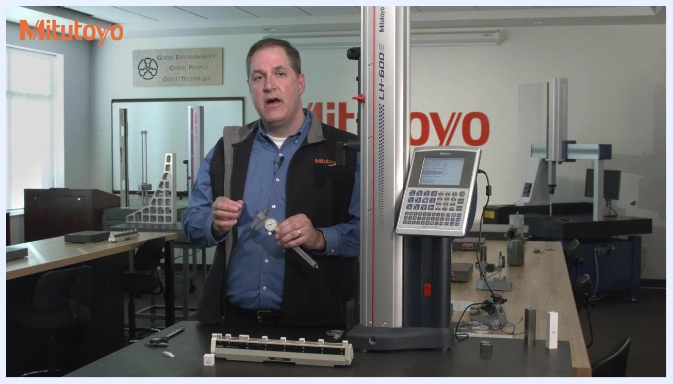
Measuring a 0.200-inch ring gauge with the inside jaws of a digital caliper; the calibration fixture is marked "INSIDE," with a 1-inch Mitutoyo gauge block and ring gauge visible
Prepare the dial caliper for the same sequence of measurements, paying close attention to the angular position of the pointer on the dial throughout.
A dial caliper held in a metrology lab, with Mitutoyo equipment and calibration fixtures visible
Measure at 1 inch using the outside jaws and observe that the pointer sits at the 12 o'clock position.
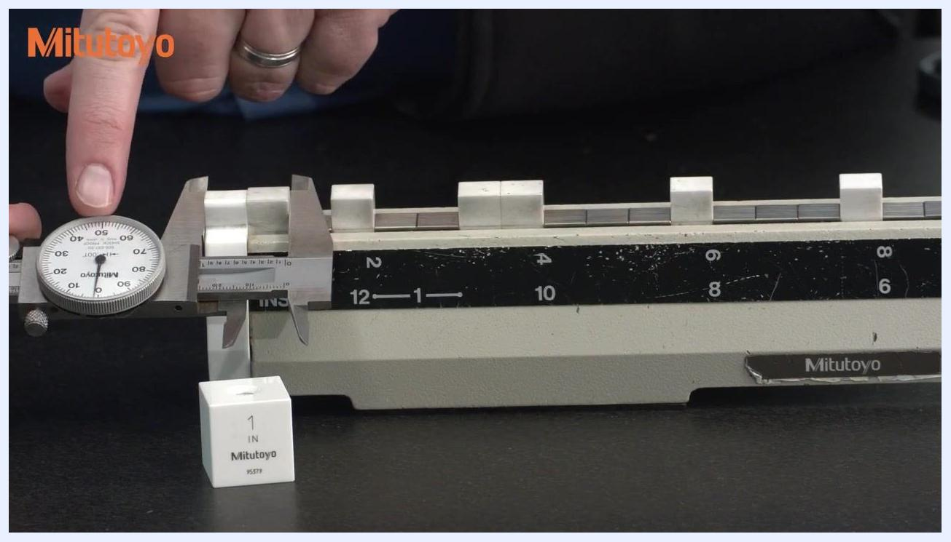
Close-up of a dial caliper measuring 1 inch on the calibration fixture, pointer at the 12 o'clock position, with a 1-inch Mitutoyo gauge block visible
Continue the outside measurements at 2 inches, 4 inches, and 6 inches, confirming for each that the pointer remains at 12 o'clock.
A dial caliper measuring at 2, 4, and 6 inches on the calibration fixture, pointer remaining at the 12 o'clock position, with a 1-inch gauge block visible
Perform the inside, depth, and step measurements with the dial caliper and observe that the pointer is still at 12 o'clock for each, showing that these standard points alone do not move the pointer to other angular positions.
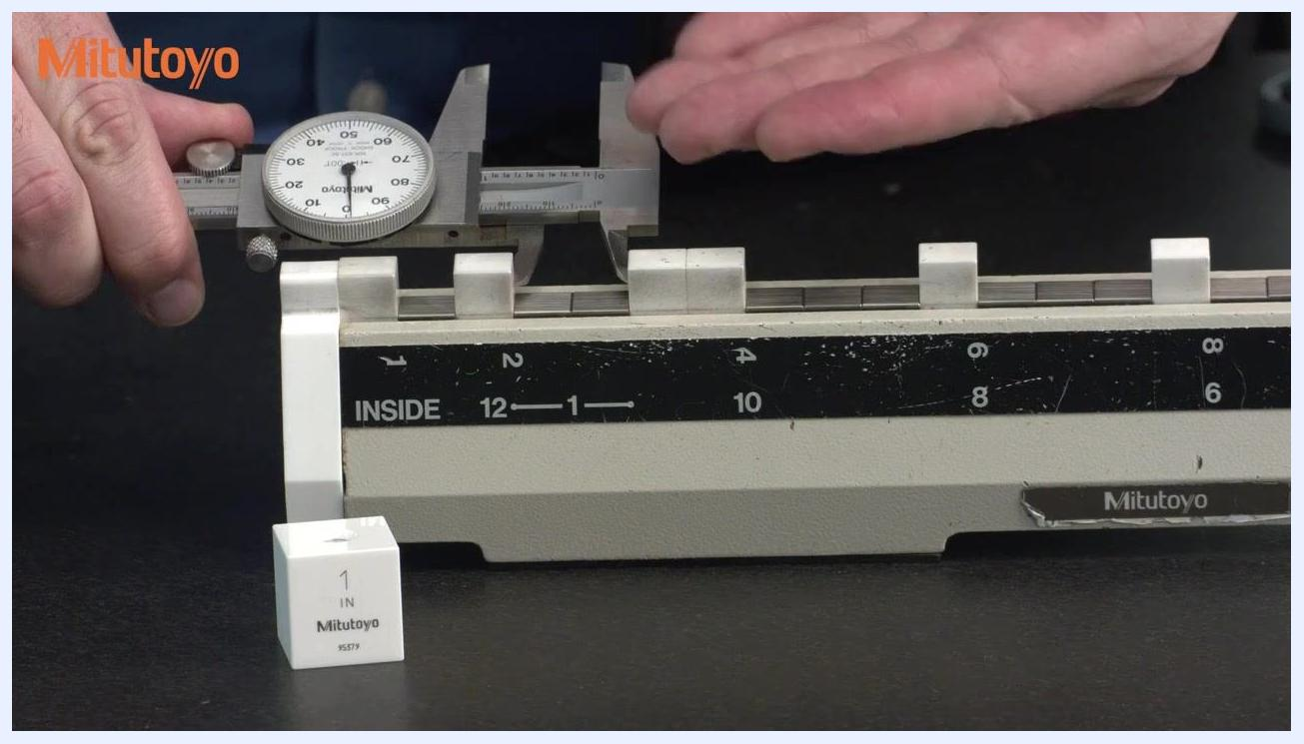
A dial caliper performing an inside, depth, or step measurement on the calibration fixture, pointer at the 12 o'clock position, with a 1-inch gauge block visible
This is a known limitation: dial calipers use internal gears that can wear over time, and errors within a single rotation of the dial go undetected if every calibration point leaves the pointer at the same position. ASME B89.1.14 requires test points that move the pointer to additional angular positions, not just 12 o'clock.
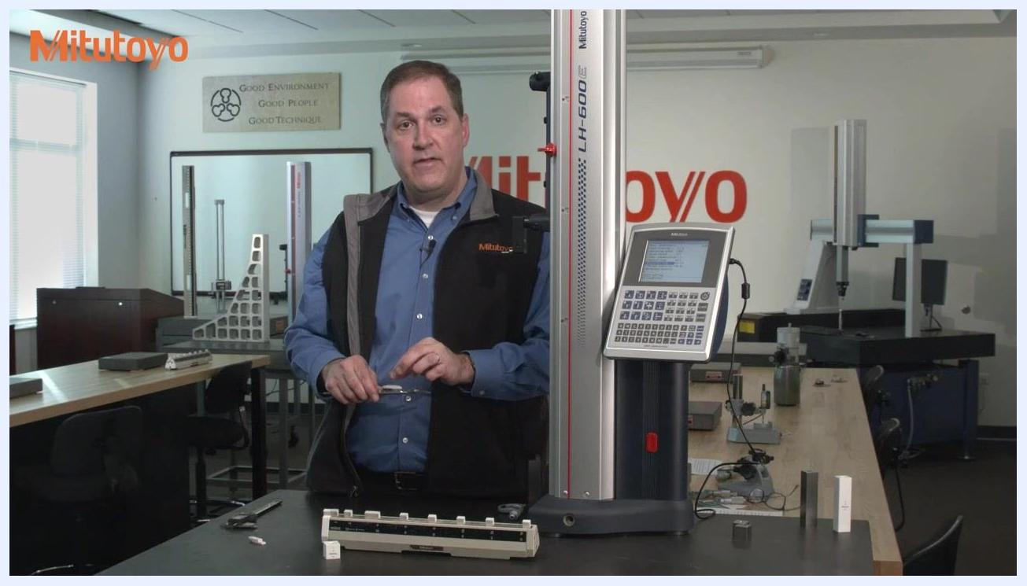
An explanation of gear wear in dial calipers, with a dial caliper held in a metrology lab alongside Mitutoyo equipment

Additional angular test points
Select a 0.125-inch (125 thousandths) gauge block and a 0.150-inch (150 thousandths) gauge block from a standard gauge block set; these are commonly available and can be rung together to create a combined test point.
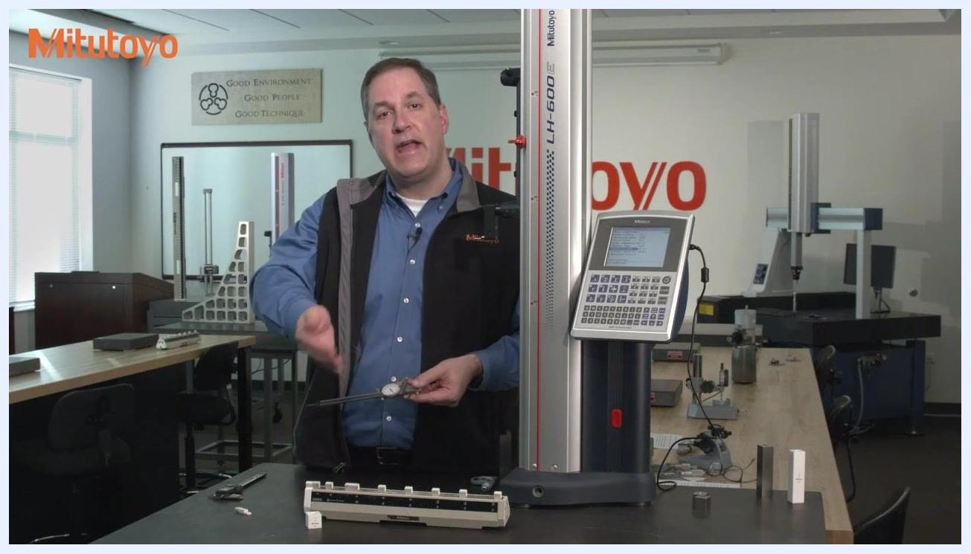
A 0.150-inch gauge block held in front of a calibration fixture labeled "INSIDE," with a 1-inch Mitutoyo gauge block visible on the table
Measure the 0.125-inch gauge block with the outside jaws of the dial caliper; the pointer should read at the 3 o'clock position.
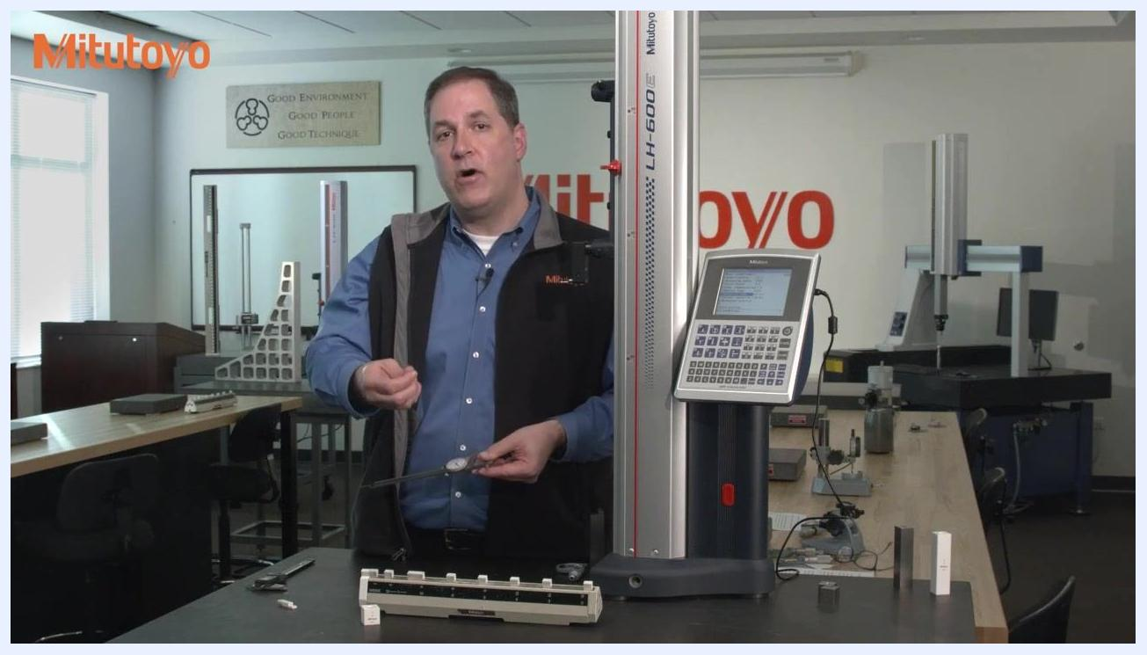
A dial caliper measuring a 0.125-inch gauge block on the calibration fixture, pointer at the 3 o'clock position
Measure the 0.150-inch gauge block with the outside jaws of the dial caliper; the pointer should read at the 6 o'clock position.
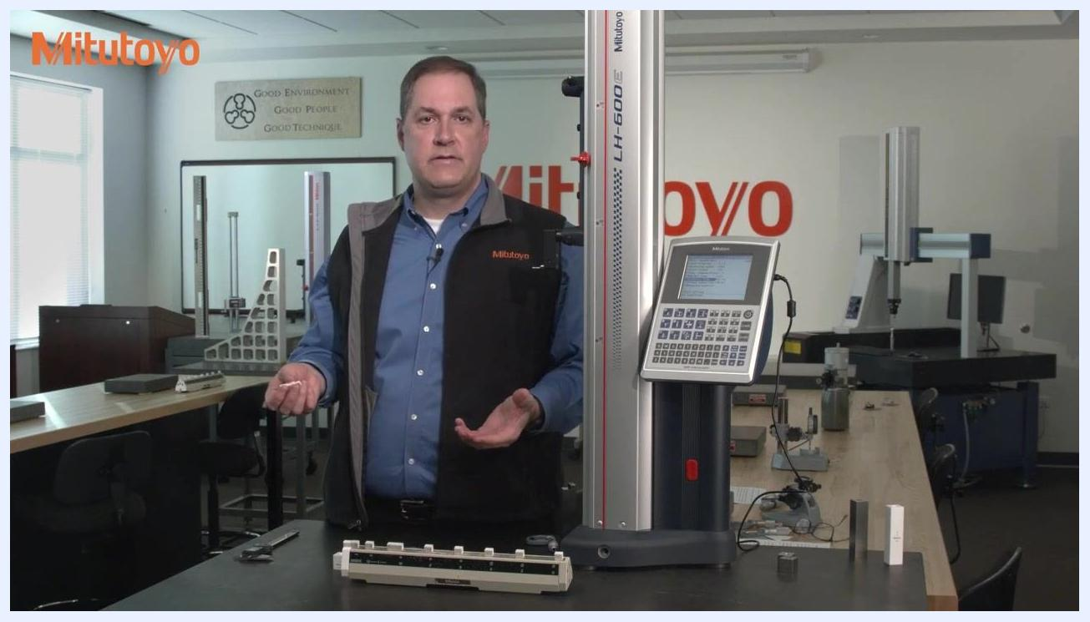
A dial caliper measuring a 0.150-inch gauge block on the calibration fixture, pointer at the 6 o'clock position
Ring the two blocks together and measure the combined 0.275-inch thickness with the outside jaws; the pointer should read at the 9 o'clock position.
A dial caliper measuring two gauge blocks rung together on the calibration fixture, pointer at the 9 o'clock position
These three measurements (0.125", 0.150", and 0.275" combined) provide three additional, easy-to-implement test points, each moving the pointer to a different angular position to help catch errors the 12 o'clock-only sequence would miss.
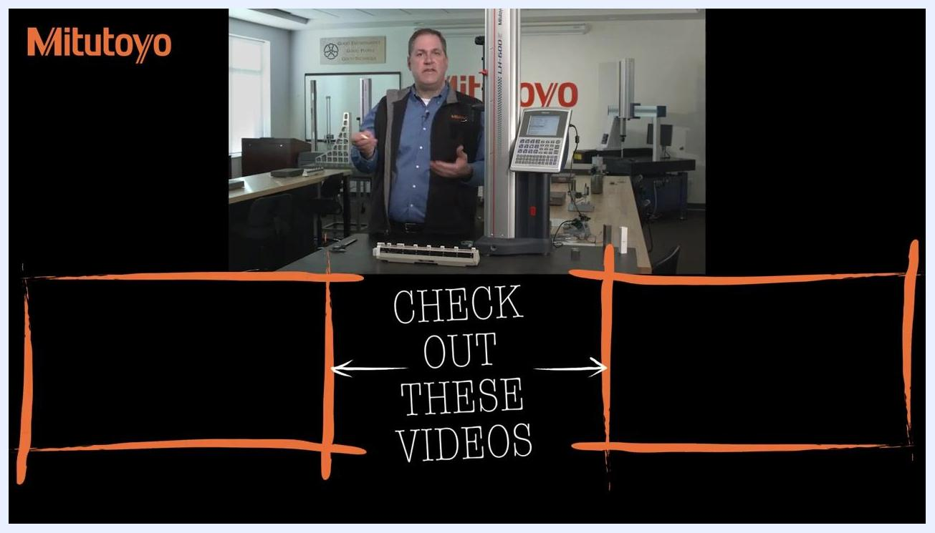
An explanation of test point flexibility, standing in a metrology lab with Mitutoyo equipment and calibration fixtures visible
ASME B89.1.14 does not prescribe specific test points, so you have flexibility in choosing them—provided the pointer is checked at various angular positions for comprehensive calibration.
Concluding the demonstration, standing in the metrology lab with Mitutoyo equipment visible

Results summary table
Test Point | Instrument Type | Nominal Value | Pointer Position (Dial) | Measured / Observed Result | Acceptance Criteria | Pass/Fail | Analyst Initials
Outside, 1" | Digital | 1.000" | N/A | 1.271 shown (demo, not precision check) | To be recorded | To be recorded | To be recorded
Outside, 2", 4", 6" | Digital | 2", 4", 6" | N/A | To be recorded | To be recorded | To be recorded | To be recorded
Inside, 1" | Digital | 1.000" | N/A | To be recorded | To be recorded | To be recorded | To be recorded
Depth bar | Digital | As shown | N/A | To be recorded | To be recorded | To be recorded | To be recorded
Step function | Digital | As shown | N/A | To be recorded | To be recorded | To be recorded | To be recorded
Inside, ring gauge | Dial | 0.200" | N/A | Confirms no knife-edge issue | To be recorded | To be recorded | To be recorded
Outside, 1", 2", 4", 6" | Dial | 1"–6" | 12 o'clock | To be recorded | To be recorded | To be recorded | To be recorded
Inside / depth / step | Dial | As shown | 12 o'clock | To be recorded | To be recorded | To be recorded | To be recorded
Outside, gauge block | Dial | 0.125" | 3 o'clock | To be recorded | To be recorded | To be recorded | To be recorded
Outside, gauge block | Dial | 0.150" | 6 o'clock | To be recorded | To be recorded | To be recorded | To be recorded
Outside, blocks rung together | Dial | 0.275" | 9 o'clock | To be recorded | To be recorded | To be recorded | To be recorded
Specific pass/fail limits, exact measured readings for each dial test point, and analyst initials were not stated in this session; record them at the time of calibration using your lab's acceptance criteria.

Maintenance
The session notes that dial calipers rely on internal gears that can wear over time, which is why pointer-position checks at multiple angular positions matter. Preventive maintenance actions, parts replaced, and any service provider used were not addressed and should be logged separately per your lab's maintenance procedure.

Out-of-Tolerance Actions
If a dial caliper only reaches the 12 o'clock pointer position across all standard test points, gear wear errors within that rotation may go undetected; testing at 3, 6, and 9 o'clock (using the 0.125", 0.150", and combined 0.275" gauge blocks) helps surface such errors. Formal impact assessment, review of affected data, quarantine procedures, and corrective action steps for an out-of-tolerance finding were not detailed in this session and should follow your lab's standard nonconformance process.

Approval
Reviewer identity, approval date, and the release-to-use decision were not part of this demonstration and should be completed by the responsible quality role after the calibration record is finalized.

What's Next
For further learning on caliper calibration and related metrology topics, refer to the additional training videos suggested at the end of this session.
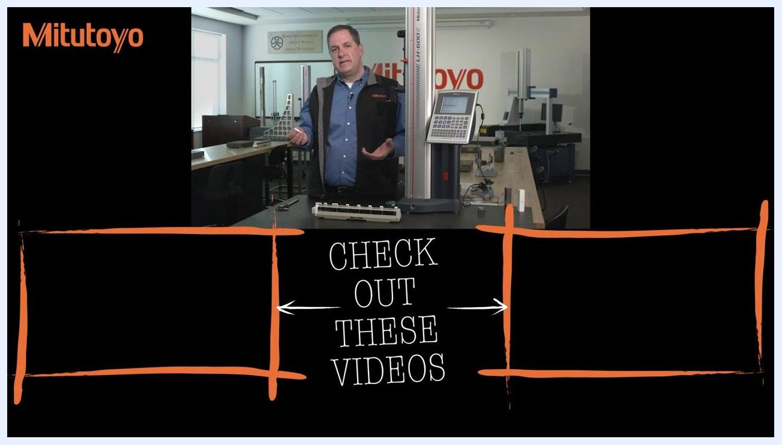
Presenter standing in the Mitutoyo Metrology Training Lab, next to a height gauge and gauge blocks, with "CHECK OUT THESE VIDEOS" and Mitutoyo branding visible
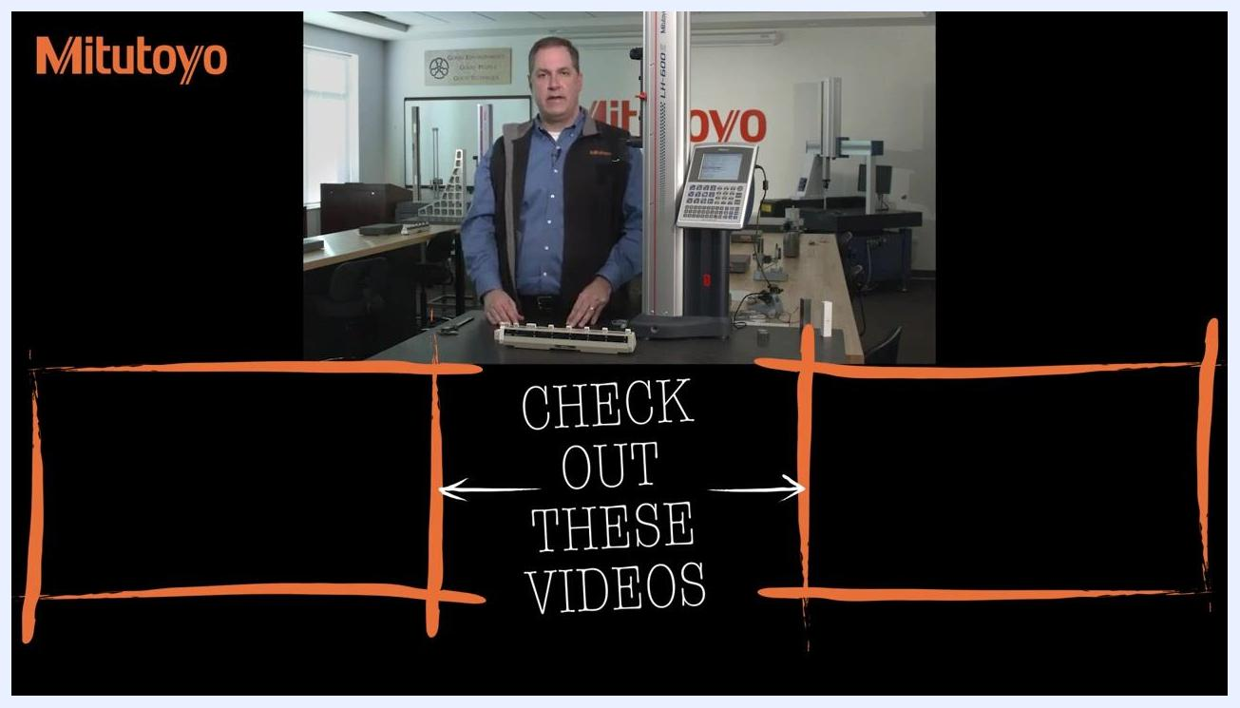
Presenter concluding the episode in the Mitutoyo Metrology Training Lab, with "CHECK OUT THESE VIDEOS" prompt and Mitutoyo branding visible

